实验三十七 交通大数据：车牌识别

37.1 实验目的
基于MapReduce思想，编写车牌识别程序。实现对江苏某两处监控图片中的车牌的识别，完成对除江苏省车辆外的外省车辆的统计，并完成对两处监控中套牌车辆的识别，并得出结果。

37.2 实验要求
要能理解MapReduce编程思想，会编写MapReduce车牌识别程序，能够利用java调用已封装好C++的so动态库完成车牌的识别，然后利用MapReduce完成对车牌的统计和对套牌车的识别。最后将其执行并分析执行过程。

37.3 实验步骤

37.3.1 编写程序
对于外省车牌的统计，我们可以理解为WordCount程序，利用WordCount的思想，在Reduce阶段对“苏”车牌不进行输出即可。
对于套牌车辆的识别，Map阶段与WordCount是一样的，在Reduce阶段我们将统计相同车牌出现的情况。
我们将编写两个类，一个类用于加载C++的so动态库，另一个完成MapReduce算法。
SelectPic.java
import java.io.File;
import java.util.Vector;

public class SelectPic {
private Vector<String> pics = null;

public SelectPic() {
pics = new Vector<>();
}

static {
System.loadLibrary("Easyper");
}

public native String getPlate(String inPath);

public void doPicNames(String inPath) {
File file = new File(inPath);
File[] listFiles = file.listFiles();
for (File files : listFiles) {
if (!files.isDirectory()) {
String name = files.getName();
String plate = getPlate(inPath + "/" + name);
if (plate.length() > 3)
plate.substring(3);
}
}
}

public static void main(String[] args) {
SelectPic sp = new SelectPic();
sp.doPicNames("image");
}

}

PlateRecog.java
import java.io.IOException;
import java.util.Vector;

import org.apache.hadoop.conf.Configuration;
import org.apache.hadoop.fs.FileSystem;
import org.apache.hadoop.fs.Path;
import org.apache.hadoop.io.IntWritable;
import org.apache.hadoop.io.LongWritable;
import org.apache.hadoop.io.NullWritable;
import org.apache.hadoop.io.Text;
import org.apache.hadoop.io.WritableComparable;
import org.apache.hadoop.io.WritableComparator;
import org.apache.hadoop.mapreduce.Job;
import org.apache.hadoop.mapreduce.Mapper;
import org.apache.hadoop.mapreduce.Reducer;
import org.apache.hadoop.mapreduce.lib.input.FileInputFormat;
import org.apache.hadoop.mapreduce.lib.output.FileOutputFormat;
import org.apache.hadoop.util.GenericOptionsParser;

public class PlateRecog {

public static class PlateRecogMapper_coll extends Mapper<LongWritable, Text, Text, IntWritable> {

private SelectPic sp = null;
private FileSystem hdfs = null;

@Override
protected void setup(Mapper<LongWritable, Text, Text, IntWritable>.Context context)
throws IOException, InterruptedException {
Configuration conf = context.getConfiguration();
sp = new SelectPic();
hdfs = FileSystem.get(conf);
}

@Override
protected void map(LongWritable key, Text value, Mapper<LongWritable, Text, Text, IntWritable>.Context context)
throws IOException, InterruptedException {
String[] splits = value.toString().split(" ");
String ds = splits[0].substring(0, splits[0].length() - 4) + "_t.jpg";
Path src = new Path(splits[0]);
Path dst = new Path(ds);
hdfs.copyToLocalFile(src, dst);
String plate = sp.getPlate(ds);
plate = plate.substring(3);
context.write(new Text(plate.substring(0, 1)), new IntWritable(1));
}
}

// 统计非江苏的车牌的数量
public static class PlateRecogReducer_coll extends Reducer<Text, IntWritable, Text, IntWritable> {
@Override
protected void reduce(Text k2, Iterable<IntWritable> v2s,
Reducer<Text, IntWritable, Text, IntWritable>.Context context)
throws IOException, InterruptedException {
if (!k2.toString().equals("苏")) {
int sum = 0;
for (IntWritable v2 : v2s) {
sum += v2.get();
}
context.write(new Text(k2.toString() + " 车牌的数量："), new IntWritable(sum));
}
}
}

public static class PlateRecogMapper_find extends Mapper<LongWritable, Text, Text, Text> {

private SelectPic sp = null;
private FileSystem hdfs = null;

@Override
protected void setup(Mapper<LongWritable, Text, Text, Text>.Context context)
throws IOException, InterruptedException {
Configuration conf = context.getConfiguration();
sp = new SelectPic();
hdfs = FileSystem.get(conf);
}

@Override
protected void map(LongWritable key, Text value, Mapper<LongWritable, Text, Text, Text>.Context context)
throws IOException, InterruptedException {
String[] splits = value.toString().split(" ");
String ds = splits[0].substring(0, splits[0].length() - 4) + "_t.jpg";
Path src = new Path(splits[0]);
Path dst = new Path(ds);
hdfs.copyToLocalFile(src, dst);
String plate = sp.getPlate(ds);
plate = plate.substring(3);
String plateInfo = plate + '_' + splits[1];

// 皖A12345_1 45
context.write(new Text(plateInfo), new Text(dst.getName().substring(0, dst.getName().length() - 6)));
}
}

public static class PlateRecogReducer_find extends Reducer<Text, Text, Text, NullWritable> {

private Vector<String> samePlates = null;

@Override
protected void setup(Reducer<Text, Text, Text, NullWritable>.Context context)
throws IOException, InterruptedException {
samePlates = new Vector<>();
}

@Override
protected void reduce(Text k2, Iterable<Text> v2s, Reducer<Text, Text, Text, NullWritable>.Context context)
throws IOException, InterruptedException {
int sum = 0;
String[] splits = k2.toString().split("_");
samePlates.clear();
for (Text v2 : v2s) {
++sum;
samePlates.add(v2.toString());
}
if (sum > 1) {
String sameplate = "";
for (int i = 0; i < samePlates.size() - 1; ++i) {
sameplate += samePlates.get(i) + " 和 ";
}
sameplate += samePlates.get(samePlates.size() - 1);
context.write(new Text("存在套牌的车辆的车牌号为 :" + splits[0] + " 车牌编号为： " + sameplate), NullWritable.get());
}
}
}

public static class findGroupComparator extends WritableComparator {

protected findGroupComparator() {
super(Text.class, true);// 注册comparator
}

@Override
public int compare(WritableComparable a, WritableComparable b) {
// TODO Auto-generated method stub
Text ti1 = (Text) a;
Text ti2 = (Text) b;
return ti1.toString().substring(0, 7).compareTo(ti2.toString().substring(0, 7));
}
}

public static void main(String[] args) {

Configuration conf = new Configuration();
try {
GenericOptionsParser goparser = new GenericOptionsParser(conf, args);
String otherargs[] = goparser.getRemainingArgs();

Job job_coll = Job.getInstance(conf);
job_coll.setJarByClass(PlateRecog.class);

job_coll.setMapperClass(PlateRecogMapper_coll.class);
job_coll.setReducerClass(PlateRecogReducer_coll.class);

job_coll.setMapOutputKeyClass(Text.class);
job_coll.setMapOutputValueClass(IntWritable.class);

FileInputFormat.addInputPath(job_coll, new Path(otherargs[0]));
FileOutputFormat.setOutputPath(job_coll, new Path(otherargs[1]));
if ((job_coll.waitForCompletion(true) ? 1 : 0) == 1) {
Job job_find = Job.getInstance(conf);
job_find.setJarByClass(PlateRecog.class);

job_find.setMapperClass(PlateRecogMapper_find.class);
job_find.setReducerClass(PlateRecogReducer_find.class);

job_find.setMapOutputKeyClass(Text.class);
job_find.setMapOutputValueClass(Text.class);
job_find.setOutputKeyClass(Text.class);
job_find.setOutputValueClass(NullWritable.class);

// job_find.setPartitionerClass(findParitioner.class);
job_find.setGroupingComparatorClass(findGroupComparator.class);

FileInputFormat.addInputPath(job_find, new Path(otherargs[0]));
FileOutputFormat.setOutputPath(job_find, new Path(otherargs[2]));
job_find.waitForCompletion(true);
}
} catch (IOException e) {
// TODO Auto-generated catch block
e.printStackTrace();
} catch (ClassNotFoundException e) {
// TODO Auto-generated catch block
e.printStackTrace();
} catch (InterruptedException e) {
// TODO Auto-generated catch block
e.printStackTrace();
}
}
}

37.3.2 环境准备
将实验数据上传到HDFS上，包括两部分，一部分是车牌照片和车牌对应的plate.txt文件。
在clinet机器上在Hadoop的HDFS中创建两个目录。
[root@client hadoop]# bin/hadoop fs -mkdir -p /user/mapreduce/platerecog/in
[root@client hadoop]# bin/hadoop fs -mkdir /user/mapreduce/platerecog/images
上传数据。
[root@client hadoop]# bin/hadoop fs -put /root/data/37/images/* /user/mapreduce/platerecog/images
[root@client hadoop]# bin/hadoop fs -put /root/data/37/in/plate.txt /user/mapreduce/platerecog/in
在master机器上，将动态库所需要的配置文件拷贝至Hadoop根目录下
[root@master hadoop]# \cp -r ../plate/use/etc/ ./
[root@master hadoop]# \cp -r ../plate/use/resources/ ./
然后将动态库和配置文件拷贝至slave1，slave2，slave3上。
先创建 machines文件写入几台机器的主机名
[root@ master hadoop]# vim machines
slave1
slave2
slave3
然后利用for进行远程拷贝
[root@master hadoop]# for x in `cat machines`;do scp -r ../plate/use/etc/ $x:/usr/cstor/hadoop/;done;
[root@master hadoop]# for x in `cat machines`;do scp -r ./resources/ $x:/usr/cstor/hadoop/;done;

37.3.2 打包提交
然后使用Eclipse开发工具将该代码打包，选择主类为PlateRecog。假定打包后的文件名为PlateRecog.jar，主类PlateRecog位于默认包下，则可使用如下命令向Hadoop集群提交本应用。
[root@client hadoop]# bin/hadoop jar PlateRecog.jar -files \
> ../plate/use/libEasyper.so,../plate/use/etc/,../plate/use/resources/ \
> /user/mapreduce/platerecog/in/plate.txt /user/mapreduce/platerecog/count/ \
> /user/mapreduce/platerecog/samePlate/
其中“hadoop”为命令，“jar”为命令参数，后面紧跟打的包，“-files”是附加文件指令，“../plate/use/libEasyper.so,../plate/use/etc/,../plate/use/resources/”是同时提交到集群上的配置文件和动态库。“/user/mapreduce/platerecog/in/plate.txt”为输入文件在HDFS中的位置，“/user/mapreduce/platerecog/count/”和 “/user/mapreduce/platerecog/samePlate/”为输出文件在HDFS中的位置，分别对应的是统计车牌的数量的输出文件count，套牌车识别的结果文件samePlate。

37.4 实验结果

37.4.1 输入数据
输入数据格式如下：plate.txt (空格（' '）分割)（数据放在/root/data/37/in目录下）
/user/mapreduce/platerecog/images/99.jpg 2
/user/mapreduce/platerecog/images/100.jpg 2
/user/mapreduce/platerecog/images/101.jpg 2
/user/mapreduce/platerecog/images/102.jpg 2
/user/mapreduce/platerecog/images/103.jpg 2
/user/mapreduce/platerecog/images/104.jpg 2
/user/mapreduce/platerecog/images/105.jpg 2
/user/mapreduce/platerecog/images/106.jpg 2
/user/mapreduce/platerecog/images/107.jpg 2
······

37.4.2 执行结果
在client上执行对hdfs上的文件/user/mapreduce/platerecog/count/part-r-00000内容查看的操作，查看外省车辆的统计情况
[root@client hadoop]# bin/hadoop fs -cat /user/mapreduce/platerecog/count/p*
屏幕上显示如下：
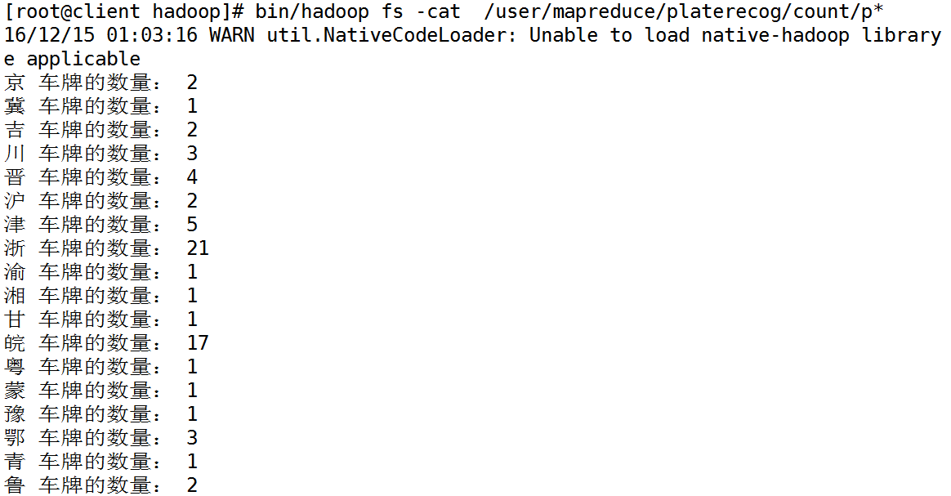

在client上执行对hdfs上的文件/user/mapreduce/platerecog/samePlate/part-r-00000内容查看的操作，查看两处监控的套牌车辆的情况。
[root@client hadoop]# bin/hadoop fs -cat /user/mapreduce/platerecog/samePlate/p*
屏幕上显示如下：
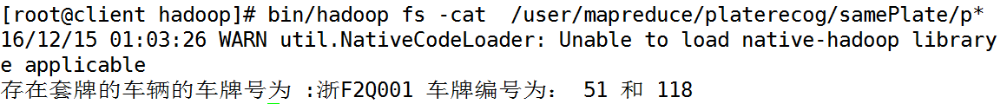
我们将两个编号的车牌图片拿出来查看一下。
