实验三十八 互联网数据处理：搜索引擎

38.1 实验目的
1. 利用大数据实验环境完成一个真实的项目。
2. 结合多个大数据的组件练习如何在实际项目中使用大数据的组件。
3. 能使用分布式的思想对数据进行清洗，处理。
4. 考虑大数据环境对数据的处理方法进行优化。
5. 利用大数据的思路，了解通用的搜索引擎技术流程。

38.2 实验要求
在实验结束的时候能达到实验结果所展示的要求，能从HBase中正确查询到所需要的数据，并且结果能按照相关性大小排序。
能明白HBase建立索引的理由，并能理解HBase建立索引的方法，能正确使用索引，利用索引在hbase中作用。
能理解在扒取互联网数据的时候的流程，再实验完整之后有兴趣可以对其他网站运用同样的方法对数据进行扒取。
能完整的将整个实验流程理解。了解大数据环境下利用HBase组件的一些功能。并能比较利用NoSQL的数据库和关系型数据库的区别。

38.3 实验步骤
我们的实验的内容主要是先从淘宝的网页中扒取部分商品的信息，然后从这些信息中提取去我们所需要的几项数据，将其存储在HBase中。然后我们可以通过关键词搜索从HBase中将这些数据根据我们的关键词提取出来。

38.3.1 新建createindex java项目
因为HBase只能使用rowKey从HBase中读取数据。而我们需要使用关键词从HBase读取数据，所以我们需要对商品的标题中提取关键词，然后对关键词和url建立索引。这样我们就可以通过商品的的标题分词过后的关键词进行搜索查询到商品的url，然后通过url去取得商品的信息。
新建createindex的项目，主要分为几个步骤，新建Hadoop任务的Map类和Reduce类，新建任务类。
项目的目录结构如下：
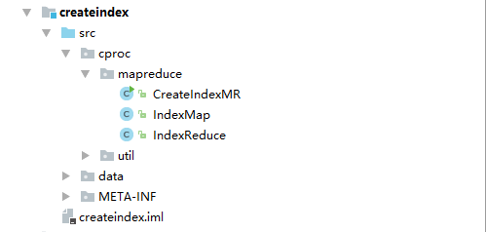

项目所需的jar可在实验的/root/data/38/jar使用ftp下载到本地即可。
新建IndexMap类。Map类的代码为
package cproc.mapreduce;
import java.io.IOException;
import java.util.ArrayList;
import java.util.HashMap;
import java.util.List;
import java.util.Map;
import org.apache.hadoop.hbase.client.Result;
import org.apache.hadoop.hbase.io.ImmutableBytesWritable;
import org.apache.hadoop.hbase.mapreduce.TableMapper;
import org.apache.hadoop.hbase.util.Bytes;
import org.apache.hadoop.io.Text;
import org.apache.hadoop.mapreduce.Mapper;
import cproc.util.BuildSegmenter;
import edu.stanford.nlp.ie.crf.CRFClassifier;
import edu.stanford.nlp.ling.CoreLabel;
public class IndexMap extends TableMapper<Text, Text> {
CRFClassifier<CoreLabel> segmenter = null;
@Override
protected void setup(
Mapper<ImmutableBytesWritable, Result, Text, Text>.Context context)
throws IOException, InterruptedException {
super.setup(context);
// 初始化分词器 —— 加载速度慢，该步骤仅操作一次，耗时约10s
if(segmenter==null){
BuildSegmenter bs = new BuildSegmenter();
segmenter = bs.BuildSegmenter();
}
}
@Override
public void map(ImmutableBytesWritable key, Result value, Context context)
throws IOException, InterruptedException {
String url = Bytes.toString(key.get());
Map<String, Integer> wordmap = null;
String title = "";
byte[] bytes = value.getValue(Bytes.toBytes("info"), Bytes.toBytes("itemTitle"));
if(bytes!=null && bytes.length>0){
title = Bytes.toString(bytes);
}
//标题分词
List<String> keyWordSeg = new ArrayList<String>();
keyWordSeg = segmenter.segmentString(title);
//每个url的标题内单词合并
wordmap = new HashMap<String, Integer>();
for(String word : keyWordSeg){
if(wordmap.containsKey(word)){
wordmap.put(word, (Integer)wordmap.get(word)+1);
}else{
wordmap.put(word, 1);
}
}
for(String word : wordmap.keySet()){
context.write(new Text(word),new Text(wordmap.get(word)+"##"+url));
}
}
}
新建IndexReduce类，Reduce类的代码如下：
package cproc.mapreduce;
import java.io.IOException;
import org.apache.hadoop.hbase.client.Put;
import org.apache.hadoop.hbase.io.ImmutableBytesWritable;
import org.apache.hadoop.hbase.mapreduce.TableReducer;
import org.apache.hadoop.hbase.util.Bytes;
import org.apache.hadoop.io.Text;
public class IndexReduce extends TableReducer<Text, Text, ImmutableBytesWritable>
{
@Override
protected void reduce(Text key, Iterable<Text> values, Context context) throws IOException, InterruptedException
{
String str = "";
for (Text value : values) {
str += value.toString() + "####";
}
if(str!=null && str.length()>4)
{
str = str.substring(0, str.length()-4);
}
Put put = null;
try{
put = new Put(Bytes.toBytes(key.toString()));
}catch (Exception e){
System.out.println("key is : "+ key.toString());
System.out.println(e.getMessage());
}
if(put!=null) {
// 列簇 , 列名, 值
put.addColumn(Bytes.toBytes("info"), Bytes.toBytes("val"), Bytes.toBytes(str));
context.write(new ImmutableBytesWritable(Bytes.toBytes(key.toString())), put);
}
}
}

新建CreateIndexMR，新建MapReduce的主方法
package cproc.mapreduce;
import org.apache.hadoop.conf.Configuration;
import org.apache.hadoop.filecache.DistributedCache;
import org.apache.hadoop.fs.Path;
import org.apache.hadoop.hbase.HBaseConfiguration;
import org.apache.hadoop.hbase.client.Scan;
import org.apache.hadoop.hbase.mapreduce.TableMapReduceUtil;
import org.apache.hadoop.hdfs.DistributedFileSystem;
import org.apache.hadoop.io.Text;
import org.apache.hadoop.mapreduce.Job;
public class CreateIndexMR {
@SuppressWarnings("deprecation")
public static void main(String[] args) throws Exception {
//初始化conf文件
Configuration conf = HBaseConfiguration.create();
//hbase配置
conf.set("hbase.zookeeper.quorum", "datacube102:2181");//你的Zookeeper的地址
conf.set("zookeeper.znode.parent", "/hbase");
//定义任务
Job job = new Job(conf, "createIndex");
job.setJarByClass(CreateIndexMR.class);
Scan scan = new Scan();
scan.setCaching(500); // 默认是1，应该设置的大一些
scan.setCacheBlocks(false); // 当mr或者全表查询的时候要设置成false，查询热数据的的时候可以使用，这样就在hbase的jvm中缓存当前记录
//设置map
TableMapReduceUtil.initTableMapperJob(
"goodinfo", // input table
scan, // Scan
IndexMap.class, // mapper class
Text.class, // mapper output key
Text.class, // mapper output value
job);
//设置reduce (output table , reducer class , job)
TableMapReduceUtil.initTableReducerJob("indexinfo", IndexReduce.class, job);
// 运行job
System.exit(job.waitForCompletion(true) ? 0 : 1);
}
}

新建BuildSegmenter类，新建分词工具类。
package cproc.util;
import java.util.Properties;
import edu.stanford.nlp.ie.crf.CRFClassifier;
import edu.stanford.nlp.ling.CoreLabel;
/**
* 初始化分词器
*/
public class BuildSegmenter {
public CRFClassifier<CoreLabel> BuildSegmenter() {
/**
* 初始化分词器
* @return
*/
//String basedir = System.getProperty("Sousuo", "data");
// String basedir = BuildSegmenter.class.getClassLoader().getResource("data").getPath();
String basedir = "/data";
Properties props = new Properties();
props.setProperty("sighanCorporaDict", basedir);
props.setProperty("serDictionary", basedir + "/dict-chris6.ser.gz");
props.setProperty("inputEncoding", "UTF-8");
props.setProperty("sighanPostProcessing", "true");
CRFClassifier<CoreLabel> segmenter = new CRFClassifier<>(props);
System.out.println(basedir);
segmenter.loadClassifierNoExceptions(basedir + "/ctb.gz", props);
return segmenter;
}
}
到此，CreateIndex代码部分已经完成。Createindex项目的作用是对Hbase 中的goodinfo集合数据建立索引表indexinfo。

38.3.2 新建demo JavaWeb项目
该项目的主要作用是提供web界面扒取淘宝的数据和搜索数据。该项目部署在本地服务器上。
该项目的目录结构如下图：
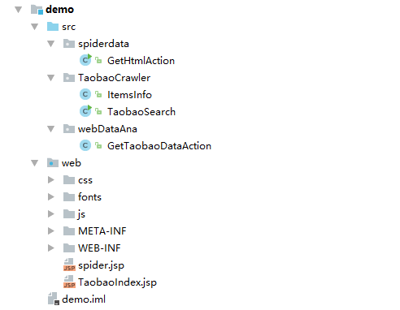
对于web目录下的除jsp页面外的代码放在/root/data/38/web 目录下，请读者自行下载加入入自己的目录下。
新建spider.jsp文件，作为页面扒取的web页面。
<!-- you_shoubian -->
<%@page import="TaobaoCrawler.ItemsInfo"%>
<%@page import="java.util.*"%>
<%@ page import="webDataAna.GetTaobaoDataAction" %>
<%@ page language="java" contentType="text/html; charset=UTF-8"
pageEncoding="UTF-8"%>
<%
String searchWord = "";
String pageNumStr = "";
String itemLen = "";
String msg = "";
%>
<!DOCTYPE html PUBLIC "-//W3C//DTD HTML 4.01 Transitional//EN" "http://www.w3.org/TR/html4/loose.dtd">
<html>
<head>
<meta http-equiv="Content-Type" content="text/html; charset=UTF-8">
<title>淘宝集合</title>
<link rel="stylesheet" href="css/bootstrap.min.css">
<link rel="stylesheet" href="css/myTaobaoCss.css">
<script type="text/javascript" src="js/jquery-1.11.3.min.js"></script>
<script type="text/javascript" src="js/bootstrap.min.js"></script>
</head>
<body>
<div class="container">
<div style="height: 100px"></div>
<div class="formStyle col-md-offset-1 col-md-10 ">
<form class="" method="post" action="/getHtml">
<div class="form-group col-md-7 mySearchMar">
<input type="text" class="form-control " id="searchWords"
name="searchWords" placeholder="请输入搜索的内容,多个关键词用 , 隔开">
</div>
<div class="form-group col-md-2 myPageMar">
<div class="input-group">
<input type="text" class="form-control" id="pageNum" name="pageNum"
placeholder="1">
<div class="input-group-addon">页</div>
</div>
</div>
<button type="submit" class="btn btn-default col-md-1"
onclick="showMsg()">检索</button>
</form>
</div>
<div class="tableStyle col-md-offset-1 col-md-10">
<div id="msg"></div>
</div>
<%
if (request.getAttribute("searchWord") != null) {
searchWord = (String) request.getAttribute("searchWord");
itemLen = (String) request.getAttribute("itemLen");
String pageNum = (String) request.getAttribute("pageNumStr");
msg = "共获取 <b>" + pageNum + "</b> 页,获取数据 <b>" + itemLen + "</b> 条,搜索词为 <b>"+searchWord+"</b>";
if(searchWord.equals("无搜索词，结果随机搜索")){
searchWord="";
}
}
%>
</div>
<script type="text/javascript">
$("#searchWord").val("<%=searchWord%>");
$("#pageNum").val("<%=pageNumStr%>");
$("#msg").html("<%=msg%>");
function showMsg() {
$("#msg").text("正在检索...");
}
</script>
</body>
</html>

新建TaobaoIndex.jsp 文件，作为Taobao数据展示web页面。
<!-- you_shoubian -->
<%@page import="TaobaoCrawler.ItemsInfo"%>
<%@page import="java.util.*"%>
<%@ page import="webDataAna.GetTaobaoDataAction" %>
<%@ page language="java" contentType="text/html; charset=UTF-8"
pageEncoding="UTF-8"%>
<%
String searchWord = "";
String pageNumStr = "";
String msg = "";
%>
<!DOCTYPE html PUBLIC "-//W3C//DTD HTML 4.01 Transitional//EN" "http://www.w3.org/TR/html4/loose.dtd">
<html>
<head>
<meta http-equiv="Content-Type" content="text/html; charset=UTF-8">
<title>淘宝集合</title>
<link rel="stylesheet" href="css/bootstrap.min.css">
<link rel="stylesheet" href="css/myTaobaoCss.css">
<script type="text/javascript" src="js/jquery-1.11.3.min.js"></script>
<script type="text/javascript" src="js/bootstrap.min.js"></script>
</head>
<body>
<div class="container">
<div style="height: 100px"></div>
<div class="formStyle col-md-offset-1 col-md-10 ">
<form class="" method="post" action="/getTaobaoData">
<div class="form-group col-md-7 mySearchMar">
<input type="text" class="form-control " id="searchWord"
name="searchWord" placeholder="请输入搜索的内容">
</div>
<div class="form-group col-md-2 myPageMar">
<div class="input-group">
<input type="text" class="form-control" id="pageNum" name="pageNum"
placeholder="1">
<div class="input-group-addon">项</div>
</div>
</div>
<button type="submit" class="btn btn-default col-md-1"
onclick="showMsg()">检索</button>
</form>
</div>
<div class="tableStyle col-md-offset-1 col-md-10">
<div id="msg"></div>
</div>
<div class="tableStyle col-md-offset-1 col-md-10">
<table class="table table-striped">
<thead>
<tr>
<th>#</th>
<th>商品名</th>
<th class="col-md-1">价格</th>
<th>交易量</th>
<th class="col-md-2">店铺</th>
<th>所在地</th>
</tr>
</thead>
<tbody>
<%
List<ItemsInfo> itemsInfoList = new ArrayList<ItemsInfo>();
if (request.getAttribute("itemsInfoList") != null) {
itemsInfoList = (ArrayList<ItemsInfo>) request.getAttribute("itemsInfoList");
searchWord = (String) request.getAttribute("searchWord");
pageNumStr = (String) request.getAttribute("pageNumStr");
int pageNum = (Integer) request.getAttribute("pageNum");
msg = "共获取数据 <b>" + itemsInfoList.size() + "</b> 条,搜索词为 <b>"+searchWord+"</b>";
if("无搜索词，结果随机搜索".equals(searchWord)){
searchWord="";
}
int len = itemsInfoList.size();
for (int i = 0; i < len; i++) {
%>
<tr>
<td><%=i + 1%></td>
<td><a href="<%=itemsInfoList.get(i).getItemAddress()%>"
title="点击查看详情"><%=itemsInfoList.get(i).getItemTitle()%></a></td>
<td><%=itemsInfoList.get(i).getItemPrice()%></td>
<td><%=itemsInfoList.get(i).getItemDealCnt()%></td>
<td><%=itemsInfoList.get(i).getItemShop()%></td>
<td><%=itemsInfoList.get(i).getItemShopLocaltion()%></td>
</tr>
<%
}
}
%>
</table>
</div>
</div>
<script type="text/javascript">
$("#searchWord").val("<%=searchWord%>");
$("#pageNum").val("<%=pageNumStr%>");
$("#msg").html("<%=msg%>");
function showMsg() {
$("#msg").text("正在检索...");
}
</script>
</body>
</html>
创建servlet类，GetHtmlAction类，这个servlet访问/getHtml的http请求。
package TaobaoCrawler;
import org.apache.hadoop.conf.Configuration;
import org.apache.hadoop.hbase.HBaseConfiguration;
import org.apache.hadoop.hbase.TableName;
import org.apache.hadoop.hbase.client.*;
import org.apache.hadoop.hbase.util.Bytes;
import org.jsoup.Jsoup;
import org.jsoup.nodes.*;
import org.jsoup.select.Elements;
import java.io.File;
import java.io.IOException;
import java.util.*;
/**
* author:you_shoubian time:2016-1-19
*/
public class TaobaoSearch {
private static final Configuration configuration = HBaseConfiguration.create();
private static Connection connection;
static {
configuration.set("hbase.zookeeper.quorum", "master:2181");//修改
configuration.set("zookeeper.znode.parent", "/hbase");
try {
connection = ConnectionFactory.createConnection(configuration);
} catch (IOException e) {
e.printStackTrace();
}
}
public static void main(String args[]) {
try{
getItemsInfoList("包邮",2);
}catch (Exception e){
e.printStackTrace();
}
}
public static List<ItemsInfo> getItemsInfoList(String searchWord, int pNum) throws IOException {
List<ItemsInfo> itemsInfoList = new ArrayList<ItemsInfo>();
TableName tbname = TableName.valueOf("indexinfo");
Table table = null;
Result result = null;
table = connection.getTable(tbname);
result = table.get(new Get(Bytes.toBytes(searchWord)));
byte[] byteurls = result.getValue(Bytes.toBytes("info"), Bytes.toBytes("val"));
String urls = "";
if(byteurls!=null && byteurls.length>0)
{
urls = new String(byteurls);
}
//带个数的url(次数##url),每个url中间用####隔开
String[] comurlarr = null;
if(urls != null && urls.length()>0)
{
comurlarr = urls.split("####");
}
Map<String,Integer> urlmap = new HashMap<>();
for(String urlandnum : comurlarr){
String[] tim = urlandnum.split("##");
urlmap.put(tim[1],Integer.parseInt(tim[0]));
}
//查询商品信息表
if(comurlarr != null && comurlarr.length>0)
{
TableName tbname2 = TableName.valueOf("goodinfo");
Table table2 = null;
table2 = connection.getTable(tbname2);
List<Get> list = new ArrayList<Get>();
Get get = null;
for(String comurl : comurlarr)
{
String[] arr = comurl.split("##");
if(arr!=null && arr.length>1){
get = new Get(Bytes.toBytes(arr[1]));
list.add(get);
}
}
Result[] results = table2.get(list);
for(Result re : results)
{
System.out.println(Bytes.toString(re.getRow()) + ": " + Bytes.toString(re.getValue(Bytes.toBytes("info"), Bytes.toBytes("itemTitle"))));
}
List<Object[]> itemsList = new ArrayList<>();
for(Result res : results){
ItemsInfo item = new ItemsInfo();
Object[] item2 = new Object[2];
item.setItemAddress(Bytes.toString(res.getRow()));
item.setItemTitle(Bytes.toString(res.getValue(Bytes.toBytes("info"),Bytes.toBytes("itemTitle"))));
item.setItemShop(Bytes.toString(res.getValue(Bytes.toBytes("info"),Bytes.toBytes("itemShop"))));
item.setItemShopLocaltion(Bytes.toString(res.getValue(Bytes.toBytes("info"),Bytes.toBytes("itemShopLocaltion"))));
item.setItemPrice(Bytes.toString(res.getValue(Bytes.toBytes("info"),Bytes.toBytes("itemPrice"))));
item.setItemDealCnt(Bytes.toString(res.getValue(Bytes.toBytes("info"),Bytes.toBytes("itemDealCnt"))));
item2[0] = item;
item2[1] = urlmap.get(item.getItemAddress());
itemsList.add(item2);
}
Collections.sort(itemsList, new Comparator<Object[]>() {
@Override
public int compare(Object[] o1, Object[] o2) {
if(o1.length != 2 || o2.length != 2 ){
return 0;
}
if((int)o1[1] < (int)o2[1]){
return 1;
}else{
return -1;
}
}
});
for(Object[] objarr : itemsList.subList(0,Math.min(pNum,itemsList.size()))){
System.out.println(objarr[1]);
itemsInfoList.add((ItemsInfo) objarr[0]);
}
}
return itemsInfoList;
}
}

创建ItemInfo类，作为从数据库读取数据的model类。
package TaobaoCrawler;
/**
* author:you_shoubian time:2016-1-19
*/
public class ItemsInfo {
String itemTitle; //商品标题(名称)
String itemShop; //商品店铺名
String itemShopLocaltion; //商品店铺所在地
String itemPrice; //商品价格
String itemDealCnt; //商品交易量
String itemAddress; //商品详细地址
public String getItemTitle() {
return itemTitle;
}
public void setItemTitle(String itemTitle) {
this.itemTitle = itemTitle;
}
public String getItemShop() {
return itemShop;
}
public void setItemShop(String itemShop) {
this.itemShop = itemShop;
}
public String getItemShopLocaltion() {
return itemShopLocaltion;
}
public void setItemShopLocaltion(String itemShopLocaltion) {
this.itemShopLocaltion = itemShopLocaltion;
}
public String getItemPrice() {
return itemPrice;
}
public void setItemPrice(String itemPrice) {
this.itemPrice = itemPrice;
}
public String getItemDealCnt() {
return itemDealCnt;
}
public void setItemDealCnt(String itemDealCnt) {
this.itemDealCnt = itemDealCnt;
}
public String getItemAddress() {
return itemAddress;
}
public void setItemAddress(String itemAddress) {
this.itemAddress = itemAddress;
}
}

创建Taobaosearch类，用于从Hbase中读取淘宝数据。
package TaobaoCrawler;
import org.apache.hadoop.conf.Configuration;
import org.apache.hadoop.hbase.HBaseConfiguration;
import org.apache.hadoop.hbase.TableName;
import org.apache.hadoop.hbase.client.*;
import org.apache.hadoop.hbase.util.Bytes;
import org.jsoup.Jsoup;
import org.jsoup.nodes.*;
import org.jsoup.select.Elements;
import java.io.File;
import java.io.IOException;
import java.util.*;
/**
* author:you_shoubian time:2016-1-19
*/
public class TaobaoSearch {
private static final Configuration configuration = HBaseConfiguration.create();
private static Connection connection;
static {
configuration.set("hbase.zookeeper.quorum", "datacube102:2181");
configuration.set("zookeeper.znode.parent", "/hbase");
try {
connection = ConnectionFactory.createConnection(configuration);
} catch (IOException e) {
e.printStackTrace();
}
}
public static void main(String args[]) {
try{
getItemsInfoList("包邮",2);
}catch (Exception e){
e.printStackTrace();
}
}
public static List<ItemsInfo> getItemsInfoList(String searchWord, int pNum) throws IOException {
List<ItemsInfo> itemsInfoList = new ArrayList<ItemsInfo>();
TableName tbname = TableName.valueOf("indexinfo");
Table table = null;
Result result = null;
table = connection.getTable(tbname);
result = table.get(new Get(Bytes.toBytes(searchWord)));
byte[] byteurls = result.getValue(Bytes.toBytes("info"), Bytes.toBytes("val"));
String urls = "";
if(byteurls!=null && byteurls.length>0)
{
urls = new String(byteurls);
}
//带个数的url(次数##url),每个url中间用####隔开
String[] comurlarr = null;
if(urls != null && urls.length()>0)
{
comurlarr = urls.split("####");
}
Map<String,Integer> urlmap = new HashMap<>();
for(String urlandnum : comurlarr){
String[] tim = urlandnum.split("##");
urlmap.put(tim[1],Integer.parseInt(tim[0]));
}
//查询商品信息表
if(comurlarr != null && comurlarr.length>0)
{
TableName tbname2 = TableName.valueOf("goodinfo");
Table table2 = null;
table2 = connection.getTable(tbname2);
List<Get> list = new ArrayList<Get>();
Get get = null;
for(String comurl : comurlarr)
{
String[] arr = comurl.split("##");
if(arr!=null && arr.length>1){
get = new Get(Bytes.toBytes(arr[1]));
list.add(get);
}
}
Result[] results = table2.get(list);
for(Result re : results)
{
System.out.println(Bytes.toString(re.getRow()) + ": " + Bytes.toString(re.getValue(Bytes.toBytes("info"), Bytes.toBytes("itemTitle"))));
}
List<Object[]> itemsList = new ArrayList<>();
for(Result res : results){
ItemsInfo item = new ItemsInfo();
Object[] item2 = new Object[2];
item.setItemAddress(Bytes.toString(res.getRow()));
item.setItemTitle(Bytes.toString(res.getValue(Bytes.toBytes("info"),Bytes.toBytes("itemTitle"))));
item.setItemShop(Bytes.toString(res.getValue(Bytes.toBytes("info"),Bytes.toBytes("itemShop"))));
item.setItemShopLocaltion(Bytes.toString(res.getValue(Bytes.toBytes("info"),Bytes.toBytes("itemShopLocaltion"))));
item.setItemPrice(Bytes.toString(res.getValue(Bytes.toBytes("info"),Bytes.toBytes("itemPrice"))));
item.setItemDealCnt(Bytes.toString(res.getValue(Bytes.toBytes("info"),Bytes.toBytes("itemDealCnt"))));
item2[0] = item;
item2[1] = urlmap.get(item.getItemAddress());
itemsList.add(item2);
}
Collections.sort(itemsList, new Comparator<Object[]>() {
@Override
public int compare(Object[] o1, Object[] o2) {
if(o1.length != 2 || o2.length != 2 ){
return 0;
}
if((int)o1[1] < (int)o2[1]){
return 1;
}else{
return -1;
}
}
});
for(Object[] objarr : itemsList.subList(0,Math.min(pNum,itemsList.size()))){
System.out.println(objarr[1]);
itemsInfoList.add((ItemsInfo) objarr[0]);
}
}
return itemsInfoList;
}
}

创建GetTaobaoDataAction servlet类，接收/getTaobaoData的http请求。
package webDataAna;
import TaobaoCrawler.ItemsInfo;
import TaobaoCrawler.TaobaoSearch;
import javax.servlet.ServletException;
import javax.servlet.annotation.WebServlet;
import javax.servlet.http.HttpServlet;
import javax.servlet.http.HttpServletRequest;
import javax.servlet.http.HttpServletResponse;
import java.io.IOException;
import java.util.ArrayList;
import java.util.List;
/**
* Servlet implementation class GetTaobaoDataAction
*/
@WebServlet("/getTaobaoData")
public class GetTaobaoDataAction extends HttpServlet {
private static final long serialVersionUID = 1L;
/**
* @see HttpServlet#HttpServlet()
*/
public GetTaobaoDataAction() {
super();
// TODO Auto-generated constructor stub
}
/**
* @see HttpServlet#doGet(HttpServletRequest request, HttpServletResponse response)
*/
protected void doGet(HttpServletRequest request, HttpServletResponse response) throws ServletException, IOException {
// TODO Auto-generated method stub
doPost(request, response);
}
/**
* @see HttpServlet#doPost(HttpServletRequest request, HttpServletResponse response)
*/
protected void doPost(HttpServletRequest request, HttpServletResponse response) throws ServletException, IOException {
// TODO Auto-generated method stub
response.setContentType("text/html;charset=UTF-8");
response.setHeader("content-type", "text/html;charset=utf-8");
response.setCharacterEncoding("UTF-8");
try {
String searchWord = new String(request.getParameter("searchWord").getBytes("iso-8859-1"), "utf-8");
String pageNumStr = new String(request.getParameter("pageNum").getBytes("iso-8859-1"), "utf-8");
int pageNum = 1;
try {
pageNum = Integer.parseInt(pageNumStr);
} catch (NumberFormatException e) {
// TODO: handle exception
System.out.println("页数不是整数，默认为1");
pageNum = 1;
}
if(searchWord.isEmpty()){
searchWord = "无搜索词，结果随机搜索";
}
//System.out.println("/"+searchWord+"/ " + pageNum+" "+searchWord.isEmpty());
List<ItemsInfo> itemsInfoList = null;
try {
itemsInfoList = TaobaoSearch.getItemsInfoList(searchWord, pageNum);
}catch (Exception e){
e.printStackTrace();
itemsInfoList = new ArrayList<>();
}
int itemsLen = itemsInfoList.size();
request.removeAttribute("itemsInfoList");
request.removeAttribute("searchWord");
request.removeAttribute("pageNumStr");
request.removeAttribute("pageNum");
request.setAttribute("itemsInfoList", itemsInfoList);
request.setAttribute("searchWord", searchWord);
request.setAttribute("pageNumStr", pageNumStr);
request.setAttribute("pageNum", pageNum);
request.getRequestDispatcher("TaobaoIndex.jsp").forward(request, response);
} catch (Exception e) {
// TODO: handle exception
}
}
}

至此这个项目的全部代码已经部署完毕，你只需要将这javaWeb项目部署到Tomcat上就可以运行了，但是在运行之前还需要配置一下你本机的Hosts文件，用于连接zookeeper。将你的集群中的机器的hostname和ip添加到你的本地中host文件。

38.3.3 网页扒取
因为淘宝在自己的网页上采用了反爬虫技术，用java代码不容易扒取到正确的数据，所以我们需要采用一些外部的插件去获取淘宝网页，为了使用这些外部的插件我们需要提前准备做一些准备。
我们首先需要从服务器上使用ftp下载phantomjs-1.9.8-windows，n1k0-casperjs-1.1-beta3-0-g4f105a9，然后将他们添加到本地的PATH中，对phantomjs-1.9.8-windows，只需要将phantomjs-1.9.8-windows/目录下的phantomjs-1.9.8-windows加入到本地PATH中，n1k0-casperjs-1.1-beta3-0-g4f105a9要将n1k0-casperjs-4f105a9\bin添加到本地PATH中。
然后再从服务器上下载casperjs文件夹，把这个目录放到D盘的根目录下，然后在D盘的根目录建立一个tempHTML然后在里面添加temp.html文件。
至此，准备工作就做完了。
接下来我们打开Tomcat，然后访问spider.jsp页面。如下图：
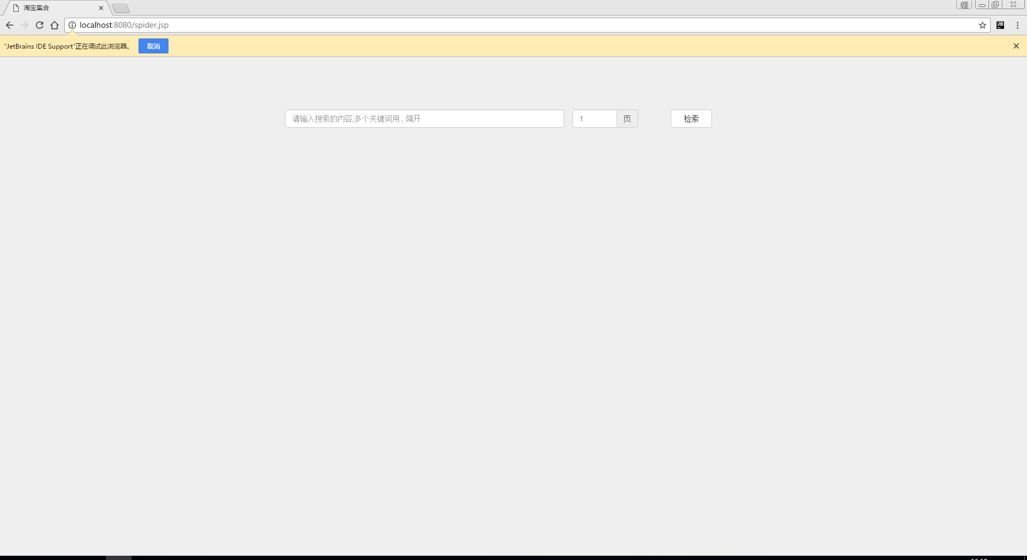
输入你想要扒取的关键词，可以同时扒取多个关键词，用逗号隔开。输入扒取的页数。稍等一会就可以看到扒取的结果（因为淘宝对同一个IP的单位时间淘宝页面的次数，所以当扒取的数量比较多的时候会比较慢。）
注：如果实验室无法连接外网，可以下载/root/data/38/data.csv文件，然后利用前面学习的HBase的导入数据的知识将数据导入到HBase中，文件以”,”分割。表名为goodinfo，和indexinfo。

38.3.4 建立关键词索引
上节扒下来的数据只是存放在hbase中goodinfo表中，这个时候没有建立索引，我们在查询的时候是从索引表中根据关键词检索出跟关键词有关的url，并按照出现的次数按照相关性大小排序。所以我们需要将扒下来的数据建立索引，然后才能正确的使用。
我们建立索引的方式式才用的MapReduce的方法。我们将createindex这个项目打包，然后向Hadoop中提交这个任务即可。Createindex会根据商品的描述的分词结果建立关键词对url的索引。所以我们还需要在建立分词的时候调用分词的数据，分词的数据存放在/root/data/37/data。 你需要将这各文件夹拷贝到运行jar的机器的根目录下。
拷贝命令如下。
[root@client ~]# cp -r /root/data/37/data /
向Hadoop提交任务的命令如下：
[root@client hadoop]# bin/hadoop jar createindex.jar

38.3.5 关键词搜索
通过浏览器访问TaobaoIndex.jsp。界面如下：
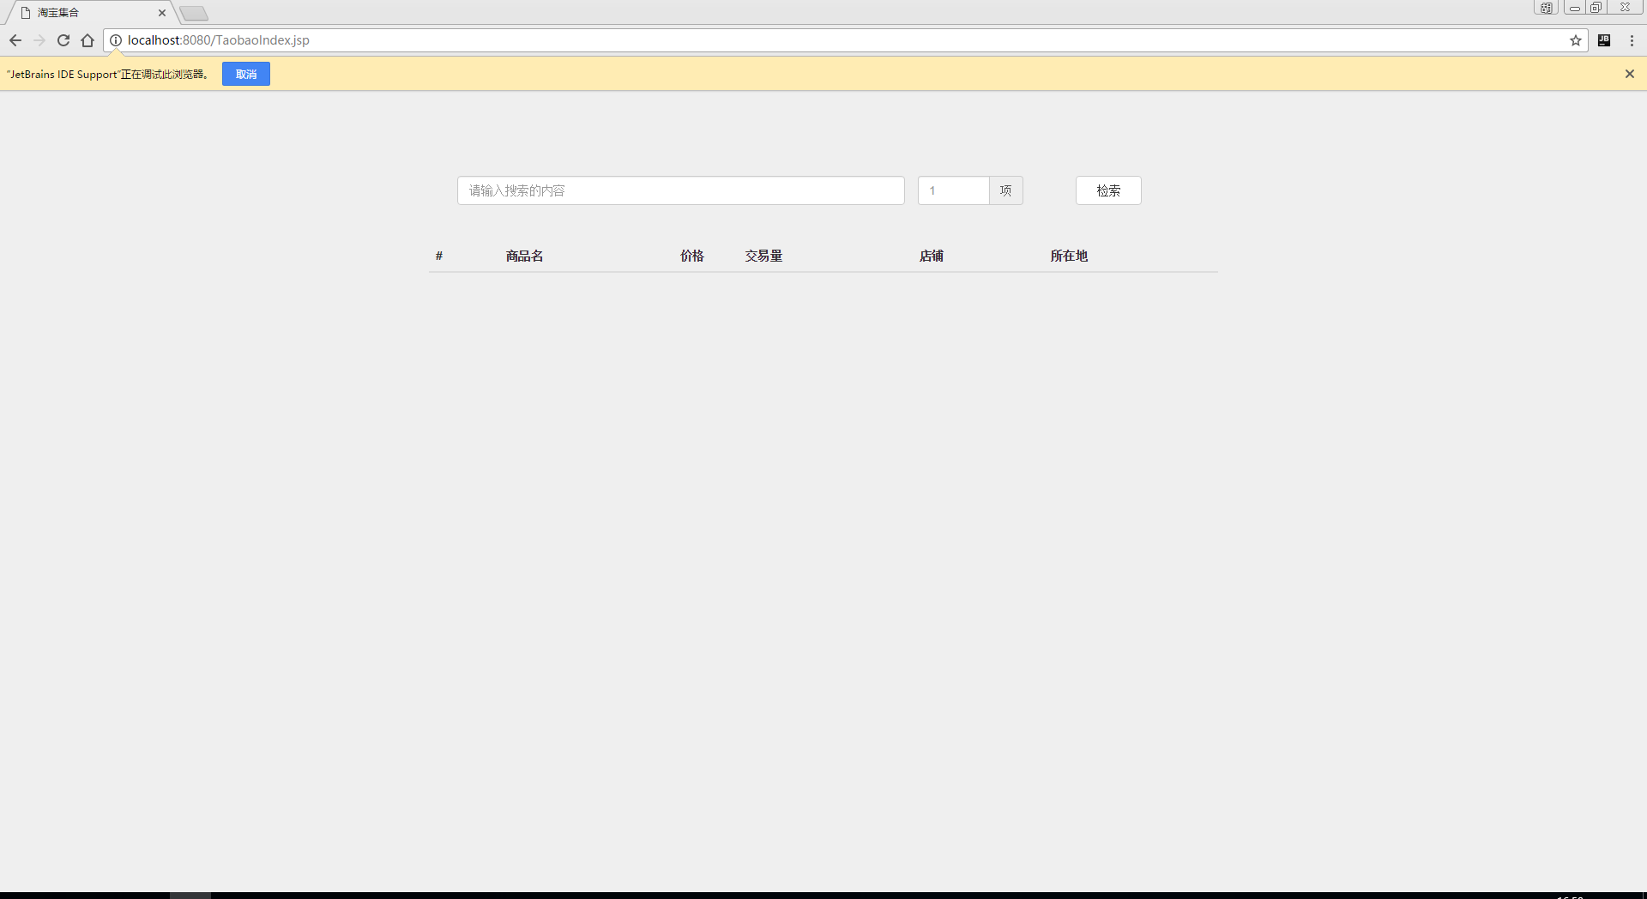
输入搜索的内容，并输入想选取的项数，然后点击检索。就会弹出你想了解的关键词的数据。

38.4 实验结果
1. 扒取结果类似如下。
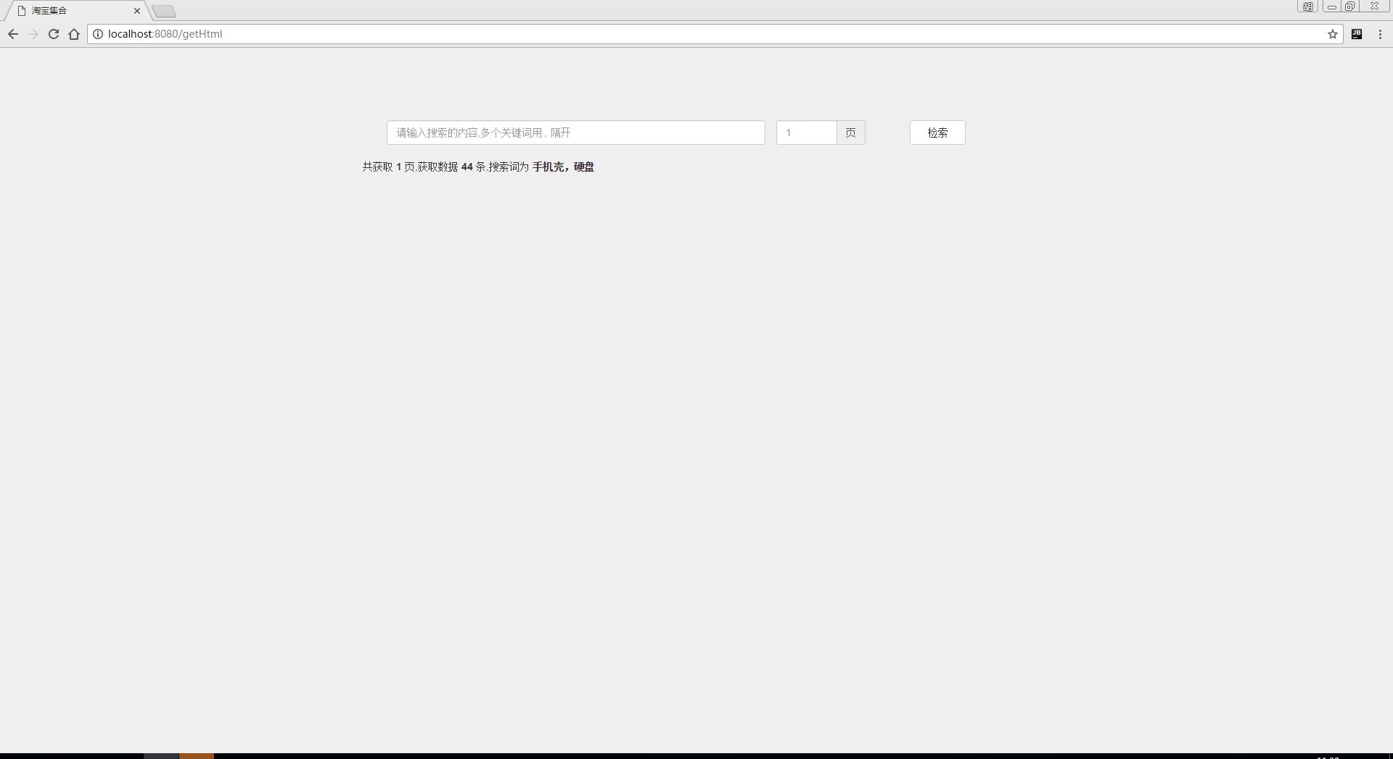

2. 建立索引任务成功
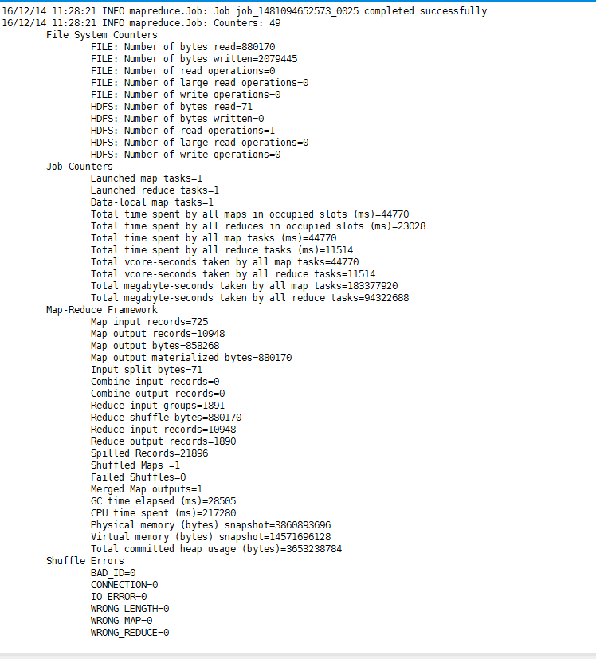
3. 搜索结果展示
