Model specification details
In this section, we introduce the quota reallocation method proposed in this paper, including models for efficiency distribution, calculating the potential loss and the sharing of carbon emissions responsibility in interregional electricity transmission, in which the model for calculating potential loss measures the impact of interregional electricity transmission on the economy and population, and the model allocating responsibility for carbon emission reduction in electricity transfer determines the allocation ratio of carbon allowances in electricity transfers. The quota reallocation method first allocates carbon emissions based on efficiency, zero-sum gains DEA, and then reallocates carbon emissions based on the model for allocating responsibility for carbon emissions in electricity transfer.

1.1 Initial allocation based on zero-sum gains DEA
We study the carbon quotas of the power industry in 30 regions in China in 2019. The formula of the ZSG-DEA model is¹⁻⁹:
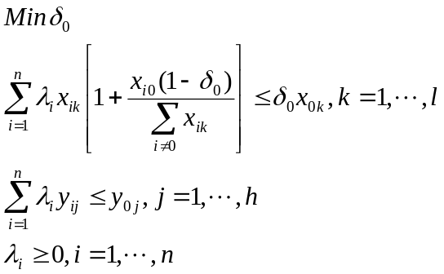 (1)
In formula (1), x is electricity; y is GDP and population; n is the number of DMUs; l is the number of input elements; h is the number of output elements.Electric energy is different from other energy sources. The transferred electricity does not produce carbon emissions in consumer areas but the production area produces carbon emissions. If the carbon emissions of electricity are used as input, it is not conducive to the study of the transferred electricity problem, and it will cause uneven distribution. Therefore, this paper employs electricity as the input variable of the ZSG-DEA model, and the output variables select population and GDP. After that, carbon allowances are allocated according to the allocated electricity, and the carbon allowances of the transferred electricity are further allocated according to its impact.

1.2 Potential loss evaluation model
The principle is that the DEA value is invalid for the decision-making unit, and when the transferred electricity is lost, the output of the minimum proportion is reduced while maintaining the original efficiency value^{10,11}.
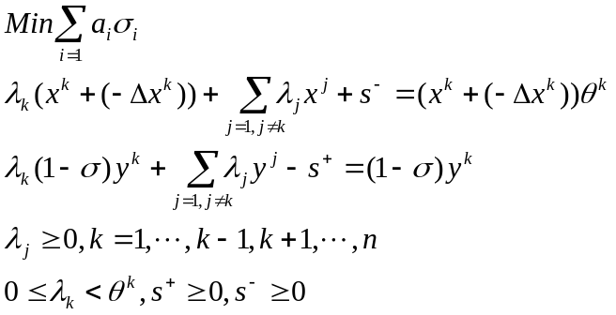 (2)
where 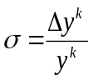, x is total electricity, Δx is the transferred electricity, and σ is the minimum loss when the transferred electricity is insufficient. Both a₁ and a₂ are 1/2. Since the loss here includes GDP and population, it must be converted into a value. Population loss can be understood as migration. Since the element in the C-D production function is labour, when calculating the value of the population, this paper transforms the population of each region according to the proportion in the labour force in each region to obtain the labour force lost in each region. The C-D production function is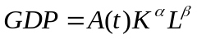. A(t) represents technological progress. K represents capital. L represents labour. α and β represent the coefficients of capital and labour, respectively. Due to the heterogeneity of the production situation across regions, this paper uses the data on each region from 2000 to 2019 to calculate the production functions of 30 regions. Therefore, the final formula for calculating economic loss is as follows.
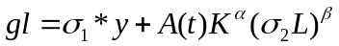 (3)
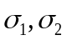are the ratios of economic loss and population loss in the above model.

1.3 Reallocation of carbon emission responsibility
The quota reallocation method distributes carbon emissions according to the proportion of the impact of the transferred electricity on each region. Because of the transferred electricity in the electricity input area, the loss of the economy and the population has been avoided, thus generating economic value. Electricity output areas have gained economic value due to the sale of electricity. As a result, a distribution mechanism for transferred electricity was created, that is, distribution based on their respective revenues. For the allocation of carbon emissions from transferred electricity, 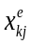 represents the amount of transferred electricity from region k to region j. For the reasonable distribution of responsibilities, electricity exporting provinces and electricity importing provinces must respectively bear their own responsibilities. The exporting party bears the responsibility of obtaining its own electricity sales revenue and the importing party bears the responsibility of transferred electricity that promotes economic development. The two responsibilities are proportionally based on their own revenue.
Responsibilities for carbon emissions undertaken by electricity exporting provinces:
(4)
Responsibilities for carbon emissions undertaken by electricity importing provinces:
(5)
C_{k} is the carbon emissions generated by the transferred electricity in area k. g_{lj} is the economic value of the transferred electricity in area j. f represents the conversion coefficient between electricity and carbon emissions, and p represents the price of electricity sold. α, β, K and L are the same as explained in the previous section.
The two regions assumed above are import and export provinces. Now we suppose there are multiple regions. The carbon emission responsibilities that region k should bear are:
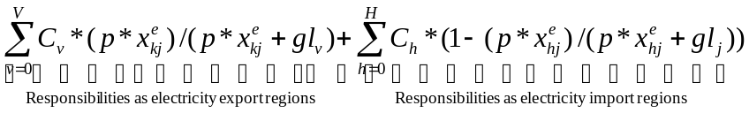
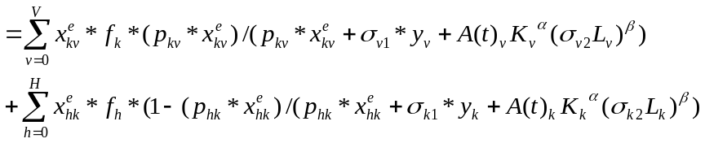 (6)
The interpretation of the variables in formula (6) is the same as the above. v represents the area where the transferred electricity from area k is received, and h represents the area where the transferred electricity is transferred to area k.
2 Data
This paper selects the data of 30 regions in China (excluding Tibet, Hong Kong, Macao and Taiwan) in 2019, including electric energy, non-electric energy, capital, labor force, GDP, total population, etc. The above data are from “China Statistical Yearbook”, “China Labor Statistics Yearbook”, “China Energy Statistical Yearbook”, “China Electric Industry Annual Development Report” and “Statistical Yearbook” of various regions.
The formula for calculating carbon emissions is as follows:
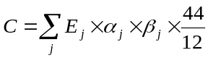 (7)
E_{j} refers to the consumption of the j-th energy (unit: 10,000 tons, 100 million cubic meters), a_{j} refers to the standard coal coefficient converted to the j-th energy; β_{j} represents the carbon emission coefficient of the j-th energy; 44/12 is the mass conversion coefficient of CO₂ molecules oxidized by carbon atoms, C represents the CO₂ emissions of the industry, and the relevant parameter refers the IPCC (2006).
As shown in Figure 1, from the perspective of power transfer, the western region is the main force of power transfer, with Inner Mongolia, Shanxi, Yunnan and Sichuan being the largest. Inner Mongolia and Shanxi are dominated by thermal power, while Yunnan and Sichuan are dominated by hydropower. Inner Mongolia is mainly exported to Hebei, and Yunnan is mainly exported to Guangdong. In the northwest region, Ningxia, Gansu and Xinjiang are also the major provinces for power transfer. Xinjiang is mainly exported to Henan, Gansu to Ningxia and Ningxia to Zhejiang. Guangdong, Hebei, Jiangsu and Zhejiang are the main recipients of external power transfer. Guangdong is dominated by hydropower, while Hebei, Jiangsu and Zhejiang are dominated by thermal power.

Table 1 Sample data
 | Min | 25% | 50% | 75% | Max | Mean | Variance
Labor (10,000 persons) | 330.20 | 1398.99 | 2154.70 | 3822.95 | 7150.25 | 2764.02 | 1825.09
Capital stock (100 million yuan) | 16494.22 | 57517.55 | 88367.88 | 142001.50 | 267352.96 | 105298.32 | 66542.32
GDP (100 million yuan) | 2941.10 | 14733.95 | 24761.30 | 41718.48 | 107986.90 | 32687.42 | 25673.82
Population (10,000 persons) | 608.00 | 2566.75 | 3924.50 | 6256.25 | 11521.00 | 4667.80 | 2855.28
Electricity (100 million kWh) | 354.58 | 1196.81 | 1885.75 | 2809.62 | 6695.85 | 2405.93 | 1679.16
Non-electric energy (10,000 tons of standard coal) | 1827.16 | 7541.75 | 10903.99 | 17790.29 | 32994.32 | 13280.17 | 7653.72
CO₂ of electricity (10,000 tons) | 820.66 | 6312.12 | 11250.61 | 20709.24 | 48203.50 | 14587.68 | 11763.22
CO₂ of non-electric energy (10,000 tons) | 2596.70 | 13034.40 | 17079.89 | 26398.74 | 313514.60 | 30124.45 | 54944.52
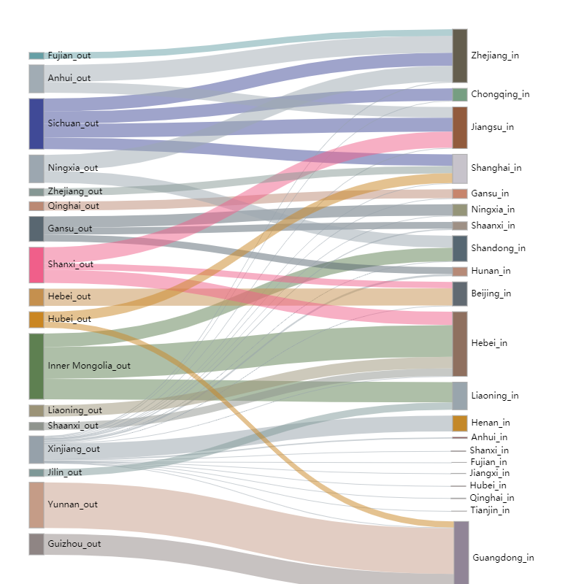
Figure 1 Power transaction
References
- Gomes, E., & Lins, M. Modelling undesirable outputs with zero sum gains data envelopment analysis models. J. Oper. Res. Soc. 59(5), 616-623 (2008).
- Fu, J., & Huang, F. Study on the Distribution Efficiency of CO₂ Emissions in China’s Carbon Trading Market. China Popul. Resour. Environ. 26(2), 1-9 (2016). (in Chinese)
- Song, J., Zhang, K., & Cao, Z. Provincial allocation of carbon emission quotas - under the fusion of fairness and efficiency. J. Arid Land Resour. Environ. 31(5), 7-13 (2017).
- Ma, C. et al. The allocation of carbon emission quotas to five major power-generation corporations in China. J. Clean. Prod. 189, 1-12 (2018).
- Cucchiella, F. et al. Efficiency and allocation of emission allowances and energy consumption over more sustainable European economies. J. Clean. Prod. 182, 805-817 (2018).
- Pang, R., Deng, Z., & Chiu, Y.. Pareto improvement through a reallocation of carbon emission quotas. Renew. Sust. Energ. Rev. 50, 419-430 (2015).
- Miao, Z., Geng, Y., & Sheng, J. Efficient allocation of CO₂ emissions in China: a zero sum gains data envelopment model. J. Clean. Prod. 112, 4144-4150 (2016).
- Wu, X. et al. A study of allocative efficiency of PM_{2.5} emission rights based on a zero sum gains data envelopment model. J. Clean. Prod. 113, 1024-1031 (2015).
- Liu, H., & Wang, Y. Research on the initial allocation of energy - consuming right and CO₂ - emission rights based on historical method and ZSG-DEA method. Chin. J. Manage. Sci. 191(9), 213-224 (2020). (in Chinese)
- Wei, Q., Zhang, J., & Zhang, X. An inverse DEA model for inputs/outputs estimate. Eur. J. Oper. Res. 121(1), 151-163 (2000).
- Hong, Y., Wei, Q., & Gang, H. DEA models for resource reallocation and production input/output estimation. Eur. J. Oper. Res. 136(1), 19-31 (2002).

