Hao Huynh

Professor Mark Lehr

CSC 11 – 48982

30 October 2015

Project 1: Paper-Rock-Scissors Game.

1. Introduction.

Paper-Rock-Scissors is a popular and simple game played between two players, and the players must form one of those three shape at the same time. In this game, the player can be either human or computer. Currently, the game supports two cases: human vs computer and computer bot vs computer bot. In addition, the winner is determined by the flowing rules:

* Paper covers rock.
* Rock breaks scissors.
* Scissors cut paper.
* A tie (both of two players have the same shape).

I decided to implement this game because the C++ code of its program is actually not complex and long, so I could finish it within a limited period of time. However, I still could demonstrate techniques such as calling external C functions as well as internal functions from an Assembly program, applying basic computational mathematics, and using Assembly constructs including if, if-else, switch, while, do-while, and for.

1. Summary.
   1. The program statistics:
      1. The number lines of code (LOC) are about 600 lines.
      2. There are 30 variables.
      3. There are 7 methods.
   2. Miscellaneous: This program took me approximately 30 hours for coding and fixing errors. Moreover, I had learned about the standard input stream buffer and the way to scan a character right after reading a number.
2. Description.
   1. The program problems:
      1. Read a character from keyboard buffer right after scanning a number.
      2. Generate random numbers.
      3. Find modulo of large numbers occupying a word.
      4. Translate the game rules from the C++ code into the Assembly language.
   2. The program solutions:
      1. Use the character scan pattern as “ %c” (the space before %c solves the new line input problem).
      2. Take advantage of C functions (i.e. time, rand, and srand).
      3. Shift the numerator (a large number) 1 bit to the right. (this is just a temporary solution)
      4. Divide C++ code into small, logical pieces (i.e. constructs), then translate those pieces into Assembly.
   3. Sample Input/Output:
      1. The Paper-Rock-Scissors game menu: (The player choose an option by its index)

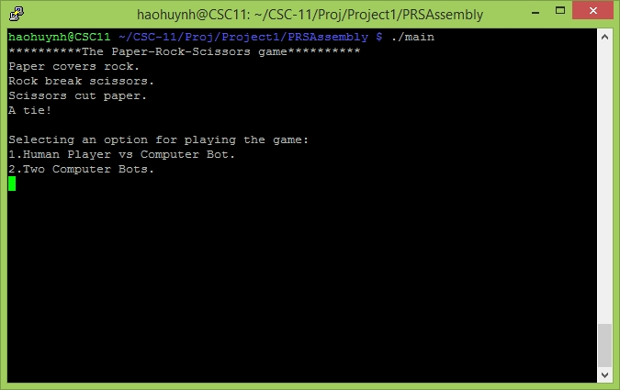

* + 1. 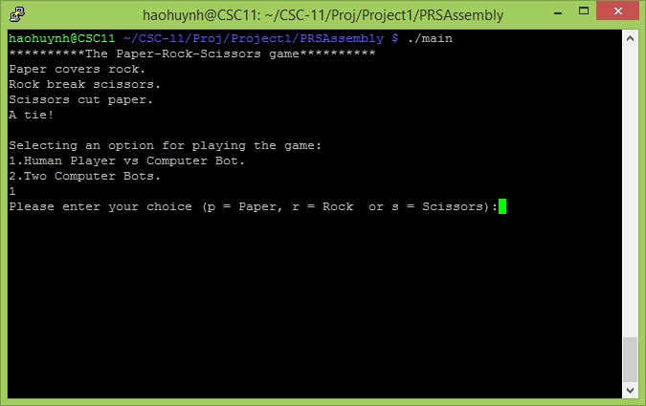Human Player vs Computer Bot:
    2. 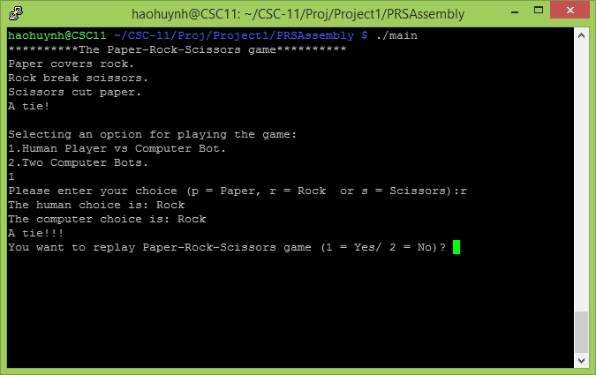The human player chooses Rock and has a tie game:
    3. The player replays the game:

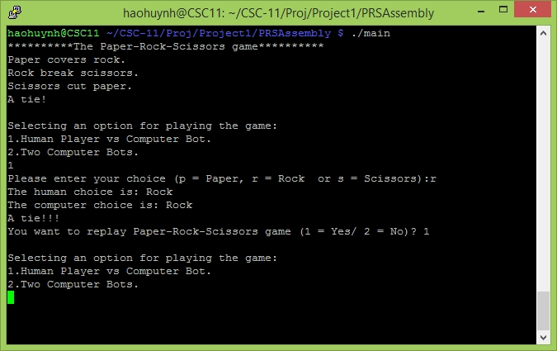

* + 1. 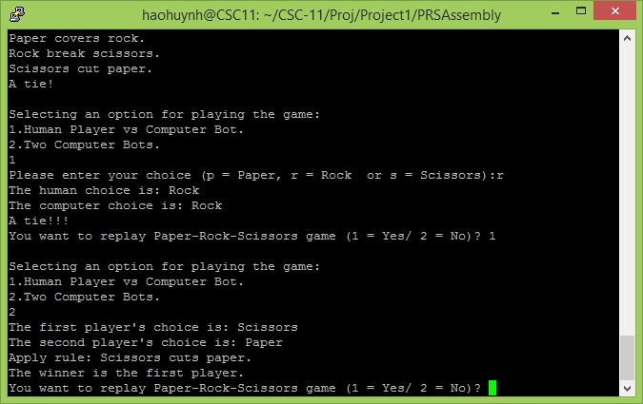Computer Bot vs Computer Bot:
    2. 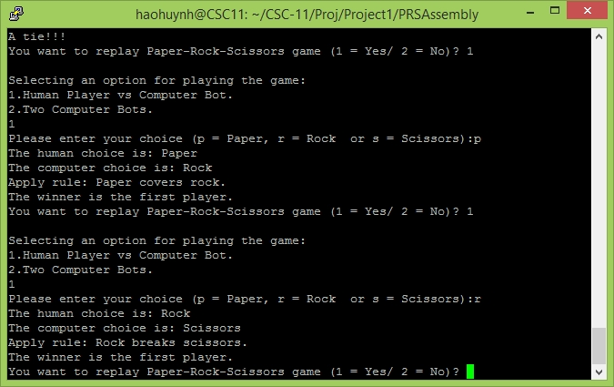Another game between Human Player and Computer Bot:
  1. Flowcharts:
  2. Variables:

|  |  |  |
| --- | --- | --- |
| Type | Name | Location |
| vector<Card*> | crCards  (The player’s current cards) | class PokerCardTable |
| vector<Card*> | crSRnks  (The player’s current cards sorted by rank) |
| vector<Card*> | crSSuits  (The player’s current cards sorted by suit) |
| set<int> | rIndexes  (The on-screen replacing indexes) | method PokerCardTable::replaceCards() |

* 1. Concepts:

|  |  |
| --- | --- |
| Concept | Location |
| 1. Memory allocation | * main function. * PokerCardTable::populateCardBy() |
| 1. Memory deallocation | * PokerCardTable::deleteCardsBy() * PokerCardTable::deleteCards() |
| 1. Data structure | * Card in “PokerCardTable.h” |
| 1. enum data type | * “PokerCardTable.h” |
| 1. Functions with structures | * Most functions in class PokerCardTable |
| 1. Arrays with structures | * class PokerCardTable |
| 1. Pointer arrays | * PokerCardTable::displayPlayerCards() |
| 1. Character arrays | * main function. |
| 1. String object | * main function. * class PokerCardTable * class PokerHelper |
| 1. Binary file IO | * class PokerHelper |
| 1. Object Oriented Programming (OOP) | * class PokerCardTable * class PokerHelper |

1. Program (Header Files).
   1. PokerCardTable.h

*/\**

*\* File: PokerCardTable.h*

*\* Author: HaoHuynh*

*\**

*\* Created on October 10, 2015, 10:49 AM*

*\*/*

**#ifndef POKERCARDTABLE_H**

**#define POKERCARDTABLE_H**

**#include <vector>**

**#include <string>**

**#include <set>**

using namespace std;

*/\**

*\* There are thirteen ranks per suit: from Ace to King.*

*\*/*

**enum** CARD_RANKS {

ACE, TWO, THREE, FOUR, FIVE, SIX, SEVEN, EIGHT, NINE, TEN, JACK, QUEEN, KING

};

*/\**

*\* There are four suits in fifty two desk cards.*

*\*/*

**enum** CARD_SUITS {

HEARTS, DIAMONDS, CLUBS, SPADES

};

*/\**

*\* A card is defined by a combination of rank and suit.*

*\* The id is the index of a card in fifty two desk cards*

*\*/*

**typedef** **struct** CARD {

**int** id;

CARD_SUITS suit;

CARD_RANKS rank;

} Card;

*/\**

*\* This class is used for managing user's cards base on the below logical mapping table*

*\**

*\* 0 1 2 3 4 5 6 7 8 9 10 11 12*

*\* Suits/Ranks Ace 2 3 4 5 6 7 8 9 10 Jack Queen King*

*\* 0 Hearts 0 1 2 3 4 5 6 7 8 9 10 11 12*

*\* 1 Diamonds 13 14 15 16 17 18 19 20 21 22 23 24 25*

*\* 2 Clubs 26 27 28 29 30 31 32 33 34 35 36 37 38*

*\* 3 Spades 39 40 41 42 43 44 45 46 47 48 49 50 51*

*\*/*

class PokerCardTable {

private:

*/\**

*\* The total of cards are 52*

*\*/*

**static** **const** **int** CARDS_TOTAL **=** 52;

*/\**

*\* There are thirteen ranks per suit.*

*\*/*

**static** **const** **int** RANKS_PER_SUIT **=** 13;

*/\**

*\* Maximum poker cards for each player.*

*\*/*

**static** **const** **int** FIVE_POKER_CARDS **=** 5;

*/\**

*\* There are 4 suits in 52 desk cards.*

*\*/*

**static** **const** **int** SUIT_MAX **=** 4;

*/\**

*\* The first poker card index*

*\*/*

**static** **const** **int** INDEX_0 **=** 0;

*/\**

*\* The second poker card index*

*\*/*

**static** **const** **int** INDEX_1 **=** 1;

*/\**

*\* The third poker card index*

*\*/*

**static** **const** **int** INDEX_2 **=** 2;

*/\**

*\* The fourth poker card index*

*\*/*

**static** **const** **int** INDEX_3 **=** 3;

*/\**

*\* The fifth poker card index*

*\*/*

**static** **const** **int** INDEX_4 **=** 4;

*/\**

*\* Labels for displaying a card suit.*

*\*/*

**static** **const** string CARD_SUIT_LABELS[SUIT_MAX];

*/\**

*\* Labels for displaying a card rank.*

*\*/*

**static** **const** string CARD_RANK_LABELS[RANKS_PER_SUIT];

*/\**

*\* Vector contains all the user's current cards*

*\*/*

vector**<**Card**\*>** crCards;

*/\**

*\* Vector contains all the user's current cards sorted by rank*

*\*/*

vector**<**Card**\*>** crSRnks;

*/\**

*\* Vector contains all the user's current cards sorted by suit*

*\*/*

vector**<**Card**\*>** crSSuits;

public:

*/\*\**

*\* The default constructor of PokerCardTable*

*\*/*

PokerCardTable();

*/\*\**

*\* The default destructor of PokerCardTable*

*\*/*

**~**PokerCardTable();

*/\*\**

*\* This function interacts with players to drive them through a game*

*\*/*

**bool** **populateConsole**();

private:

*/\*\**

*\* This function create a Card by mapping the id to a Card structure through*

*\* the logical Card Table*

*\* @param id*

*\* @return Card*

*\*/*

Card**\*** populateCardBy(**int** id);

*/\*\**

*\* This function uses the id to check if a card has been dealt*

*\* @param id : the Card Table index*

*\* @return true/false : A card is existed or not*

*\*/*

**bool** **isCardExistedBy**(**int** id);

*/\*\**

*\* This function tries to dealt a new card to the current hand without*

*\* duplicating any existed one*

*\* @param id : the Card Table index*

*\* @return true/false : Insertion success or not*

*\*/*

**bool** **isCardInsertedBy**(**int** id);

*/\*\**

*\* This function deals first five poker cards for the player*

*\*/*

**void** **dealsCards**();

*/\*\**

*\* This function sends all current hand cards to the console*

*\*/*

**void** **displayPlayerCards**();

*/\*\**

*\* This function generates a new card for the replacing process.*

*\* The new one should not be duplicated with any card in the current hand*

*\* @return a new Card structure*

*\*/*

Card**\*** **dealsNewCard**();

*/\*\**

*\* This function generates a new one that has not been dealt before*

*\* for the replacement process*

*\* @return a new Card structure*

*\*/*

Card**\*** **getNewCardForReplacement**();

*/\*\**

*\* This functions collects all the cards user want to replace and*

*\* replaces them with new ones*

*\*/*

**void** **replaceCards**();

*/\*\**

*\* This functions creates a list of current hand cards sorted by rank.*

*\*/*

**void** **sortCardsByRank**();

*/\*\**

*\* This functions creates a list of current hand cards sorted by suit.*

*\*/*

**void** **sortCardsBySuit**();

*/\*\**

*\* This functions check if there is an ACE, and all five poker cards are flush and straight*

*\* @return true/false*

*\*/*

**bool** **isRoyalFlush**();

*/\*\**

*\* This functions check if all five poker card are flush and straight*

*\* @return true/false*

*\*/*

**bool** **isStraightFlush**();

*/\*\**

*\* This function checks if all five poker cards have the same suit.*

*\* After sorting by suit, if the lowest card has the same suit as the highest one,*

*\* then all five poker cards will have the same suit.*

*\* @return true/false*

*\*/*

**bool** **isFlush**();

*/\*\**

*\* This function checks if all five poker cards make a straight:*

*\* Case 1: There is an ACE and the other fours are {TEN, JACK, QUEEN, KING}*

*\* or {TWO, THREE, FOUR, FIVE}*

*\* Case 2: The ranks of all cards are increasing continuously*

*\* @return true/false*

*\*/*

**bool** **isStraight**();

*/\*\**

*\* This function checks for four of the same card in a rank*

*\* Two cases: 4 + 1 or 1 + 4*

*\* @return true/false*

*\*/*

**bool** **isFourOfAKind**();

*/\*\**

*\* This function checks for 3 of the same card in a rank*

*\* and 2 of the same card in another rank*

*\* Two cases: 3 + 2 or 2 + 3*

*\* @return true/false*

*\*/*

**bool** **isFullHouse**();

*/\*\**

*\* This function checks for 3 of the same card after checking four of a kind and full house.*

*\* Three cases: 3 + 1 + 1 or*

*\* 1 + 3 + 1 or*

*\* 1 + 1 + 3.*

*\* @return true/false*

*\*/*

**bool** **isThreeOfAKind**();

*/\*\**

*\* This function checks for 2 different pairs after checking four of a kind, full house,*

*\* and three of a kind.*

*\* Three cases: 2 + 2 + 1 or*

*\* 2 + 1 + 2 or*

*\* 1 + 2 + 2.*

*\* @return true/false*

*\*/*

**bool** **isTwoPairs**();

*/\*\**

*\* This function checks for two of the same card after checking four of a kind, full house,*

*\* three of a kind and two pairs*

*\* Four cases: 2 + 1 + 1 + 1 or*

*\* 1 + 2 + 1 + 1 or*

*\* 1 + 1 + 2 + 1 or*

*\* 1 + 1 + 1 + 2 or*

*\* @return true/false*

*\*/*

**bool** **isPair**();

*/\*\**

*\* This function checks if the current hand win or lose*

*\* @return true/false: win/lose*

*\*/*

**bool** **isPlayerWin**();

*/\*\**

*\* This function deallocates the memories of a set of elements in cards and clears the cards*

*\* @param cards : a vector of Card Structure pointers*

*\* @param poss : a set of positions in cards*

*\*/*

**void** **deleteCardsBy**(vector**<**Card**\*>&** cards, **const** set**<int>&** poss);

*/\*\**

*\* This function deallocates the memories of all elements in cards and clears the cards*

*\* @param cards : a vector of Card Structure pointers*

*\*/*

**void** **deleteCards**(vector**<**Card**\*>&** cards);

*/\*\**

*\* This function reset all the current cards for a new game*

*\*/*

**void** **clean**();

};

**#endif** */* POKERCARDTABLE_H */*

* 1. PokerHelper.h

*/\**

*\* File: PokerHelper.h*

*\* Author: HaoHuynh*

*\**

*\* Created on October 10, 2015, 10:35 AM*

*\*/*

**#ifndef POKERHELPER_H**

**#define POKERHELPER_H**

**#include <string>**

**#include <fstream>**

class PokerHelper {

private:

*/\**

*\* Relative maximum lines of a monitor*

*\*/*

**static** **const** **int** MAX_MONITOR_LINES **=** 200;

*/\*\**

*\* The default file that stores the current bank roll*

*\*/*

**static** **const** std**::**string DEFAULT_FILE_NAME;

public:

*/\*\**

*\* Clear the screen after a certain event.*

*\*/*

**static** **void** clearMonitor();

*/\*\**

*\* Validate input of an integer number from lowerLimit to upperLimit*

*\* @param number*

*\* @param lowerLimit*

*\* @param upperLimit*

*\*/*

**static** **void** **validateValueOf**(**int&** number, **int** lowerLimit, **int** upperLimit);

*/\*\**

*\* This function saves the current bank roll to a file*

*\* @param crBkRoll : the current bank roll*

*\* @param fName : a file name*

*\*/*

**static** **void** **save**(**int** crBkRoll);

*/\*\**

*\* This function loads the current bank roll from a file*

*\* @param crBkRoll : the current bank roll*

*\* @param fName : a file name*

*\*/*

**static** **void** **load**(**int&** crBkRoll);

};

**#endif** */* POKERHELPER_H */*