



GEORGE BROWN COLLEGE

SCHOOL OF COMPUTER TECHNOLOGY

**PERSONAL RESTAURANT GUIDE**

**iOS MOBILE APPLICATION PROJECT**

**GROUP 32**

Minh Quang Truong - 101160445

Hao Huynh - 101140368

Shineng Zheng - 101167765

Thi Thanh Truc Kieu - 101140870

Thi Kim Thao Tran - 101156327

March 2021

**PROJECT DESCRIPTION**

1. **User target**

The application is targeted to the users who are using iOS devices, especially those who are in the age range from 15 – 65 that use applications on their phone frequently, as well as those who eat out often.

1. **Problem that it solves**

This application is a tool to assist the users with storing information about restaurants that they have visited or suggested from family or friends. Therefore, the users will have a list of restaurants as a guide. Next time they have visited a restaurant, they can easily find the one they want based on the information they have entered into the application such as the name, address, a description and any tags that suit the restaurant. They may also share the restaurant by email or social media.

1. **How the project is done**

It works like a note application with some specific functions as below:

* Allows users to input the information about restaurants such as name, location, phone number, description, type of restaurant (Tag), rating (1-5 stars)
* Shows the location of the restaurant on the map and gets direction from their current location using Google Maps API
* Provides an option to share information about the restaurant to Facebook, Twitter or email
* Provides search capabilities based on name and tags
* Shows details and rating of a restaurant
* Allows users to edit rating and remove a restaurant from listing

The application is developed with SwiftUI. In addition, the project is divided into 4 stages:

* Documentation: Project Description, Application Design and Mockups
* Prototype 1: UI for all screens with logic implemented for at least 2 functions
* Prototype 2: Improved UI screens, 80% functions implemented and a data access layer
* Final stage: Improved UI from prototype 2, full features implemented and application testing

**SCREEN DESIGN MOCK-UP**

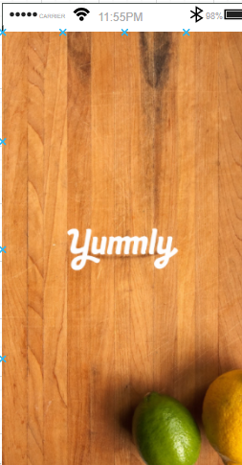

The launch screen will be displayed first when the user clicks on the icon logo of the application on their phone. The splash screen will show logo and introduction image. Then it will take the user to the default Home screen where the list of restaurants is shown.

The Default Home Page. This screen will be displayed to the user after the splash screen and once the app has loaded.

The Home Screen with Menu on the left side bar. The top 4 rated restaurants will also be displayed here, along with an extra button to access the search function for more restaurants. The search can be done with name of the restaurant or by tags. Any restaurant that match will be displayed below the search fields.

The Add screen with the Menu on left side and a button to add more restaurants into the list, where all the input about a specific restaurant is shown with name, address, phone number, description, tags and rating stars.

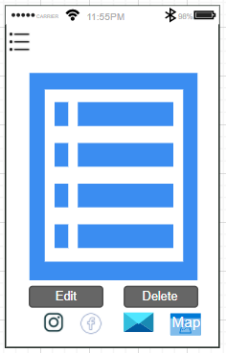

When you click on the restaurant it will show the details of a chosen restaurant with name, address, phone number, description, tags and rating stars and edit and delete button. It also shows Google Map and direction to the restaurant from user’s current location. There will be options to share information through email/Facebook.

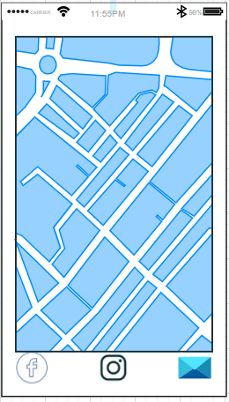

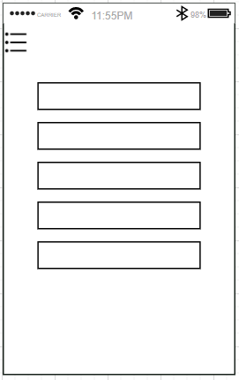

The About page of the application where shows all the team members’ information.