Nice Neighbour Pharmacy

FIT5032 Assignment 1 – Design Report

***Student Name: Hao Xu***

***Student ID: 32767919***

1. Web Application Title and Description

**Nice Neighbour Pharmacy** is a web-based application, which provides online medicine ordering services. This application is built in ASP.NET MVC structure, with MS SQL database. It can be also responsive to different screen size. There are two actors in this application, customers and administrators. Both internal and external user authentication methods will be implemented. By using this app, customers can view all medicines online, add wanted medicines into shopping cart and place orders. After successfully placing an order and picking a proper time without conflict, a confirmation email with order details will be sent to the customer. Also, customers can use Maps function to get direction information to the pharmacy, in order to pick up their order later. After using the medicine, they can give their rate and comments. Admins could use this web application to manage medicines and customers’ orders, including adding medicines, marking order as completed, etc. This application will make Nice Neighbour Pharmacy’s “click & collect” business better and easier.

2. High Level Block Diagram

In this section, a 4-level block diagram of this web application are shown:

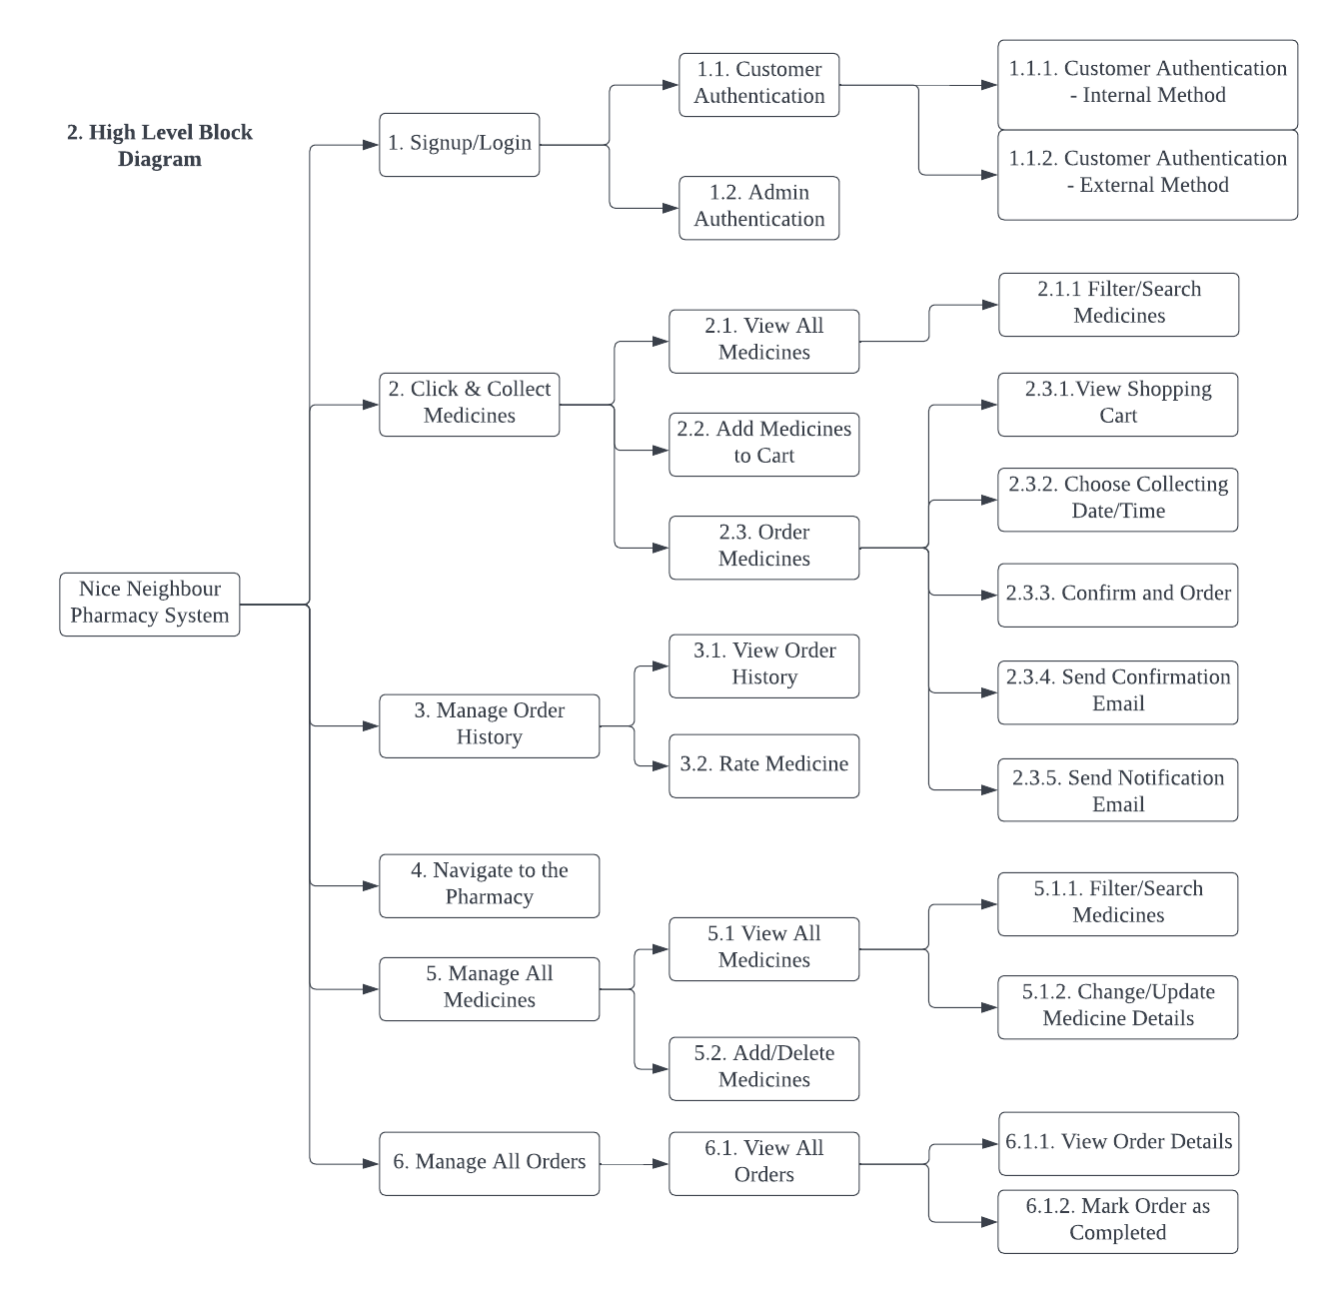

3. Use Case Diagram

In this section, a use case diagram includes 5 business requirements are shown. They are authentication (sign-up and login), rating medicines, sending confirmation email, navigating to the pharmacy and interactive tables (viewing all medicines, managing all medicines and managing all customers’ orders).

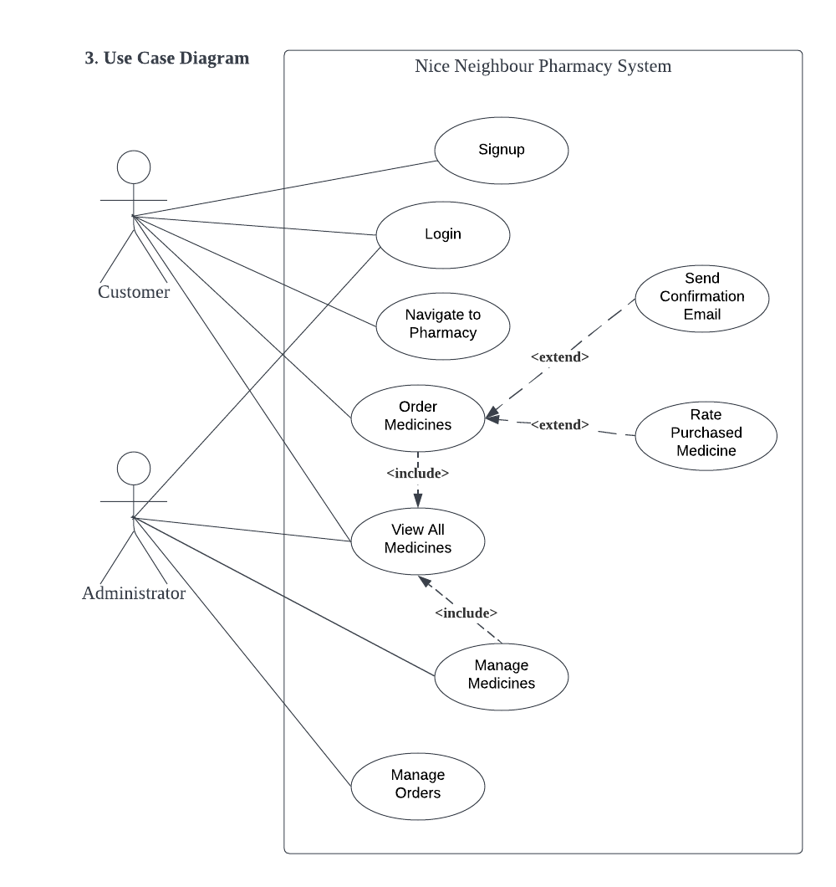

4. Validations

In this section, 4 different validations in business requirements are introduced:

1. Role Based Authentication (Sign-up/Login)

When customers and admins try to sign up or login to the system, in the front-end (webpage), the format of email (username) and password will be checked, such as email must contain “@”, password should contain at least 1 uppercase, 1 lowercase, 1 digit and 1 special character, and so on. After front-end check, login information will be compared with the customers and admins credentials database respectively. If the input login information matches the credentials in the database, login will be successful. Otherwise, login will be failed and other services, such as ordering medicine, cannot be used.

2. Booking Constraint

When customers complete ordering medicines online, they are required to book a date and time slot for collecting their medicines in store. The booking date and time slots will be designed as 10 minutes each, and they cannot be duplicated among different orders. Thus, a new date and time slot picked will be compared to existing picked slots in the database. If the user’s picking slot is not in the database, which means it is a valid slot, the slot booking will be successful, and this slot will be added to the database, so that new order cannot pick this slot again. Otherwise, if the user’s picking slot is already in the database, this process will be failed, and the customer will be required to pick another valid date and time slot.

3. Rating

The application will limit the rating score ranging from 0 star to 5 stars. Also, only customers, who have already bought this medicine, can rate this medicine. This comparation can be done by looking at the buying history in database. Thus, if the customer has not bought the medicine, the rating operation will always be failed, and an error prompt will be displayed. If the customer has already bought this medicine, then he/she can successfully rate this medicine once.

4. Interactive Table Data

There will be multiple validations for this business requirement. For customers, they can list, search and sort all medicines. However, they can only add valid quantities of a medicine into their e-shopping cart. For example, if there are only 10 stocks for medicine A, then a customer cannot add more than 10 medicine A into the shopping cart, meaning that these kinds of operations will be failed. Another validation is that only admins can successfully see the table for all customers’ orders. Thus, a customer-role user cannot access this table.

5. Mock-up Prototypes Design

In this section, a prototype design including at least 5 business requirements are shown:

1. Authentication (Login)

2. Ratings

3. Booking Constraints

4. Interactive Tables

5. Maps

Since the prototype diagram is a large PDF, it will be attached to the last page. (**See Page 4**)

Declaration

I declare that this Studio Assessment Task 1 report is my individual work. I have not copied from any other student’s work or from any other source except where due acknowledgment is made explicitly in the report, nor has any part of this submission been written for me by another person.

___