Nice Neighbor Pharmacy

FIT5032 Assignment 3

Student Name: **Hao Xu**

Student ID: **32767919**

GitHub Link for the whole Project: <https://github.com/BrantleyXU/FIT5032/tree/main/portfolio/NiceNeighbourPharmacy>

# 1. File Upload and Send Email with Attachments

**GitHub Link**: <https://github.com/BrantleyXU/FIT5032/blob/main/portfolio/NiceNeighbourPharmacy/NiceNeighbourPharmacy/Controllers/OrdersController.cs>

<https://github.com/BrantleyXU/FIT5032/blob/main/portfolio/NiceNeighbourPharmacy/NiceNeighbourPharmacy/Utils/SendEmailUtil.cs>

This application allows Pharmacists to send notification emails to Customers’ who have un-collected orders. A sample .PDF file is used to demonstrate the implementation of “File Upload” function. SendGrid is used to implement “Send Email with Attachments” function.

Figure 1: SendGroupEmail Controller integrated in Order Controller and SendEmailUtil class

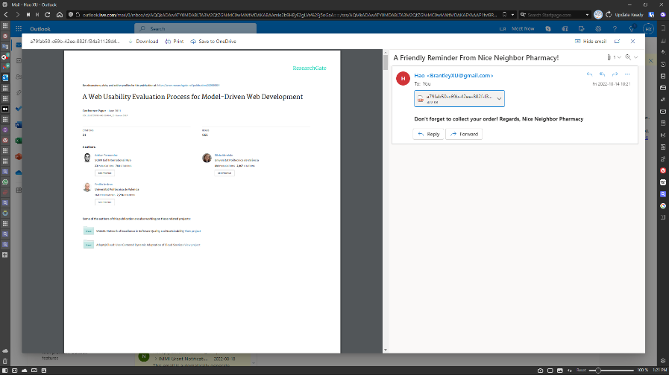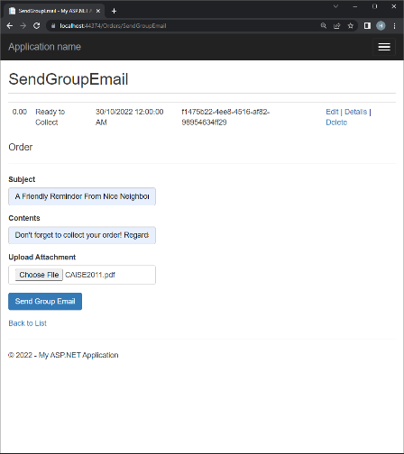

Figure 2: Left: Send Email with subject, text contents, uploaded sample pdf attachment. Right: Received Email with the attachment

# 2. Innovative Feature (Live Chat using SignalR)

## User Story

As a Nice Neighbor Pharmacy customer, I would like to have live chat with pharmacists when I choose medicines on the website, so that I can order the correct medicines with respect to my health.

**GitHub Link**: <https://github.com/BrantleyXU/FIT5032/blob/main/portfolio/NiceNeighbourPharmacy/NiceNeighbourPharmacy/Hubs/LiveChatHub.cs>

<https://github.com/BrantleyXU/FIT5032/blob/main/portfolio/NiceNeighbourPharmacy/NiceNeighbourPharmacy/Views/Home/LiveChat.cshtml>

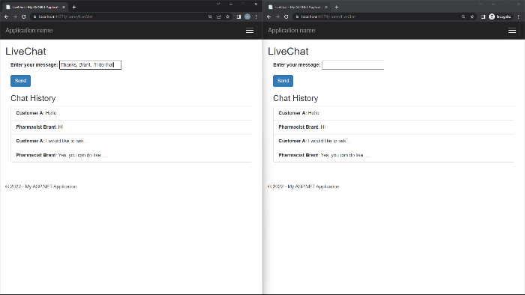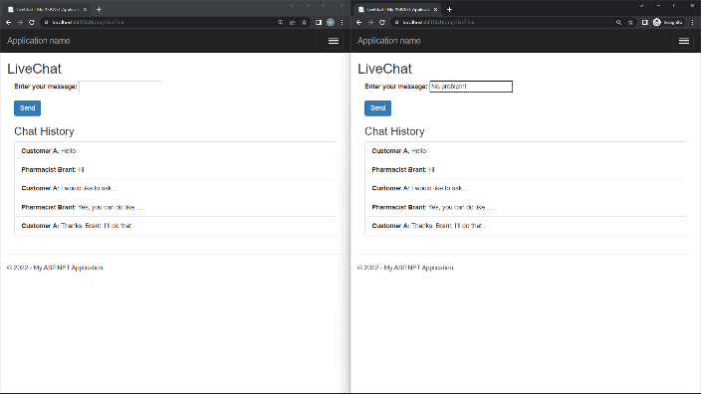

Figure 3: Live Chat in 2 different Browser

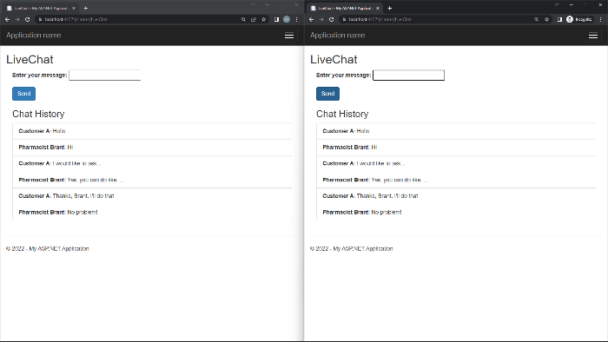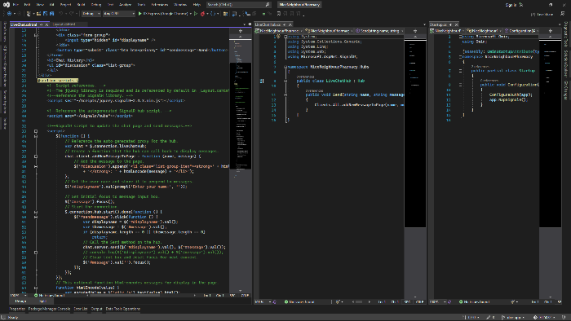

Figure 4: Left: Live Chat continue. Right: LiveChatHub and the view of Live Chat

# Declaration

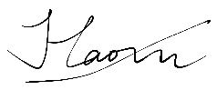I declare that this Studio Assessment Task 3 report is my individual work. I have not copied from any other student’s work or from any other source except where due acknowledgment is made explicitly in the report, nor has any part of this submission been written for me by another person.

Signature: ____________________________