FIT5032 Design Report

Major Application Development

Self-Evaluation: **H**igh **D**istinction

Nice **Neighbor** Pharmacy

Hao Xu (32767919)

Table of Contents

Credit Level 3

1. Web Application Title and Description 3

2. User Stories and Use Case Diagram 3

3. Block/Functional Diagram 4

4. Selected Approach when Constructing the Application 5

Additional Distinction Level 5

5. Class Diagram or Entity Relation Diagram 5

6. Data Dictionary 6

7. Mockup Prototypes and Implementation with User Registration and Authentication 6

8. Usability Design Review 7

Additional High Distinction Level 7

9. Development Methodology 10

10. Versioning 10

11. Innovation and Research 11

References 11

Checklist of Site Functionality 12

Appendix 14

# Credit Level

## 1. Web Application Title and Description

**Nice Neighbor Pharmacy** is a web-based application, which provides online medicine ordering services. This application is built in ASP.NET MVC structure, with MS SQL database. It can be also responsive to different screen size. There are two actors in this application which are customers and pharmacists. Both internal and external user authentication methods will be implemented. By using this app, customers can view all medicines online, add wanted medicines into shopping cart and place orders. After successfully placing an order and picking a proper time without conflict, a confirmation email with order details will be sent to the customer. Also, customers can use Maps function to get direction information to the pharmacy, to pick up their order later. After using the medicine, they can give their rate and comments. Pharmacists could use this web application to manage medicines and customers’ orders, including adding medicines, marking order as completed, etc. Both customer and pharmacist could communicate with “Live Chat”. This application will make Nice Neighbor Pharmacy’s “click & collect” business better and easier.

## 2. User Stories and Use Case Diagram

User Story 1: As a customer, I would like to have interactive table when I look for medicines, so that I can perform searching or sorting to locate medicines I needed very quickly.

User Story 2: As a customer, I would like to have navigation function in map, so that I can easily go to pharmacy to collect my order.

User Story 3: As a customer, I would like to have rating function, so that I can get rating opinions from other customers before I decide to buy medicine.

User Story 4: As a pharmacist, I would like to send email, so that I can send notification to my customers.

In this section, a use case diagram includes 5 business requirements are shown. They are authentication (sign-up and login), rating medicines, sending confirmation email, navigating to the pharmacy and interactive tables (viewing all medicines, managing all medicines and managing all customers’ orders).

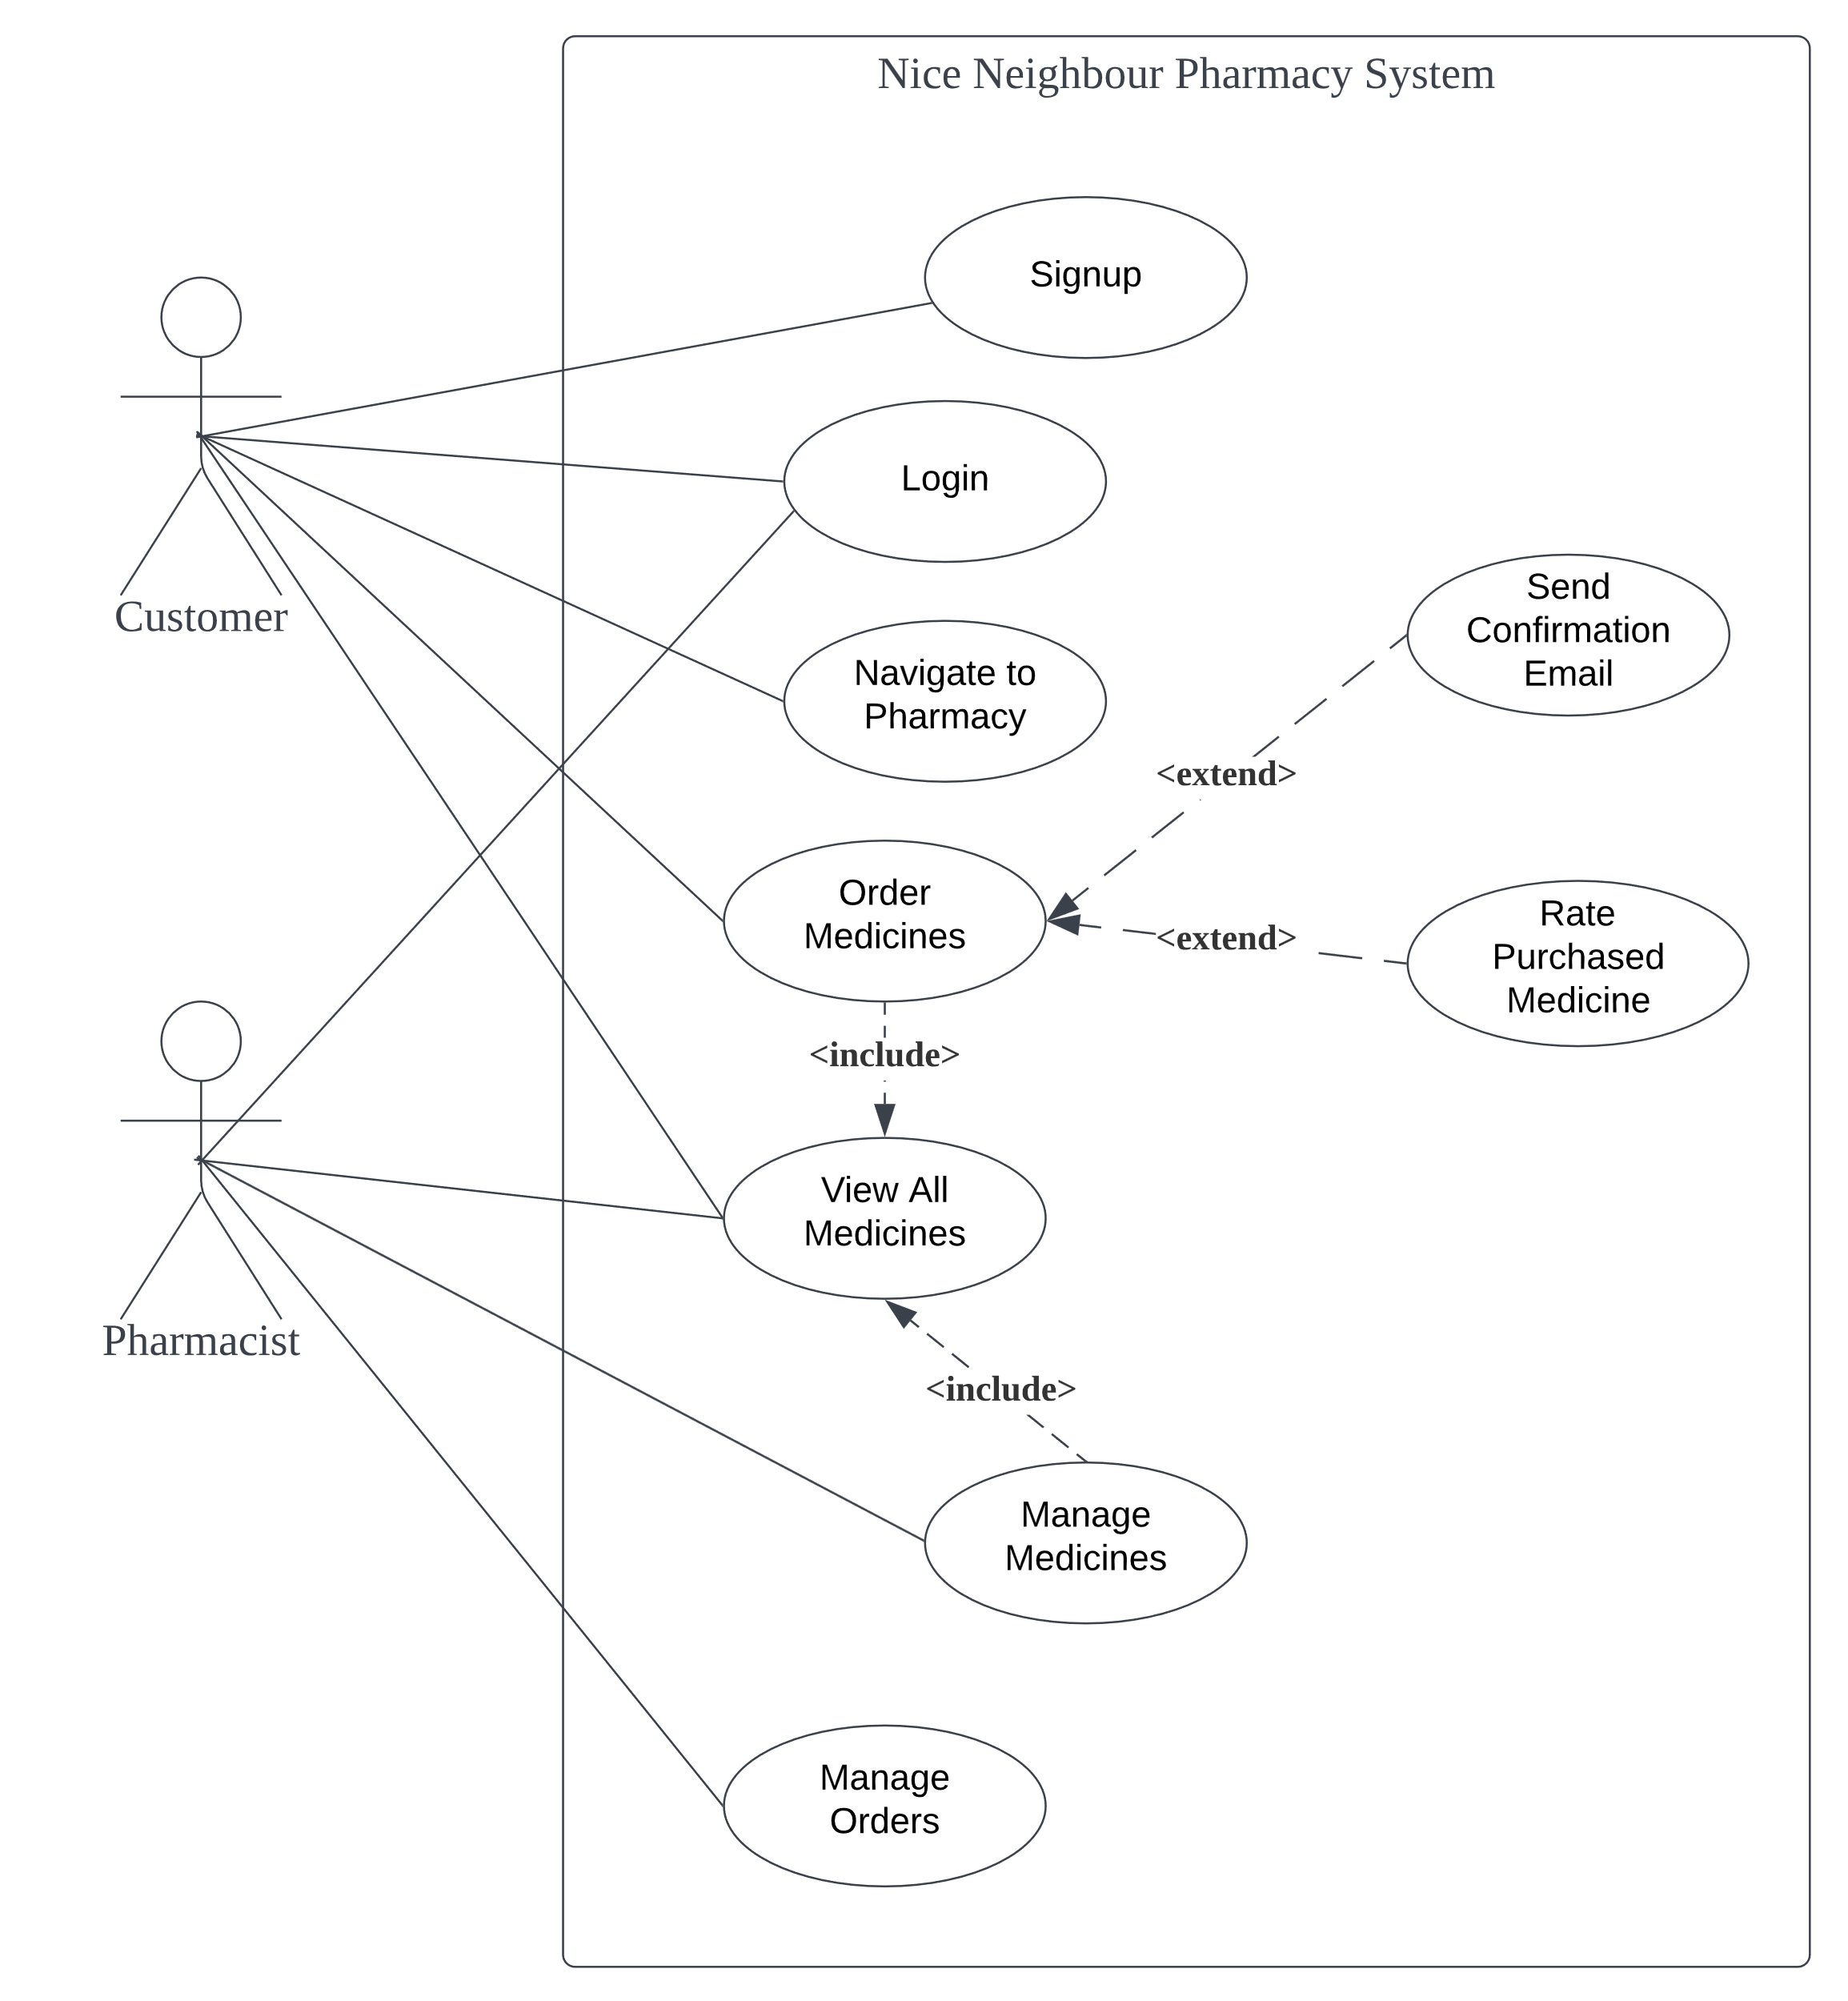

## 3. Block/Functional Diagram

In this section, a 4-level block diagram of this web application is shown:

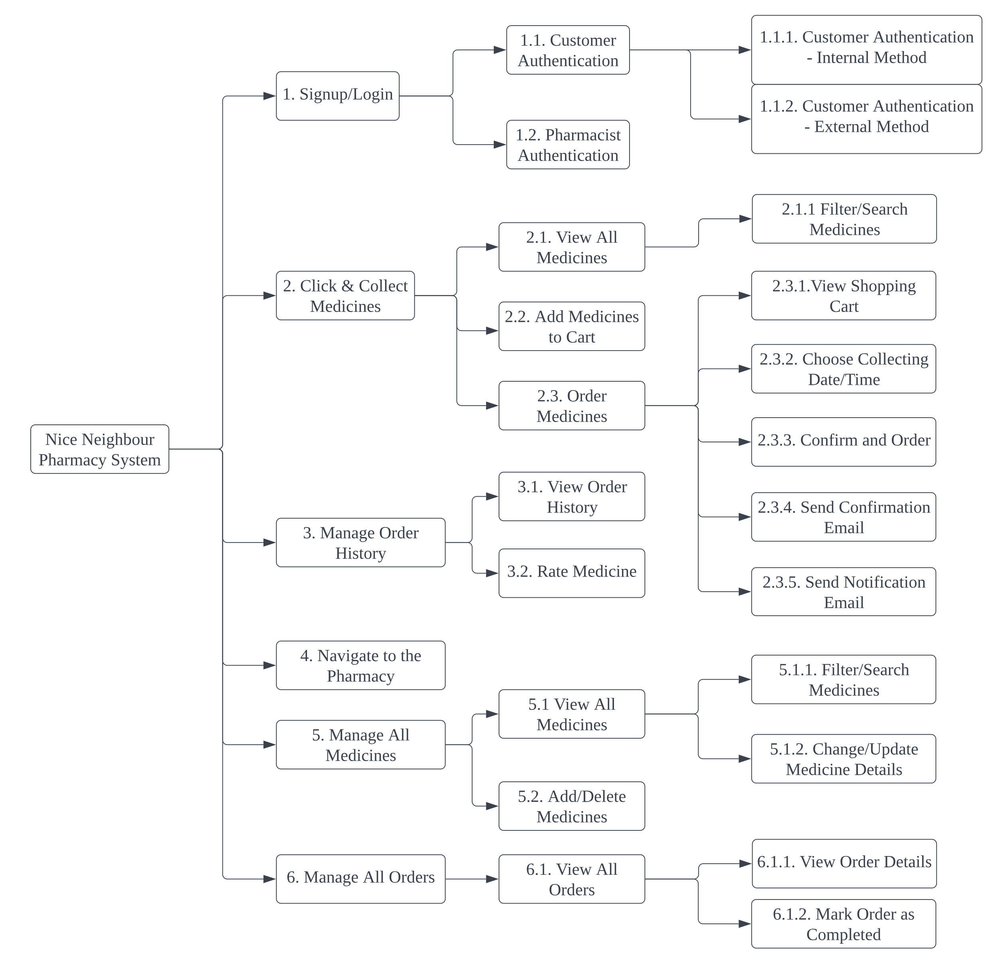

## 4. Selected Approach when Constructing the Application

During the development of this web application, Database First approach is selected. There are 2 reasons for this choice. Firstly, since all business requirements are given, it is completely possible to determine the number of tables and the relationship between tables in this project. After that, models and the relationship between models can be easily created. Controllers and views can also be scaffolded quickly. Secondly, it would be convenient to insert mock data when the database is created, which is really useful to test the application by using mock data.

# Distinction Level

## 5. Class Diagram or Entity Relation Diagram

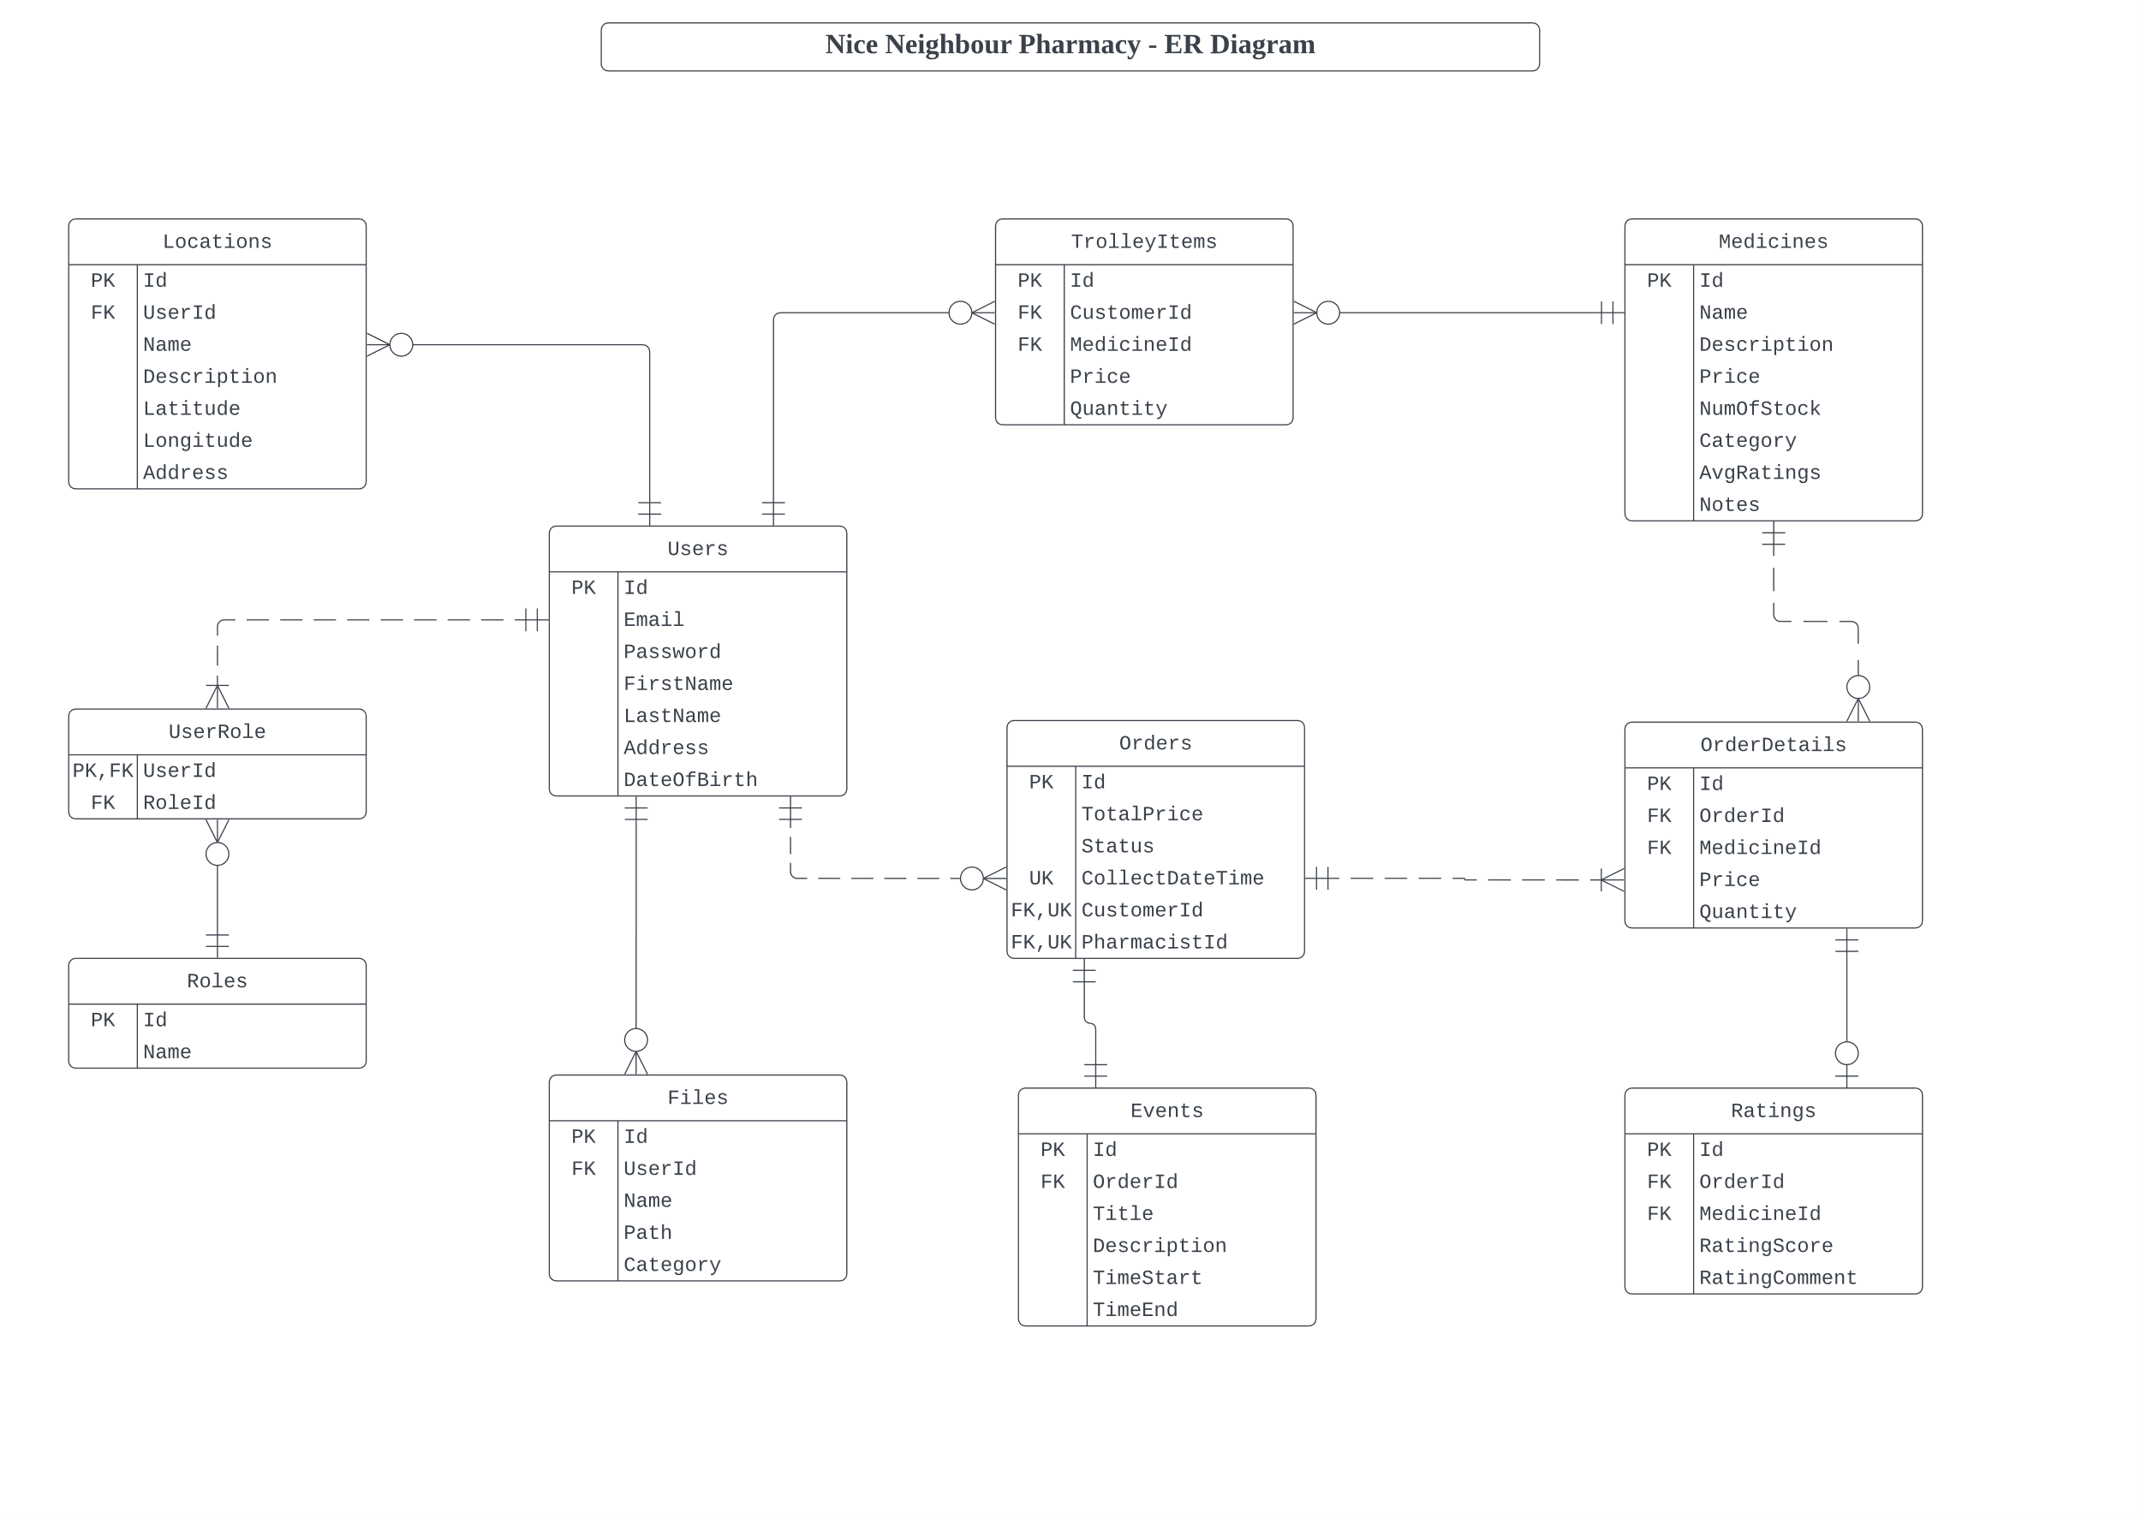

In this ER Diagram, at least 4 business requirements are related:

1. B.1.: Authentication: only authenticated customers are allowed to order medicines. Otherwise, they cannot see “Medicine” pages.

2. C.1.: Role based authentication: there are 2 roles in the application, pharmacists and customers. Customers can order medicines; however, pharmacists can see all orders from all customers.

3. D.3.: Rating: in the “medicine” entity, there is a field called “ratings” which is a rate score given by all customers who have already bought and used this medicine.

4. D.4.: Booking constraint: in the “order” entity, there is a field called “collect_date” which is a collecting date chose by customers. The constraint is that customers cannot choose the same date and time as previous customers.

## 6. Data Dictionary

In this section, all datatypes used in this application are shown:

1. string: string is used in many places, such as user email, user’s name, rating comments, medicine name, and so on. Different validations are applied in different fields, such as email validation on user email, string length validation on rating comments.

2. int: int is used to show quantities, such as quantity of medicine in order entity, number of stocks in medicine entity. Non-negative validation is always applied on this datatype in the application.

3. decimal: decimal is used for price and (average) rating score. Usually, non-negative validation is applied on decimal. Also, two decimal is applied for price.

4. DateTime: DateTime is used in booking constraint, which is collect date and time in application. To simplify the development of the application, ISO format date and time is always valid. And booking constraint is applied through attribute on model class which is an inheritance of base validation.

## 7. Mockup Prototypes and Implementation with User Registration and Authentication

In this section, a prototype design including at least 5 business requirements are shown:

1. Authentication (Login)

2. Ratings

3. Booking Constraints

4. Interactive Tables

5. Maps

Since the prototype diagram is a large PDF, it is **attached to the last page**. (**See Appendix**)

User registration is implemented in AccountController. Validations are implemented in Models. Authentications are implemented in various Controllers.

GitHub Link of the whole project: <https://github.com/BrantleyXU/FIT5032/tree/main/portfolio/NiceNeighbourPharmacy/NiceNeighbourPharmacy>

Screenshot of HomeController:

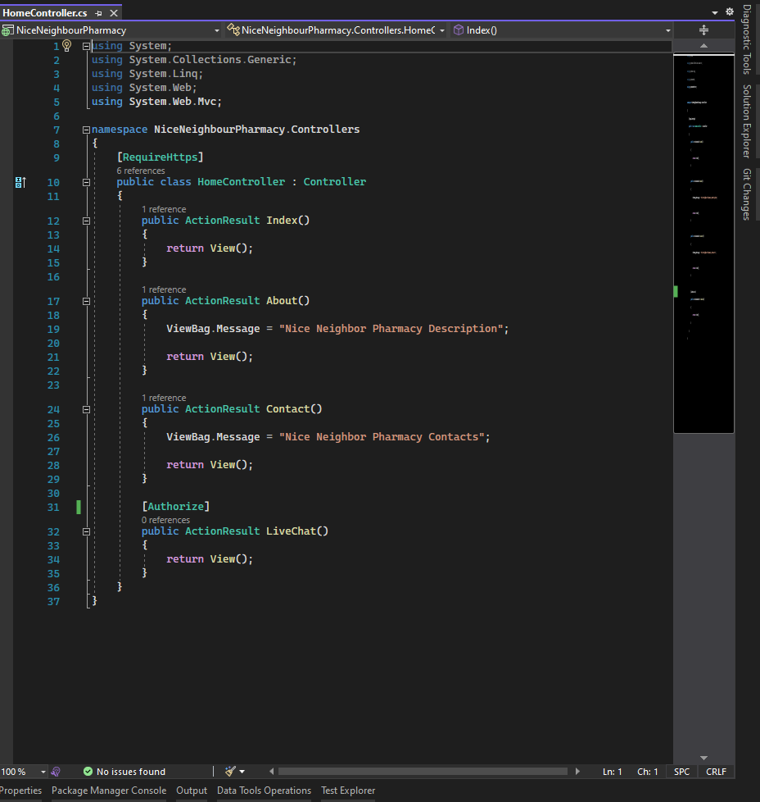

## 8. Usability Design Review

Don Norman’s 6 golden rules are used to evaluate the UI design.

1. Visibility: Users should know, just by looking at an interface, what their options are and how to access them. Here, a navigation bar used in the application is a good example of visibility.

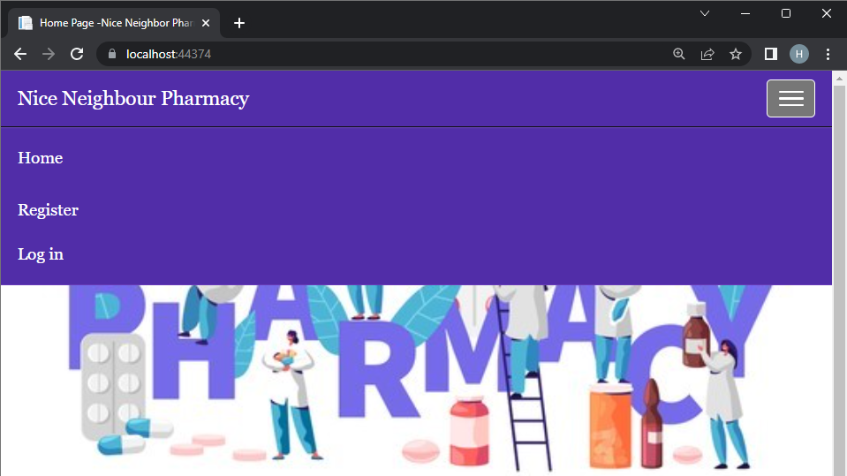

2. Feedback: User must receive feedback after every action they perform to let them know whether their action was successful. For example, if user put wrong information in register, error messages will be displayed.

3. Affordance: Items on the website can show the link between how things look and how they’re used. For example, on navigation bar, a “hamburger” shows collapsed items.

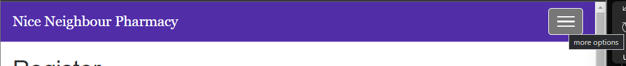

4. Mapping: In a good design, the controls for something will closely resemble their effect. For example, in interactive table, the search bar maps the corresponding table.

5. Constraints: Constraints restrict a particular form of user interaction with an interface. For example, when pharmacists create medicine, they can only input non-negative decimal in price fields.

6. Consistency: Consistency is key for these patterns to be recognized and learned by users. The website only uses 4 colors, purple, blue, black and white. Also, there is always a navigation bar on the top. Both show consistency in the website.

# High Distinction Level

## 9. Development Methodology

During the development of this application, Code and Fix method is used, since it is easy to be applied for this application. The process is Code, Runtime-Test, and then Fix. For example, during the implementation of booking constraint, the initial codes are created. Then IIS webpage is executed to test if the function meets the requirement. If the function could perform well, then the implementation of this function is done. Otherwise, a possible failure reason could be found, and the the source code file is fixed and modified. This code-fix process is a iterative circle, until the function is executed well.

## 10. Versioning

During the development of this application, Git versioning tool is used, especially GitHub. There are 3 reasons to use GitHub. Firstly, it can directly and clearly show a history timeline of developing the application, so that the effort can be shown easily. Secondly, when catastrophic mistake occurs on the application development, it is easy to go back to previous version and do it again. Thirdly, it is easy to create different branches based on one single commit to test different functions, ensuring they can work well independently, and then integrate them together.

## 11. Innovation and Research

To enhance the user experience and business value of this application, an innovative feature, which is called “Live Chat” is implemented. To be specific, a public live chat room is created for customers and pharmacists, so that they could exchange opinions in real-time. For example, new customers can get feedback of specific medicine from old customers. Another example is that customers can ask help from pharmacists to choose correct medicines. Also, customer can check order details, location of pharmacy, etc., from pharmacists. The function has been implemented; however the research report is not completed due to the limitation of time.

# References

Educative. (2022). What are Norman’s design principles?. *Educative*. <https://www.educative.io/answers/what-are-normans-design-principles>

Offutt, J. (2002). Quality attributes of web software applications. *IEEE software*, 19(2), 25-32.

Neuwirth, C. M., & Regli, S. H. (2002). Guest Editors' Introduction: Usability and the Web. *IEEE Internet Computing*, 6(2), 44.

Rekhi, S. (January 24, 2017). Don Norman’s Principles of Interaction Design. *Medium*. <https://medium.com/@sachinrekhi/don-normans-principles-of-interaction-design-51025a2c0f33>

User3559349. (2015, June 9). Adding html attributes using Html.EditorFor(). [Answer to the online question Display a tooltip with Html helper.]. *Stack Overflow*. <https://stackoverflow.com/a/30743880>

# Checklist of Site Functionality

|  |  |
| --- | --- |
| **1. (Layout Page)** | **TICK if complete** |
| Good Design | Y |
| Stylesheet | Y |
| JavaScript | Y |
| Menu | Y |
|  |  |
| **2. (Home page)** |  |
| Design and content | Y |
| Banner Image | Y |
|  |  |
| **3. (User Log in)** |  |
| Web form and validation controls | Y |
| Formatted data entry display | Y |
| Overall page design | Y |
|  |  |
| **4. (Customised Views and Controllers)** |  |
| Customised Views | Y |
| Customised Controllers | Y |
| Other customisations | Y |
|  |  |
| **5. (Documentation)** |  |
| Code Comments | Y |
| Attribution of Source of any code used | Y |
|  |  |
| **6 Business Requirements** |  |
| **BR(A1): for P** | Y |
| **BR(A2): for P** | Y |
| **BR(B1): for C to C+** | Y |
| **BR(B2): for C to C+** | Y |
| **BR(C1): for C+ to C++** | Y |
| **BR(C2): for C+ to C++** | Y |
| **BR(C3): for C+ to C++** | Y |
| **BR(C4): for C+ to C++** | Y |
| **BR(D1): for D to D++** | Y |
| **BR(D2): for D to D++** | Y |
| **BR(D3): for D to D++** | Y |
| **BR(D4): for D to D++** | Y |
| **BR(E1): for HD to HD+** | Y |
| **BR(E2): for HD to HD+** | Y |
| **BR(F1): for HD+ to HD++** | (Partially Yes). Code implemented, without Research Repot |
|  |  |
| **Audit** |  |
| No breaking of copyright | Y |

# Appendix

