Learning Summary

Student ID: 32767919

Student Name: Hao Xu

# Introduction

This report summaries what I learnt in FIT5032 Internet applications development (S2 2022). It includes a self-assessment against the criteria described in the unit outline, a justification of the pieces, details of the coverage of the unit’s learning outcomes, and a reflection on my learning.

# Overview of Pieces Included

This section outlines the pieces that I have included in my portfolio:

1. Task 01.1. ASP.NET MVC IIS local server.
2. Task 01.2. Features of VS Community Edition used in portfolio.
3. Task 02.1. Responsiveness by Bootstrap.
4. Task 02.1. VS Scaffolding.
5. Task 03.1. C#.
6. Task 03.2. GitHub version control.
7. Task 04.1. Model first and scaffolding
8. Task 04.2. Code first database schema
9. Task 05.1. Notify.js
10. Task 05.2. Bootstrap DateTimePicker in JavaScript
11. Task 06.1. View Model and Data Annotation
12. Task 06.2. JQuery unobtrusive validation
13. Task 07.1. ASP.NET Identity
14. Task 07.2. External authentication with Google Account
15. Task 08.1. SendGrid API to send email
16. Task 08.2. 3rd-party emailing tools
17. Task 09.1. Responsive images
18. Task 09.2. .NET Core application
19. Task 10.1. Web API using .NET Core
20. Task 10.2. AngularJS application
21. Task 11.1. Azure deploys ASP.NET MVC project
22. Task 11.2. ASP.NET MVC units testing

# Coverage of the Learning Outcomes

## LO1: demonstrate the impact of the history of web applications development on current web-technology

Task 06.2. A .PDF containing introduction of JQuery unobstructive validation.

Task 07.1. A .PPT containing the weakness and alternatives of MD5 and SHA1, and A screenshot of correct setup of ASP.NET MVC Identity.

## LO2: design, construct and publish web-database applications

Task 01.1. A screenshot of running default ASP.NET MVC application in VS Community Edition IIS localhost server.

Task 03.2. A .PDF containing the GitHub username and repository URL of eFolio folder.

Task 06.1. A screenshot of implementation of View Model and Data Annotation.

Task 07.2. A screenshot of implementation of external authentication using Google account in ASP.NET MVC

Task 08.1. A screenshot of SendGrid console successfully showing implementation of sending email from web application.

Task 11.1. A screenshot of deployment of ASP.NET MVC with Azure Cloud Platform, and a .PDF containing explanations of Continuous Integration (CI) and Continuous Delivery/Deployment (CD).

## LO3: analyse and critique the key technological issues confronting developers building web-database applications

Task 01.2. A .PDF containing research of 5 different IDEs and features of VS Community Edition IDE.

Task 08.2. A .PDF containing explanations of advantages and disadvantages of 3rd party emailing tools.

Task 09.1. A .PDF containing explanations of .WOFF and .WOFF2 font and a screenshot of demonstration of using Responsive images.

## LO4: test the key features of programming languages which are commonly used for developing web-database application

Task 02.1. A screenshot to demonstrate CSS examples and a screenshot to demonstrate Bootstrap responsiveness using ASP.NET MVC.

Task 03.1. A screenshot of successfully changing display of “About” page.

Task 05.1. A screenshot of website using Notify.JS, and a .PDF explaining “defer” and “async” key words in importing JS to .HTML file.

Task 05.2. A screenshot of implementation of Bootstrap DateTimePicker in JavaScript

Task 10.2. A screenshot of implementation of AngularJS application.

## LO5: assess the MVC design pattern and construct a web-database application using the MVC design pattern

Task 02.2. A screenshot of implementation of Database First Development in ASP.NET MVC application.

Task 04.1. A screenshot of implementation of Model First Development in ASP.NET MVC with database schema

Task 04.2. A screenshot of implementation of Code First Development in ASP.NET MVC with database schema

## LO6: apply, analyse and critique a professional approach towards the development of web-database applications

Task 09.2. A .PDF containing the difference between ASP.NET MVC and Asp.NET Core

Task 10.1. A screenshot of implementation of ASP.NET Core Web API with response from that Web API.

Task 11.2. A screenshot of running ASP.NET MVC unit testing.

# Reflection

The most important things I learned is the MVC Web application design and implementation by using .NET Framework with C# language. By doing so, I could go though a whole development process as a full-stack developer, controlling both front-end and back-end. Also, I could get familiar with the .NET web technology stack, which is interesting.

The things that helped me most were Microsoft official learning documents and the online Q&A website, such as Geeksforgeeks and Stack Overflow. With them, I could enhance what I learned during lecture and tutorial to get further understanding and knowledges.

I found the following topic is particularly challenging, that is, dealing with Date and Time datatype while developing the web application. Since there are many different formats of date and time. For example, the order of date in the US is month, day and year, however, in AUS that is day, month and year. Time format also contains 12 hours format and 24 hours format. To deal with them, I must put enough efforts on developing and testing.

I fell I learned the following concepts, and tools well. They are MVC design pattern, .NET Framework and Visual Studio IDE. MVC gives me a concept to develop a web application. .NET Framework is a technology stack I could use. And Visual Studio is smooth to develop .NET application.

I still need to work on the following area, that is, to get further understanding of .NET technologies, such as .NET Core. More knowledge in various technologies will apparently improve flexibility when choosing suitable technologies to meet the business requirement in the future.

My progress in this unit was to complete work pieces in each week, and then put everything together in the final portfolio application. I completed all tasks within each week, including P/CR/D/HD tasks and submitted all of them on time to get feedback from tutors.

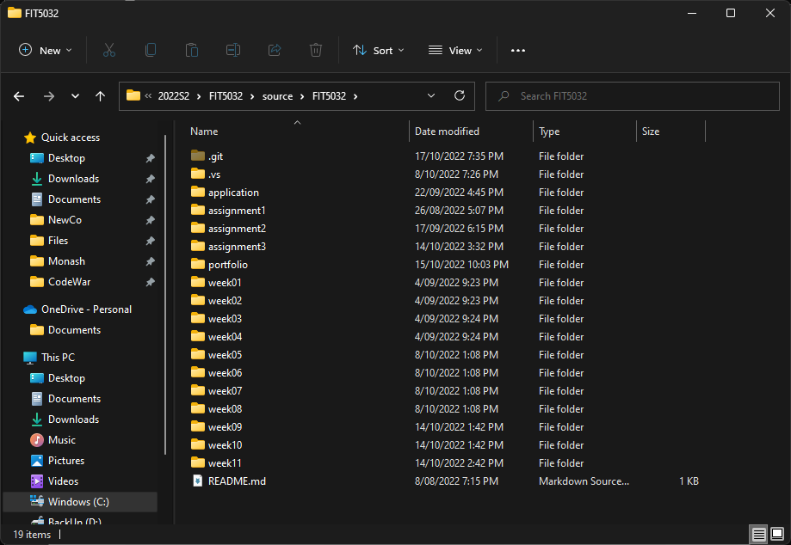

This unit will help me to find a related .NET development job in the future. More knowledge and experiences on various technologies will give more choices when looking for a job.

If I did this unit again, I would do the following things differently, that is to first understand the function of each component of MVC design pattern fully. And then get understanding of C# syntax.

# Declaration

I declare that this learning summary, eFolio tasks and the linked code are my individual work except group submission. I have not copied from any other student’s work or from any other source except where due acknowledgment is made explicitly in the text and code, nor has any part of this submission been written for me by another person.

____________