**Fortnightly eFolio Submission**

**Studio 1**

Student Name and Id

**Hao Xu 32767919**

Self-Evaluation:

|  |  |  |  |  |  |
| --- | --- | --- | --- | --- | --- |
| Need Help | Work in Progress | Pass | Credit | Distinction | High Distinction |

Task 1.1 (P and C Level)

**GitLab Link**: <https://git.infotech.monash.edu/hao-xu/fit5032/-/tree/main/week01>

A screenshot with successfully running Visual Studio Community Edition IDE IIS localhost:

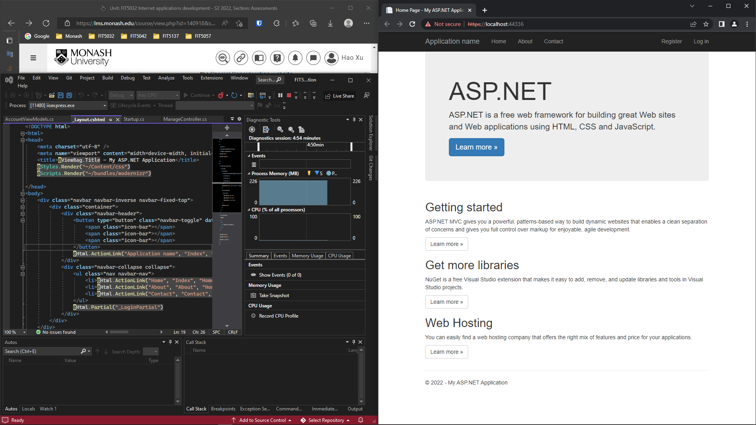

Figure 1 my first application running in localhost

Task 1.2 (H and HD Level)

1. **A list of 5 current industry used IDEs (integrated development environment):**

**Visual Studio**: from Microsoft. It can be used to develop cross-platform applications especially with .NET Framework and C#.

**IntelliJ IDEA**: from JetBrains. It can be used to develop computer software which are written in Java, Kotlin and other languages that are JVM compatible or JAR based.

**PyCharm**: from JetBrains. It can be used to develop computer software which are written in Python.

**Eclipse**: original from IBM, now free and open source. It can be also used to develop applications by using Java.

**Android Studio**: from Google. It can be used to develop Android mobile applications by using Java, Kotlin, XML, etc.

**XCode**: from Apple. It can be used to develop applications for iOS, macOS, iPadOS, etc.

1. **Discussion about 5 features of Visual Studio Community Edition as an IDE**
2. Develop: as an IDE, Visual Studio has a lot of shortcuts to speed up programmers’ editing. Also, it has intelligent auto-completion, syntax highlighting and tips & tricks by using “light bulbs”.

Figure 2 VS auto-completion

1. Debug: as an IDE, Visual Studio has rich debugging for the code and exception information.

Figure 3 VS exception details

1. Test: using a lot of built-in test frameworks that is even cross-platform.

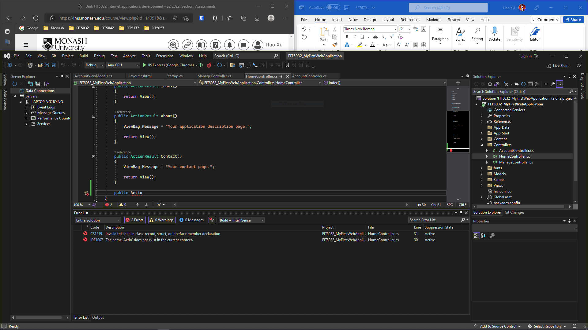

Figure 4 VS test schema

1. Collaborate: VS can use Git to distribute version control.

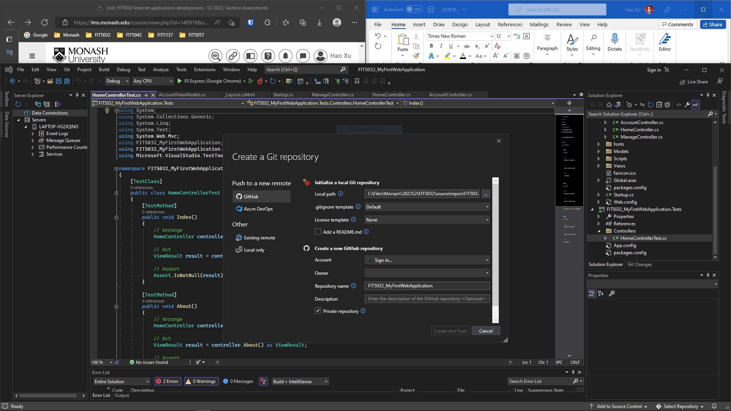

Figure 5 VS Git version control

1. Extend: there are a lot of extensions to enhance and customize the IDE.

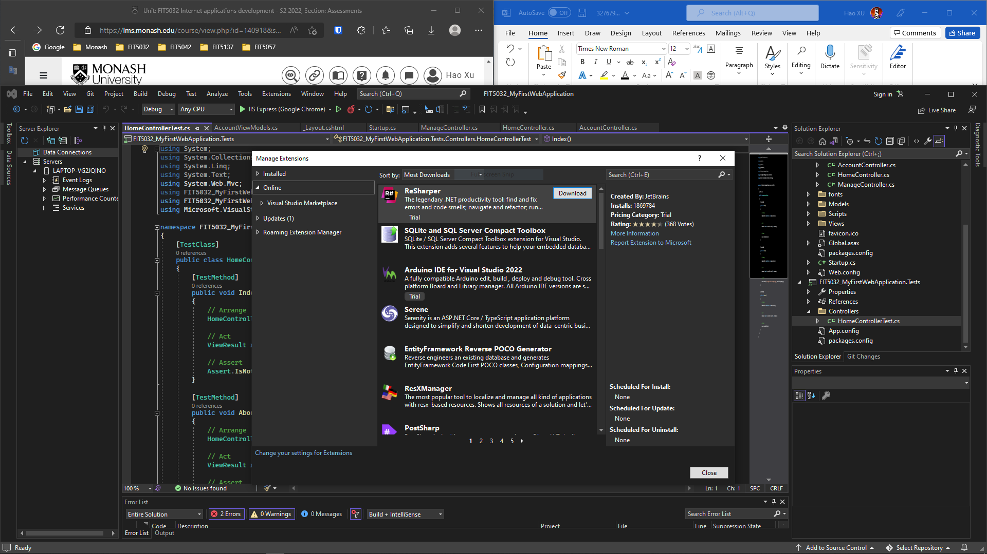

Figure 6 VS very rich amounts of extensions in online market