**Fortnightly eFolio Submission**

**Studio 2**

Student Name and Id

**Hao Xu 32767919**

Self-Evaluation:

|  |  |  |  |  |  |
| --- | --- | --- | --- | --- | --- |
| Need Help | Work in Progress | Pass | Credit | Distinction | High Distinction |

Task 2.1 (P and C Level)

**GitLab Link**: <https://git.infotech.monash.edu/hao-xu/fit5032/-/tree/main/week02>

A screenshot of using CSS examples and code:

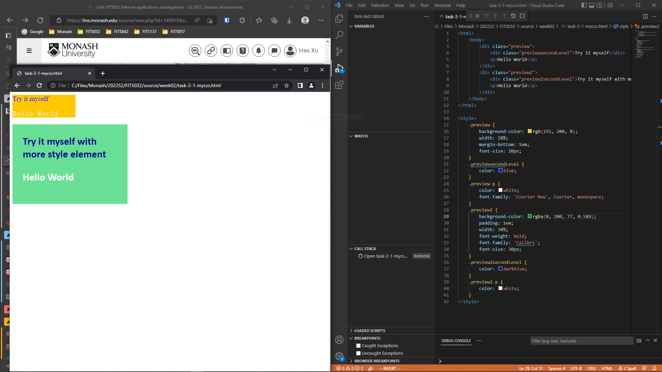

Figure 1 Using CSS examples and code

A screenshot of using Bootstrap responsiveness examples and code:

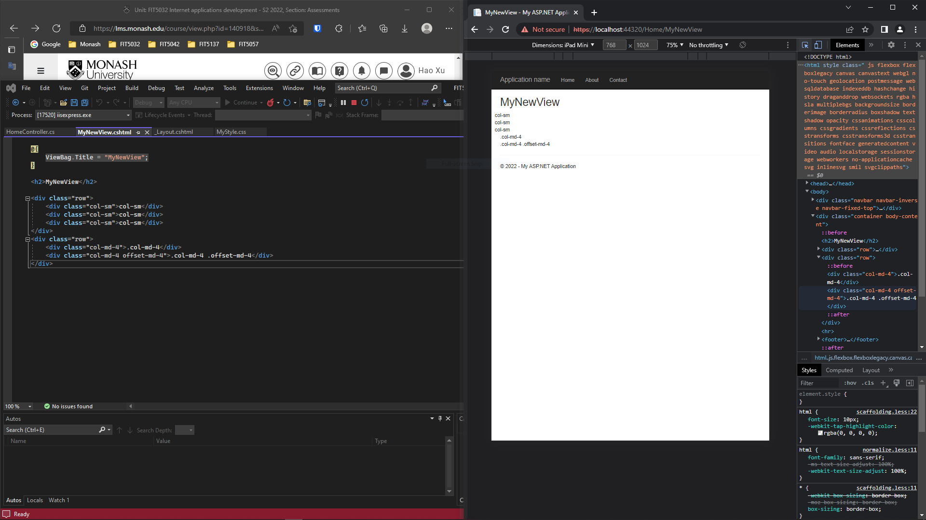

Figure 2 Using Bootstrap examples and code

Task 2.2 (D and HD Level)

**GitLab Link**: <https://git.infotech.monash.edu/hao-xu/fit5032/-/tree/main/week02/FIT5032_W02MyDBFirst>

A screenshot of ASP .NET MVC Web Application with database schema and code.

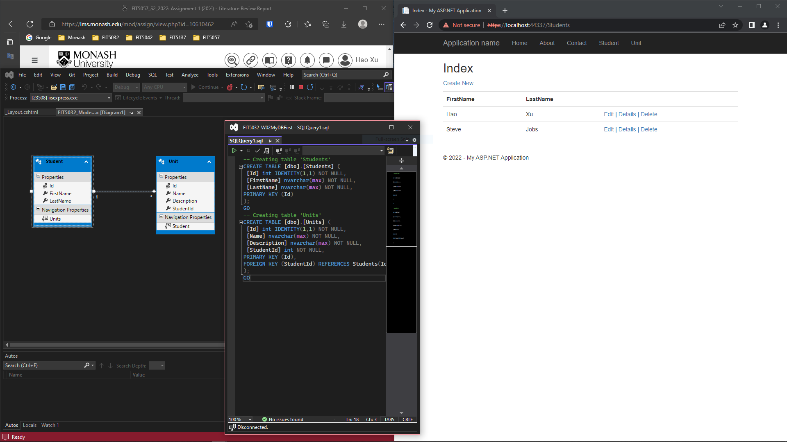

Figure 3 database first application with schema and code

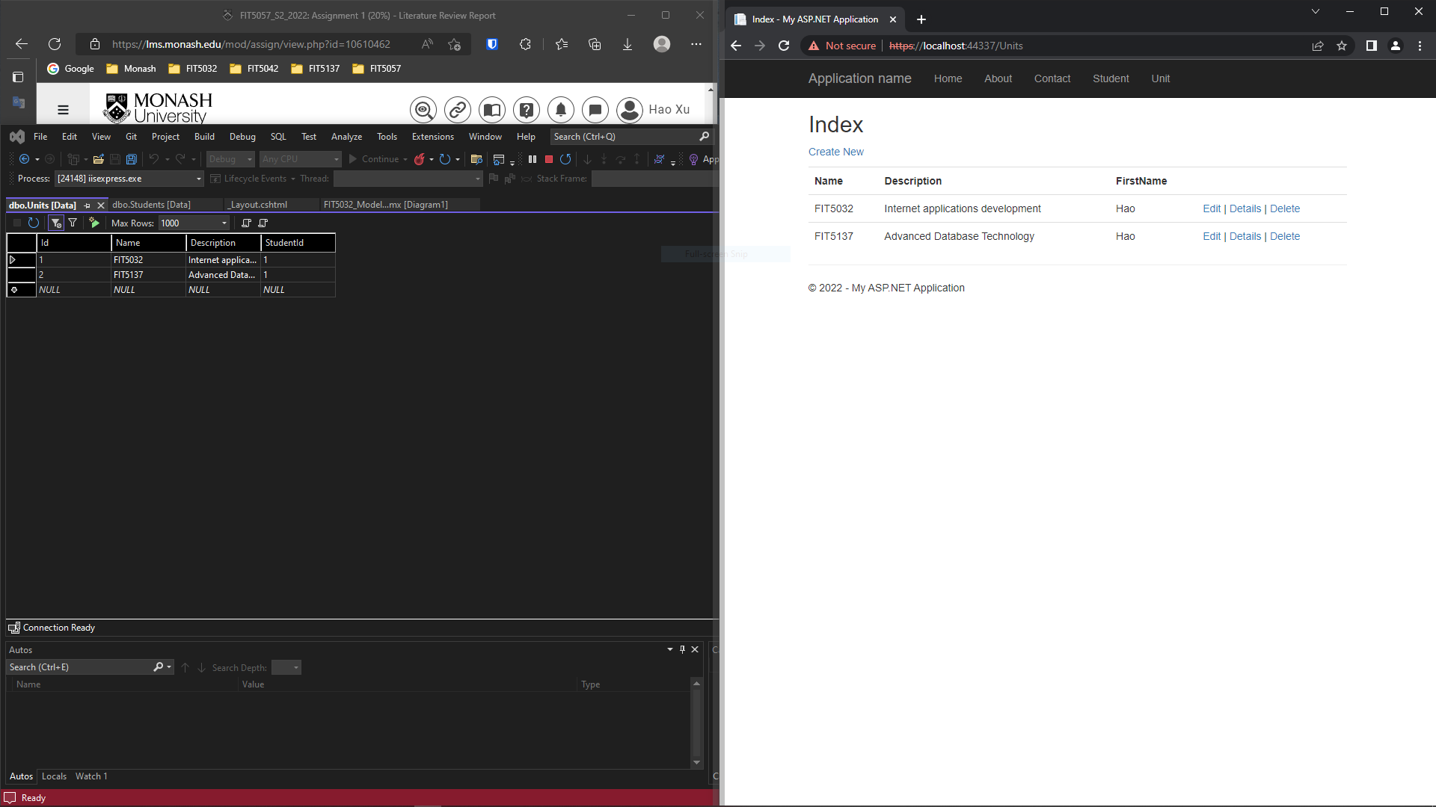

Figure 4 database first application with data manipulation