**Fortnightly eFolio Submission - Studio 3**

Student Name and Id

**Hao Xu 32767919**

Self-Evaluation:

**High Distinction**

Task 3.1 (P and C Level)

**GitHub Link of This Project**: <https://github.com/BrantleyXU/FIT5032/tree/main/week03/FIT5032_MyCodeSnippet>

A screenshot showing successfully accomplish of “Step 9”, which displays “Hello, World” in the “About” page:

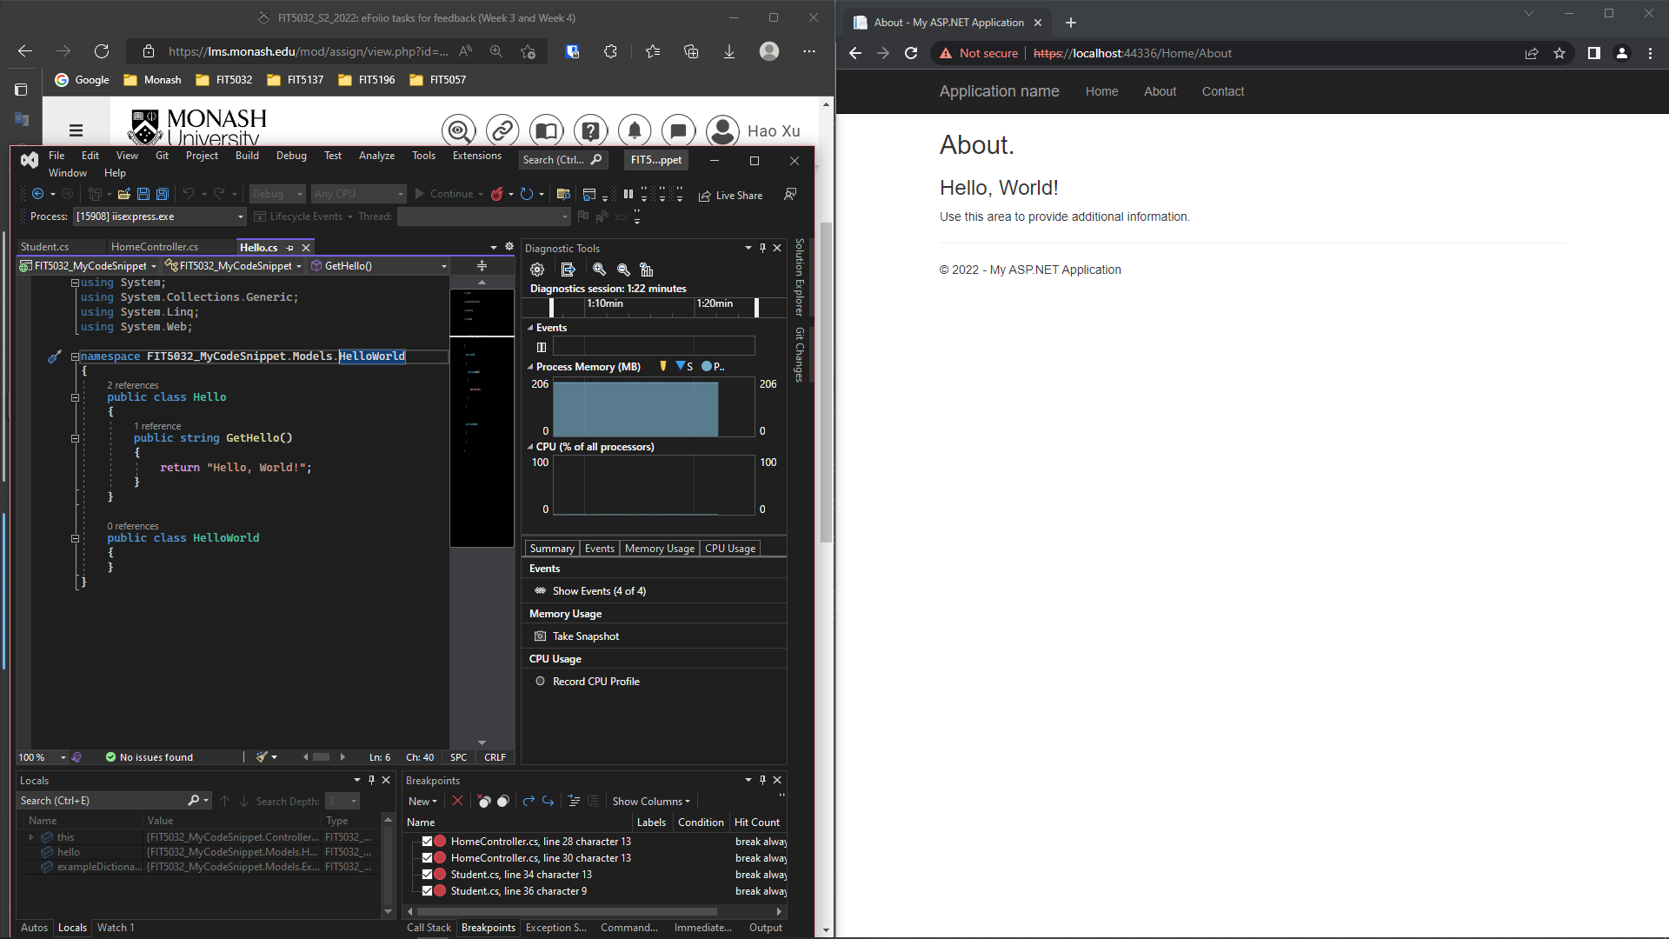

Figure 1 my application successfully running “Step 9” instruction

Task 3.2 (H and HD Level)

Successfully create my GitHub repository for the FIT5032 unit.

**GitHub Username**: @BrantleyXU

**GitHub FIT5032 Repository URL**: <https://github.com/BrantleyXU/FIT5032>