**Fortnightly eFolio Submission - Studio 4**

Student Name and Id

**Hao Xu 32767919**

Self-Evaluation:

**High Distinction**

Task 4.1 (Modle-First approach)

**Project GitHub Link:** [**https://github.com/BrantleyXU/FIT5032/tree/main/week04/FIT5032_MyModelFirst**](https://github.com/BrantleyXU/FIT5032/tree/main/week04/FIT5032_MyModelFirst)

**Database Code Link:** [**https://github.com/BrantleyXU/FIT5032/blob/main/week04/FIT5032_MyModelFirst/ddl-modelfirst-01.sql**](https://github.com/BrantleyXU/FIT5032/blob/main/week04/FIT5032_MyModelFirst/ddl-modelfirst-01.sql)

**Screenshots and Explanations:**

In this screenshot, a model has been manually created. The database will be generated based on this schema:

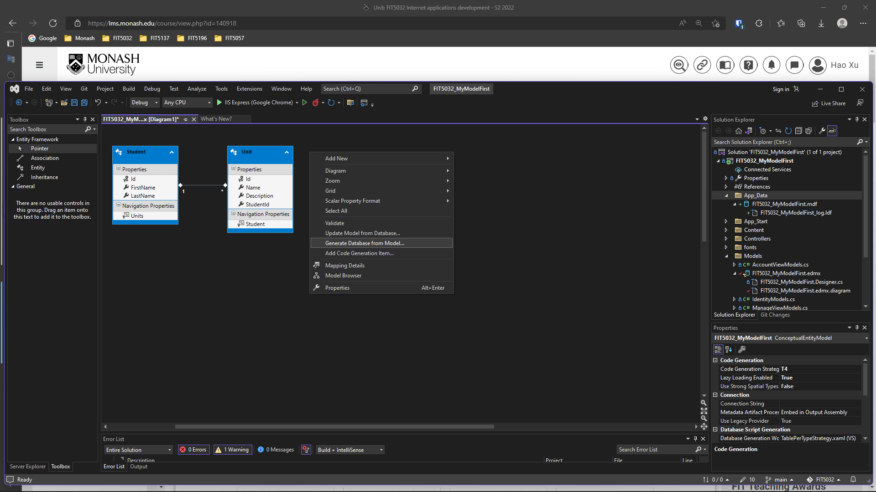

In this screenshot, a database code has been automatically generated:

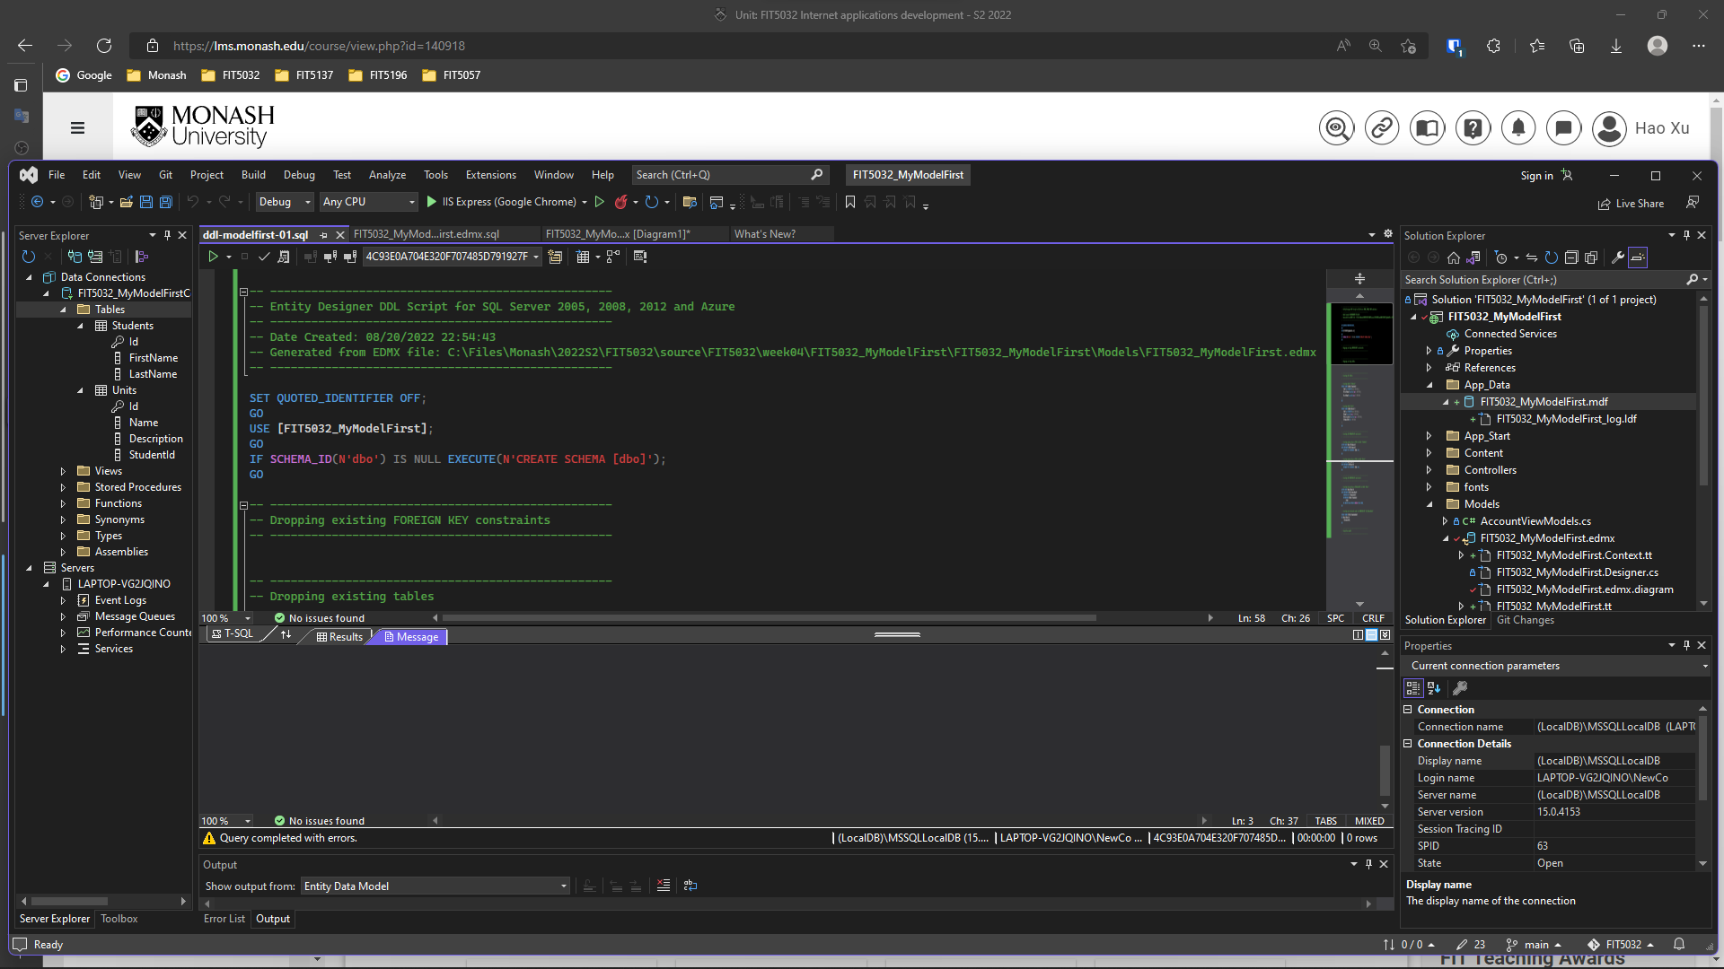

This screenshot shows the ASP.NET MVC application is running successfully:

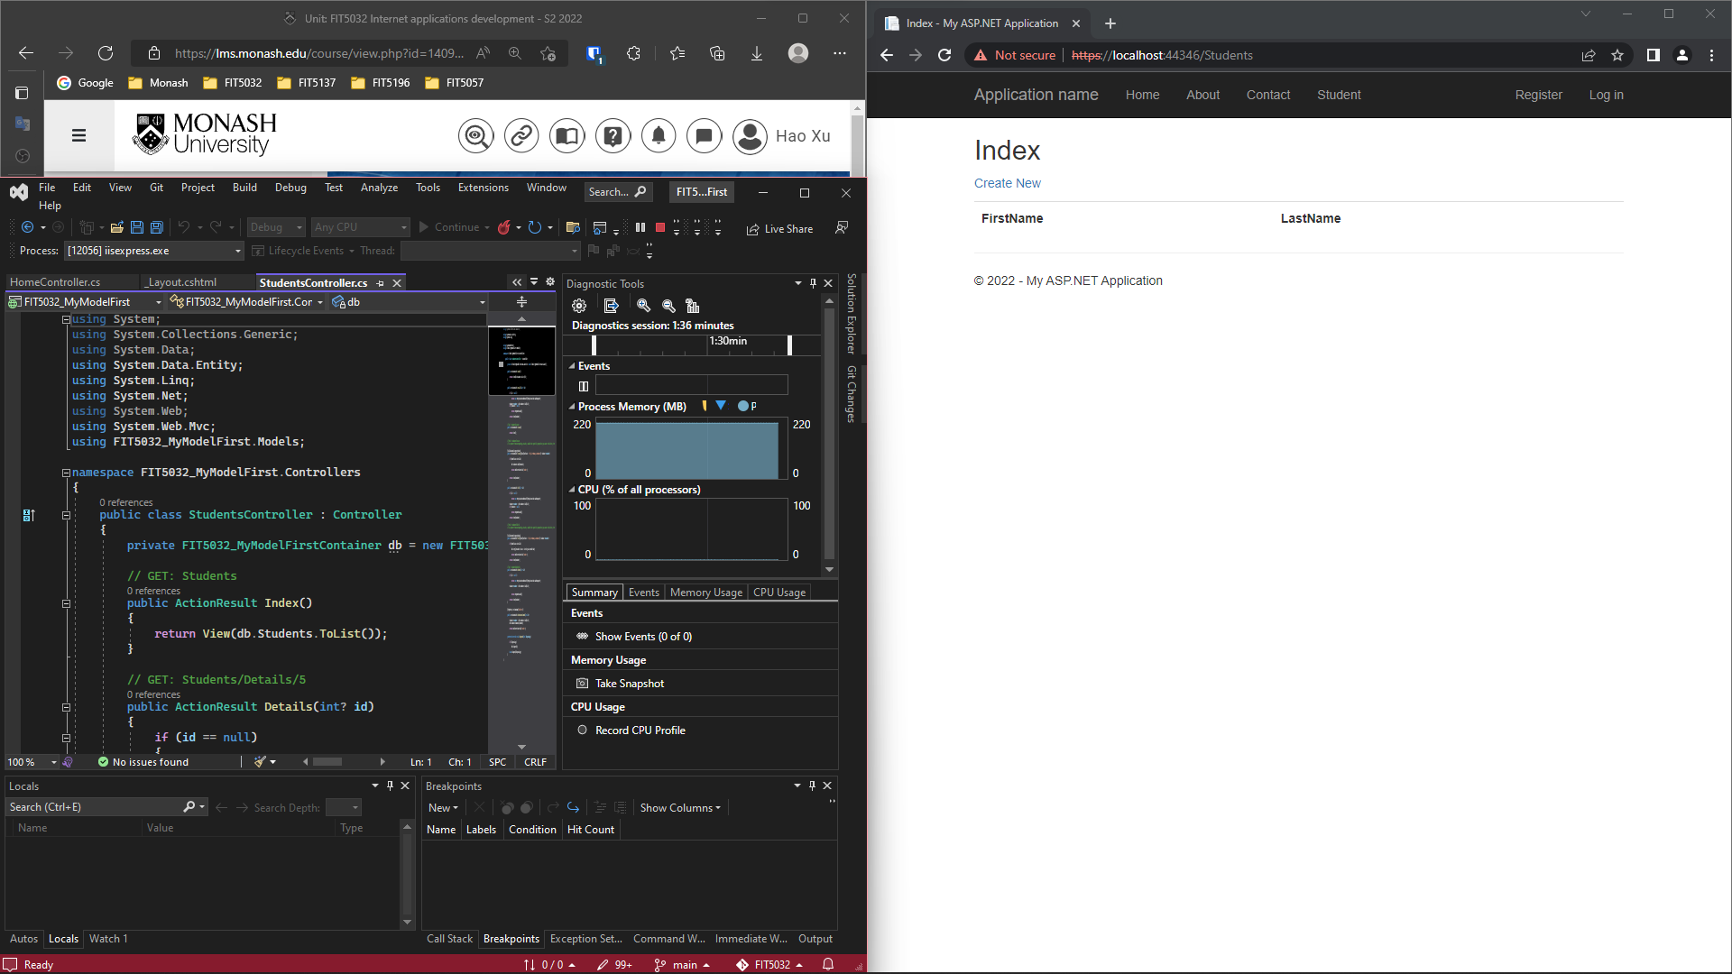

This screenshot shows that the database can be used successfully:

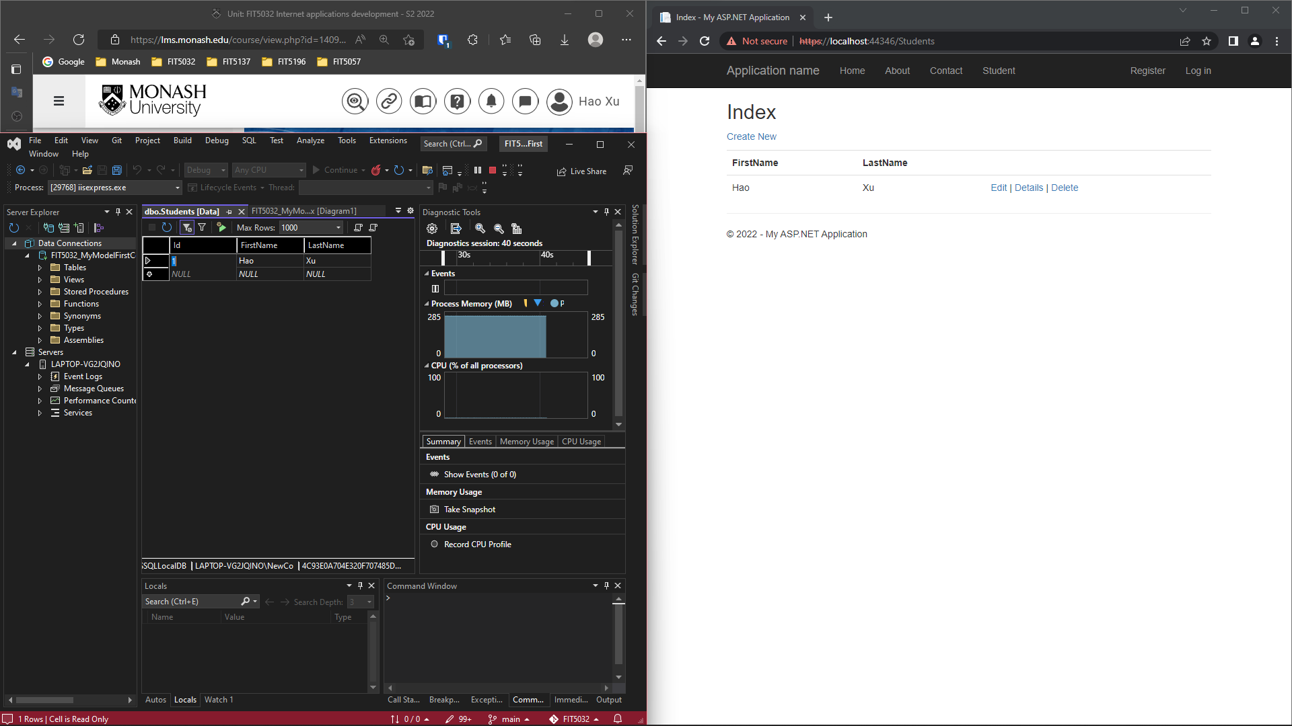

Task 4.2 (Code-First Approach)

**Project GitHub Link:** [**https://github.com/BrantleyXU/FIT5032/tree/main/week04/FIT5032_MyCodeFirst**](https://github.com/BrantleyXU/FIT5032/tree/main/week04/FIT5032_MyCodeFirst)

**Database Code Link:** [**https://github.com/BrantleyXU/FIT5032/blob/main/week04/FIT5032_MyCodeFirst/ddl-my-code-first.sql**](https://github.com/BrantleyXU/FIT5032/blob/main/week04/FIT5032_MyCodeFirst/ddl-my-code-first.sql)

**Screenshots and Explanations:**

In this screenshot, C# codes for Student model is first created:

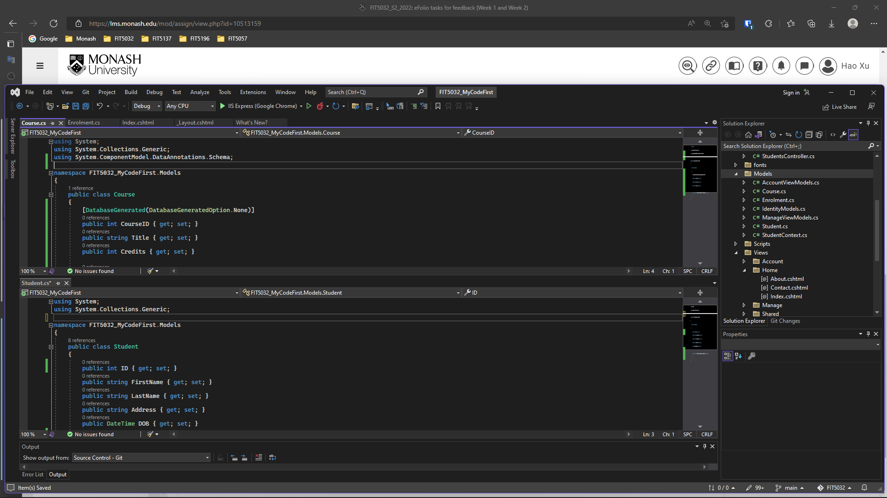

In this screenshot, the database context and initializer have been created successfully:

This screenshot shows a set of data to initialize the database:

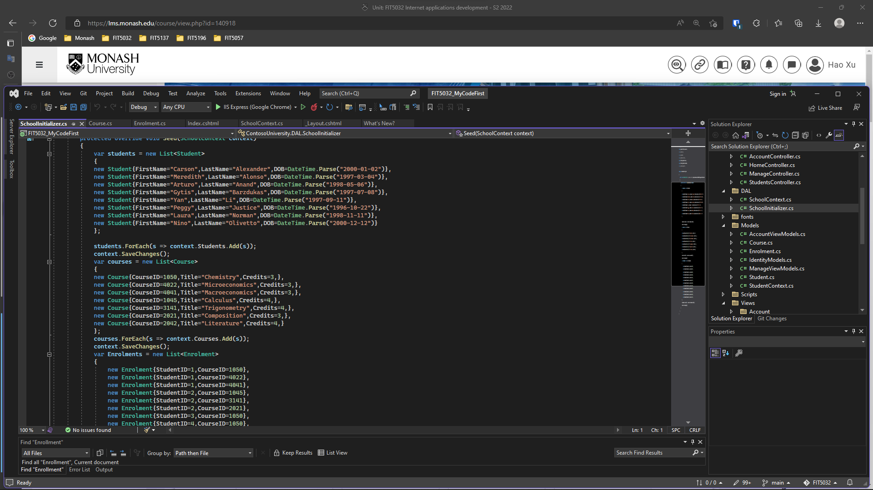

This screenshot shows the ASP.NET MVC application is running successfully, and the database has been created and used successfully, based on the codes typed. The data is stored in LocalDB, whose .mdf file is in App_Data folder.

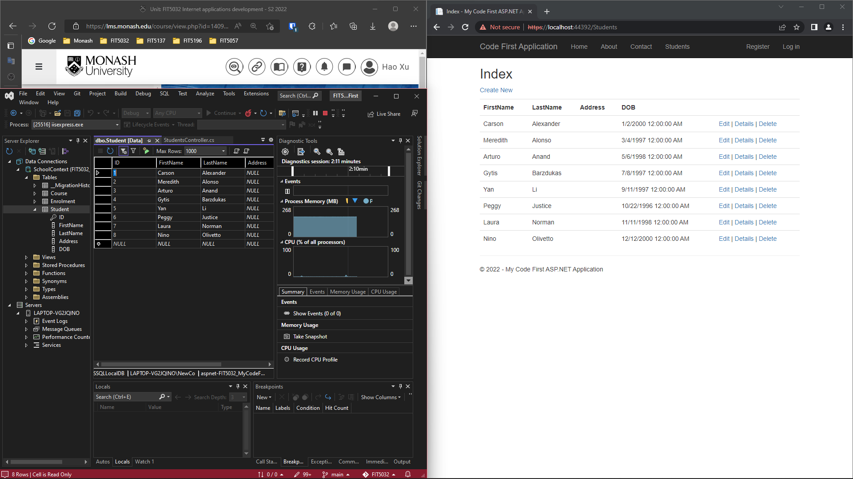

This screen shows corresponding database schema and code which are created by EntityFramework Power Tool:

