Fortnightly eFolio Submission – Studio 5

# Student Name and ID

**Hao Xu (32767919)**

# Self-Evaluation

**High Distinction**

# Task 5.1 (Notify.js, and the difference between “async” and “defer”)

**Project GitHub Link**: <https://github.com/BrantleyXU/FIT5032/tree/main/week05/FIT5032_MyJS>

## 5.1.1 Screenshots and explanations of using “Notify.js”:

This screenshot shows the success of Notify.js working with the application, by displaying a “Testing internal on JS” text at the top-right corner. The JS codes are written in the “_Layout.cshtml” file, i.e., internal JavaScript way.

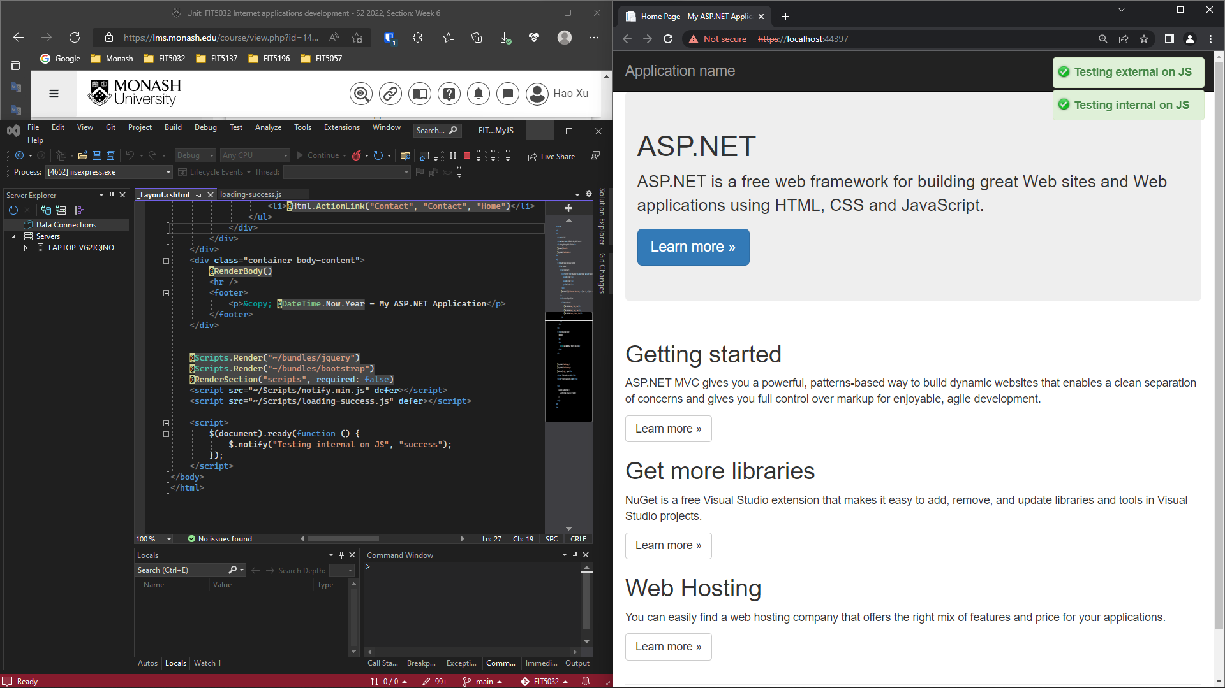

This screenshot shows the success of Notify.js working with the application, by displaying a “Testing external on JS” text at the top-right corner. At this time, the JS codes are written in an external JS file, then imported in “_Layout.cshtml”.

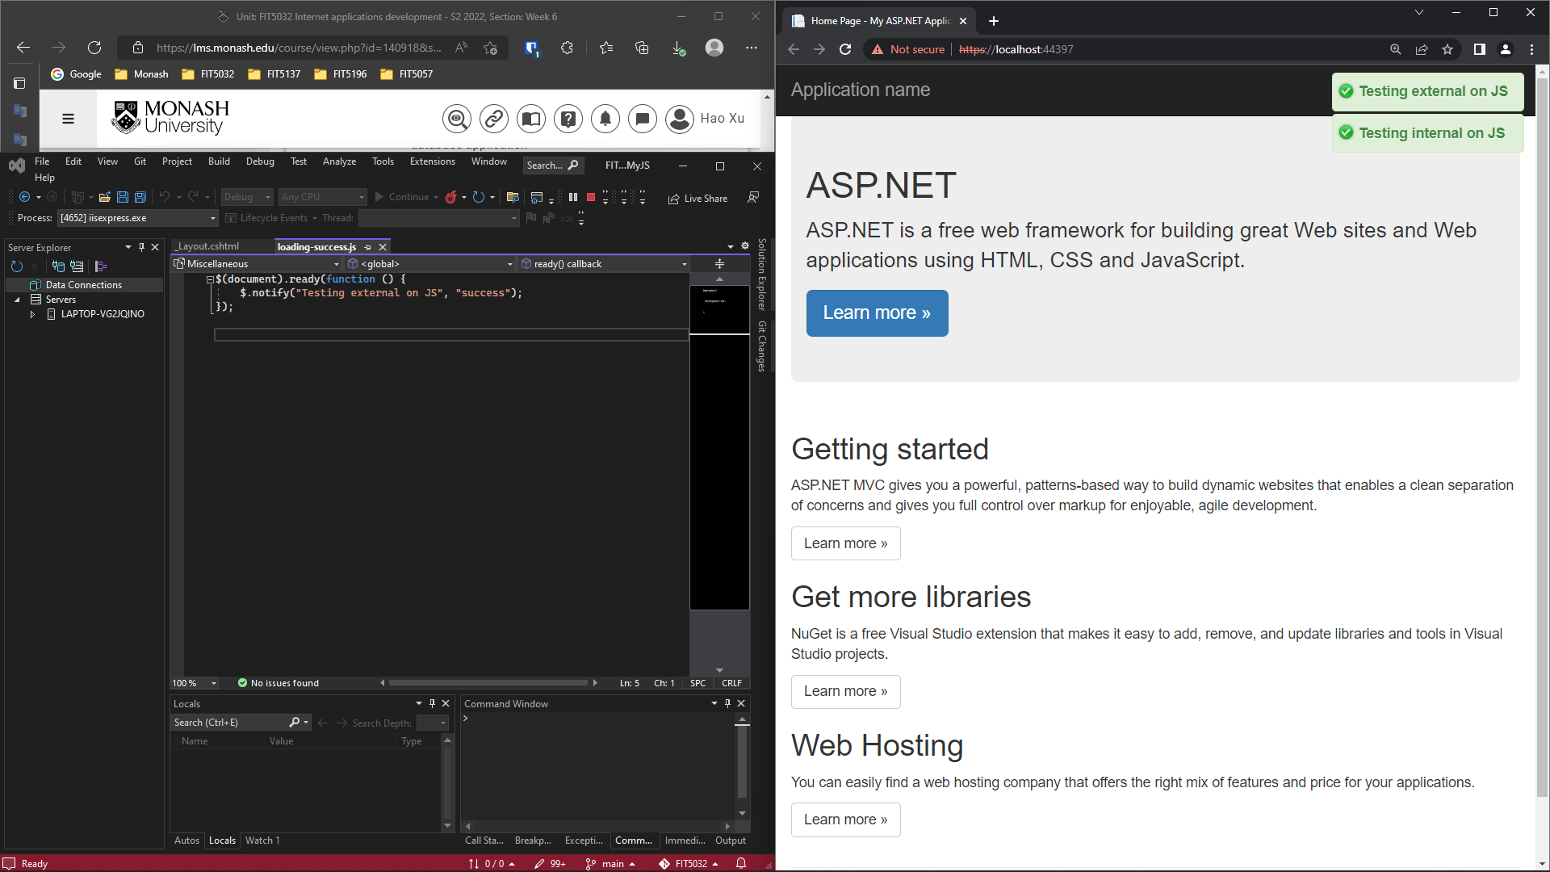

5.1.2 Explanation of the difference between “defer” and “async” in JavaScript:

The attribute “**async**” means that the script tags are executed asynchronously. It means that the browser is not blocked when the scripts are downloaded, and then the scripts are immediately executed. Moreover, the order of downloading and executing could not be the same order of the scripts in the source code. For example, the “script2.js” could be executed before the “script1.js” (See Figure 5.1.1).

Figure 5.1.1: Examples of the “async" attribute

The attribute “**defer**” means that the script tags are deferred to be executed until the entire document has been loaded. The browser is also not blocked, however, the order of executing of the scripts has the same order of the scripts in the source code. For example, “script1.js” and “script2.js” are executed in order, after the document has been parsed by the browser (See Figure 5.1.2).

Figure 5.1.2: Example of the “defer” attribute

Examples and Scenarios:

To enhance performance of the website and give users better experiences, the most state-of-the-art approach to load JavaScript online modules is to put these script tags inside “<head>” section with “async” or “defer” attributes.

1. Use “async”, when:

1) the script is independent of other scripts, or

2) the scripts can be executed parallel along with parsing of the HTML file.

2. Use “defer”, when:

1) the scripts are dependent on each other, and they must be executed in order.

## References:

Bart. (2014, June 5). Here's what happens when a browser loads a website with a <script> tag on it. [Answer to the online question *Where should I put <script> tags in HTML markup?*]. Stack Overflow. <https://stackoverflow.com/a/24070373>.

Haritsinh Gohil. (2019, July 9). The best place to put <script> tag. [Answer to the online question *Where should I put <script> tags in HTML markup?*]. Stack Overflow. <https://stackoverflow.com/a/56950478>.

# Task 5.2 (Bootstrap datepicker)

**Project GitHub Link**: <https://github.com/BrantleyXU/FIT5032/tree/main/week05/FIT5032_MyJS>

## Screenshots and Explanations:

This screenshot shows that Bootstrap datepicker is successfully working along with the application, with the default time set to August 20th, 2022.

