Fortnightly eFolio Submission – Studio 6

# Student Name and ID

**Hao Xu (32767919)**

# Self-Evaluation

**High Distinction**

# Task 6.1 (Application of View Model)

**Project GitHub Link**: <https://github.com/BrantleyXU/FIT5032/tree/main/week06/FIT5032_MyViewModel>

## Screenshots and explanations

The following screenshots display the code of “FormOneViewModel” class and the running application with validations.

This screenshot shows the code:

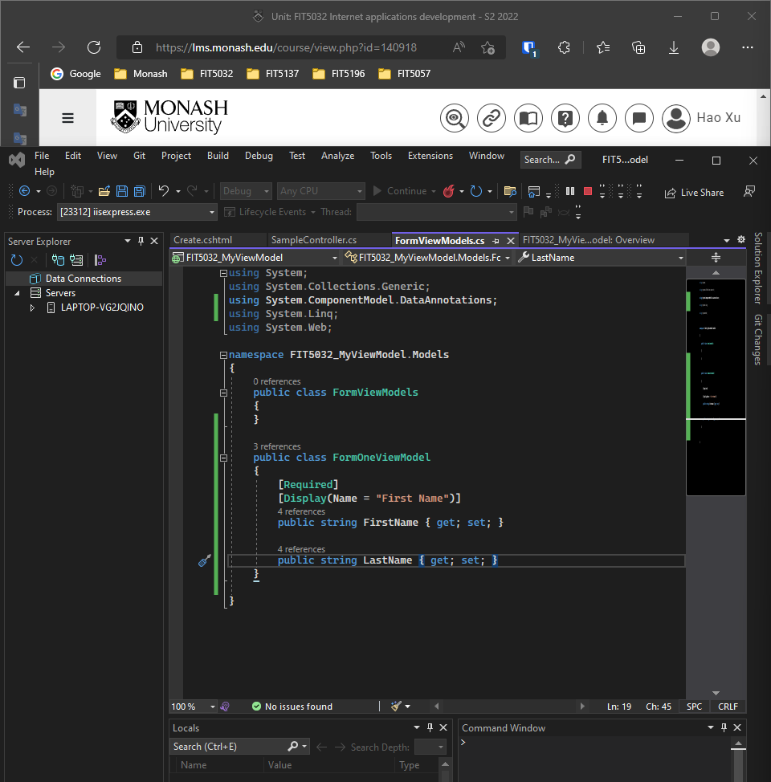

These 2 screenshots show the validation. When the field is left blank, an error message will display; when the field is filled and “Create” has been clicked, a response text will be displayed.

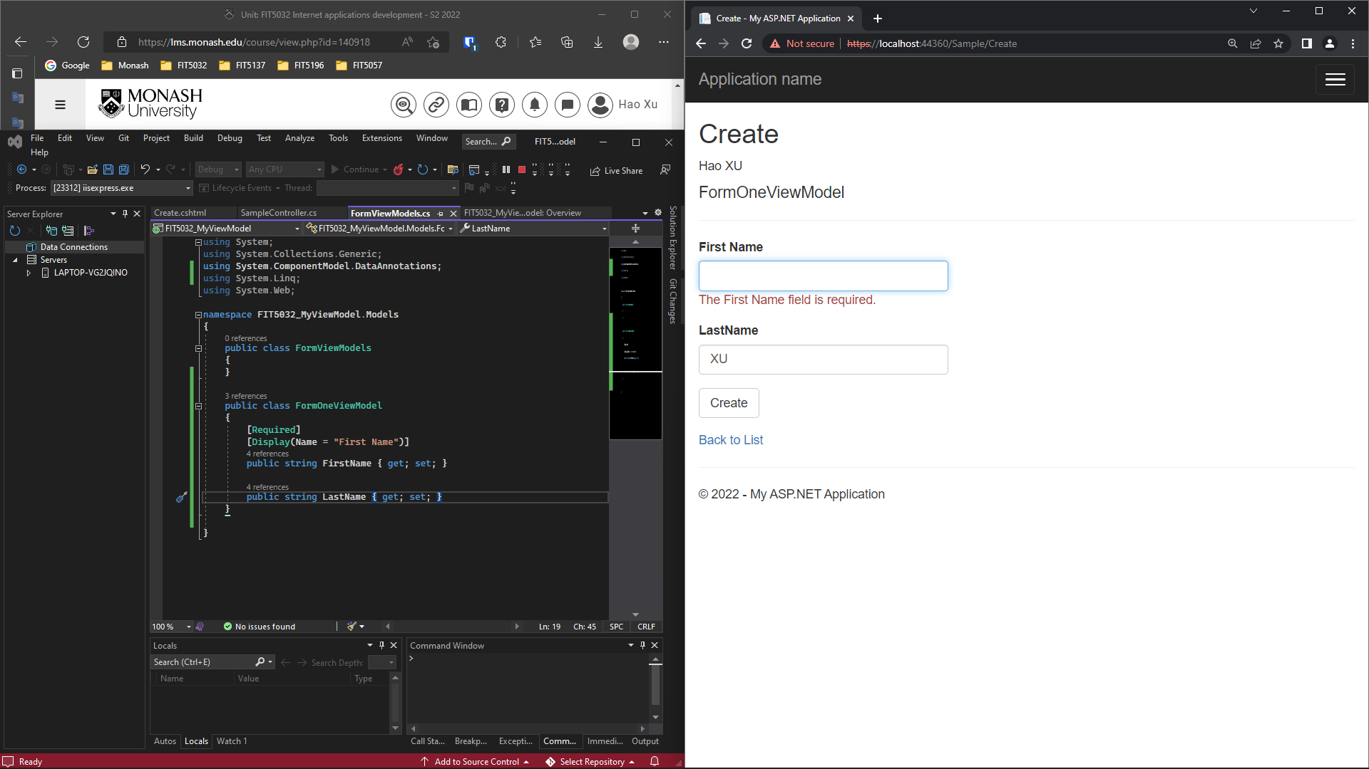

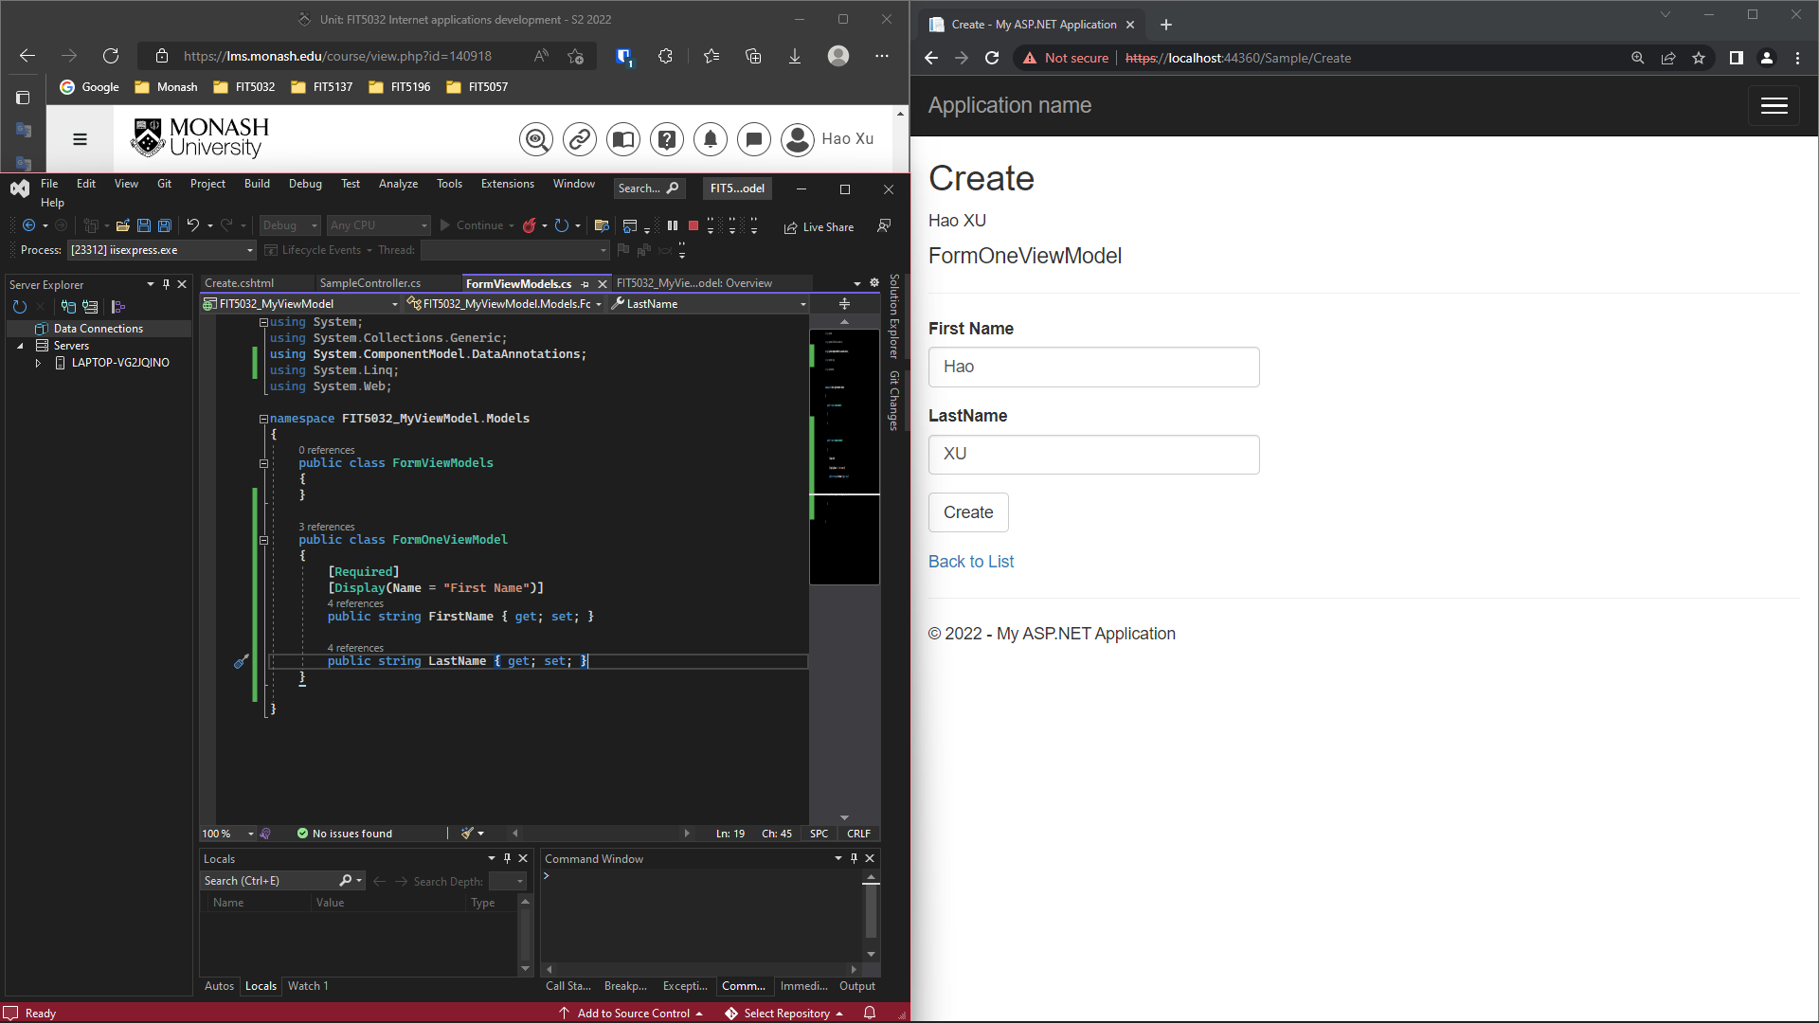

# Task 6.2 (jQuery unobtrusive validation)

The jQuery unobtrusive validation is a set of ASP.NET MVC HTML helper extensions, used to perform simple input validations on the client-side. This could be done by specifying “data-” attributes in HTML file, rather than calling “validate()” method, which is a kind of traditional way (See Figure 6.2.1).

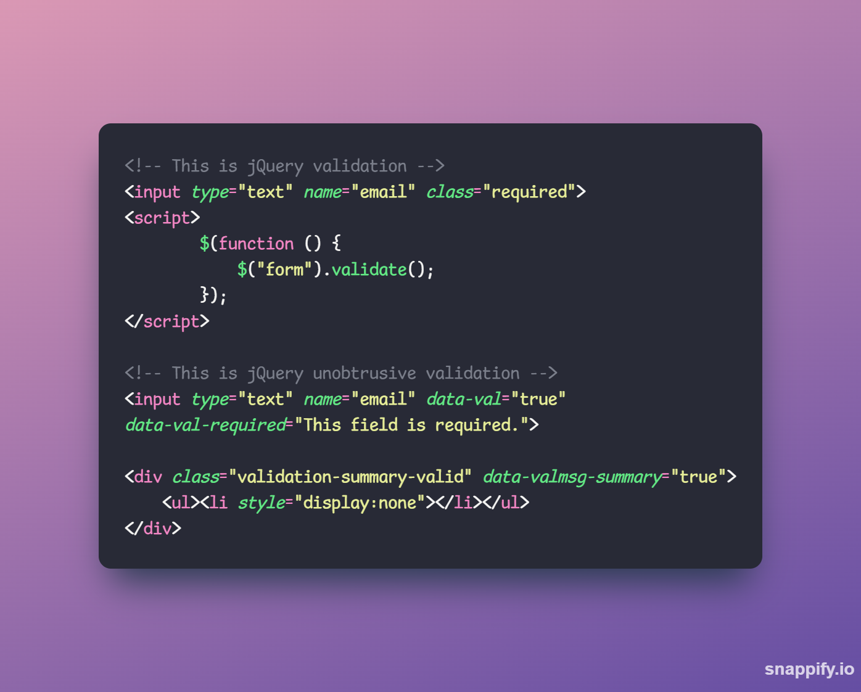

Figure 6.2.1: Examples of jQuery Validation and jQuery Unobtrusive Validation

To work with “ViewModels”, the jQuery unobtrusive validation is written in HTML file, which makes use of jQuery validation supported by HTML 5 data attributes. The validation is performed in the client-side, meaning that there is no need to change validation data through the server and the client. Thus, it is completed in “View” module in MVC framework.

## References:

James Lawruk. (2013, December 3). With the unobtrusive way. [Answer to the online question What is jQuery Unobtrusive Validation?]. Stack Overflow. <https://stackoverflow.com/a/20362167>.