Fortnightly eFolio Submission – Studio 7

# Student Name and ID

Hao Xu (32767919)

# Self-Evaluation

High Distinction

# Task 7.1 (Topic Presentation and ASP.NET Identity)

## Topic Presentation (MD5 and SHA1’s weaknesses and alternative)

In this tutorial, the topic related to MD5 and SHA1 is assigned to our group. I was responsible for researching the weaknesses of MD5. There are several aspects of presentation that can be improved. For example, the history of MD5, the details and functions of MD5 can be included. Also, some presentation technics can be enhanced, such as introducing presenters’ name, introducing the next presenter, etc.

The presentation slide is included in the GitHub Link. Also, the slides are included in the last pages of this document as appendix.

**GitHub Link**: <https://github.com/BrantleyXU/FIT5032/blob/main/week07/FIT5032-Week07-Group1.pptx>

## ASP.NET Identity

**GitHub Link**: <https://github.com/BrantleyXU/FIT5032/tree/main/week07/FIT5032_MyIdentity>

The following screenshot shows that a user is successfully created.

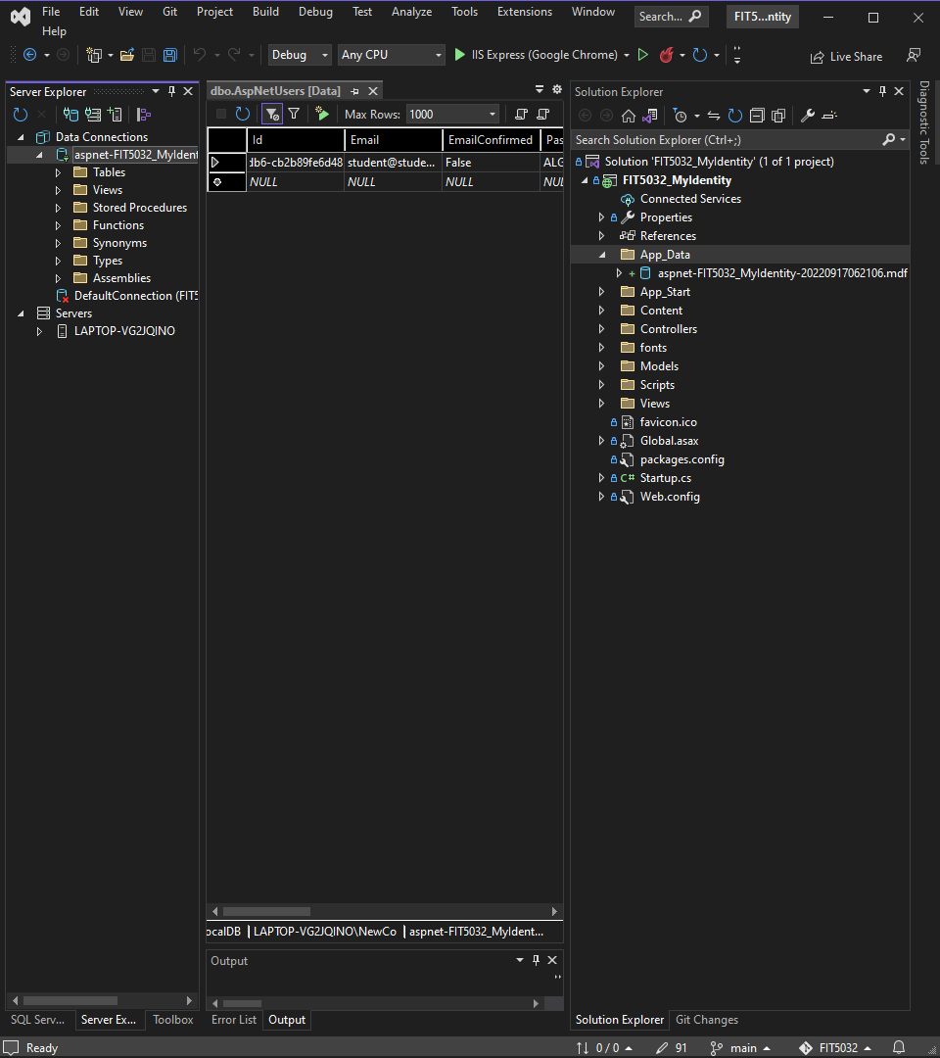

The following screenshots show that MS Identity is successfully setup.

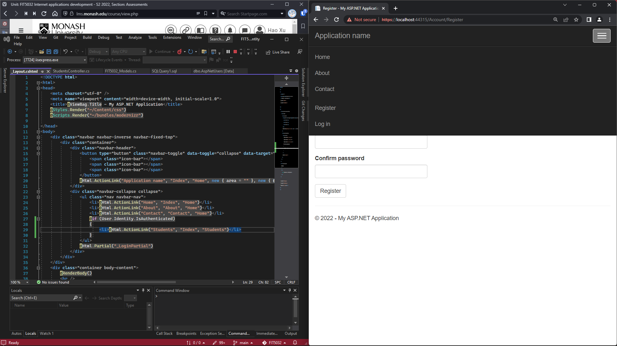

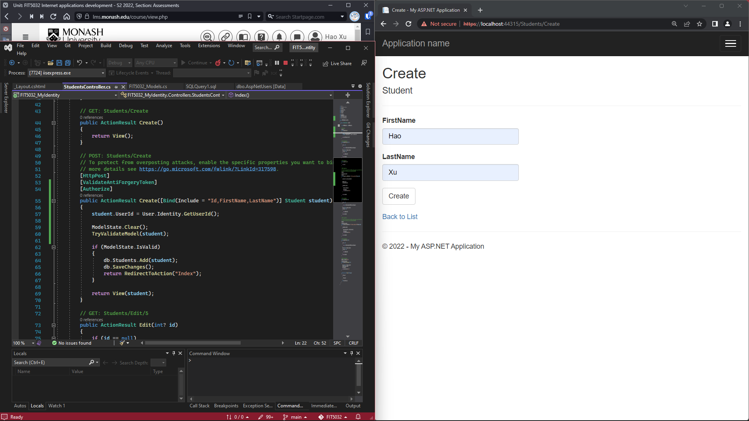

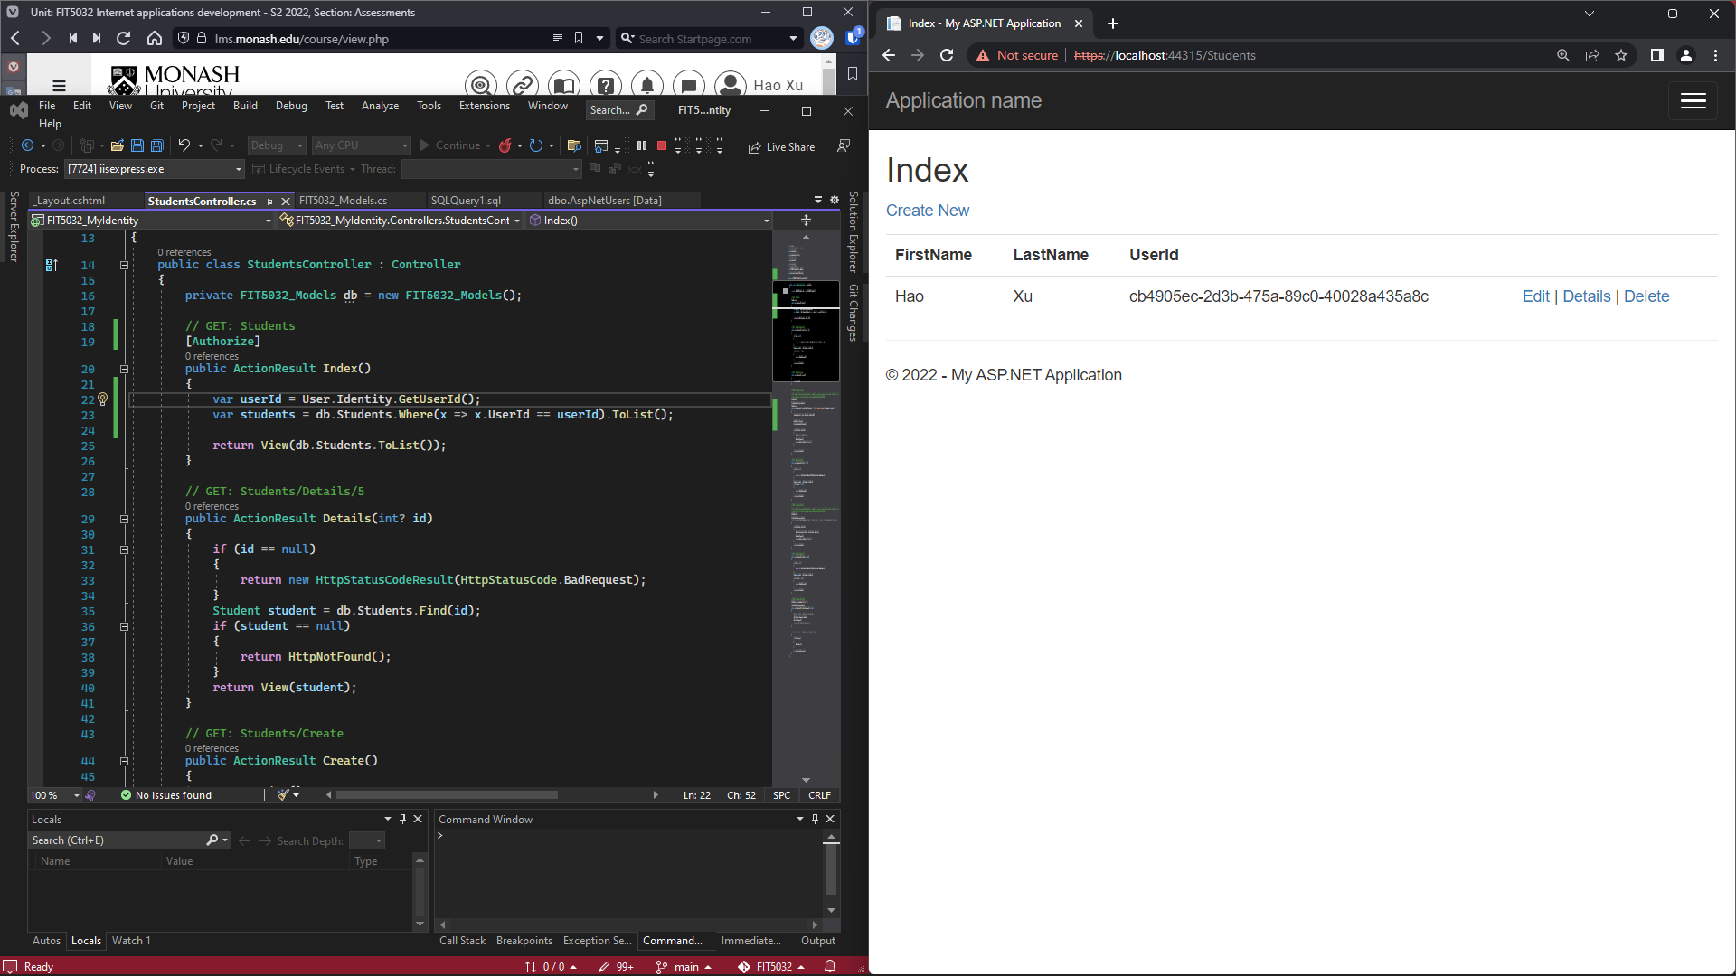

# Task 7.2 (MS Identity with Google Authentication)

**GitHub Link** of “Startup.Auth.cs” file: <https://github.com/BrantleyXU/FIT5032/blob/main/week07/FIT5032_MyIdentity/FIT5032_MyIdentity/App_Start/Startup.Auth.cs>

The following screenshots show that Google Authentication is successfully integrated with the application. Accounts registration can be done via Google Authentication. The “Startup.Auth.cs” file is also shown in the screenshots.

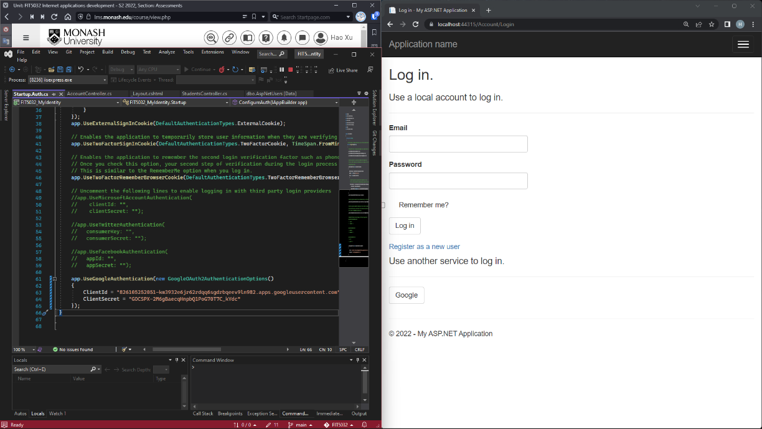

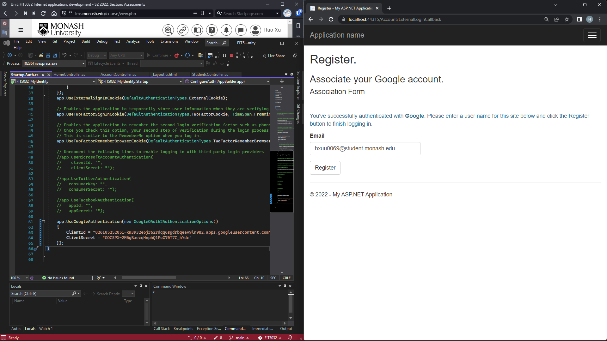

The following screenshots show that the list of students and students’ details.

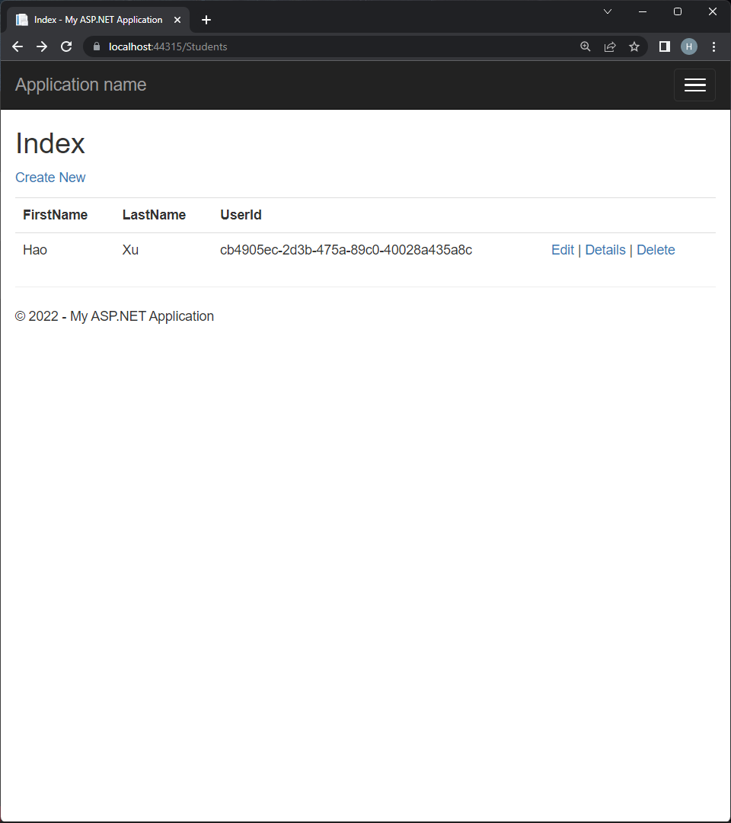 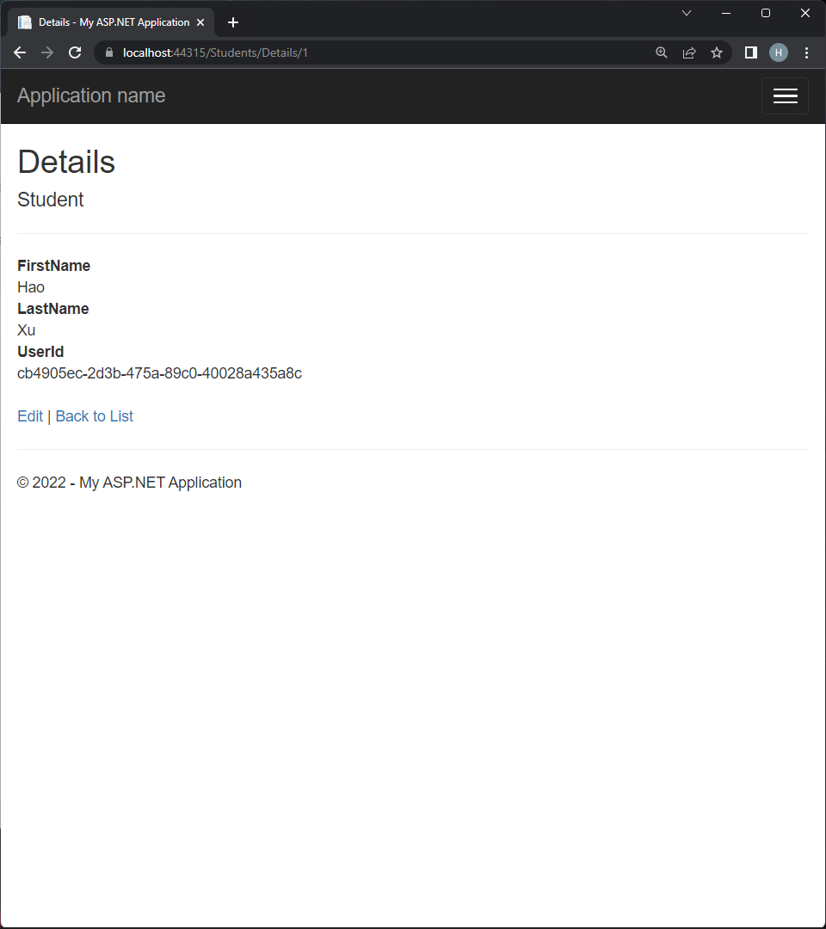

The following screenshot shows that the codes of student controller and student model.

