Fortnightly eFolio Submission – Studio 8

# Student Name and ID

Hao Xu (32767919)

# Self-Evaluation

High Distinction

# Task 8.1 (SendGrid API)

**GitHub Link** of “EmailSender.cs” file: <https://github.com/BrantleyXU/FIT5032/blob/main/week08/FIT5032_Week08A/FIT5032_Week08A/Utils/EmailSender.cs>

The following screenshot shows that SendGrid API can work well, integrated with .NET application. There are some deliverables are rejected by Google email server, maybe because they are somehow considered as “junk emails” by Google. Outlook.com does not regard emails from SendGrid as “junk emails”, so they can be received correctly.

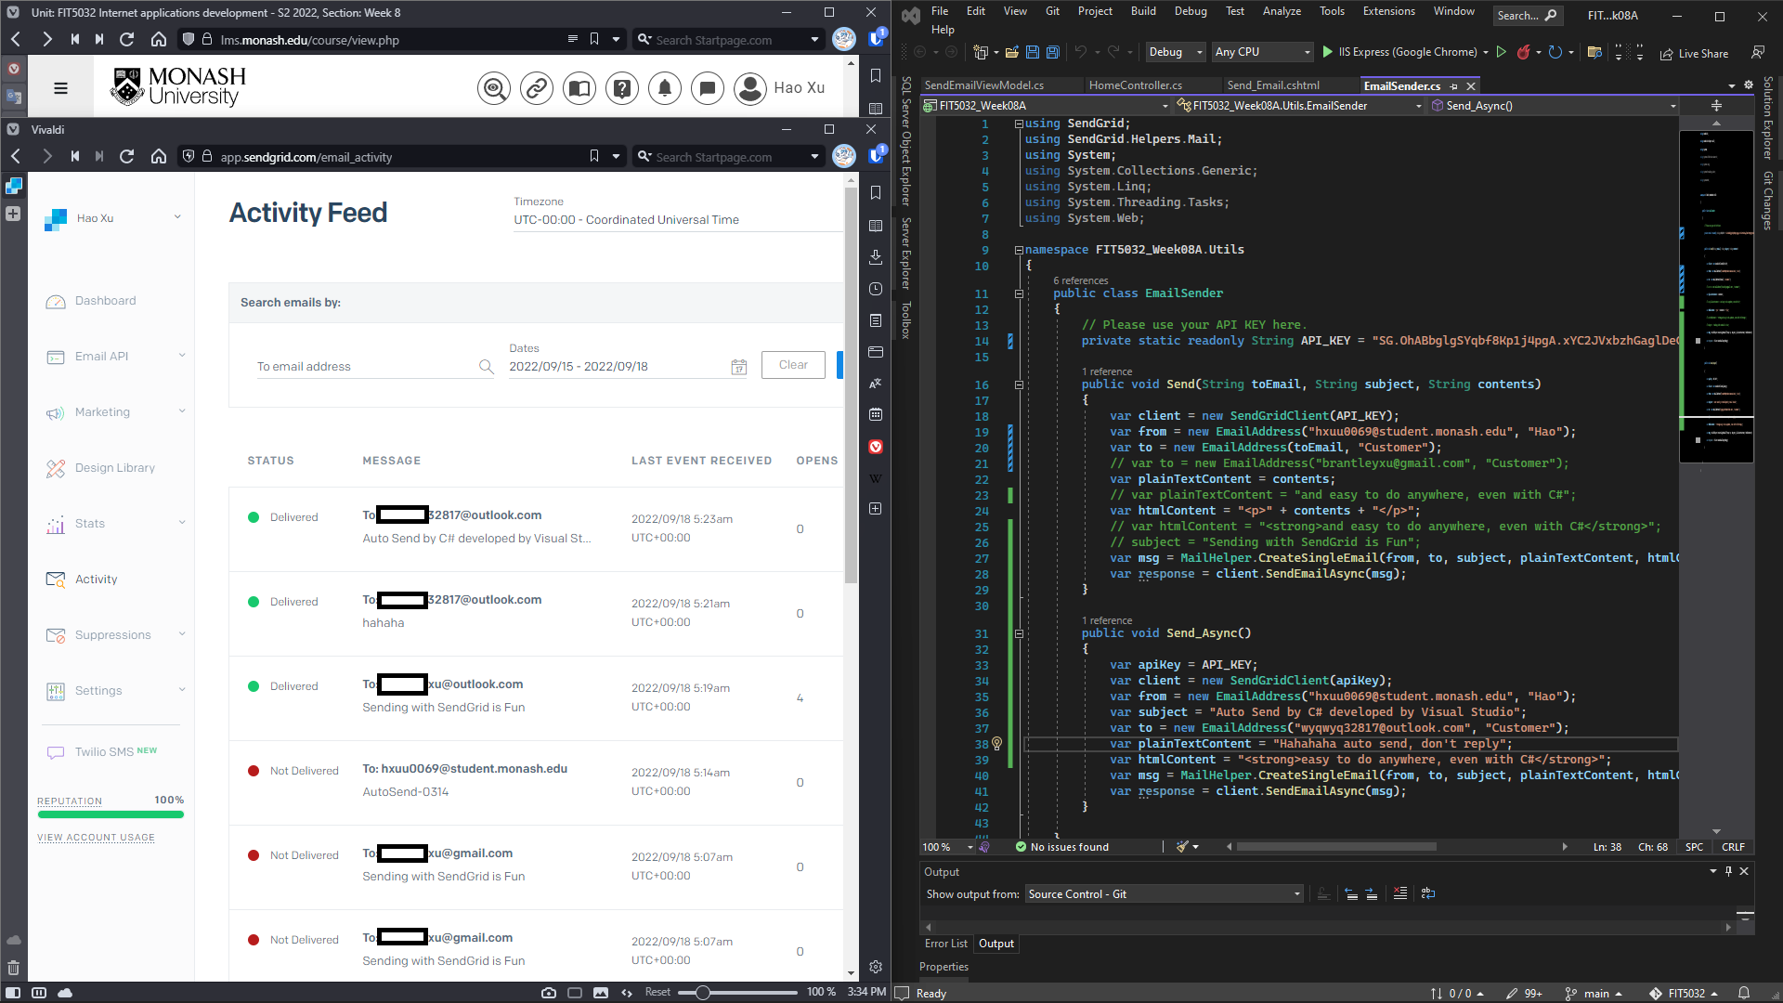

# Task 8.2 (Pros and Cons of Using 3rd Party Emailing Tool)

Advantages:

1. Efficiency Improvement of application development process: by using 3rd party emailing tool, developers do not need to focus on building their own emailing logic. They could use mature application instead. They can focus on their own business requirements.

2. Payment for Needed: When using 3rd party emailing tool, DevOps just pay a monthly fee for the used limit instead of paying a high fee for hardware, software, and every other thing from scratch.

3. Easy Integration: compared to “reinvent wheel”, using 3rd party tools is easier to implement.

Disadvantages:

1. Vendor lock-in: If developers sign a contract with a vendor, however, they are not satisfied with the 3rd party solution, it may be hard to migrate to another solution immediately, because of the vendor lock-in.

2. Security and Privacy Concern: since the 3rd party emailing tool is sending emails representing you, it may cause security and privacy issues.

References:

Janus, J., Chojnacki, M., & Szwajkiewicz, W. (2020, December 23). Pros and Cons of Using Third-Party Software in Your App Development. *Droids On Roids*. <https://www.thedroidsonroids.com/blog/third-party-software-pros-and-cons>

Karkovack E. (2020, August 19). The Pros and Cons of Building Websites with Third-Party Products. *Specky Boy*. <https://speckyboy.com/pros-cons-building-websites-third-party-products/>