Fortnightly eFolio Submission – Studio 9

# Student Name and ID

Hao Xu (32767919)

# Self-Evaluation

High Distinction

# Task 9.1 (Responsive Images and Web Fonts)

## Demonstration of Responsive Images

**GitHub Link**: <https://github.com/BrantleyXU/FIT5032/tree/main/week09/FIT5032_ResponsiveImage>

The following screenshots show a demonstration of using responsive images. At the right side of screenshots, the codes to achieve the responsive image are shown. In Figure 1, the 100 px image is used since the width of the screen is 220. In Figure 2, the 240 px image is used since the width of the screen is 380. In Figure 3, the 480 px image is used since the width of the screen is 620. The chosen image is based on the width of the screen which achieve responsiveness.

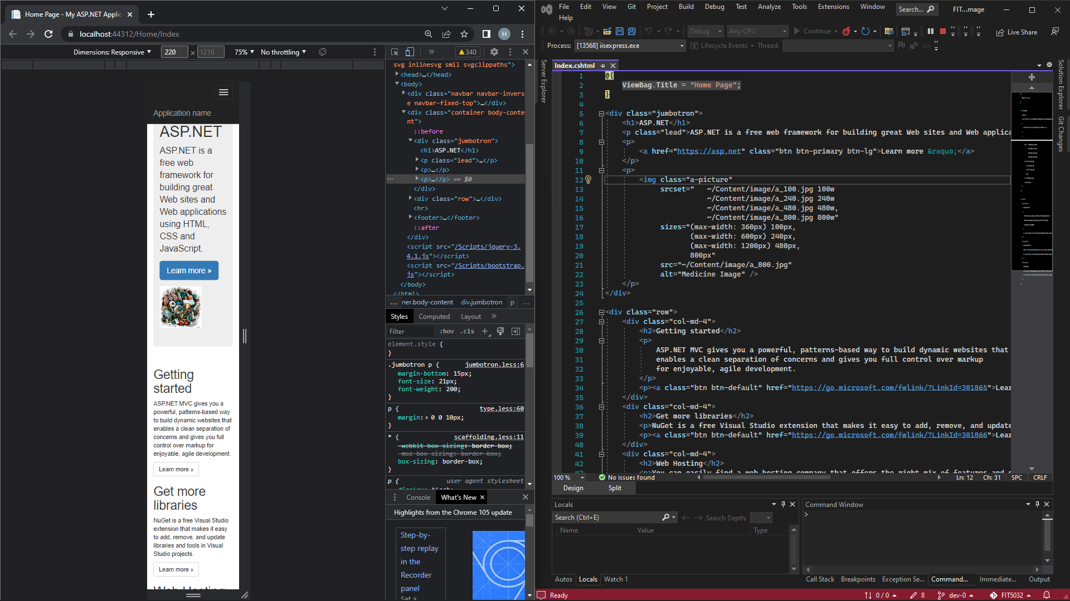

Figure 1: width = 220

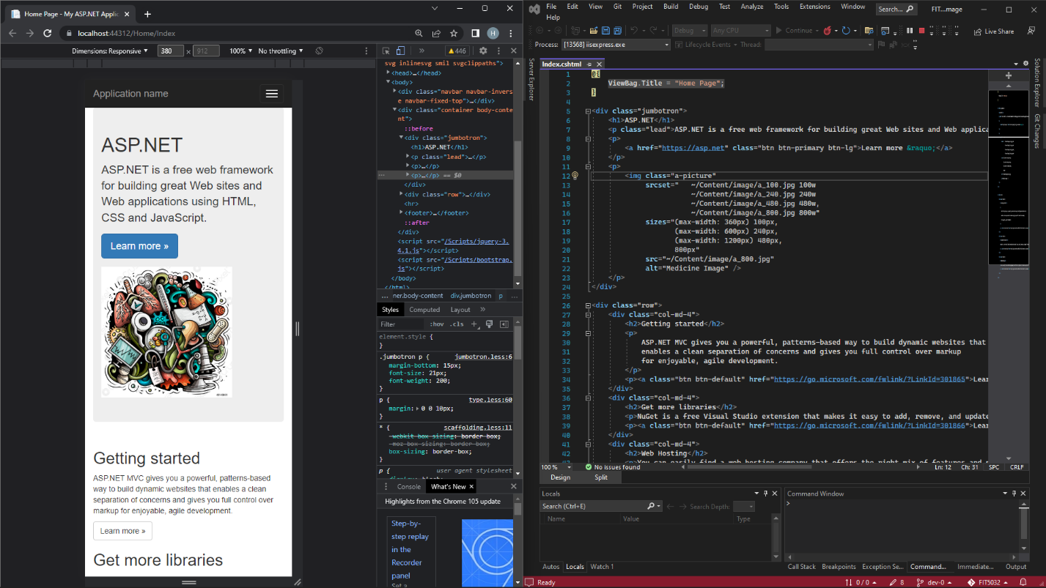

Figure 2: width = 380

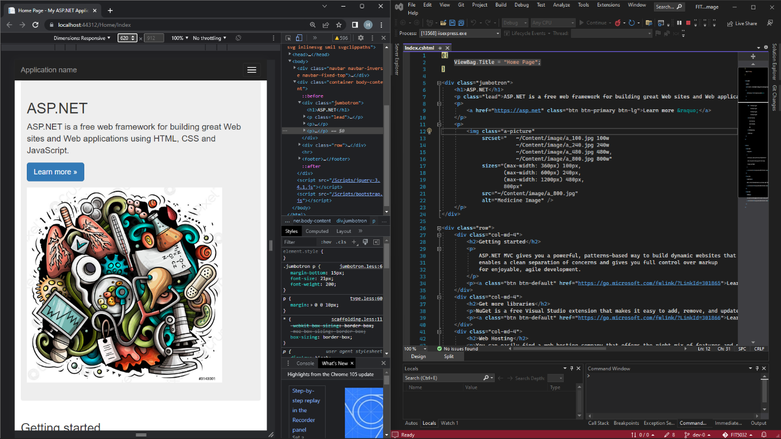

Figure 3: width = 620

## Web Fonts (Difference between WOFF and WOFF2)

1. **Web Open Font Format (WOFF)** was developed in 2009 by Mozilla and other organizations. **Web Open Font Format 2 (WOFF2)** is an update to the original WOFF format, developed by Google.

2. Both compress the files compared to traditional TrueType (TTF) or OpenType (EOF) file types, however WOFF2 compression format offers a 30% average gain compared to WOFF (Pandey, 2018).

3. Both are supported by modern browsers (Blancpain, 2018). Since WOFF2 is a recommended upgrade of WOFF, WOFF2 is not supported by browsers as widely as WOFF.

# Task 9.2 (.NET Core)

## ASP.NET Core New features

1. ASP.NET is a cross-platform web framework, completely rewriting the .NET Framework to work with .NET 6, to build web applications.

2. A new “csproj” file is in .NET Core, which contains a list of files in the project, along with the references to system assemblies.

3. There are some updated namespaces. For example, “Microsoft.AspNetCore” updates “System.Web”.

## Difference between the ASP.NET Core and ASP.NET Framework (GeeksforGeeks, 2022):

1. Application scope: .NET Core focuses on web, windows mobile and windows store application development. However, .NET Framework could be used to develop both desktop and web applications.

2. Platform Compatibility: .NET Core is cross-platform, compatible with Windows, Linux and Mac OS. However, .NET Framework is only compatible with Windows.

3. Micro-services: Both support REST API services. However, only .NET Core supports development and implementation of micro-services.

# References

Blancpain, T. (2018, February 23). Understanding Web Fonts and Getting the Most Out of Them. *CSS-TRICKS*. <https://css-tricks.com/understanding-web-fonts-getting/>

GeeksforGeeks. (2022, June 02). Differences Between .NET Core and .NET Framework. *GeeksforGeeks*. <https://www.geeksforgeeks.org/differences-between-net-core-and-net-framework/>

Pandey, A. (2018, December 11). Understanding of Font Formats: TTF, OTF, WOFF, EOT & SVG. *Medium*. <https://medium.com/@aitareydesign/understanding-of-font-formats-ttf-otf-woff-eot-svg-e55e00a1ef2>