Fortnightly eFolio Submission – Studio 11

# Student Name and ID

Hao Xu (32767919)

# Self-Evaluation

High Distinction

# GitHub Link

I use the same application to show Azure Cloud Deployment and Unit Testing tasks.

<https://github.com/BrantleyXU/FIT5032/tree/main/week11/FIT5032_W11APP>

# Task 11.1 (Difference between CI and CD, and Azure Cloud Deployment)

## Difference between the Continuous Integration and Continuous Deployment

CI/CD usually refers to a continuous pipeline of software development. They are 3 different phases and/or approaches to mitigate issues during the software development process.

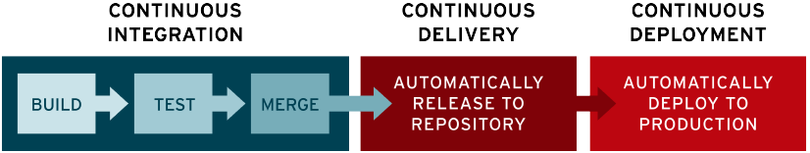

Image Source: <https://www.redhat.com/en/topics/devops/what-is-ci-cd>

CI stands for Continuous Integration, meaning that new code changes are always regularly built, tested and merged into the main branch in the shared repository, which is a good solution for too many branches with respect to a single application development that may produce conflicts with each other (Pittet, n.d.).

CD stands for Continuous Delivery and/or Continuous Deployment, meaning that new changes to the application are always automatically tested, uploaded and released to the repository, and then automatically deployed to the production, which is a good solution for lack of communication and visibility between the development team and business teams, and also a good method to reduce the overloading of operations teams with manual deployment processes which could slow down the application delivery (Red Hat, 2022).

## Azure Cloud Deployment

Application URL: <https://fit5032azureapp.azurewebsites.net>

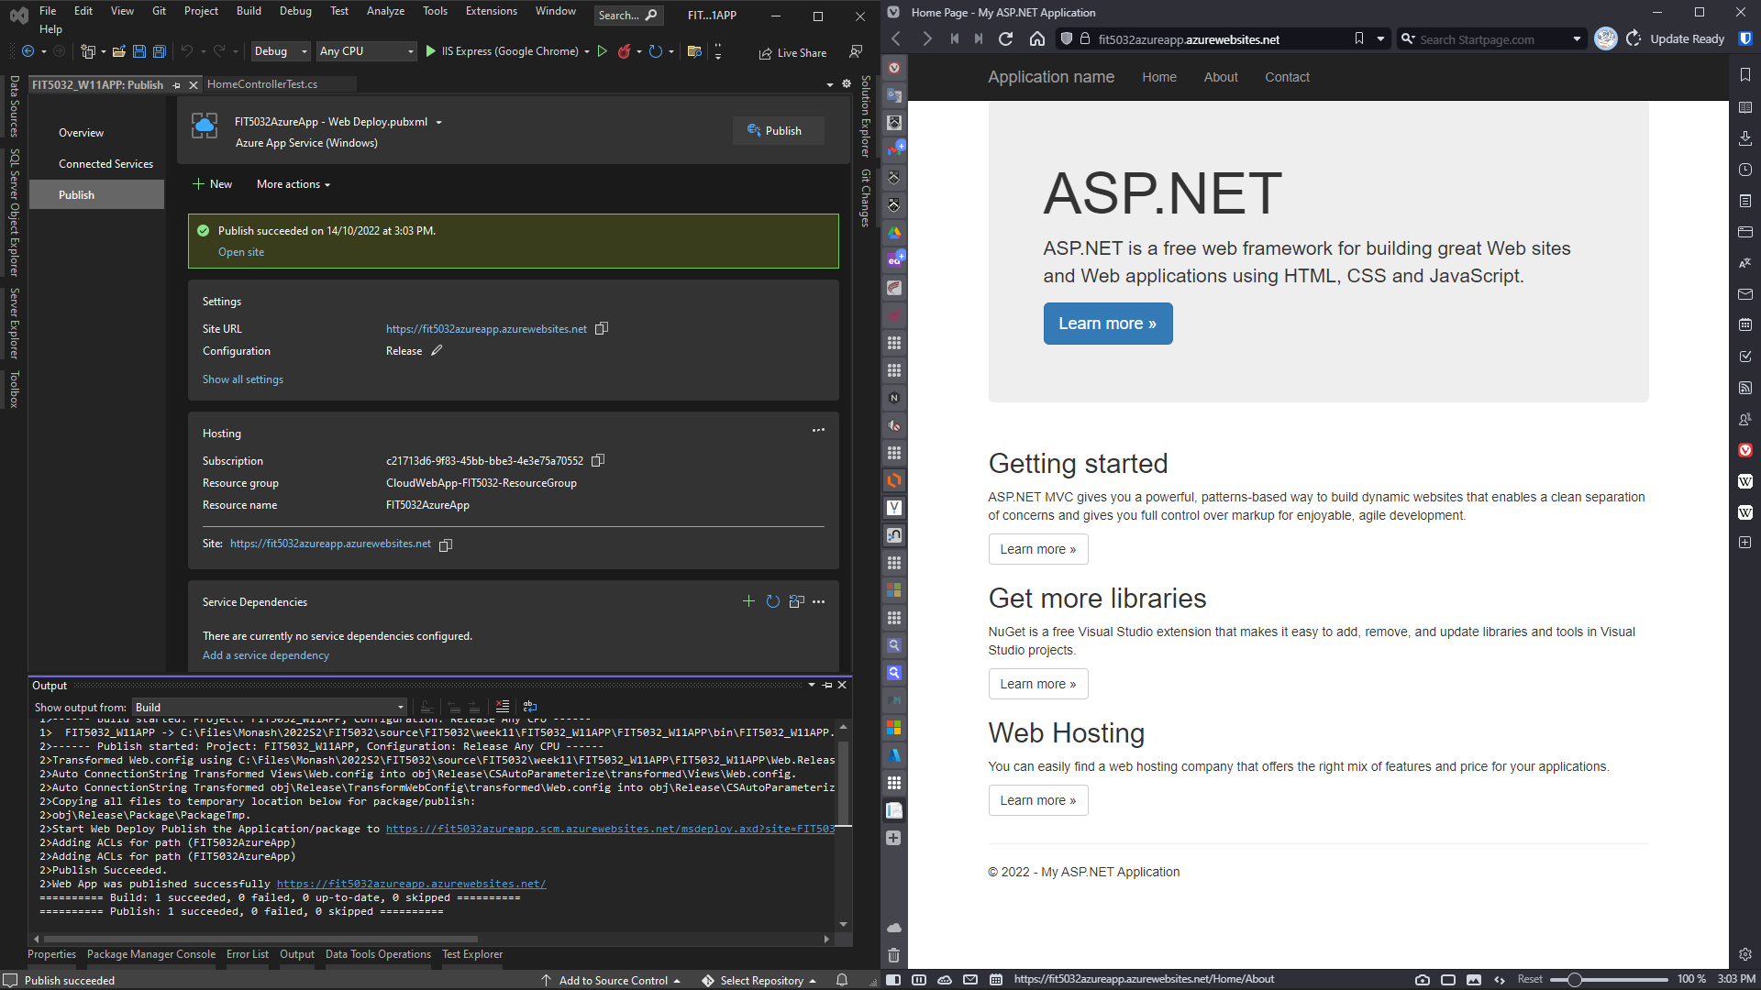

# Task 11.2 (Software Testing Approaches, and Unit Testing in ASP.NET MVC)

## Software Testing Approaches

List of software testing approaches (Educba, n.d.):

1. **model-based test approach**: to select a formal model for critical system behavior.

2. **dynamic test approach**: to find as many as possible defects during test execution.

3. **analytical tests approach**: to use some analytical techniques.

4. **Process or standard-compliant test approach**: to rely on an externally developed approach to test

5. **regression-averse test approach**: to use a set of automated procedures to detect regression defects.

List of software testing types (Pittet, n.d.):

1. **Unit Tests**: to test individual methods, classes, components or modules.

2. **Integration Tests**: to verity that different modules or services could work well together.

3. **Functional Tes**ts: to test business functional requirements are met well in the application.

4. **End-to-end Tests**: to replicate users’ behavior with the software in a complete application environment.

5. **Acceptance Tests**: to formally test and verity if the system satisfies business requirements.

## Unit Testing for ASP.NET MVC

The following screenshot shows the unit test for HomeController.cs in the ASP.NET MVC application.

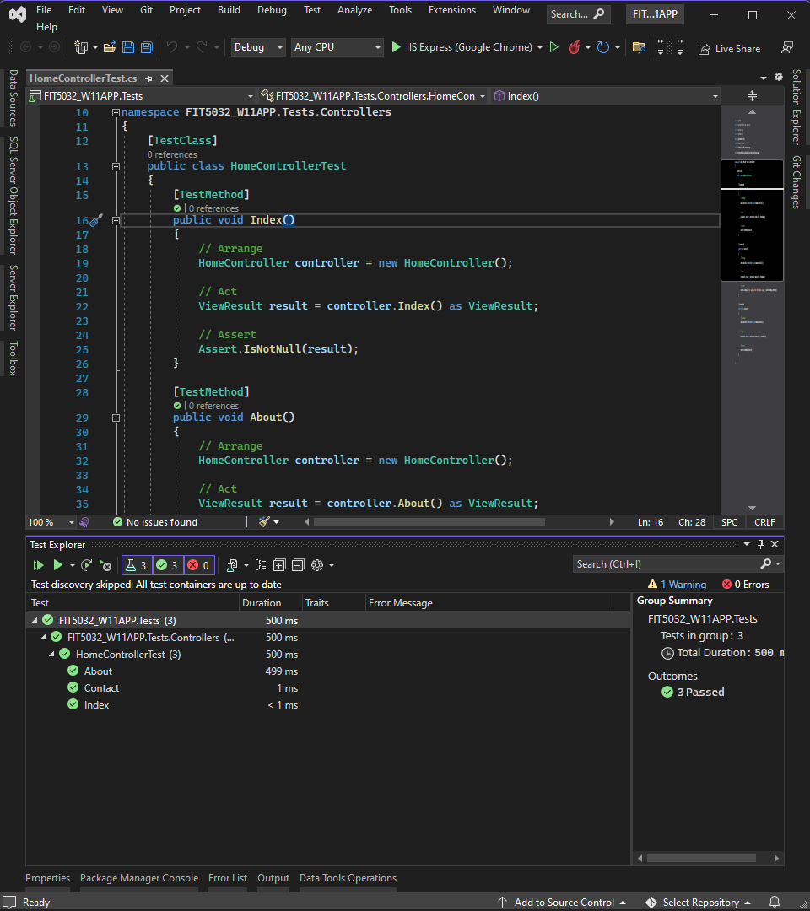

# References

Educba. (n.d.). Test Approaches. *EDUCBA*. <https://www.educba.com/test-approaches/>

Pittet, S. (n.d.). Continuous integration vs. delivery vs. deployment. *ATLASSIAN*. <https://www.atlassian.com/continuous-delivery/principles/continuous-integration-vs-delivery-vs-deployment>

Pittet, S. (n.d.). The different types of software testing. *ATLASSIAN*. <https://www.atlassian.com/continuous-delivery/software-testing/types-of-software-testing>

Red Hat. (2022, May 11). What is CI/CD?. *Red Hat*. <https://www.redhat.com/en/topics/devops/what-is-ci-cd>