TPO TPO 01 task1
Talk about a book you have read that was important to you for some reason. Explain why the book was important to you. Give specific details and examples to explain your answer.
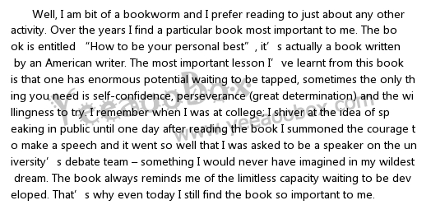
Choose a place you go to often that is important to you and explain why it is important. Please include specific details in your explanation.

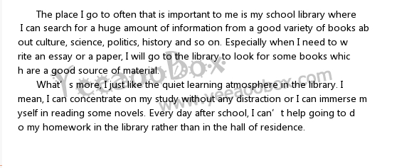
What characteristics do you think make someone a good parent? Explain why these characteristics are important to you.
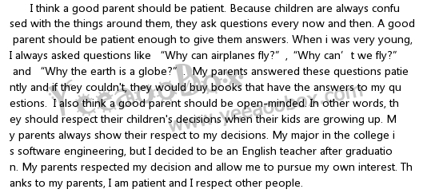
What do you miss most about your home when you are away? Use specific details in your explanation
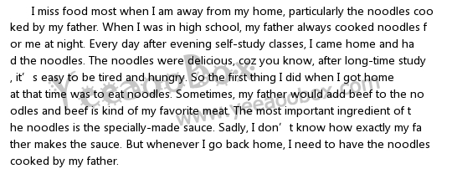
Talk about a place you enjoyed going to or visiting when you were a child. Describe the place. Explain why you enjoyed it.
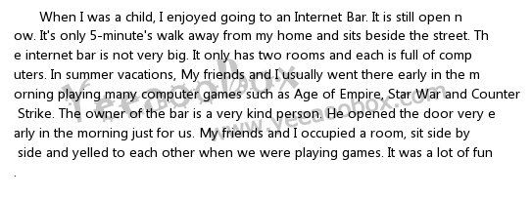
Talk about a photograph or painting you have seen that was memorable. Explain what you liked or disliked about it.
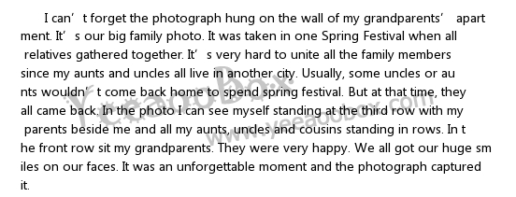
If friends from another country were going to spend time in your country, what city or place would you suggest they visit? Using details and examples, and explain why.
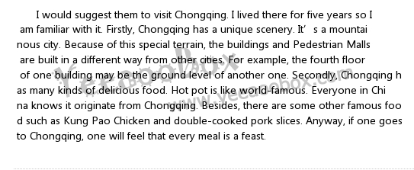
Talk about a time when a friend or family member helped you in the past. Describe how the person helped you. Then explain why this was important to you.

Talk about an important experience that you recently had. Describe what happened and explain why it was important to you.
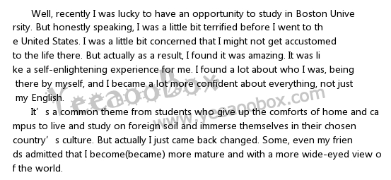
Talk about a time when you accomplished something you did not think you could do. What did you accomplish? Why did you think you could not do it?
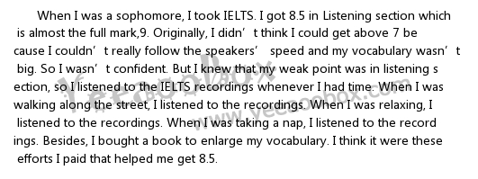
Talk about an interesting book you have read. Explain why you thought the book was interesting. Give specific details and examples to explain your answer

What is the most efficient type of transportation in your country? Explain why you think it is efficient. Include specific reasons or examples.
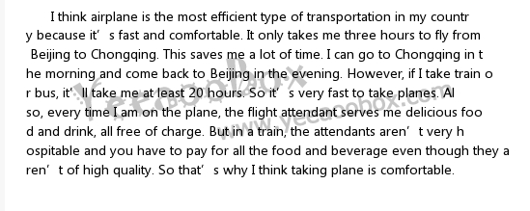
Talk about a game, sport or other group activity that is played in your country. Explain why you think the activity is enjoyable
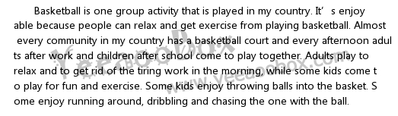
"People enjoy reading many different types of books such as mystery, biography, romance, ets. Of all the different types of books that there are, what type do you most enjoy? Explain why
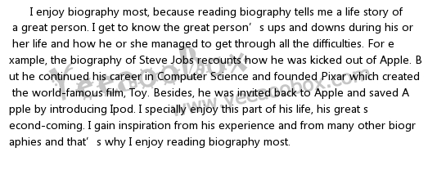
People make friends in many different ways. What do you think is a good way to make new friends? Use specific details and examples in your response.
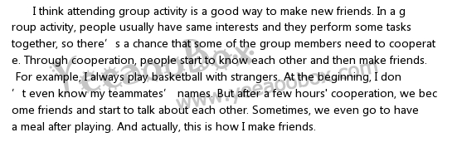
If you could have any job or career you wanted, which would you choose and why? Give specific details to explain your response


Talk about a special opportunity that was given to you. Explain why the opportunity was important.
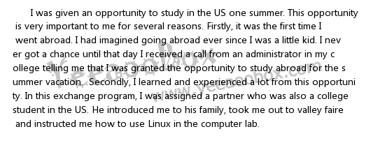
Imagine your life ten years in the future. Talk about one way you think your life will be different in ten years than it is now. Use details to explain your answer.
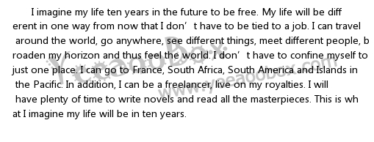
Talk about a skill or ability that you consider especially important for a student to have. Use details and examples to explain your answer.
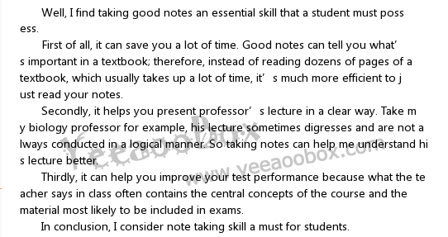
Choose a quality you think makes someone a valuable member of a team. Explain why you think it is an important quality for a team or group member to have.
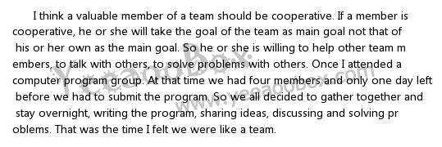
Talk about an important news event that happened recently in your country. Describe the event and explain why it was important
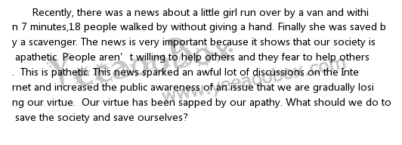
Talk about one way your personality has changed since you were a child. Use examples and details to explain your answer.

There can be several advantages to spending time living in another country. Talk about one advantage and explain how living in another country provides that advantage. Use details and examples in your response.
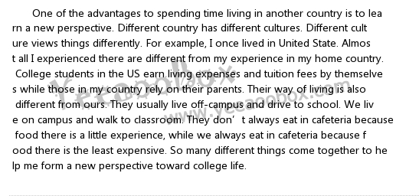
Talk about a popular gathering place in your town where people like to go. Describe the place and explain why people enjoy going there
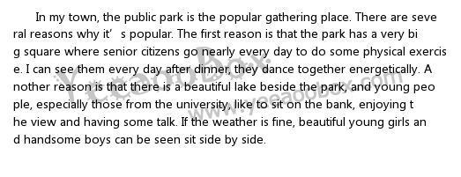
Students often want to get better grades in their classes. Explain what students should do in order to improve their performance in a class

