# AND THE HEAT GOES ON: POLICE REPRESSION AND THE MODALITIES OF POWER

**ONLINE APPENDIX**

1. Exponential Decay Formula

In mathematics, exponential decay describes the process of reducing an amount by a consistent percentage rate over a period of time. It is typically expressed by the formula *y* = *a*(1 *−b*)*t* wherein y is the final amount, *a* is the original amount, *b* is the decay factor, and *t* is the amount of time that has passed. The exponential decay formula is useful in a variety of real world applications, most notably for tracking inventory that’s used regularly in the same quantity (like food for a school cafeteria) and it is especially useful in its ability to quickly assess the long-term cost of use of a product over time. To adapt it to our study, we provide a starting amount *y*0 and an end amount *yf* (zero in our case) at a rate *α*, and the exponential decay is specified as *e−αt*. The decay rate is determined by the inverse road distance to the capital city for each municipality. The formula can be expressed as the following:

*y*(*t*) = *yf* + (*y*0 *− yf* )*e−αt*

1

**Table A.1.** Statistical models

|  |  |  |
| --- | --- | --- |
|  | Model 1 | Model 2 |
| Earthquake Fault Zone | 0*.*8765*∗∗∗* | 0*.*8765*∗∗∗* |
| Time | (0*.*0527) | (0*.*0527)  *−*0*.*0113*∗∗∗*  (0*.*0016) |
| Time2 |  | *−*0*.*0196*∗∗∗* |
| Time3 |  | (0*.*0025)  0*.*0129*∗∗∗* |

(0*.*0017)

R2 0.7682 0.7686

Adj. R2 0.7682 0.7685

|  |  |  |
| --- | --- | --- |
| Num. obs. | 27216 | 27216 |
| F statistic | 90205.6051 | 22592.2279 |
| RMSE | 0.4814 | 0.4811 |

*∗∗∗p <* 0*.*01, *∗∗p <* 0*.*05, *∗p <* 0*.*1. Standard Error Clustered at the Municipal Level.

**Table A.2.** IV Results (2SLS): Police Repression

2SLS 2SLS 2SLS S-2SLS S-2SLS

Infrastructural Damage 0*.*0033*∗∗∗* 0*.*0027*∗∗* 0*.*0027*∗∗* 0*.*0027*∗∗* 0*.*0028*∗∗*

(0*.*0013) (0*.*0013) (0*.*0013) (0*.*0013) (0*.*0013)

Overt Challenges 0*.*1930*∗∗∗* 0*.*1909*∗∗∗* 0*.*1896*∗∗∗* 0*.*1899*∗∗∗* 0*.*1896*∗∗∗*

(0*.*0226) (0*.*0215) (0*.*0215) (0*.*0215) (0*.*0215)

Mobilization Activities 0*.*0361*∗* 0*.*0355*∗* 0*.*0354*∗* 0*.*0354*∗* 0*.*0354*∗*

(0*.*0210) (0*.*0208) (0*.*0207) (0*.*0207) (0*.*0207)

Campaign Activities 0*.*0245*∗∗∗* 0*.*0236*∗∗∗* 0*.*0236*∗∗∗* 0*.*0236*∗∗∗* 0*.*0236*∗∗∗*

(0*.*0027) (0*.*0027) (0*.*0027) (0*.*0027) (0*.*0027)

Insurgent Violence 0*.*0884*∗∗∗* 0*.*0889*∗∗∗* 0*.*0881*∗∗∗* 0*.*0882*∗∗∗* 0*.*0882*∗∗∗*

*− − − − −*

(0*.*0231) (0*.*0220) (0*.*0220) (0*.*0220) (0*.*0220)

Ln Population 0*.*0076*∗∗∗* 0*.*0071*∗∗∗* 0*.*0071*∗∗∗* 0*.*0071*∗∗∗* 0*.*0071*∗∗∗*

(0*.*0017) (0*.*0016) (0*.*0016) (0*.*0016) (0*.*0016)

HQ Location 0*.*0051*∗∗∗* 0*.*0051*∗∗∗* 0*.*0051*∗∗∗* 0*.*0051*∗∗∗* (0*.*0016) (0*.*0016) (0*.*0016) (0*.*0016)

HQ Distance 0*.*0025*∗∗∗* 0*.*0022*∗∗* 0*.*0022*∗∗* 0*.*0023*∗∗* (0*.*0009) (0*.*0009) (0*.*0009) (0*.*0009)

Democratic Inclusion 0*.*0149*∗∗∗* 0*.*0128*∗∗∗* 0*.*0132*∗∗∗* 0*.*0095*∗∗∗* (0*.*0017) (0*.*0016) (0*.*0018) (0*.*0029)

*− − − −*

Spatial Lag 0*.*0053*∗∗∗* 0*.*0043*∗∗* 0*.*0037*∗∗* (0*.*0014) (0*.*0018) (0*.*0018)

Time 0*.*0564*∗∗∗*

*−*

(0*.*0106)

Time2 0*.*1323*∗∗∗*

(0*.*0274)

Time3 0*.*0725*∗∗∗*

*−*

(0*.*0177)

R2 0.4964 0.5053 0.5061 0.5061 0.5068

Adj. R2 0.4963 0.5051 0.5059 0.5059 0.5066

Num. obs. 27216 27216 27216 27216 27216

F statistic 155.1843 152.8317 139.6139 140.5551 133.2011

RMSE 0.1177 0.1166 0.1165 0.1166 0.1165

N Clusters 324 324 324 324 324

*∗∗∗p <* 0*.*01, *∗∗p <* 0*.*05, *∗p <* 0*.*1. Standard Error Clustered at the Municipal Level.

**Table A.3.** IV Results (2SLS): Police Repression (Year FE)

2SLS 2SLS 2SLS S-2SLS

Infrastructural Damage 0*.*0033*∗∗* 0*.*0027*∗∗* 0*.*0027*∗∗* 0*.*0028*∗∗*

(0*.*0013) (0*.*0013) (0*.*0013) (0*.*0013)

Overt Challenges 0*.*1925*∗∗∗* 0*.*1910*∗∗∗* 0*.*1900*∗∗∗* 0*.*1902*∗∗∗*

(0*.*0220) (0*.*0216) (0*.*0217) (0*.*0217)

Mobilization Activities 0*.*0356*∗* 0*.*0354*∗* 0*.*0354*∗* 0*.*0354*∗*

(0*.*0207) (0*.*0207) (0*.*0207) (0*.*0207)

Campaign Activities 0*.*0237*∗∗∗* 0*.*0235*∗∗∗* 0*.*0235*∗∗∗* 0*.*0235*∗∗∗*

(0*.*0027) (0*.*0027) (0*.*0027) (0*.*0027)

Insurgent Violence 0*.*0910*∗∗∗* 0*.*0896*∗∗∗* 0*.*0888*∗∗∗* 0*.*0890*∗∗∗*

*− − − −*

(0*.*0225) (0*.*0222) (0*.*0222) (0*.*0222)

Ln Population 0*.*0079*∗∗∗* 0*.*0072*∗∗∗* 0*.*0072*∗∗∗* 0*.*0072*∗∗∗*

(0*.*0017) (0*.*0016) (0*.*0016) (0*.*0016)

HQ Location 0*.*0051*∗∗∗* 0*.*0051*∗∗∗* 0*.*0051*∗∗∗* (0*.*0016) (0*.*0016) (0*.*0016)

HQ Distance 0*.*0025*∗∗∗* 0*.*0023*∗∗* 0*.*0023*∗∗∗* (0*.*0009) (0*.*0009) (0*.*0009)

Spatial Lag 0*.*0043*∗∗∗* 0*.*0031*∗*

(0*.*0013) (0*.*0018)

Year FE Yes Yes Yes Yes

R2 0.5057 0.5067 0.5073 0.5072

Adj. R2 0.5055 0.5065 0.5070 0.5070

Num. obs. 27216 27216 27216 27216

RMSE 0.1166 0.1165 0.1164 0.1164

N Clusters 324 324 324 324

*∗∗∗p <* 0*.*01, *∗∗p <* 0*.*05, *∗p <* 0*.*1. Standard Error Clustered at the Municipal Level.

**Table A.4.** IV Results (2SLS): Police Repression (Interactive Effect)

|  |  |  |  |
| --- | --- | --- | --- |
| 2SLS | 2SLS | 2SLS | S-2SLS |
| Dissent x Infrastructural Damage 0*.*0413 | 0*.*0336 | 0*.*0510 | 0*.*0147*∗∗* |
| (0*.*2204) | (0*.*4990) | (0*.*7517) | (0*.*0064) |
| Infrastructural Damage *−*0*.*0019  (0*.*0106)  Dissent 0*.*0130  (0*.*9871)  Ln Population 0*.*0001  (0*.*0657)  HQ Location HQ Distance  Democratic Inclusion  Spatial Lag | *−*0*.*0015  (0*.*0231)  0*.*0423  (2*.*1968)  *−*0*.*0023  (0*.*2046)  0*.*0462  (0*.*3213)  *−*0*.*0099  (0*.*3908)  *−*0*.*0102  (0*.*0901) | *−*0*.*0023  (0*.*0347)  *−*0*.*0350  (3*.*3063)  *−*0*.*0095  (0*.*3075)  0*.*0572  (0*.*4843)  *−*0*.*0266  (0*.*5780)  *−*0*.*0046  (0*.*1277)  0*.*0931  (0*.*2986) | *−*0*.*0006*∗∗* (0*.*0003) 0*.*1239*∗* (0*.*0708)  0*.*0053  (0*.*0032)  0*.*0338*∗∗∗* (0*.*0125)  0*.*0010  (0*.*0080)  *−*0*.*0104*∗∗∗*  (0*.*0019)  0*.*1202*∗∗∗* (0*.*0398) |
| R2 *−*2*.*4621 | *−*1*.*3878 | *−*4*.*1459 | 0*.*1684 |

Adj. R2 *−*2*.*4626 *−*1*.*3884 *−*4*.*1474 0*.*1681

Num. obs. 27216 27216 27216 27216

F statistic 8*.*8399 17*.*0962 10*.*1614 39*.*0547

RMSE 0*.*3085 0*.*2563 0*.*3762 0*.*1512

N Clusters 324 324 324 324

*∗∗∗p <* 0*.*01; *∗∗p <* 0*.*05; *∗p <* 0*.*1. Standard Error Clustered at the Municipal Level.

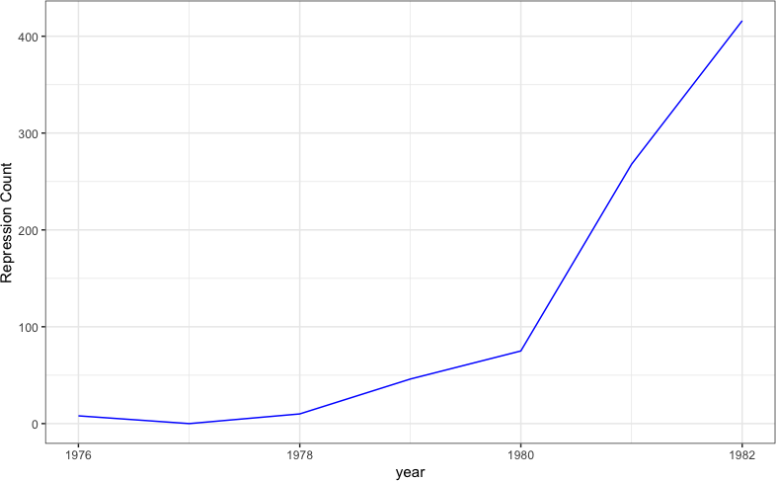**Figure A.1.** The number of Police Violence Events Over Time

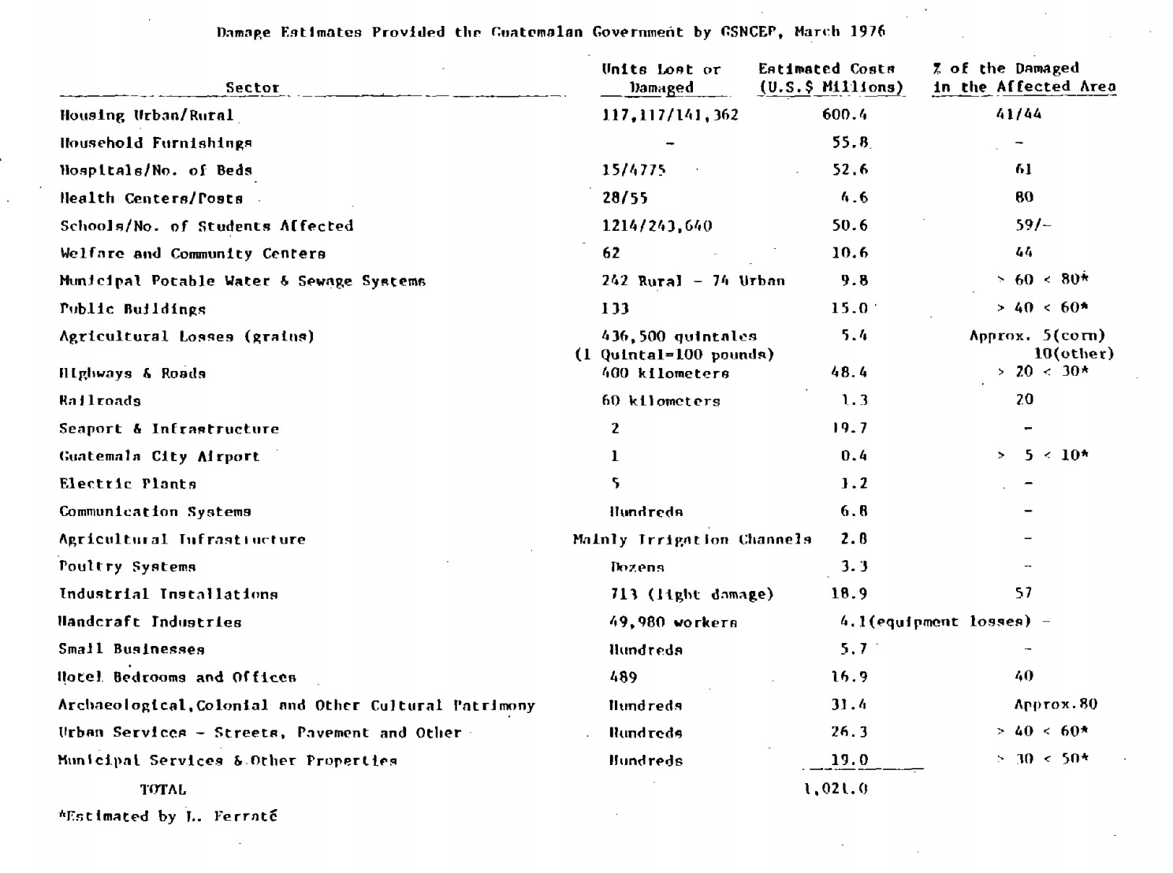**Figure A.2.** The Report on Types of Earthquake Damage