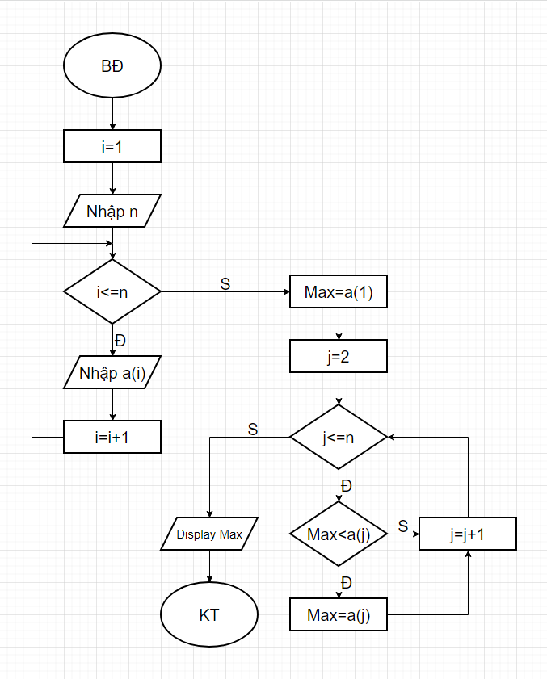Begin

Input i=1

Input n

While i<=n

Do

Input a(i)

I=i+1

End do

Input Max=a(1)

Input j=2

While j<=n

Do

If a(j)>Max then Max=a(j)

End if

j=j+1

end do

Display Max

End