**HO CHI MINH INTERNATIONAL UNIVERSITY UNIVERSITY OF SCIENCE**





**LAB1: HOMEPAGE**

**Introduce Software Engineering**

**Lecture:** **Nguyen Minh Huy**

**Ho Tuan Thanh**

**Nguyen Le Hoang Dung**

**Class: 20CLC10**

Ho Chi Minh, June 24th 2022

## Table of Contents

1. **Information:** .................................................................................................................................................... 3
2. **The picture of login page:** ....................................................................................................................... 3
3. **The picture of commit on github:** ..................................................................................................... 7
4. **References:** ....................................................................................................................................................... 7

1. **Introduction**

|  |  |
| --- | --- |
| **Name** | Pham Anh Hao |
| **MSSV** | 20127155 |
| **Role** | Front-end |
| **Framework** | React |
| **Tutorial** | Homepage |
| **Link Github** | https://github.com/haomapu/SE-Project-Bookaholic.git |
| **Account’s name** | haomapu |

1. **Content**
2. **Demo**



**Top bar**



**Header picture**

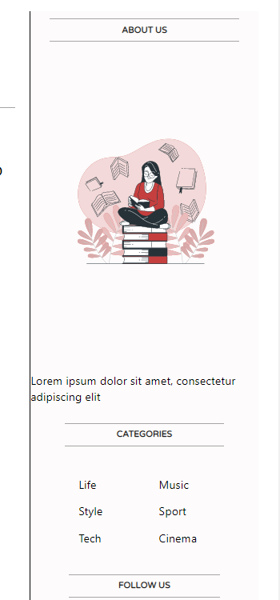

**Sidebar**

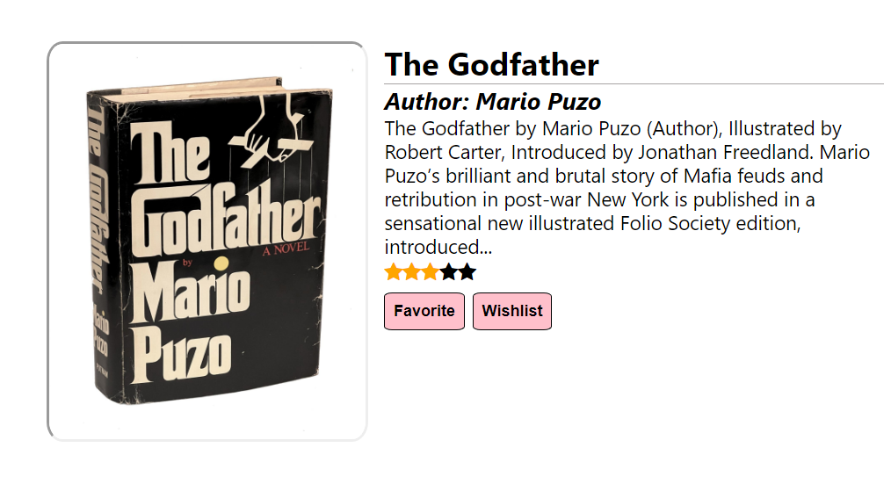

**Book picture, description, favorite, wishlist, and rating**

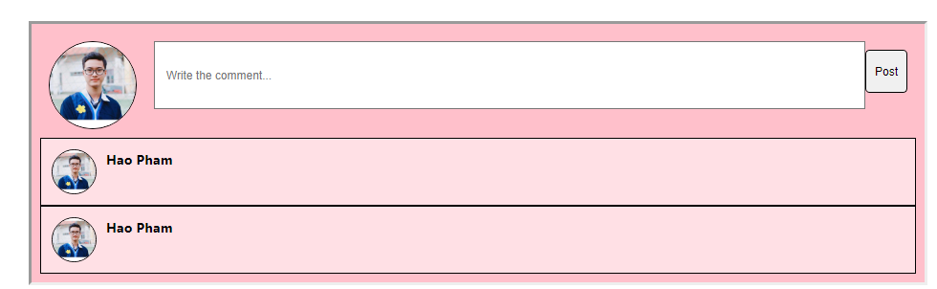

**Comments**

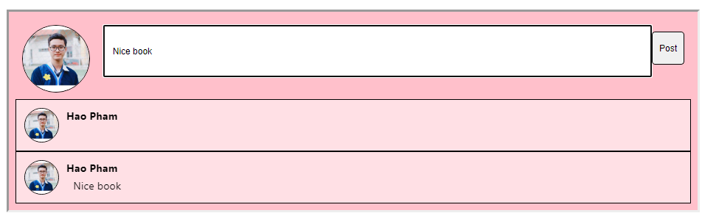

**Error when comments (will fix later)**

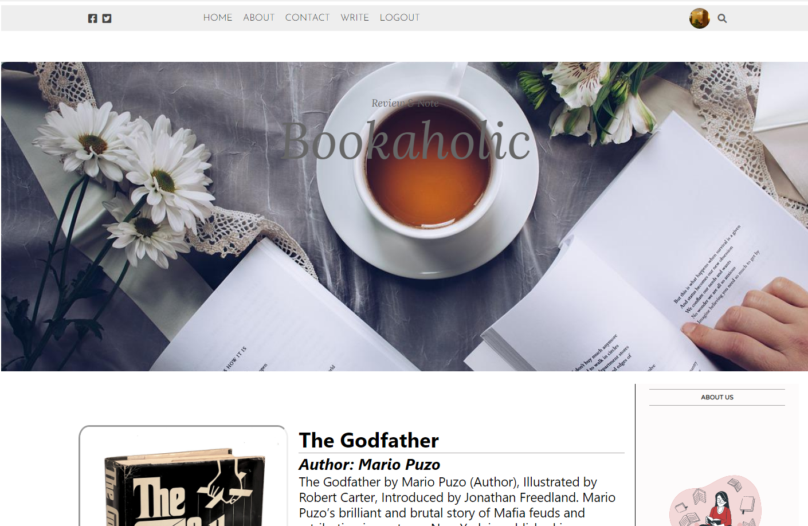

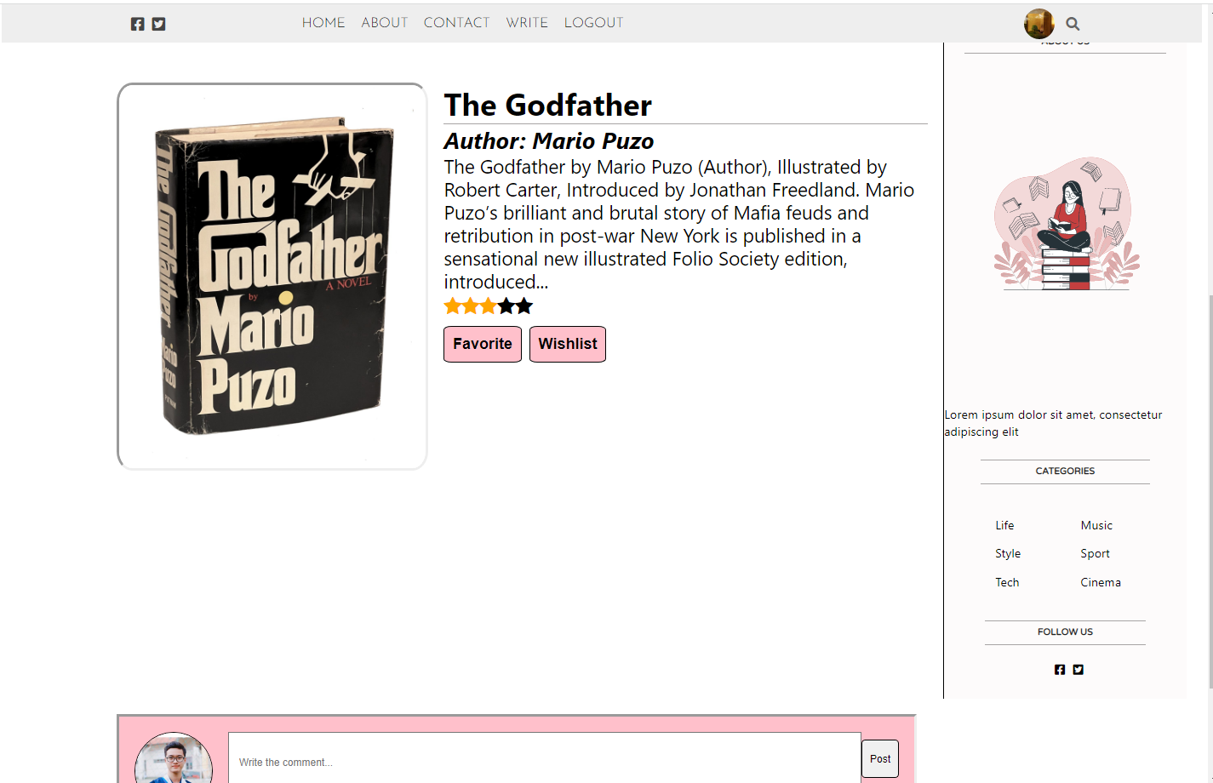

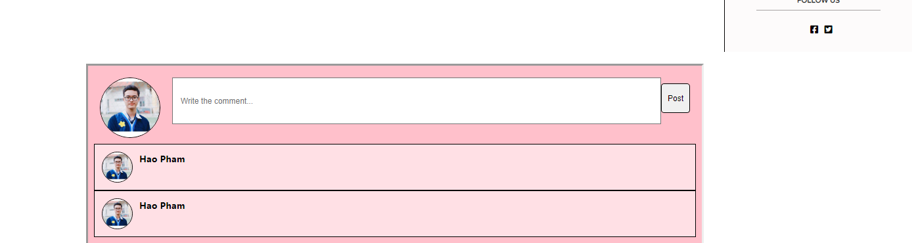

Overall

1. **Github commits**
2. **References**