Affect as a Dynamical System:
A Control-Theoretic N-of-1 Self-Experiment
Miura Meng
May 2026

Abstract
This study applies a control-theoretic framework to the intensive longitudinal self-study of affective dynamics in a single individual. Over a 70-day protocol, momentary emotional valence, perceived agency, and metacognitive awareness were sampled three times daily via ecological momentary assessment (195 observations, 92.9% compliance). A discrete external perturbation, nightly 3 mg melatonin administration, was introduced according to a pre-generated randomized schedule. The pre-specified 70-day schedule contained 35 active and 35 control protocol days; calendar-date aggregation yielded 35 control and 36 melatonin daily aggregates. The individual was modeled as a dynamical system, and melatonin was treated not as a candidate treatment but as a probe of known presence and absence, applied to characterize the system’s response function. Three nested autoregressive models, a local-level state-space (Kalman) model, impulse response analysis, incremental R² decomposition, conditional heteroskedasticity modeling, and a metacontrol interaction test were used to estimate the contributions of internal behavioral drivers and the external probe to daily mood. Internal drivers (agency and metacognitive awareness) jointly accounted for 51.6% of the daily-mood variance over and above an AR(1) baseline (β_agency = 0.54, p < .001; β_metacog = 0.44, p < .001), while melatonin explained effectively no unique variance and contributed negligibly to mean-level mood variation (Δ = +1.03 on a 0–100 scale, d = 0.19, p = .44). A heteroskedasticity analysis suggested smaller residual variance on melatonin days (α₁ = −1.21, p = .044), a pattern compatible with melatonin’s known chronobiotic rather than antidepressant function. The metacontrol interaction was direction-consistent but underpowered (β = −0.14, p = .54). At the individual level, day-to-day affective dynamics were organized primarily by internal self-regulatory drivers; the external probe identified a sensitivity boundary rather than signaling an absence of evidence.

1. Introduction

1.1 The Problem with Average-Centered Behavioral Science
Conventional behavioral intervention research operates by averaging treatment effects across samples. The implicit assumption is that an individual’s response is a noisy realization of a population-level signal, recoverable by aggregating across persons. This logic underwrites randomized controlled trials, between-subject experiments, and effect-size syntheses. As an inferential strategy for population claims, it is sound.
It fails at the level of the individual. A person is not a sample from a population but a system with its own organizational logic, dynamic parameters, and sensitivity boundaries. Aggregated treatment effects, however statistically robust at the group level, cannot answer the question that matters most to any given individual: how does my system respond? Molenaar (2004) and Molenaar and Campbell (2009) have argued that group-level estimates are not generally informative about individual-level processes unless strong ergodicity assumptions hold—assumptions that, in the domain of affect, almost never do.
The present study departs from the average-centered tradition. It adopts the logic of personal science (Myin-Germeys & Kuppens, 2022) and idiographic behavioral science (Molenaar, 2004), treating a single individual as the unit of analysis—not a proxy for a group, but a system in its own right. The aim is not to generalize across persons; it is to characterize the structure of one person’s affective dynamics with the same formal precision that group-level work brings to population-level inference.

1.2 Intervention as Perturbation
Standard intervention logic treats external inputs as levers: pull the lever, observe the outcome. The framing assumes the system is passive—that it transmits the input without transformation—and effect sizes are read as estimates of the lever’s causal force.
Dynamical systems theory offers a different account, articulated in the affect literature over the past two decades. In a complex, self-organizing system, an external input does not simply cause an output; it perturbs the system, which then responds according to its own internal structure—inertia, attractor states, sensitivity to inputs of particular magnitude and timing (Bringmann et al., 2013; Hamaker, 2012; Wichers, 2014). The response is therefore informative not primarily about the perturbation, but about the system itself. The input becomes a probe of system response—a means of estimating an underlying transfer function rather than of demonstrating an effect.
This conception has empirical specificity. Affective dynamics research has documented that day-to-day variation in mood is partially organized by autoregressive carryover, often termed emotional inertia (Houben, Van Den Noortgate, & Kuppens, 2015; Koval & Kuppens, 2012; Kuppens, Allen, & Sheeber, 2010). Higher inertia is associated with reduced responsiveness to environmental input and with markers of psychological maladjustment; the capacity of a system to be perturbed is itself a meaningful individual-level variable. Critical-fluctuation studies have further shown that meaningful change in mood is often preceded by detectable shifts in the system’s variability structure rather than its mean level (Olthof et al., 2020). What an external input does to the system is therefore a more nuanced empirical question than “mean shift,” and intensive longitudinal designs are well-suited to making these distinctions.
This reframing carries a methodological consequence: a non-significant intervention effect is not a design failure. The conventional reading—that the design lacks power to reject the null—presupposes a hypothesis-testing framework in which the intervention is a treatment whose efficacy is being assayed. Within that framework, a formal equivalence procedure such as Lakens’s (2017) two one-sided tests is the appropriate response. The present study does not adopt that framework. Within the control-theoretic framing, the evidential question is not whether the intervention coefficient differs from zero in absolute terms, but how its contribution to the system’s variance compares to the contributions of endogenous drivers, and whether its effect manifests in features of the trajectory other than the mean. A well-characterized null in this framing identifies the system’s sensitivity boundary; it does not signal an absence of evidence.

1.3 What Governs Affective Dynamics?
What governs day-to-day affective state is one of psychology’s oldest questions, and the answers have varied with each generation’s theoretical commitments. Affect has been modeled as a dimensional state organized along valence and arousal (Russell, 1980; Russell & Barrett, 1999), as the output of cognitive appraisal (Frijda, 1986; Lazarus, 1991), as a continuous regulator of homeostasis and somatic state (Craig, 2009; Damasio, 1999), and as a property of self-organizing dynamical systems whose structure differs across persons (Kuppens et al., 2010; Wichers, 2014). These accounts are not strictly competing; they pick out different aspects of what affect is and what predicts its moment-to-moment trajectory. The present study takes no comprehensive position on the broader question. It addresses a narrower empirical version: in this individual system, sampled three times a day for 70 days, what proportion of daily variation in self-reported mood is accounted for by a discrete external input, and what proportion by internal behavioral state?
The dominant implicit model in mood-intervention research is that affect is improved by adding beneficial inputs—better sleep, reduced stress, optimized nutrition, pharmacological support. Mood is treated as a passive output of external conditions; intervention becomes a question of which conditions to optimize. Much of the sleep-intervention, nutritional-psychiatry, and supplement literature proceeds within this frame. The present study does not contest its value at the population level; it contests only the implicit assumption that the same frame should organize an individual person’s account of their own affective dynamics.
An alternative account holds that affective states are organized primarily by internal behavioral dynamics: by the degree to which the individual is acting intentionally, completing tasks, making progress toward goals, and maintaining awareness of their own state. On this view, mood is less a response to external inputs than a signature of how well the individual’s behavioral system is functioning as a self-regulating agent. The present study compares these accounts at the individual level, with two theoretical commitments grounding the internal-dynamics account.
The first commitment is that perceived agency—the felt sense of intentional, goal-directed action—is a primary organizer of affective state. This commitment derives most directly from Bandura’s (1989, 2001, 2006) social cognitive theory of human agency. Bandura characterizes persons not as reactive organisms shepherded by environmental contingencies but as proactive, self-organizing, and self-regulating agents who exercise causal influence over their own functioning. Four core features specify agentic functioning: intentionality (forming and pursuing action plans), forethought (anticipating consequences and adjusting course), self-reactiveness (translating intentions into action and regulating that regulation), and self-reflectiveness (examining one’s own functioning and revising one’s beliefs about oneself). The latter two correspond directly to the variables operationalized here. A complementary tradition in self-determination theory (Deci & Ryan, 2000; Ryan & Deci, 2017) treats autonomy—behavior experienced as self-endorsed and volitional—as a basic psychological need whose satisfaction predicts subjective well-being. The hypothesis that perceived agency predicts mood receives more specific theoretical support from Carver and Scheier’s (1990, 1998) control-process model, which proposes that mood functions as a real-time feedback signal about the rate of progress toward valued goals. Positive affect arises when actual progress exceeds expected progress; negative affect, when it falls below. The construct of agency in the present study—operationalized as the perceived sense of task progress and forward motion—is a direct experiential correlate of what Carver and Scheier’s model identifies as the proximal cause of affect.
The second commitment is that metacognitive awareness—the system’s read-out of its own internal state—both predicts mood and modulates the system’s responsiveness to external perturbation. Metacognition was originally defined by Flavell (1979) as cognition about cognition, encompassing metacognitive knowledge, metacognitive experiences, and metacognitive strategies. Schraw and Moshman (1995) distinguished three types of metacognitive theory along which the construct can be elaborated; Efklides (2008) drew it closer to affective experience by showing how metacognitive experiences—feelings of difficulty, confidence, fluency—are themselves affectively colored and feed back into self-regulation. The construct has been operationalized here using the monitoring–control framework of Nelson and Narens (1990), in which a metalevel system continuously reads out and regulates object-level processes. This framework is well-suited to the present design because it treats metacognition as varying in real time and therefore samplable at the same temporal resolution as mood. Metcalfe and Greene (2007) extend the monitoring–control framework to agency, demonstrating that judgments of personal control and authorship are products of metacognitive monitoring and that errors in agency attribution arise predictably from monitoring biases. This connection—between agency and metacognition as jointly constitutive of self-regulatory functioning—motivates the metacontrol hypothesis tested below: a system better able to monitor its own state may also be less easily swayed by exogenous inputs of small magnitude.
Taken together, the agency tradition (Bandura; Carver and Scheier; Deci and Ryan) and the metacognition tradition (Flavell; Nelson and Narens; Metcalfe and Greene; Efklides) imply a parsimonious empirical prediction the present design can test: in a single individual sampled densely enough to estimate within-person dynamics, the affective trajectory should be more strongly predicted by moment-to-moment variation in agency and metacognitive awareness than by a discrete external probe. The internal-dynamics account does not predict that external probes do nothing; it predicts that what they do is small relative to the system’s own self-regulatory machinery, and that what they do may show up in features of the trajectory other than its mean level—its variability or decay rate. The research questions in Section 1.4 are designed to make these predictions empirically separable.

Construct delineation
Because the term agency carries divergent meanings across traditions, its scope here warrants explicit delimitation, to preempt the cross-traditional drift that complicates interpretation when distinct uses of a word converge in the same paper. In sociology, agency is most often defined in opposition to social structure. Following Giddens (1984), agency refers to the capacity of individuals to act with reflective intentionality within and against the structuring conditions of social life—class, gender, ethnicity, institutional position—that shape but do not determine the field of available action. Related accounts in this tradition (Archer, 2003; Bourdieu, 1990) elaborate the same dialectic through habitus, field, and reflexive deliberation under structural constraints. These accounts share a scale: the relation between persons and the social-historical structures that condition them. The construct of agency in the present study does not engage that scale. The structural conditions of this individual’s life are held analytically constant across the 70-day window; what varies is the within-day, within-person experience of acting intentionally toward immediate task goals. The two uses share a word but not a referent.
In philosophy of mind and cognitive neuroscience, agency refers to a different question: whether and how the felt experience of being the author of one’s actions is produced, and whether that experience is veridical or partially confabulatory. Wegner’s (2002) The Illusion of Conscious Will argues that conscious will is a product of post hoc inference rather than a direct read-out of behavioral causes, and that systematic distortions of this inference produce both false attribution of agency and disownership of actions one in fact produced. The neurocognitive comparator-model literature (Frith, 2005; Haggard, 2017; Moore & Fletcher, 2012; Synofzik, Vosgerau, & Newen, 2008) has separated the implicit feeling of agency that accompanies action from the explicit judgment one constructs afterward, tracing each to distinct neural substrates. The present study takes no position on these questions. It treats the participant’s self-reported sense of intentional progress as a phenomenological signal—a psychological variable the system tracks and reports, regardless of whether the experience is veridical, constructed, or mixed. The empirical question is narrower: does day-to-day variation in the felt sense of intentional progress predict day-to-day variation in affective state? That question can be addressed without resolving whether the felt sense is, in some deeper sense, true.
The construct of metacognition is similarly subject to scope ambiguity. Flavell’s (1979) typology distinguishes metacognitive knowledge (relatively stable beliefs about one’s own cognitive abilities and the demands of various tasks) from metacognitive experiences (in-the-moment feelings of knowing, difficulty, or confidence) and metacognitive strategies (procedures for monitoring and regulation). Schraw and Moshman (1995) further separate metacognitive theories—integrated frameworks organizing one’s understanding of one’s own cognition—from the local monitoring-and-control processes that operate during task performance. A substantial educational-psychology literature elaborates metacognition primarily in the first sense, as stable knowledge structures assessable cross-sectionally (Veenman, Van Hout-Wolters, & Afflerbach, 2006). The construct as used here is restricted to in-the-moment self-monitoring in the Nelson and Narens (1990) sense, closer in spirit to Flavell’s metacognitive-experience strand than to the metacognitive-knowledge strand. This restriction is not a claim that broader uses are misguided; it is a measurement choice imposed by the high-frequency sampling design, which captures momentary variation well but is not suited to assessing stable knowledge structures.

1.4 Research Questions
Primary (empirical). Within a continuous hormonal-contraceptive background condition, does melatonin administration meaningfully shift average momentary emotional valence?
System-level. In this individual behavioral system, does a discrete external perturbation (melatonin) produce affective change that exceeds the system’s own predicted trajectory, or do internal drivers—agency and metacognitive awareness—account for substantially more variance than the external intervention?
Metacontrol. Does metacognitive awareness moderate the system’s sensitivity to external perturbation? That is, does higher metacognition buffer the individual against the influence of melatonin?

1.5 Study Origin and Scope
This study began as a course project in single-case experimental design. The participant designed and ran a 44-day randomized N-of-1 alternating-treatment experiment with three-times-daily ecological momentary assessment (EMA) sampling. The course-required analysis followed a between-condition framework: a mean comparison and Monte Carlo randomization test (10,000 permutations) yielded a small, non-significant intervention effect (p = .40). The descriptive time series, however, displayed structure the between-condition framework did not address: autoregressive momentum, candidate latent dynamics, and apparent moderation by internal behavioral variables.
The present study extends the original protocol to a full 70-day window and shifts the analytic question from “did the intervention produce an average effect?” to “what is the dynamic structure of the system, and how do internal and external drivers contribute to it?” The methods reported here—autoregressive modeling with exogenous inputs, state-space modeling with Kalman filtering, impulse response analysis, and conditional heteroskedasticity—reflect that re-framing. Two protocol features are noted in the Method: agency and metacognitive awareness items were added on Day 18 following an interim review, and analyses involving these variables are correspondingly restricted.

2. Method

2.1 Participant
The participant is the author of this paper. The use of a single-subject design follows the personal science tradition of systematic self-experimentation with rigorous measurement and transparent analysis (Myin-Germeys & Kuppens, 2022). Single-subject designs are appropriate when the research question concerns individual-level processes that are obscured by group averaging (Molenaar, 2004; Molenaar & Campbell, 2009). At the time of data collection, the participant was a 23-year-old graduate student in language and intercultural studies, reported no current psychiatric or other medical diagnoses, and was taking no medication beyond the hormonal contraceptive described in Section 2.2.

2.2 Background Condition
The participant has been taking a continuous hormonal contraceptive (drospirenone/ethinyl estradiol; trade name YAZ) for an extended period prior to and throughout the study, prescribed for the management of premenstrual mood symptoms. This pharmacological background creates a stable hormonal regime, suppressing the cyclical affective fluctuation associated with the natural menstrual cycle. This stabilization is not an intervention in the present study. It is a fixed background parameter that reduces baseline affective noise, increasing the signal-to-noise ratio for detecting effects of the primary manipulation. Stability in this study is not the outcome; it is what makes change observable.

2.3 Intervention
Melatonin (3 mg, standard over-the-counter formulation) was administered before sleep on a schedule generated by a pre-registered randomization algorithm. The 70-day schedule was constrained to produce 35 active and 35 control days with no runs longer than two consecutive days in either condition, ensuring within-person crossover for time-series analysis and reducing the risk of carry-over effects from extended runs. The schedule was generated and stored in a JSON protocol file before data collection began and was not accessible to the participant during the EMA logging process; the daily condition was confirmed only after the corresponding evening’s EMA prompt had been completed.
In the present study, melatonin is conceptualized not as a treatment under test but as an analytic probe: a perturbation input of known presence/absence, applied to an otherwise free-running system in order to characterize the system’s response function. The absolute magnitude of the melatonin effect on average mood is not the primary inferential target. The primary targets are (a) the fraction of variance in the system’s affective trajectory accounted for by the probe relative to the system’s endogenous drivers, and (b) whether the probe’s effect appears in features of the trajectory other than the mean, such as variability or decay rate (cf. Section 1.2).

2.4 Procedure and Measurement

Design and sampling
The study employed a 70-day intensive longitudinal N-of-1 alternating-treatment design. Each day was randomly assigned to either an active (melatonin) or control (no melatonin) condition according to the pre-registered schedule described in Section 2.3. Ecological momentary assessment (EMA) prompts were delivered three times per day, at approximately 10:00, 16:00, and 22:00 local time, via automated iOS Shortcuts. The protocol began with the 22:00 evening prompt on the first study day; because EMA observations were aggregated by their calendar date of recording, this evening-start convention produced 71 calendar-date partitions (2026-02-18 to 2026-04-29) and an asymmetric tally of 35 control and 36 melatonin daily aggregates rather than the planned 35 vs. 35 (cf. Section 3.1). Of 210 planned EMA observations across the 70-day window, 195 were recorded (compliance rate = 92.9%; 55 days with three observations, 14 with two, and 2 with one).

Measures
At each EMA prompt, four substantive items and one free-text deviation note were collected. Mood (current emotional state) was rated on a 0–100 visual slider as a single-item measure of momentary affect (Eisele et al., 2022); see the measurement-error note below. Agency (task progress / sense of forward motion) was rated on a 0–100 slider, operationalizing the experiential component of intentional, goal-directed action specified by Bandura (2001) and the proximal cause of affect identified by Carver and Scheier’s (1990) control-process model. Metacognition (awareness of current internal state) was rated on a 0–100 slider, operationalizing in-the-moment self-monitoring in the Nelson and Narens (1990) sense (cf. Section 1.3a). Melatonin intake was recorded as a binary indicator (“Did you take melatonin tonight?”) and served as a manipulation check. A free-text override field captured deviation notes for any prompt completed late, manually, or with anomalies.
Prior psychometric work suggests that single-item momentary affect ratings can contain substantial measurement-error variance, with Dejonckheere et al. (2022) estimating error variance at approximately 27%. This motivates cautious interpretation of small effects in the present study.

Day-18 protocol amendment
Of the four substantive measures, mood and the melatonin manipulation check were collected from Day 1 of data collection (2026-02-18). Agency and metacognition items were added on Day 18 (2026-03-07) following an interim review of the protocol, in which the participant determined that the original mood-only design was insufficient to test the internal-versus-external research questions formulated in Section 1.4. All analyses involving agency or metacognition are restricted to Days 18–70. Within this window, the randomized schedule yielded 54 daily aggregates (27 control and 27 melatonin days) and 144 momentary observations; the AR(1) model with lag-1 alignment uses 53 days, because the first day in the window has no within-window predecessor. Mood-only analyses—descriptive statistics, between-condition mean comparison, and the observation-level AR(1) inertia estimate—use the full 195-observation sample.

Data acquisition pipeline
The data collection pipeline was implemented in iOS Shortcuts as a conditional programming environment, with control flow (variables, conditionals, dictionaries, file I/O) treated as equivalent to any lightweight scripting language. This implementation was developed because standard EMA platforms (Qualtrics, REDCap) introduced too much per-entry friction for a high-frequency, three-times-daily protocol over a 70-day window. Each prompt took approximately 8–12 seconds to complete and appended one row to a CSV file with an ISO-8601 timestamp. A Python validation layer ran after each new entry, performing range checks (mood, agency, and metacognition within 0–100), completeness checks (no required field missing), and duplicate-timestamp checks. Responses were typically completed within minutes of the scheduled prompt and, when delayed, within one hour. Because all entries were timestamped and the primary analyses were conducted either on daily means or on timestamp-ordered observations, these minor response latencies were retained as part of the natural EMA sampling process rather than treated as a separate manual-entry condition. Full pipeline source and validation code are available in the project repository (Section 6).

2.5 Analytic Strategy

2.5.1 Autoregressive model with exogenous inputs
Three nested autoregressive models were fit to daily mean mood. The baseline model (M0) is a first-order autoregression:
moodₜ = α + φ · moodₜ₋₁ + εₜ
Model M1 adds the external probe:
moodₜ = α + φ · moodₜ₋₁ + β₁ · melatoninₜ + εₜ
Model M2 adds the internal drivers:
moodₜ = α + φ · moodₜ₋₁ + β₁ · melatoninₜ + β₂ · agencyₜ + β₃ · metacognitionₜ + εₜ
The autoregressive coefficient φ estimates day-to-day emotional inertia: the degree to which mood persists across consecutive days. Each β estimates the marginal contribution of its predictor over and above the system’s own carryover. Models M1 and M2 were fit on the Day 18–70 subsample (n = 53 days with non-missing lag-1 observations) to ensure that all three models were estimated on identical data, permitting incremental-R² comparison.

2.5.2 State-space model (Kalman filter)
A local-level (random-walk-plus-noise) state-space model was fit to the daily mood series via maximum-likelihood Kalman filtering, with the following structure:
Observation: yₜ = xₜ + vₜ, vₜ ~ N(0, σ²_v)
State: xₜ = xₜ₋₁ + wₜ, wₜ ~ N(0, σ²_w)
The model decomposes observed daily mood into an unobserved latent trajectory (xₜ) and observation noise (vₜ), yielding a smoothed estimate of the underlying affective state and its 95% confidence band. The signal-to-noise ratio σ²_w / σ²_v summarizes how much of the observed daily variation is attributable to genuine latent change versus measurement and sampling noise.

2.5.3 Impulse response and half-life
The impulse response function (IRF) for an AR(1) process is given by IRF(h) = φʰ, and the half-life of an affective perturbation—the number of time steps required for an external impulse to decay to half its initial magnitude—follows directly:
half-life = log(0.5) / log(φ)
The IRF was computed at both the daily level and the observation level. The daily-level estimate used the AR(1) coefficient fit on the full 70-day sample (φ_day, full sample), which provides a more stable estimate of the system’s typical daily inertia than the Day 18–70 nested-model coefficient (φ_day, nested) reported in M0. The observation-level estimate (φ_obs) was fit on the full set of 195 EMA pings, ordered by timestamp; its half-life was converted to physical time using the median between-prompt interval. The choice of sample window for IRF estimation is reported transparently in Section 3.3.

2.5.4 Incremental R² comparison
To quantify the internal-versus-external prediction, drop-one incremental R² was computed for each of the three predictors in M2:
ΔR²(predictor) = R²(M2 with predictor) − R²(M2 without predictor)
This decomposition isolates the unique variance each predictor accounts for over and above the others, permitting direct comparison of the magnitudes of the agency and metacognition contributions to the magnitude of the melatonin contribution.

2.5.5 Metacontrol interaction
The metacontrol hypothesis—that metacognitive awareness moderates the system’s responsiveness to external perturbation—was tested by adding a melatonin × metacognition interaction term, with metacognition mean-centered:
moodₜ = α + φ · moodₜ₋₁ + β₁ · melatoninₜ + β₂ · meta_cₜ + β₃ · (melatoninₜ × meta_cₜ) + εₜ
A negative β₃ is predicted by the metacontrol hypothesis: higher metacognition would attenuate the system’s sensitivity to the external probe. Simple slopes for melatonin were computed at −1 SD, the mean, and +1 SD of metacognition.

2.5.6 Affective variability
In addition to the mean-shift analyses above, three indices of mood variability were computed by condition: (a) the standard deviation of daily mood within each condition; (b) the mean squared successive difference (MSSD; Jahng, Wood, & Trull, 2008), computed within contiguous within-condition runs of EMA observations and averaged across runs; and (c) the Brown–Forsythe Levene test of homogeneity of variance across conditions. A complementary heteroskedasticity model was fit by regressing the log-squared residuals from M2 on the melatonin indicator: log(ε²ₜ) = α₀ + α₁ · melatoninₜ + uₜ. A negative α₁ coefficient indicates that the model’s residual variance is smaller on melatonin days than on control days, consistent with a stability-enhancing rather than level-shifting effect of the probe.

2.5.7 State-dependent decay (sensitivity)
To examine whether the AR(1) decay rate itself differs by condition, the M0 specification was augmented with a melatonin × moodₜ₋₁ interaction:
moodₜ = α + φ₀ · moodₜ₋₁ + β · melatoninₜ + δ · (melatoninₜ × moodₜ₋₁) + εₜ
The implied φ in each condition is then φ₀ (control) and φ₀ + δ (melatonin). A negative δ would indicate that perturbations decay faster on melatonin days—that is, that the system recovers more quickly. Given the limited sample size for an interaction of this kind, this analysis is reported as a sensitivity check rather than a primary test.

2.5.8 Robustness check
One robustness check was performed: an agency × melatonin interaction term was added to the M2 framework to test whether the agency–mood relation was robust across conditions. Results are reported in Section 3.5.

2.5.9 Supplementary Bayesian robustness analysis
As a supplementary robustness check, the primary M2 regression (Section 2.5.1) was re-estimated in a Bayesian framework using brms (Bürkner, 2017) in R, with Stan used for MCMC posterior sampling. Continuous variables (mood, lagged mood, agency, metacognitive awareness) were standardized prior to fitting; the melatonin indicator was retained on its original 0/1 scale. Weakly informative priors were placed on the regression coefficients (Normal(0, 1)), the intercept (Student-t(3, 0, 2.5)), and the residual standard deviation (Exponential(1)). Four chains were run for 4,000 iterations each with 1,000 warmup iterations and adapt_delta = 0.95, yielding 12,000 post-warmup posterior draws per parameter. A secondary Bayesian model additionally included a melatonin × metacognition interaction to provide a Bayesian counterpart of the metacontrol test (Section 2.5.5). This analysis is not a replacement for the primary frequentist results; it is a robustness check evaluating whether the posterior pattern reproduces the main conclusion that internal behavioral drivers account for substantially more daily mood variation than the external melatonin probe.

Software
Primary analyses were performed in Python 3.11 using statsmodels (Seabold & Perktold, 2010) for OLS and state-space modeling, scipy.stats for nonparametric tests, and pandas and NumPy for data handling. Figures were produced with matplotlib. Supplementary Bayesian robustness models were fit in R 4.5 using brms (Bürkner, 2017) with Stan used for MCMC posterior sampling. Analysis code is available in the project repository described in Section 6.

3. Results

3.1 Sample and Descriptive Statistics
Of 210 planned EMA observations across the 70-day study window (2026-02-18 to 2026-04-29), 195 were recorded, yielding a compliance rate of 92.9% (55 calendar dates with three observations, 14 with two, 2 with one). As described in Section 2.3, the protocol’s evening-start convention produced 71 calendar-date partitions across the 70 planned study days, with 35 control and 36 melatonin daily aggregates. Within the Day 18–70 window in which agency and metacognition were also collected, 27 control and 27 melatonin days yielded 144 complete observations.
Daily mean mood was high overall (M = 77.18, SD = 5.59), with a range from 50.00 to 86.50 across the 70-day window. By condition, daily mood averaged 76.67 (SD = 6.41) on control days and 77.70 (SD = 4.47) on melatonin days. Daily agency averaged 77.71 (SD = 4.50) on control days and 78.57 (SD = 3.16) on melatonin days. Daily metacognition averaged 79.39 (SD = 3.98) on control days and 80.10 (SD = 3.25) on melatonin days. The descriptive time series of daily mean mood and of all 195 momentary mood observations are shown in Figures 1 and 2, respectively, with melatonin and control days color-coded.
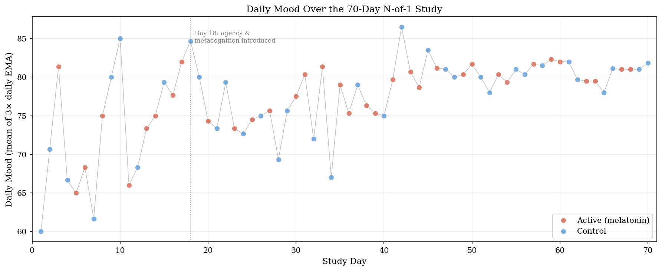
Figure 1. Daily mean mood across the 70-day window. Each dot represents the average of up to three EMA observations on that day, colored by daily condition. The light gray line connects daily means; the dotted vertical line at Day 18 marks the point at which agency and metacognition items were added to the protocol.
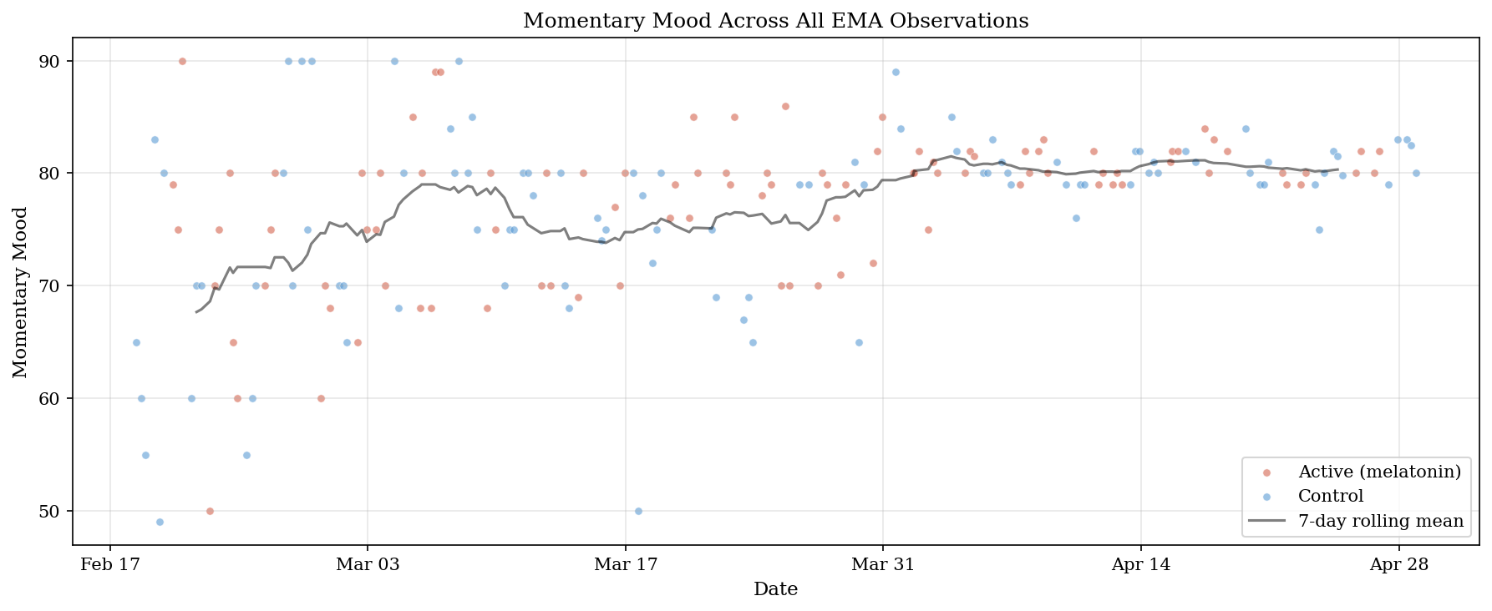
Figure 2. All 195 momentary mood observations across the 70-day window, colored by daily condition. The dark line shows the 7-day rolling mean of daily mood, indicating a gradual upward trend that stabilizes from approximately Day 40 onward.

3.2 Internal Drivers as Primary Predictors of Daily Mood
Three nested autoregressive models were fit to daily mean mood on the Day 18–70 subsample (n = 53 days; Table 1). The baseline AR(1) model (M0) yielded φ = 0.33, 95% CI [0.07, 0.60], p = .014, accounting for 11.1% of the variance in daily mood and confirming the presence of day-to-day emotional inertia. Adding the melatonin probe (M1) increased explained variance only marginally (R² = 0.121, ΔR² = 0.010; β = 0.73, 95% CI [−1.23, 2.70], p = .456). Adding the two internal drivers (M2) increased explained variance dramatically (R² = 0.637, adjusted R² = 0.607).
In the full M2 model, agency emerged as a strong positive predictor of daily mood (β = 0.54, 95% CI [0.33, 0.74], p < .001), as did metacognition (β = 0.44, 95% CI [0.20, 0.67], p < .001). The melatonin coefficient was estimated near zero (β = 0.06, 95% CI [−1.24, 1.36], p = .927). The autoregressive coefficient flipped sign in the full model and was no longer reliably distinguishable from zero (β = −0.13, 95% CI [−0.34, 0.08], p = .218), suggesting that the apparent emotional inertia detected by M0 was substantially absorbed by the two internal drivers once they were included as predictors.
Table 1. Coefficient estimates for nested autoregressive models of daily mood.
Term | β | SE | 95% CI | p
M0: Intercept | 52.35 | 10.33 | [31.63, 73.07] | < .001
M0: moodₜ₋₁ | 0.33 | 0.13 | [0.07, 0.60] | .014
M1: Intercept | 52.21 | 10.37 | [31.39, 73.03] | < .001
M1: moodₜ₋₁ | 0.33 | 0.13 | [0.07, 0.59] | .015
M1: melatonin | 0.73 | 0.98 | [−1.23, 2.70] | .456
M2: Intercept | 12.12 | 8.36 | [−4.67, 28.92] | .153
M2: moodₜ₋₁ | −0.13 | 0.10 | [−0.34, 0.08] | .218
M2: melatonin | 0.06 | 0.65 | [−1.24, 1.36] | .927
M2: agency | 0.54 | 0.10 | [0.33, 0.74] | < .001
M2: metacognition | 0.44 | 0.12 | [0.20, 0.67] | < .001
Note. All models fit on the Day 18–70 subsample (n = 53 days). M0: R² = .111, adjusted R² = .094. M1: R² = .121, adjusted R² = .086. M2: R² = .637, adjusted R² = .607. Predictors are on their original 0–100 scales. M2 residuals showed no remaining serial dependence (Ljung–Box p > .18 at lags 1, 5, 10) and were approximately normal (Shapiro–Wilk W = 0.98, p = .530).
The drop-one incremental R² comparison made the magnitudes of these contributions directly comparable (Figure 3). Agency uniquely accounted for 20.1% of the variance in daily mood beyond what the other predictors in M2 captured; metacognition uniquely accounted for 10.6%; melatonin uniquely accounted for 0.01%. The internal-driver block (agency and metacognition jointly) accounted for 51.6% of the variance over and above the AR(1) baseline. The internal-driver contribution exceeds that of the external probe by several orders of magnitude.
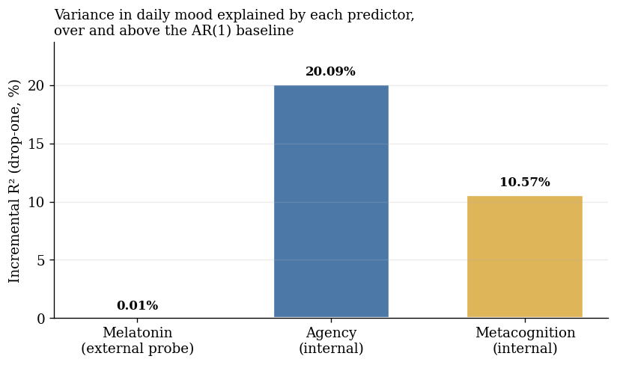
Figure 3. Incremental R² for each predictor in the full AR(1)-with-exogenous-inputs model, computed as the drop in R² when that predictor is removed. Agency and metacognition together account for over half of the day-to-day variance in mood; the melatonin probe accounts for essentially none.
The same qualitative pattern was recovered in a supplementary Bayesian analysis with weakly informative priors on all model parameters, with high posterior probability for the agency and metacognition coefficients (see Section 3.6).

3.3 Emotional Inertia and Latent State
Three estimates of emotional inertia were computed at different sampling resolutions and windows. At the observation level (n = 194 lag-1 pairs across the full 195-observation sample), AR(1) estimation yielded φ_obs = 0.23, 95% CI [0.09, 0.37], p = .001. At the daily level computed on the full 70-day sample (n = 70 lag-1 pairs), φ_day ≈ 0.43 (Figure 4; OLS point estimate φ̂ = 0.4206, rounded for reporting consistency with the figure). On the Day 18–70 subsample used in the nested-model comparison reported in Section 3.2 (n = 53), the corresponding daily-level coefficient was φ = 0.33 (M0 in Table 1). The two daily-level estimates differ because of the sample window: the first 17 days of mood-only data contribute substantial early variability (cf. Figure 1) that is excluded from the nested-model subsample. The system's typical daily emotional inertia is best characterized by the full-sample estimate φ ≈ 0.43; the smaller nested-model coefficient should be interpreted as a within-window estimate constrained by data availability.
The corresponding half-lives—the number of time steps for an external impulse to decay to half its initial magnitude—were 0.47 EMA pings (approximately 2.9 hours, given a 6.17-hour median between-prompt interval) at the observation level, and 0.82 days at the daily level using the full-sample estimate (Figure 5).
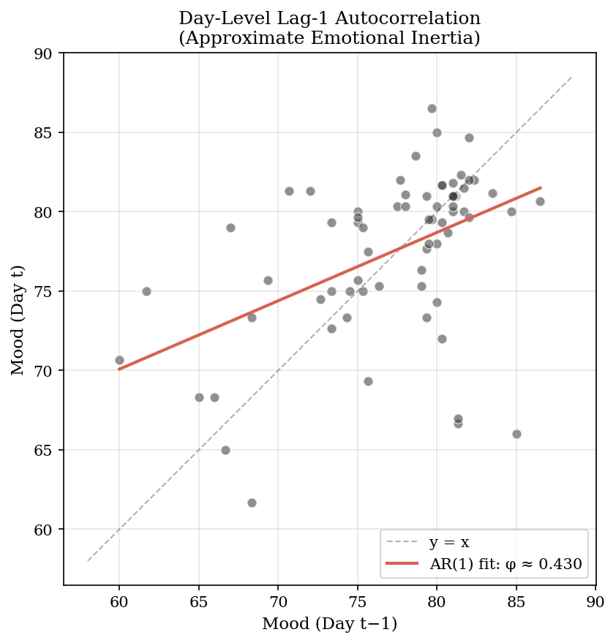
Figure 4. Lag-1 autocorrelation of daily mood, computed on the full 70-day sample. Each point represents one observation pair (mood at day t plotted against mood at day t − 1). The red regression line corresponds to the daily-level AR(1) coefficient (φ ≈ 0.43); the dashed line shows the y = x reference.
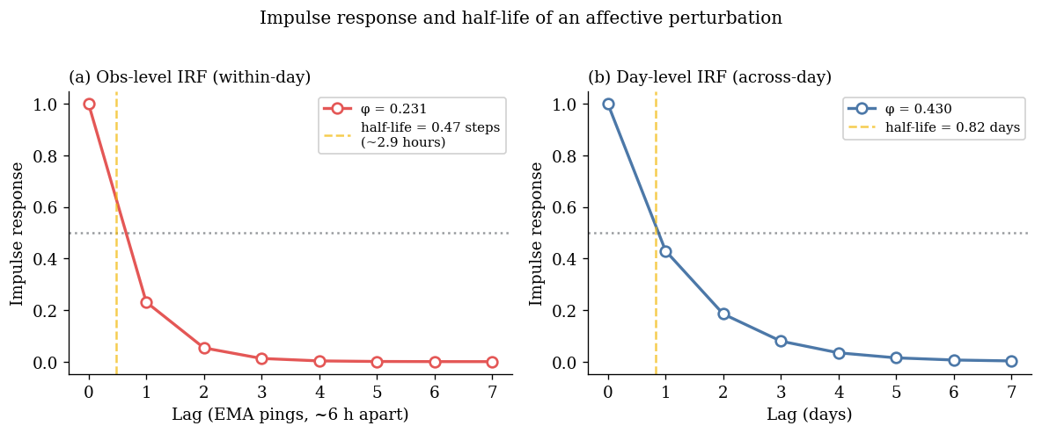
Figure 5. Impulse response and half-life of an affective perturbation, computed from the estimated AR(1) coefficients. Panel (a) shows the observation-level IRF using φ_obs = 0.23, with a within-day half-life of approximately 2.9 hours. Panel (b) shows the day-level IRF using the full-sample coefficient φ_day ≈ 0.43, with a half-life of 0.82 days.
The local-level state-space model (Section 2.5.2) decomposed the observed daily mood series into a smoothed latent trajectory and observation noise. Maximum-likelihood estimates were σ²_v = 17.34 (observation noise) and σ²_w = 1.09 (latent state innovation), implying a signal-to-noise ratio of 0.063. The smoothed latent state and its 95% confidence band are shown in Figure 6. The latent series rises from approximately 70 in the first ten days to approximately 80 by Day 40 and remains in the high 70s thereafter, suggesting a slow upward trend across the 70-day window that is largely independent of condition assignment.
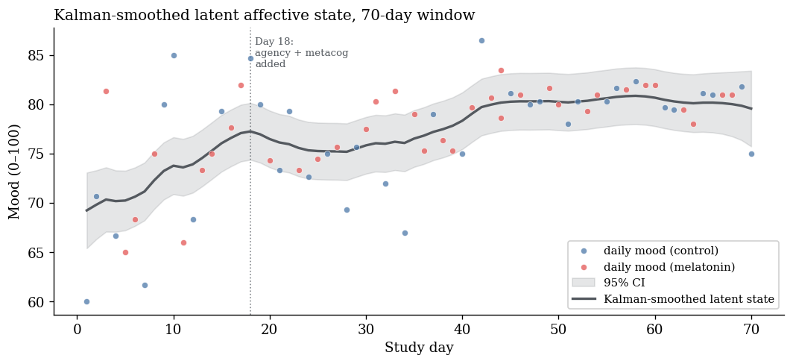
Figure 6. Kalman-smoothed latent affective state across the 70-day window. The dark line shows the smoothed latent state estimate; the gray band shows the 95% confidence interval. Daily observed means are plotted as dots, colored by condition. The latent trajectory's low signal-to-noise ratio (σ²_w / σ²_v = 0.063) indicates that most short-timescale day-to-day variation is sampling and measurement noise around a slowly drifting underlying state.

3.4 Melatonin Probe: Null on Mean, Suggestive on Variability
Consistent with the M1 result above, the between-condition comparison of daily mean mood yielded a small and non-significant difference: melatonin minus control = +1.03 mood points, Welch t(60.6) = 0.78, p = .437, Cohen's d = 0.19 (Figure 7). Within the framing developed in Section 1.2, this null on the mean is interpreted as identifying the system's sensitivity boundary on the level dimension of mood: a probe of this magnitude does not detectably shift the mean.
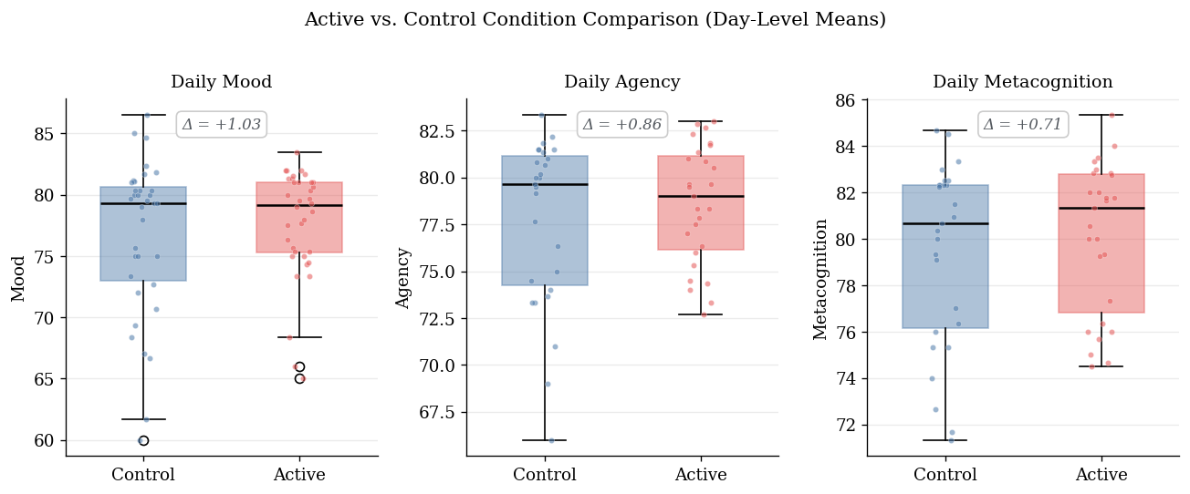
Figure 7. Between-condition comparison of daily mood, agency, and metacognition. Boxes show interquartile range; horizontal lines show medians; jittered points show individual days. Mean differences (melatonin minus control) are annotated above each panel and are small for all three variables.
The variability analyses (Section 2.5.6) yielded a more nuanced picture. Three of four indices pointed in the same direction, with melatonin days showing lower mood variability than control days: daily mood SD was 4.47 (melatonin) versus 6.41 (control); MSSD across within-condition runs was 57.35 versus 88.26; observation-level mood SD was 6.54 versus 8.26. The univariate Levene and MSSD tests did not reach significance (Levene W = 2.01, p = .161; MSSD Welch t = −0.94, p = .355). The heteroskedasticity model regressing log-squared M2 residuals on the melatonin indicator, however, yielded a reliably negative coefficient (α₁ = −1.21, 95% CI [−2.38, −0.03], p = .044), indicating that the model's residual variance was smaller on melatonin days than on control days. The collective pattern—three direction-consistent variability indices, with one of them (the AR(1)-residual-based test) reaching conventional significance—is suggestive of a stability-enhancing rather than level-shifting effect of the probe, but the inferential support for any single test is modest and the present analysis cannot rule out that the heteroskedasticity finding is a chance result of multiple testing.
The state-dependent decay analysis (Section 2.5.7) cohered with this pattern in direction. The interaction-augmented AR(1) yielded estimated φ_control = 0.47 and φ_melatonin = 0.22, with the lag-1 × melatonin interaction coefficient δ = −0.25, 95% CI [−0.78, +0.29], p = .360. Although this coefficient was not statistically distinguishable from zero, its direction—faster decay on melatonin days—is consistent with the variability findings above.

3.5 Metacontrol and Robustness
The metacontrol interaction term β₃ was negative, as predicted by the metacontrol hypothesis (β₃ = −0.14), but not reliably distinguishable from zero (95% CI [−0.60, +0.32], p = .544). Simple-slope decomposition placed the melatonin slope at +0.84 at one standard deviation below mean metacognition, +0.33 at the mean, and −0.17 at one standard deviation above mean metacognition. The qualitative pattern is consistent with the metacontrol hypothesis—the apparent direction of the melatonin effect reverses across the metacognition continuum—but the present sample is underpowered to support this as a strong inferential claim.
The agency × melatonin robustness check (Section 2.5.8) yielded an interaction coefficient indistinguishable from zero (β = −0.02, 95% CI [−0.38, +0.34], p = .919), indicating that the agency–mood relation was statistically identical in the two conditions. This supports the interpretation of agency as a robust internal organizer of affect within this individual: its predictive contribution does not depend on whether the external probe is present.

3.6 Supplementary Bayesian Robustness
The supplementary Bayesian M2 regression (Section 2.5.9) reproduced the qualitative pattern of the primary frequentist analysis under different inferential assumptions (Table 2). The purpose of this analysis was not to replace the OLS model but to test whether the primary conclusion depended on the choice of estimation framework. If, under a Bayesian posterior, agency and metacognition remained reliably positive while melatonin remained centered near zero, the primary finding would be less likely to be an artifact of a single inferential approach.
The posterior pattern was consistent with this expectation. The posterior effects for agency and metacognition were clearly positive in standardized units, with both 95% credible intervals well above zero and posterior probabilities of being greater than zero of essentially 1. The melatonin coefficient was centered near zero with a credible interval that spanned zero. The lagged-mood coefficient was attenuated and its credible interval included zero, consistent with the frequentist M2 in which apparent emotional inertia was absorbed by the internal drivers once they were included as predictors. All R-hat values were ≤ 1.001 and effective sample sizes exceeded 9,000 for every parameter, indicating excellent MCMC convergence.
Table 2. Posterior summaries for the supplementary Bayesian M2 robustness regression.
Parameter | Posterior M | 95% CrI | Pr(β > 0) | R̂ / ESS_bulk
Intercept | −0.01 | [−0.26, +0.23] | .47 | 1.00 / 11177
mood_t−1 (z) | −0.12 | [−0.33, +0.08] | .12 | 1.00 / 9763
melatonin | +0.02 | [−0.32, +0.35] | .54 | 1.00 / 11204
agency (z) | +0.55 | [+0.34, +0.76] | 1.00 | 1.00 / 9894
metacognition (z) | +0.42 | [+0.20, +0.64] | .9998 | 1.00 / 9306
σ | +0.64 | [+0.52, +0.78] | — | 1.00 / 10011
Note. Day 18–70 subsample (n = 53). Continuous variables standardized; melatonin retained as 0/1. Priors: coefficients ~ Normal(0, 1); intercept ~ Student-t(3, 0, 2.5); σ ~ Exponential(1). Four MCMC chains yielded 12,000 post-warmup posterior draws. Posterior M = posterior mean. CrI = 95% equal-tailed credible interval. Pr(β > 0) = proportion of posterior draws greater than zero. All R̂ values ≤ 1.001; ESS_bulk reported. All ESS_tail also exceeded 7,000 (not shown), indicating adequate sampling convergence.
The Bayesian metacontrol model (Section 2.5.9, secondary) yielded a negative posterior mean for the melatonin × metacognition interaction (β = −0.04, 95% CrI [−0.39, +0.31], Pr(β < 0) = .59), consistent with the hypothesized direction of metacognitive buffering but with a credible interval clearly spanning zero. The metacontrol interaction therefore remains direction-consistent but underpowered under both frequentist and Bayesian inferential frameworks, and is interpreted as suggestive rather than confirmatory.

4. Discussion

4.1 The Melatonin Probe: Null on Level, by Design
The most direct empirical question—whether melatonin shifts average daily mood—yielded a small and statistically non-significant mean difference. The point estimate was Δ = +1.03 on a 0–100 scale (d = 0.19), the M1 model added negligible variance over the AR(1) baseline (ΔR² = 0.010), and within the full model containing internal drivers the melatonin coefficient was essentially zero (β = 0.06, 95% CI [−1.24, +1.36]). Within a hypothesis-testing framework, this would constitute an inconclusive null: a non-significant result with insufficient evidence to support inference in either direction.
The framing developed in Section 1.2 was intended to change what such a null is taken to mean rather than to dispute the result itself. Within a control-theoretic account of the system, melatonin is treated not as a candidate treatment but as a perturbation of known presence and absence, applied to characterize the system’s response function. From this vantage point, the relevant evidential question is not whether the probe’s contribution to the mean differs from zero but how it compares in magnitude to the contributions of the system’s endogenous drivers. The drop-one decomposition reported in Section 3.2 makes that comparison directly: melatonin’s unique contribution to daily-mood variance is 0.01% in the full model, while agency and metacognition jointly account for 51.6%. The internal-driver contribution exceeds that of the external probe by several orders of magnitude—on this individual’s data, agency and metacognition predict the affective trajectory while the external probe contributes effectively none. In the language of Section 1.2, this identifies a sensitivity boundary: at this individual’s measurement scale and over 70 days of observation, the system is functionally insensitive to a daily melatonin perturbation on the dimension of mean mood.
The conclusion is constrained in two ways that should be made explicit. The 95% confidence interval on the M2 melatonin coefficient does not exclude small effects in either direction, and the present sample contains 53 days of full-model data and cannot rule out a small mean shift that would be detectable at higher power. The interpretation offered here is therefore not “melatonin has no effect on this person’s mood” but “melatonin’s contribution to this person’s daily mood, in the presence of measured internal drivers, is functionally negligible relative to those drivers.”

4.2 Internal Behavioral State as the Primary Organizer of Daily Affect
The most informative finding in this study is the magnitude of the internal-driver contribution. Daily perceived agency contributed an incremental 20.1% of variance to the daily-mood model after accounting for emotional inertia, the external probe, and metacognitive awareness. Daily metacognition contributed an incremental 10.6% under the same controls. Both effects were estimated with narrow confidence intervals and reliably distinguishable from zero (β_agency = 0.54, 95% CI [0.33, 0.74], p < .001; β_metacog = 0.44, 95% CI [0.20, 0.67], p < .001). The two internal drivers jointly raised the model R² from .121 (M1) to .637 (M2), an increase of more than half a unit of variance.
This pattern fits the theoretical commitments developed in Section 1.3. Bandura’s (2001) claim that humans are best characterized as proactive, self-organizing, and self-regulating agents rather than as reactive organisms shepherded by environmental contingencies receives empirical support here at the individual level: the same person whose mood was largely insensitive to a daily pharmacological probe showed strong day-to-day mood responsiveness to her own sense of intentional progress. The construct’s quantitative behavior also fits Carver and Scheier’s (1990) control-process model: agency, operationalized as the perceived rate of progress toward valued goals, was the strongest predictor of mood among the variables tested, consistent with their proposal that mood is a real-time feedback signal about that rate.
The agency × melatonin robustness check provided further evidence for agency as a stable internal organizer. The interaction coefficient was indistinguishable from zero (β = −0.02, 95% CI [−0.38, +0.34], p = .919), indicating that the agency–mood relation is statistically identical across the two conditions. The contribution of agency to daily mood does not depend on whether the participant has taken melatonin; the relation is invariant to the presence or absence of the external probe.
The role of metacognition was somewhat more complex. As a main-effect predictor, metacognition contributed reliably to daily mood (β = 0.44, p < .001), suggesting that the system’s awareness of its own state is itself bound up with its affective state. The metacontrol interaction—the prediction that higher metacognition would buffer the system against external perturbation—was direction-consistent but not statistically distinguishable from zero (β₃ = −0.14, 95% CI [−0.60, +0.32], p = .544). The simple-slope pattern, in which the apparent melatonin slope reversed sign across the metacognition continuum (from +0.84 at one SD below mean metacognition to −0.17 at one SD above), is consistent with the metacontrol hypothesis advanced by Metcalfe and Greene (2007) but underpowered to support it inferentially. Larger samples, or interventions that more strongly perturb the system, would be needed to evaluate this hypothesis more rigorously. The pattern is reported as a direction-consistent suggestion rather than as a confirmed effect.

4.3 A Suggestive Variability Signal: Probe Affects Stability, Not Level
A more nuanced reading of the melatonin probe is supported by the variability analyses reported in Section 3.4. Three of four indices of mood variability pointed in the same direction, with melatonin days showing lower variability than control days. The univariate Levene and MSSD tests were direction-consistent but did not reach conventional significance. The most powerful test in this set—the heteroskedasticity model regressing log-squared M2 residuals on the melatonin indicator—did reach conventional significance (α₁ = −1.21, p = .044). The state-dependent decay analysis, although individually underpowered, was direction-consistent with this variability pattern: the daily AR(1) coefficient was lower on melatonin days (φ = 0.22) than on control days (φ = 0.47), implying faster recovery from perturbation on melatonin days.
This pattern is consistent with the pharmacology of melatonin. Melatonin is a chronobiotic, not an antidepressant: its primary physiological function is the entrainment and stabilization of circadian rhythm, not the elevation of mood. A pharmacological agent that stabilizes the timing of the sleep–wake cycle is plausibly an agent that stabilizes the daily affective state without lifting it. Within the control-theoretic framing of the study, this would manifest as an effect on variance and decay-rate parameters of the system’s affective trajectory rather than as a shift in its mean. The pattern observed here is consistent with this interpretation but, given the modest inferential support for any single test and the multiple-testing context, should not be over-interpreted. A larger replication with a priori specification of variability as the primary outcome would be needed to evaluate this finding more rigorously.

4.4 Limitations
The single-subject design limits external generalizability by construction. The findings cannot be generalized to other persons or to the same person at other points in time, and the design does not aim to. A sharper version of this limitation also applies: whether the present individual exhibits unusually strong internal-driver organization, or whether a comparable contrast between internal-driver variance and external-probe variance is a general feature of human affect under stable environmental conditions, cannot be distinguished from a single-subject design. The 51.6% versus 0.01% contrast is informative about this system but not about whether this system is typical or atypical. The contribution claimed here is therefore methodological and theoretical (a template for control-theoretic single-system characterization, and an individual-level instance consistent with the agency framework of Bandura and Carver and Scheier) rather than empirical evidence of inter-individual differences. Multi-subject extensions of the same idiographic pipeline would be needed to evaluate whether the pattern observed here reflects this person specifically or a broader regularity.
Several measurement-level concerns constrain interpretation. Single-item momentary affect measures carry non-trivial measurement error (Dejonckheere et al., 2022), and the Day-18 protocol amendment restricts the data window for analyses involving agency and metacognition to 53 days, contributing to limited statistical power for interaction tests. More substantively, mood, agency, and metacognitive awareness were all measured by single-item self-report at the same EMA prompt, while the melatonin indicator was recorded objectively as a 0/1 manipulation check. The three internal variables share an instrument, a reporter, and a response scale that the external probe does not; their covariance therefore carries a common-method component that may inflate the apparent predictive contribution of agency and metacognition. The 51.6% versus 0.01% variance contrast reported in Section 3.2 should be read as a comparison that favors the internal drivers on measurement grounds, not as a calibrated quantitative estimate across measurement modalities. Finally, the thrice-daily monitoring of agency and metacognitive awareness may itself have increased the salience of these internal states and thereby their observed predictive contribution, a measurement-reactivity concern common to intensive longitudinal designs employing self-report (Barta et al., 2012; Conner & Reid, 2012).
Several design choices warrant explicit note. Blinding was partial; the participant was aware of having taken melatonin within minutes of bedtime, and complete blinding of self-administered, self-reported intervention is not achievable in N-of-1 designs of this kind. The melatonin dose (3 mg) was not titrated, and dose-response characterization is beyond the scope of the present design. EMA timing was approximate rather than exact: delayed responses were retained when completed within one hour of the scheduled prompt, adding minor timing noise to observation-level analyses but unlikely to affect the daily-mean analyses that carry primary inferential weight. The participant’s continuous use of a combined oral contraceptive (Section 2.2) suppressed the cyclical affective variation associated with the natural menstrual cycle. While this served the design goal of reducing baseline noise, it also restricts generalizability: in the presence of stronger, cyclically varying internal perturbations, the relative contribution of stable internal drivers might be diminished.
Three inferential limitations should also be noted. The autoregressive lag in M2 does not resolve contemporaneous endogeneity between mood and the internal-driver variables. Because the EMA protocol measures mood, agency, and metacognitive awareness simultaneously at equally spaced intervals, and the internal-driver variables are collected at the same prompt as mood, the present design cannot construct a true cross-lagged identification, and the causal direction between affect and the felt sense of intentional progress therefore cannot be tested. The analysis estimates predictive contributions, not causal ones. Relatedly, the within-day temporal dependence between lagged mood and the internal-driver variables may produce multicollinearity that partly inflates the internal-driver coefficients in M2: the sign reversal of the autoregressive coefficient when agency and metacognition are added (Section 3.2) is consistent with such absorption, and the present analysis does not formally distinguish substantive absorption from shared variance. Future replications should report variance inflation factors and fit cross-lagged regression structures. Finally, the variability findings reported in Section 3.4 derive their conventional-significance support from a single test in a multi-test family; the direction-consistent pattern across four indices is informative, but the variability signal should be treated as suggestive rather than as a robust finding, pending pre-registered replication.

4.5 Contribution
The present study offers three modest contributions to the affective-dynamics literature.
First, methodologically, it demonstrates the application of control-theoretic methods—system identification, impulse response analysis, state-space modeling, and conditional heteroskedasticity modeling—to the intensive longitudinal self-study of affect in a single individual. The pipeline (iOS Shortcuts automation, Python validation, pre-registered randomization schedule, open analysis code) is offered as a template for personal-science research that aims to go beyond descriptive single-case reporting toward formal system characterization. The control-theoretic terminology used here (perturbation, sensitivity boundary, system identification) is intended in an analytic and conceptual sense, as a vocabulary for organizing dynamical questions about a single person across time; it is not a claim that the present analyses estimate engineering transfer functions or recover a closed-form physical plant model.
Second, theoretically, the study provides individual-level empirical support for an agentic account of affective dynamics in the tradition of Bandura (2001) and Carver and Scheier (1990). The same person whose mood was largely insensitive to a daily pharmacological probe showed mood that covaried strongly with her own moment-to-moment sense of intentional action and self-monitoring. The variance ratios reported here suggest, at least for this individual, that the system’s affective trajectory appears organized primarily by its own self-regulatory machinery and only secondarily by external inputs of small magnitude.
Third, empirically, the study offers a refined reading of melatonin’s signature in this individual’s affect. The probe was null on mean mood and suggestive on mood variability—a pattern a pattern compatible with melatonin’s known chronobiotic rather than antidepressant function, and one that points to the importance of testing pharmacological effects on the dynamics of affective trajectories rather than only on their levels. This finding warrants larger and pre-registered replication.
A non-significant intervention effect, read within a control-theoretic framework, can be informative rather than inconclusive: it identifies the sensitivity boundary of a system whose primary organizing forces lie elsewhere.

5. Data and Code Availability
Data and analysis code are available at: https://github.com/haomeng797-ship-it/N-of-1-Melatonin-Study. The repository includes the preregistered randomization schedule, iOS Shortcuts data-collection pipeline, Python validation layer, cleaned EMA dataset, and reproducible scripts for the figures and statistical estimates reported in this manuscript.

6. References
Archer, M. S. (2003). Structure, agency, and the internal conversation. Cambridge University Press.
Bandura, A. (1989). Human agency in social cognitive theory. American Psychologist, 44(9), 1175–1184.
Bandura, A. (2001). Social cognitive theory: An agentic perspective. Annual Review of Psychology, 52, 1–26.
Bandura, A. (2006). Toward a psychology of human agency. Perspectives on Psychological Science, 1(2), 164–180.
Barta, W. D., Tennen, H., & Litt, M. D. (2012). Measurement reactivity in diary research. In M. R. Mehl & T. S. Conner (Eds.), Handbook of research methods for studying daily life (pp. 108–123). Guilford Press.
Bourdieu, P. (1990). The logic of practice (R. Nice, Trans.). Stanford University Press. (Original work published 1980)
Bringmann, L. F., Vissers, N., Wichers, M., Geschwind, N., Kuppens, P., Peeters, F., Borsboom, D., & Tuerlinckx, F. (2013). A network approach to psychopathology: New insights into clinical longitudinal data. PLoS ONE, 8(4), e60188.
Bürkner, P.-C. (2017). brms: An R package for Bayesian multilevel models using Stan. Journal of Statistical Software, 80(1), 1–28.
Carver, C. S., & Scheier, M. F. (1990). Origins and functions of positive and negative affect: A control-process view. Psychological Review, 97(1), 19–35.
Carver, C. S., & Scheier, M. F. (1998). On the self-regulation of behavior. Cambridge University Press.
Conner, T. S., & Reid, K. A. (2012). Effects of intensive mobile happiness reporting in daily life. Social Psychological and Personality Science, 3(3), 315–323.
Craig, A. D. (2009). How do you feel — now? The anterior insula and human awareness. Nature Reviews Neuroscience, 10(1), 59–70.
Damasio, A. R. (1999). The feeling of what happens: Body and emotion in the making of consciousness. Harcourt.
Deci, E. L., & Ryan, R. M. (2000). The “what” and “why” of goal pursuits: Human needs and the self-determination of behavior. Psychological Inquiry, 11(4), 227–268.
Dejonckheere, E., Demeyer, F., Geusens, B., Piot, M., Tuerlinckx, F., Verdonck, S., & Mestdagh, M. (2022). Assessing the reliability of single-item momentary affective measurements in experience sampling. Psychological Assessment, 34(12), 1138–1154.
Efklides, A. (2008). Metacognition: Defining its facets and levels of functioning in relation to self-regulation and co-regulation. European Psychologist, 13(4), 277–287.
Eisele, G., Vachon, H., Lafit, G., Kuppens, P., Houben, M., Myin-Germeys, I., & Viechtbauer, W. (2022). The effects of sampling frequency and questionnaire length on perceived burden, compliance, and careless responding in experience sampling data in a student population. Assessment, 29(2), 136–151.
Flavell, J. H. (1979). Metacognition and cognitive monitoring: A new area of cognitive–developmental inquiry. American Psychologist, 34(10), 906–911.
Frijda, N. H. (1986). The emotions. Cambridge University Press.
Frith, C. (2005). The self in action: Lessons from delusions of control. Consciousness and Cognition, 14(4), 752–770.
Giddens, A. (1984). The constitution of society: Outline of the theory of structuration. University of California Press.
Haggard, P. (2017). Sense of agency in the human brain. Nature Reviews Neuroscience, 18(4), 196–207.
Hamaker, E. L. (2012). Why researchers should think “within-person”: A paradigmatic rationale. In M. R. Mehl & T. S. Conner (Eds.), Handbook of research methods for studying daily life (pp. 43–61). Guilford Press.
Houben, M., Van Den Noortgate, W., & Kuppens, P. (2015). The relation between short-term emotion dynamics and psychological well-being: A meta-analysis. Psychological Bulletin, 141(4), 901–930.
Jahng, S., Wood, P. K., & Trull, T. J. (2008). Analysis of affective instability in ecological momentary assessment: Indices using successive difference and group comparison via multilevel modeling. Psychological Methods, 13(4), 354–375.
Koval, P., & Kuppens, P. (2012). Changing emotion dynamics: Individual differences in the effect of anticipatory social stress on emotional inertia. Emotion, 12(2), 256–267.
Kuppens, P., Allen, N. B., & Sheeber, L. B. (2010). Emotional inertia and psychological maladjustment. Psychological Science, 21(7), 984–991.
Lakens, D. (2017). Equivalence tests: A practical primer for t tests, correlations, and meta-analyses. Social Psychological and Personality Science, 8(4), 355–362.
Lazarus, R. S. (1991). Emotion and adaptation. Oxford University Press.
Metcalfe, J., & Greene, M. J. (2007). Metacognition of agency. Journal of Experimental Psychology: General, 136(2), 184–199.
Molenaar, P. C. M. (2004). A manifesto on psychology as idiographic science: Bringing the person back into scientific psychology, this time forever. Measurement: Interdisciplinary Research and Perspectives, 2(4), 201–218.
Molenaar, P. C. M., & Campbell, C. G. (2009). The new person-specific paradigm in psychology. Current Directions in Psychological Science, 18(2), 112–117.
Moore, J. W., & Fletcher, P. C. (2012). Sense of agency in health and disease: A review of cue integration approaches. Consciousness and Cognition, 21(1), 59–68.
Myin-Germeys, I., & Kuppens, P. (Eds.). (2022). The open handbook of experience sampling methodology (2nd ed.). Center for Research on Experience Sampling and Ambulatory Methods Leuven.
Nelson, T. O., & Narens, L. (1990). Metamemory: A theoretical framework and new findings. In G. H. Bower (Ed.), The psychology of learning and motivation (Vol. 26, pp. 125–173). Academic Press.
Olthof, M., Hasselman, F., Strunk, G., Aas, B., Schiepek, G., Bosman, A. M. T., & Lichtwarck-Aschoff, A. (2020). Critical fluctuations as an early-warning signal for sudden gains and losses in patients suffering from mood disorders. Clinical Psychological Science, 8(1), 25–35.
Russell, J. A. (1980). A circumplex model of affect. Journal of Personality and Social Psychology, 39(6), 1161–1178.
Russell, J. A., & Barrett, L. F. (1999). Core affect, prototypical emotional episodes, and other things called emotion: Dissecting the elephant. Journal of Personality and Social Psychology, 76(5), 805–819.
Ryan, R. M., & Deci, E. L. (2017). Self-determination theory: Basic psychological needs in motivation, development, and wellness. Guilford Press.
Schraw, G., & Moshman, D. (1995). Metacognitive theories. Educational Psychology Review, 7(4), 351–371.
Seabold, S., & Perktold, J. (2010). statsmodels: Econometric and statistical modeling with Python. In Proceedings of the 9th Python in Science Conference (Vol. 57, pp. 92–96).
Synofzik, M., Vosgerau, G., & Newen, A. (2008). Beyond the comparator model: A multifactorial two-step account of agency. Consciousness and Cognition, 17(1), 219–239.
Veenman, M. V. J., Van Hout-Wolters, B. H. A. M., & Afflerbach, P. (2006). Metacognition and learning: Conceptual and methodological considerations. Metacognition and Learning, 1(1), 3–14.
Wegner, D. M. (2002). The illusion of conscious will. MIT Press.
Wichers, M. (2014). The dynamic nature of depression: A new micro-level perspective of mental disorder that meets current challenges. Psychological Medicine, 44(7), 1349–1360.

