What organizes daily affect in one person:
A 70-day N-of-1 characterization with a nightly melatonin probe
Author and corresponding author
Miura Meng
Graduate School of Education, University of Pennsylvania
3700 Walnut Street, Philadelphia, PA 19104, United States
Email: meng10@upenn.edu
Telephone: +1 (773) 406-8649

Abstract
Over 70 days, one adult recorded momentary emotional valence three times a day, adding perceived agency and metacognitive awareness from Day 18 onward, and took 3 mg of melatonin on the nights assigned by a pre-generated randomized schedule. This yielded 193 scheduled observations at 91.9% compliance across 35 control and 35 melatonin days. Melatonin left mean daily mood essentially unchanged: the difference was +0.86 points on a 0 to 100 scale, d = 0.16, and an equivalence test placed it inside an analysis-defined bound of five points, which gives the null a stated width. What moved with mood was the person’s own regulatory state. Perceived agency and metacognitive awareness together accounted for a further 52.8% of daily-mood variance, over the 53 days on which they were collected, beyond autoregressive carryover and the probe, lifting model R² from .116 to .644, and the internal-over-probe contrast persisted under multilevel re-estimation. The comparison is between predictors of different kinds: agency and metacognition were self-reported alongside mood, while melatonin acts on it only indirectly through sleep. One signal ran the other way, though only suggestively: residual variance was smaller on melatonin nights, compatible with a chronobiotic effect on stability while level is untouched. The individual is modeled here as a dynamical system and melatonin as a probe, used to map where that system responds and where it does not. The estimates are idiographic and are not offered as population effects. The procedure transfers even where the numbers do not: any variable that can be sampled repeatedly can take the place of the ones used here.
Keywords: N-of-1; ecological momentary assessment; dynamical systems; autoregressive model; idiographic; personal science; intensive longitudinal data; affect dynamics

1. Introduction

1.1 What Organizes One Person’s Daily Affect?
A common implicit model in mood-intervention research is that affect improves when beneficial inputs are added: better sleep, less stress, optimized nutrition, pharmacological support. Mood becomes a passive output of external conditions, and intervention becomes a question of which conditions to optimize. What this study contests is the assumption that the same frame should organize an individual person’s account of her own affective dynamics.
An alternative account holds that affective states are organized primarily by internal behavioral dynamics: by the degree to which the individual is acting intentionally, making progress toward goals, and maintaining awareness of her own state. On this view mood is closer to a signature of how well the behavioral system is functioning as a self-regulating agent than to a readout of what has been added to it. These two accounts make different predictions about what a dense record of one person’s days should look like, and that difference is testable within the person.
This study puts them side by side in a single individual sampled three times daily for 70 days, with a nightly melatonin probe delivered on a pre-generated randomized schedule. The prediction that follows from the internal-dynamics account is parsimonious: the affective trajectory should be more strongly predicted by moment-to-moment variation in agency and metacognitive awareness than by the external probe. The account predicts that their effect is small relative to the system’s own self-regulatory machinery, and that whatever effect exists may appear in features of the trajectory other than its mean level.

1.2 Two Theoretical Commitments
The internal-dynamics account is grounded here in two commitments.
The first is that perceived agency, the felt sense of intentional goal-directed action, is a primary internal driver of affective state. This draws on Bandura’s (1989, 2001, 2006) social cognitive theory of human agency, in which persons exercise causal influence over their own functioning through intentional, self-regulating action. It also draws on Carver and Scheier’s (1990, 1998) control-process model, which specifies that affect is generated by the perceived rate of progress toward active goals.
The second is that metacognitive awareness, the system’s read-out of its own internal state, both predicts mood and modulates responsiveness to external perturbation. Flavell (1979) defined metacognition as cognition about cognition; Efklides (2008) drew the construct closer to affective experience by showing how metacognitive experiences are themselves affectively colored. Metacognition is operationalized here using the monitoring-control framework of Nelson and Narens (1990), in which a metalevel system continuously reads and regulates object-level processes.
Both constructs carry divergent meanings across traditions, so their scope here is delimited. Agency is used only as the participant’s moment-to-moment phenomenological sense of intentional progress toward immediate task goals, a signal the system tracks and reports. Metacognition is likewise restricted to in-the-moment self-monitoring in the Nelson and Narens sense.

1.3 Why a Single Person, and Why a Probe
Two design choices follow from the question, and both depart from convention.
The first is the unit of analysis. Conventional intervention research averages treatment effects across samples, on the assumption that an individual’s response is a noisy realization of a population-level signal. As an inferential strategy for population claims that logic is sound. It does not carry down to the individual: group-level estimates are not generally informative about individual-level processes unless strong ergodicity conditions hold, which for psychological processes they typically do not (Molenaar, 2004; Molenaar & Campbell, 2009). A person is a system with its own organizational logic, dynamic parameters, and sensitivity boundaries, and the question of how that system responds can only be answered within it. The present study therefore adopts the logic of personal science (Wolf & De Groot, 2020) and idiographic behavioral science (Molenaar, 2004), treating one individual as the unit of analysis in her own right.
The second is what the melatonin is for. Standard intervention logic treats an external input as a lever: pull it, observe the outcome, read the effect size as the lever’s causal force. Dynamical systems accounts of affect describe something different. An external input perturbs a self-organizing system, which then responds according to its own internal structure, its inertia, its attractor states, and its sensitivity to inputs of particular magnitude and timing (Bringmann et al., 2013, 2022; Hamaker, 2012; Wichers, 2014). The response is informative primarily about the system, and only secondarily about the perturbation. Affective dynamics research gives this specificity: day-to-day mood variation is partly organized by autoregressive carryover, often termed emotional inertia. The capacity of a system to be perturbed at all is itself a meaningful individual difference (Houben, Van Den Noortgate, & Kuppens, 2015; Koval & Kuppens, 2012; Kuppens, Allen, & Sheeber, 2010).
The control-theoretic vocabulary used here, including the language of system identification, is intended in an analytic and conceptual sense, as a way of organizing dynamical questions about a single person across time. On this framing the evidential question is where the system is sensitive and where it is not. A probe that moves nothing on the mean has located one of those boundaries, provided the bound itself is estimated. Section 2.5.10 states how that bound was obtained.

1.4 Research Questions
Primary. In this individual behavioral system, do internal drivers, specifically moment-to-moment agency and metacognitive awareness, account for substantially more of the affective trajectory than a discrete external perturbation does? This is the question the completed 70-day record is best positioned to answer, and it treats a small pharmacological effect as a system-identification result: evidence that this system is more sensitive to internal self-regulatory variation than to an external probe of this magnitude.
Probe. Within a continuous hormonal-contraceptive background condition, does melatonin administration meaningfully shift average momentary emotional valence? Melatonin is widely consumed as a chronobiotic and sleep aid and is sometimes assumed to lift mood as well. The present design tests that assumption at the individual level, in a system where the cyclical hormonal contribution to affect has been pharmacologically stabilized. It also estimates a bound on that effect, which a significance test alone would not provide.
Exploratory. Does metacognitive awareness moderate the system’s sensitivity to the probe? A buffering interaction would indicate that monitoring one’s own state changes the system’s functional coupling to external inputs, a higher-order regulatory property not captured by main effects (Metcalfe & Greene, 2007). This question is exploratory: the design was not powered for an interaction of the expected size, and it is reported as such.

1.5 Study Origin and Analytic Reframing
This study began as a course project in single-case experimental design, for which the participant designed a randomized N-of-1 alternating-treatment experiment with three-times-daily EMA sampling. The complete 70-day randomization schedule was generated from a pre-specified algorithm and fixed in a stored protocol file before any data were collected (Section 2.3). At the course deadline only the first 44 days were available, and the course-required analysis reported that interim window under a between-condition framework, using a mean comparison and Monte Carlo randomization inference.
The present paper analyzes the complete 70-day protocol and asks a different question of it. The original question concerned an average intervention effect. The present one concerns the dynamic structure of the system, and how internal and external drivers contribute to it. The research questions in Section 1.4 took their present form during that reframing, after the interim window had been seen. The design, the randomization schedule, and the sampling protocol were fixed beforehand; the analytic framing was not, and it is reported here as reframing, with no claim of preregistration attached to it. Two protocol features follow from the study’s origin and are detailed in the Method: agency and metacognitive awareness items were added on Day 18 (Section 2.4), and the background hormonal condition was continuous throughout (Section 2.2).

2. Methods

2.1 Participants
The participant is the author of this paper. The use of a single-subject design follows the personal science tradition of systematic self-experimentation with rigorous measurement and transparent analysis (Wolf & De Groot, 2020). Single-subject designs are appropriate when the research question concerns individual-level processes that are obscured by group averaging (Molenaar, 2004; Molenaar & Campbell, 2009). At the time of data collection, the participant was a 23-year-old graduate student, reported no current psychiatric or other medical diagnoses, and was taking no medication beyond the hormonal contraceptive described in Section 2.2. The University of Pennsylvania Institutional Review Board determined that this study constitutes Not Human Subjects Research (NHSR) and does not require formal IRB approval (email determination, May 13, 2026). As the sole investigator and sole participant, the author consented to her own participation.

2.2 Background Condition
The participant has been taking a continuous hormonal contraceptive (drospirenone/ethinyl estradiol; trade name YAZ) for an extended period prior to and throughout the study, prescribed for the management of premenstrual mood symptoms. This pharmacological background creates a stable hormonal regime, suppressing the cyclical affective fluctuation associated with the natural menstrual cycle. It is a fixed background parameter that reduces baseline affective noise, increasing the signal-to-noise ratio for detecting effects of the primary manipulation.

2.3 Intervention
Melatonin (3 mg, standard over-the-counter formulation) was administered before sleep on a schedule generated by a pre-specified randomization algorithm. The constrained-randomization procedure used to generate the schedule was later incorporated into the R package nof1kit (Version 0.1.0; Meng, 2026). The 70-day schedule was constrained to produce 35 active and 35 control days with no runs longer than two consecutive days in either condition, ensuring within-person crossover for time-series analysis and reducing the risk of carry-over effects from extended runs. The schedule was generated and stored in a JSON protocol file before data collection began and was not accessible to the participant during the EMA logging process; the daily condition was confirmed only after the corresponding evening’s EMA prompt had been completed.
Melatonin functions here as an analytic probe: a perturbation input of known presence and absence, applied to an otherwise free-running system in order to characterize the system’s response function. The primary targets are (a) the fraction of variance in the system’s affective trajectory accounted for by the probe relative to the system’s endogenous drivers, and (b) whether the probe’s effect appears in features of the trajectory other than the mean, such as variability or decay rate (cf. Section 1.3).

2.4 Procedure and Measurement

Design and sampling
The study employed a 70-day intensive longitudinal N-of-1 alternating-treatment design. Each day was randomly assigned to either an active (melatonin) or control (no melatonin) condition according to the pre-specified schedule described in Section 2.3. Ecological momentary assessment (EMA) prompts were delivered three times per day, at approximately 10:00, 16:00, and 22:00 local time, via automated iOS Shortcuts. Each study day is a calendar date, and EMA observations were aggregated to the study day, yielding the planned 35 control and 35 melatonin daily aggregates over the 70-day window (2026-02-18 to 2026-04-29). Two records were entered on 2026-04-03, after the three prompts for that study day had already been completed on 2026-04-02. They fill none of the 210 planned prompt slots, so they are retained in the archived log and excluded from the analytic dataset (cf. Section 3.1). Compliance and the realized sample are reported in Section 3.1.

Measures
At each EMA prompt, three momentary ratings, a protocol-adherence item and one free-text deviation note were collected. Mood (current emotional state) was rated on a 0–100 visual slider as a single-item measure of momentary affect (Eisele et al., 2022); see the measurement-error note below. Agency (task progress / sense of forward motion) was rated on a 0–100 slider, operationalizing the experiential component of intentional, goal-directed action specified by Bandura (2001) and the proximal cause of affect identified by Carver and Scheier’s (1990) control-process model. Metacognition (awareness of current internal state) was rated on a 0–100 slider, operationalizing in-the-moment self-monitoring in the Nelson and Narens (1990) sense (cf. Section 1.2). The Shortcut also recorded whether the participant had followed the assigned melatonin protocol. For analysis, condition was coded from the randomized schedule (1 = melatonin taken the preceding night, 0 = control), not from that record. A free-text override field captured deviation notes for any prompt completed late, manually, or with anomalies.
Prior psychometric work suggests that single-item momentary affect ratings can contain substantial measurement-error variance, with Dejonckheere et al. (2022) estimating error variance at approximately 27%. This motivates cautious interpretation of small effects in the present study.

Day-18 protocol amendment
Of the three momentary ratings, mood was collected from Day 1 of data collection (2026-02-18). Agency and metacognition were added on Day 18 (2026-03-07) following an interim review of the protocol, in which the participant determined that the original mood-only design was insufficient to test the internal-versus-external research questions formulated in Section 1.4. All analyses involving agency or metacognition are restricted to Days 18–70. Within this window, the randomized schedule yielded 53 daily aggregates (27 control and 26 melatonin days) and 142 momentary observations. The AR(1) model with lag-1 alignment uses 53 days, with the first day in the window (Day 18) using Day 17’s mood as its lag-1 predecessor. Mood-only analyses (descriptive statistics, between-condition mean comparison, and the observation-level AR(1) inertia estimate) use the full 193-observation analytic sample.

Data acquisition pipeline
The data collection pipeline was implemented in iOS Shortcuts as a conditional programming environment, with control flow (variables, conditionals, dictionaries, file I/O) treated as equivalent to any lightweight scripting language. This implementation was developed because standard EMA platforms (Qualtrics, REDCap) introduced too much per-entry friction for a high-frequency, three-times-daily protocol over a 70-day window. Each prompt took approximately 8–12 seconds to complete and appended one row to a CSV file with an ISO-8601 timestamp. A Python validation layer ran after each new entry, performing range checks (mood, agency, and metacognition within 0–100), completeness checks (no required field missing), and duplicate-timestamp checks. Responses were typically completed within minutes of the scheduled prompt and, when delayed, within one hour. Because all entries were timestamped and the primary analyses were conducted either on daily means or on timestamp-ordered observations, these minor response latencies were retained as part of the natural EMA sampling process rather than treated as a separate manual-entry condition. Documentation and an installable copy of the Shortcut used in this study, together with the Python validation code, are available in the repositories described in Section 9.

2.5 Analytic Strategy
The analyses are organized in three tiers. The primary inference runs through the nested autoregressive models, their incremental-R² decomposition, and the equivalence test that bounds the probe’s mean effect (Sections 2.5.1, 2.5.4, and 2.5.10); the state-space model and the impulse-response functions (Sections 2.5.2 and 2.5.3) characterize the dynamics that frame that comparison. The remaining sections are sensitivity, exploratory, and robustness analyses: the metacontrol and decay interactions, the variability indices, and a multilevel re-estimation that repeats the primary comparison without daily aggregation (Sections 2.5.5 through 2.5.9).

2.5.1 Autoregressive model with exogenous inputs
Three nested autoregressive models were fit to daily mean mood, estimated as regressions with lagged mood as a predictor. The state-space model reported separately in Section 2.5.2 characterizes the latent daily trajectory and is not part of this nested comparison. The baseline model (M0) is a first-order autoregression:
moodₜ = α + φ · moodₜ₋₁ + εₜ
Model M1 adds the external probe:
moodₜ = α + φ · moodₜ₋₁ + β₁ · melatoninₜ + εₜ
Model M2 adds the internal drivers:
moodₜ = α + φ · moodₜ₋₁ + β₁ · melatoninₜ + β₂ · agencyₜ + β₃ · metacognitionₜ + εₜ
The autoregressive coefficient φ estimates day-to-day emotional inertia: the degree to which mood persists across consecutive days. Each β estimates the marginal contribution of its predictor over and above the system’s own carryover. Models M1 and M2 were fit on the Day 18–70 subsample (n = 53 days) to ensure that all three models were estimated on identical data, permitting incremental-R² comparison. Lag-order sensitivity was evaluated on the same Day 18–70 window. In the outcome-only model the second lag was positive (β = 0.33, 95% CI [0.06, 0.61], p = .017). When the second lag was added to the full M2 specification, however, it was smaller and not reliably distinguishable from zero (β = 0.12, 95% CI [−0.07, 0.32], p = .212), and both AIC and BIC favored the more parsimonious AR(1) M2 (AIC 244.28 against 244.51; BIC 254.13 against 256.33). The substantive contrast persisted in the AR(2) specification: agency β = 0.49, metacognition β = 0.45, and melatonin β = −0.01. A Ljung-Box test found no residual autocorrelation in the AR(1) M2 residuals (lag 10, p = .354), supporting the first-order specification.

2.5.2 State-space model (Kalman filter)
A local-level (random-walk-plus-noise) state-space model was fit to the daily mood series via maximum-likelihood Kalman filtering, with the following structure:
Observation: yₜ = xₜ + vₜ, vₜ ~ N(0, σ²_v)
State: xₜ = xₜ₋₁ + wₜ, wₜ ~ N(0, σ²_w)
The model decomposes observed daily mood into an unobserved latent trajectory (xₜ) and observation noise (vₜ), yielding a smoothed estimate of the underlying affective state and its 95% confidence band. The signal-to-noise ratio σ²_w / σ²_v summarizes how much of the observed daily variation is attributable to genuine latent change versus measurement and sampling noise.

2.5.3 Impulse response and half-life
The impulse response function (IRF) for an AR(1) process is given by IRF(h) = φʰ, and the half-life of an affective perturbation, the number of time steps required for an external impulse to decay to half its initial magnitude, follows directly:
half-life = log(0.5) / log(φ)
The IRF was computed at both the daily level and the observation level. The daily-level estimate used the AR(1) coefficient fit on the full 70-day sample (φ_day, full sample), which provides a more stable estimate of the system’s typical daily inertia than the Day 18–70 nested-model coefficient (φ_day, nested) reported in M0. The observation-level estimate (φ_obs) was fit on the full set of 193 EMA pings, ordered by timestamp; its half-life was converted to physical time using the median between-prompt interval. The choice of sample window for IRF estimation is reported in Appendix A.

2.5.4 Incremental R² comparison
To quantify the internal-versus-external prediction, drop-one incremental R² was computed for each of the three predictors in M2:
ΔR²(predictor) = R²(M2 with predictor) − R²(M2 without predictor)
This decomposition isolates the unique variance each predictor accounts for over and above the others, permitting direct comparison of the magnitudes of the agency and metacognition contributions to the magnitude of the melatonin contribution.

2.5.5 Metacontrol interaction
The metacontrol hypothesis holds that metacognitive awareness moderates the system’s responsiveness to external perturbation. It was tested by adding a melatonin × metacognition interaction term, with metacognition mean-centered:
moodₜ = α + φ · moodₜ₋₁ + β₁ · melatoninₜ + β₂ · meta_cₜ + β₃ · (melatoninₜ × meta_cₜ) + εₜ
A negative β₃ is predicted by the metacontrol hypothesis: higher metacognition would attenuate the system’s sensitivity to the external probe. Simple slopes for melatonin were computed at −1 SD, the mean, and +1 SD of metacognition.

2.5.6 Affective variability
In addition to the mean-shift analyses above, three descriptive indices of mood variability were computed by condition: (a) the standard deviation of daily mean mood within each condition; (b) the mean squared successive difference (MSSD; Jahng, Wood, & Trull, 2008), computed within contiguous within-condition runs of EMA observations and averaged across runs; and (c) the standard deviation of all momentary mood observations within each condition. Differences between conditions were tested with the Brown–Forsythe Levene test of homogeneity of variance and with a Welch comparison of run-level MSSD. A complementary heteroskedasticity model was fit by regressing the log-squared residuals from M2 on the melatonin indicator: log(ε²ₜ) = α₀ + α₁ · melatoninₜ + uₜ. A negative α₁ coefficient indicates that the model’s residual variance is smaller on melatonin days than on control days, consistent with a stability-enhancing rather than level-shifting effect of the probe.

2.5.7 State-dependent decay (sensitivity)
To examine whether the AR(1) decay rate itself differs by condition, the M0 specification was augmented with a melatonin × moodₜ₋₁ interaction:
moodₜ = α + φ₀ · moodₜ₋₁ + β · melatoninₜ + δ · (melatoninₜ × moodₜ₋₁) + εₜ
The implied φ in each condition is then φ₀ (control) and φ₀ + δ (melatonin). A negative δ would indicate that perturbations decay faster on melatonin days, that is, that the system recovers more quickly. This analysis is reported as a sensitivity check rather than a primary test.

2.5.8 Robustness check
One robustness check was performed: an agency × melatonin interaction term was added to the M2 framework to test whether the agency–mood association differed between conditions. Results are reported in Section 3.4.

2.5.9 Multilevel (mixed-effects) robustness analysis
The primary models in Section 2.5.1 were fit to daily mean mood, collapsing the up-to-three momentary observations recorded each day into a single value. Although this aggregation stabilizes daily estimates, it discards within-day variation and treats each day as a single observation. The comparison was therefore re-estimated at the momentary level. A linear mixed-effects model retained every EMA observation and accounted for its nesting within days. Momentary mood was regressed on momentary agency and momentary metacognitive awareness (both grand-mean-centered) and the day’s melatonin indicator, with a random intercept for day:
moodᵢⱼ = γ₀₀ + γ₁₀ · agencyᵢⱼ + γ₂₀ · metacognitionᵢⱼ + γ₃₀ · melatoninⱼ + u₀ⱼ + eᵢⱼ ,
where i indexes the momentary observation within day j, u₀ⱼ ~ N(0, τ₀₀) is the day-level random intercept, and eᵢⱼ ~ N(0, σ²) is the within-day residual. The random intercept absorbs the between-day dependence that daily aggregation had otherwise handled by collapsing each day to its mean. Models were fit by restricted maximum likelihood in R 4.5 using lme4 (Bates, Mächler, Bolker, & Walker, 2015), with Satterthwaite-approximated p-values from lmerTest (Kuznetsova, Brockhoff, & Christensen, 2017). Between-day clustering was summarized by the intraclass correlation (ICC) from an unconditional model; variance explained was summarized by marginal R² (fixed effects only) and conditional R² (fixed effects plus random intercept). This analysis is restricted to the Day 18–70 window in which agency and metacognition were collected.

2.5.10 Equivalence test for the melatonin mean effect
Because a non-significant mean difference does not by itself establish the absence of a meaningful effect, the melatonin mean effect was also evaluated with a two one-sided tests (TOST) equivalence procedure (Lakens, 2017). A smallest effect size of interest (SESOI) of ±5 points on the 0–100 mood scale was defined for this analysis as the smallest day-level mean shift judged practically meaningful for this individual, approximately 0.9 of the daily mood standard deviation. The TOST evaluates whether the observed effect is statistically closer to zero than to either equivalence bound, which is equivalent to testing whether the 90% confidence interval of the mean difference falls entirely within the bounds. A tighter ±3-point bound is reported alongside for comparison.

Software
Primary analyses were performed in Python 3.11 using statsmodels (Seabold & Perktold, 2010) for OLS and state-space modeling, scipy.stats for nonparametric tests, and pandas and NumPy for data handling. Figures were produced with matplotlib. Analysis code is available in the project repository described in Section 9. The multilevel robustness models (Section 3.4; Appendix B) were fit in R 4.5 using lme4 (Bates et al., 2015) and lmerTest (Kuznetsova et al., 2017). The equivalence test (Section 2.5.10) was computed in R 4.5 using the TOSTER package (Lakens, 2017).

3. Results

3.1 Sample and Descriptive Statistics
The raw EMA log contained 195 records. Of these, 193 filled one of the 210 prompt slots planned across the 70-day study window (2026-02-18 to 2026-04-29), a scheduled-response compliance of 91.9% (55 study days with three scheduled observations, 13 with two, and 2 with one). Two further records were entered on April 3, after that study day’s three prompts had been completed the previous day; they remain in the archived raw log and were excluded from all analyses. As described in Section 2.3, the protocol’s 70-day randomized schedule yielded 35 control and 35 melatonin study days. Within the Day 18–70 window in which agency and metacognition were also collected, 27 control and 26 melatonin days yielded 142 complete observations.
Daily mean mood was high overall (M = 77.10, SD = 5.49), with a range from 60.00 to 86.50 across the 70-day window. By condition, daily mood averaged 76.67 (SD = 6.41) on control days and 77.53 (SD = 4.42) on melatonin days. Within the Day 18–70 window, daily agency averaged 77.71 (SD = 4.50) on control days and 78.48 (SD = 3.18) on melatonin days. Daily metacognition averaged 79.39 (SD = 3.98) on control days and 80.11 (SD = 3.32) on melatonin days. The descriptive time series of daily mean mood and of all 193 momentary mood observations are shown in Figures 1 and 2, respectively, with melatonin and control days color-coded.
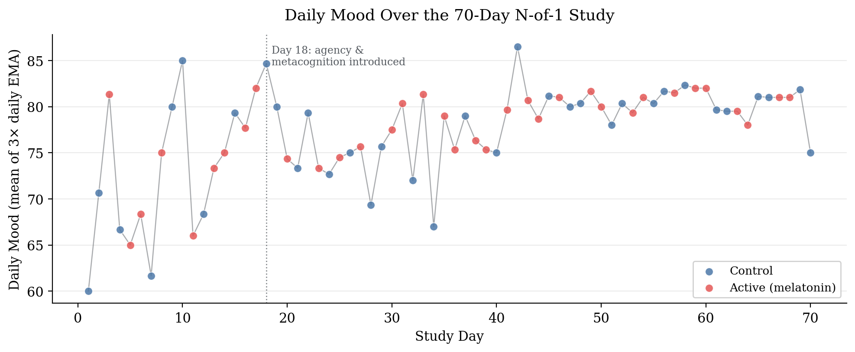
Figure 1. Daily mean mood across the 70-day window.
Note. Each dot represents the average of up to three EMA observations on that day, colored by daily condition (control or melatonin). The light gray line connects daily means; the dotted vertical line at Day 18 marks the point at which agency and metacognition items were added to the protocol.
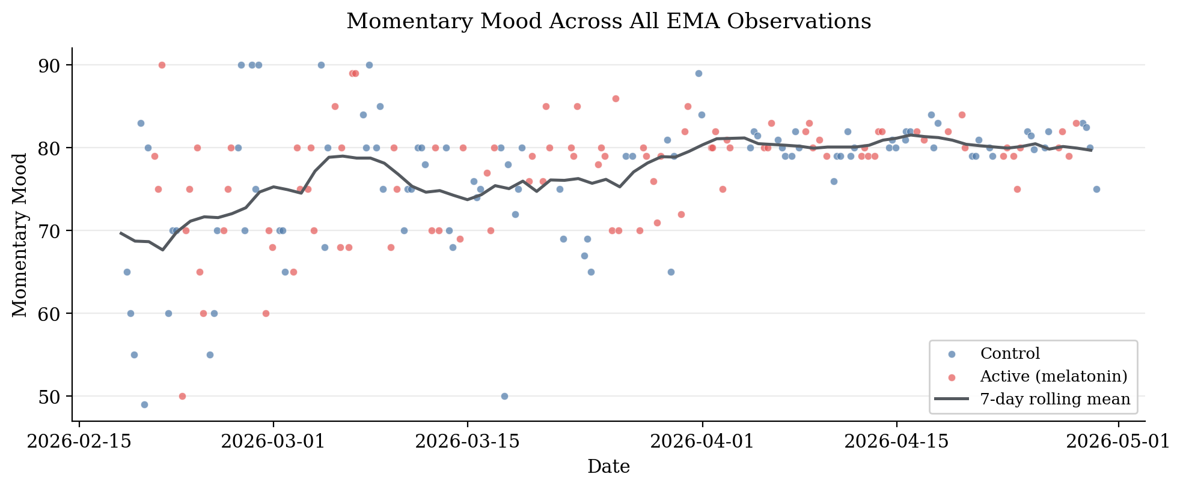
Figure 2. All momentary mood observations with 7-day rolling mean.
Note. All 193 scheduled momentary mood observations are colored by daily condition. The dark line shows the 7-day rolling mean, indicating a gradual upward trend that stabilizes from approximately Day 40 onward.

3.2 Internal Drivers as Primary Predictors of Daily Mood
Three nested autoregressive models were fit to daily mean mood on the Day 18–70 subsample (n = 53 days; Table 1). The baseline AR(1) model (M0) yielded φ = 0.33, 95% CI [0.06, 0.60], p = .016, accounting for 10.9% of the variance in daily mood and confirming the presence of day-to-day emotional inertia. Adding the melatonin probe (M1) increased explained variance only marginally (R² = 0.116, ΔR² = 0.007; β = 0.62, 95% CI [−1.35, 2.60], p = .530). Adding the two internal drivers (M2) increased explained variance dramatically (R² = 0.644, adjusted R² = 0.614).
In the full M2 model, agency emerged as a strong positive predictor of daily mood (β = 0.52, 95% CI [0.32, 0.73], p < .001), as did metacognition (β = 0.46, 95% CI [0.23, 0.69], p < .001). The melatonin coefficient was estimated near zero (β = −0.09, 95% CI [−1.38, 1.20], p = .886). The autoregressive coefficient flipped sign in the full model and was no longer reliably distinguishable from zero (β = −0.15, 95% CI [−0.36, 0.06], p = .156). This suggests that the apparent emotional inertia detected by M0 was substantially absorbed by the two internal drivers once they were included as predictors. Collinearity diagnostics did not indicate problematic collinearity as an alternative account of that change: variance inflation factors in M2 stayed below 1.8 for every predictor (highest 1.73, for metacognition), and the condition number of the standardized predictor matrix was 2.22.
Table 1. Coefficient estimates for nested autoregressive models of daily mood.
Term | β | SE | 95% CI | p
M0: Intercept | 52.54 | 10.42 | [31.63, 73.45] | < .001
M0: moodₜ₋₁ | 0.33 | 0.13 | [0.06, 0.60] | .016
M1: Intercept | 52.26 | 10.49 | [31.20, 73.33] | < .001
M1: moodₜ₋₁ | 0.33 | 0.13 | [0.06, 0.60] | .017
M1: melatonin | 0.62 | 0.98 | [−1.35, 2.60] | .530
M2: Intercept | 13.12 | 8.24 | [−3.45, 29.69] | .118
M2: moodₜ₋₁ | −0.15 | 0.10 | [−0.36, 0.06] | .156
M2: melatonin | −0.09 | 0.64 | [−1.38, 1.20] | .886
M2: agency | 0.52 | 0.10 | [0.32, 0.73] | < .001
M2: metacognition | 0.46 | 0.12 | [0.23, 0.69] | < .001
Note. All models fit on the Day 18–70 subsample (n = 53 days). M0: R² = .109, adjusted R² = .091. M1: R² = .116, adjusted R² = .081. M2: R² = .644, adjusted R² = .614. Predictors are on their original 0–100 scales. M2 residuals showed no remaining serial dependence (Ljung–Box p = .157, .527, and .354 at lags 1, 5, and 10) and were approximately normal (Shapiro–Wilk W = 0.98, p = .393).
The drop-one incremental R² comparison made the magnitudes of these contributions directly comparable (Figure 3). Agency uniquely accounted for 19.6% of the variance in daily mood beyond what the other predictors in M2 captured; metacognition uniquely accounted for 11.7%; melatonin uniquely accounted for 0.02%. The internal-driver block (agency and metacognition jointly) accounted for 52.8% of the variance beyond the autoregressive-plus-melatonin model (M1), raising R² from .116 (M1) to .644 (M2). Because agency and metacognition are themselves correlated, this joint contribution exceeds the sum of their unique drop-one contributions (19.6% and 11.7%); the difference reflects variance the two share.
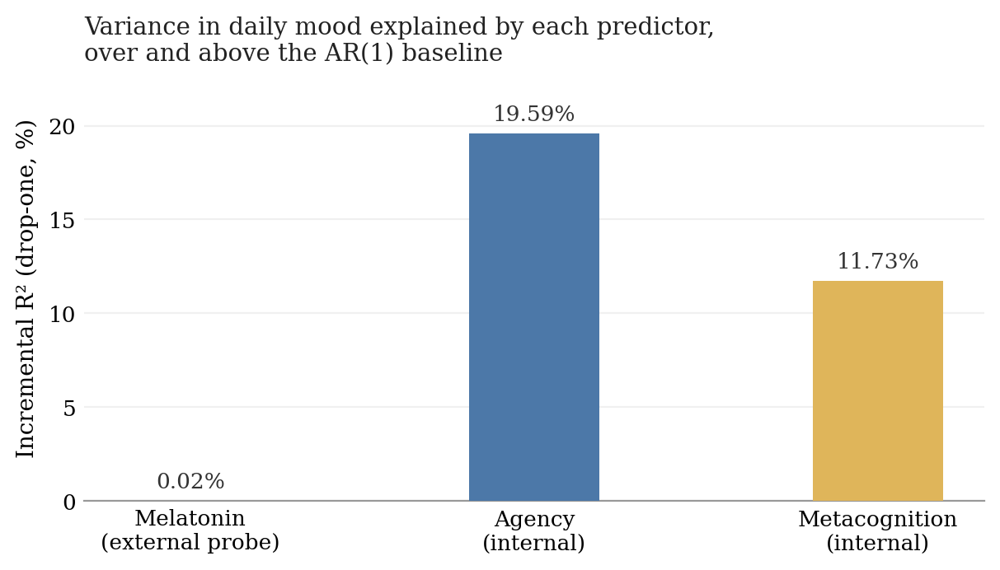
Figure 3. Incremental R² for each predictor in the AR(1) model.
Note. Incremental R² is computed as the drop in R² when that predictor is removed from the full AR(1)-with-exogenous-inputs model. Agency and metacognition together account for over half of the day-to-day variance in mood; the melatonin probe accounts for essentially none.

3.3 The Probe: A Bounded Null on the Mean, a Suggestive Signal on Variability
Consistent with the M1 result above, the between-condition comparison of daily mean mood yielded a small and non-significant difference: melatonin minus control = +0.86 mood points, Welch t(60.4) = 0.66, p = .514, Cohen’s d = 0.16 (Figure 4). A two one-sided tests (TOST) equivalence procedure sharpened this null: the 90% confidence interval for the mean difference, [−1.34, +3.06] points, fell within the analysis-defined ±5-point bound, establishing equivalence at that bound (TOST p = .001). At a tighter 3-point bound the interval was not fully contained and equivalence was not established (p = .055). The data therefore bound the melatonin mean effect to at most roughly +3 points on the high side, a bound the interval itself supplies.
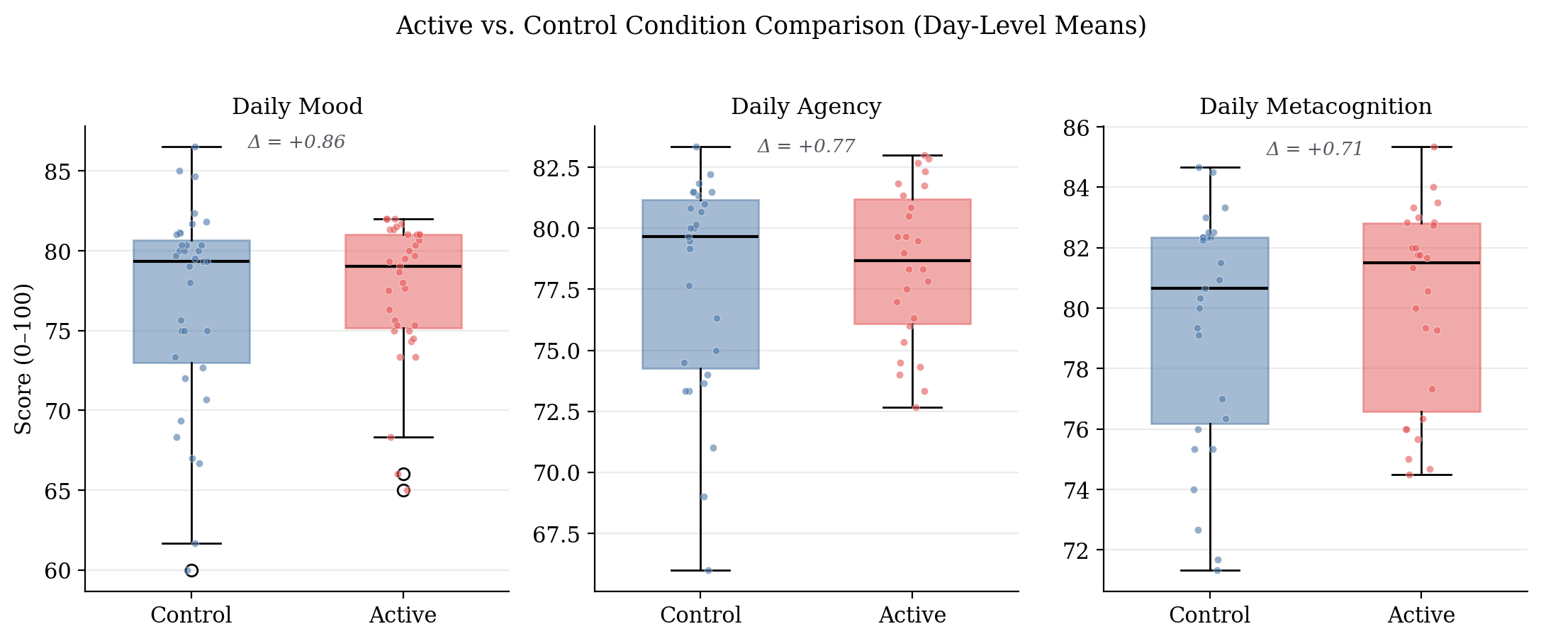
Figure 4. Between-condition comparison of daily mood, agency, and metacognition.
Note. Boxes show interquartile range; horizontal lines show medians; jittered points show individual days. Mean differences (melatonin minus control) are annotated within each panel and are small for all three variables.
The variability analyses gave a more nuanced picture. Three descriptive indices pointed the same way, with melatonin days showing lower mood variability than control days: daily mood SD was 4.42 against 6.41, MSSD across within-condition runs was 57.36 against 88.26, and observation-level mood SD was 6.55 against 8.26. The univariate Levene and MSSD tests did not reach significance; full statistics are in Appendix C. The model-based heteroskedasticity analysis, regressing log-squared M2 residuals on the melatonin indicator, pointed in the same direction but did not reach conventional significance either (α₁ = −1.24, p = .149). A state-dependent decay analysis was direction-consistent as well, with faster estimated decay on melatonin days, though its interaction coefficient also spanned zero; full estimates are in Appendix C.
Taken together, the probe moved the level of this system by an amount the design can bound, and it may have moved the stability of the system, on evidence that is consistent in direction across four tests and short of conventional significance in each.

3.4 Robustness and Secondary Analyses
The primary comparison was reproduced without daily aggregation. A multilevel re-analysis of all 142 momentary observations again placed both internal-state predictors far above the probe (agency β = 0.34, metacognition β = 0.48, both p < .001; melatonin β = −0.05, p = .937; Table B.1). The two exchange rank at this resolution, with metacognition the larger of the pair, so the ordering that holds throughout is between the internal block and the probe rather than within the block. An unconditional model placed approximately 31% of the variance in momentary mood between days (ICC = .31 in the full sample, .25 in the analysis window). The three daily prompts are therefore not independent observations and require either aggregation or an explicit nesting term; the within-day variance that daily aggregation sets aside is the larger share.
Two further checks bear on the interpretation of the main result. The agency by melatonin interaction provided no evidence that the agency to mood association differed between conditions (β = −0.06, 95% CI [−0.42, +0.30], p = .756). The metacontrol interaction, treated here as exploratory, was negative as predicted but not reliably distinguishable from zero; simple slopes are in Appendix C.
Emotional inertia was positive at both sampling resolutions, with an observation-level φ of 0.23, 95% CI [0.09, 0.36], and a daily-level φ of approximately 0.42 on the full sample (Figure A.1). The two do not stand in the relation φ_day = φ_obs³ that a single first-order process would imply, so the AR(1) description should be read as resolution-specific. A local-level state-space decomposition of the daily series, the associated impulse response functions and half-lives, and the smoothed latent trajectory are reported in Appendix A (Figures A.2 and A.3).

4. Discussion

4.1 Internal Behavioral State as the Dominant Predictor of Daily Affect
The most informative finding in this study is the magnitude of the internal-driver contribution. Daily perceived agency contributed an incremental 19.6% of variance to the daily-mood model after accounting for emotional inertia, the external probe, and metacognitive awareness. Daily metacognition contributed an incremental 11.7% under the same controls. Both effects were estimated with narrow confidence intervals and were reliably distinguishable from zero, and the internal-over-probe contrast persisted in a multilevel re-analysis that did not aggregate to days.
This pattern fits the theoretical commitments developed in Section 1.2. Bandura’s (2001) characterization of persons as proactive, self-organizing and self-regulating agents receives individual-level empirical support here: the same person whose mood was largely insensitive to a daily pharmacological probe showed strong day-to-day mood responsiveness to her own sense of intentional progress. Carver and Scheier’s (1990) control-process account, in which affect tracks the perceived rate of progress toward active goals, is consistent with the size and sign of the agency coefficient.
The agency by melatonin robustness check is consistent with this reading. That interaction provided no evidence that the agency to mood association differed between conditions, so nothing in these data indicates that the contribution of agency to daily mood depends on whether the participant had taken melatonin. The interval is too wide to establish that the two associations are equal.
Metacognition behaved more simply than predicted. As a main-effect predictor it contributed reliably to daily mood, suggesting that the system’s read-out of its own state is bound up with that state. The metacontrol prediction, that higher metacognition would buffer the system against external perturbation, was direction-consistent but did not reach significance. It is reported here as exploratory, and the estimates are in Appendix C.

4.2 Interpreting the Probe Result
The most direct empirical question, whether melatonin shifts average daily mood, yielded a small and statistically non-significant mean difference. The evidential question set out in Section 2.3 is how the probe’s contribution compares in magnitude with the system’s endogenous drivers. The drop-one decomposition in Section 3.2 answers it directly: agency’s unique contribution was 19.6% of daily-mood variance, and the probe’s was 0.02%, indistinguishable from zero.
The interval is what turns this into a result. Section 3.3 places the effect at no more than about three points on the high side, and small effects in either direction remain compatible with it; fifty-three days of full-model data cannot exclude a shift that a higher-powered design would detect. A bounded null of this kind constrains what the system can be doing, where an unqualified null would report only a failure to detect.
The variability analyses point somewhere the mean analysis does not reach. The direction-consistent pattern reported in Section 3.3 is the one melatonin’s pharmacology predicts. Melatonin is a chronobiotic whose primary function is the entrainment and stabilization of circadian rhythm, and an agent that stabilizes the timing of the sleep-wake cycle is plausibly one that stabilizes daily affective state without lifting it. A level-only analysis could not have drawn that distinction.

4.3 Limitations
The single-subject design limits external generalizability by construction. The findings cannot be extended to other persons, or to this person at other points in time. Whether this individual exhibits unusually strong internal-driver organization, or whether a comparable contrast between internal and external variance is a general feature of affect under stable environmental conditions, cannot be settled from a single case.
The variability signal carries an inferential caveat of its own. Four significance tests bear on this signal, the Levene, MSSD, heteroskedasticity and state-dependent decay tests, and the strongest of them reached p = .149, so the present analysis cannot rule out that this result is a chance product of multiple testing. It is reported as suggestive, and it would need a design powered for variance effects to be treated as more than that.
Measurement and design impose further constraints. Mood, agency and metacognitive awareness were single-item self-reports collected at the same EMA prompt; single-item momentary measures carry non-trivial measurement error (Dejonckheere et al., 2022). The three internal variables also share an instrument, a reporter, and a response scale that the probe does not. Common-method variance may therefore inflate their apparent contribution, and thrice-daily self-monitoring may itself have heightened the salience of these internal states (Barta et al., 2012; Conner & Reid, 2012). The Day-18 amendment restricts the internal-driver analyses to 53 days, which limits power for interaction tests. Blinding was partial, since the participant knew when she had taken melatonin, and complete blinding is not achievable in self-administered N-of-1 designs. The 3 mg dose was not titrated, and EMA timing was approximate, with delayed responses retained within one hour of the scheduled prompt.
Two inferential limits deserve emphasis because they bear on the central comparison. First, the autoregressive lag in M2 does not resolve contemporaneous endogeneity between mood and the internal drivers. Because the protocol measures all three at the same prompt, the design cannot construct a cross-lagged identification, and the causal direction between affect and the felt sense of intentional progress is untestable here.
Second, the two classes of predictor are not directly comparable in kind. Agency and metacognitive awareness are subjective states measured at the same moment as mood, which places them in a contemporaneous and possibly mutually constitutive relation with it. Melatonin acts on mood only indirectly, through sleep onset and circadian phase, on a slower timescale and through a longer causal chain. A variance comparison between them is therefore a comparison between a proximal and a distal quantity, and the size of the gap reported here should be read with that asymmetry in view.

4.4 Contribution
What this study adds is an individual-level test of a claim usually argued at the population level. In one densely sampled person, the affective trajectory was far more strongly predicted by her own moment-to-moment sense of agency and self-monitoring than by a nightly pharmacological input, and the equivalence interval placed an upper bound on the input’s mean effect. The same design that produced that bound also produced a stability signal that a level-only analysis would have missed, which is an argument for testing pharmacological effects on the dynamics of affective trajectories as well as on their levels.
The apparatus is offered as a template. The pipeline used here, iOS Shortcuts automation with Python validation, a randomization schedule fixed in advance, and open analysis code, is deliberately light enough to be rebuilt by a single person, and nothing in it is specific to melatonin or to affect. Any input that can be scheduled and any state that can be sampled repeatedly can be substituted for the ones used here.
A natural extension is to incorporate objective sleep variables, for example actigraphy as in Knapen et al. (2025), so that the indirect path from melatonin through sleep to mood can be decomposed within the same idiographic framework.

5. Acknowledgments
This manuscript grew out of a course taught by David Lydon-Staley at the University of Pennsylvania. I am grateful for his extensive comments on the interim report that preceded this manuscript, as well as for his recommendation of the Journal for Person-Oriented Research as a venue for this work. I am also deeply grateful to Michael Rovine, whose detailed comments on two earlier drafts substantially strengthened the present version.

6. Funding
This research received no specific grant from any funding agency in the public, commercial, or not-for-profit sectors.

7. Author Contributions
Miura Meng (MM) designed the study, collected the data, performed the statistical analyses, and wrote the manuscript. The author read and approved the final manuscript.

8. Ethics Statement
The University of Pennsylvania Institutional Review Board reviewed this study and determined that it constitutes Not Human Subjects Research, so formal Institutional Review Board approval was not required. The determination was issued by email on May 13, 2026. Determinations of this kind are not assigned an approval number, and the correspondence is available from the author on request. As the sole investigator and sole participant, the author consented to her own participation.

9. Data and Code Availability
Data and analysis code are available at https://github.com/haomeng797-ship-it/n-of-1-melatonin-study. The repository contains the pre-specified randomization schedule with a script that verifies it against the protocol constraints, the Python validation layer, the archived 195-record EMA log, the documented analysis-inclusion rule and the 193-record analytic dataset it produces, and reproducible scripts for the figures and statistical estimates reported here. Documentation and an installable copy of the Shortcut used for data collection are available at https://github.com/haomeng797-ship-it/melatonin-ema-logger. The same repository also contains source code for a native iOS implementation developed after data collection; that application was not used in this study. The constrained-randomization procedure used to generate the schedule was later incorporated into nof1kit (Version 0.1.0; Meng, 2026).

10. Declaration of Interests
The author declares that there is no conflict of interest.

11. References
Bandura, A. (1989). Human agency in social cognitive theory. American Psychologist, 44(9), 1175–1184. https://doi.org/10.1037/0003-066X.44.9.1175
Bandura, A. (2001). Social cognitive theory: An agentic perspective. Annual Review of Psychology, 52, 1–26. https://doi.org/10.1146/annurev.psych.52.1.1
Bandura, A. (2006). Toward a psychology of human agency. Perspectives on Psychological Science, 1(2), 164–180. https://doi.org/10.1111/j.1745-6916.2006.00011.x
Barta, W. D., Tennen, H., & Litt, M. D. (2012). Measurement reactivity in diary research. In M. R. Mehl & T. S. Conner (Eds.), Handbook of research methods for studying daily life (pp. 108–123). Guilford Press.
Bates, D., Mächler, M., Bolker, B., & Walker, S. (2015). Fitting linear mixed-effects models using lme4. Journal of Statistical Software, 67(1), 1–48. https://doi.org/10.18637/jss.v067.i01
Bringmann, L. F., Vissers, N., Wichers, M., Geschwind, N., Kuppens, P., Peeters, F., Borsboom, D., & Tuerlinckx, F. (2013). A network approach to psychopathology: New insights into clinical longitudinal data. PLoS ONE, 8(4), e60188. https://doi.org/10.1371/journal.pone.0060188
Bringmann, L. F., Albers, C., Bockting, C., Borsboom, D., Ceulemans, E., Cramer, A. O. J., Epskamp, S., Eronen, M. I., Hamaker, E., Kuppens, P., Lutz, W., McNally, R. J., Molenaar, P., Tio, P., Voelkle, M. C., & Wichers, M. (2022). Psychopathological networks: Theory, methods and practice. Behaviour Research and Therapy, 149, 104011. https://doi.org/10.1016/j.brat.2021.104011
Carver, C. S., & Scheier, M. F. (1990). Origins and functions of positive and negative affect: A control-process view. Psychological Review, 97(1), 19–35. https://doi.org/10.1037/0033-295X.97.1.19
Carver, C. S., & Scheier, M. F. (1998). On the self-regulation of behavior. Cambridge University Press.
Conner, T. S., & Reid, K. A. (2012). Effects of intensive mobile happiness reporting in daily life. Social Psychological and Personality Science, 3(3), 315–323. https://doi.org/10.1177/1948550611419677
Dejonckheere, E., Demeyer, F., Geusens, B., Piot, M., Tuerlinckx, F., Verdonck, S., & Mestdagh, M. (2022). Assessing the reliability of single-item momentary affective measurements in experience sampling. Psychological Assessment, 34(12), 1138–1154. https://doi.org/10.1037/pas0001178
Efklides, A. (2008). Metacognition: Defining its facets and levels of functioning in relation to self-regulation and co-regulation. European Psychologist, 13(4), 277–287. https://doi.org/10.1027/1016-9040.13.4.277
Eisele, G., Vachon, H., Lafit, G., Kuppens, P., Houben, M., Myin-Germeys, I., & Viechtbauer, W. (2022). The effects of sampling frequency and questionnaire length on perceived burden, compliance, and careless responding in experience sampling data in a student population. Assessment, 29(2), 136–151. https://doi.org/10.1177/1073191120957102
Flavell, J. H. (1979). Metacognition and cognitive monitoring: A new area of cognitive–developmental inquiry. American Psychologist, 34(10), 906–911. https://doi.org/10.1037/0003-066X.34.10.906
Hamaker, E. L. (2012). Why researchers should think “within-person”: A paradigmatic rationale. In M. R. Mehl & T. S. Conner (Eds.), Handbook of research methods for studying daily life (pp. 43–61). Guilford Press.
Houben, M., Van Den Noortgate, W., & Kuppens, P. (2015). The relation between short-term emotion dynamics and psychological well-being: A meta-analysis. Psychological Bulletin, 141(4), 901–930. https://doi.org/10.1037/a0038822
Jahng, S., Wood, P. K., & Trull, T. J. (2008). Analysis of affective instability in ecological momentary assessment: Indices using successive difference and group comparison via multilevel modeling. Psychological Methods, 13(4), 354–375. https://doi.org/10.1037/a0014173
Knapen, S. E., Snippe, E., Smit, A. C., Schoevers, R. A., & Riemersma-van der Lek, R. F. (2025). Sleep disturbances in the prodromal phase of mood episodes in patients with bipolar disorder: A replicated single-case design. Journal for Person-Oriented Research, 11(3), 142–168. https://doi.org/10.17505/jpor.2025.28202
Koval, P., & Kuppens, P. (2012). Changing emotion dynamics: Individual differences in the effect of anticipatory social stress on emotional inertia. Emotion, 12(2), 256–267. https://doi.org/10.1037/a0024756
Kuppens, P., Allen, N. B., & Sheeber, L. B. (2010). Emotional inertia and psychological maladjustment. Psychological Science, 21(7), 984–991. https://doi.org/10.1177/0956797610372634
Kuznetsova, A., Brockhoff, P. B., & Christensen, R. H. B. (2017). lmerTest package: Tests in linear mixed effects models. Journal of Statistical Software, 82(13), 1–26. https://doi.org/10.18637/jss.v082.i13
Lakens, D. (2017). Equivalence tests: A practical primer for t tests, correlations, and meta-analyses. Social Psychological and Personality Science, 8(4), 355–362. https://doi.org/10.1177/1948550617697177
Meng, M. (2026). nof1kit: Design, monitor, and analyze single-case (N-of-1) intensive longitudinal studies (Version 0.1.0) [Computer software]. Comprehensive R Archive Network. https://doi.org/10.32614/CRAN.package.nof1kit
Metcalfe, J., & Greene, M. J. (2007). Metacognition of agency. Journal of Experimental Psychology: General, 136(2), 184–199. https://doi.org/10.1037/0096-3445.136.2.184
Molenaar, P. C. M. (2004). A manifesto on psychology as idiographic science: Bringing the person back into scientific psychology, this time forever. Measurement: Interdisciplinary Research and Perspectives, 2(4), 201–218. https://doi.org/10.1207/s15366359mea0204_1
Molenaar, P. C. M., & Campbell, C. G. (2009). The new person-specific paradigm in psychology. Current Directions in Psychological Science, 18(2), 112–117. https://doi.org/10.1111/j.1467-8721.2009.01619.x
Nelson, T. O., & Narens, L. (1990). Metamemory: A theoretical framework and new findings. In G. H. Bower (Ed.), The psychology of learning and motivation (Vol. 26, pp. 125–173). Academic Press. https://doi.org/10.1016/S0079-7421(08)60053-5
Seabold, S., & Perktold, J. (2010). statsmodels: Econometric and statistical modeling with Python. In Proceedings of the 9th Python in Science Conference (pp. 92–96). https://doi.org/10.25080/Majora-92bf1922-011
Wichers, M. (2014). The dynamic nature of depression: A new micro-level perspective of mental disorder that meets current challenges. Psychological Medicine, 44(7), 1349–1360. https://doi.org/10.1017/S0033291713001979
Wolf, G. I., & De Groot, M. (2020). A conceptual framework for personal science. Frontiers in Computer Science, 2, Article 21. https://doi.org/10.3389/fcomp.2020.00021

Appendix A. Dynamic Structure of the Affective Series
This appendix reports the analyses that characterize the dynamic structure of the daily mood series: emotional inertia at two sampling resolutions, the implied impulse response and half-life, and a local-level state-space decomposition. The methods are given in Sections 2.5.2 and 2.5.3, and they use wider samples than the Day 18–70 primary models: the full 70-day daily series and the timestamp-ordered observation series.
Three estimates of emotional inertia were computed. At the observation level (n = 192 lag-1 pairs across the full 193-observation analytic sample), AR(1) estimation yielded φ_obs = 0.23, 95% CI [0.09, 0.36], p = .002. At the daily level on the full 70-day sample (n = 69 lag-1 pairs), φ_day ≈ 0.42 (OLS point estimate 0.4155). On the Day 18–70 subsample used for the nested-model comparison in Section 3.2 (n = 53), the daily-level coefficient was φ = 0.33 (M0 in Table 1). The two daily-level estimates differ because of the sample window: the first 17 days of mood-only data contribute early variability that the nested-model subsample excludes. The system’s typical daily inertia is best characterized by the full-sample estimate, and the smaller nested-model coefficient should be read as a within-window estimate constrained by data availability. At the observation level a second autoregressive lag was significant (φ₂ = 0.36, 95% CI [0.23, 0.49]), consistent with within-day structure that no single first-order process captures, reinforcing the resolution-specific reading in Section 3.4.
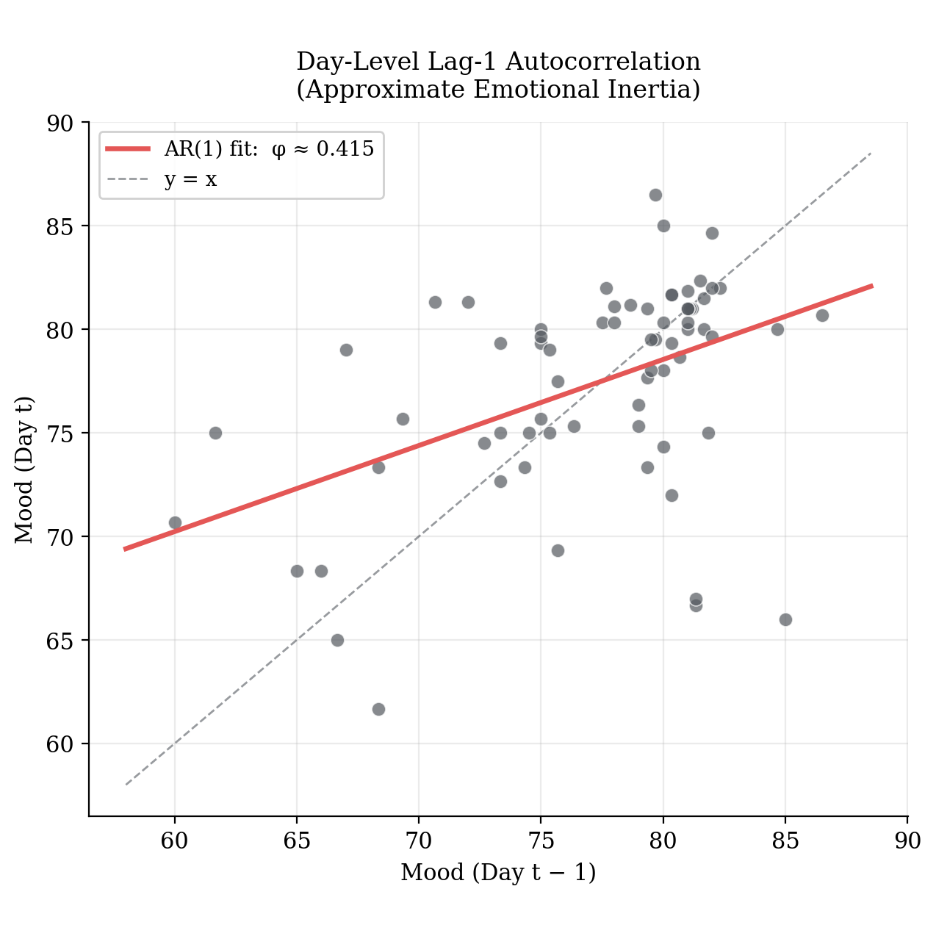
Figure A.1. Lag-1 autocorrelation of daily mood across the 70-day sample.
Note. Each point represents one observation pair (mood at day t plotted against mood at day t − 1). The regression line corresponds to the OLS estimate φ_day ≈ 0.42.
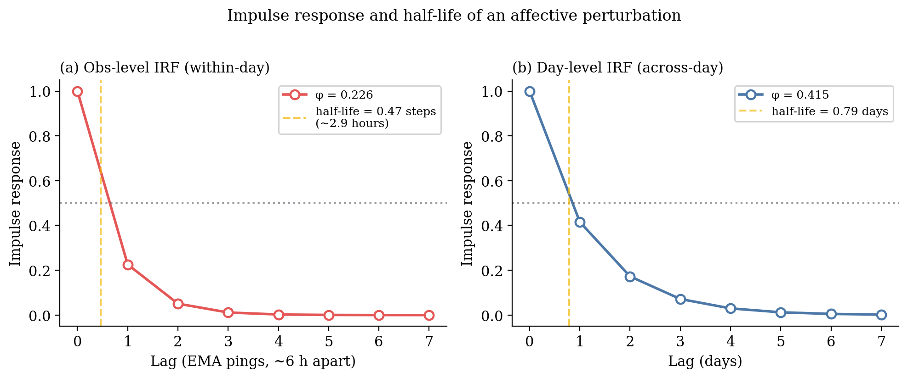
Figure A.2. Impulse response and half-life of an affective perturbation.
Note. Computed from the estimated AR(1) coefficients. Panel (a) shows the observation-level IRF using φ_obs = 0.23, with a within-day half-life of approximately 2.9 hours given a 6.17-hour median between-prompt interval. Panel (b) shows the daily-level IRF using the full-sample coefficient φ_day ≈ 0.42, with a half-life of 0.79 days.
The local-level state-space model decomposed the observed daily series into a smoothed latent trajectory and observation noise. Maximum-likelihood estimates were σ²_v = 17.50 (observation noise) and σ²_w = 1.05 (latent state innovation), implying a signal-to-noise ratio of 0.060. The latent series rises from approximately 70 in the first ten days to approximately 80 by Day 40 and remains in the high 70s thereafter, a slow upward trend across the window that is largely independent of condition assignment.
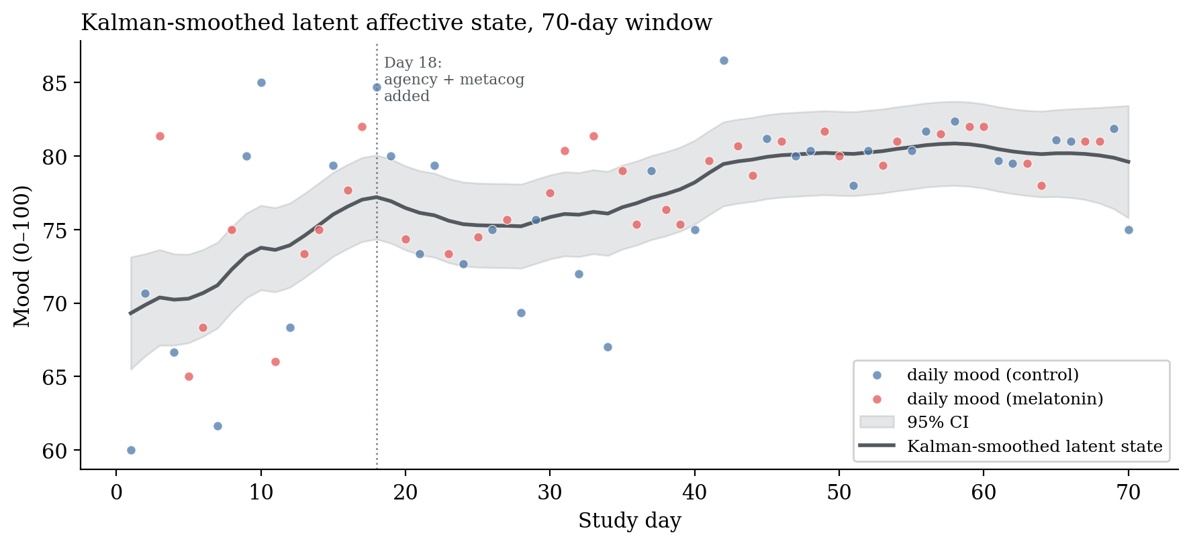
Figure A.3. Kalman-smoothed latent affective state across the 70-day window.
Note. The dark line shows the Kalman-smoothed latent state estimate and the gray band the 95% confidence interval. Daily observed means are plotted as light points for reference.

Appendix B. Multilevel Re-estimation
This appendix reports the multilevel model summarized in Section 3.4, fit to the momentary observations without daily aggregation. The method is given in Section 2.5.9.
Both internal drivers remained reliably positive predictors of momentary mood and the probe remained indistinguishable from zero (Table B.1). The fixed effects jointly accounted for half of the variance in momentary mood (marginal R² = .50); adding the day-level random intercept changed this little (conditional R² = .52), indicating that the internal drivers rather than stable day-level offsets carry most of the explained variance. The momentary coefficients differ in magnitude from the daily-aggregated M2 estimates because the mixed-effects coefficients blend within-day and between-day association, whereas the daily-mean analysis estimated a purely between-day relation. A full within/between decomposition by person-mean centering is left to future work.
Table B.1. Fixed-effect estimates for the multilevel model of momentary mood.
Term | β | SE | 95% CI | p
Intercept | 78.45 | 0.44 | [77.59, 79.31] | < .001
Agency (centered) | 0.34 | 0.06 | [0.22, 0.46] | < .001
Metacognition (centered) | 0.48 | 0.07 | [0.34, 0.62] | < .001
Melatonin | −0.05 | 0.64 | [−1.30, 1.20] | .937
Note. n = 142 momentary observations nested within 53 days (Day 18–70; 27 control, 26 melatonin). Random intercept for day: variance = 0.48; within-day residual variance = 12.93. Marginal R² = .50; conditional R² = .52. Agency and metacognition centered at their sample means (77.94 and 79.57). Fit by REML in lme4; 95% CIs are Wald intervals; p-values use the Satterthwaite approximation.

Appendix C. Secondary Analyses
This appendix reports the analyses referred to in Sections 3.3 and 4.1 as secondary or exploratory: the full variability statistics, the state-dependent decay check, and the metacontrol interaction.

C.1 Full variability statistics
Three descriptive indices of mood variability were computed, with two univariate tests and a model-based heteroskedasticity check. The three descriptive indices pointed the same way, with melatonin days showing lower variability than control days: daily mood SD was 4.42 against 6.41; MSSD across within-condition runs was 57.36 against 88.26; and observation-level mood SD was 6.55 against 8.26. The two univariate tests did not reach conventional significance: the Brown-Forsythe Levene test of homogeneity of variance gave W = 2.07, p = .155, and the MSSD comparison gave Welch t = −0.94, p = .355. The heteroskedasticity model regressing log-squared M2 residuals on the melatonin indicator yielded a negative coefficient that also fell short of conventional significance (α₁ = −1.24, 95% CI [−2.93, +0.46], p = .149), with the point estimate indicating smaller model residual variance on melatonin days.
The collective pattern is direction-consistent across the indices without any single test reaching conventional significance. It is suggestive of a stability-enhancing effect of the probe on the trajectory without a shift in its level, but the inferential support for any single test is modest, and the analysis cannot rule out that the heteroskedasticity result is a chance product of multiple testing.

C.2 State-dependent decay
The method for this analysis is given in Section 2.5.7.
The interaction-augmented AR(1) yielded φ_control = 0.47 and φ_melatonin = 0.22, with a lag-1 by melatonin interaction coefficient of δ = −0.25, 95% CI [−0.79, +0.29], p = .350. The coefficient is not statistically distinguishable from zero. Its direction, faster decay on melatonin days, is consistent with the variability pattern in C.1.

C.3 Metacontrol interaction
The method for this analysis is given in Section 2.5.5.
The interaction term was negative as predicted (β₃ = −0.14) but not reliably distinguishable from zero (95% CI [−0.59, +0.31], p = .540). Simple-slope decomposition placed the melatonin slope at +0.65 at one standard deviation below mean metacognition, +0.14 at the mean, and −0.36 at one standard deviation above. The qualitative pattern is consistent with the hypothesis, since the apparent direction of the melatonin effect reverses across the metacognition continuum, but the sample is underpowered to support this as an inferential claim.

