What organizes daily affect in one person:
A 70-day N-of-1 characterization with a nightly melatonin probe
Miura Meng
July 2026

Abstract
Over 70 days, one adult recorded momentary emotional valence, perceived agency, and metacognitive awareness three times a day, and took 3 mg of melatonin on the nights assigned by a pre-generated randomized schedule, giving 195 observations at 92.9% compliance across 35 control and 35 melatonin days. Melatonin left mean daily mood essentially unchanged: the difference was +0.92 points on a 0 to 100 scale, d = 0.17, and an equivalence test placed it inside a pre-specified bound of five points, which gives the null a stated width. What moved with mood was the person’s own regulatory state. Perceived agency and metacognitive awareness together accounted for a further 51.5% of daily-mood variance beyond autoregressive carryover and the probe, lifting model R² from .125 to .641, and the same ordering held under Bayesian and multilevel re-estimation. The comparison is between predictors of different kinds: agency and metacognition were self-reported alongside mood, while melatonin acts on it only indirectly through sleep. One signal ran the other way, though only suggestively: residual variance was smaller on melatonin nights, compatible with a chronobiotic effect on stability while level is untouched. The individual is modeled here as a dynamical system and melatonin as a probe, used to map where that system responds and where it does not. The estimates are idiographic and are not offered as population effects. The procedure transfers even where the numbers do not: any variable that can be sampled repeatedly can take the place of the ones used here.
Keywords: N-of-1; ecological momentary assessment; dynamical systems; autoregressive model; idiographic; personal science; intensive longitudinal data; affect dynamics

1. Introduction

1.1 What Organizes One Person’s Daily Affect?
A common implicit model in mood-intervention research is that affect improves when beneficial inputs are added: better sleep, less stress, optimized nutrition, pharmacological support. Mood becomes a passive output of external conditions, and intervention becomes a question of which conditions to optimize. That frame is productive at the population level, and the present study does not contest it there. What it contests is the assumption that the same frame should organize an individual person’s account of her own affective dynamics.
An alternative account holds that affective states are organized primarily by internal behavioral dynamics: by the degree to which the individual is acting intentionally, making progress toward goals, and maintaining awareness of her own state. On this view mood is closer to a signature of how well the behavioral system is functioning as a self-regulating agent than to a readout of what has been added to it. These two accounts make different predictions about what a dense record of one person’s days should look like, and that difference is testable within the person.
This study puts them side by side in a single individual sampled three times daily for 70 days, with a nightly melatonin probe delivered on a pre-generated randomized schedule. The prediction that follows from the internal-dynamics account is parsimonious: the affective trajectory should be more strongly predicted by moment-to-moment variation in agency and metacognitive awareness than by the external probe. The account does not predict that external probes do nothing. It predicts that their effect is small relative to the system’s own self-regulatory machinery, and that whatever effect exists may appear in features of the trajectory other than its mean level.

1.2 Two Theoretical Commitments
The internal-dynamics account is grounded here in two commitments.
The first is that perceived agency, the felt sense of intentional goal-directed action, is a primary internal driver of affective state. This draws on Bandura’s (1989, 2001, 2006) social cognitive theory of human agency, in which persons exercise causal influence over their own functioning through intentional, self-regulating action, and on Carver and Scheier’s (1990, 1998) control-process model, which specifies that affect is generated by the perceived rate of progress toward active goals.
The second is that metacognitive awareness, the system’s read-out of its own internal state, both predicts mood and modulates responsiveness to external perturbation. Flavell (1979) defined metacognition as cognition about cognition; Efklides (2008) drew the construct closer to affective experience by showing how metacognitive experiences are themselves affectively colored. Metacognition is operationalized here using the monitoring-control framework of Nelson and Narens (1990), in which a metalevel system continuously reads and regulates object-level processes.
Both constructs carry divergent meanings across traditions, so their scope here is delimited. Agency is used only as the participant’s moment-to-moment phenomenological sense of intentional progress toward immediate task goals, a signal the system tracks and reports. It is not used in its sociological sense of acting within social structure (Giddens, 1984), nor in the philosophical sense concerning the veridicality of felt authorship (Wegner, 2002; Synofzik et al., 2008). Metacognition is likewise restricted to in-the-moment self-monitoring in the Nelson and Narens sense.

1.3 Why a Single Person, and Why a Probe
Two design choices follow from the question, and both depart from convention.
The first is the unit of analysis. Conventional intervention research averages treatment effects across samples, on the assumption that an individual’s response is a noisy realization of a population-level signal. As an inferential strategy for population claims that logic is sound. It does not carry down to the individual: group-level estimates are not generally informative about individual-level processes unless strong ergodicity conditions hold, which for psychological processes they typically do not (Molenaar, 2004; Molenaar & Campbell, 2009). A person is a system with its own organizational logic, dynamic parameters, and sensitivity boundaries, and the question of how that system responds can only be answered within it. The present study therefore adopts the logic of personal science (Myin-Germeys & Kuppens, 2022) and idiographic behavioral science (Molenaar, 2004), treating one individual as the unit of analysis in her own right.
The second is what the melatonin is for. Standard intervention logic treats an external input as a lever: pull it, observe the outcome, read the effect size as the lever’s causal force. Dynamical systems accounts of affect describe something different. An external input perturbs a self-organizing system, which then responds according to its own internal structure, its inertia, its attractor states, and its sensitivity to inputs of particular magnitude and timing (Bringmann et al., 2013, 2022; Hamaker, 2012; Wichers, 2014). The response is informative primarily about the system, and only secondarily about the perturbation. Affective dynamics research gives this specificity: day-to-day mood variation is partly organized by autoregressive carryover, often termed emotional inertia, and the capacity of a system to be perturbed at all is itself a meaningful individual difference (Houben, Van Den Noortgate, & Kuppens, 2015; Koval & Kuppens, 2012; Kuppens, Allen, & Sheeber, 2010).
This carries a methodological consequence that matters for how the results below should be read. A small or non-significant probe effect is a system-identification result, not a design failure. The conventional reading, that the design lacked power, presupposes a framework in which the intervention is a treatment whose efficacy is being assayed. That is not the framework here. The evidential question is where this system is sensitive and where it is not, and a probe that moves nothing on the mean has located one of those boundaries, provided the bound itself is estimated. Section 2.5.11 states how that bound was obtained. The control-theoretic vocabulary used here, including the language of system identification, is intended in an analytic and conceptual sense, as a way of organizing dynamical questions about a single person across time. It is not a claim that these analyses estimate engineering transfer functions or recover a closed-form physical plant model.

1.4 Research Questions
Primary. In this individual behavioral system, do internal drivers, specifically moment-to-moment agency and metacognitive awareness, account for substantially more of the affective trajectory than a discrete external perturbation does? This is the question the completed 70-day record is best positioned to answer, and it treats a small pharmacological effect as a system-identification result: evidence that this system is more sensitive to internal self-regulatory variation than to an external probe of this magnitude.
Probe. Within a continuous hormonal-contraceptive background condition, does melatonin administration meaningfully shift average momentary emotional valence? Melatonin is widely consumed as a chronobiotic and sleep aid and is sometimes assumed to lift mood as well. The present design tests that assumption at the individual level, in a system where the cyclical hormonal contribution to affect has been pharmacologically stabilized. It also estimates a bound on that effect, which a significance test alone would not provide.
Exploratory. Does metacognitive awareness moderate the system’s sensitivity to the probe? A buffering interaction would indicate that monitoring one’s own state changes the system’s functional coupling to external inputs, a higher-order regulatory property not captured by main effects (Metcalfe & Greene, 2007). This question is exploratory: the design was not powered for an interaction of the expected size, and it is reported as such.

1.5 Study Origin and Analytic Reframing
This study began as a course project in single-case experimental design, for which the participant designed a randomized N-of-1 alternating-treatment experiment with three-times-daily EMA sampling. The complete 70-day randomization schedule was generated from a pre-specified algorithm and fixed in a stored protocol file before any data were collected (Section 2.3). At the course deadline only the first 44 days were available, and the course-required analysis reported that interim window under a between-condition framework, using a mean comparison and Monte Carlo randomization inference.
The present paper analyzes the complete 70-day protocol and asks a different question of it. The original question concerned an average intervention effect. The present one concerns the dynamic structure of the system, and how internal and external drivers contribute to it. The research questions in Section 1.4 took their present form during that reframing, after the interim window had been seen. The design, the randomization schedule, and the sampling protocol were fixed beforehand; the analytic framing was not, and it is reported here as reframing, with no claim of preregistration attached to it. Two protocol features follow from the study’s origin and are detailed in the Method: agency and metacognitive awareness items were added on Day 18 (Section 2.4), and the background hormonal condition was continuous throughout (Section 2.2).

2. Methods

2.1 Participants
The participant is the author of this paper. The use of a single-subject design follows the personal science tradition of systematic self-experimentation with rigorous measurement and transparent analysis (Myin-Germeys & Kuppens, 2022). Single-subject designs are appropriate when the research question concerns individual-level processes that are obscured by group averaging (Molenaar, 2004; Molenaar & Campbell, 2009). At the time of data collection, the participant was a 23-year-old graduate student, reported no current psychiatric or other medical diagnoses, and was taking no medication beyond the hormonal contraceptive described in Section 2.2. The University of Pennsylvania Institutional Review Board determined that this study constitutes Not Human Subjects Research (NHSR) and does not require formal IRB approval (email determination, May 13, 2026). As the sole investigator and sole participant, the author consented to her own participation.

2.2 Background Condition
The participant has been taking a continuous hormonal contraceptive (drospirenone/ethinyl estradiol; trade name YAZ) for an extended period prior to and throughout the study, prescribed for the management of premenstrual mood symptoms. This pharmacological background creates a stable hormonal regime, suppressing the cyclical affective fluctuation associated with the natural menstrual cycle. This stabilization is not an intervention in the present study. It is a fixed background parameter that reduces baseline affective noise, increasing the signal-to-noise ratio for detecting effects of the primary manipulation.

2.3 Intervention
Melatonin (3 mg, standard over-the-counter formulation) was administered before sleep on a schedule generated by a pre-specified randomization algorithm. The 70-day schedule was constrained to produce 35 active and 35 control days with no runs longer than two consecutive days in either condition, ensuring within-person crossover for time-series analysis and reducing the risk of carry-over effects from extended runs. The schedule was generated and stored in a JSON protocol file before data collection began and was not accessible to the participant during the EMA logging process; the daily condition was confirmed only after the corresponding evening’s EMA prompt had been completed.
In the present study, melatonin is conceptualized not as a treatment under test but as an analytic probe: a perturbation input of known presence/absence, applied to an otherwise free-running system in order to characterize the system’s response function. The absolute magnitude of the melatonin effect on average mood is not the primary inferential target. The primary targets are (a) the fraction of variance in the system’s affective trajectory accounted for by the probe relative to the system’s endogenous drivers, and (b) whether the probe’s effect appears in features of the trajectory other than the mean, such as variability or decay rate (cf. Section 1.3).

2.4 Procedure and Measurement

Design and sampling
The study employed a 70-day intensive longitudinal N-of-1 alternating-treatment design. Each day was randomly assigned to either an active (melatonin) or control (no melatonin) condition according to the pre-specified schedule described in Section 2.3. Ecological momentary assessment (EMA) prompts were delivered three times per day, at approximately 10:00, 16:00, and 22:00 local time, via automated iOS Shortcuts. The protocol began with the 22:00 evening prompt on the first study day; EMA observations were aggregated to the study day, yielding the planned 35 control and 35 melatonin daily aggregates over the 70-day window (2026-02-18 to 2026-04-29). One study day (Day 44) had EMA pings recorded on two adjacent calendar dates under this evening-start convention; these were aggregated into a single day-level observation (cf. Section 3.1). Compliance and the realized sample are reported in Section 3.1.

Measures
At each EMA prompt, four substantive items and one free-text deviation note were collected. Mood (current emotional state) was rated on a 0–100 visual slider as a single-item measure of momentary affect (Eisele et al., 2022); see the measurement-error note below. Agency (task progress / sense of forward motion) was rated on a 0–100 slider, operationalizing the experiential component of intentional, goal-directed action specified by Bandura (2001) and the proximal cause of affect identified by Carver and Scheier’s (1990) control-process model. Metacognition (awareness of current internal state) was rated on a 0–100 slider, operationalizing in-the-moment self-monitoring in the Nelson and Narens (1990) sense (cf. Section 1.2). Melatonin intake was recorded as a binary indicator (“Did you take melatonin tonight?”) and served as a manipulation check. A free-text override field captured deviation notes for any prompt completed late, manually, or with anomalies.
Prior psychometric work suggests that single-item momentary affect ratings can contain substantial measurement-error variance, with Dejonckheere et al. (2022) estimating error variance at approximately 27%. This motivates cautious interpretation of small effects in the present study.

Day-18 protocol amendment
Of the four substantive measures, mood and the melatonin manipulation check were collected from Day 1 of data collection (2026-02-18). Agency and metacognition items were added on Day 18 (2026-03-07) following an interim review of the protocol, in which the participant determined that the original mood-only design was insufficient to test the internal-versus-external research questions formulated in Section 1.4. All analyses involving agency or metacognition are restricted to Days 18–70. Within this window, the randomized schedule yielded 53 daily aggregates (27 control and 26 melatonin days) and 144 momentary observations; the AR(1) model with lag-1 alignment uses 53 days, with the first day in the window (Day 18) using Day 17's mood as its lag-1 predecessor. Mood-only analyses (descriptive statistics, between-condition mean comparison, and the observation-level AR(1) inertia estimate) use the full 195-observation sample.

Data acquisition pipeline
The data collection pipeline was implemented in iOS Shortcuts as a conditional programming environment, with control flow (variables, conditionals, dictionaries, file I/O) treated as equivalent to any lightweight scripting language. This implementation was developed because standard EMA platforms (Qualtrics, REDCap) introduced too much per-entry friction for a high-frequency, three-times-daily protocol over a 70-day window. Each prompt took approximately 8–12 seconds to complete and appended one row to a CSV file with an ISO-8601 timestamp. A Python validation layer ran after each new entry, performing range checks (mood, agency, and metacognition within 0–100), completeness checks (no required field missing), and duplicate-timestamp checks. Responses were typically completed within minutes of the scheduled prompt and, when delayed, within one hour. Because all entries were timestamped and the primary analyses were conducted either on daily means or on timestamp-ordered observations, these minor response latencies were retained as part of the natural EMA sampling process rather than treated as a separate manual-entry condition. Full pipeline source and validation code are available in the project repository (Section 5).

2.5 Analytic Strategy

2.5.1 Autoregressive model with exogenous inputs
Three nested autoregressive models were fit to daily mean mood. The baseline model (M0) is a first-order autoregression:
moodₜ = α + φ · moodₜ₋₁ + εₜ
Model M1 adds the external probe:
moodₜ = α + φ · moodₜ₋₁ + β₁ · melatoninₜ + εₜ
Model M2 adds the internal drivers:
moodₜ = α + φ · moodₜ₋₁ + β₁ · melatoninₜ + β₂ · agencyₜ + β₃ · metacognitionₜ + εₜ
The autoregressive coefficient φ estimates day-to-day emotional inertia: the degree to which mood persists across consecutive days. Each β estimates the marginal contribution of its predictor over and above the system’s own carryover. Models M1 and M2 were fit on the Day 18–70 subsample (n = 53 days) to ensure that all three models were estimated on identical data, permitting incremental-R² comparison.

2.5.2 State-space model (Kalman filter)
A local-level (random-walk-plus-noise) state-space model was fit to the daily mood series via maximum-likelihood Kalman filtering, with the following structure:
Observation: yₜ = xₜ + vₜ, vₜ ~ N(0, σ²_v)
State: xₜ = xₜ₋₁ + wₜ, wₜ ~ N(0, σ²_w)
The model decomposes observed daily mood into an unobserved latent trajectory (xₜ) and observation noise (vₜ), yielding a smoothed estimate of the underlying affective state and its 95% confidence band. The signal-to-noise ratio σ²_w / σ²_v summarizes how much of the observed daily variation is attributable to genuine latent change versus measurement and sampling noise.

2.5.3 Impulse response and half-life
The impulse response function (IRF) for an AR(1) process is given by IRF(h) = φʰ, and the half-life of an affective perturbation, the number of time steps required for an external impulse to decay to half its initial magnitude, follows directly:
half-life = log(0.5) / log(φ)
The IRF was computed at both the daily level and the observation level. The daily-level estimate used the AR(1) coefficient fit on the full 70-day sample (φ_day, full sample), which provides a more stable estimate of the system’s typical daily inertia than the Day 18–70 nested-model coefficient (φ_day, nested) reported in M0. The observation-level estimate (φ_obs) was fit on the full set of 195 EMA pings, ordered by timestamp; its half-life was converted to physical time using the median between-prompt interval. The choice of sample window for IRF estimation is reported in Appendix A.

2.5.4 Incremental R² comparison
To quantify the internal-versus-external prediction, drop-one incremental R² was computed for each of the three predictors in M2:
ΔR²(predictor) = R²(M2 with predictor) − R²(M2 without predictor)
This decomposition isolates the unique variance each predictor accounts for over and above the others, permitting direct comparison of the magnitudes of the agency and metacognition contributions to the magnitude of the melatonin contribution.

2.5.5 Metacontrol interaction
The metacontrol hypothesis, that metacognitive awareness moderates the system’s responsiveness to external perturbation, was tested by adding a melatonin × metacognition interaction term, with metacognition mean-centered:
moodₜ = α + φ · moodₜ₋₁ + β₁ · melatoninₜ + β₂ · meta_cₜ + β₃ · (melatoninₜ × meta_cₜ) + εₜ
A negative β₃ is predicted by the metacontrol hypothesis: higher metacognition would attenuate the system’s sensitivity to the external probe. Simple slopes for melatonin were computed at −1 SD, the mean, and +1 SD of metacognition.

2.5.6 Affective variability
In addition to the mean-shift analyses above, three indices of mood variability were computed by condition: (a) the standard deviation of daily mood within each condition; (b) the mean squared successive difference (MSSD; Jahng, Wood, & Trull, 2008), computed within contiguous within-condition runs of EMA observations and averaged across runs; and (c) the Brown–Forsythe Levene test of homogeneity of variance across conditions. A complementary heteroskedasticity model was fit by regressing the log-squared residuals from M2 on the melatonin indicator: log(ε²ₜ) = α₀ + α₁ · melatoninₜ + uₜ. A negative α₁ coefficient indicates that the model’s residual variance is smaller on melatonin days than on control days, consistent with a stability-enhancing rather than level-shifting effect of the probe.

2.5.7 State-dependent decay (sensitivity)
To examine whether the AR(1) decay rate itself differs by condition, the M0 specification was augmented with a melatonin × moodₜ₋₁ interaction:
moodₜ = α + φ₀ · moodₜ₋₁ + β · melatoninₜ + δ · (melatoninₜ × moodₜ₋₁) + εₜ
The implied φ in each condition is then φ₀ (control) and φ₀ + δ (melatonin). A negative δ would indicate that perturbations decay faster on melatonin days, that is, that the system recovers more quickly. Given the limited sample size for an interaction of this kind, this analysis is reported as a sensitivity check rather than a primary test.

2.5.8 Robustness check
One robustness check was performed: an agency × melatonin interaction term was added to the M2 framework to test whether the agency–mood relation was robust across conditions. Results are reported in Section 3.4.

2.5.9 Bayesian robustness analysis
As a robustness check, the primary M2 regression (Section 2.5.1) was re-estimated in a Bayesian framework using brms (Bürkner, 2017) in R, with Stan used for MCMC posterior sampling. Continuous variables (mood, lagged mood, agency, metacognitive awareness) were standardized prior to fitting; the melatonin indicator was retained on its original 0/1 scale. Weakly informative priors were placed on the regression coefficients (Normal(0, 1)), the intercept (Student-t(3, 0, 2.5)), and the residual standard deviation (Exponential(1)). Four chains were run for 4,000 iterations each with 1,000 warmup iterations and adapt_delta = 0.95, yielding 12,000 post-warmup posterior draws per parameter. A secondary Bayesian model additionally included a melatonin × metacognition interaction to provide a Bayesian counterpart of the metacontrol test (Section 2.5.5; Appendix C). This analysis is not a replacement for the primary frequentist results; it is a robustness check evaluating whether the posterior pattern reproduces the main conclusion that internal behavioral drivers account for substantially more daily mood variation than the external melatonin probe.

2.5.10 Multilevel (mixed-effects) robustness analysis
The primary models in Section 2.5.1 were fit to daily mean mood, collapsing the up-to-three momentary observations recorded each day into a single value. Although this aggregation stabilizes daily estimates, it discards within-day variation and treats each day as a single observation. As a robustness check on the internal-versus-external comparison, the relation among the internal drivers, the external probe, and mood was therefore re-estimated at the momentary level using a linear mixed-effects model that retained every EMA observation and accounted for its nesting within days. Momentary mood was regressed on momentary agency and momentary metacognitive awareness (both grand-mean-centered) and the day’s melatonin indicator, with a random intercept for day:
moodᵢⱼ = γ₀₀ + γ₁₀ · agencyᵢⱼ + γ₂₀ · metacognitionᵢⱼ + γ₃₀ · melatoninⱼ + u₀ⱼ + eᵢⱼ ,
where i indexes the momentary observation within day j, u₀ⱼ ~ N(0, τ₀₀) is the day-level random intercept, and eᵢⱼ ~ N(0, σ²) is the within-day residual. The random intercept absorbs the between-day dependence that daily aggregation had otherwise handled by collapsing each day to its mean. Models were fit by restricted maximum likelihood in R 4.5 using lme4 (Bates, Mächler, Bolker, & Walker, 2015), with Satterthwaite-approximated p-values from lmerTest (Kuznetsova, Brockhoff, & Christensen, 2017). Between-day clustering was summarized by the intraclass correlation (ICC) from an unconditional model; variance explained was summarized by marginal R² (fixed effects only) and conditional R² (fixed effects plus random intercept). This analysis is restricted to the Day 18–70 window in which agency and metacognition were collected.

2.5.11 Equivalence test for the melatonin mean effect
Because a non-significant mean difference does not by itself establish the absence of a meaningful effect, the melatonin mean effect was also evaluated with a two one-sided tests (TOST) equivalence procedure (Lakens, 2017). A smallest effect size of interest (SESOI) of ±5 points on the 0–100 mood scale was specified as the smallest day-level mean shift judged practically meaningful for this individual, approximately 0.9 of the daily mood standard deviation. The TOST evaluates whether the observed effect is statistically closer to zero than to either equivalence bound, which is equivalent to testing whether the 90% confidence interval of the mean difference falls entirely within the bounds. A tighter ±3-point bound is reported alongside for comparison.

Software
Primary analyses were performed in Python 3.11 using statsmodels (Seabold & Perktold, 2010) for OLS and state-space modeling, scipy.stats for nonparametric tests, and pandas and NumPy for data handling. Figures were produced with matplotlib. Bayesian robustness models were fit in R 4.5 using brms (Bürkner, 2017) with Stan used for MCMC posterior sampling. Analysis code is available in the project repository described in Section 5. The multilevel robustness models (Section 3.4; Appendix B) were fit in R 4.5 using lme4 (Bates et al., 2015) and lmerTest (Kuznetsova et al., 2017). The equivalence test (Section 2.5.11) was computed in R 4.5 using the TOSTER package (Lakens, 2017).

3. Results

3.1 Sample and Descriptive Statistics
Of 210 planned EMA observations across the 70-day study window (2026-02-18 to 2026-04-29), 195 were recorded, yielding a compliance rate of 92.9% (54 study days with three observations, 13 with two, 2 with one, and 1 with five). As described in Section 2.3, the protocol’s 70-day randomized schedule yielded 35 control and 35 melatonin study days (Day 44, whose EMA pings spanned two adjacent calendar dates, was aggregated into a single study-day observation). Within the Day 18–70 window in which agency and metacognition were also collected, 27 control and 26 melatonin days yielded 144 complete observations.
Daily mean mood was high overall (M = 77.13, SD = 5.50), with a range from 60.00 to 86.50 across the 70-day window. By condition, daily mood averaged 76.67 (SD = 6.41) on control days and 77.59 (SD = 4.45) on melatonin days. Daily agency averaged 77.71 (SD = 4.50) on control days and 78.50 (SD = 3.19) on melatonin days. Daily metacognition averaged 79.39 (SD = 3.98) on control days and 80.17 (SD = 3.25) on melatonin days. The descriptive time series of daily mean mood and of all 195 momentary mood observations are shown in Figures 1 and 2, respectively, with melatonin and control days color-coded.
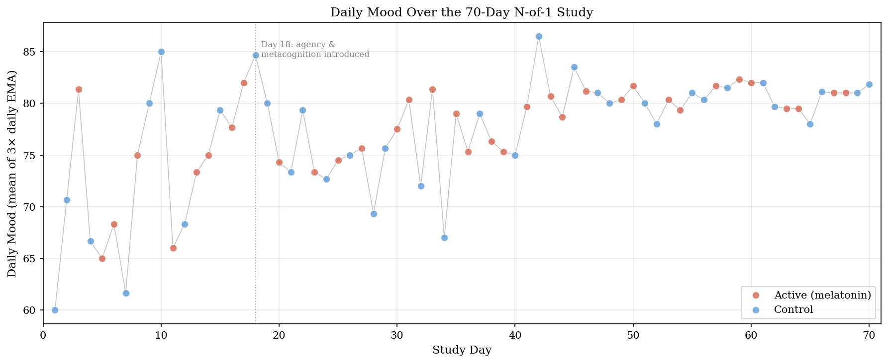
Figure 1. Daily mean mood across the 70-day window.
Note. Each dot represents the average of up to three EMA observations on that day, colored by daily condition (control or melatonin). The light gray line connects daily means; the dotted vertical line at Day 18 marks the point at which agency and metacognition items were added to the protocol.
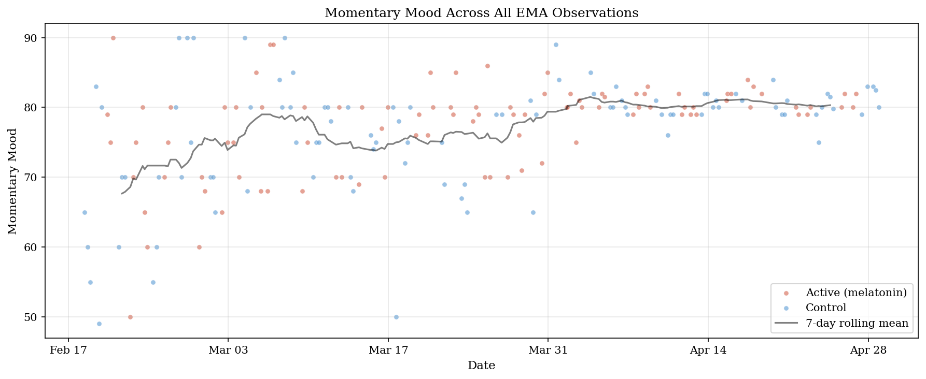
Figure 2. All momentary mood observations with 7-day rolling mean.
Note. All 195 momentary mood observations are colored by daily condition. The dark line shows the 7-day rolling mean, indicating a gradual upward trend that stabilizes from approximately Day 40 onward.

3.2 Internal Drivers as Primary Predictors of Daily Mood
Three nested autoregressive models were fit to daily mean mood on the Day 18–70 subsample (n = 53 days; Table 1). The baseline AR(1) model (M0) yielded φ = 0.34, 95% CI [0.08, 0.61], p = .013, accounting for 11.6% of the variance in daily mood and confirming the presence of day-to-day emotional inertia. Adding the melatonin probe (M1) increased explained variance only marginally (R² = 0.125, ΔR² = 0.009; β = 0.72, 95% CI [−1.25, 2.69], p = .466). Adding the two internal drivers (M2) increased explained variance dramatically (R² = 0.641, adjusted R² = 0.611).
In the full M2 model, agency emerged as a strong positive predictor of daily mood (β = 0.53, 95% CI [0.32, 0.73], p < .001), as did metacognition (β = 0.45, 95% CI [0.22, 0.69], p < .001). The melatonin coefficient was estimated near zero (β = −0.07, 95% CI [−1.37, 1.24], p = .919). The autoregressive coefficient flipped sign in the full model and was no longer reliably distinguishable from zero (β = −0.14, 95% CI [−0.36, 0.07], p = .181), suggesting that the apparent emotional inertia detected by M0 was substantially absorbed by the two internal drivers once they were included as predictors. Collinearity diagnostics rule out variance inflation as an alternative account of that change: variance inflation factors in M2 stayed below 1.8 for every predictor (highest 1.76, for metacognition), and the condition number of the standardized predictor matrix was 2.25.
Table 1. Coefficient estimates for nested autoregressive models of daily mood.
Term | β | SE | 95% CI | p
M0: Intercept | 51.73 | 10.38 | [30.88, 72.58] | < .001
M0: moodₜ₋₁ | 0.34 | 0.13 | [0.08, 0.61] | .013
M1: Intercept | 51.34 | 10.45 | [30.36, 72.32] | < .001
M1: moodₜ₋₁ | 0.34 | 0.13 | [0.08, 0.61] | .013
M1: melatonin | 0.72 | 0.98 | [−1.25, 2.69] | .466
M2: Intercept | 12.75 | 8.29 | [−3.92, 29.41] | .131
M2: moodₜ₋₁ | −0.14 | 0.11 | [−0.36, 0.07] | .181
M2: melatonin | −0.07 | 0.65 | [−1.37, 1.24] | .919
M2: agency | 0.53 | 0.10 | [0.32, 0.73] | < .001
M2: metacognition | 0.45 | 0.12 | [0.22, 0.69] | < .001
Note. All models fit on the Day 18–70 subsample (n = 53 days). M0: R² = .116, adjusted R² = .099. M1: R² = .125, adjusted R² = .090. M2: R² = .641, adjusted R² = .611. Predictors are on their original 0–100 scales. M2 residuals showed no remaining serial dependence (Ljung–Box p > .16 at lags 1, 5, 10) and were approximately normal (Shapiro–Wilk W = 0.98, p = .483).
The drop-one incremental R² comparison made the magnitudes of these contributions directly comparable (Figure 3). Agency uniquely accounted for 19.7% of the variance in daily mood beyond what the other predictors in M2 captured; metacognition uniquely accounted for 11.0%; melatonin uniquely accounted for 0.01%. The internal-driver block (agency and metacognition jointly) accounted for 51.5% of the variance beyond the autoregressive-plus-melatonin model (M1), raising R² from .125 (M1) to .641 (M2). Because agency and metacognition are themselves correlated, this joint contribution exceeds the sum of their unique drop-one contributions (19.7% and 11.0%); the difference reflects variance the two share.
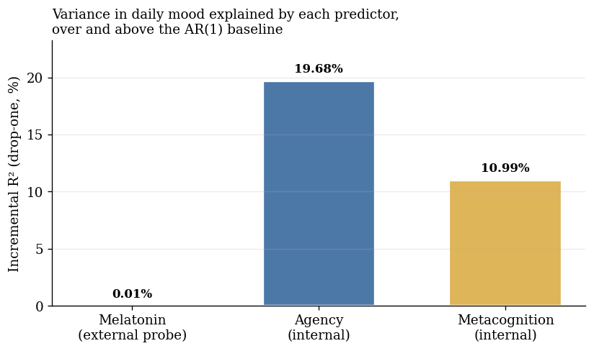
Figure 3. Incremental R² for each predictor in the AR(1) model.
Note. Incremental R² is computed as the drop in R² when that predictor is removed from the full AR(1)-with-exogenous-inputs model. Agency and metacognition together account for over half of the day-to-day variance in mood; the melatonin probe accounts for essentially none.

3.3 The Probe: A Bounded Null on the Mean, a Suggestive Signal on Variability
Consistent with the M1 result above, the between-condition comparison of daily mean mood yielded a small and non-significant difference: melatonin minus control = +0.92 mood points, Welch t(60.6) = 0.70, p = .489, Cohen’s d = 0.17 (Figure 4). A two one-sided tests (TOST) equivalence procedure sharpened this null: the 90% confidence interval for the mean difference, [−1.29, +3.12] points, fell within the pre-specified ±5-point bound, establishing equivalence at that bound (TOST p = .002). At a tighter 3-point bound the interval was not fully contained and equivalence was not established (p = .060). The data therefore bound the melatonin mean effect to at most roughly +3 points on the high side, a bound the interval itself supplies.
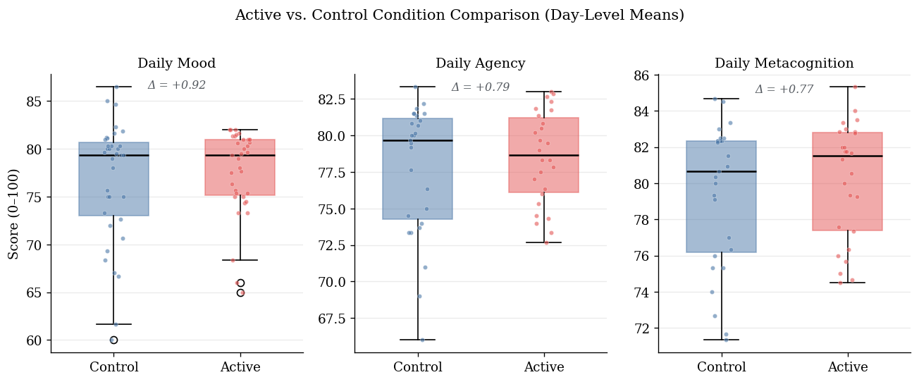
Figure 4. Between-condition comparison of daily mood, agency, and metacognition.
Note. Boxes show interquartile range; horizontal lines show medians; jittered points show individual days. Mean differences (melatonin minus control) are annotated within each panel and are small for all three variables.
The variability analyses gave a more nuanced picture. Three descriptive indices pointed the same way, with melatonin days showing lower mood variability than control days: daily mood SD was 4.45 against 6.41, MSSD across within-condition runs was 57.35 against 88.26, and observation-level mood SD was 6.54 against 8.26. The univariate Levene and MSSD tests did not reach significance; full statistics are in Appendix C. The most powerful test in this set, the heteroskedasticity model regressing log-squared M2 residuals on the melatonin indicator, pointed in the same direction but did not reach conventional significance either (α₁ = −1.11, p = .071). A state-dependent decay analysis was direction-consistent as well, with faster estimated decay on melatonin days, though its interaction coefficient also spanned zero; full estimates are in Appendix C.
Taken together, the probe moved the level of this system by an amount the design can bound, and it may have moved the stability of the system, on evidence that is consistent in direction across four indices and short of conventional significance in each.

3.4 Robustness and Secondary Analyses
The primary comparison was reproduced under two alternative estimation frameworks, reported in full in Appendix B. A supplementary Bayesian regression with weakly informative priors placed the agency and metacognition coefficients clearly above zero (posterior probabilities of essentially 1) and the melatonin coefficient at approximately zero with a credible interval spanning it (Table B1). A multilevel re-analysis of all 144 momentary observations, without daily aggregation, again placed both internal drivers far above the probe (agency β = 0.34, metacognition β = 0.48, both p < .001; melatonin β = 0.04, p = .946; Table B2). The two internal drivers exchange rank at this resolution, with metacognition the larger of the pair, so the ordering that holds throughout is between the internal block and the probe rather than within the block. An unconditional model placed approximately 32% of the variance in momentary mood between days (ICC = .32 in the full sample, .26 in the analysis window), so the three daily prompts are not independent observations and require either aggregation or an explicit nesting term; the within-day variance that daily aggregation sets aside is the larger share.
Two further checks bear on the interpretation of the main result. The agency by melatonin interaction was indistinguishable from zero (β = −0.05, 95% CI [−0.41, +0.31], p = .791), so the agency to mood relation was statistically the same in both conditions and does not depend on the probe. The metacontrol interaction, treated here as exploratory, was negative as predicted but not reliably distinguishable from zero in either the frequentist or the Bayesian estimate; simple slopes and posterior summaries are in Appendix C.
Emotional inertia was positive at both sampling resolutions, with an observation-level φ of 0.23, 95% CI [0.09, 0.37], and a daily-level φ of approximately 0.42 on the full sample (Figure A1). The two do not stand in the relation φ_day = φ_obs³ that a single first-order process would imply, so the AR(1) description should be read as resolution-specific. A local-level state-space decomposition of the daily series, the associated impulse response functions and half-lives, and the smoothed latent trajectory are reported in Appendix A (Figures A2 and A3).

4. Discussion

4.1 Internal Behavioral State as the Dominant Predictor of Daily Affect
The most informative finding in this study is the magnitude of the internal-driver contribution. Daily perceived agency contributed an incremental 19.7% of variance to the daily-mood model after accounting for emotional inertia, the external probe, and metacognitive awareness. Daily metacognition contributed an incremental 11.0% under the same controls. Both effects were estimated with narrow confidence intervals and were reliably distinguishable from zero, and the same ordering survived a Bayesian re-estimation and a multilevel re-analysis that did not aggregate to days.
This pattern fits the theoretical commitments developed in Section 1.2. Bandura’s (2001) characterization of persons as proactive, self-organizing and self-regulating agents receives individual-level empirical support here: the same person whose mood was largely insensitive to a daily pharmacological probe showed strong day-to-day mood responsiveness to her own sense of intentional progress. Carver and Scheier’s (1990) control-process account, in which affect tracks the perceived rate of progress toward active goals, is consistent with the size and sign of the agency coefficient.
The agency by melatonin robustness check strengthens this reading. That interaction was indistinguishable from zero, which means the agency to mood relation was statistically identical in the two conditions. The contribution of agency to daily mood does not depend on whether the participant had taken melatonin, so it is invariant to the presence of the external probe.
Metacognition behaved more simply than predicted. As a main-effect predictor it contributed reliably to daily mood, suggesting that the system’s read-out of its own state is bound up with that state. The metacontrol prediction, that higher metacognition would buffer the system against external perturbation, was direction-consistent in both the frequentist and Bayesian estimates and reached significance in neither. It is reported here as exploratory, and the estimates are in Appendix C.

4.2 Interpreting the Probe Result
The most direct empirical question, whether melatonin shifts average daily mood, yielded a small and statistically non-significant mean difference. Within a hypothesis-testing framework this would be an inconclusive result. The present analysis, however, does not read melatonin as a treatment under test. Section 2.3 states the probe framing adopted in the reframing described in Section 1.5: an input of known presence and absence, applied to characterize the system’s response. On that framing the evidential question is how the probe’s contribution compares in magnitude with the system’s endogenous drivers, and the drop-one decomposition in Section 3.2 answers it directly: agency’s unique contribution was 19.7% of daily-mood variance, and the probe’s was 0.01%, indistinguishable from zero.
The interval is what turns this into a result. Section 3.3 places the effect at no more than about three points on the high side, and small effects in either direction remain compatible with it; fifty-three days of full-model data cannot exclude a shift that a higher-powered design would detect. A bounded null of this kind constrains what the system can be doing, where an unqualified null would report only a failure to detect.
The variability analyses point somewhere the mean analysis does not reach. The direction-consistent pattern reported in Section 3.3 is the one melatonin’s pharmacology predicts. Melatonin is a chronobiotic whose primary function is the entrainment and stabilization of circadian rhythm, and an agent that stabilizes the timing of the sleep-wake cycle is plausibly one that stabilizes daily affective state without lifting it. A level-only analysis could not have drawn that distinction.

4.3 Limitations
The single-subject design limits external generalizability by construction. The findings cannot be extended to other persons, or to this person at other points in time. Whether this individual exhibits unusually strong internal-driver organization, or whether a comparable contrast between internal and external variance is a general feature of affect under stable environmental conditions, cannot be settled from a single case.
The variability signal carries an inferential caveat of its own. Four indices were examined and the strongest of them reached p = .071, so the present analysis cannot rule out that this result is a chance product of multiple testing. It is reported as suggestive, and it would need a design powered for variance effects to be treated as more than that.
Measurement and design impose further constraints. Mood, agency and metacognitive awareness were single-item self-reports collected at the same EMA prompt; single-item momentary measures carry non-trivial measurement error (Dejonckheere et al., 2022). The three internal variables also share an instrument, a reporter, and a response scale that the probe does not, so common-method variance may inflate their apparent contribution, and thrice-daily self-monitoring may itself have heightened the salience of these internal states (Barta et al., 2012; Conner & Reid, 2012). The Day-18 amendment restricts the internal-driver analyses to 53 days, which limits power for interaction tests. Blinding was partial, since the participant knew when she had taken melatonin, and complete blinding is not achievable in self-administered N-of-1 designs. The 3 mg dose was not titrated, and EMA timing was approximate, with delayed responses retained within one hour of the scheduled prompt.
Two inferential limits deserve emphasis because they bear on the central comparison. First, the autoregressive lag in M2 does not resolve contemporaneous endogeneity between mood and the internal drivers. Because the protocol measures all three at the same prompt, the design cannot construct a cross-lagged identification, and the causal direction between affect and the felt sense of intentional progress is untestable here. The estimates are predictive, and they are not causal.
Second, the two classes of predictor are not directly comparable in kind. Agency and metacognitive awareness are subjective states measured at the same moment as mood, which places them in a contemporaneous and possibly mutually constitutive relation with it. Melatonin acts on mood only indirectly, through sleep onset and circadian phase, on a slower timescale and through a longer causal chain. A variance comparison between them is therefore a comparison between a proximal and a distal quantity, and the size of the gap reported here should be read with that asymmetry in view.

4.4 Contribution
What this study adds is an individual-level test of a claim usually argued at the population level. In one densely sampled person, the affective trajectory was organized far more by her own moment-to-moment sense of agency and self-monitoring than by a nightly pharmacological input, and the equivalence interval placed an upper bound on the input’s mean effect. The same design that produced that bound also produced a stability signal that a level-only analysis would have missed, which is an argument for testing pharmacological effects on the dynamics of affective trajectories as well as on their levels.
The apparatus is offered as a template. The pipeline used here, iOS Shortcuts automation with Python validation, a randomization schedule fixed in advance, and open analysis code, is deliberately light enough to be rebuilt by a single person, and nothing in it is specific to melatonin or to affect. Any input that can be scheduled and any state that can be sampled repeatedly can be substituted for the ones used here.
A natural extension is to incorporate objective sleep variables, for example actigraphy as in Knapen et al. (2025), so that the indirect path from melatonin through sleep to mood can be decomposed within the same idiographic framework.

5. Data and Code Availability
Data and analysis code are available at: https://github.com/haomeng797-ship-it/n-of-1-melatonin-study. The repository includes the pre-specified randomization schedule, iOS Shortcuts data-collection pipeline, Python validation layer, cleaned EMA dataset, and reproducible scripts for the figures and statistical estimates reported in this manuscript.

6. Author Contributions
Miura Meng (MM) designed the study, collected the data, performed the statistical analyses, and wrote the manuscript.

7. Declaration of Interests
The author declares no conflict of interest.

8. Acknowledgments
I thank David Lydon-Staley for recommending the Journal for Person-Oriented Research as a venue for this work.

9. Funding
This research received no specific grant from any funding agency in the public, commercial, or not-for-profit sectors.

10. References
Bandura, A. (1989). Human agency in social cognitive theory. American Psychologist, 44(9), 1175–1184. https://doi.org/10.1037/0003-066X.44.9.1175
Bandura, A. (2001). Social cognitive theory: An agentic perspective. Annual Review of Psychology, 52, 1–26. https://doi.org/10.1146/annurev.psych.52.1.1
Bandura, A. (2006). Toward a psychology of human agency. Perspectives on Psychological Science, 1(2), 164–180. https://doi.org/10.1111/j.1745-6916.2006.00011.x
Barta, W. D., Tennen, H., & Litt, M. D. (2012). Measurement reactivity in diary research. In M. R. Mehl & T. S. Conner (Eds.), Handbook of research methods for studying daily life (pp. 108–123). Guilford Press.
Bates, D., Mächler, M., Bolker, B., & Walker, S. (2015). Fitting linear mixed-effects models using lme4. Journal of Statistical Software, 67(1), 1–48. https://doi.org/10.18637/jss.v067.i01
Bringmann, L. F., Vissers, N., Wichers, M., Geschwind, N., Kuppens, P., Peeters, F., Borsboom, D., & Tuerlinckx, F. (2013). A network approach to psychopathology: New insights into clinical longitudinal data. PLoS ONE, 8(4), e60188. https://doi.org/10.1371/journal.pone.0060188
Bringmann, L. F., Albers, C., Bockting, C., Borsboom, D., Ceulemans, E., Cramer, A. O. J., ... & Wichers, M. (2022). Psychopathological networks: Theory, methods and practice. Behaviour Research and Therapy, 149, 104011. https://doi.org/10.1016/j.brat.2021.104011
Bürkner, P.-C. (2017). brms: An R package for Bayesian multilevel models using Stan. Journal of Statistical Software, 80(1), 1–28. https://doi.org/10.18637/jss.v080.i01
Carver, C. S., & Scheier, M. F. (1990). Origins and functions of positive and negative affect: A control-process view. Psychological Review, 97(1), 19–35. https://doi.org/10.1037/0033-295X.97.1.19
Carver, C. S., & Scheier, M. F. (1998). On the self-regulation of behavior. Cambridge University Press.
Conner, T. S., & Reid, K. A. (2012). Effects of intensive mobile happiness reporting in daily life. Social Psychological and Personality Science, 3(3), 315–323. https://doi.org/10.1177/1948550611419677
Dejonckheere, E., Demeyer, F., Geusens, B., Piot, M., Tuerlinckx, F., Verdonck, S., & Mestdagh, M. (2022). Assessing the reliability of single-item momentary affective measurements in experience sampling. Psychological Assessment, 34(12), 1138–1154. https://doi.org/10.1037/pas0001178
Efklides, A. (2008). Metacognition: Defining its facets and levels of functioning in relation to self-regulation and co-regulation. European Psychologist, 13(4), 277–287. https://doi.org/10.1027/1016-9040.13.4.277
Eisele, G., Vachon, H., Lafit, G., Kuppens, P., Houben, M., Myin-Germeys, I., & Viechtbauer, W. (2022). The effects of sampling frequency and questionnaire length on perceived burden, compliance, and careless responding in experience sampling data in a student population. Assessment, 29(2), 136–151. https://doi.org/10.1177/1073191120957102
Flavell, J. H. (1979). Metacognition and cognitive monitoring: A new area of cognitive–developmental inquiry. American Psychologist, 34(10), 906–911. https://doi.org/10.1037/0003-066X.34.10.906
Giddens, A. (1984). The constitution of society: Outline of the theory of structuration. University of California Press.
Hamaker, E. L. (2012). Why researchers should think “within-person”: A paradigmatic rationale. In M. R. Mehl & T. S. Conner (Eds.), Handbook of research methods for studying daily life (pp. 43–61). Guilford Press.
Houben, M., Van Den Noortgate, W., & Kuppens, P. (2015). The relation between short-term emotion dynamics and psychological well-being: A meta-analysis. Psychological Bulletin, 141(4), 901–930. https://doi.org/10.1037/a0038822
Jahng, S., Wood, P. K., & Trull, T. J. (2008). Analysis of affective instability in ecological momentary assessment: Indices using successive difference and group comparison via multilevel modeling. Psychological Methods, 13(4), 354–375. https://doi.org/10.1037/a0014173
Knapen, S. E., Snippe, E., Smit, A. C., Schoevers, R. A., & Riemersma-van der Lek, R. F. (2025). Sleep disturbances in the prodromal phase of mood episodes in patients with bipolar disorder: A replicated single-case design. Journal for Person-Oriented Research, 11(3), 142-168. https://doi.org/10.17505/jpor.2025.28202
Koval, P., & Kuppens, P. (2012). Changing emotion dynamics: Individual differences in the effect of anticipatory social stress on emotional inertia. Emotion, 12(2), 256–267. https://doi.org/10.1037/a0024756
Kuppens, P., Allen, N. B., & Sheeber, L. B. (2010). Emotional inertia and psychological maladjustment. Psychological Science, 21(7), 984–991. https://doi.org/10.1177/0956797610372634
Kuznetsova, A., Brockhoff, P. B., & Christensen, R. H. B. (2017). lmerTest package: Tests in linear mixed effects models. Journal of Statistical Software, 82(13), 1–26. https://doi.org/10.18637/jss.v082.i13
Lakens, D. (2017). Equivalence tests: A practical primer for t tests, correlations, and meta-analyses. Social Psychological and Personality Science, 8(4), 355–362. https://doi.org/10.1177/1948550617697177
Metcalfe, J., & Greene, M. J. (2007). Metacognition of agency. Journal of Experimental Psychology: General, 136(2), 184–199. https://doi.org/10.1037/0096-3445.136.2.184
Molenaar, P. C. M. (2004). A manifesto on psychology as idiographic science: Bringing the person back into scientific psychology, this time forever. Measurement: Interdisciplinary Research and Perspectives, 2(4), 201–218. https://doi.org/10.1207/s15366359mea0204_1
Molenaar, P. C. M., & Campbell, C. G. (2009). The new person-specific paradigm in psychology. Current Directions in Psychological Science, 18(2), 112–117. https://doi.org/10.1111/j.1467-8721.2009.01619.x
Myin-Germeys, I., & Kuppens, P. (Eds.). (2022). The open handbook of experience sampling methodology (2nd ed.). Center for Research on Experience Sampling and Ambulatory Methods Leuven.
Nelson, T. O., & Narens, L. (1990). Metamemory: A theoretical framework and new findings. In G. H. Bower (Ed.), The psychology of learning and motivation (Vol. 26, pp. 125–173). Academic Press.
Seabold, S., & Perktold, J. (2010). statsmodels: Econometric and statistical modeling with Python. In Proceedings of the 9th Python in Science Conference (pp. 92–96).
Synofzik, M., Vosgerau, G., & Newen, A. (2008). Beyond the comparator model: A multifactorial two-step account of agency. Consciousness and Cognition, 17(1), 219–239. https://doi.org/10.1016/j.concog.2007.03.010
Wegner, D. M. (2002). The illusion of conscious will. MIT Press.
Wichers, M. (2014). The dynamic nature of depression: A new micro-level perspective of mental disorder that meets current challenges. Psychological Medicine, 44(7), 1349–1360. https://doi.org/10.1017/S0033291713001979

Appendix A. Dynamic Structure of the Affective Series
This appendix reports the analyses that characterize the dynamic structure of the daily mood series: emotional inertia at two sampling resolutions, the implied impulse response and half-life, and a local-level state-space decomposition. All use the same data as the primary models.
Method
A local-level (random-walk-plus-noise) state-space model was fit to the daily mood series by maximum-likelihood Kalman filtering, with observation equation yₜ = xₜ + vₜ, vₜ ~ N(0, σ²_v), and state equation xₜ = xₜ₋₁ + wₜ, wₜ ~ N(0, σ²_w). The model decomposes observed daily mood into an unobserved latent trajectory and observation noise, yielding a smoothed estimate of the underlying affective state with a 95% confidence band. The signal-to-noise ratio σ²_w / σ²_v summarizes how much of the observed daily variation is attributable to latent change rather than to measurement and sampling noise.
The impulse response function for an AR(1) process is IRF(h) = φʰ, and the half-life of an affective perturbation follows as log(0.5) / log(φ). The IRF was computed at both the daily and the observation level. The daily-level estimate used the AR(1) coefficient fit on the full 70-day sample, which is more stable than the Day 18–70 nested-model coefficient reported as M0. The observation-level estimate was fit on all 195 EMA pings ordered by timestamp, and its half-life was converted to physical time using the median between-prompt interval.
Results
Three estimates of emotional inertia were computed. At the observation level (n = 194 lag-1 pairs across the full 195-observation sample), AR(1) estimation yielded φ_obs = 0.23, 95% CI [0.09, 0.37], p = .001. At the daily level on the full 70-day sample (n = 69 lag-1 pairs), φ_day ≈ 0.42 (OLS point estimate 0.4204). On the Day 18–70 subsample used for the nested-model comparison in Section 3.2 (n = 53), the daily-level coefficient was φ = 0.34 (M0 in Table 1). The two daily-level estimates differ because of the sample window: the first 17 days of mood-only data contribute early variability that the nested-model subsample excludes. The system’s typical daily inertia is best characterized by the full-sample estimate, and the smaller nested-model coefficient should be read as a within-window estimate constrained by data availability.
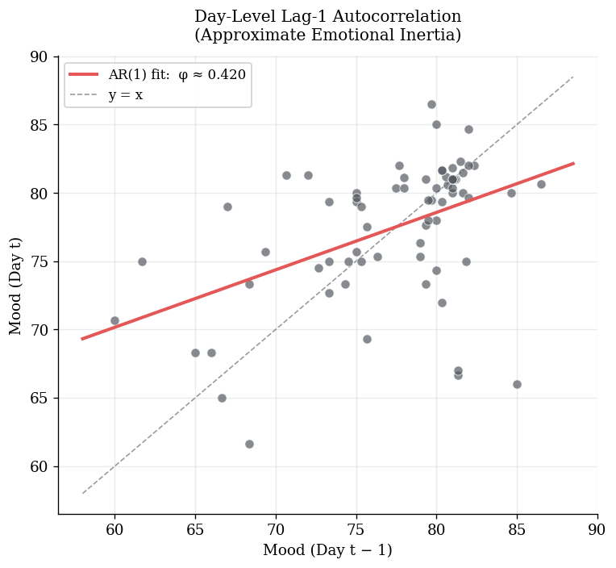
Figure A1. Lag-1 autocorrelation of daily mood across the 70-day sample.
Note. Each point represents one observation pair (mood at day t plotted against mood at day t − 1). The regression line corresponds to the OLS estimate φ_day ≈ 0.42.
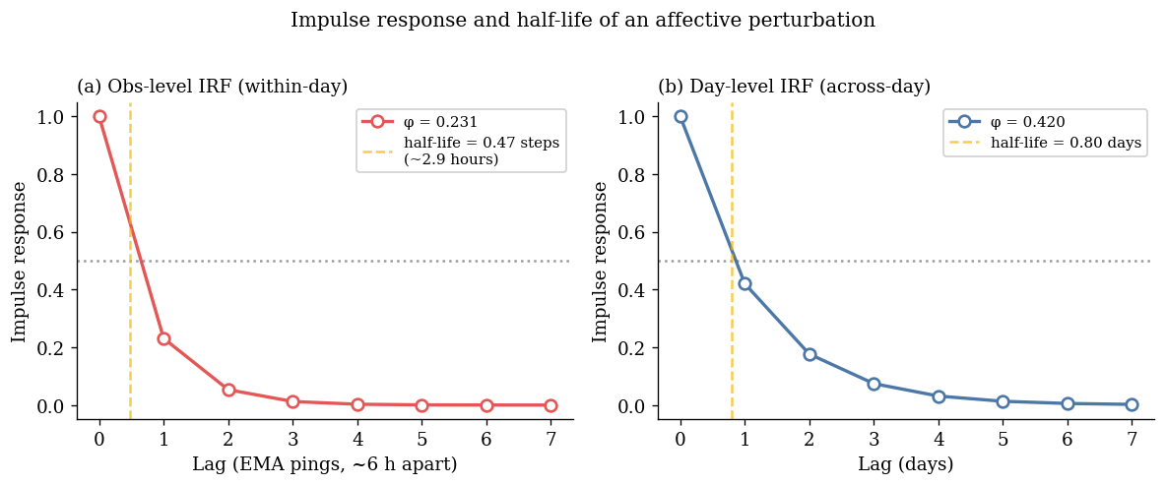
Figure A2. Impulse response and half-life of an affective perturbation.
Note. Computed from the estimated AR(1) coefficients. Panel (a) shows the observation-level IRF using φ_obs = 0.23, with a within-day half-life of approximately 2.9 hours given a 6.17-hour median between-prompt interval. Panel (b) shows the daily-level IRF using the full-sample coefficient φ_day ≈ 0.42, with a half-life of 0.80 days.
The local-level state-space model decomposed the observed daily series into a smoothed latent trajectory and observation noise. Maximum-likelihood estimates were σ²_v = 17.40 (observation noise) and σ²_w = 1.09 (latent state innovation), implying a signal-to-noise ratio of 0.063. The latent series rises from approximately 70 in the first ten days to approximately 80 by Day 40 and remains in the high 70s thereafter, a slow upward trend across the window that is largely independent of condition assignment.
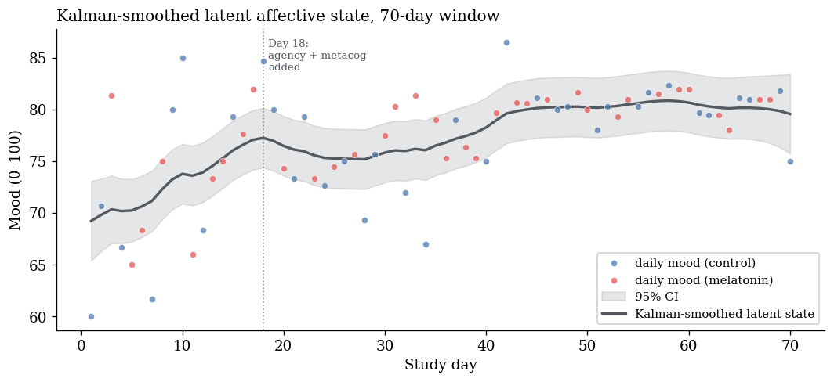
Figure A3. Kalman-smoothed latent affective state across the 70-day window.
Note. The dark line shows the Kalman-smoothed latent state estimate and the gray band the 95% confidence interval. Daily observed means are plotted as light points for reference.

Appendix B. Robustness Re-estimation
This appendix reports the two alternative estimation frameworks summarized in Section 3.4: a Bayesian re-estimation of M2 and a multilevel model fit to the momentary observations without daily aggregation.

B.1 Bayesian re-estimation
Method
The primary M2 regression was re-estimated in a Bayesian framework using brms (Bürkner, 2017) with Stan for MCMC sampling. Continuous variables were standardized before fitting and the melatonin indicator was retained on its 0/1 scale. Weakly informative priors were placed on the regression coefficients (Normal(0, 1)), the intercept (Student-t(3, 0, 2.5)), and the residual standard deviation (Exponential(1)). Four chains were run for 4,000 iterations each with 1,000 warmup iterations and adapt_delta = 0.95, yielding 12,000 post-warmup draws per parameter. A secondary model added a melatonin × metacognition interaction as a Bayesian counterpart of the metacontrol test reported in Appendix C.
Results
The posterior pattern reproduced the frequentist result under different inferential assumptions (Table B1). The agency and metacognition effects were clearly positive in standardized units, with both credible intervals above zero and posterior probabilities of exceeding zero of essentially 1. The melatonin coefficient was centered near zero with a credible interval spanning it. The lagged-mood coefficient was attenuated with a credible interval including zero, consistent with the frequentist M2. All R-hat values were ≤ 1.001 and effective sample sizes exceeded 8,000 for every parameter.
Table B1. Posterior summaries for the Bayesian re-estimation of M2.
Parameter | Posterior M | 95% CrI | Pr(β > 0) | R̂ / ESS_bulk
Intercept | −0.01 | [−0.26, +0.23] | .47 | 1.00 / 11177
mood_t−1 (z) | −0.12 | [−0.33, +0.08] | .12 | 1.00 / 9763
melatonin | +0.02 | [−0.32, +0.35] | .54 | 1.00 / 11204
agency (z) | +0.55 | [+0.34, +0.76] | 1.00 | 1.00 / 9894
metacognition (z) | +0.42 | [+0.20, +0.64] | 1.00 | 1.00 / 9306
σ | +0.64 | [+0.52, +0.78] | n/a | 1.00 / 10011
Note. Day 18–70 subsample (n = 53). Continuous variables standardized; melatonin retained as 0/1. Priors: coefficients ~ Normal(0, 1); intercept ~ Student-t(3, 0, 2.5); σ ~ Exponential(1). Four chains yielded 12,000 post-warmup draws. CrI = equal-tailed credible interval. All R̂ ≤ 1.001; all ESS_tail exceeded 7,000.
The Bayesian metacontrol model yielded a negative posterior mean for the melatonin × metacognition interaction (β = −0.04, 95% CrI [−0.39, +0.31], Pr(β < 0) = .59), consistent in direction with metacognitive buffering but with a credible interval clearly spanning zero.

B.2 Multilevel re-estimation
Method
The primary models were fit to daily mean mood, which discards within-day variation. As a robustness check the relation among the internal drivers, the probe, and mood was re-estimated at the momentary level with a linear mixed-effects model retaining every EMA observation and accounting for its nesting within days: moodᵢⱼ = γ₀₀ + γ₁₀ · agencyᵢⱼ + γ₂₀ · metacognitionᵢⱼ + γ₃₀ · melatoninⱼ + u₀ⱼ + eᵢⱼ, where i indexes the momentary observation within day j, u₀ⱼ ~ N(0, τ₀₀) is the day-level random intercept, and eᵢⱼ ~ N(0, σ²) is the within-day residual. Agency and metacognition were grand-mean-centered. Models were fit by restricted maximum likelihood in R 4.5 using lme4 (Bates et al., 2015) with Satterthwaite-approximated p-values from lmerTest (Kuznetsova et al., 2017). This analysis is restricted to the Day 18–70 window.
Results
Both internal drivers remained reliably positive predictors of momentary mood and the probe remained indistinguishable from zero (Table B2). The fixed effects jointly accounted for half of the variance in momentary mood (marginal R² = .50); adding the day-level random intercept changed this little (conditional R² = .52), indicating that the internal drivers rather than stable day-level offsets carry most of the explained variance. The momentary coefficients differ in magnitude from the daily-aggregated M2 estimates because the mixed-effects coefficients blend within-day and between-day association, whereas the daily-mean analysis estimated a purely between-day relation. A full within/between decomposition by person-mean centering is left to future work.
Table B2. Fixed-effect estimates for the multilevel model of momentary mood.
Term | β | SE | 95% CI | p
Intercept | 78.47 | 0.45 | [77.59, 79.34] | < .001
Agency (centered) | 0.34 | 0.06 | [0.22, 0.47] | < .001
Metacognition (centered) | 0.48 | 0.07 | [0.34, 0.62] | < .001
Melatonin | 0.04 | 0.64 | [−1.22, 1.31] | .946
Note. n = 144 momentary observations nested within 53 days (Day 18–70; 27 control, 26 melatonin). Random intercept for day: variance = 0.74; within-day residual variance = 12.71. Marginal R² = .50; conditional R² = .52. Agency and metacognition centered at their sample means (77.98 and 79.57). Fit by REML in lme4; 95% CIs are Wald intervals; p-values use the Satterthwaite approximation.

Appendix C. Secondary Analyses
This appendix reports the analyses referred to in Sections 3.3 and 4.1 as secondary or exploratory: the full variability statistics, the state-dependent decay check, and the metacontrol interaction.

C.1 Full variability statistics
Four indices of mood variability were computed. Three descriptive indices pointed in the same direction, with melatonin days showing lower variability than control days: daily mood SD was 4.45 against 6.41; MSSD across within-condition runs was 57.35 against 88.26; and observation-level mood SD was 6.54 against 8.26. The two univariate tests did not reach conventional significance: the Brown-Forsythe Levene test of homogeneity of variance gave W = 1.94, p = .168, and the MSSD comparison gave Welch t = −0.94, p = .355. The heteroskedasticity model regressing log-squared M2 residuals on the melatonin indicator yielded a negative coefficient that also fell short of conventional significance (α₁ = −1.11, 95% CI [−2.31, +0.10], p = .071), with the point estimate indicating smaller model residual variance on melatonin days.
The collective pattern is direction-consistent across the indices without any single test reaching conventional significance. It is suggestive of a stability-enhancing effect of the probe on the trajectory without a shift in its level, but the inferential support for any single test is modest, and the analysis cannot rule out that the heteroskedasticity result is a chance product of multiple testing.

C.2 State-dependent decay
Method
To examine whether the AR(1) decay rate itself differs by condition, the M0 specification was augmented with a melatonin × moodₜ₋₁ interaction: moodₜ = α + φ₀ · moodₜ₋₁ + β · melatoninₜ + δ · (melatoninₜ × moodₜ₋₁) + εₜ. The implied φ is φ₀ in the control condition and φ₀ + δ on melatonin days. A negative δ would indicate faster decay of perturbations on melatonin days. Given the sample size available for an interaction of this kind, this analysis is a sensitivity check rather than a primary test.
Results
The interaction-augmented AR(1) yielded φ_control = 0.48 and φ_melatonin = 0.22, with a lag-1 by melatonin interaction coefficient of δ = −0.25, 95% CI [−0.79, +0.28], p = .343. The coefficient is not statistically distinguishable from zero. Its direction, faster decay on melatonin days, is consistent with the variability pattern in C.1.

C.3 Metacontrol interaction
Method
The metacontrol hypothesis, that metacognitive awareness moderates the system’s responsiveness to external perturbation, was tested by adding a melatonin × metacognition interaction with metacognition mean-centered: moodₜ = α + φ · moodₜ₋₁ + β₁ · melatoninₜ + β₂ · meta_cₜ + β₃ · (melatoninₜ × meta_cₜ) + εₜ. A negative β₃ is predicted. Simple slopes for melatonin were computed at −1 SD, the mean, and +1 SD of metacognition.
Results
The interaction term was negative as predicted (β₃ = −0.13) but not reliably distinguishable from zero (95% CI [−0.59, +0.33], p = .564). Simple-slope decomposition placed the melatonin slope at +0.66 at one standard deviation below mean metacognition, +0.17 at the mean, and −0.31 at one standard deviation above. The qualitative pattern is consistent with the hypothesis, since the apparent direction of the melatonin effect reverses across the metacognition continuum, but the sample is underpowered to support this as an inferential claim. The Bayesian counterpart in Appendix B agrees in direction and is likewise inconclusive.
The agency × melatonin robustness check yielded an interaction coefficient indistinguishable from zero (β = −0.05, 95% CI [−0.41, +0.31], p = .791), indicating that the agency-mood relation was statistically identical in the two conditions.

