Manual for Game.

This game is based off of the popular television series The Longest Day in Chang’an, where the protagonist searches through Chang’an to catch terrorists to thwart a terrorist plot. The series was acclaimed for its accurate and vivid portrayal of the Tang Dynasty and its capital. Each grid in this game represents a sector of the city; however, not all sectors are depicted. The game aimed to use a variety of Tang symbols, poetry, and music to recreate this theme.

Objective.
The objective of the game is to successfully apprehend all three terrorists, or 狼卫, using the three different armies. The player will aim to capture all terrorists in the least amount of moves.

How to begin.

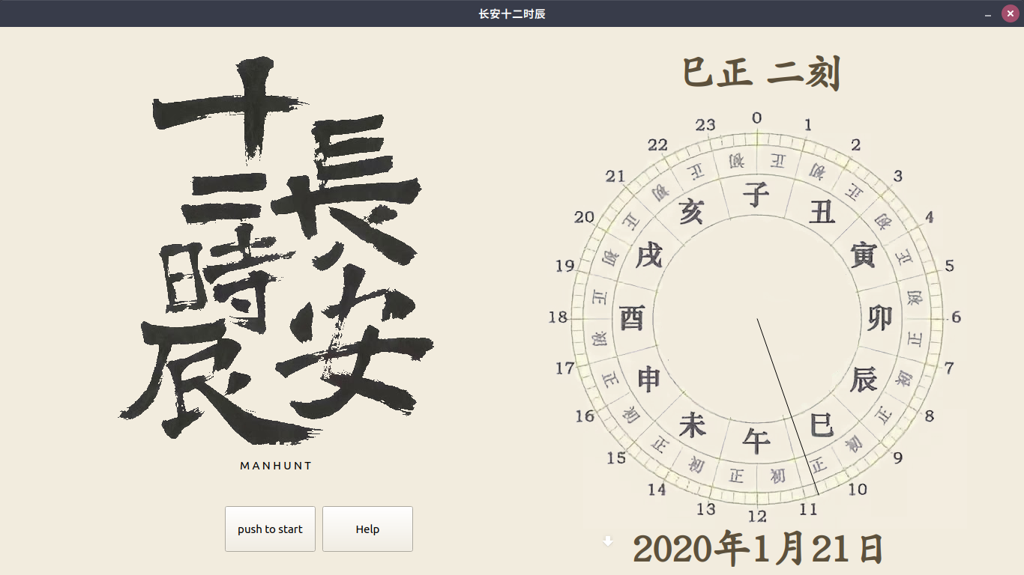
Upon entering the program, there is a start screen. This screen displays the time and date, and also has a help button that reminds players on how the game is played. Once ready, press the start button to continue to the main game.

How to play the game.

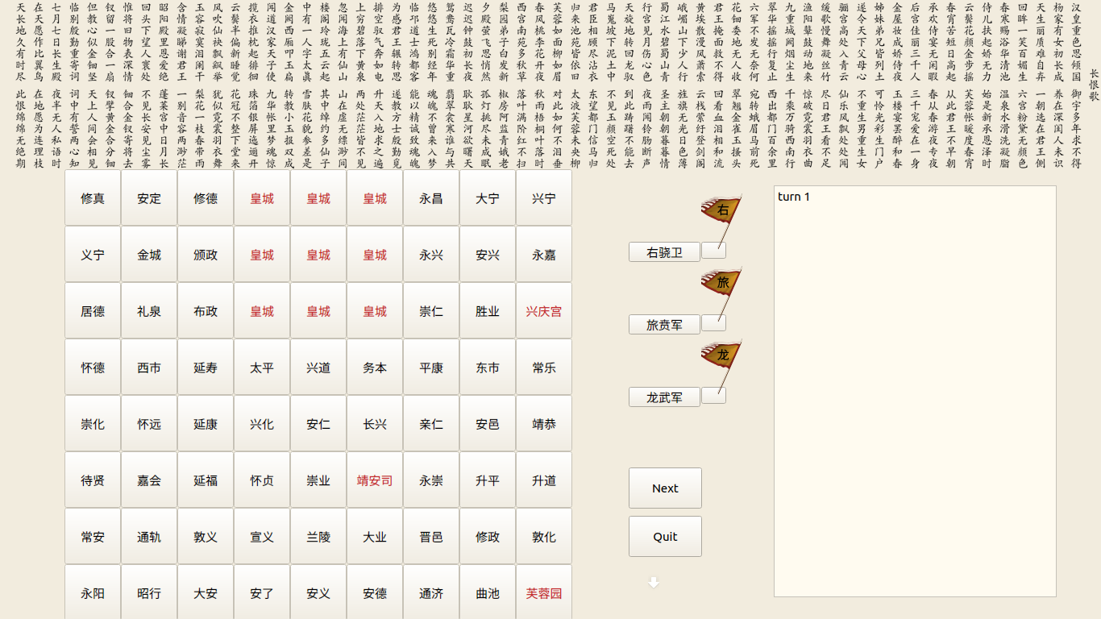
The gameplay is turn based. The turn count, and other important information, is displayed in the message box on the right. Pressing the next button ends the turn. Note that the location of the terrorists are not displayed, and it is up to the player to find where they are located.

Terrorists start at a random initial position, while the troops start out in their bases. The player may toggle one of the troops using the buttons bearing their names, then select the desired sector to move the troops in. The flag denoting these soldiers will be placed in the corresponding square on the map, showing that these soldiers have been moved to this sector. Players may choose to move any number of troops each turn, and they can be moved anywhere, with the exception that two troops cannot occupy the same sector. Troops can be recalled back to base by clicking on the small button to the right of the troop selection button (when the troop is toggled). Note that only one troop can be toggled at a time; to switch troops, one must first click the toggled troop’s button to untoggle it. At the end of each turn, press next; the terrorists each look at the neighboring squares (up, down, left and right), and randomly move into an available space. Sectors that are protected (in red) and or have troops stationed on them are avoided by the terrorist. Two terrorists will not occupy the same sector. A terrorist does not move if all four neighbors are invalid. If the terrorist attempts to (or actually does) move out of a sector that is adjacent – up, down, left, or right – to somewhere with troops stationed, the troop there would detect this and give out a warning to the message box.

How to win:
The game is won when all terrorists have been caught. To do this, one must use the warnings that the troops give to pinpoint the exact location of terrorists, and move troops into the square containing the terrorist (and subsequently pressing next) to catch them. Catching a terrorist will return a message in the message box. Catching all three terrorists will win the game, and the player’s score is how many moves they took, with a lower score being better. There is no way to lose the game, but it is possible to quit the game whilst playing.

Ending the game:
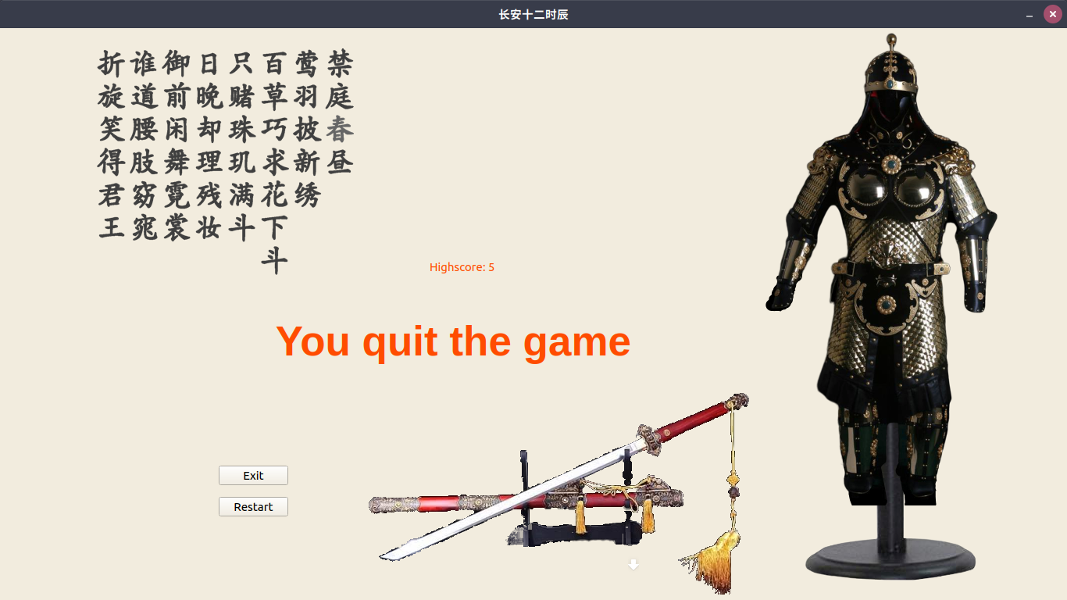
Once the player has won or quit, the ending screen comes up, displaying the score and the current highscore. The player may choose to exit the game, or restart the game again.

Frequently asked questions:

What do all of the decorations and writings mean?
Many of the terms are written in Chinese as the terms do not have a equally elegant translation.
- All words in the grid are the names of the sectors of the city.
- 龙武军: The Longwu Army, denoted by flag with “龙”
- 旅贲军: The Lvben Army, denoted by flag with “旅”
- 右骁卫: The Youxiao Guards, denoted by flag with “右”
- 狼卫: The terrorists

The writing on the top of the game window, and the writing on the end screen, are two separate poems writing about the time period of The Longest Day in Chang’an. They are 长恨歌 (Chang hen ge) and 清平乐-禁庭春昼 (Qing ping yue Jin ting chun zhou).
The clock displayed on the start screen is a traditional sundial, marked with the twelve 时辰(shichen) that a day was divided into.
The sword and armor displayed on the end screen are Tang-era artifacts; they were the most advanced at its time.

What is the Tang Dynasty?
The Tang was a dynasty that lasted from the 7th century to the 10th century. It is regarded as one of the most glorious eras of Chinese history, and things such as poetry, music, and even feminism were at its height during the Tang Dynasty. Therefore, it is a common setting for contemporary works.

What is the background music?
The two pieces of music are both rearrangements of music from the soundtrack of The Longest Day in Chang’an. The music was rearranged and performed by Zide Guqin Studio using a variety of traditional instruments.

