Project

Teamnaam: [TEAMNAAM]

Team:

Cohort: 2021

Klant:

Versie: september 2022

Datum:

Technisch Ontwerp

ROC Mondriaan | Den Haag

2022

# Inhoud

Inhoud 1

1. ERD 2
2. Data Dictionary 3
3. Screenshot database 4

# ERD

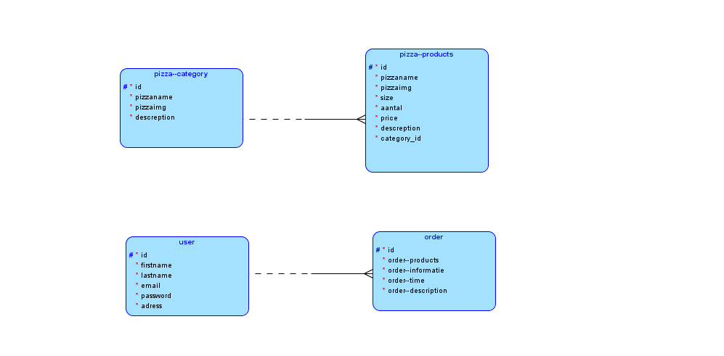

1: One pizza—category mag have one or more pizza—products.

One pizza-product must have one and only one pizza—category.

2: One user may take one or more orders.

One order must have one and only one user.

# Data Dictionary

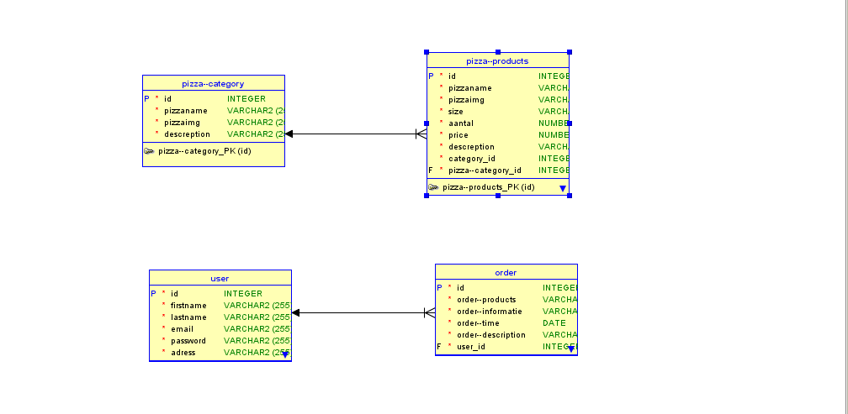

# Screenshot database



