Where Does Latent Planning Fail?
Controlled Bottleneck Attribution for World-Model Planning
PhysPlan Technical Report
Completed experimental study • August 2026

Core thesis: diagnose the dominant recoverable bottleneck before retraining the world model or changing the planner.

Case study | Planning regime | Dominant signal | Intervention result
Push-T (controlled local) | Fixed local candidate slice | Decision metric | Targeted metric repair strongly positive
Wall (independent replication) | Controlled waypoint candidates | Prediction | Targeted predictor repair strongly positive
Push-T H6 (official planner) | High-dimensional adaptive CEM | Mixed; prediction > metric | Scorer repair positive but statistically inconclusive

Evidence-status note: all numeric results in this report are consolidated from completed project experiments and frozen summaries supplied for PhysPlan. The report intentionally distinguishes statistically supported findings from directional or inconclusive results.

1. Executive Summary
World-model planning failures are often attributed to prediction error by default. PhysPlan tests a stricter alternative: planning is a multi-component pipeline, and failure can arise from representation/readout, prediction, the decision metric, or search/proposal. The project uses controlled oracle substitutions to estimate the recoverable decision headroom associated with each component before choosing an intervention.
The main result is not that one component is universally broken. The main result is that the dominant bottleneck changes across tasks and planning regimes. In a controlled local Push-T protocol, prediction headroom was negligible while decision-metric headroom was large; a targeted metric repair reduced regret substantially, while a predictor-precision control did not. In an independently replicated Wall protocol, the opposite pattern appeared: prediction headroom was large, the metric gap was near zero, and predictor repair produced a large improvement while a metric-side control did not. In the official high-dimensional Push-T H6 planner, prediction headroom again exceeded metric headroom, and a scorer intervention altered CEM search coverage, exposing an interaction between scoring and adaptive search.
This evidence supports a conservative claim: controlled oracle substitutions can identify where recoverable decision quality resides, and this diagnosis can guide which component to repair. It also shows why local diagnostic conclusions should not be assumed to transfer unchanged to a different planning regime.
Result | Value | Interpretation
Local Push-T prediction gap | 0.0071 | Little recoverable headroom from perfecting the predictor under the controlled protocol
Local Push-T metric gap | 0.0851 | Substantial downstream decision-metric headroom
Local targeted metric repair | +0.0815 [0.0563, 0.1079] | Strong intervention support
Wall prediction gap | 0.5636 [0.4871, 0.6373] | Prediction-limited regime
Wall predictor repair | +0.3891 [0.2930, 0.4804] | Strong independent intervention support
Official Push-T H6 prediction gap | 0.1608 [0.0565, 0.2725] | Prediction headroom persists in the full planner
Official Push-T H6 metric gap | 0.0950 [0.0026, 0.1978] | Metric headroom also exists, but is smaller
Official H6 scorer repair | +0.0843 [-0.00008, 0.1684] | Directionally positive; statistically inconclusive

2. Motivation and Research Question
A latent world-model planner can fail even when each individual subsystem appears reasonable. A representation may preserve information but expose a poor geometry for decision making. A predictor may minimize average latent error while losing task-relevant distinctions. A score function may rank candidates incorrectly even when future latents are accurate. An adaptive search procedure may fail to visit good actions even with an informative model and score.
PhysPlan therefore asks a diagnostic question before proposing a new model:
Where is the dominant recoverable bottleneck in a frozen world-model planning pipeline?
The key word is recoverable. The framework does not claim to uniquely decompose all causal responsibility or to make component gaps additive. Instead, each oracle substitution estimates how much decision quality could be recovered if one interface were replaced by a stronger reference while holding the rest of the evaluation protocol fixed.

3. Controlled Bottleneck Attribution
The planning pipeline is treated as a sequence of interfaces:
representation/readout → prediction → decision metric → search/proposal → selected action → simulator outcome
The attribution procedure uses controlled substitutions rather than assuming a priori that a poor planner implies a poor predictor.
Component | Diagnostic substitution | Quantity of interest
Representation/readout | Ground-truth future latent + frozen task readout | Can the latent representation expose task-relevant information?
Prediction | Ground-truth future latent vs predicted future latent under the same readout | How much decision quality is lost through prediction?
Decision metric | Predicted future latent scored by task-aligned readout vs default latent objective | How much ranking quality is lost at the model-to-decision interface?
Search/proposal | Best simulator outcome among actually searched candidates vs a stronger reference candidate set | How much headroom is lost because good actions are never proposed?
Within-search selection | Planner-selected candidate vs simulator-best candidate among the same searched set | How much headroom is lost by scoring/ranking within covered candidates?

Because adaptive search couples the score to the candidates that will be visited next, attribution on a fixed candidate trace and end-to-end intervention are reported separately. This distinction becomes essential in the official H6 experiments.

4. Case Study I: Controlled Local Push-T
The first case study freezes a local Push-T planning protocol and asks whether prediction fidelity or the downstream decision metric offers more recoverable decision headroom. This protocol is intentionally controlled: it is not the official full high-dimensional action-sequence planner, and conclusions are scoped accordingly.
Quantity | Measured value
GT latent readout ranking | Spearman ρ = 0.696; regret = 0.0289
Predicted latent readout ranking | Spearman ρ = 0.689; regret = 0.0360
Prediction gap | 0.0071; CI [-0.0051, 0.0198]
Decision-metric gap | 0.0851; CI [0.0608, 0.1109]
Search/proposal gap | 0.0074

Diagnosis: the predictor has little recoverable decision headroom in this controlled setting, while the decision metric has a large and statistically supported gap. The project therefore precommits to a metric-side repair rather than retraining the predictor.
Intervention | Regret / improvement | Interpretation
Baseline BF16 + latent-L2 | Regret 0.1237 | Frozen baseline
Targeted BF16 + task readout | Regret 0.0421; improvement +0.0815 [0.0563, 0.1079] | Strong targeted recovery
FP32 predictor + latent-L2 | Improvement +0.0017; CI crosses 0 | Increasing predictor inference precision does not recover planning performance

The targeted repair helps 62% of evaluated states, leaves 21% unchanged, and harms 17%. The correct interpretation of the FP32 control is narrow: increasing predictor inference precision did not recover planning performance. It is not evidence that every possible predictor improvement would be ineffective.

5. Case Study II: Independent Wall Replication
The Wall experiment was designed as a stronger replication with a development → frozen diagnosis → repair-validation split. The diagnosis was committed before repair evaluation, and the repair set contained 80 entirely new states.
Quantity | Measured value
Prediction gap | 0.5636 [0.4871, 0.6373]
Metric gap | -0.0279; CI crosses 0
Baseline regret | 0.5561
Predictor-repair regret | 0.1670
Predictor-repair improvement | 0.3891 [0.2930, 0.4804]
Wrong-layer metric repair | 0.0069 [-0.0489, 0.0625]
Full-trajectory latent MSE | 0.8564 → 0.1999

Diagnosis: Wall is prediction-limited under this protocol. The intervention result independently confirms the diagnosis: predictor repair produces a large reduction in planning regret, while a metric-side control has no reliable effect.
A notable counterexample is preserved rather than hidden: one Wall anchor exhibits a large latent-MSE improvement but its planning regret worsens from 0.215 to 0.991. This demonstrates that average prediction-error improvement is not sufficient to guarantee state-wise decision improvement, reinforcing the need to evaluate the planning interface directly.

6. Case Study III: Official High-Dimensional Push-T H6
The final validation tests whether the controlled local attribution survives the official high-dimensional action-sequence planner with adaptive CEM search. The protocol uses the official H6 planning setting and records candidate traces so that fixed-trace attribution can be separated from adaptive end-to-end intervention.
Quantity | Measured value | Interpretation
Prediction gap | 0.1608 [0.0565, 0.2725] | Larger than in the local protocol and statistically positive
Metric gap | 0.0950 [0.0026, 0.1978] | Also positive, but smaller than prediction headroom
Scorer-repair mean improvement | 0.0843 [-0.00008, 0.1684] | Positive direction; CI narrowly crosses zero
Episode outcomes | 16 improved / 9 unchanged / 5 worsened | Heterogeneous intervention effect over 30 episodes

The local conclusion does not replicate mechanically: the official planner is not simply a metric-limited version of the controlled local slice. Prediction headroom becomes larger, while metric headroom remains nonzero. This is evidence of bottleneck migration across planning regimes.
The scorer intervention also changes CEM search coverage. Therefore a metric change can affect both within-set ranking and which regions of action space are explored in later CEM iterations. This interaction explains why a fixed-candidate metric gap cannot be interpreted as a guaranteed end-to-end gain under adaptive search.

7. Cross-Regime Result Synthesis
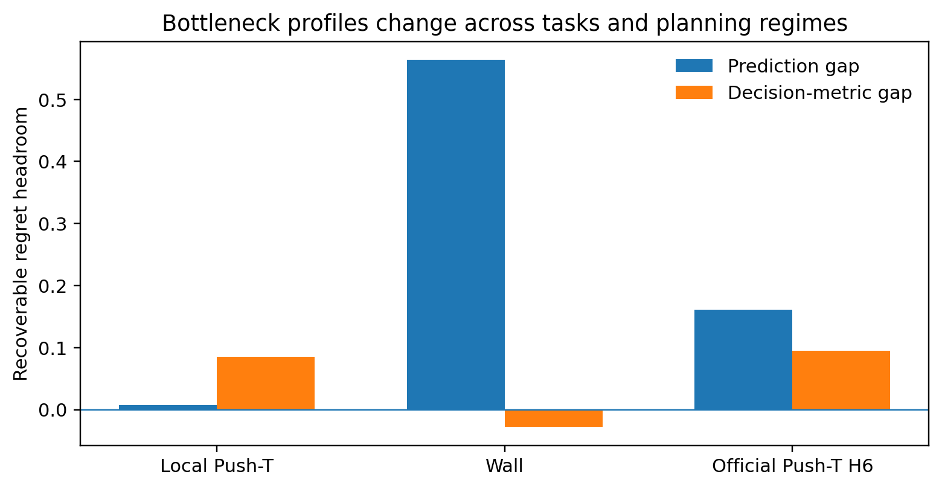
Figure 1. Recoverable prediction and decision-metric headroom changes substantially across the controlled local Push-T protocol, Wall, and the official Push-T H6 planner.
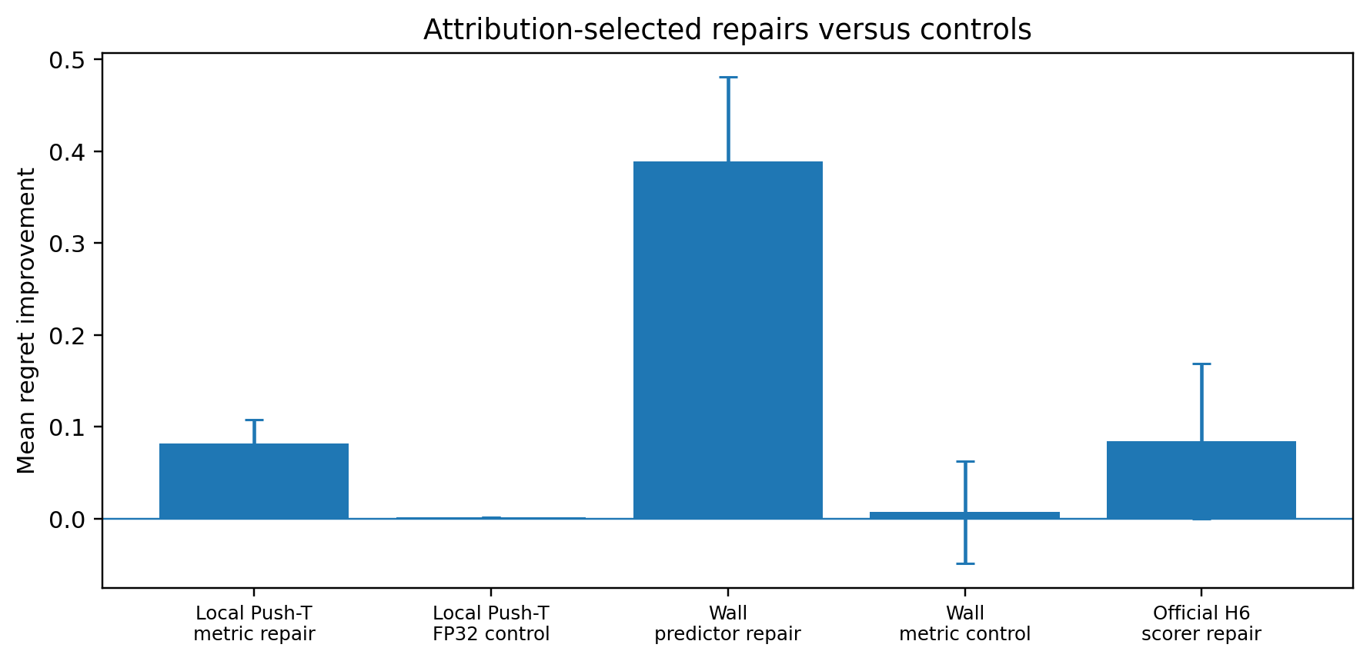
Figure 2. Attribution-selected repairs strongly recover decision quality in the controlled Push-T and independent Wall cases. The official H6 scorer repair is directionally positive but statistically inconclusive.
Taken together, the three cases rule out two overly broad stories. First, world-model planning is not uniformly predictor-limited: local Push-T exhibits negligible prediction headroom and large metric headroom. Second, world-model planning is not uniformly metric-limited: Wall and the official H6 setting expose substantial prediction headroom. The stable conclusion is therefore about diagnosis, not about one universally superior component.

8. Scientific Interpretation

8.1 Prediction fidelity is not equivalent to decision utility
A predictor can have low average latent error yet still fail on candidate distinctions that matter for control, and conversely a large reduction in latent MSE need not improve every planning state. PhysPlan therefore evaluates predictor quality through decision headroom and planning regret rather than treating representation-space error as a sufficient proxy.

8.2 Decision metrics can be bottlenecks even with informative predicted latents
The local Push-T case shows that predicted latents can preserve nearly all of the available ranking information while the default decision metric still leaves substantial recoverable regret. This separates predictive sufficiency from decision-metric alignment.

8.3 Search and scoring interact under adaptive planners
In fixed candidate sets, a score function can be evaluated as a pure ranking interface. Under CEM, however, the score changes the proposal distribution itself. The official H6 result therefore motivates a two-part analysis: selection gap on a frozen candidate trace and end-to-end search coverage under the intervened scorer.

8.4 The central object is bottleneck attribution, not a new universal loss
PhysPlan is intentionally not framed as a new learned scorer, predictor architecture, or search algorithm. Its contribution is a controlled experimental framework for deciding which interface offers recoverable decision headroom before intervention, followed by matched repairs that test whether the diagnosis predicts where improvement is obtainable.

9. Claims and Evidence Ledger
Claim | Direct evidence | Boundary / limitation
Different planning problems can be limited by different components. | Local Push-T is metric-limited; Wall is prediction-limited; official H6 is mixed with prediction > metric. | Three controlled regimes; not a universal taxonomy of all world models.
Controlled oracle substitutions can identify recoverable headroom before intervention. | Local and Wall diagnoses were frozen before targeted repairs. | Gaps need not be additive; substitutions can interact.
Diagnosis can guide which component to repair. | Metric repair wins in local Push-T; predictor repair wins in Wall; wrong-layer controls are weak. | Strongest evidence is in controlled protocols; H6 repair is inconclusive.
Planning regime can change the diagnosed bottleneck. | Local Push-T metric dominance does not persist in official H6. | Could reflect horizon, action dimensionality, adaptive search, or their interaction.
Adaptive scorer changes can alter search coverage. | Official H6 failure analysis shows scorer-dependent CEM candidate coverage. | Needs separate fixed-trace and end-to-end reporting.

10. Limitations
- The controlled local Push-T protocol uses a restricted local action slice and should not be presented as the official full planner.
- The Wall protocol is controlled and uses a 1-D waypoint candidate construction rather than a broad benchmark suite.
- The official Push-T H6 validation contains 30 episodes; the scorer-repair confidence interval narrowly crosses zero.
- Oracle gaps are diagnostic headroom estimates and are not assumed to be additive because representation, metric, and search can interact.
- The current study focuses on latent world-model planning pipelines and does not establish that the same decomposition is sufficient for policy-learning or real-robot systems.
- Predictor repair in Wall was evaluated with one training seed; future archival work should strengthen intervention replication before making broader claims.

11. Project Status and Reproducibility
The core research project is complete. The official H6 validation was frozen and checked against saved artifacts. Reported completion checks include 30/30 raw JSON/NPZ pairs, 18/18 related tests, 53/53 immutable historical scientific artifacts, and 117/117 SHA-256 manifest checks. The final reported code state was clean, with final commit ceb6122 and frozen protocol commit 3cbd3c5.
The remaining work is paper packaging rather than exploratory experimentation: tighten the narrative, present the bottleneck-migration figure, formalize the distinction between fixed-trace attribution and adaptive-search intervention, and prepare the workshop manuscript.

12. Interview and Resume Framing

12.1 Twenty-second specialty answer
Most world-model planning work assumes the predictor is the problem and retrains it. I built a controlled attribution protocol that separately measures prediction, decision-metric, and search headroom before intervention. In Push-T and Wall it diagnosed different bottlenecks, and the targeted repair matched the diagnosis; in the official H6 planner the bottleneck shifted again and scoring interacted with CEM coverage.

12.2 One-minute technical narrative
I started from a simple question: when a latent world-model planner fails, how do we know whether to retrain the predictor, change the decision metric, or improve search? I used oracle substitutions under fixed candidate sets to estimate recoverable headroom at each interface, then froze the diagnosis before running a targeted repair. In a controlled Push-T setting, the GT-to-predicted gap was tiny but the metric gap was large, and a task-aligned scorer recovered most of that regret while an FP32 predictor control did not. I then replicated the protocol on Wall with new repair states and got the opposite result: prediction was the bottleneck, and predictor repair worked while the metric control did not. Finally, under the official high-dimensional Push-T H6 planner, prediction headroom became larger than metric headroom and the scorer changed CEM search coverage. The result is a diagnostic framework for deciding what to repair before spending compute on the wrong component.

12.3 Resume bullet candidates
- Built a controlled bottleneck-attribution framework for latent world-model planning, separating prediction, decision-metric, and search headroom through oracle substitutions on fixed candidate traces.
- Diagnosed contrasting metric-limited and prediction-limited regimes across Push-T and Wall, with attribution-selected repairs reducing planning regret by 0.0815 and 0.3891, respectively, while matched wrong-layer controls had negligible effects.
- Validated the framework under an official high-dimensional Push-T H6 CEM planner, where prediction headroom exceeded metric headroom and scorer intervention exposed metric-search coupling through changed candidate coverage.

13. Conclusion
PhysPlan argues for diagnosis before retraining. Across three planning regimes, the dominant recoverable bottleneck is not stable: a local Push-T protocol is primarily metric-limited, an independent Wall replication is prediction-limited, and the official high-dimensional Push-T planner exhibits mixed headroom with stronger prediction limitations and score-search interaction. Controlled oracle substitutions provide a practical way to identify these regimes, and targeted interventions show that the diagnosis can predict where repair is effective in controlled settings.
The strongest defensible claim is therefore methodological rather than architectural: world-model planning failures should be attributed at the decision pipeline level before modifying the predictor, metric, or search procedure.

