Haorui Zhang

5-6-2020

* 1. 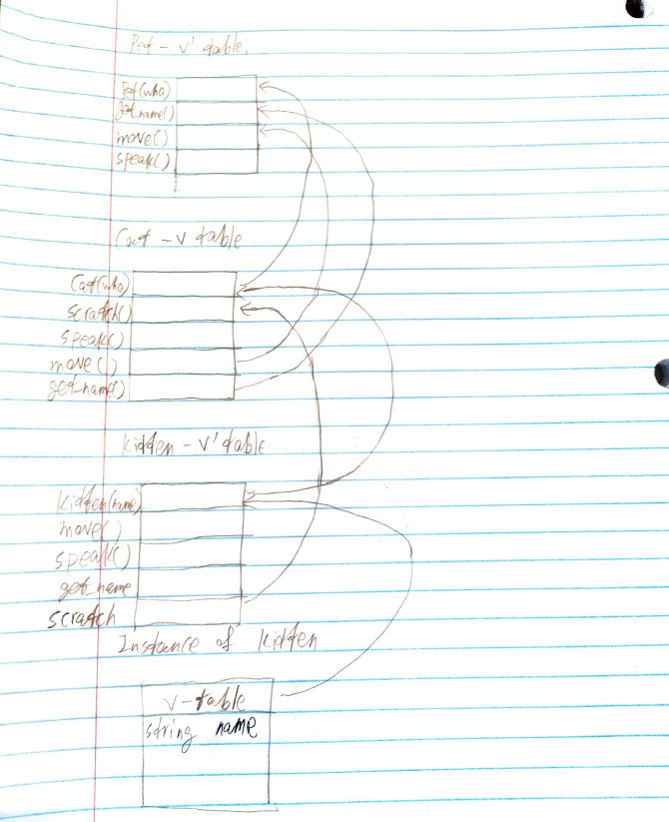
  2. Yes. Critter->speak() will print “meow” by calling cat class speak() when kat->speak() will print “yip” by calling kitten class speak().
  3. No. they both call get_name() in Pet
  4. Yes. Kat->move() calls kitten class move() while critter->move() calls Pet class move()
  5. Foo function reverse the given list while add a “0” to the front. Helper function append x to a newly construct list. Mystery function reverses what Helper function produces with a 0 in the front.
  6. 1) Given [1, 2, 3] Output: [0,1,2,3,1,2,1]

2) Given [3,2,1] Output: [0, 3,2,1,3,2,3]

* 1. Yes
  2. No

1. 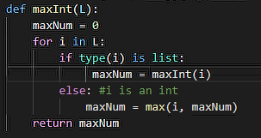
2. List:
   1. Line 1: No error: “Computer Science”
   2. Line 2: error: Don’t know which function to use to get output
   3. Line 4: No error: 15000
   4. Line 5: Error. No variable GPA exist or assigned.
   5. 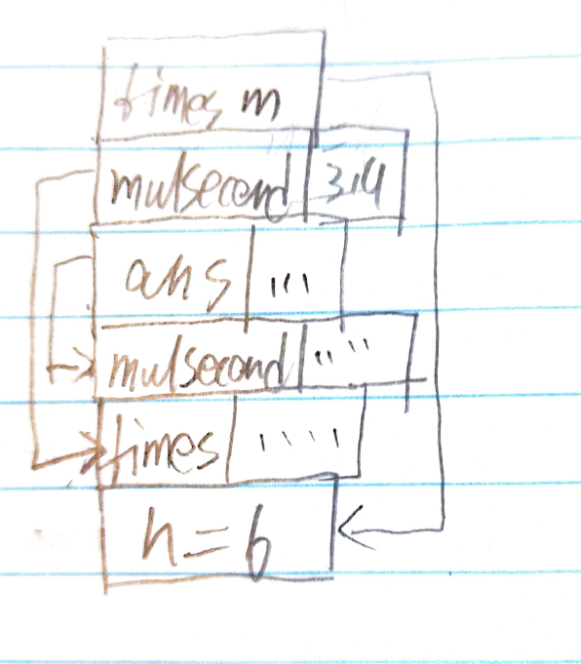
   6. The result would be 15. Since dynamical scope uses the value that is closest to the call, in this part, n in times call would be 3, instead of 6 in static scope, which results in (3*4)+3 = 15.
   7. {c=5, d=8, a=9}
   8. {a=9, d= 10, e=13}
   9. {c= 11, e= 13, d=15,a=9}
   10. {a=9, d=8, c = 5}
   11. While running interpreting Java in a virtual machine, the code does not need to be translated to machine code. Compare to C, this saves a lot of time and need to do less work.
   12. Lists in Java using reference to store. This means different reference can refer to different object with different length.
   13. Because in C/C++, functions are stored through pointers in memory rather than reference. They also don’t support lambda function, which makes a function an entry like normal value types.
3. In this part, since it is dynamic scoping, b would be the closest b push to the stack (0 in the fist place, for example). Therefore, the foldl in f would result in: 0+1+2+3 = 6