Haorui Zhang

9-14-2021

CS 440 HW3

* 1. BFS

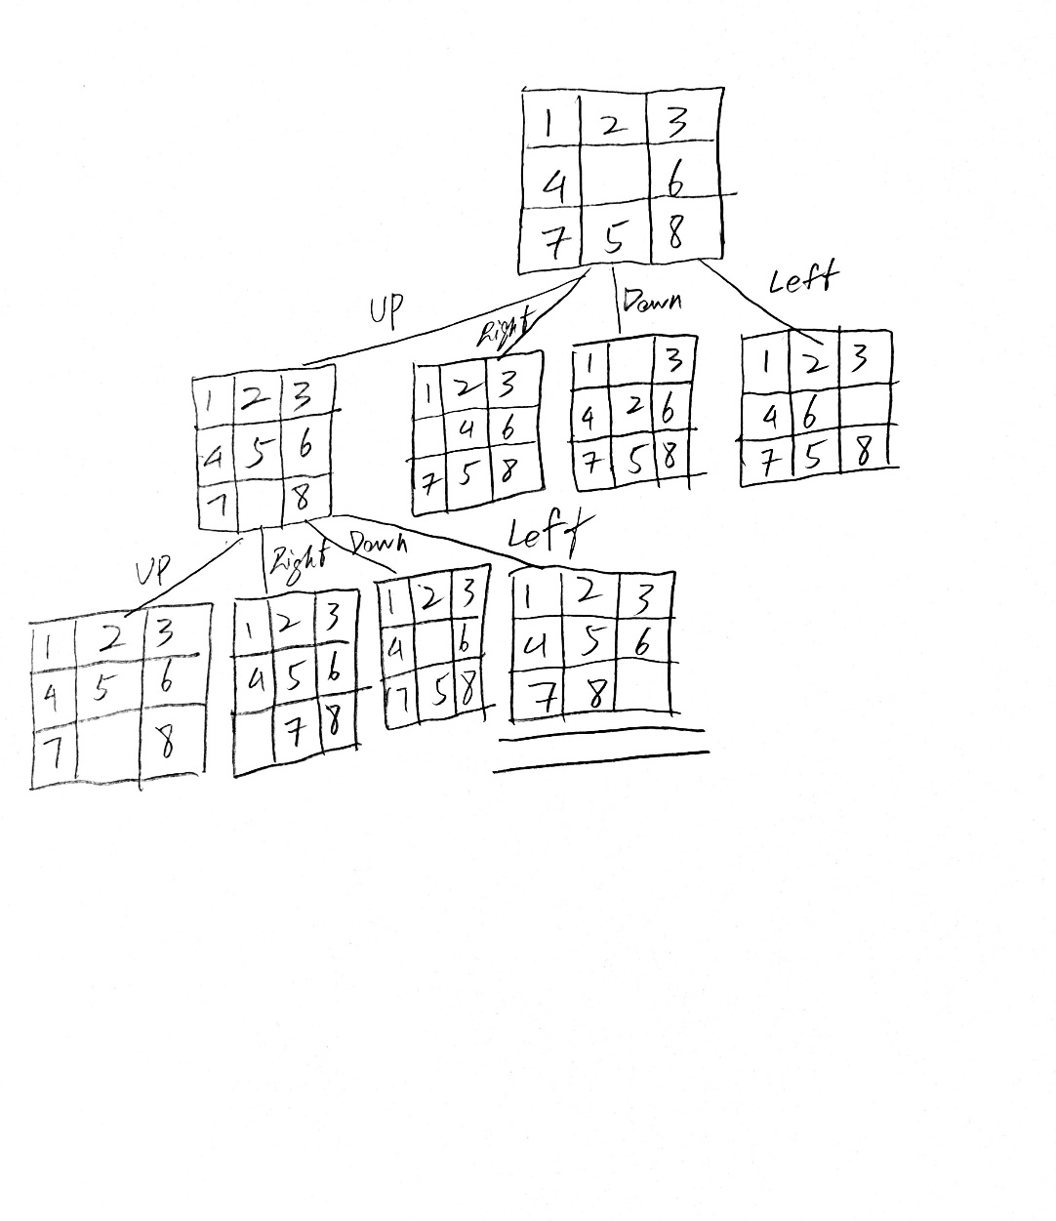

* 1. Iterative-deepening Search

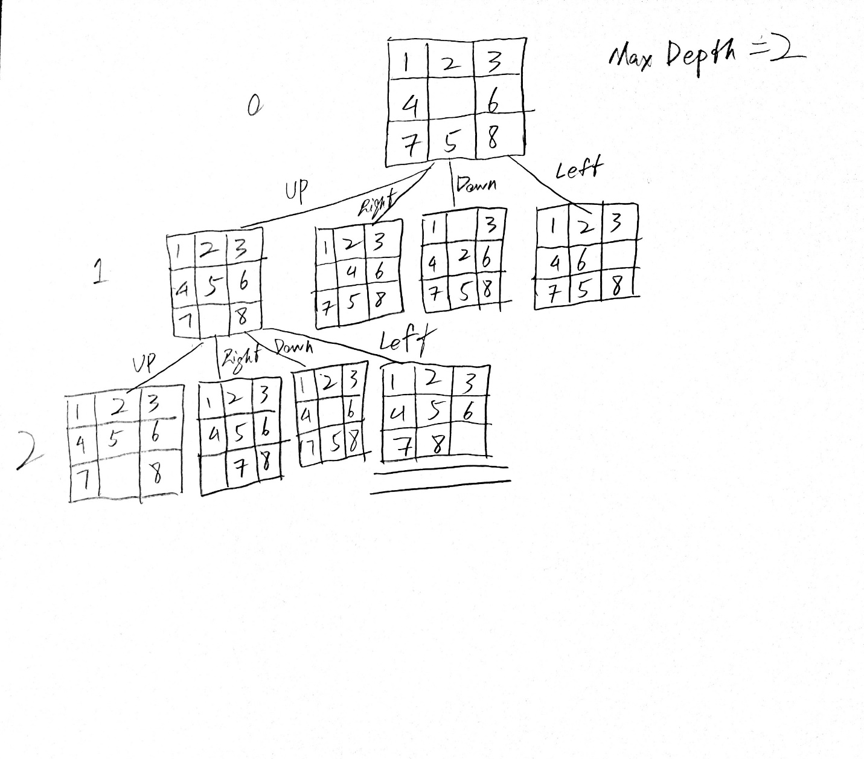

* 1. A\*

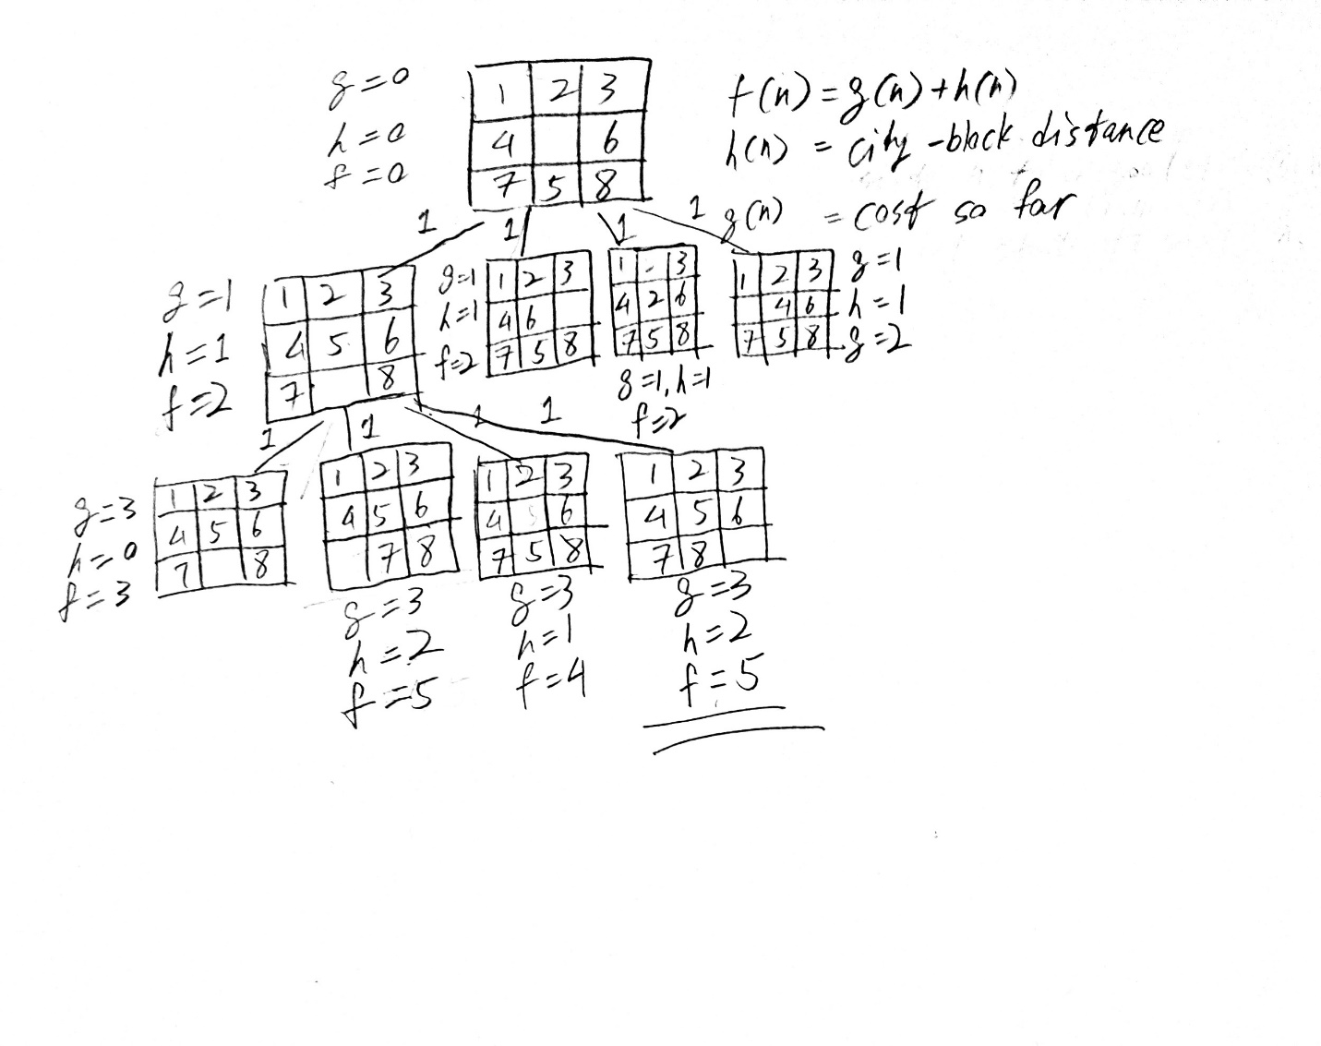

* 1. Hill-climbing

