Haorui Zhang

9/5/2021

Assignment 2

* 1. Min number of edges is 0. A simple graph can have no edge.
  2. Since it is a simple graph and no parallel edges or loops are allowed, each vertex can connect all other vertices with one edge excluding itself. In this case, each vertex can have 99 edges to other vertices. So the max number of edges is n(n-1)/2 = 100(99)/2 = 4950.
  3. 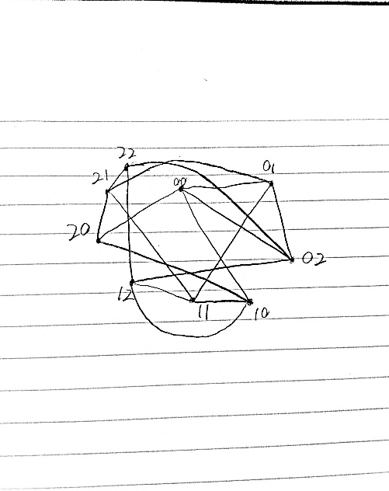



* 1. Every vertex has degree of 4. So the edge number is 9\*4/2 = 18
  2. R is the number of rows while s is the number of cols. So the total number of vertices in ${V(P}_{r},_{s})=r*s$.
 $The number of edges of P{}_{r},_{s}=\left(r-1\right)*s+\left(s-1\right)*r=sr-s+sr-r=2sr-s-r$

 3. A cubic graph is a regular graph which all vertices have degree of 3. It means for each vertex, there needs to be other 3 vertices to connect to. So there needs to be at least 4 vertices to be a valid cubic graph and based on handshaking lemma theory, the number of vertices of odd degree in a graph must be even. Therefore, a cubic graph must has even number of vertices.
  4. Assume there is a 2\*n vertices graph G with n≥3. Then V(G) = {-n, -(n-1), -(n-2)….-1, 1, 2, 3 …. n}. To construct a cubic graph, each vertex must have degree of 3. To achieve it, each vertex needs 3 edges to other vertices. First make a cycle graph from V(G), connect vertex -n to vertex n. After this, each vertex has degree of 2. Then for each negative vertex, connect its opposite vertex. For instance, connect vertices n and -n, connect –(n-1) to (n-1). After this, all vertices have 3 degrees and G is a simple 3-regular graph. Therefore, for every n ≥ 3, there exists a simple cubic graph with 2n vertices.