Haorui Zhang

9/12/2021

CS 453

* 1. The number of ${V(C}_{n}*C_{n})=n*n$
  2. To prove that $C_{n}*C_{n}$ is a 4-regular graph, we need to show that for any vertex (a, b) of the graph $C_{n}*C_{n}$, (a, b) is adjacent to exactly other four vertices. For two vertices (a, b) and (c, d) be adjacent in $C_{n}*C_{n}$, either $a=c and b is adjacent to d$, or $b=d and a is adjacent to c$. Since the $C_{n}$ is a cycle, it is a 2-regular graph, and each vertex is adjacent to vertices next to it. For $C_{n}*C_{n}$, each vertex in $G_{1}$ is adjacent to the vertices which the corresponding vertex in $G_{2}$ is adjacent to, which is another 2 vertices. Therefore, $C_{n}*C_{n}$ is a 4-regular graph for n≥3
  3. Number of edges in $C_{n}=n$, and number of edges of $C_{n}*C_{n}=n*n+n*n=2n^{2}.$
  4. Assume $G=\left(V_{1},E_{1}\right) is a n-regular graph and H=\left(V_{2},E_{2}\right) is a m-regular graph$, then $G*H=(V_{1}*V_{2}, E$). $E=\left\{\left(v_{1},v_{2}\right)\left(u_{1},u_{2}\right)\right| \left(v_{1}=u_{1} and v_{2}u_{2}∈E_{2}\right)or\left(v_{2}=u_{2} and v_{1}u_{1}∈E_{1}\right)$}. So for $\left(v_{1},v_{2}\right),$ there are m edges from $E_{2}$ and n edges from $E_{1}$. Therefore, G\*H is a (n+m)-regular graph.
  5. 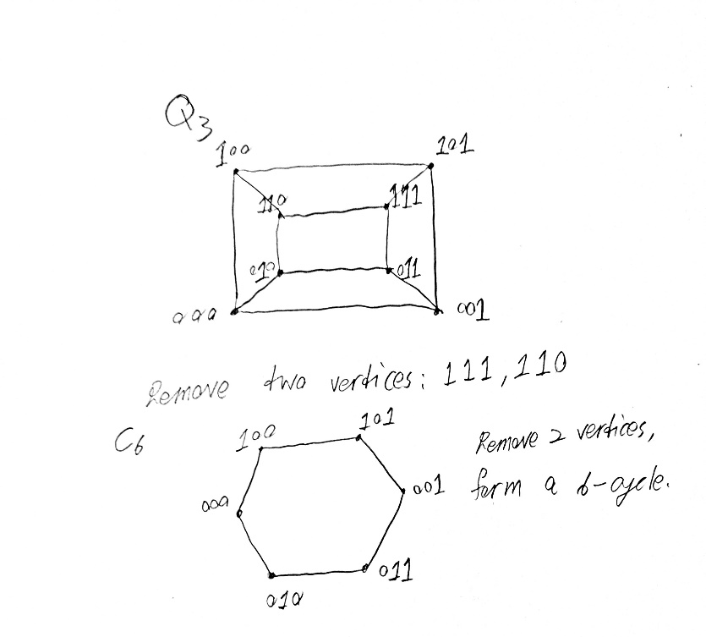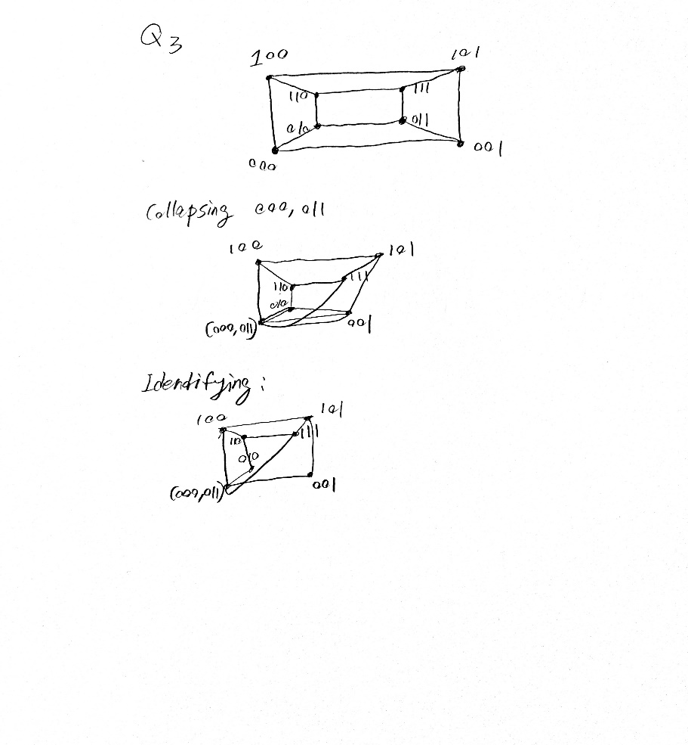

W has 4-degree.

* 1. Since W has a length of k and W’ has a length of k+1, for any k ≥ 1, it means that W’ always has one more vertex connects in the walk than W, which means the graph contains loop or cycle. Therefore, G can not have a longest walk.
  2. A path is a walk does not repeat a vertex. Therefore, if W is a walk in the graph G has length of k, which is larger than b the upper bound length of path in G, it means W must contains one or more repeated nodes since the path does not contain repeat nodes and b is the length of walk that does not contain repeat nodes.