1.

Before transaction:

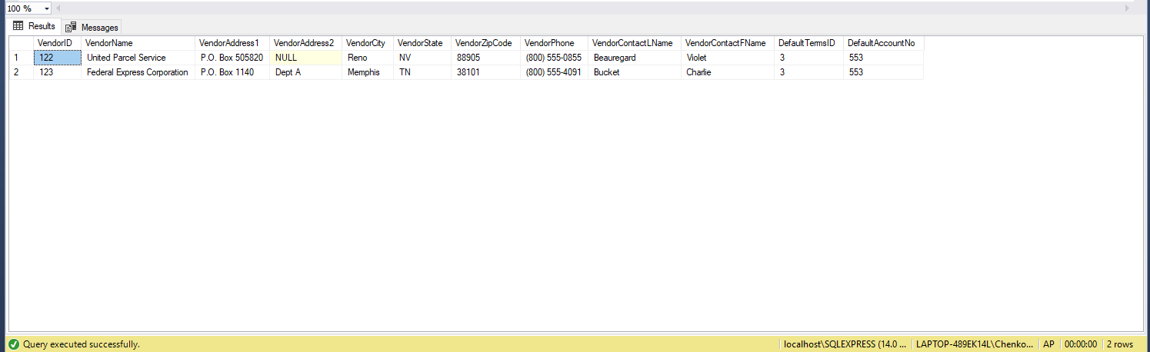

transaction:

BEGIN TRANSACTION

UPDATE Invoices SET VendorID = 122 WHERE VendorID = 123;

DELETE Vendors WHERE VendorID = 123;

UPDATE Vendors SET VendorName = 'FedUp' WHERE VendorID = 122;

COMMIT TRANSACTION

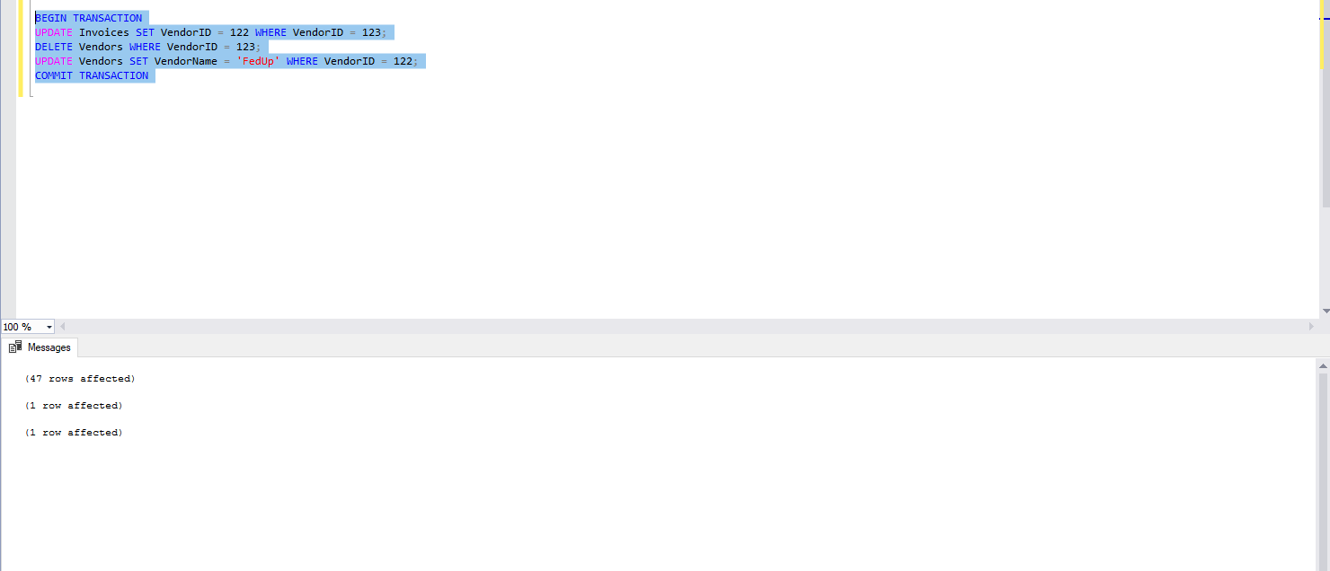

After transaction:

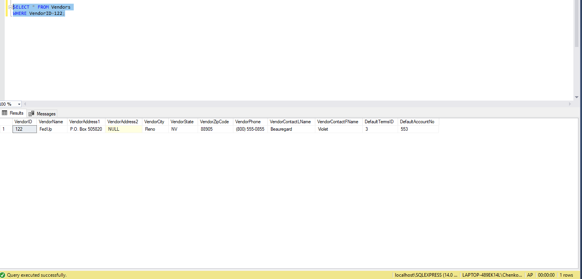

2.

BEGIN TRANSACTION

INSERT INTO InvoiceArchive

SELECT Invoices.\* FROM Invoices LEFT JOIN InvoiceArchive

ON Invoices.InvoiceID = InvoiceArchive.InvoiceID

WHERE (Invoices.InvoiceTotal - Invoices.CreditTotal - Invoices.PaymentTotal) = 0

AND InvoiceArchive.InvoiceID IS NULL;

DELETE Invoices WHERE InvoiceID IN (SELECT InvoiceID FROM InvoiceArchive)

COMMIT TRANSACTION

After transaction:

