Research and Education at the Convergence of Frontier Technologies

Vikram Kapila, Professor of Mechanical and Aerospace Engineering
Mechatronics, Controls, and Robotics Laboratory (MCRL)
NYU Tandon School of Engineering, Brooklyn, NY
http://engineering.nyu.edu/mechatronics/

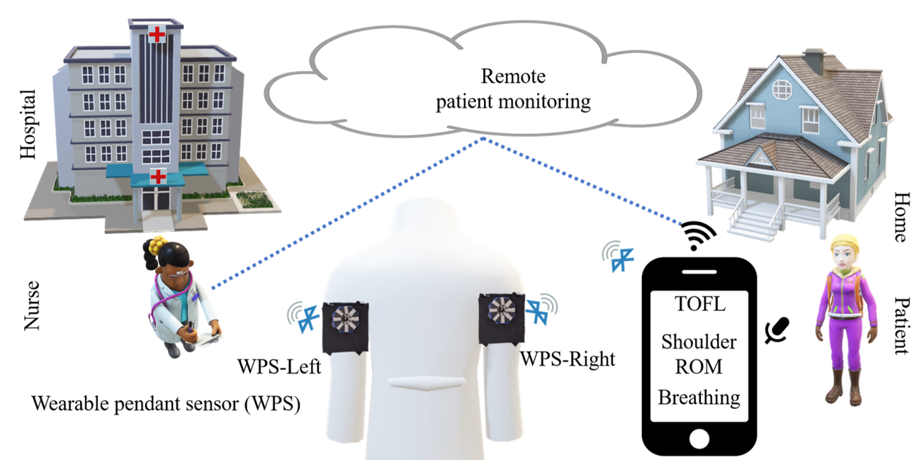
In this talk, I will lay out the evolution of research and education activities in MCRL. Slightly over two decades ago, I began by developing a hands-on control-engineering program that slowly transformed into research and education activities focused on mechatronics. A decade ago, with the arrival of smart mobile devices (smartphones and tablets), MCRL focused its efforts on mechatronics and robotics with applications to natural and intuitive human-machine interaction as well as health and wellness. More recently, having observed the rapid progress in several emerging technologies and their potential for broad societal impact, MCRL has transitioned its activities to explore and perform education and research activities at the convergence of robotics, artificial intelligence, augmented reality/virtual reality, and blockchain technologies. In this talk, in addition to sharing an overview of our education activities, I will showcase examples of our research products.

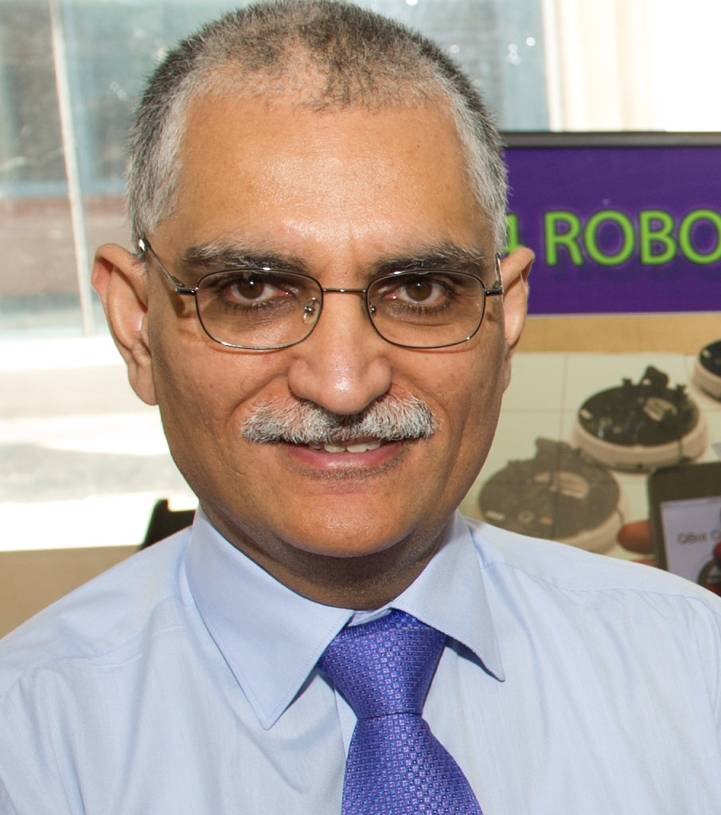
Vikram Kapila is a Professor of Mechanical and Aerospace Engineering at the NYU Tandon School of Engineering, where he directs a Mechatronics, Controls, and Robotics Laboratory; a Research Experience for Teachers Site in Mechatronics and Entrepreneurship; a DR K-12 and an ITEST STEM education research project; all funded by NSF. He has held visiting positions with the Air Force Research Laboratories in Dayton, OH. His research interests are focused on the convergence of frontier technologies (robotics, artificial intelligence, augmented/virtual reality, and blockchain) and STEM education. He is an author or co-author of more than 240 peer-reviewed scholarly publications, including books, book chapters, journal papers, and conference articles. He is a named inventor on two awarded patents. He has received five teaching awards and a leadership award, all at NYU Tandon. Moreover, he is a recipient of 2014-2015 University Distinguished Teaching Award at NYU. He has mentored more than 50 graduate researchers and more than 60 undergraduate researchers. In addition, he has conducted significant K-12 education, training, mentoring, and outreach activities to integrate engineering concepts in science classrooms and labs of dozens of New York City public schools.

