**Question 1:**

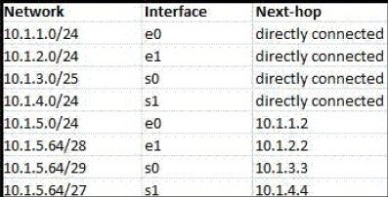

According to the routing table, where will the router send a packet destined for 10.1.5.65? Why?

* 10.1.5.64/29

**Question 2:**

Classless Inter-domain Routing (CIDR) receives a packet with address 131.23.151.76. The router’s routing table has the following entries:

Prefix Output Interface Identifier

131.16.0.0/12 3

131.28.0.0/14 5

131.19.0.0/16 2

131.22.0.0/15 1

The identifier of the output interface on which this packet will be forwarded is ______. Why?

* 131.22.0.0 to 131.23.255.255, identifier 1

**Question 3:**

Consider the following routing table of a router.

| **PREFIX** | **NEXT HOP** |
| --- | --- |
| 192.24.0.0/18 | D |
| 192.24.12.0/22 | B |

Consider the following three IP addresses, what their next hop will be?

1. 192.24.6.0 D
2. 192.24.14.32 B
3. 192.24.54.0 D

**Question 4:**

Draw an TCP header. Capture packets using wireshark and explain the fields for a particular TCP packet captured. Try to explain the purpose of each field.

**Question 5:**

Draw an UDP header. Capture packets using wireshark and explain the fields for a particular UDP packet captured. Try to explain the purpose of each field.