**This lab is worth 5% of your final AI4G grade.**

**Due End of Day Tuesday February 5th**

**How to Train your Artificially Intelligent Dragon via Backpropagation**

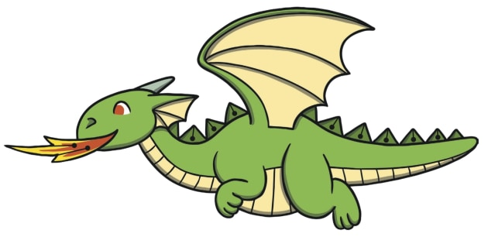

**Lab 7**

Follow the instructions in “Back Propagation Solution Walk Through.docx”.

Type your name here 🡪 Haotai Xiong C00265675

Copy in screen shots here to demonstrate completion of the following (something in the image should identify your own machine):

1. The TensorFlow training showing the 15 predictions it makes at the end of the training process.

1. Successful execution of the “convert_flappy_model_weights_to_csv.py” script.

1. 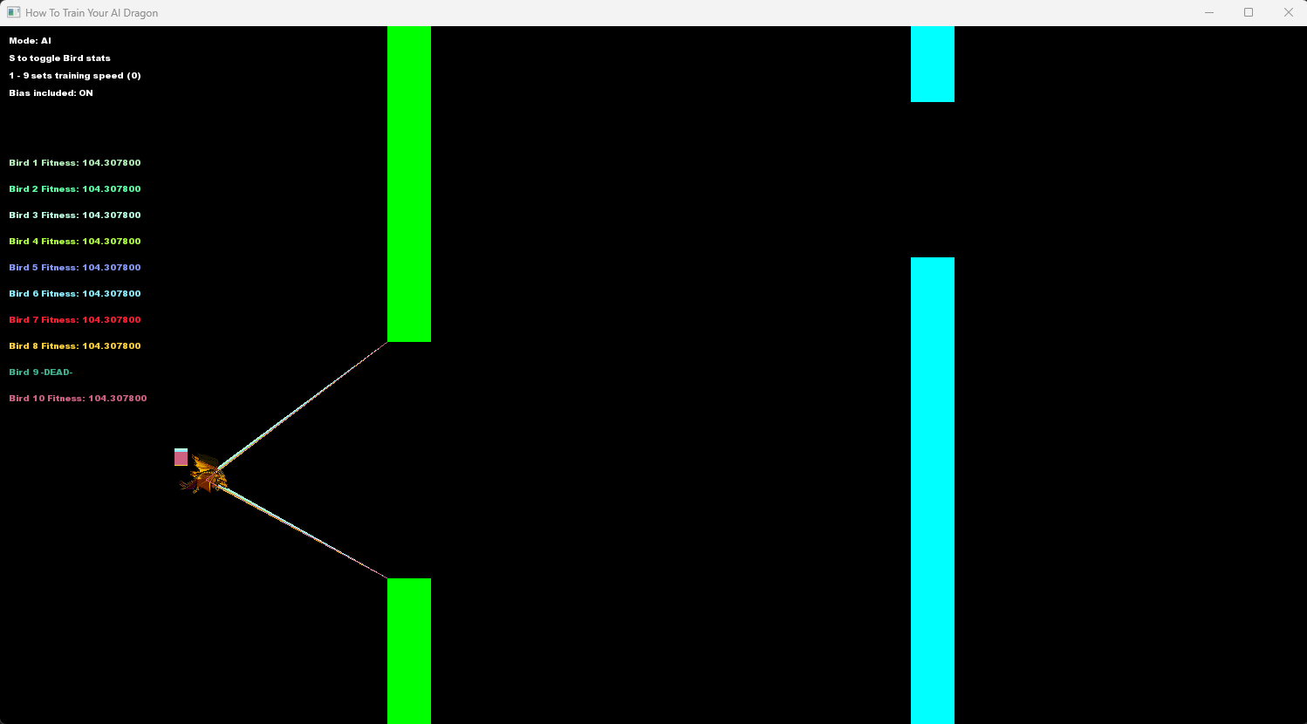The AI playing the game with the trained weights showing at least one bird with a fitness > 100

