Proposal of a Digital Companion App for "Top of the Class"  
Haotai Xiong – C00265675

## Summary

The element of the board game I am working with is a digital companion app for the "Top of the Class" board game. The app aims to enhance the game's accessibility and engagement by integrating remote play capabilities and adding new modern question cards, offering an innovative blend of traditional and modern questions, and providing a user-friendly interface suitable for a diverse player base. The primary goal is to modernize the board game experience, making it accessible and enjoyable for both local and remote players.

## ***Project Overview***

### ***Objectives***

1. Develop a digital companion app that enables remote playing, allowing for various configurations of local and remote players.

2. Introduce modern question cards alongside the original question cards to diverse interests and knowledge areas.

3. Create an engaging and accessible gaming experience that appeals to both existing fans and new players.

### ***Target Audience***

- Existing "Top of the Class" players seeking digital experience.

- New players, especially those familiar with digital gaming platforms.

- Educational institutions and families looking for interactive learning tools.

## ***Features and Specifications***

***1. Gameplay Mode***:

- Remote Play: Up to 5 players can join remotely, with at least 1 player being local.

- Local Play: local players will be asked to open digital companion when someone is playing remotely. Local players will move not only in the board game but also in the digital companion.

***2. Question Cards***:

- Modern Question Cards: A newly developed set featuring contemporary and trending topics.

***3. User Interface***:

- Same looking like the original game board.

### ***4. Communication Tools:***

- Option for players to communicate via external platforms if preferred.

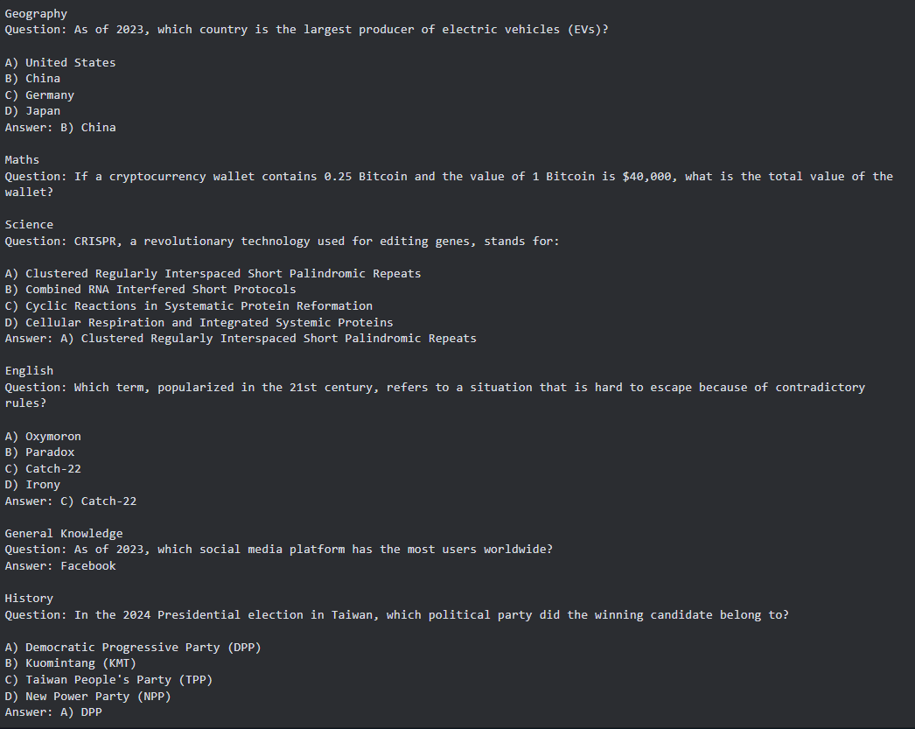Example of Modern Questions

## ***Project Justification***

1. Enhancing Engagement: The app introduces new dynamics to the game, such as remote collaboration and competition, making it more engaging and relevant in a digitally connected world.

2. Broader Accessibility: Remote play options make the game accessible to players who are unable to participate in traditional board game settings due to geographical or physical constraints.

3. Content Relevance: The addition of modern question decks ensures the game remains appealing and challenging for contemporary players.

## ***Conclusion***

The proposed digital companion app for "Top of the Class" aims to revolutionize the traditional board game experience. By embracing digital innovation, the game will cater to a broader audience, offering an engaging and modern educational experience. The successful implementation of this project will set a precedent for the integration of digital technology in board gaming.