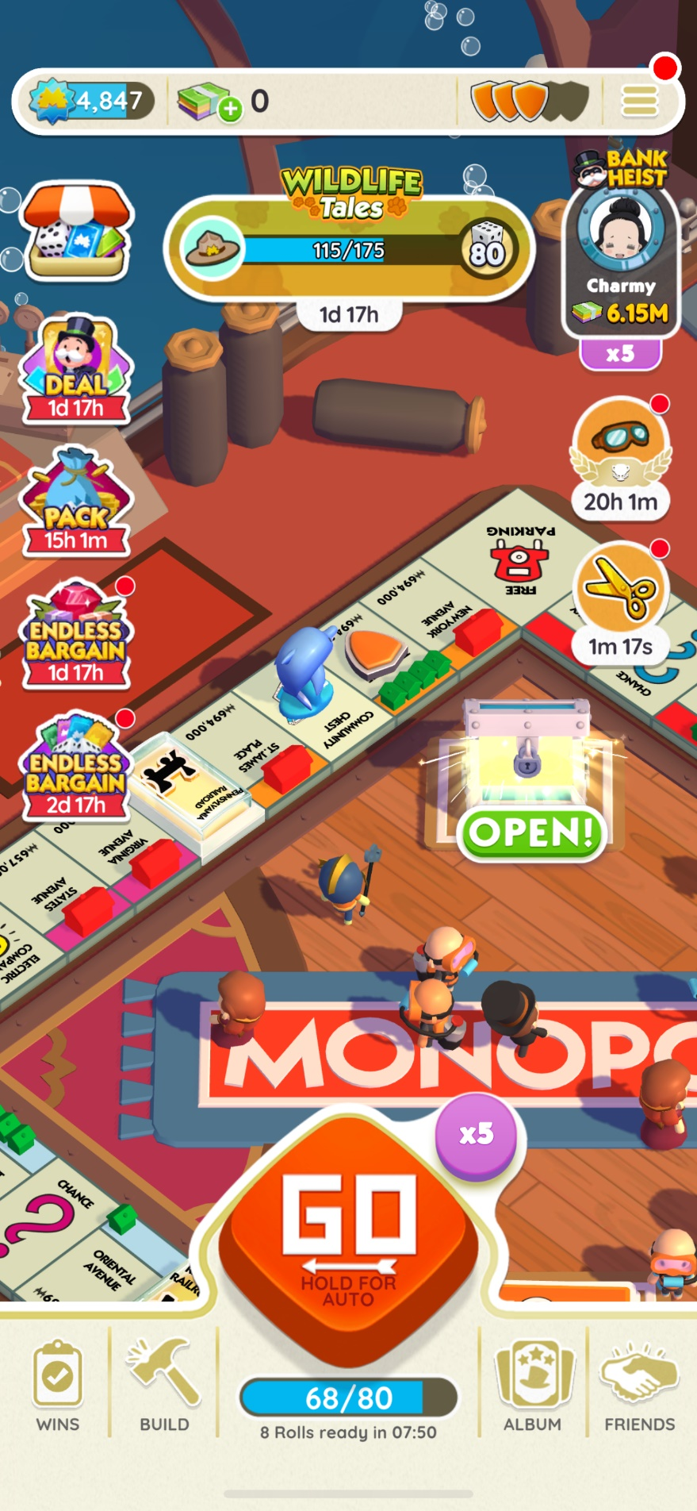Love the design of “Go” Button, in TOTC, only one button is needed for rolling dice and randomly choosing subjects.

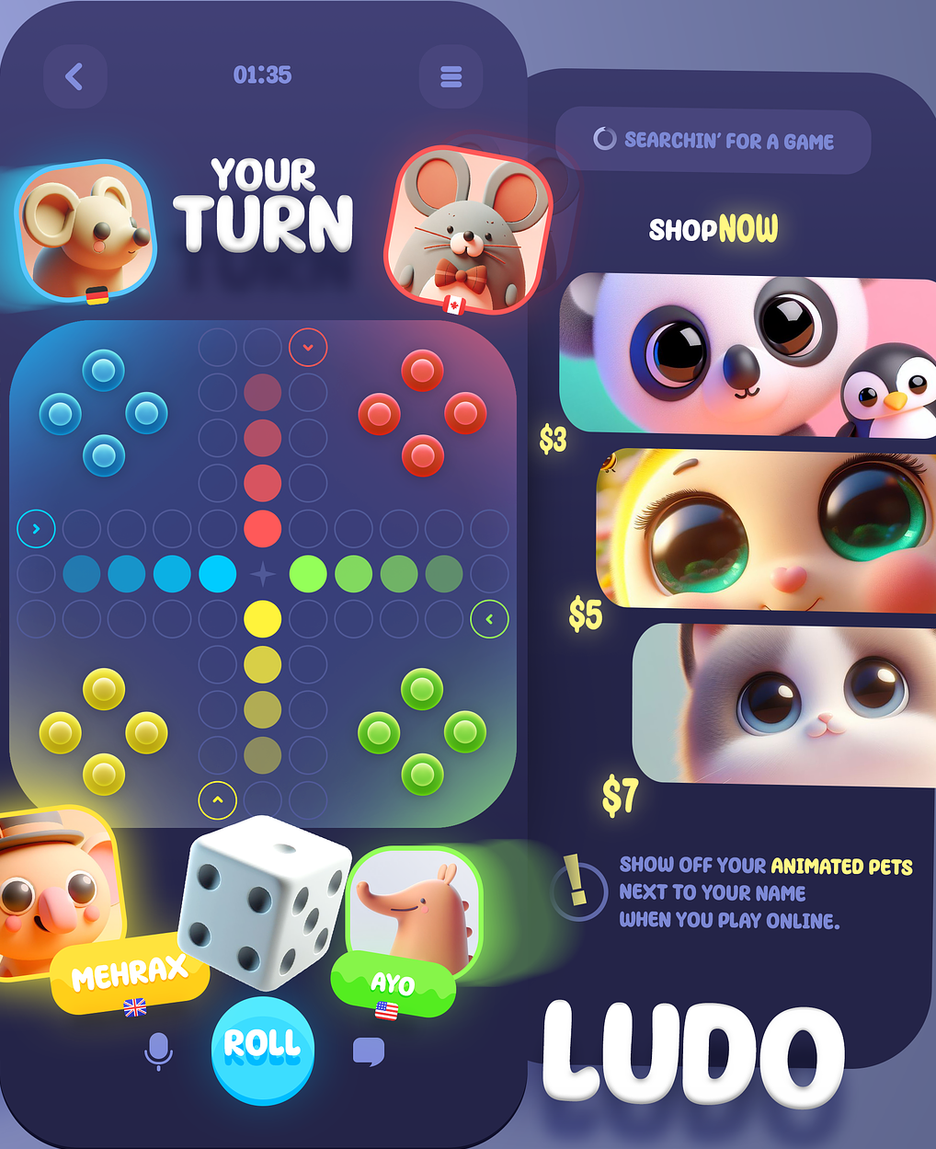Nice design of UI for determining whose turn it is at the moment, and you can see other players’ avatars as well.

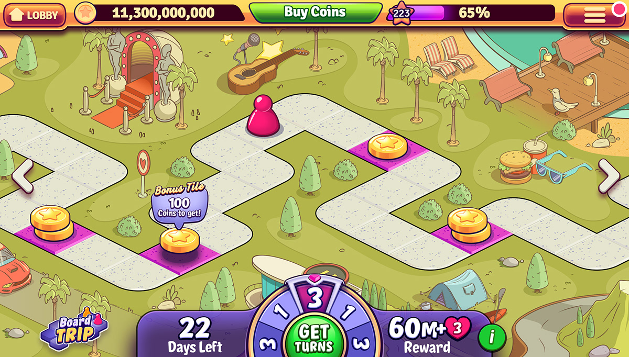The piece shape is what we need for our game, not just the regular circle on the game board!