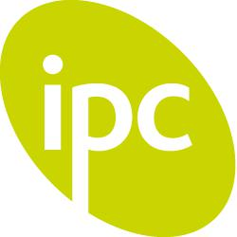 Chocolate
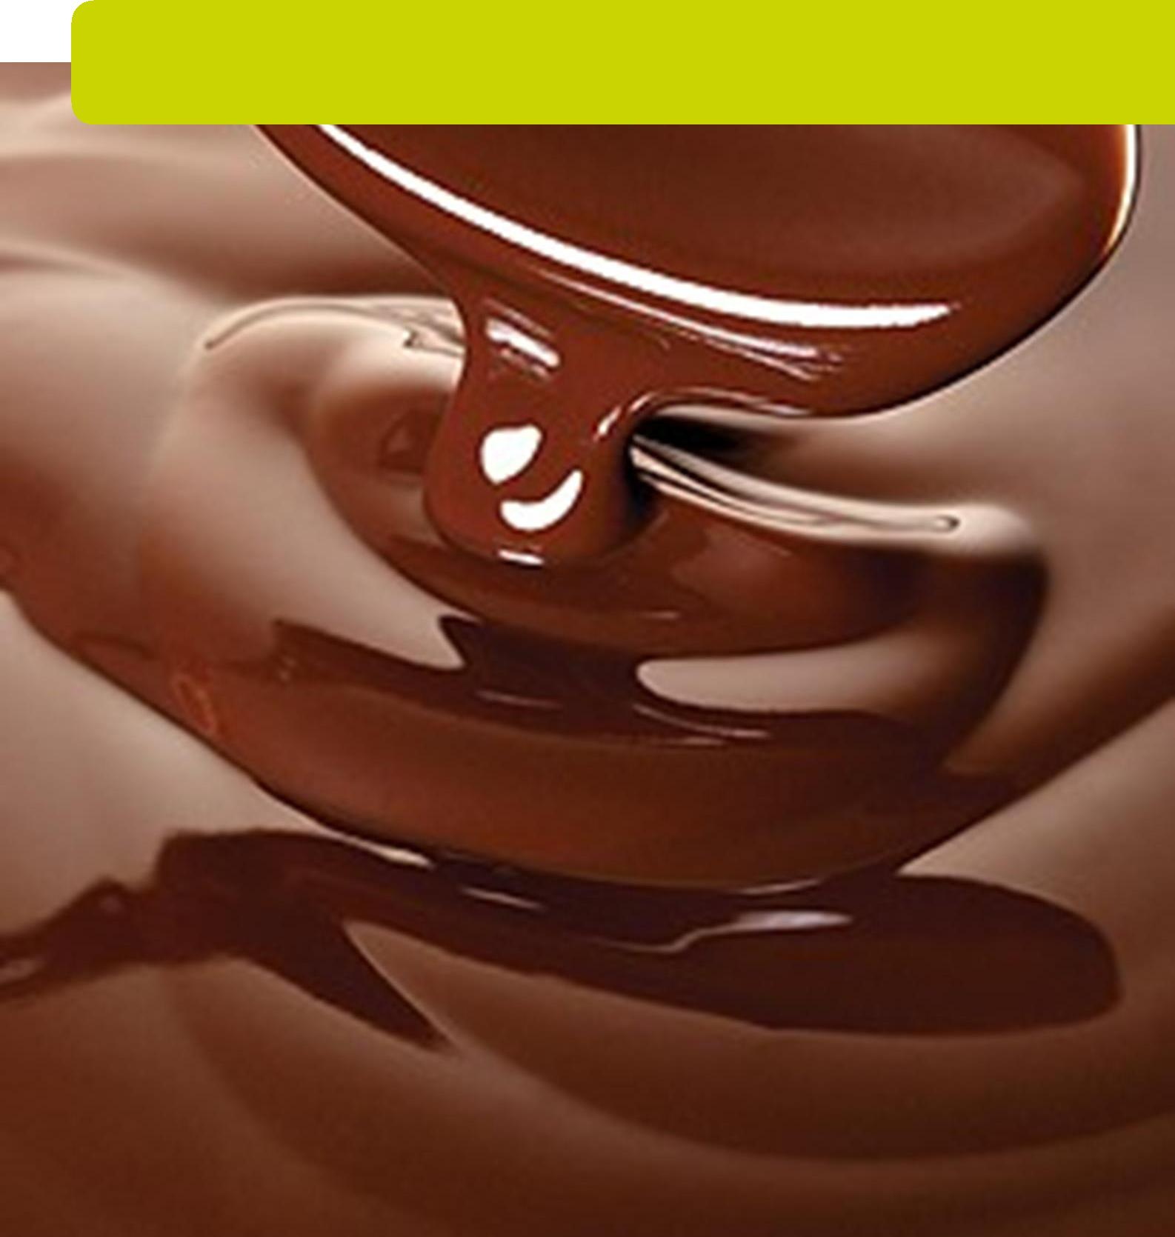

Food


greatlearning.com/ipc

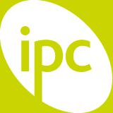 Chocolate

Contents

Contents | 2
Basic Information | 4
Learning Goals | 5
Assessment for Learning | 9
The Entry Point | 12
Knowledge Harvest | 14
The Big Idea | 15
Explaining The Theme | 15
The Big Picture | 16
Geography Learning Goals | 19
Geography Task 1 | 20
Geography Task 2 | 24
Geography Extension Task | 27
History Learning Goals | 30
History Task 1 | 31
History Task 2 | 34
History Extension Task | 36
Science Learning Goals | 39
Science Task 1 | 40
Science Task 2 | 43
Science Task 3 | 46
Science Task 4 | 49
Science Extension Task | 52
Technology Learning Goals | 55
Technology Task 1 | 56

2
Downloaded for use by Blackmore Community Primary School on 02 July 2018.

From Fieldwork Education, a part of the Nord Anglia Education family. © WCL Group Limited. All rights reserved. Not to be reproduced without permission.
Chocolate

Technology Task 2 | 59
Technology Extension Task | 61
Art Learning Goals | 62
Art Task | 63
Art Extension Task | 65
International Learning Goals | 67
International Task 1 | 68
International Task 2 | 70
International Extension Task | 71
The Exit Point | 72
Resources | 73

3
Downloaded for use by Blackmore Community Primary School on 02 July 2018.

From Fieldwork Education, a part of the Nord Anglia Education family. © WCL Group Limited. All rights reserved. Not to be reproduced without permission.
Chocolate

Basic Information

This section details the time allocation for this unit of work, links to other subjects and Assessment for Learning opportunities.

Timings

This unit of work is intended to last about 8 ¼ weeks.

The following suggested timings are approximate guides and are dependent on each school's individual context.

 | No of Hours | No of Weeks
Entry Point, Knowledge Harvest, Explain the Theme | 6 | ¾
Geography | 8 | 1
History | 8 | 1
Science | 12 | 1 ½
Technology | 16 | 2
Art | 8 | 1
International | 4 | ½
Exit Point | 4 | ½

Links to other IPC subjects

Links to ICT & Computing, Art, Science and Technology are provided at the end of tasks where appropriate.

Language Arts and Mathematics links

Suggestions of how to include links to Language Arts and Mathematics are provided where appropriate at the end of tasks.

4
Downloaded for use by Blackmore Community Primary School on 02 July 2018.

From Fieldwork Education, a part of the Nord Anglia Education family. © WCL Group Limited. All rights reserved. Not to be reproduced without permission.
Chocolate

Learning Goals

Art Learning Goals

Children will:

2.01 Know how a number of artists - including some from their home country and the host country - use forms, materials and processes to suit their purpose


2.03 Be able to use art as a means of self expression

2.04 Be able to choose materials and techniques which are appropriate for their task

2.05 Be able to explain their own work in terms of what they have done and why

2.06 Be able to talk about works of art, giving reasons for their opinions

Geography Learning Goals

Children will:

2.01 Know how particular localities have been affected by human activities

2.03 Know how the nature of particular localities affect the lives of people

2.04 Know about the weather and climatic conditions in the host country and how they affect the environment and the lives of people living there

2.05 Be able to use geographical terms

2.08 Be able to use maps at a variety of scales to locate the position and geographical features of particular localities

2.09 Be able to use secondary sources to obtain geographical information

2.10 Be able to express views on the features of an environment and the way it is being harmed or improved

2.11 Be able to communicate their geographical knowledge and understanding to ask and answer questions about geographical and environmental features

2.12 Understand how places fit into a wider geographical context

2.13 Understand that the quality of the environment can be sustained and improved

5

Downloaded for use by Blackmore Community Primary School on 02 July 2018.

From Fieldwork Education, a part of the Nord Anglia Education family. © WCL Group Limited. All rights reserved. Not to be reproduced without permission.
Chocolate

History Learning Goals

Children will:

2.01 Know about the main events, dates and characteristics of the past societies they have studied

2.02 Know about the lives of people in those periods

2.03 Know about the main similarities and differences between the past societies they have studied

2.04 Be able to give some reasons for particular events and changes

2.05 Be able to gather information from simple sources

2.06 Be able to use their knowledge and understanding to answer simple questions about the past and about changes

International Learning Goals

Children will:

2.01 Know about some of the similarities and differences between the different home countries and between them and the host country

2.02 Know about ways in which these similarities and differences affect the lives of people

2.03 Be able to identify activities and cultures which are different from but equal to their own

Science Learning Goals

Children will:

2.01a Be able to carry out simple investigations

2.01b Be able to prepare a simple investigation which is fair, with one changing factor

2.01c Be able to predict the outcome of investigations

2.01d Be able to use simple scientific equipment

2.01e Be able to test ideas using evidence from observation and measurement

2.01f Be able to link evidence to broader scientific knowledge and understanding

2.01g Be able to use evidence to draw conclusions

6

Downloaded for use by Blackmore Community Primary School on 02 July 2018.

From Fieldwork Education, a part of the Nord Anglia Education family. © WCL Group Limited. All rights reserved. Not to be reproduced without permission.
Chocolate

2.02 Be able to gather information from simple texts

2.03 Understand the importance of collecting scientific evidence

2.07 Know about the principles of nutrition, growth, movement and reproduction

2.13 Know about the function and care of teeth in humans and other animals

2.17 Know about the effect of exercise on the human body

2.19 Know about the effect of diet on the human body

2.31 Be able to compare common materials and objects according to their properties

2.34 Understand that different materials are suited for different purposes

Technology Learning Goals

Children will:

2.01 Know that the way in which products in everyday use are designed and made affects their usefulness

2.02 Be able to design and make products to meet specific needs

2.03 Be able to make usable plans

2.05 Be able to use simple tools and equipment with some accuracy

2.06 Be able to identify and implement improvements to their designs and products

2.07 Be able to identify the ways in which products in everyday use meet specific needs

2.08 Be able to suggest improvements to products in everyday use

ICT & Computing Opportunities

The table below shows you where you can cover the following ICT & Computing Learning Goals.

7

Downloaded for use by Blackmore Community Primary School on 02 July 2018.

From Fieldwork Education, a part of the Nord Anglia Education family. © WCL Group Limited. All rights reserved. Not to be reproduced without permission.
Chocolate

Task | Goals
Art Extension Task | 2.1, 2.5, 2.8
Art Task 1 | 2.1, 2.5, 2.8
Geography Extension Task | 2.4
Geography Task 1 | 2.4
Geography Task 2 | 2.4
History Extension Task | 2.4
History Task 1 | 2.4
History Task 2 | 2.4
International Extension Task | 2.1, 2.2, 2.5, 2.8
International Task 1 | 2.4
Science Task 3 | 2.1,2.5
Technology Task | 2.1, 2.5

8
Downloaded for use by Blackmore Community Primary School on 02 July 2018.

From Fieldwork Education, a part of the Nord Anglia Education family. © WCL Group Limited. All rights reserved. Not to be reproduced without permission.
Chocolate

Assessment for Learning

Are your children busy, or are they busy learning? This is the question that we need to be able to answer throughout each IPC unit – what improvements are being made to children’s learning as a result of studying this theme?

There are three areas of learning to reflect on, and three types of learning to assess.

The Three Areas of Learning: Academic, Personal and International

The three areas include academic, personal and international learning. To reflect on these, you will need access to the IPC Learning Goals for each subject (including International) and the IPC Personal Goals – a list of these can be found in Appendix A of the IPC Implementation File. You can also find a full list of IPC Learning Goals in the Assess section of the Members’ Lounge.

The Three Types of Learning: Knowledge, Skills and Understanding

The three types of learning include knowledge, skills and understanding. We believe that differentiating between knowledge, skills and understanding is crucial to the development of children’s learning. We also believe that knowledge, skills and understanding have their own distinct characteristics that impact on how each is planned for, learned, taught, assessed and reported on. The implications of these differences are therefore far-reaching and deserve proper consideration.

Knowledge refers to factual information. Knowledge is relatively straightforward to teach and assess (through quizzes, tests, multiple choice, etc.), even if it is not always that easy to recall. You can ask your children to research the knowledge they have to learn but you could also tell them the knowledge they need to know. Knowledge is continually changing and expanding – this is a challenge for schools that have to choose what knowledge children should know and learn in a restricted period of time.

The IPC does not provide examples of knowledge assessment (tests or exams) as the knowledge content of the curriculum can be adapted to any national curricula requirements.

Skills refer to things children are able to do. Skills have to be learned practically and need time to be practiced. The good news about skills is the more your practice, the better you get at them! Skills are also transferable and tend to be more stable than knowledge – this is true for almost all school subjects.

The IPC supports skills tracking and assessment through the IPC Assessment for Learning Programme. This programme includes Teachers’ Rubrics, Children’s Rubrics and Learning Advice.

Understanding refers to the development or ‘grasping’ of conceptual ideas, the ‘lightbulb’ moment that we all strive for. Understanding is always developing.

The IPC units can’t assess understanding for you, but they do allow you to provide a whole range of different experiences through which children’s understandings can deepen.

(Please note: as well as the IPC Assessment for Learning Programme, we also offer an online Assessment Tracking Tool, developed in partnership with Classroom Monitor. Please email members@fieldworkeducation.com for more information on how to sign up to this tool.)

9

Downloaded for use by Blackmore Community Primary School on 02 July 2018.

From Fieldwork Education, a part of the Nord Anglia Education family. © WCL Group Limited. All rights reserved. Not to be reproduced without permission.
Chocolate

Planning for Assessment

Once you have planned for the different IPC Learning Goals for each subject it is important to plan for assessment opportunities within each unit of work. Assessment needs to be balanced but rigorous to ensure that the children have learned what we planned for them to learn. The diagram below illustrates the processes you may want to use to ensure this happens.
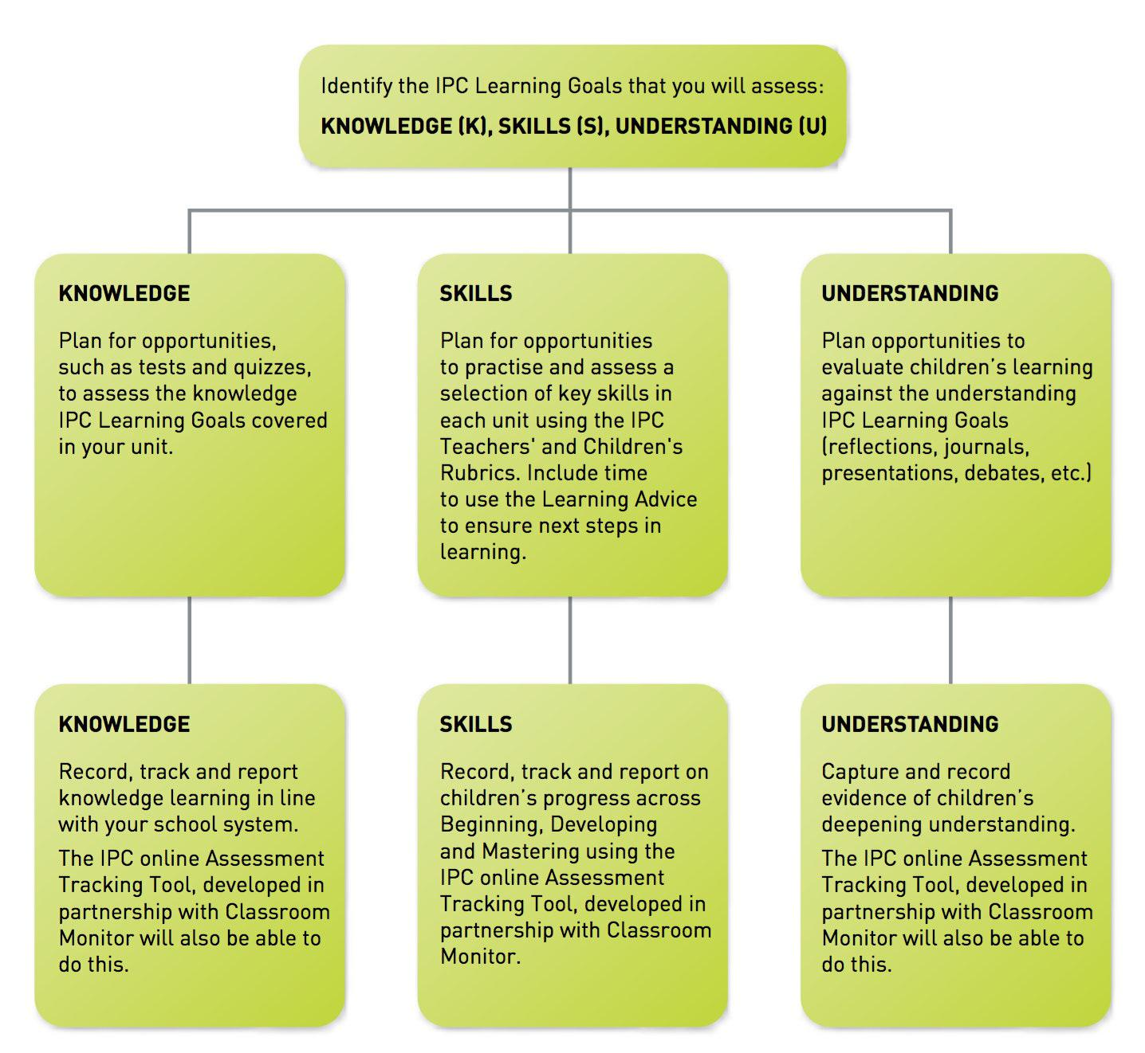

Helping Children Reflect on Their Own Learning

In addition to teacher assessment, it is also vital to include children in reflecting on their learning and setting next steps for improvement. Ask the children to carry out self-assessments throughout each unit (using the Children’s Rubrics to assess skills, and other methods chosen by the school for knowledge and understanding).

They could use the following headings to list/make notes on their newly acquired knowledge, skills and

10

Downloaded for use by Blackmore Community Primary School on 02 July 2018.

From Fieldwork Education, a part of the Nord Anglia Education family. © WCL Group Limited. All rights reserved. Not to be reproduced without permission.
Chocolate

understanding – ‘new things I now know’, ‘new things that I can do’ and ‘new things I am beginning to understand’.

Ask the children to evaluate different aspects of their learning – what did they do well, what could improve next time and how, what did they find the most/least interesting? How did they prefer to learn – as an individual/in pairs/small groups/large groups/as a whole class? What was their preferred method of researching and recording - writing/talking/making, etc.? This evaluation aspect will also support the development of the IPC Personal Goals.

Further Information

For more information on assessment, and knowledge, skills and understanding, please refer to:

The IPC Implementation File

The Assessment for Learning Implementation File

The IPC Self-Review Process

Or contact the Membership Support team at members@fieldworkeducation.com

11

Downloaded for use by Blackmore Community Primary School on 02 July 2018.

From Fieldwork Education, a part of the Nord Anglia Education family. © WCL Group Limited. All rights reserved. Not to be reproduced without permission.
Chocolate

The Entry Point

Safety note: It is essential before beginning this topic to check up on any food allergies, especially any cases of diabetes or nut allergies, which can be fatal. This cannot be emphasised too strongly. Even traces of nut can have serious consequences for a small number of children. If you have any doubts, do not tackle the practical work.

Set up a senses laboratory in a corner of the classroom. Have different areas for different senses as they relate to chocolate. Decorate each of the senses areas with relevant pictures. For each sense, think of one or two fun questions that the children could investigate in their role as chocolate scientists or taste testers, for example:

Tasting

Can our class really taste the difference between dark, milk and white chocolate?

Does our class prefer sweet tastes such as chocolate or savoury tastes such as cheese?

Smelling

If chocolate smelled like onion would we still like it?

If we couldn’t smell chocolate could we still taste it? *

Seeing

Why don’t manufacturers make green or purple chocolate?

If chocolate were the colour of cabbage would we still eat it?

Touching

What is the lowest melting point of chocolate?

Does chocolate that has been refrigerated feel (and/or taste) different to chocolate kept at room temperature?

Hearing

Does chocolate have a sound?

When I eat popping chocolate can other people hear the popping in my mouth?

Assign each sense area to a different group of scientists. Ask them to devise an appropriate test to examine each question and use their findings to reach an answer. For example, the following test will address the taste questions.

You will need:

Taste testers – choose willing volunteers. Make sure none of them have allergies to the food you are going to test

12
Downloaded for use by Blackmore Community Primary School on 02 July 2018.

From Fieldwork Education, a part of the Nord Anglia Education family. © WCL Group Limited. All rights reserved. Not to be reproduced without permission.
Chocolate

Blindfolds

Totally clean conditions – this may be a scientific test, but it has to be treated like any other meal

A range of foods to compare, for example:

Dark bitter chocolate, cut into small pieces

Sweet milk chocolate, cut into small pieces

White chocolate, cut into small pieces

Crisps – flavoured or salted

Nuts – sweet and salted

Dried fruit, cut into small pieces

- Ensure that conditions are completely hygienic.

- Using a clean kitchen knife, cut the foods that can be cut into portions of equal size.

- Blindfold your volunteer. Ask them for their preference between two samples – by taste alone.

- Test enough people to make the evidence reliable.

- Report your evidence in the form of tally charts and bar graphs. What are the preferred foods? Is there a clear favourite?

- For this smell test, you could repeat the taste test above but this time ask your volunteer to hold their nose. They might find it’s hard to taste anything. (Remember how your taste is weakened when your nose is blocked by a cold!)

13

Downloaded for use by Blackmore Community Primary School on 02 July 2018.

From Fieldwork Education, a part of the Nord Anglia Education family. © WCL Group Limited. All rights reserved. Not to be reproduced without permission.
Chocolate

Knowledge Harvest

Prepare in advance a set of ‘Willy Wonka’ chocolate bar wrappers, enough for one for each child – make them yourself using design software and print them out. Hide a few golden wrappers (decorated with gold stars) amongst them. On the back of the golden wrappers you should write one interesting fact about chocolate, e.g. chocolate (cocoa) beans grow inside pods. Leave the other wrappers blank on the back.

Place all the wrappers in a hat (Willy Wonka’s hat) and invite the children to close their eyes and choose one. If they choose a golden wrapper they can read out to the class the fact written on the back. If they choose one of the other wrappers they need to write a fact of their own about chocolate on the back and then read it out to the class! The children cannot repeat a fact so the game gets progressively harder! At the end of the game, the children should display the wrappers as part of their knowledge harvest.

Now watch an excerpt from a Charlie and the Chocolate Factory DVD. Choose a chocolate-making scene.

Afterwards, ask the children to imagine they are visiting a real chocolate factory – not Willy Wonka’s.

What do they expect to see?

What arrives at the factory?

Where does it come from?

What goes in and what comes out?

What is produced by the factory?

How is it wrapped and packed?

Invite the children to draw a chocolate machine.

From their drawings and from the facts written on the wrappers, you could create a flow diagram of all the children’s ideas collected so far and display this in class to refer back to throughout the unit. As the children learn more about the different stages of chocolate production and manufacture, they could replace some of their guesses with the facts.

14

Downloaded for use by Blackmore Community Primary School on 02 July 2018.

From Fieldwork Education, a part of the Nord Anglia Education family. © WCL Group Limited. All rights reserved. Not to be reproduced without permission.
Chocolate

The Big Idea

Wouldn’t it be amazing if chocolate grew on trees? Well, it does! Wouldn’t it be amazing if I said we were going to make some chocolate? Well, we are! And we’re going to discover even more amazing things about chocolate…

Explaining The Theme

In Geography, we’ll be finding out:

Where cacao trees are found

About the factors affecting the growth of cacao trees

About other cash crops

In History, we’ll be finding out:

Who first discovered chocolate

Who took the first chocolate to Europe

About the importance of cocoa beans for trade

In Science, we’ll be finding out:

About the ingredients in chocolate

If chocolate causes tooth decay

Why chocolate wrappers are made from special materials

What the melting point of chocolate is

In Technology, we’ll be finding out:

How to make our own chocolate

What we can add to chocolate

In Art, we’ll be finding out:

How to design a wrapper for our chocolate bar

In International, we’ll be finding out:

What fair trade chocolate is

What other fair trade products there are

How important chocolate is

15
Downloaded for use by Blackmore Community Primary School on 02 July 2018.

From Fieldwork Education, a part of the Nord Anglia Education family. © WCL Group Limited. All rights reserved. Not to be reproduced without permission.
Chocolate

The Big Picture

Cacao

Cacao originates from the Maya and was grown mainly in Guatemala. It was a highly valued commodity. When processed, the bean of the cacao tree became the chocolate used in chocolate drinks. Like us, the Maya loved chocolate, but rather than eat it in bars, they drank it. They flavoured their chocolate drinks with spices such as chilli and sometimes they would use honey. They made sure that their drink was frothy and we see many depictions on vases of these frothy drinks. We also see depictions of how they made the drink frothy – by pouring the liquid into another pot from a height. Cacao beans can be roasted, then easily stored and transported – for that reason cacao became a medium of exchange (currency) in the great market economies of the Postclassic and contact periods – so at this time the Maya were literally drinking money!

The tradition of using the cacao beans as currency and for drink-making was also continued by the Aztec people of Central and South America. They called the drink 'chocolatl'. It was their ‘food of the gods’ and a royal drink served in golden cups. Emperor Montezuma is said to have drunk 50 cups a day! Chocolate wasn’t just a favourite drink – it was an important part of the religious and social lives of the Maya and Aztec people.

Columbus and Cortés

The 16th-century explorer, Christopher Columbus brought back some cocoa beans to Spain in 1504 from the ‘New World’, as America was then called. The King and Queen of Spain failed to realise the importance of the beans among the gold and precious gemstones Columbus returned with. This was discovered some twenty years later by Hernán Cortés when he arrived in Mexico in 1519. He was offered the bitter drink chocolatl by Montezuma but it was not to his liking. But he noticed that the beans were being used as local currency (four beans bought one rabbit, ten beans bought one slave) and realised the significance of what he had found – he could grow ‘money’ on trees!

More about Hernán Cortés

Cortés was a Spanish explorer who conquered the Aztec Empire in 1521. His white skin and beard convinced Montezuma II and the Aztec people that Cortés was the god Quetzalcoatl whose return was prophesied. But Cortés and his men didn’t behave like gods and the Aztecs grew suspicious. They were asked to leave, and they did. But later Cortés returned with 600 armed soldiers. Cortés captured and destroyed the Aztec capital of Tenochtitlan, and built Mexico City in its place. All that remains of the original city is the ruin of the main temple.

Chocolate spread

The first official shipment of chocolate from Veracruz to Seville, Spain, was made in 1585. Chilli pepper was replaced by sugar to make a sweet drink that became popular in the 17th century among the European nobility. The English, French and Dutch introduced the cacao tree into their colonies. In the US, chocolate was first manufactured near Dorchester, Massachusetts, in 1765. The first solid bar of chocolate was made by Fry’s in London in 1847. Two years later, Cadbury’s made a similar product. Milk chocolate was first made in Switzerland in 1876 by Daniel Peter, simply by adding powdered milk. White chocolate was introduced by Nestlé a few years after World War I. It contains cocoa butter, but no cocoa solids at all. For this reason, some people argue that it should not really be called ‘chocolate’.

16
Downloaded for use by Blackmore Community Primary School on 02 July 2018.

From Fieldwork Education, a part of the Nord Anglia Education family. © WCL Group Limited. All rights reserved. Not to be reproduced without permission.
Chocolate

Today 80% of the world’s chocolate is manufactured by just six multinational companies including Nestlé, Mars and Cadbury. The biggest consumer of chocolate is Switzerland with an annual consumption of over 10 kg (22 lb) per person. The top ten consumers in order are: Switzerland, Germany, Austria, Ireland, United Kingdom, Norway, Estonia, Slovakia, Sweden and Kazakhstan.

Main producers

Cacao trees grow in West Africa, Central and South America, and in Southeast Asia. Main producers are:

Ivory Coast, Ghana, Indonesia, Nigeria, Cameroon, Brazil, Ecuador and Malaysia.

Tropical biome

Cacao trees grow in tropical countries that have an equatorial climate with little seasonal variation. Temperatures are hot throughout the year, rarely falling below 25oC in any month. Rainfall and humidity are both high and the air still. Soils are fertile, made up of animal, mineral and organic deposits. It’s a natural greenhouse for the cacao tree and many other plants!

Cacao trees

The cacao tree is quite fragile – it needs warmth, water and shelter from the wind and hot sun. It grows best when planted underneath bigger tropical trees, growing to between 6 to 10 metres high. The tree doesn’t have many branches. When it is between 4 to 5 years old it develops pink flowers. The fruits, often called ‘pods’ (about 15 cm long and shaped like a rugby ball) grow close to the tree on short stalks. Each fruit has about 30-40 seeds (cocoa beans). The fruits are green at first but when they are ripe they become yellow. The beans are purple and the pulp inside the fruit is white. In the wild, monkeys break open the fruit to eat the pulp and so help to disperse the seeds.

Harvesting

The fruits are harvested with long knives and taken to the village, where they are cut, making sure the precious beans are not smashed. The beans are removed from the white pulp and put underneath banana leaves to mature. After a week they are brown and they smell and taste like cacao. Then they are put in the sun to dry. When the beans are dry, they’re placed in linen bags and shipped to processing factories.

Processing

The cocoa beans are made into chocolate in the factory. First they’re cleaned. Then they are roasted in a huge oven. After that the beans go in a machine where they are made into a paste. The paste is pressed and the oil that comes out is cacao butter. The butter, sugar and paste go in a pan and it has to be stirred for 2- 3 days and then you have chocolate! To make 20 bars of chocolate, you need the harvest of one cacao tree.

Cash crops

Cash crops are grown in one country, not to eat but to sell to another country. Cash crop farming has a huge impact on the environment. Over the past fifty years, large areas of land in the developing world have been turned over to single crops such as cotton, maize, soya, sugar beet and cacao. Sometimes the land is not suited to growing cash crops like these. The land may need irrigating or the crops may need to be protected with pesticides. Big companies may take over the land because they can provide the technology to grow cash crops. In some countries, poor farmers who cannot afford this kind of technology go into the forests, slashing and burning the trees to find better farmland. Because the land is turned over

17

Downloaded for use by Blackmore Community Primary School on 02 July 2018.

From Fieldwork Education, a part of the Nord Anglia Education family. © WCL Group Limited. All rights reserved. Not to be reproduced without permission.
Chocolate

to cash crops, it is difficult for poor countries to feed their own populations, leading to poor health and malnutrition.

Fair trade

Many farmers who produce cash crops work for small returns. They are paid an unfair price for their labour. Fair trade organisations and policies aim to pay farmers a fair price for the produce they grow.

The rainforest

At least 50 million acres of rainforest a year are lost, an area roughly the size of Italy. At the current pace of habitat destruction, only 5% of the world’s rainforest will be left by 2050.

The rainforest habitat is important because:

Tropical rainforests are the Earth’s oldest living ecosystems. They have existed in their present form for 70 to 100 million years

Rainforests are home to half of the five to ten million plant and animal species on the globe

An average of 137 species of life forms is driven into extinction every day in the world’s tropical rainforests

A quarter of all medicines available today owe their existence to plants found in the rainforests of the world

Rainforests help control the world’s climate – when they are cleared the water cycle is disrupted, droughts increase and deserts form

Rainforests are often termed the ‘lungs of the world’ because they are believed to be responsible for producing over 20% of the world’s oxygen. More recently, some scientists have refuted this claim – but remain in agreement that losing our rainforests could have dire consequences for the future of our planet.

18

Downloaded for use by Blackmore Community Primary School on 02 July 2018.

From Fieldwork Education, a part of the Nord Anglia Education family. © WCL Group Limited. All rights reserved. Not to be reproduced without permission.
Chocolate

Geography Learning Goals

Children will:

2.01 Know how particular localities have been affected by human activities

2.03 Know how the nature of particular localities affect the lives of people

2.04 Know about the weather and climatic conditions in the host country and how they affect the environment and the lives of people living there

2.05 Be able to use geographical terms

2.08 Be able to use maps at a variety of scales to locate the position and geographical features of particular localities

2.09 Be able to use secondary sources to obtain geographical information

2.10 Be able to express views on the features of an environment and the way it is being harmed or improved

2.11 Be able to communicate their geographical knowledge and understanding to ask and answer questions about geographical and environmental features

2.12 Understand how places fit into a wider geographical context

2.13 Understand that the quality of the environment can be sustained and improved

19

Downloaded for use by Blackmore Community Primary School on 02 July 2018.

From Fieldwork Education, a part of the Nord Anglia Education family. © WCL Group Limited. All rights reserved. Not to be reproduced without permission.
Chocolate

Geography Task 1

Learning Goals

2.04 Know about the weather and climatic conditions in the host country and how they affect the environment and the lives of people living there

2.05 Be able to use geographical terms

2.08 Be able to use maps at a variety of scales to locate the position and geographical features of particular localities

2.09 Be able to use secondary sources to obtain geographical information

2.11 Be able to communicate their geographical knowledge and understanding to ask and answer questions about geographical and environmental features

2.12 Understand how places fit into a wider geographical context

20

Downloaded for use by Blackmore Community Primary School on 02 July 2018.

From Fieldwork Education, a part of the Nord Anglia Education family. © WCL Group Limited. All rights reserved. Not to be reproduced without permission.
Chocolate


Research activity

Where does chocolate come from?

Some of the children will remember that it grows on trees (recall the knowledge harvest). Draw a tree on the board with bars of chocolate hanging from the branches. Ask the class, is this what you mean? Now show them a picture of a cacao tree. You will find lots of images to choose from by entering ‘cacao tree’ into the Google Images search box (images.google.com).

The children should then research the following:

Where do chocolate (cacao) trees grow?

Could we grow cacao trees in the school grounds or local area? Could we grow them in the home countries?

What climate/soil conditions are required for growth?

The following books and websites provide a useful starting point for research:

A Chocolate Bar, How It’s Made series, by Sarah Ridley, Franklin Watts, 2009

Smart about Chocolate, by Sandra Markle, Grosset & Dunlap, 2004

Chocolate: Riches from the Rainforest, by Robert Burleigh, 2002

cacaoweb.net/cacao-tree.html – Cacao web has a feature with photographs about chocolate production and manufacture.

thestoryofchocolate.com – The Story of Chocolate has a ‘where is it from?’ section, that features information, photographs and videos on the origin of chocolate.

wildernessclassroom.com/students/archives/2006/03/chocolate_treec.html – Wilderness Classroom has images and facts about the cacao tree.

The children will discover that cacao trees grow in South and Central America, West Africa, Southeast Asia and other equatorial countries where the climate is hot and wet (with regular rainfall), and where soils are fertile. Take this opportunity to ensure children know what plants and trees need for life and growth (air, light, water, nutrients from soil, and room to grow). Through their research on cacao trees, they should understand that these needs can vary from plant to plant, and tree to tree.

Look at a climate map of the world. Locate the host country and home countries, and a main cacao producer, e.g. Dominican Republic, on a climate map.

Find out what the weather is like in a country where cacao is grown. Search for a weather report on the World Meteorological Association website:

worldweather.wmo.int/index.htm – World Meteorological Association has maps, monthly average temperatures and total rainfall figures.

What does tropical weather feel like? Tell the children it’s like being in a greenhouse! Visit one if you get the chance – some local parks and garden centres have a greenhouse.
21

Downloaded for use by Blackmore Community Primary School on 02 July 2018.

From Fieldwork Education, a part of the Nord Anglia Education family. © WCL Group Limited. All rights reserved. Not to be reproduced without permission.
Chocolate


Recording activity

The children should be able to find the Equator on a world map. Now ask them to colour in the main producers (Ivory Coast, Ghana, Nigeria, Brazil, Ecuador, Venezuela, Dominican Republic, Papua New Guinea, Indonesia) on an outline world map. Compare this with a world climate map. What do they notice? (producers are tropical/equatorial countries)

They could annotate the map with a current weather report for one of these countries.
Compare this weather report with that of the host country.

Older children should be able to define the terms ‘climate’ and ‘weather’. What is a country’s climate? What is weather? (Climate is the average weather over a number of years. Weather is a measure of temperature, rainfall, wind speed.)

In conclusion, ask the children, could we grow cacao trees in the local area? If not, why not?

Mathematics link: this task provides an ideal opportunity to introduce older/more able

children to the concept of a mean or ‘average’ measurement. They could compare average

monthly rainfall totals and average monthly temperatures in a cacao producing country

and the host country. Draw bar charts to compare the weather in these two places. Calculate
the difference.

Science link: if we planted a piece of chocolate would it grow? If we planted a cacao pod would it grow? If we planted a cacao seed would it grow?

Invite suggestions from the class. Try to draw comparisons with other trees (e.g. fruit trees) in your local environment.

In pairs, ask the children to find out:

What the cacao tree looks like: average height, fruits, seeds, leaves, flowers, etc.

Conditions for growth (warmth, humidity and shade)

How it reproduces (in the wild, monkeys disperse the seeds by breaking the pod open to eat the pulp; in plantations, it grows from cuttings)

How it is the same/different to other trees in your environment

Enter ‘cacao tree’ into the Google Images search engine (images.google.com) to find dozens of useful images.

The following websites also provide useful information:

xocoatl.org/tree.htm – Xocoatl website has information and photographs about the life cycle of the cacao tree.

youtube.com/watch?v=LJ-1snuKJ7o – YouTube hosts this animated education video, which explains how the cacao tree grows.

(To watch a YouTube video in safe mode, scroll to the bottom of the page and click on the ‘safety’ tab which brings up the

22

Downloaded for use by Blackmore Community Primary School on 02 July 2018.

From Fieldwork Education, a part of the Nord Anglia Education family. © WCL Group Limited. All rights reserved. Not to be reproduced without permission.
Chocolate

‘Safety mode’ information. Under this section, select the ‘on’ option, then click 'save’)

The children could draw annotated diagrams of the cacao tree and one tree from their local environment side by side. Take this opportunity to recap the key parts of each tree and their functions (roots, leaves, trunk, fruit, flowers, etc.).

They should be able to point out the similarities and differences between the two trees. For example, do the trees reproduce in the same way? Do they both have fruit? How could each tree be classified? Would they belong to the same group? How do the trees reproduce?

Children should be able to describe how each tree produces flowers and is pollinated to produce fruit/seeds.

Older children in the age group could create a chart with two columns: similarities and differences, and write their findings in the relevant column.

Younger children could take photographs of the tree from the host country and compare these with photographs of the cacao tree.

As an extension, children could perform an experiment to observe how water is transported in plants/trees. Simply add food colouring to a pot of water and place a stick of celery in the pot. Children can then observe and record what happens over time - using a magnifying glass to observe the tubes in the celery more closely. (Children will eventually be able to record liquid movement through the celery stalk as the dye colours the celery tubes.) Children can return to their diagrams and add notes to relate their learning to the function of the roots and stem/trunk in transporting water and nutrients from the soil.

Personal Goals

Adaptability

Communication

Enquiry

Thoughtfulness

23

Downloaded for use by Blackmore Community Primary School on 02 July 2018.

From Fieldwork Education, a part of the Nord Anglia Education family. © WCL Group Limited. All rights reserved. Not to be reproduced without permission.
Chocolate

Geography Task 2

Learning Goals

2.03 Know how the nature of particular localities affect the lives of people

2.05 Be able to use geographical terms

2.09 Be able to use secondary sources to obtain geographical information

2.11 Be able to communicate their geographical knowledge and understanding to ask and answer questions about geographical and environmental features

2.12 Understand how places fit into a wider geographical context

24

Downloaded for use by Blackmore Community Primary School on 02 July 2018.

From Fieldwork Education, a part of the Nord Anglia Education family. © WCL Group Limited. All rights reserved. Not to be reproduced without permission.
Chocolate

Research activity

Would you like to work on a cacao farm? Would you get to eat lots of chocolate? Let’s find out.

Start by explaining the term ‘cash crop’: a crop grown for sale and not for local consumption. This means that the people who grow cacao trees don’t eat chocolate themselves!

Why don’t they eat chocolate? Invite suggestions from the class. (It would melt in the hot weather and it’s too expensive.) The farmers sell the cocoa beans to other countries, e.g. the USA, Switzerland, Germany and Belgium. These other (industrialised and cooler) countries process and manufacture the beans to turn them into chocolate.

Ask the children to find out what these terms mean:

Cacao – the name given to the tree

Cocoa – the bean inside the pod

Cocoa exporters – countries that sell cocoa beans (the growers)

Cocoa importers – countries that buy cocoa beans (the manufacturers)

The following websites provide useful background information and links:

globaldimension.org.uk/news/item/14702 – Global Dimension features information and videos exploring the global aspects of chocolate production.

sfu.ca/geog351fall03/groups-webpages/gp8/intro/intro.html – the World Atlas of Chocolate explores the geography of chocolate production and consumption.

ngm.nationalgeographic.com/ngm/0404/resources_geo2.html – National Geographic website has useful background information: On the Trail of Chocolate (with further links).

Older children in the age group could find out about the following problems:

Local people earn little money from working on a cocoa bean farm

Many farmers employ children, who work long hours to support their families

25

Downloaded for use by Blackmore Community Primary School on 02 July 2018.

From Fieldwork Education, a part of the Nord Anglia Education family. © WCL Group Limited. All rights reserved. Not to be reproduced without permission.
Chocolate

Recording activity

Ask the children to locate the countries where chocolate is manufactured on an outline map of the world. They should colour in and annotate the map with the country names. (UK, USA, Switzerland, Germany, Belgium, etc.)

Now put two maps together – the map showing cacao growers (from Geography Task 1) and the map of chocolate manufacturers from this task. Now the children will see at a glance where chocolate is grown and where it is manufactured. Draw lines indicating exports from the growers to the manufacturers. Use a colour key to distinguish growers from manufacturers.

Can older children think of solutions to the problems of low wages and child labour? How could their ideas be implemented or followed through? You could encourage them to write to a major chocolate manufacturer to find out what they are doing about these problems. See also International Task 1.

Technology link: find out how cacao trees are grown and about the process and manufacture of cocoa beans into chocolate. Present the findings as a series of step-by-step illustrations, cartoons or animations.

The following websites provide a useful starting point:

dubble.co.uk/bean2bar – Dubble website has information and videos for children, ‘Bean 2 Bar’.

divinechocolate.com/uk/about-us/research-resources/divine-story/bean-to-bar – Divine Chocolate features information and photographs explaining the process of chocolate-making, from the cacao tree to the consumer.

scharffenberger.com/our-story/artisan-process/ – Scharffenberger website explains the process of chocolate making at their factory.

cocoaskiss.blogspot.com – Cocoaskiss website provides useful information and photographs for teachers about everything to do with chocolate.

Personal Goals

Communication

Enquiry

Morality

Thoughtfulness

26

Downloaded for use by Blackmore Community Primary School on 02 July 2018.

From Fieldwork Education, a part of the Nord Anglia Education family. © WCL Group Limited. All rights reserved. Not to be reproduced without permission.
Chocolate

Geography Extension Task

Learning Goals

2.01 Know how particular localities have been affected by human activities

2.03 Know how the nature of particular localities affect the lives of people

2.05 Be able to use geographical terms

2.09 Be able to use secondary sources to obtain geographical information

2.10 Be able to express views on the features of an environment and the way it is being harmed or improved

2.11 Be able to communicate their geographical knowledge and understanding to ask and answer questions about geographical and environmental features

2.12 Understand how places fit into a wider geographical context

2.13 Understand that the quality of the environment can be sustained and improved

27

Downloaded for use by Blackmore Community Primary School on 02 July 2018.

From Fieldwork Education, a part of the Nord Anglia Education family. © WCL Group Limited. All rights reserved. Not to be reproduced without permission.
Chocolate
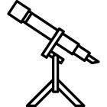

Extension activity

How is coffee like chocolate? It grows in the same climate and is also a cash crop.

‘Money grows on trees.’ Introduce the saying to the class and discuss with reference to cash crops such as cacao and coffee. Large areas of rainforest are being cleared to make way for cash crops. What effect does the growing of cash crops have on the environment and local people?

The following websites provide a useful starting point:

environment.nationalgeographic.com/environment/photos/rainforest-deforestation//#/madagascar-slash-burn_278_600x450.jpg – National Geographic website has photographs of deforestation in the rainforest.

rainforestsaver.org/what-slash-and-burn-farmingR – Rainforest Saver website explains what slash-and-burn farming is.

edenproject.com/rainforest – Eden project website explains the importance of the rainforest.

worldcocoafoundation.org – World Cocoa Foundation website has information and videos about sustainable cocoa farming.

Ask the children, in small groups, to research the following:

'Slash-and-burn’ – why and where does it happen?

Cash crops – what are the advantages and disadvantages?

Deforestation – what are the effects on world climate, plants and animals?

Estimates say only 5% of the world’s rainforest will be left by 2050 – why do we need to save the world’s rainforests?

People – how else could local people earn a living?

You could assign a different question to each group, according to ability.

The children could present their research through a play, poem or song. As a class, discuss the pros and cons of clearing the rainforest to grow cash crops.

The following video explains how the organic growing of cacao trees can save the rainforest:

video.nationalgeographic.com/video/player/news/environment-news/domrep-cacao-wcvin.html – National Geographic website has this video about how organic farming of cacao is actually saving the rainforest in the Dominican Republic.

28

Downloaded for use by Blackmore Community Primary School on 02 July 2018.

From Fieldwork Education, a part of the Nord Anglia Education family. © WCL Group Limited. All rights reserved. Not to be reproduced without permission.
Chocolate

Personal Goals

Communication

Enquiry

Morality

Respect

Thoughtfulness

29

Downloaded for use by Blackmore Community Primary School on 02 July 2018.

From Fieldwork Education, a part of the Nord Anglia Education family. © WCL Group Limited. All rights reserved. Not to be reproduced without permission.
Chocolate

History Learning Goals

Children will:

2.01 Know about the main events, dates and characteristics of the past societies they have studied

2.02 Know about the lives of people in those periods

2.03 Know about the main similarities and differences between the past societies they have studied

2.04 Be able to give some reasons for particular events and changes

2.05 Be able to gather information from simple sources

2.06 Be able to use their knowledge and understanding to answer simple questions about the past and about changes

30

Downloaded for use by Blackmore Community Primary School on 02 July 2018.

From Fieldwork Education, a part of the Nord Anglia Education family. © WCL Group Limited. All rights reserved. Not to be reproduced without permission.
Chocolate

History Task 1

Learning Goals

2.01 Know about the main events, dates and characteristics of the past societies they have studied

2.02 Know about the lives of people in those periods

2.04 Be able to give some reasons for particular events and changes

2.05 Be able to gather information from simple sources

2.06 Be able to use their knowledge and understanding to answer simple questions about the past and about changes

31

Downloaded for use by Blackmore Community Primary School on 02 July 2018.

From Fieldwork Education, a part of the Nord Anglia Education family. © WCL Group Limited. All rights reserved. Not to be reproduced without permission.
Chocolate

Research activity

People have been drinking chocolate for thousands of years – not the supermarket ‘hot chocolate’ you might drink, but something called ‘xocolatl’ or ‘chocolatl’.

Ask the children, in small groups, to research the history of chocolate, focusing on these main questions:

What was chocolatl? Who made it and how was it made?

Who drank it and on what occasions?

Why did Spanish explorers not like the taste?

How was it different to the chocolate we drink today?

Why was the cocoa bean ignored when Columbus brought it to Spain for the first time?

Which Spanish explorer set up the first cacao plantations?

What happened after that?

The following books and websites provide a useful starting point:

The Story of Chocolate, by Caryn Jenner, Dorling Kindersley, 2005 The Story of Chocolate, by Katie Daynes, Usborne Publishing, 2006
mexicolore.co.uk/maya/chocolate – this educational website focuses specifically on the role of chocolate (cacao) among the Aztecs and the Maya, with articles suitable for teachers and children.

exploratorium.edu/exploring/exploring_chocolate/choc_2.html – Exploratorium website explores the history of chocolate.

inventors.about.com/od/foodrelatedinventions/a/chocolate.htm – About.com website has an historical timeline of the cocoa bean. (Note: this site does feature advertising.)

thestoryofchocolate.com – The Story of Chocolate has a ‘who depends on it?’ section, that features information on the impact of chocolate on the peoples of the past.

sfu.ca/geog351fall03/groups-webpages/gp8/history/history.html – SFU website contains useful information on the history of chocolate.

32

Downloaded for use by Blackmore Community Primary School on 02 July 2018.

From Fieldwork Education, a part of the Nord Anglia Education family. © WCL Group Limited. All rights reserved. Not to be reproduced without permission.
Chocolate

Recording activity

In their groups, ask the children to use their research findings to write a sequence of short plays or vignettes to explain key events in the history of chocolate. For example:

- Start with the Aztec Emperor, Montezuma, offering his guests chocolate served in golden cups.

- Columbus showing gold, precious stones and cocoa beans to the King and Queen of Spain. They might have looked at the cocoa beans with disapproval and distaste.

- Then Hernan Cortès arrives on the scene. He doesn’t like the bitter chocolatl drink but sees the beans being used as money!

- Cortès returns to Spain with the cocoa beans. The Spanish add sugar instead of spices – and suddenly everyone likes this new chocolate drink.

- But not everyone can afford it – only the European nobility, the rich and the royal can enjoy this luxury.

Etc.

In addition, the children could draw an illustrated timeline with relevant names and dates. Or produce a story board with cartoon drawings and captions describing the sequence of events that led from the Aztec Emperor Montezuma drinking chocolatl in a golden cup to us buying drinking chocolate in a tin from the supermarket. (Link to Geography Task 2.)

Art link: research Aztec art. Make a simple pinch pot or coil pot from clay in the shape of a drinking cup. Fire, decorate and glaze it. Use yellow as a base and decorate with a black, brown and white geometric patterns. Then fire again.

The following website provides a useful starting point:

kinderart.com/sculpture/clay.shtml – Kinderart website has information for teachers about making pottery.

Personal Goals

Adaptability

Communication

Enquiry

Thoughtfulness

33
Downloaded for use by Blackmore Community Primary School on 02 July 2018.

From Fieldwork Education, a part of the Nord Anglia Education family. © WCL Group Limited. All rights reserved. Not to be reproduced without permission.
Chocolate

History Task 2

Learning Goals

2.01 Know about the main events, dates and characteristics of the past societies they have studied

2.02 Know about the lives of people in those periods

2.03 Know about the main similarities and differences between the past societies they have studied

2.04 Be able to give some reasons for particular events and changes

2.05 Be able to gather information from simple sources

2.06 Be able to use their knowledge and understanding to answer simple questions about the past and about changes

Research activity

Show the class a portrait of Hernan Cortès (sometimes written Hernando Cortez). Ask them, who was Hernan Cortès? Recall what they already know about him from History Task 1. Why did he want to conquer the Aztec people? How was the Aztec empire different from the Spanish empire at that time?

The following websites will provide a useful starting point:

pbs.org/opb/conquistadors/mexico/adventure2/a1.htm – the PBS website provides an ‘On-line Learning Adventure’ about Cortès and Spanish explorers in the 15th century. Resources are suitable for older children, but contains useful information for teachers.

aztecs.mrdonn.org/spanish-arrival.html – Mr Donn website has a feature about Cortès and the Aztec empire. (Note: this site does feature advertising.)

bbc.co.uk/history/historic_figures/cortes_hernan.shtml – BBC History website has biographical information about Cortès.

wlcsd.org/loonlake.cfm?subpage=1471242 – the Walled Lake School District website provides a useful overview of Cortés’ life accompanied by a gallery of images.

ducksters.com/history/aztec_empire/spanish_conquest.php – Ducksters features information on Hernan Cortés and his conquest of the Aztec Empire. (Note: this site does feature advertising.)

34

Downloaded for use by Blackmore Community Primary School on 02 July 2018.

From Fieldwork Education, a part of the Nord Anglia Education family. © WCL Group Limited. All rights reserved. Not to be reproduced without permission.
Chocolate

Recording activity

After the research, begin with a role play in which the teacher takes on the role of Cortès. The children could take turns to interview him, asking him to reflect on past historical events.

They could interview him when he first meets the Aztecs and later they could pretend to visit him at his home in Spain towards the end of his life. When the children grasp the technique you can swap roles.

You could use other drama techniques to find out what Cortès might have been thinking and feeling at significant points in his life, e.g. take him down ‘conscience alley’ to find out what he was thinking at the time when he saw the magnificent Aztec city of Tenochtitlan for the first time. Children line up facing each other to make an alley, down which Cortès will pass. As he walks slowly down the alley, children on both sides say what they think

he might be feeling. Different sides of the alley could have opposing thoughts, e.g. negative thoughts coming from one side and positive from the other.

This activity could be extended to include an interview with the Aztec Emperor, Montezuma.

Through this task you want to see evidence that the children know about the differences (and similarities) between the Spanish and Aztec societies at this time in history.

Personal Goals

Adaptability

Communication

Enquiry

Morality

Thoughtfulness

35

Downloaded for use by Blackmore Community Primary School on 02 July 2018.

From Fieldwork Education, a part of the Nord Anglia Education family. © WCL Group Limited. All rights reserved. Not to be reproduced without permission.
Chocolate

History Extension Task

Learning Goals

2.01 Know about the main events, dates and characteristics of the past societies they have studied

2.02 Know about the lives of people in those periods

2.03 Know about the main similarities and differences between the past societies they have studied

2.04 Be able to give some reasons for particular events and changes

2.05 Be able to gather information from simple sources

2.06 Be able to use their knowledge and understanding to answer simple questions about the past and about changes

36

Downloaded for use by Blackmore Community Primary School on 02 July 2018.

From Fieldwork Education, a part of the Nord Anglia Education family. © WCL Group Limited. All rights reserved. Not to be reproduced without permission.
Chocolate

Extension activity

At first, the Spanish wanted to keep chocolate as their secret drink but gradually other European traders got to hear about it. By the 17th century, chocolate was a popular drink among rich and royal Europeans. The British, French, Spanish and Dutch set up cacao plantations in their colonies to provide all the beans they needed. But cacao farming needed lots of workers too. Traders and plantation owners forced people from Africa to work as slaves on their cacao farms – they also worked on coffee, cotton and sugar plantations.

Ask the children to trace the historic ‘triangular trade’ route. This could be linked back to geography and work on cash crops.

The following websites provide a useful starting point:

nmm.ac.uk/freedom/viewTheme.cfm/theme/triangular – The National Maritime Museum has an interactive ‘triangular trade’ map.

en.wikipedia.org/wiki/Atlantic_slave_trade – Wikipedia provides photographs and information on the slave trade.

africa.mrdonn.org/slavetrade.html – Mr Donn website has a feature and lesson plans about the Atlantic slave trade. (Note: this site does feature advertising.

bbc.co.uk/bitesize/ks3/history/industrial_era/the_slave_trade/revision/4 – the BBC Bitesize website has a map and information on the slave trade.

theschoolrun.com/homework-help/the-atlantic-slave-trade – the School Run has a good overview of the slave trade, with accompanying images and a timeline.

abolition.e2bn.org/slavery_43.html – the Abolition Project provides information on the three stages of the triangular slave trade.

liverpoolmuseums.org.uk/ism/slavery – the International Slavery Musuem website contains facts about life on board a slave ship, as well as a first-person account by a slave.

Allow the children to report their findings in a manner of their choosing. For example, they may wish to create an oral or interactive presentation, develop a hot-seating role-play (based on their experiences from the previous task), or create a poster featuring annotated maps and a timeline.

Language Arts link: children could write a diary account or short story featuring a slave child who has been captured and put on board a slave ship. Prompt them to consider what the conditions on a slave ship might have been like. How would they feel to know that they are traveling to a strange land, where they may never see their family again?

37

Downloaded for use by Blackmore Community Primary School on 02 July 2018.

From Fieldwork Education, a part of the Nord Anglia Education family. © WCL Group Limited. All rights reserved. Not to be reproduced without permission.
Chocolate

Personal Goals

Adaptability

Communication

Enquiry

Morality

Thoughtfulness

38

Downloaded for use by Blackmore Community Primary School on 02 July 2018.

From Fieldwork Education, a part of the Nord Anglia Education family. © WCL Group Limited. All rights reserved. Not to be reproduced without permission.
Chocolate

Science Learning Goals

Children will:

2.01a Be able to carry out simple investigations

2.01b Be able to prepare a simple investigation which is fair, with one changing factor

2.01c Be able to predict the outcome of investigations

2.01d Be able to use simple scientific equipment

2.01e Be able to test ideas using evidence from observation and measurement

2.01f Be able to link evidence to broader scientific knowledge and understanding

2.01g Be able to use evidence to draw conclusions

2.02 Be able to gather information from simple texts

2.03 Understand the importance of collecting scientific evidence

2.07 Know about the principles of nutrition, growth, movement and reproduction

2.13 Know about the function and care of teeth in humans and other animals

2.17 Know about the effect of exercise on the human body

2.19 Know about the effect of diet on the human body

2.31 Be able to compare common materials and objects according to their properties

2.34 Understand that different materials are suited for different purposes

39

Downloaded for use by Blackmore Community Primary School on 02 July 2018.

From Fieldwork Education, a part of the Nord Anglia Education family. © WCL Group Limited. All rights reserved. Not to be reproduced without permission.
Chocolate

Science Task 1

Learning Goals

2.02 Be able to gather information from simple texts

2.07 Know about the principles of nutrition, growth, movement and reproduction

2.17 Know about the effect of exercise on the human body

2.19 Know about the effect of diet on the human body

40

Downloaded for use by Blackmore Community Primary School on 02 July 2018.

From Fieldwork Education, a part of the Nord Anglia Education family. © WCL Group Limited. All rights reserved. Not to be reproduced without permission.
Chocolate

Research activity

Show the children a chocolate bar. Ask them: is chocolate good or bad for our health? You will probably get a mixed response. (It’s good because it gives us energy. It’s bad because it can make us obese.)

What is chocolate made of? Refer back to the geography tasks. Then look at the nutritional information printed on the chocolate wrapper. It might read something like this:
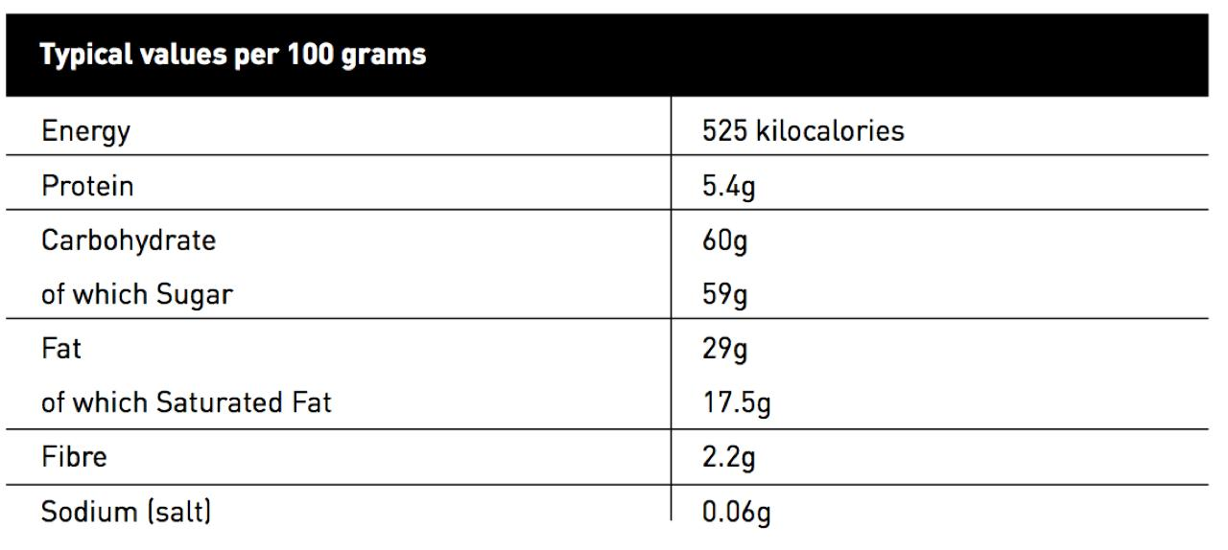

The main ingredients in chocolate are sugar and fat. Challenge the children in pairs to find out how their body uses sugar and fat. How much sugar and fat do we need each day?

The following websites provide a useful starting point:

bbc.co.uk/northernireland/schools/4_11/uptoyou/healthy/nutrientfacts5.shtml – the BBC website has information on fats and sugars, with a podcast interview with a community dietician.

kidshealth.org/kid/stay_healthy/index.html#cat119 – KidsHealth website has a series of features about healthy eating.

choosemyplate.gov – Choose My Plate website has information about the main food groups.

A chocolate bar provides you with a lot of energy. If your body released this energy instantly, you would explode like a stick of dynamite. But this doesn’t happen because your body burns the energy off slowly, doing all the things it needs to do to keep you alive and working properly.

The amount of energy you need depends on many things including how much exercise you do. Your body is using energy all the time – even when you are asleep. Discuss with the class the different physical activities that burn off energy more quickly, e.g. playing football, doing gymnastics, dancing, running around, etc.

The World Health Organisation recommends that 5- to 17-year-olds should do 60 minutes of vigorous to moderate exercise each day to keep their bodies healthy. (This is a cumulative total.) Discuss what is meant by vigorous to moderate exercise, e.g. running, jumping, playing football, and so on.

41

Downloaded for use by Blackmore Community Primary School on 02 July 2018.

From Fieldwork Education, a part of the Nord Anglia Education family. © WCL Group Limited. All rights reserved. Not to be reproduced without permission.
Chocolate

Recording activity

Display the following information on the board or knowledge harvest.

Time taken to eat a chocolate bar: 1 minute

Time taken to burn off the energy from a chocolate bar:

Running – 14 minutes

Walking – 52 minutes

Swimming – 24 minutes

Watching TV – 4 hours

Sleeping – 5 hours

Ask the children to record this information as a bar graph and discuss it along with their research. Then, in pairs, answer these questions:

If you were going to run a marathon, would it be better to eat a chocolate bar before or after you ran the marathon?

Why is it important to balance chocolate-eating with activity?

What happens to the energy you don’t burn off?

Is it a good idea to eat chocolate at bedtime?

How can we enjoy chocolate as part of a healthy diet?

Science/Language Arts link: challenge the children to use books and the internet to find out about the human digestive system and what happens to our food inside our bodies. Based on their research, children could draw an annotated diagram showing the journey of a piece of chocolate, or even create their own comic strip or story to explore what happens. The following book provides an ideal starting point:

See Inside Your Body (Usborne Flap Books), by Katie Daynes, Usborne Publishing, 2006

Personal Goals

Communication

Enquiry

Respect

Thoughtfulness

42
Downloaded for use by Blackmore Community Primary School on 02 July 2018.

From Fieldwork Education, a part of the Nord Anglia Education family. © WCL Group Limited. All rights reserved. Not to be reproduced without permission.
Chocolate

Science Task 2

Learning Goals

2.02 Be able to gather information from simple texts

2.07 Know about the principles of nutrition, growth, movement and reproduction

2.19 Know about the effect of diet on the human body

43

Downloaded for use by Blackmore Community Primary School on 02 July 2018.

From Fieldwork Education, a part of the Nord Anglia Education family. © WCL Group Limited. All rights reserved. Not to be reproduced without permission.
Chocolate

Research activity

Ask the children why they eat chocolate. Is it as a snack between meals? Is it part of a meal? Or is it eaten as a treat? How often do they eat chocolate: every day/once a week/special occasions? Compile a class questionnaire to find out about their chocolate-eating habits or ask the class to make a ‘chocolate diary’ for a week.

You will probably discover that chocolate is most often eaten as a snack between meals.

Extend Science Task 2 with older children in the age group by comparing the nutritional value of a bar of chocolate with other high-energy snack foods such as crisps or mixed nuts.

Crisps
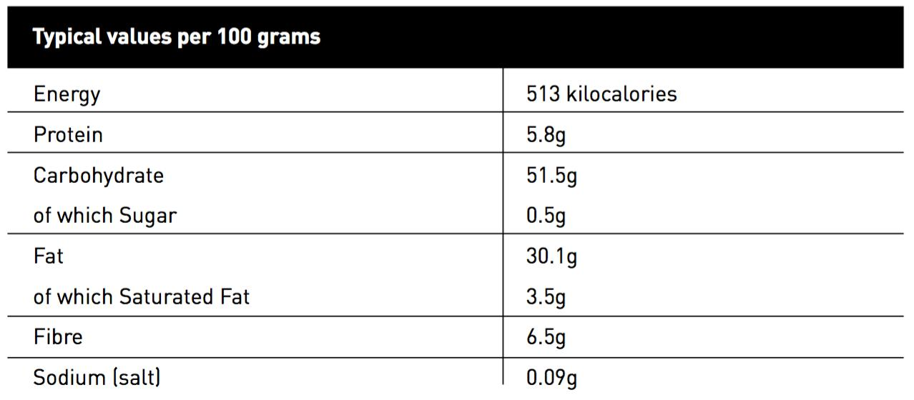

Mixed nuts
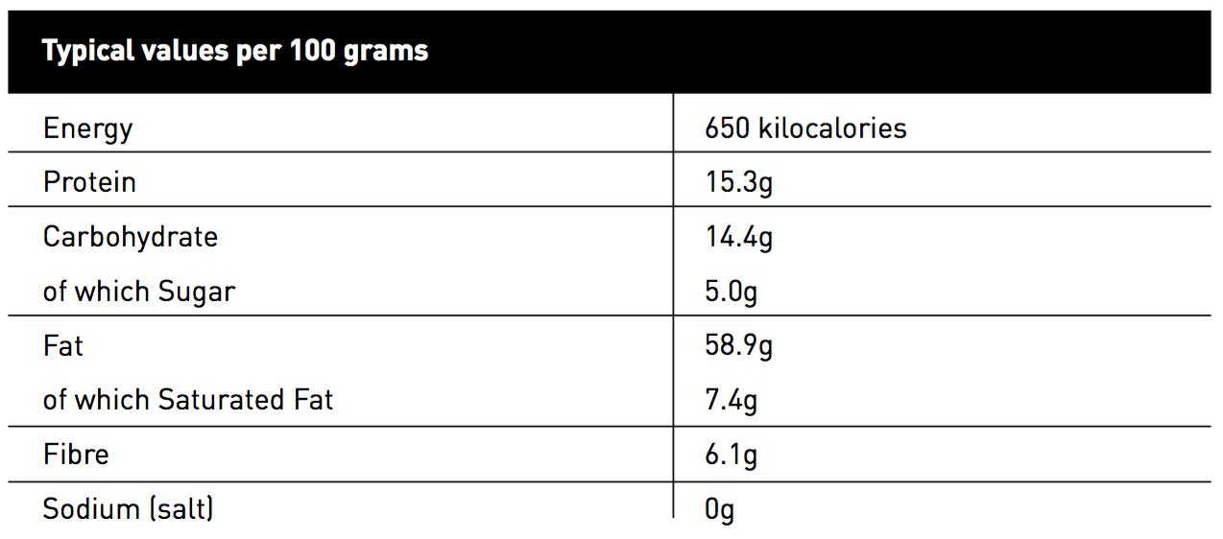

Ask the children to identify other snack foods containing high amounts of energy (calories) by comparing food labels. What have they learned about the nutritional value of snack foods? Should any of these snacks come with a health warning?

44

Downloaded for use by Blackmore Community Primary School on 02 July 2018.

From Fieldwork Education, a part of the Nord Anglia Education family. © WCL Group Limited. All rights reserved. Not to be reproduced without permission.
Chocolate

Recording activity

Draw bar graphs and pie charts to help you analyse the results of the chocolate-eating habits among the children in your class. What do the results show? Is chocolate being eaten as a snack every day between meals? Or as an occasional treat?

Sort the snack food labels into different groups – snacks high in sugar,snacks high in fat, and snacks high in both sugar and fat. The children could draw a Venn diagram to present the results.

Is it healthier to eat a packet of crisps, a bag of mixed nuts or a bar of chocolate? Ask for comments from the class.

The children could produce a chart to show the different values of sugar, fat and protein in different snack foods.

What place should high-energy foods have in our diet? Should any of these snacks come with a government health warning? Or a traffic-light system, e.g. with a ‘red light’ to say eat only in small amounts? (Link to the Art and Technology Tasks.)

Technology link: explore a selection of food items, including seasonal fruits and vegetables. Discuss their role in a healthy and balanced diet. Using some of the food items, children can be challenged to create their own healthy drink/shake, nutritious salad or a savoury snack (such as a cheese/fruit muffin) to serve as an alternative to chocolate. Depending on their choice of recipe, children should explore the taste of different ingredients and consider how they might combine these ingredients in their recipe. Explore different techniques for preparing and presenting these ingredients. When displaying their finished dishes, prompt the children to talk about the different ingredients that they used. They should also be explain the reasons for their choices. Then you can have a fun tasting session – or even invite other members of the school community to taste the drinks/dishes and judge the results. (Note: always be aware of any allergies when handling or tasting different foods.)

Personal Goals

Communication

Cooperation

Enquiry

Morality

Thoughtfulness

45
Downloaded for use by Blackmore Community Primary School on 02 July 2018.

From Fieldwork Education, a part of the Nord Anglia Education family. © WCL Group Limited. All rights reserved. Not to be reproduced without permission.
Chocolate

Science Task 3

Learning Goals

2.01a Be able to carry out simple investigations

2.01b Be able to prepare a simple investigation which is fair, with one changing factor

2.01c Be able to predict the outcome of investigations

2.01d Be able to use simple scientific equipment

2.01e Be able to test ideas using evidence from observation and measurement

2.01f Be able to link evidence to broader scientific knowledge and understanding

2.01g Be able to use evidence to draw conclusions

2.03 Understand the importance of collecting scientific evidence

2.13 Know about the function and care of teeth in humans and other animals

46

Downloaded for use by Blackmore Community Primary School on 02 July 2018.

From Fieldwork Education, a part of the Nord Anglia Education family. © WCL Group Limited. All rights reserved. Not to be reproduced without permission.
Chocolate

Research activity

Does chocolate give you tooth decay? Talk about this with the class and ask them how they could find out. Use this opportunity to recap the different types of teeth and their functions. What are your teeth for? Your teeth are specially designed to bite, tear and chew a variety of foods. They have different shapes for different jobs – and different names. Do the children know the names for any of their teeth.

Cutting teeth are called incisors (front teeth), stabbing teeth are canines (pointy teeth) and chewing and crushing teeth are molars (back teeth). When carrying out their investigations in this task, encourage the children to look out for the different types of teeth.

One way would be to test chocolate and other snack foods (see Science Task 3). Which snack food will leave the most plaque on our teeth?

Divide the children into groups and give each group:

A piece of chocolate

A piece of fresh carrot, apple or orange

A few potato crisps

Disclosing tablets

Hand mirrors

Disposable toothbrushes (one for each child)

Toothpaste

Ask them to make a prediction first. Then discuss how they could devise a fair test of these snack foods. How could they measure the plaque on their teeth? (use disclosing tablets, take photographs, draw diagrams)

They might carry out the test as follows:

- Clean their teeth

- Eat a piece of chocolate

- Observe the results

- Eat a disclosing tablet

- Photograph the results

- Clean their teeth

To make the test fair, they would need to follow these same steps with each snack food.

47

Downloaded for use by Blackmore Community Primary School on 02 July 2018.

From Fieldwork Education, a part of the Nord Anglia Education family. © WCL Group Limited. All rights reserved. Not to be reproduced without permission.
Chocolate

Recording activity

The children should record their results as photographic or video evidence, annotated diagrams and written descriptions.

Which snack food left the most plaque on their teeth? Was this as they predicted? Ask them what they have learned from this experiment. Can they apply what they have learned to caring for their teeth?

Personal Goals

Communication

Enquiry

Respect

Thoughtfulness

48

Downloaded for use by Blackmore Community Primary School on 02 July 2018.

From Fieldwork Education, a part of the Nord Anglia Education family. © WCL Group Limited. All rights reserved. Not to be reproduced without permission.
Chocolate

Science Task 4

Learning Goals

2.01a Be able to carry out simple investigations

2.01b Be able to prepare a simple investigation which is fair, with one changing factor

2.01c Be able to predict the outcome of investigations

2.01d Be able to use simple scientific equipment

2.01e Be able to test ideas using evidence from observation and measurement

2.01f Be able to link evidence to broader scientific knowledge and understanding

2.01g Be able to use evidence to draw conclusions

2.02 Be able to gather information from simple texts

2.03 Understand the importance of collecting scientific evidence

2.31 Be able to compare common materials and objects according to their properties

2.34 Understand that different materials are suited for different purposes

49

Downloaded for use by Blackmore Community Primary School on 02 July 2018.

From Fieldwork Education, a part of the Nord Anglia Education family. © WCL Group Limited. All rights reserved. Not to be reproduced without permission.
Chocolate

Research activity

Examine some chocolate wrappers. What material is used to wrap chocolate? Why is this material used? What properties does it have? (prevents melting, keeps chocolate fresh, keeps out other scents and flavours)

Invite the children to plan an investigation testing the suitability of different materials for wrapping chocolate. For example:

They could try wrapping small pieces of chocolate in:

Greaseproof or waxed paper

Kitchen foil

Paper towel

Cling film

Standard chocolate wrapper

- Seal them in a polythene sandwich bag with a strong-smelling food, e.g. onion slices or crushed garlic

- Wrap one piece of chocolate in a standard chocolate wrapper – this is the ‘control’ in the test

- Leave for a few days

- Predict what you think will happen

- Unwrap the chocolate and taste it

- Which wrappers kept out the taste? Can you explain why?

With older/more able children, you could extend this research investigation by testing which of these materials (in the list of wrappings above) are best at insulating chocolate, i.e. will stop it from melting. Challenge the children to devise a suitable test.

Recording activity

The children should record their investigation as a report with annotated diagrams or as a video.

What conclusions can they draw from their test? Was it fair, e.g. did they use the same amount of onion/garlic in each bag? Are the results valid?

50

Downloaded for use by Blackmore Community Primary School on 02 July 2018.

From Fieldwork Education, a part of the Nord Anglia Education family. © WCL Group Limited. All rights reserved. Not to be reproduced without permission.
Chocolate

Personal Goals

Communication

Enquiry

Resilience

Thoughtfulness

51

Downloaded for use by Blackmore Community Primary School on 02 July 2018.

From Fieldwork Education, a part of the Nord Anglia Education family. © WCL Group Limited. All rights reserved. Not to be reproduced without permission.
Chocolate

Science Extension Task

Learning Goals

2.01a Be able to carry out simple investigations

2.01b Be able to prepare a simple investigation which is fair, with one changing factor

2.01c Be able to predict the outcome of investigations

2.01d Be able to use simple scientific equipment

2.01e Be able to test ideas using evidence from observation and measurement

2.01f Be able to link evidence to broader scientific knowledge and understanding

2.01g Be able to use evidence to draw conclusions

2.03 Understand the importance of collecting scientific evidence

2.31 Be able to compare common materials and objects according to their properties

Extension activity

Place a small piece of chocolate into the palm of each child’s hand. Ask them to observe what happens. Does the chocolate start to melt? Why does it melt? (Your body temperature is higher than the temperature of the chocolate.) Will it melt completely? If not, why not?

Can the children think of any other food that will melt in their hand? (butter, ice cream)

Now ask the children to carry out their own investigation to find out which type of chocolate has the lowest melting point. Dark, white or milk?

Each group will need:

A piece of dark, white and milk chocolate

A timer

A cooking thermometer (optional)

A bowl of hot water (caution: no hotter than tap water)

Three foil cake cases or ‘boats’

- Place a piece of chocolate in each case

- Float the cases on the water

52

Downloaded for use by Blackmore Community Primary School on 02 July 2018.

From Fieldwork Education, a part of the Nord Anglia Education family. © WCL Group Limited. All rights reserved. Not to be reproduced without permission.
Chocolate

- Observe the effects as the chocolate melts

- Let the water cool

- Observe the effects as the chocolate solidifies again

Before they begin the investigation, you should ask the children to make a prediction first and decide what measurements they will take. For example, the time the chocolate starts to melt, the time when it has melted completely, the time it solidifies again.

Older children in the age group might want to record the changing temperature of the water in a line graph.

Make a video of the investigation that you can show to the parents for the exit point.

The children should record the order and time of melting in a bar chart. They should be able to use the terms ‘solid’, ‘solidify’ and ‘liquid’, ‘liquify’ and apply these terms to other foods.

This activity will have shown them how a solid can turn into a liquid and back again. Can they explain why this happens? Does this apply to all solids? Can they think of any other foods that act in this way? (Butter)

The children could then go on to research the changing states of different materials through heating and cooling, and the temperature at which this happens (in degrees Celsius, °C).

In this task the children have been using the terms ‘solid’ and ‘liquid’ but can they name the third state of matter? (Gas) Can the children think of any examples of materials that are solids, liquids and gases? Draw a three-column chart on the board headed: solids, liquids and gases, and ask the children to fill in the chart with examples. Look at the materials in each column and discuss what they have in common. For example, we can feel solids and they have a shape. Liquids flow and we can pour them. Gases are often invisible, and we don’t often feel them but we can sometimes smell them.

Children may already be familiar with the fact that water can exist in all three states and that when heated, can eventually turn into a gas. If they have not experienced this learning yet, you might want to demonstrate the process of the water cycle, and the part played by evaporation and condensation, associating the rate of evaporation with temperature (for more information on this, and on solids, liquids and gases please see the Milepost 2 unit Material World).

If we continued to heat chocolate would it turn into a gas? Take the children’s suggestions, and explore with the class.

Safety note: the teacher should be in charge of heating the chocolate, and children should be supervised closely during this activity.

53

Downloaded for use by Blackmore Community Primary School on 02 July 2018.

From Fieldwork Education, a part of the Nord Anglia Education family. © WCL Group Limited. All rights reserved. Not to be reproduced without permission.
Chocolate

Personal Goals

Communication

Enquiry

Thoughtfulness

54

Downloaded for use by Blackmore Community Primary School on 02 July 2018.

From Fieldwork Education, a part of the Nord Anglia Education family. © WCL Group Limited. All rights reserved. Not to be reproduced without permission.
Chocolate

Technology Learning Goals

Children will:

2.01 Know that the way in which products in everyday use are designed and made affects their usefulness

2.02 Be able to design and make products to meet specific needs

2.03 Be able to make usable plans

2.05 Be able to use simple tools and equipment with some accuracy

2.06 Be able to identify and implement improvements to their designs and products

2.07 Be able to identify the ways in which products in everyday use meet specific needs

2.08 Be able to suggest improvements to products in everyday use

55

Downloaded for use by Blackmore Community Primary School on 02 July 2018.

From Fieldwork Education, a part of the Nord Anglia Education family. © WCL Group Limited. All rights reserved. Not to be reproduced without permission.
Chocolate

Technology Task 1

Learning Goals

2.01 Know that the way in which products in everyday use are designed and made affects their usefulness

2.02 Be able to design and make products to meet specific needs

2.05 Be able to use simple tools and equipment with some accuracy

2.06 Be able to identify and implement improvements to their designs and products

2.07 Be able to identify the ways in which products in everyday use meet specific needs

2.08 Be able to suggest improvements to products in everyday use

56

Downloaded for use by Blackmore Community Primary School on 02 July 2018.

From Fieldwork Education, a part of the Nord Anglia Education family. © WCL Group Limited. All rights reserved. Not to be reproduced without permission.
Chocolate

Research activity

If we were going to make our own chocolate, what would we need? Ask for suggestions from the class. Recall Science Task 1 when you studied the ingredients on the chocolate wrapper.

Tell the children, they can make their own chocolate bar. Give them this recipe to follow.

You will need:

Two tablespoons of powdered cocoa

Two tablespoons of sugar – fruit sugar for smooth chocolate

One teaspoon of unsalted butter or vegetable shortening

A bain-marie or double boiler

Waxed paper

  - With adult help, bring the water in the boiler to the boil

  - Turn off the heat and put the ingredients in the upper boiler

  - Stir until the mixture is smooth

  - Pour the mixture onto waxed paper

  - Allow it to harden, cut and taste*

* Link to the Science Extension Task, when you observed the melted chocolate becoming solid again.

The children could try varying the amounts of each ingredient to change the taste of the chocolate. For example, adding extra cocoa will give darker chocolate. Ask them how they could make a lighter chocolate (by adding milk).

57

Downloaded for use by Blackmore Community Primary School on 02 July 2018.

From Fieldwork Education, a part of the Nord Anglia Education family. © WCL Group Limited. All rights reserved. Not to be reproduced without permission.
Chocolate

Recording activity

Make a video or take photographs of the children’s chocolate-making activity. Ask the children to write captions or step-by-step instructions to explain to other classes in the school and parents how they made their chocolate.

Have a tasting session. Ask them, when they next make chocolate, is there anything they would do to improve the texture or the flavour?

Challenge older children to think about changing the shape of their chocolate by using a mould. Extend this activity to test out their ideas.

The following website explains how to use balloons to make chocolate cup shapes:

exploratorium.edu/exploring/exploring_chocolate/activity.html – Exploratorium explores different activities using chocolate.

Personal Goals

Communication

Enquiry

Thoughtfulness

58

Downloaded for use by Blackmore Community Primary School on 02 July 2018.

From Fieldwork Education, a part of the Nord Anglia Education family. © WCL Group Limited. All rights reserved. Not to be reproduced without permission.
Chocolate

Technology Task 2

Learning Goals

2.01 Know that the way in which products in everyday use are designed and made affects their usefulness

2.02 Be able to design and make products to meet specific needs

2.03 Be able to make usable plans

2.05 Be able to use simple tools and equipment with some accuracy

2.06 Be able to identify and implement improvements to their designs and products

2.07 Be able to identify the ways in which products in everyday use meet specific needs

2.08 Be able to suggest improvements to products in everyday use

Research activity

What other ingredients are often added to the chocolate bars we buy in the shops?

Divide the children into pairs and invite them to devise ingredients that could be added to a chocolate bar.

Provide them with a selection of dried fruit and nuts (attention to allergies!). The children could make imaginative mixes and compare their popularity and taste among their classmates and other teachers who can act as taste-testers or focus groups. Hygiene precautions must be carefully followed.

Suggest they try combinations such as sunflower seeds and chopped apricot or raisins and peanuts.

59

Downloaded for use by Blackmore Community Primary School on 02 July 2018.

From Fieldwork Education, a part of the Nord Anglia Education family. © WCL Group Limited. All rights reserved. Not to be reproduced without permission.
Chocolate

Recording activity

The children should record their most popular combinations and plan a marketing strategy for the new product.

Who will their chocolate bar appeal to?

Who will buy it?

What should they wrap it in?

What design will they choose for the wrapper?

How much will it cost to make?

They should refer to Science Task 5 when choosing the best material for the wrapper and to Art Tasks 1 and 2 to create a design for the outer wrapper.

Personal Goals

Adaptability

Communication

Enquiry

Thoughtfulness

60

Downloaded for use by Blackmore Community Primary School on 02 July 2018.

From Fieldwork Education, a part of the Nord Anglia Education family. © WCL Group Limited. All rights reserved. Not to be reproduced without permission.
Chocolate

Technology Extension Task

Learning Goals

2.01 Know that the way in which products in everyday use are designed and made affects their usefulness

2.02 Be able to design and make products to meet specific needs

2.05 Be able to use simple tools and equipment with some accuracy

2.06 Be able to identify and implement improvements to their designs and products

2.07 Be able to identify the ways in which products in everyday use meet specific needs

2.08 Be able to suggest improvements to products in everyday use

Extension activity

Small groups of children could make their new chocolate bar – with added ingredients suggested from their research for the previous task.

Test out the new brand of chocolate on likely buyers from your school. Be sure to remind the children of food allergies. All ingredients used in their chocolate bar should be displayed and made clear to their buyers! Children could use their prototype chocolate wrapper (see Art Task 1) to help communicate the list of ingredients and any allergy warnings.)

Is it a success? What could be improved?

Personal Goals

Communication

Enquiry

Thoughtfulness

61

Downloaded for use by Blackmore Community Primary School on 02 July 2018.

From Fieldwork Education, a part of the Nord Anglia Education family. © WCL Group Limited. All rights reserved. Not to be reproduced without permission.
Chocolate

Art Learning Goals

Children will:

2.01 Know how a number of artists - including some from their home country and the host country - use forms, materials and processes to suit their purpose

2.03 Be able to use art as a means of self expression

2.04 Be able to choose materials and techniques which are appropriate for their task

2.05 Be able to explain their own work in terms of what they have done and why

2.06 Be able to talk about works of art, giving reasons for their opinions

62

Downloaded for use by Blackmore Community Primary School on 02 July 2018.

From Fieldwork Education, a part of the Nord Anglia Education family. © WCL Group Limited. All rights reserved. Not to be reproduced without permission.
Chocolate

Art Task

Learning Goals

2.01 Know how a number of artists - including some from their home country and the host country - use forms, materials and processes to suit their purpose

2.03 Be able to use art as a means of self expression

2.04 Be able to choose materials and techniques which are appropriate for their task

2.05 Be able to explain their own work in terms of what they have done and why

2.06 Be able to talk about works of art, giving reasons for their opinions

Research activity

Start the task with a recording of a TV commercial for a chocolate bar.

Ask the class, who is this advert aimed at? Is it aimed at children or adults? Boys or girls?
Men or women?

What is the advert trying to say? Does it succeed?

Tell the children that advertisers employ commercial artists and designers to create TV and other advertisements. Like all artists, they have to think carefully about colour, shape, form and technique to provide the right message about the product to the viewer.

Make a collection of chocolate wrappers. Talk about the design of each one.

What colours have been used and how have they been used?

Are the colours contrasting or complimentary?

What type of font has been used on the lettering? For example, joined script or spaced letters? Upper or lower case?

What shapes, lines, patterns, tones and textures are used?

Which chocolate wrappers do the children prefer?

Point out to the children that some text on the wrapper is a legal requirement, e.g. the list of ingredients, name and address of manufacturer, weight, etc. (Link to Task 1.)

63

Downloaded for use by Blackmore Community Primary School on 02 July 2018.

From Fieldwork Education, a part of the Nord Anglia Education family. © WCL Group Limited. All rights reserved. Not to be reproduced without permission.
Chocolate

Recording activity

Ask the children to design a wrapper for the chocolate bar they produced in the Technology Extension Task. They should invent a name for the new chocolate bar and think carefully about the colour, shape, line, pattern and illustration they will use in their design.

ICT link: the children could use design software to create and print out a wrapper for their chocolate bar. They should measure the bar first and allow room all around for folds and tucks. They should use all the design tools available in the software to choose fonts, sizes, colours, patterns, etc, to create a finished design.

Science link: should they include a ‘health-warning’ on their chocolate bar wrapper? Think about Science Task 3 (chocolate’s high energy content) and Task 4 (dental hygiene). It might reduce their sales of chocolate as a result but balance this with a moral duty to inform consumers.

Personal Goals

Communication

Enquiry

Thoughtfulness

64

Downloaded for use by Blackmore Community Primary School on 02 July 2018.

From Fieldwork Education, a part of the Nord Anglia Education family. © WCL Group Limited. All rights reserved. Not to be reproduced without permission.
Chocolate

Art Extension Task

Learning Goals

2.01 Know how a number of artists - including some from their home country and the host country - use forms, materials and processes to suit their purpose

2.04 Be able to choose materials and techniques which are appropriate for their task

2.05 Be able to explain their own work in terms of what they have done and why

Extension activity

Design a publicity campaign to educate the public about your new chocolate bar or a new fair trade chocolate bar that you have produced (see International Task 1).

List your products key selling points, for example:

Delicious taste

Fair trade ingredients

Sustainable cocoa farming

Rainforest-friendly chocolate

The following websites are a useful starting point:

nestle.co.uk/csv2013/socialimpact/responsiblesourcing/nestlecocoaplan – the Nestlé website has information on its sustainable cocoa plan.

papapaa.org - Pa Pa Paa website has a wealth of free, comprehensive lesson plans and resources for teaching about fair trade and chocolate.

Ask the children, working in groups as artists and designers, to plan TV, billboard and newspaper advertising. These, and the wrappers, must have a common design or ‘brand identity’. Encourage the children to collaborate with each other in deciding on logos, colours, illustrations, photographs, etc, that will deliver a clear message to the consumer. Remind them that they are creating a piece of art.

Older children could go on to video their own TV commercial for their brand and show it to parents for the exit point activity.

65

Downloaded for use by Blackmore Community Primary School on 02 July 2018.

From Fieldwork Education, a part of the Nord Anglia Education family. © WCL Group Limited. All rights reserved. Not to be reproduced without permission.
Chocolate

Personal Goals

Communication

Cooperation

Enquiry

Resilience

Thoughtfulness

66

Downloaded for use by Blackmore Community Primary School on 02 July 2018.

From Fieldwork Education, a part of the Nord Anglia Education family. © WCL Group Limited. All rights reserved. Not to be reproduced without permission.
Chocolate

International Learning Goals

Children will:

2.01 Know about some of the similarities and differences between the different home countries and between them and the host country

2.02 Know about ways in which these similarities and differences affect the lives of people

2.03 Be able to identify activities and cultures which are different from but equal to their own

67

Downloaded for use by Blackmore Community Primary School on 02 July 2018.

From Fieldwork Education, a part of the Nord Anglia Education family. © WCL Group Limited. All rights reserved. Not to be reproduced without permission.
Chocolate

International Task 1

Learning Goals

2.01 Know about some of the similarities and differences between the different home countries and between them and the host country

2.02 Know about ways in which these similarities and differences affect the lives of people

2.03 Be able to identify activities and cultures which are different from but equal to their own

Research activity

Many cocoa farmers are paid such a low wage that they have to send their children out to work to get enough money to feed their families. Recall the Geography Extension Task.

What can be done to make sure cocoa farmers get paid a fair wage? Is this an international problem – a problem that chocolate-eating countries should sort out together?

Help the children find out about fair trade organisations that are working to get a decent wage for cocoa growers.

Look on the websites of major chocolate manufacturers in the host or home countries to find out if they are buying fair trade cocoa beans. Look on chocolate wrappers for the fair trade logo. If you can’t find the information you need, ask the children to write to the manufacturer to find out if they have a fair trade buying policy.

The following websites will also provide a useful starting point:

nestle.co.uk/csv2013/socialimpact/responsiblesourcing/nestlecocoaplan – the Nestlé website has information on its sustainable cocoa plan.

dagobachocolate.com/circle.asp – DAGOBA Organic Chocolate website has information about its fair trade chocolate.

thehersheycompany.com/social-responsibility.aspx – Hershey’s website has information about its social responsibility.

cargill.com/corporate-responsibility/pov/cocoa-sourcing/index.jsp – Cargill website has information and videos about its company’s sustainable sourcing of cocoa beans.

papapaa.org - Pa Pa Paa website has a wealth of free, comprehensive lesson plans and resources for teaching about fair trade and chocolate.

68

Downloaded for use by Blackmore Community Primary School on 02 July 2018.

From Fieldwork Education, a part of the Nord Anglia Education family. © WCL Group Limited. All rights reserved. Not to be reproduced without permission.
Chocolate

Recording activity

Is enough being done to help cocoa farmers? Ask the children to write a report on their findings.

What have the children learned from their research? Could their family, their school, their IPC community, their country do more? Invite ideas and suggestions from the class.

Technology/Art link: did they use fair trade cocoa when they made their own chocolate bar? If not, they could recognise this as one way of improving their product for the exit point activity.

Personal Goals

Communication

Enquiry

Morality

Respect

Thoughtfulness

69

Downloaded for use by Blackmore Community Primary School on 02 July 2018.

From Fieldwork Education, a part of the Nord Anglia Education family. © WCL Group Limited. All rights reserved. Not to be reproduced without permission.
Chocolate

International Task 2

Learning Goals

2.01 Know about some of the similarities and differences between the different home countries and between them and the host country

2.02 Know about ways in which these similarities and differences affect the lives of people

2.03 Be able to identify activities and cultures which are different from but equal to their own

Research activity

Make a collection of other fair trade products. Pass them around the class. Can the children spot the logos on the packaging? Are any of these items cash crops? Establish the connection with the Geography Extension Task.

As a home-learning task, ask the children to look in their cupboards at home to find out if they have recently bought any fair trade products. If so, what were they?

If fair trade products are not available in the host country the equivalent might be to buy locally-produced food. Consider why it might be important to help support local food producers. Do any of the children’s families buy locally-produced foods? Explore some examples.

Recording activity

The children could create a display of fair trade products and/or locally-made products.

Personal Goals

Communication

Enquiry

Morality

Thoughtfulness

70

Downloaded for use by Blackmore Community Primary School on 02 July 2018.

From Fieldwork Education, a part of the Nord Anglia Education family. © WCL Group Limited. All rights reserved. Not to be reproduced without permission.
Chocolate

International Extension Task

Learning Goals

2.03 Be able to identify activities and cultures which are different from but equal to their own

Extension activity

How important is chocolate in our lives today?

The questionnaire from Science Task 3 will provide some of the answers.

Talk about the children’s chocolate consumption in the host country and the home countries. Is there a difference? If so, what might be the reasons for this? Refer to the geography tasks – richer countries with cooler climates consume the most chocolate.

The following website ranks chocolate-consuming countries:

sfu.ca/geog351fall03/groups-webpages/gp8/consum/consum.html – SFU website has a world atlas of chocolate and information about the main consumers.

Recall the part played by chocolate in the religious and social lives of the Maya (the Cacao God is depicted in their pottery) and Aztecs in the history tasks. Compare this with the role chocolate has in our religious and social lives today, e.g. chocolate Easter Eggs, chocolate coins (gelt) given at Hanukah, chocolates given as birthday gifts, and so on.

The children could find out about the chocolate-eating habits of children in other schools in the IPC community. They could collaborate with each other and share information, ideas and research. They could do this via email, VoIP (e.g. Skype) or collaborative (e.g. Huddle) software.

Personal Goals

Adaptability

Communication

Enquiry

Thoughtfulness

71

Downloaded for use by Blackmore Community Primary School on 02 July 2018.

From Fieldwork Education, a part of the Nord Anglia Education family. © WCL Group Limited. All rights reserved. Not to be reproduced without permission.
Chocolate

The Exit Point

Why not create your own ‘Chocolate Factory’ for the exit point!

Link back to the knowledge harvest and to the book Charlie and the Chocolate Factory by Roald Dahl that many of you will have chosen to read alongside this unit.

The children should give out their class-made chocolate bars to other children in the school and the parents. The lucky children and parents who find a ‘golden ticket’ inside the wrapper (all of them!) are specially invited to visit your Chocolate Factory.

Inside the Chocolate Factory you will tell the story of chocolate using lots of visuals in the form of displays, role play and background props to entertain and educate your visitors in an exciting way.

Start with the Maya, Aztecs, Cortès and Montezuma – much of what you have learned in the history tasks could be performed as vignettes or role play, with the children acting out the roles of different people. Show videos of your science experiments and tell the audience what you have discovered about the explosive amount of energy we get from chocolate! Tell them about how you made your chocolate bars in technology and how you wrapped them up in your own designs in art. Display the maps from your geography activities and talk about the serious side of chocolate – issues surrounding fair trade and the rainforest.

Most of all, make sure your guests enjoy their visit – unlike in the storybook! (Note: please check children’s allergies beforehand.)

The IPC community would love to see examples of your learning, in any subject, at any stage in the learning process. If you have any pictures or stories you would like to share please visit our Facebook page at facebook.com/InternationalPrimaryCurriculum, tweet @The_IPC or email stories@greatlearning.com.

72

Downloaded for use by Blackmore Community Primary School on 02 July 2018.

From Fieldwork Education, a part of the Nord Anglia Education family. © WCL Group Limited. All rights reserved. Not to be reproduced without permission.
Chocolate

Resources

For this unit, you will need some, but not necessarily all, of the following:
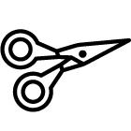

Equipment

Blindfolds

Dark bitter chocolate, cut into small pieces

Sweet milk chocolate, cut into small pieces

White chocolate, cut into small pieces

Crisps - flavoured or salted

Nuts - sweet and salted

Dried fruit, cut into small pieces

Kitchen bowls and utensils

Selection of chocolate wrappers

Videos of chocolate commercials

World maps and globes

Kiln clay, paints and glaze

Poster paints/coloured pens

Copies of world maps

Kitchen foil

Plastic bags

Onion/garlic

Cooking thermometer

A timer

Foil cake cases

Different kinds of chocolate

Selection of nuts and dried fruits

Powdered cocoa

73
Downloaded for use by Blackmore Community Primary School on 02 July 2018.

From Fieldwork Education, a part of the Nord Anglia Education family. © WCL Group Limited. All rights reserved. Not to be reproduced without permission.
Chocolate

Sugar - fruit sugar for smooth chocolate

Unsalted butter or vegetable shortening

Bain-marie or double boiler

Waxed paper

Milk

Video camera

Digital camera

Software:

Google Earth software (earth.google.com)

Presentation software such as Microsoft PowerPoint

Design software such as such as Microsoft Paint (microsoft.com) Adobe Photoshop Elements (adobe.com) or Tux Paint (tuxpaint.org).


Links

http://inventors.about.com/od/foodrelatedinventions/a/chocolate.htm About.com website has an historical timeline of the cocoa bean.

http://www.bbc.co.uk/history/historic_figures/cortes_hernan.shtml BBC History website has biographical information about Cortès.
http://www.cacaoweb.net/cacao-tree.html

Cacao web has a feature with photographs about chocolate production and manufacture.

http://www.cargill.com/corporate-responsibility/pov/cocoa-sourcing/index.jsp Cargill website has information and videos about its company’s sustainable sourcing of cocoa beans.

http://www.choosemyplate.gov/
Choose My Plate website has information about the main food groups.

http://cocoaskiss.blogspot.com/

Cocoaskiss website provides useful information and photographs for teachers about everything to do with chocolate.

http://www.confectionerynews.com/Markets/Chocolate-consumption-by-country-2014 Confectionary News has the latest figures for chocolate consumption by country.

http://www.dagobachocolate.com/circle.asp

DAGOBA Organic Chocolate website has information about its fair trade chocolate.

http://www.divinechocolate.com/uk/about-us/research-resources/divine-story/bean-to-bar

74

Downloaded for use by Blackmore Community Primary School on 02 July 2018.

From Fieldwork Education, a part of the Nord Anglia Education family. © WCL Group Limited. All rights reserved. Not to be reproduced without permission.
Chocolate

Divine Chocolate features information and photographs explaining the process of chocolate-making, from the cacao tree to the consumer.

http://www.ducksters.com/history/aztec_empire/spanish_conquest.php

Ducksters features information on Hernan Cortés and his conquest of the Aztec Empire. (Note: this site does feature advertising.)

http://www.edenproject.com/rainforest/
Eden project website explains the importance of the rainforest.

http://www.exploratorium.edu/exploring/exploring_chocolate/activity.html Exploratorium explores different activities using chocolate.

http://www.exploratorium.edu/exploring/exploring_chocolate/choc_2.html Exploratorium website explores the history of chocolate.

http://www.thehersheycompany.com/social-responsibility.aspx Hershey’s website has information about its social responsibility.
http://http://kidshealth.org/kid/stay_healthy/index.html#cat119
KidsHealth website has a series of features about healthy eating.

http://www.kinderart.com/sculpture/clay.shtml
Kinderart website has information for teachers about making pottery.

http://aztecs.mrdonn.org/spanish-arrival.html

Mr Donn website has a feature about Cortès and the Aztec empire. (Note: this site does feature advertising.)

http://africa.mrdonn.org/slavetrade.html
Mr Donn website has a feature and lesson plans about the Atlantic slave trade.

http://environment.nationalgeographic.com/environment/photos/rainforest-deforestation//#/madagascar-slash-burn_278_600x450.jpg
National Geographic website has photographs of deforestation in the rainforest.

http://video.nationalgeographic.com/video/player/news/environment- news/domrep-cacao-wcvin.html

National Geographic website has this video about how organic farming of http://ngm.nationalgeographic.com/ngm/0404/resources_geo2.html

National Geographic website has useful background information: On the Trail of Chocolate (with further links).

http://www.papapaa.org/

Pa Pa Paa website has a wealth of free, comprehensive lesson plans and resources for teaching about fair trade and chocolate.

http://www.pbs.org/opb/conquistadors/mexico/adventure2/a1.htm

Provides an ‘On-line Learning Adventure’ about Cortès and Spanish explorers in the 15th century. Resources are suitable for older children, but contains useful information for teachers.

http://www.rainforestsaver.org/what-slash-and-burn-farming Rainforest Saver website explains what slash-and-burn farming is.

75

Downloaded for use by Blackmore Community Primary School on 02 July 2018.

From Fieldwork Education, a part of the Nord Anglia Education family. © WCL Group Limited. All rights reserved. Not to be reproduced without permission.
Chocolate

http://www.scharffenberger.com/our-story/artisan-process/

Scharffenberger website explains the process of chocolate making at their factory.

http://www.scharffenberger.com/chocolatefaqs3.asp

Scharffenberger website has information and photographs of the cacao pod and beans.

http://www.sfu.ca/geog351fall03/groups-webpages/gp8/history/history.html SFU website contains useful information on the history of chocolate.

http://www.sfu.ca/geog351fall03/groups-webpages/gp8/consum/consum.html

SFU website has a world atlas of chocolate and information about the main consumers.

http://www.treecrops.org

Sustainable Tree Crops website has information about sustainable cocoa, coffee and cashew production.

http://abolition.e2bn.org/slavery_43.html

The Abolition Project provides information on the three stages of the triangular slave trade.

http://www.bbc.co.uk/bitesize/ks3/history/industrial_era/the_slave_trade/revision/4/ The BBC Bitesize website has a map and information on the slave trade.

http://www.bbc.co.uk/northernireland/schools/4_11/uptoyou/healthy/nutrientfacts5.shtml The BBC website has information on fats and sugars, with a podcast interview with a community dietician.

http://www.liverpoolmuseums.org.uk/ism/slavery/

The International Slavery Musuem website contains facts about life on board a slave ship, as well as a first-person account by a slave.

http://www.nmm.ac.uk/freedom/viewTheme.cfm/theme/triangular The National Maritime Museum has an interactive ‘triangular trade’ map.

http://www.nestle.co.uk/csv2013/socialimpact/responsiblesourcing/nestlecocoaplan The Nestlé website has information on its sustainable cocoa plan.

http://www.theschoolrun.com/homework-help/the-atlantic-slave-trade

The School Run has a good overview of the slave trade, with accompanying images and a timeline.

http://www.thestoryofchocolate.com

The Story of Chocolate has a ‘where is it from?’ section, that features information, photographs and videos on the origin of chocolate.

http://www.wlcsd.org/loonlake.cfm?subpage=1471242

The Walled Lake School District website provides a useful overview of Cortés’ life accompanied by a gallery of images.

http://https://www.sfu.ca/geog351fall03/groups-webpages/gp8/intro/intro.html The World Atlas of Chocolate explores the geography of chocolate production and consumption.

http://mexicolore.co.uk/maya/chocolate/
This educational website focuses specifically on the role of chocolate (cacao) among the Aztecs and the Maya, with articles suitable for teachers and children

76

Downloaded for use by Blackmore Community Primary School on 02 July 2018.

From Fieldwork Education, a part of the Nord Anglia Education family. © WCL Group Limited. All rights reserved. Not to be reproduced without permission.
Chocolate

http://en.wikipedia.org/wiki/Atlantic_slave_trade
Wikipedia provides photographs and information on the slave trade.

http://www.wildernessclassroom.com/students/archives/2006/03/chocolate_treec.html Wilderness Classroom has images and facts about the cacao tree.
http://www.worldcocoafoundation.org

World Cocoa Foundation website has information and videos about sustainable cocoa farming.

http://worldweather.wmo.int/index.htm

World Meteorological Association has maps, monthly average temperatures and total rainfall figures.

http://www.xocoatl.org/tree.htm

Xocoatl website has information and photographs about the life cycle of the cacao tree.

http://www.youtube.com/watch?v=LJ-1snuKJ7o

YouTube hosts this animated education video, which explains how the cacao tree grows.


Books

Atlases

Books about chocolate include:

Charlie and the Chocolate Factory, by Roald Dahl, HarperCollins, 2005

See Inside Your Body (Usborne Flap Books), by Katie Daynes, Usborne Publishing , 2006 Smart about Chocolate, by Sandra Markle, Grosset & Dunlap, 2004

The Story of Chocolate, by Caryn Jenner, Dorling Kindersley, 2005 The Story of Chocolate, by Katie Daynes, Usborne Publishing, 2006
The True History of Chocolate, by Sophie and Michael Coe, Thames and Hudson, 2013

A Chocolate Bar, How It’s Made series, by Sarah Ridley, Franklin Watts, 2009

Chocolate: Riches from the Rainforest, by Robert Burleigh, 2002

Charlie and the Chocolate Factory, DVD, 2005

77

Downloaded for use by Blackmore Community Primary School on 02 July 2018.

From Fieldwork Education, a part of the Nord Anglia Education family. © WCL Group Limited. All rights reserved. Not to be reproduced without permission.


INTERNATIONAL PRIMARY CURRICULUM

27-28 Clements Lane, London EC4N 7AE

 +44 020 7531 9696

info@greatlearning.com

 greatlearning.com/ipc

TheInternationalPrimaryCurriculum

The_IPC

From Fieldwork Education, a part of the Nord Anglia Education family.

©WCL Group Limited. All rights reserved.

