**CSc 335 Analysis and Design Artifacts for Jukebox**

*Each team complete this form, put it in your project in a folder named* **doc** *and push to Github. This will be part of your Iteration 1 grade*

**1) Team Members**: _______Haotian Yuan_____Jiaming Hao___________________

**2) Candidate Objects**

List the most important objects, or an inheritance hierarchy name, and the responsibility of each.

|  |  |
| --- | --- |
| **Candidate Object** | **Responsibility in 1 or 2 sentences** |
| Song | Each of this object represents a single song for users to choose |
| User account | User account a super class that has two sub classes, they are normal user and  administrator with different capabilities and stores all different kinds of information about a user. |
| Music play list | The play list will be implemented as a queue(or use Java queue class), which stores all songs needed to be played, and keeps track of the details of each playable song |
| GUI | The graphic user interface of the Jukebox to interact with users, which provides functions like log in, log out, choose songs etc. |
| Data base | Store all the Users’ objects |
|  |  |
|  |  |
|  |  |
|  |  |
|  |  |
|  |  |

**3) Sequence Diagram:** Write a UML Sequence Diagram should show the most important scenario you can think of. Your sequence diagram should show most of your candidate objects you listed above and how they communicate with each other.

**Recommended:** *Use the Sequence Diagram editor found at*

<https://www.websequencediagrams.com/>

*Export and Image and copy and paste it here*

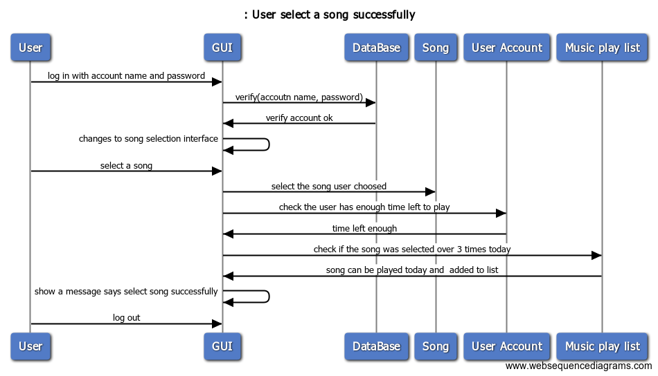

**4) Class Diagram:** Write a UML Class Diagram that shows all of your candidate objects from above. Show any relationships between them the classes such as inheritance or interface implementation. Draw general associations such as dependency or aggregation. Label some to help explain things. Add any multiplicity adornments that seem appropriate. Use notes to explain things if you feel it will help. Each UML class must show the class name. For full credit, each class must have an average of at least one attribute per class. There must be an average of about 1.5 methods per class.

**Optional:**  *Instead of using pencil, paper and scanning to insert an image, use a new Eclipse Project to add classes, methods, and instance variables. No implementation needed. Then use Object Aid UML tool to reverse engineer your code to get the UML class diagram.*

*Installation of Eclipse Plugin in case you don't have it:*

<http://www.objectaid.com/installation>

*Export and Image and copy and paste it here*

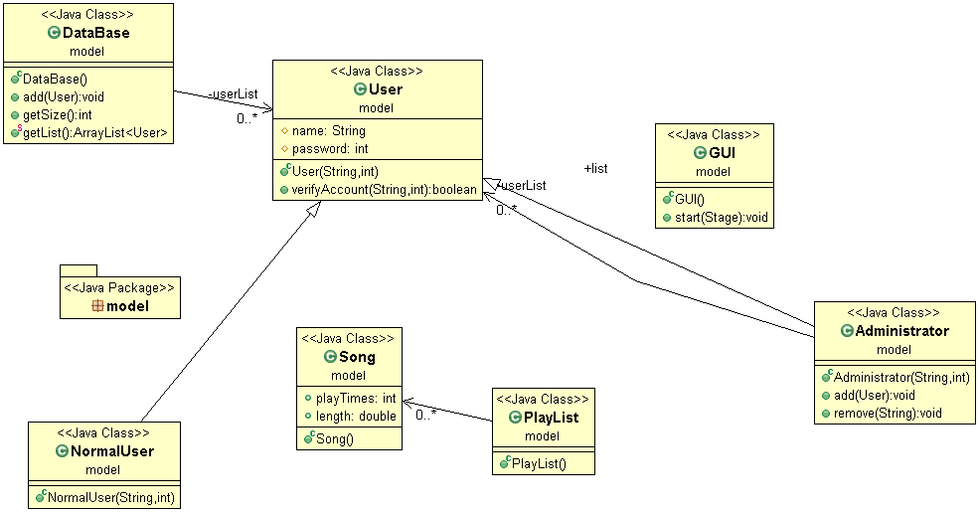

**5) Estimate and Assign Tasks** For each Iteration 1 task, estimate its difficulty using the numbers 1, 2, 3, 5, or 8. These are points that represent the relative complexity of the task. Mark 8 for the most difficult and/or time consuming and 1 for what appears to be the easiest. Indicate which person (s) will complete the task before iteration 1 due date.

|  |  |  |
| --- | --- | --- |
| **Points** | **Who will**  **complete this?** | **Task** |
| 1 | Jiaming Hao | Your GitHub repo has a completed copy of this analysis and design document in a folder named **doc** that represents a serious effort to analyze and design Jukebox |
| 3 | Haotian Yuan | Users can log in and log out |
| 2 | Jiaming Hao | Songs can be ***selected*** up to a maximum of 3 times per calendar date. Use the time the song is added to the song queue, not when the song ends |
| 2 | Haotian Yuan | Any valid user can select a maximum of 3 songs per calendar date. Use the time the song is added to the queue, not when the song ends. Reset time occurs at midnight, so users could have three new plays tomorrow.  A song that has played 3 times today, could be played 3 times tomorrow. |
| 3 | Jiaming Hao | The administrator can add and remove accounts |
| 2 | Haotian Yuan | Songs can be played in FIFO order, like a Jukebox, the first one plays on order. |
| 2 | both | Complete a functional spike to determine the interactions are actually working. JukeboxStartGUI.java in package controller is an event-driven program with a graphical user interface to affirm the functionality all Iteration 1 tasks have been completed and are working correctly.  We will use this to test your code for the first 100 points of Jukebox. |