**C Sc 335 Analysis and Design Artifacts for Final Project**

**1. Team Name:**  Mewtwo

**2. Project: Pokemon_Safari_Zone**

**3. Team Members**: Mengtao Tang

Shanrui Zhang

Chengyu Sun

**4. Candidate Objects or Class Hierarchies**

List the most important objects, or an inheritance hierarchy name, and the single responsibility of each.

|  |  |
| --- | --- |
| **Candidate Object** | **Single Responsibility in 1 or 2 sentences** |
| Player | This object store the basic information of each player, including their inventory and pokemon collection and identification information |
| Inventory | This object store the items collection each player has |
| PokemonCollection | This object store the pokemon that each player has |
| Item | This object defines the properties of each item |
| pokemon | This object defines the properties of each pokemon |
| PokemonPool | This is the collection of all the pokemons that will appear in the game |
| ItemPool | This is the collection of all the items that will appear in the game |
| Map | This store the information of each map in the game, it will contain path/pokemon distribution etc |
| Game | This will store the up-to-date information of each objects in the game and also the rule of the game |
| GUI | Apparently an GUI for the game is really necessary, it will interact with the game object |

**5. Sequence Diagram 1:** Your team UML Sequence Diagram should show the most important scenario you can think of. Your sequence diagram should show most of your objects from above and how they communicate with each other.

*This Sequence Diagram must be created with the sequence diagram editor* [https://www.websequencediagrams.com/#](https://www.websequencediagrams.com/)

*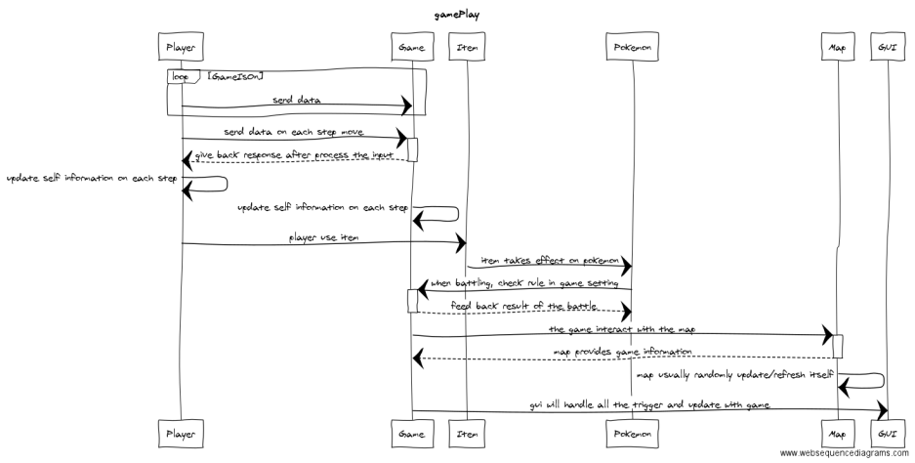Export and Image and copy and paste it here*

**6. Sequence Diagram 2:** Your team UML Sequence Diagram should show the seconf most important scenario you can think of. Your sequence diagram should show most of your objects from above and how they communicate with each other.

*This Sequence Diagram must be created with the sequence diagram editor* [https://www.websequencediagrams.com/#](https://www.websequencediagrams.com/)

*Export and Image and copy and paste it here*

