* Adding document for every classes, methods, block of code that is a huge business logic.
  + Remember, the more details you give in a doc, the less burdensome you (or somebody) maintain the code in the future.
  + If it’s simple method, it’s not necessary to do the Docs, otherwise, just do it as much as possible to help other understand it.
  + Simple method

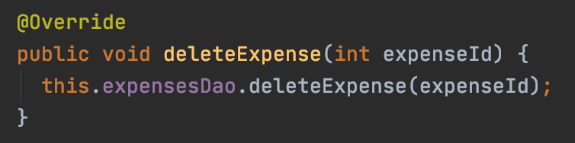

* + Complicated method

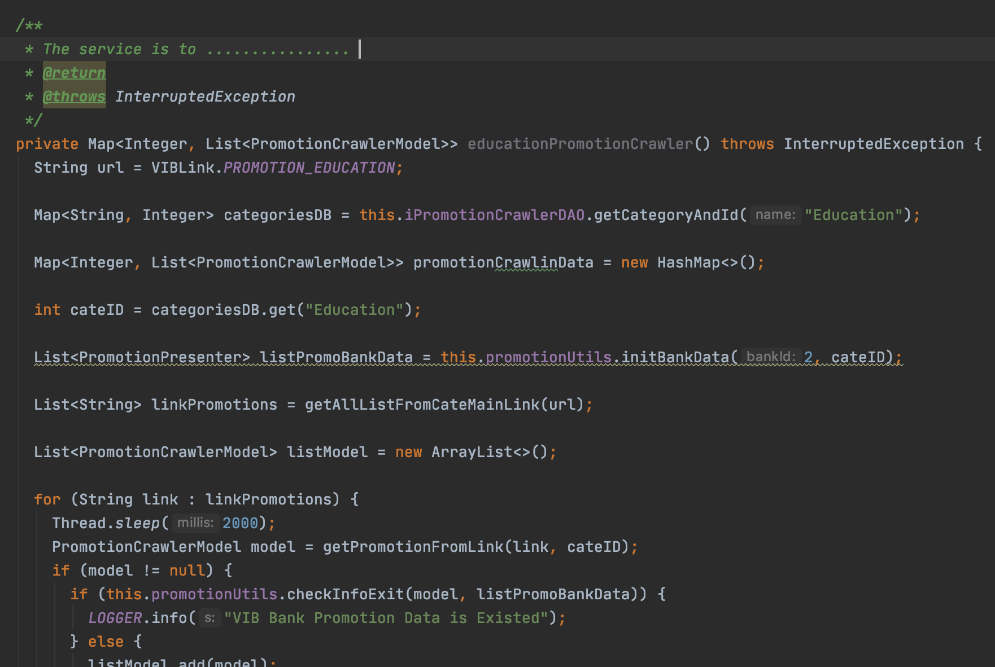

-Naming package, class, method, etc

- Package name should be noun and in lowercase.

- Class name should be a noun and with First letter of a word in uppercase.

- Method is an action, so name it like: getSomething, handleSomething, doSomething.

- Write unit test

- Make the class under the package named the same with tested class.

for example: we make a test for MoneyFlowResource in package: fm.api.rest.moneyflow

we should make a new test class: MoneyFlowResourceTest in package fm.api.rest.moneyflow in test section

- Do validation at Resource layer

- Do NOT do any business logic in Resource layer

- Do business at Service layer

- Do NOT do any business at DAO layer (or in case we have to do that, just minimize as much as possible by doing it in Service layer)