Project 2 of CSE 473/573
Haowei Zhou 50248857

1. Image Features and Homography
1.1 Key Points
The key points of left mountain and right mountain are shown below:
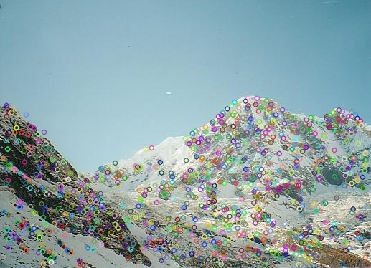
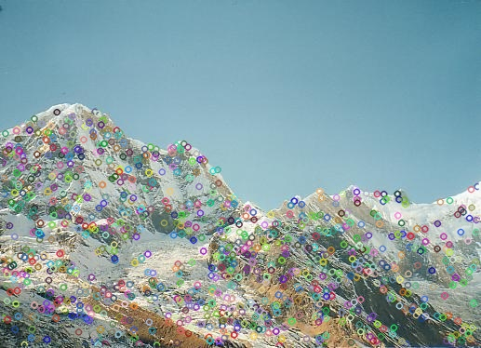

1.2 Match Image
The match image contains both inliers and outliers are shown below:
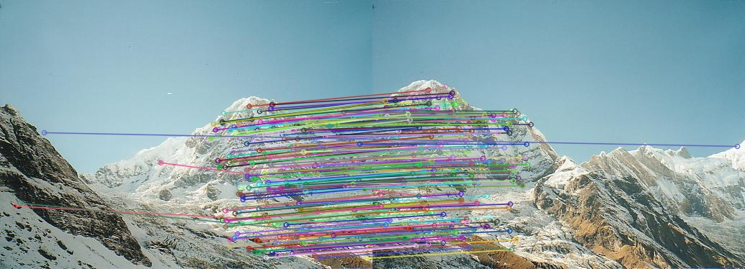

1.3 Homography Matrix H
The homography matrix is shown below:
[[ 1.59239961e+00 -2.92376916e-01 -3.96644342e+02]
[ 4.50342898e-01 1.43500407e+00 -1.91260571e+02]
[ 1.21743590e-03 -5.86467972e-05 1.00000000e+00]]

1.4 Match Image Using Only Inliers
The match image using only inliers are shown below:
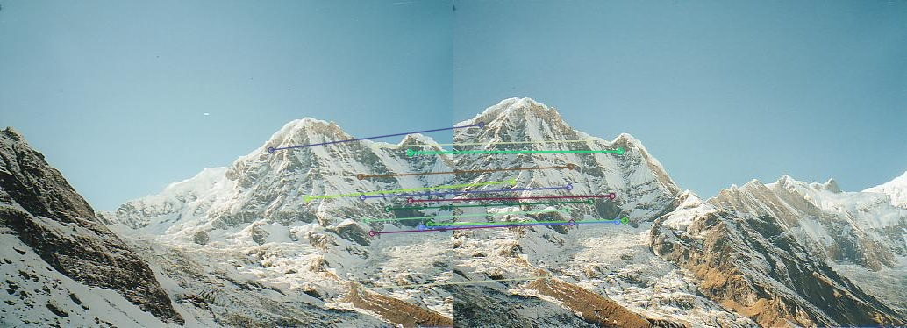
1.5 Panorama Snitching Result
The panorama snitching result is shown below:
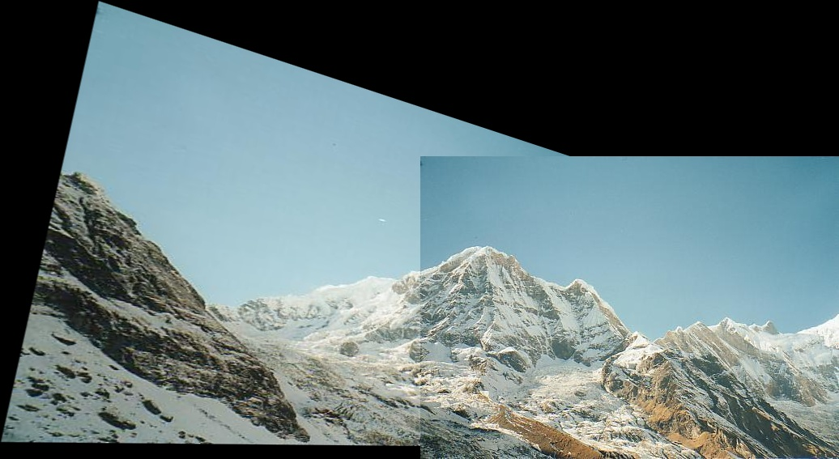

2. Epipolar Geometry
2.1 Key Points and Match Image
The key points of left image and right image are shown below:
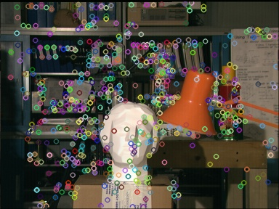
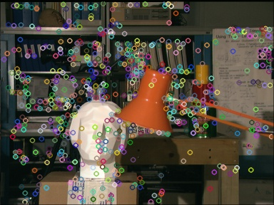
The match image contains both inliers and outliers are shown below:
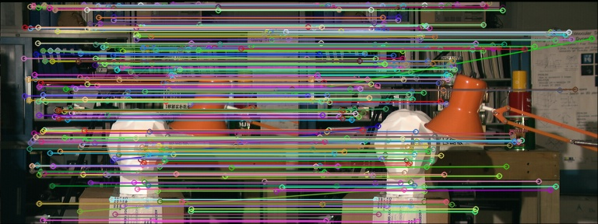
2.2 Fundamental Matrix
The fundamental matrix is shown below:
[[-1.07832959e-07 -7.11948899e-04 5.57647085e-02]
[ 7.15827498e-04 -8.90557705e-05 -1.11432709e+00]
[-5.58854787e-02 1.10821089e+00 1.00000000e+00]]

2.3 Epilines in Left and Right Image
The epilines in left and right images are shown below:
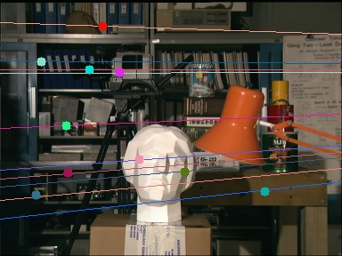
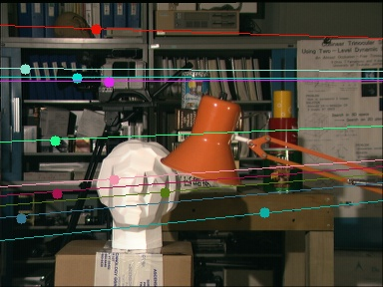
2.4 Disparity Map
The disparity map is shown below:
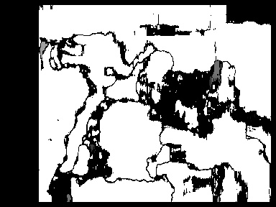

3. K-means Clustering
3.1 Classification of the First Iteration
The classification of one iteration result is: A((4.6,2.9),(4.7,3.2),(4.9,3.1),(5.0,3.0),(5.1,3.8),(5.9,3.2),(6.0,3.0)), B((5.5,4.2)), C((6.2,2.8),(6.7,3.1)) the image is shown below:
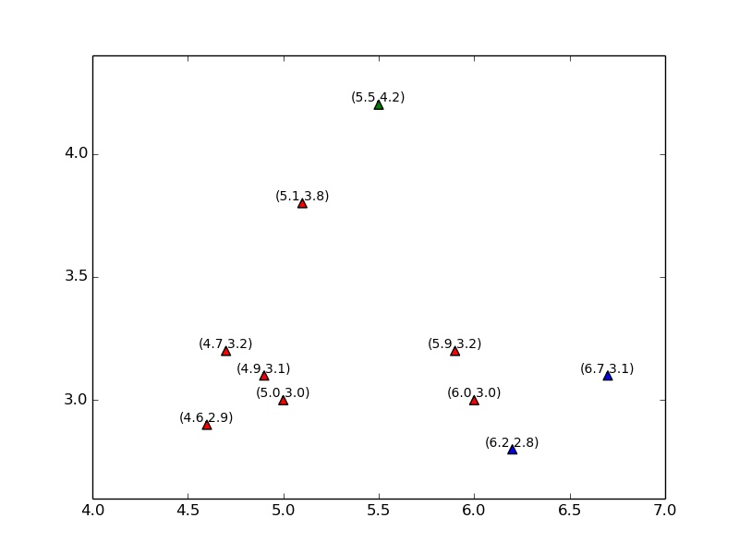

3.2 New Center of the First iteration
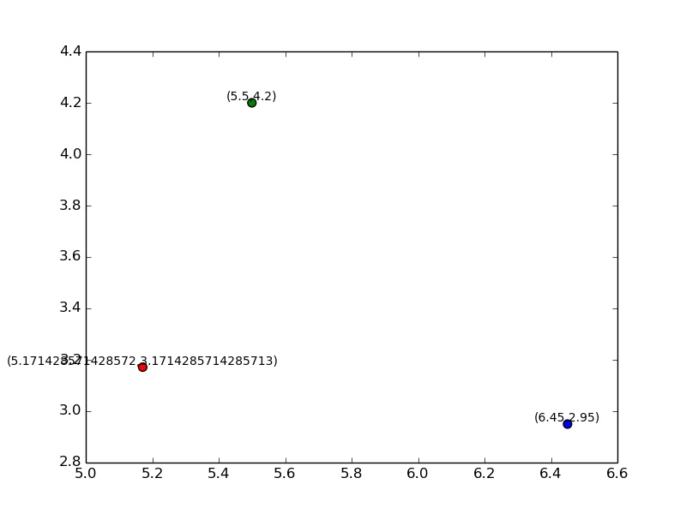
The new center is A(5.17,3.17), B(5.5,4.2), C(6.45,2.95), the result is shown below:
3.3 Classification and New Center for the Second iteration
The classification and new center results are shown below:
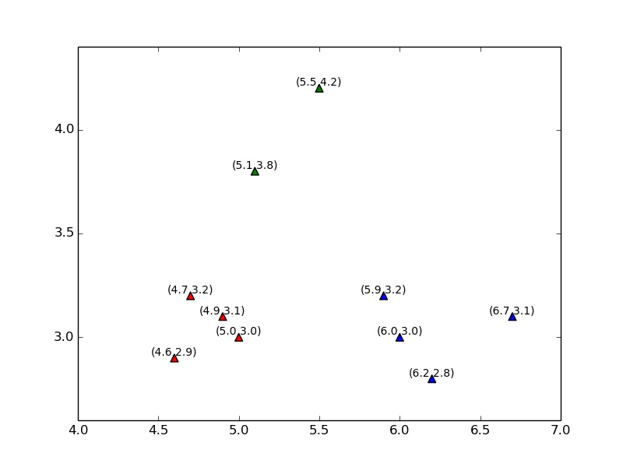
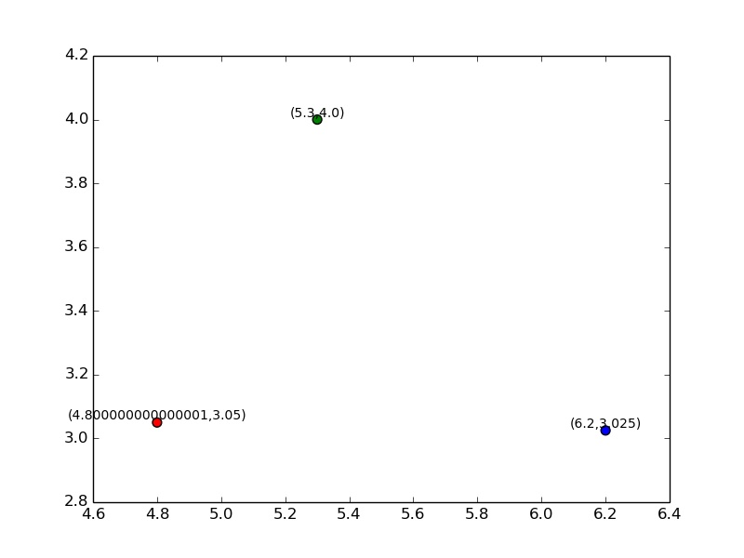
3.4 Color Quantization
The color quantization results which k=3,5,10,20 are shown below:
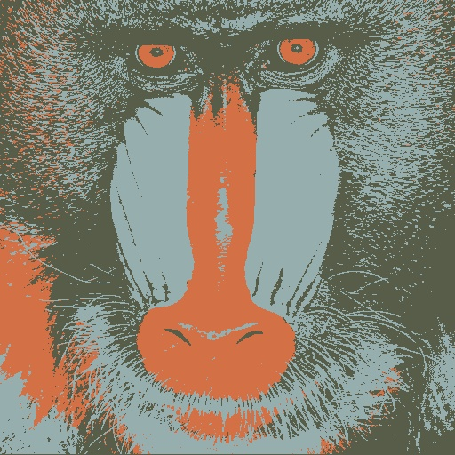
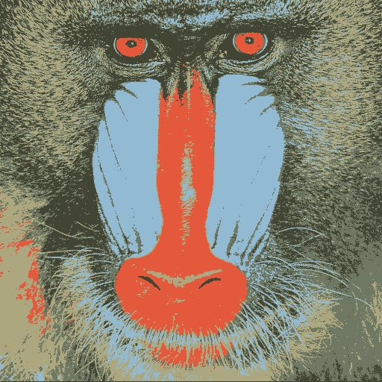

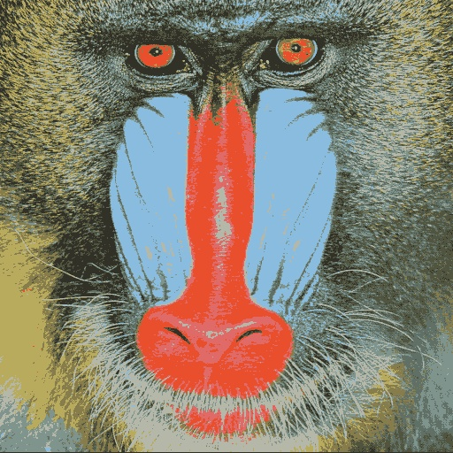
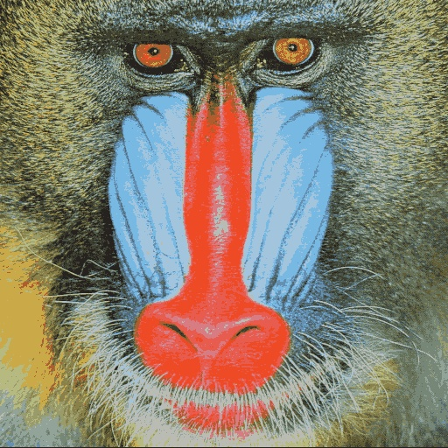

4. Bonus
4.1 Mean Value of the First Iteration
The mean value after the first iteration is:
[[5.3165079 3.21527292]
[5.61129795 3.38505311]
[5.60443565 3.14420061]]

4.2 First Five Iteration Results
The first five iteration results are :
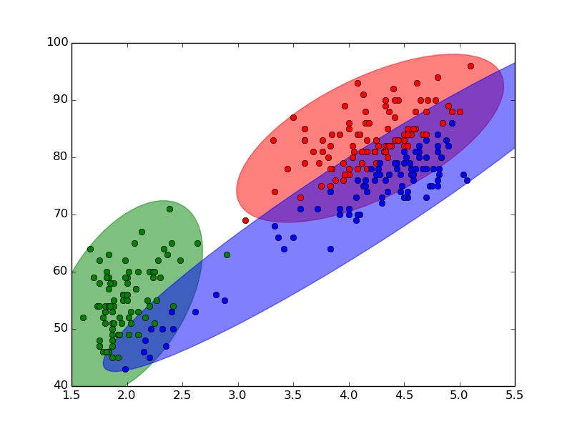
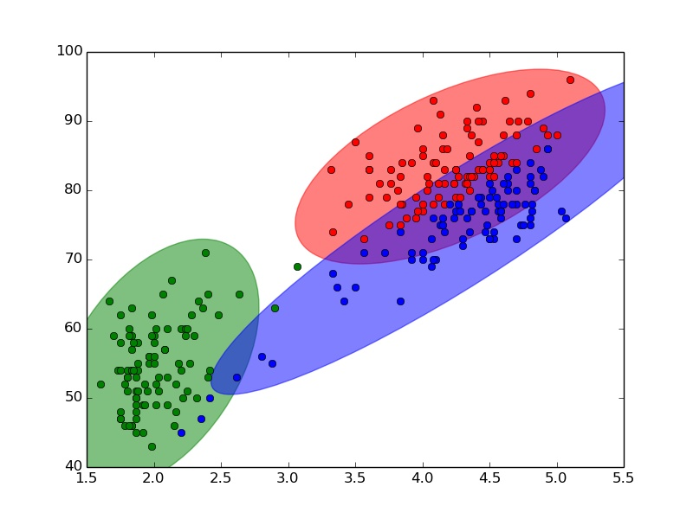

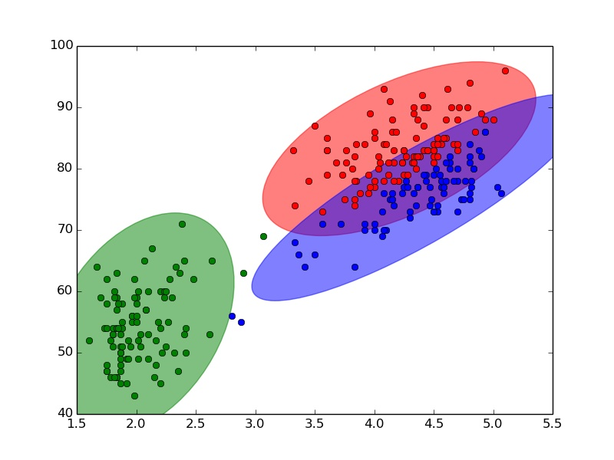
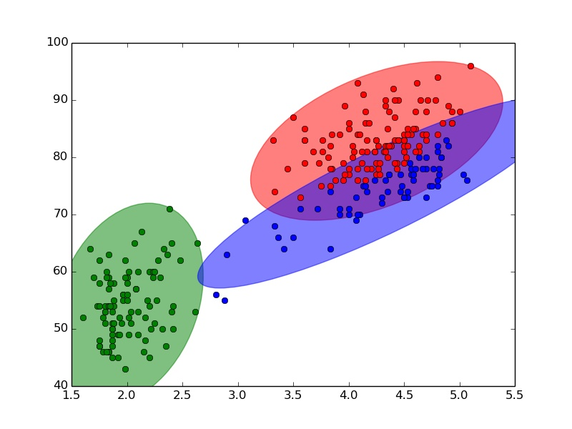
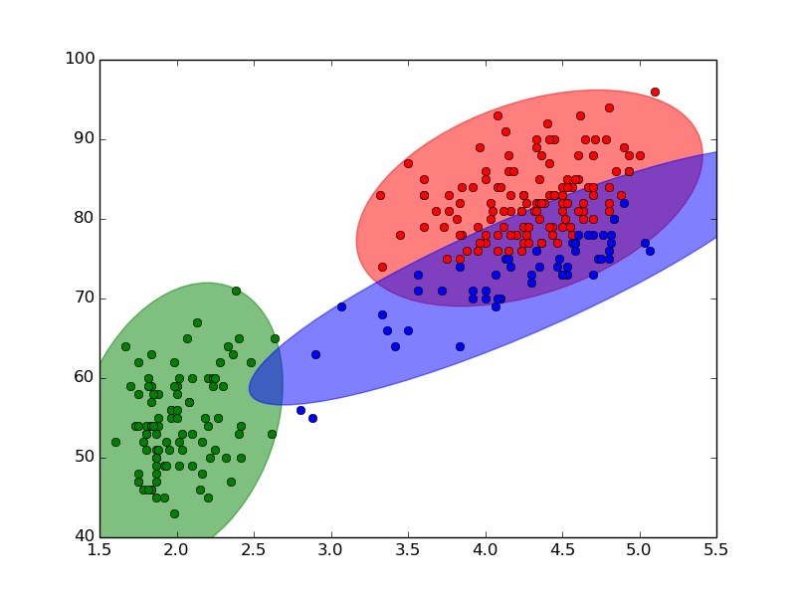

5. Code
5.1 Task1
UBIT = "haoweizh"
import numpy as np
import cv2
import os
np.random.seed(sum([ord(c) for c in UBIT]))

def mkdir(path):
folder = os.path.exists(path)
if not folder:
os.makedirs(path)

def generate_Keypoints(imgpath,outputpath):
img = cv2.imread(imgpath)
sift = cv2.xfeatures2d.SIFT_create()
kp,des = sift.detectAndCompute(img,None)
imgkp = cv2.drawKeypoints(img,kp,img)
cv2.imwrite(outputpath,imgkp)
img = cv2.imread(imgpath)
return img,kp,des

def draw_match(img1,kp1,des1,img2,kp2,des2,outputmatch):
bf = cv2.BFMatcher()
matches = bf.knnMatch(des1,des2,k=2)
good1 = []
for m,n in matches:
if m.distance < 0.75*n.distance:
good1.append(m)
good2 = np.expand_dims(good1,1)
img = cv2.drawMatchesKnn(img1,kp1,img2,kp2,good2,None,flags=2)
cv2.imwrite(outputmatch,img)
return good1,good2,img

def get_homography_matrix(kp1,kp2,good1):
src_pts = np.float32([ kp1[m.queryIdx].pt for m in good1 ]).reshape(-1,1,2)
dst_pts = np.float32([ kp2[m.trainIdx].pt for m in good1 ]).reshape(-1,1,2)
H,mask = cv2.findHomography(src_pts,dst_pts,cv2.RANSAC,5.0)
print H
return H,mask

def draw_inliers(ranmatchnum,img1,kp1,img2,kp2,good1,H,mask,inlierpath):
matchesMask = mask.ravel().tolist()
h,w,d = img1.shape
pts = np.float32([ [0,0],[0,h-1],[w-1,h-1],[w-1,0] ]).reshape(-1,1,2)
dst = cv2.perspectiveTransform(pts,H)
masklen = len(matchesMask)
partmatchesMask = []
partgood1 = []
for i in range(0,ranmatchnum):
index = np.random.randint(0,masklen)
partmatchesMask.append(matchesMask[index])
partgood1.append(good1[index])
draw_params = dict(matchesMask = partmatchesMask,flags = 2)
img = cv2.drawMatches(img1,kp1,img2,kp2,partgood1,None,**draw_params)
cv2.imwrite(inlierpath,img)

def transfer(H,dx,dy):
transfermat = np.array([[1,0,dx],[0,1,dy],[0,0,1]])
return np.dot(transfermat,H)

def splice(img1,img2,H,panopath):
dx = 700
dy = 700
transfermat = transfer(H,dx,dy)
wrap = cv2.warpPerspective(img1,transfermat,(img1.shape[1]+img2.shape[1]+dx,img2.shape[0]+img2.shape[0]+dy))
wrap[dx:img1.shape[0]+dx,dy:img1.shape[1]+dy] = img2
rows,cols = np.where(wrap[:,:,0] != 0)
min_row,max_row = min(rows),max(rows)+1
min_col,max_col = min(cols),max(cols)+1
wrap = wrap[min_row:max_row,min_col:max_col,:]
cv2.imwrite(panopath,wrap)

if __name__ == "__main__":
folder = "part1_result"
mkdir(folder)
imgpath1 = "data/mountain1.jpg"
outputpath1 = "part1_result/task1_sift1.jpg";
img1,kp1,des1 = generate_Keypoints(imgpath1,outputpath1);
imgpath2 = "data/mountain2.jpg"
outputpath2 = "part1_result/task1_sift2.jpg";
img2,kp2,des2 = generate_Keypoints(imgpath2,outputpath2);
outputmatch = "part1_result/task1_matches_knn.jpg"
good1,good2,img = draw_match(img1,kp1,des1,img2,kp2,des2,outputmatch)
H,mask = get_homography_matrix(kp1,kp2,good1)
inlierpath = "part1_result/task1_matches.jpg"
ran_match_number = 15
draw_inliers(ran_match_number,img1,kp1,img2,kp2,good1,H,mask,inlierpath)
panopath = "part1_result/task1_pano.jpg"
splice(img1,img2,H,panopath)

5.2 Task2
UBIT = "haoweizh"
import numpy as np
import cv2
import os
np.random.seed(sum([ord(c) for c in UBIT]))

def mkdir(path):
folder = os.path.exists(path)
if not folder:
os.makedirs(path)

def generate_Keypoints(imgpath,outputpath):
img = cv2.imread(imgpath)
sift = cv2.xfeatures2d.SIFT_create()
kp,des = sift.detectAndCompute(img,None)
imgkp = cv2.drawKeypoints(img,kp,img)
cv2.imwrite(outputpath,imgkp)
img = cv2.imread(imgpath)
return img,kp,des

def draw_match(img1,kp1,des1,img2,kp2,des2,outputmatch):
bf = cv2.BFMatcher()
matches = bf.knnMatch(des1,des2,k=2)
good1 = []
for m,n in matches:
if m.distance < 0.75*n.distance:
good1.append(m)
good2 = np.expand_dims(good1,1)
img = cv2.drawMatchesKnn(img1,kp1,img2,kp2,good2,None,flags=2)
cv2.imwrite(outputmatch,img)
return good1,good2,img,matches

def get_fundamental_matrix(kp1,kp2,matches):
pts1 = []
pts2 = []
for m,n in matches:
if m.distance < 0.75*n.distance:
pts1.append(kp1[m.queryIdx].pt)
pts2.append(kp2[m.trainIdx].pt)
pts1 = np.int32(pts1)
pts2 = np.int32(pts2)
F,mask = cv2.findFundamentalMat(pts1,pts2,cv2.RANSAC)
print F
return F,mask,pts1,pts2

def drawlines(img1,img2,lines,pts1,pts2):
r,c,d = img1.shape
for r,pt1,pt2 in zip(lines,pts1,pts2):
color = tuple(np.random.randint(0,255,3).tolist())
x0,y0 = map(int, [0, -r[2]/r[1] ])
x1,y1 = map(int, [c, -(r[2]+r[0]*c)/r[1] ])
img1 = cv2.line(img1, (x0,y0), (x1,y1), color,1)
img1 = cv2.circle(img1,tuple(pt1),5,color,-1)
img2 = cv2.circle(img2,tuple(pt2),5,color,-1)
return img1,img2

def get_epiline(numpairs,img1,img2,pts1,pts2,leftpath,rightpath):
pts1 = pts1[mask.ravel()==1]
pts2 = pts2[mask.ravel()==1]
ptsnum = pts1.shape[0]
partpts1 = np.zeros(shape=(0,2),dtype='int32')
partpts2 = np.zeros(shape=(0,2),dtype='int32')
for i in range(0,numpairs):
index = np.random.randint(0,ptsnum)
pt1 = pts1[index]
pt1 = pt1[np.newaxis,:]
pt2 = pts2[index]
pt2 = pt2[np.newaxis,:]
partpts1 = np.r_[partpts1,pt1]
partpts2 = np.r_[partpts2,pt2]
lines1 = cv2.computeCorrespondEpilines(partpts2.reshape(-1,1,2),2,F)
lines1 = lines1.reshape(-1,3)
img3,img4 = drawlines(img1,img2,lines1,partpts1,partpts2)
lines2 = cv2.computeCorrespondEpilines(partpts1.reshape(-1,1,2),1,F)
lines2 = lines2.reshape(-1,3)
img5,img6 = drawlines(img2,img1,lines2,partpts2,partpts1)
cv2.imwrite(leftpath,img3)
cv2.imwrite(rightpath,img5)

def disparity(img1,img2,disparitypath):
stereo = cv2.StereoBM_create(numDisparities=48,blockSize=15)
disparity = stereo.compute(img1,img2)
cv2.imwrite(disparitypath,disparity)

if __name__ == "__main__":
folder = "part2_result"
mkdir(folder)
imgpath1 = "data/tsucuba_left.png"
outputpath1 = "part2_result/task2_sift1.jpg";
img1,kp1,des1 = generate_Keypoints(imgpath1,outputpath1);
imgpath2 = "data/tsucuba_right.png"
outputpath2 = "part2_result/task2_sift2.jpg";
img2,kp2,des2 = generate_Keypoints(imgpath2,outputpath2);
outputmatch = "part2_result/task2_matches_knn.jpg"
good1,good2,img,matches = draw_match(img1,kp1,des1,img2,kp2,des2,outputmatch)
F,mask,pts1,pts2 = get_fundamental_matrix(kp1,kp2,matches)
leftpath = "part2_result/task2_epi_left.jpg"
rightpath = "part2_result/task2_epi_right.jpg"
numpairs = 10
get_epiline(numpairs,img1,img2,pts1,pts2,leftpath,rightpath)
disparitypath = "part2_result/task2_disparity.jpg"
img1 = cv2.imread(imgpath1,0)
img2 = cv2.imread(imgpath2,0)
disparity(img1,img2,disparitypath)

5.3 Task3
UBIT = "haoweizh"
import numpy as np
import os
import sys
import cv2
from matplotlib import pyplot as plt
np.random.seed(sum([ord(c) for c in UBIT]))

X = np.array([
[5.9,3.2],
[4.6,2.9],
[6.2,2.8],
[4.7,3.2],
[5.5,4.2],
[5.0,3.0],
[4.9,3.1],
[6.7,3.1],
[5.1,3.8],
[6.0,3.0]])

center = np.array([
[6.2,3.2],
[6.6,3.7],
[6.5,3.0]])

color = ['r','g','b']

def mkdir(path):
folder = os.path.exists(path)
if not folder:
os.makedirs(path)

def reclassify(savepath):
kind2index = dict()
for i in range(0,X.shape[0]):
dist = sys.maxint
kind = -1
for j in range(0,center.shape[0]):
d = (X[i][0]-center[j][0])**2+(X[i][1]-center[j][1])**2
if d<dist:
dist = d
kind = j
if kind2index.has_key(kind)==False:
kind2index[kind] = []
kind2index[kind].append(X[i])
ax = plt.subplot()
for elem in kind2index:
x_list = []
y_list = []
pts = kind2index[elem]
for pt in pts:
x_list.append(pt[0])
y_list.append(pt[1])
plt.text(pt[0],pt[1],"("+str(pt[0])+","+str(pt[1])+")",ha='center',va='bottom',fontsize=10)
ax.scatter(x_list,y_list,c=color[elem],marker='^',s=50,alpha=1)
plt.savefig(savepath)
plt.clf()
return kind2index

def recompute_mean(kind2index,meanpath):
ax = plt.subplot()
for elem in kind2index:
x_list = [0.0]
y_list = [0.0]
pts = kind2index[elem]
for pt in pts:
x_list[0] = x_list[0]+pt[0]
y_list[0] = y_list[0]+pt[1]
x_list[0] = x_list[0]/len(pts)
y_list[0] = y_list[0]/len(pts)
center[elem][0] = x_list[0]
center[elem][1] = y_list[0]
plt.text(x_list[0],y_list[0],"("+str(x_list[0])+","+str(y_list[0])+")",ha='center',va='bottom',fontsize=10)
ax.scatter(x_list,y_list,c=color[elem],s=50,alpha=1)
plt.savefig(meanpath)
plt.clf()

def initcenter(img,k):
r,c,d = img.shape
center = np.zeros(shape=(0,d))
for i in range(0,k):
x = np.random.randint(0,r)
y = np.random.randint(0,c)
p = img[x][y]
core = p[np.newaxis,:]
center = np.r_[center,core]
return center

def classifyimg(center,img):
result = dict()
r,c,d = img.shape
for i in range(0,r):
for j in range(0,c):
dist = sys.maxint
kind = -1
for e in range(0,center.shape[0]):
dt = 0
for k in range(0,d):
dt += (img[i][j][k]-center[e][k])**2
if dt<dist:
dist = dt
kind = e
if result.has_key(kind)==False:
result[kind] = []
result[kind].append([i,j])
return result

def recompute_center(img,classify,center):
r,c,d = img.shape
newcenter = np.zeros(shape=(0,d))
for elem in classify:
pts = classify[elem]
ct = np.array([0,0,0])
for pt in pts:
for t in range(0,d):
ct[t] = ct[t]+img[pt[0]][pt[1]][t]
for t in range(0,d):
ct[t] = ct[t]/len(pts)
ct = ct[np.newaxis,:]
newcenter = np.r_[newcenter,ct]
return newcenter

def compare(oldcenter,newcenter):
return (oldcenter==newcenter).all()

def color_quant(imgpath,outpath,k):
img = cv2.imread(imgpath)
oldcenter = initcenter(img,k)
flag = True
while flag==True:
classify = classifyimg(oldcenter,img)
newcenter = recompute_center(img,classify,oldcenter)
if compare(oldcenter,newcenter)==True:
r,c,d = img.shape
for elem in classify:
pts = classify[elem]
for pt in pts:
for t in range(0,d):
img[pt[0]][pt[1]][t] = newcenter[elem][t]
flag = False
else:
oldcenter = newcenter
cv2.imwrite(outpath,img)
print "save image "+str(k)

if __name__ == "__main__":
folder = "part3_result"
mkdir(folder)
savepath = "part3_result/task3_iter1_a.jpg"
kind2index = reclassify(savepath)
meanpath = "part3_result/task3_iter1_b.jpg"
recompute_mean(kind2index,meanpath)
savepath = "part3_result/task3_iter2_a.jpg"
kind2index = reclassify(savepath)
meanpath = "part3_result/task3_iter2_b.jpg"
recompute_mean(kind2index,meanpath)
imgpath = "data/baboon.jpg"
outpath = "part3_result/task3_baboon_3.jpg"
color_quant(imgpath,outpath,3)
outpath = "part3_result/task3_baboon_5.jpg"
color_quant(imgpath,outpath,5)
outpath = "part3_result/task3_baboon_10.jpg"
color_quant(imgpath,outpath,10)
outpath = "part3_result/task3_baboon_20.jpg"
color_quant(imgpath,outpath,20)

5.4 bonus1
import numpy as np
import copy
from scipy.stats import multivariate_normal

X = np.array([
[5.9,3.2],
[4.6,2.9],
[6.2,2.8],
[4.7,3.2],
[5.5,4.2],
[5.0,3.0],
[4.9,3.1],
[6.7,3.1],
[5.1,3.8],
[6.0,3.0]])

u = np.array([
[6.2,3.2],
[6.6,3.7],
[6.5,3.0]])

var = np.array([
[[0.5,0],
[0,0.5]],
[[0.5,0],
[0,0.5]],
[[0.5,0],
[0,0.5]]
])

pi = np.array([1.0/3,1.0/3,1.0/3])

def Expectation(localu,localvar,localpi):
probability = []
for i in range(0,len(X)):
total = 0.0
for j in range(0,len(u)):
total += localpi[j]*multivariate_normal.pdf(X[i],mean=localu[j],cov=localvar[j])
prob = []
for j in range(0,len(u)):
up = localpi[j]*multivariate_normal.pdf(X[i],mean=localu[j],cov=localvar[j])
prob.append(up/total)
probability.append(prob)
return probability

def Maximization(probability,localpi):
newu = copy.deepcopy(u)
newvar = copy.deepcopy(var)
newpi = copy.deepcopy(pi)
for j in range(0,len(newu)):
Nk = 0.0
up = [0.0,0.0]
for i in range(0,len(X)):
Nk += probability[i][j]
up += probability[i][j]*X[i]
newu[j] = up/Nk
varup = np.array([[0.0,0.0],[0.0,0.0]])
for i in range(0,len(X)):
delta = X[i]-newu[j]
delta_axis = delta[np.newaxis,:]
varup += probability[i][j]*np.dot(np.transpose(delta_axis),delta_axis)
newvar[j] = varup/Nk
newpi[j] = Nk/len(X)
return newu,newvar,newpi

def GMMOneiter():
localu = copy.deepcopy(u)
localvar = copy.deepcopy(var)
localpi = copy.deepcopy(pi)
probablity = Expectation(localu,localvar,localpi)
newu,newvar,newpi = Maximization(probablity,localpi)
print newu

if __name__ == "__main__":
GMMOneiter()

5.5 bonus2
import numpy as np
import os
import copy
from scipy.stats import multivariate_normal
from error_ellipse import plot_point_cov
import matplotlib.pyplot as plt

u = np.array([
[4.0,81],
[2.0,57],
[4.0,71]])

var = np.array([
[[1.3,13.98],
[13.98,184.82]],
[[1.3,13.98],
[13.98,184.82]],
[[1.3,13.98],
[13.98,184.82]]
])

pi = np.array([1.0/3,1.0/3,1.0/3])

rgbcolor = ['r','g','b']

def mkdir(path):
folder = os.path.exists(path)
if not folder:
os.makedirs(path)

def readfile(path):
alldata = []
with open(path) as file:
line = file.readline()
while line:
oneline = line.split()
data = []
for i in range(1,len(oneline)):
data.append(float(oneline[i]))
alldata.append(data)
line = file.readline()
return np.array(alldata)

def Expectation(localu,localvar,localpi,alldata):
probability = []
for i in range(0,len(alldata)):
total = 0.0
for j in range(0,len(u)):
total += localpi[j]*multivariate_normal.pdf(alldata[i],mean=localu[j],cov=localvar[j])
prob = []
for j in range(0,len(u)):
up = localpi[j]*multivariate_normal.pdf(alldata[i],mean=localu[j],cov=localvar[j])
prob.append(up/total)
probability.append(prob)
return probability

def Maximization(probability,localpi,alldata):
newu = copy.deepcopy(u)
newvar = copy.deepcopy(var)
newpi = copy.deepcopy(pi)
for j in range(0,len(newu)):
Nk = 0.0
up = [0.0,0.0]
for i in range(0,len(alldata)):
Nk += probability[i][j]
up += probability[i][j]*alldata[i]
newu[j] = up/Nk
varup = np.array([[0.0,0.0],[0.0,0.0]])
for i in range(0,len(alldata)):
delta = alldata[i]-newu[j]
delta_axis = delta[np.newaxis,:]
varup += probability[i][j]*np.dot(np.transpose(delta_axis),delta_axis)
newvar[j] = varup/Nk
newpi[j] = Nk/len(alldata)
return newu,newvar,newpi

def OneIter(localu,localvar,localpi,alldata,count):
probability = Expectation(localu,localvar,localpi,alldata)
newu,newvar,newpi = Maximization(probability,localpi,alldata)
kind2index = classify(probability)
draw(alldata,kind2index,count)
return newu,newvar,newpi

def classify(probability):
kind2index = dict()
for i in range(0,len(probability)):
kind = -1
maxprob = 0.0
for j in range(0,len(probability[i])):
if probability[i][j]>maxprob:
maxprob = probability[i][j]
kind = j
if kind not in kind2index:
kind2index[kind] = []
kind2index[kind].append(i)
return kind2index

def draw(alldata,kind2index,count):
for elem in kind2index:
data = []
for index in kind2index[elem]:
data.append(alldata[index])
data = np.array(data)
x,y = np.array(data).T
plt.plot(x, y, 'ro',color=rgbcolor[elem])
plot_point_cov(data, nstd=3, alpha=0.5, color=rgbcolor[elem])
plt.savefig("bonus_result/task3_gmm_iter"+str(count)+".jpg")
plt.clf()

if __name__ == "__main__":
folderpath = "bonus_result"
mkdir(folderpath)
alldata = readfile("data.txt")
localu = copy.deepcopy(u)
localvar = copy.deepcopy(var)
localpi = copy.deepcopy(pi)
count = 1
while count<=5:
newu,newvar,newpi = OneIter(localu,localvar,localpi,alldata,count)
localu = newu
localvar = newvar
localpi = newpi
count += 1

