Project 3 of CSE 473/573
Haowei Zhou 50248857

1. Morphology image processing
1.1 Remove noises of images
The two images using opening and closing operators are shown below:

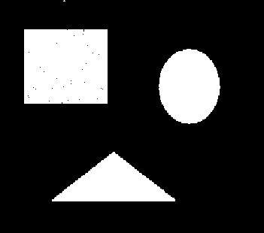
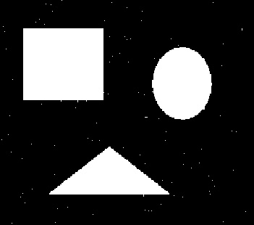

1.2 Compare opening and closing
As we can see above, the opening and closing operators to remove noises are different. For opening operator, we implement erosion followed by dilation, which erase the white noise outside the rectangle, however, we expand the black noise in rectangle. For closing operator, we implement dilation followed by erosion, which erase the black noise in the rectangle, however, we cannot erase the white noise outside the rectangle.

1.3 Extract boundary
The two images's boundary are shown below:
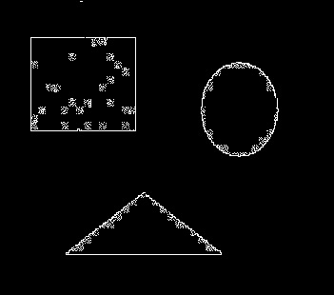
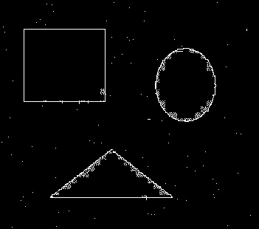

2. Image segmentation and point detection
2.1 Point detection
The point I detected is shown below, the coordinator is (249,445):


2.2 Segmentation
The detected object with bounding box is shown below, I choose 210 as its threshold, the rectangle's parameters are (165,29) and (419,285):

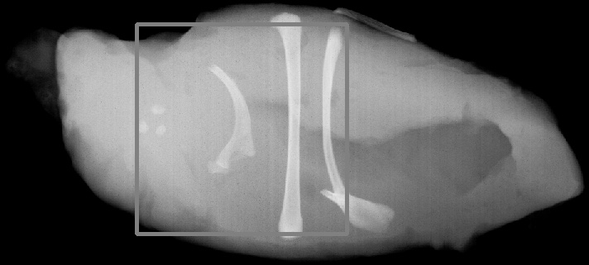

3. Hough transform
3.1 Detect the red line
The red lines I detected are shown below, I detect all of the red lines:

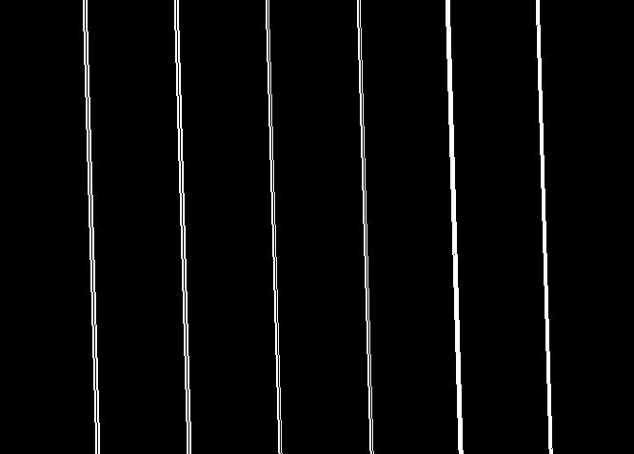

3.2 Detect the blue line
The blue lines I detected are shown below, I detect five of nine blue lines because other blue lines are too short so that in hough space, the mapping point cannot get enough counts:


