Building Block Configuration Guide  SAP Fiori apps rapid-deployment solution  Document Version: 1.0 – 2015-07-06 | Customer
SAP Fiori Technical Foundation Configuration(EE0)

Typographic Conventions
Type Style | Description
Example | Words or characters quoted from the screen. These include field names, screen titles, pushbuttons labels, menu names, menu paths, and menu options.  Textual cross-references to other documents.
Example | Emphasized words or expressions.
EXAMPLE | Technical names of system objects. These include report names, program names, transaction codes, table names, and key concepts of a programming language when they are surrounded by body text, for example, SELECT and INCLUDE.
Example | Output on the screen. This includes file and directory names and their paths, messages, names of variables and parameters, source text, and names of installation, upgrade and database tools.
Example | Exact user entry. These are words or characters that you enter in the system exactly as they appear in the documentation.
<Example> | Variable user entry. Angle brackets indicate that you replace these words and characters with appropriate entries to make entries in the system.
EXAMPLE | Keys on the keyboard, for example, F2 or ENTER.

Document History
Version | Date | Change
1.0 | 2015-07-06 | Version 1
Table of Contents
1 Purpose 5
2 Technical System Landscape 6
2.1.1 Transactional Apps Landscape 6
2.1.2 Fact Sheets Landscape 7
2.1.3 Analytical Apps Landscape 7
3 Generic Configuration 9
3.1 Technical Configuration Automation 9
3.1.1 Purpose 9
3.1.2 Prerequisites 9
3.1.3 Procedure 10
3.1.3.1 Task List SAP Gateway - Basic Configuration 10
3.1.3.2 Task List SAP Fiori Launchpad Initial Setup 11
3.1.3.3 Task List Create Trusted Connection from SAP System to SAP Gateway 13
3.1.3.4 Task List SAP Gateway - Add Backend System 14
3.1.3.5 Task List SAP Basis SSL Check 14
3.1.3.6 Displaying Log Information for Task List Runs 15
3.2 Creating Fiori Users 16
3.3 Connecting SAP NetWeaver Gateway to SAP Business Suite 17
3.3.1 Gateway System: Assign role template for administrators 17
3.3.2 Gateway System: Creating Trusted RFC in NetWeaver Gateway to SAP Business Suite 17
3.3.3 Defining Trust between SAP Business Suite and SAP NetWeaver Gateway 19
3.3.4 Gateway System: Creating System Alias 20
3.3.5 Gateway System: Activating SAP NetWeaver Gateway 21
3.4 Configuring SAP Web Dispatcher 22
3.5 Setting up the Fiori Launchpad and Launchpad Designer 25
3.5.1 Gateway System: Activating Launchpad OData Services 25
3.5.2 Gateway System: Configuring ICF Nodes 26
3.5.3 Gateway System: Configuring Login Screen for Launchpad and Launchpad Designer 28
3.5.4 Gateway System: Adapting the Logout Page in the SAP Fiori Launchpad (Optional) 29
3.5.5 Gateway System: Configuring Authorization Roles 31
3.5.6 Gateway System: Assign Generic Roles for administrators and end users 32
3.5.7 Testing the Fiori Launchpad 33
3.6 Generic Configuring for Fact Sheet 34
3.6.1 Backend System: Assign Roles for Embedded Search administration 34
3.6.2 Backend System: Activating Embedded Search Business Functions 34
3.6.3 Backend System: Check Primary Database Connection to SAP HANA 35
3.6.4 Backend System: Creating a Connection between Embedded Search and SAP HANA 36
3.6.5 Backend System: Activating Embedded Search UI Services 36
3.6.6 Backend System: Check UI Area Key for Fact Sheet 37
3.6.7 Backend System: Prepare Model Data 38
3.7 Generic Configuration for Analytical App 38
3.7.1 HANA DB: Assign Roles for accessing SAP Smart Business Modeler 38
3.7.2 Gateway System: Assign role for accessing SAP Smart Business Modeler 39
3.7.3 HANA DB: Generating Time Dimension 40
3.7.4 HANA DB: Setting Up Database Tables for the SAP Smart Business Modeler 41

Purpose
Following are the two purposes of this document
- To describe the general configuration steps required to manually set up the configuration within the system landscape; alternatively, perform ABAP system configuration tasks in an automated way by using predefined task lists for some configuration steps
- To provide the general configuration steps in each SAP Fiori scenario. There are three scenarios for SAP Fiori: Transactional apps, Analytical apps and Fact sheets. Each scenario has its specific systems or software to be installed. By reading through this document, it is able to setup the customer specific SAP Fiori landscape based on the required system environment.

Technical System Landscape
SAP Fiori has three app types, each distinguished by their focus and infrastructure requirements:
- Transactional apps
- Fact sheets
- Analytical apps (smart business apps and Non – smart business apps)
When installing SAP Fiori apps, we recommend separating the front-end components with the UI layer from the back-end components that contain the business logic and the back-end data. For more detail information regarding the installation, please refer to Configuration Guide - Getting started with implementing the SAP Fiori Apps Rapid-Deployment Solution.

Transactional Apps Landscape
These are mainly apps that run best on SAP HANA but can also be ported to other databases with reasonable efforts and acceptable performance. These scenarios are typically transactional and represent views on and interaction with existing business processes and solutions.
These apps are used for performing transactional tasks, such as creating a leave request for an employee. They represent simplified views and interaction with existing business processes and solutions. They run best on an SAP HANA database.
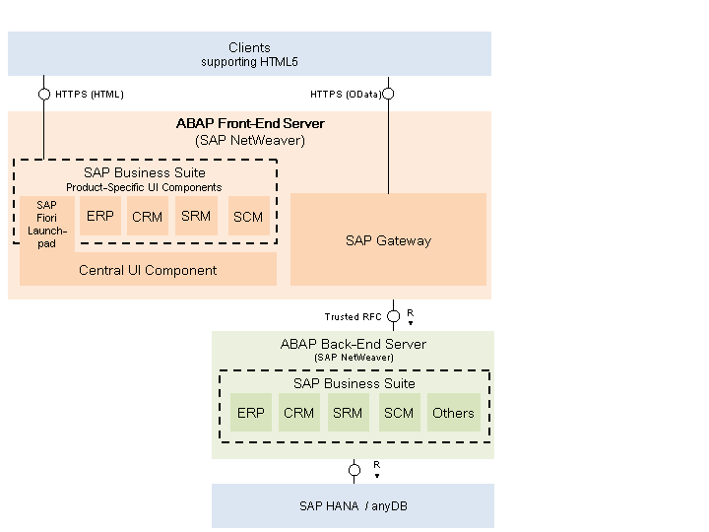
The figure below shows the System Landscape for Transactional Apps.

Fact Sheets Landscape
Contextual information about central objects used in the business operations are displayed in these apps. Fact sheets are designed to be intuitive and harmonized. From a fact sheet area (tile), it is possible to drill down into its details. It's easy to navigate from one fact sheet to its related fact sheets. For example, navigate from a document to the related business partner or to the master data. From fact sheets, it is also possible to access related transactions in operational systems. Access the back-end system to display document details or to edit the document from a document fact sheet is also possible.
Fact sheets run only on an SAP HANA database and require an ABAP stack. The figure below shows the System Landscape for Fact Sheets.
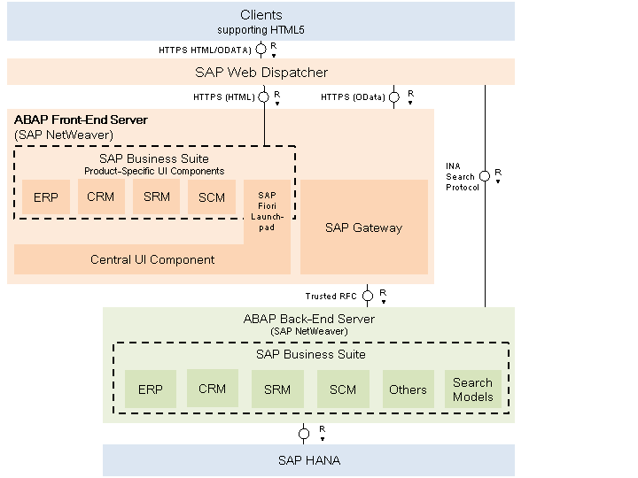

Analytical Apps Landscape
It is possible to get a role-based insight into real-time operations of the business by collecting and displaying key figures directly in the browser through the SAP Analytical apps. To do this, the SAP Analytical apps combine the data and analytical power of SAP HANA with the integration and interface components of SAP Business Suite. With SAP Analytical, the customer's company is able to closely monitor its most important KPIs in real time and react immediately on changes in market conditions or operations.
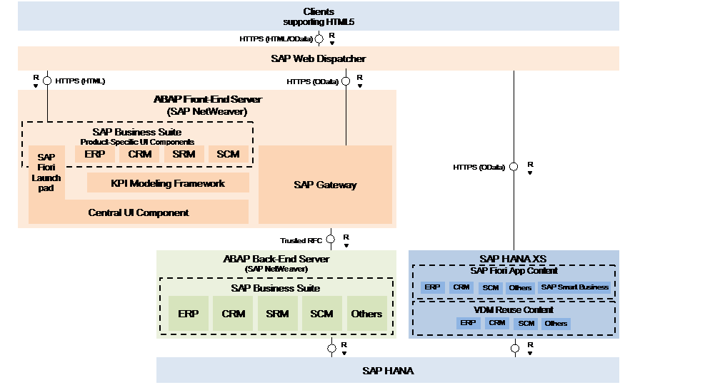
The figure below shows the System Landscape for Analytical Apps:

Generic Configuration
This section includes the generic configuration steps that have to perform for the following:
- Creating Fiori Users
- Connecting SAP NetWeaver Gateway to SAP Business Suite
- Configuring SAP Web Dispatcher(Fact sheets and Analytical apps only)
- Setting up the Fiori Launchpad and Launchpad Designer
- Configuring Embedded Search in the Back-End Suite On HANA(Fact sheets only)
Note
For some manual configuration steps, you can alternatively perform ABAP system configuration tasks in an automated way by using predefined task lists in an SAP NetWeaver 7.40 system landscape. For more details, see chapter Technical Configuration Automation.

Technical Configuration Automation

Purpose
The steps covered in chapter Generic Configuration describe manual steps. For some manual configuration steps, you can alternatively perform ABAP system configuration tasks in an automated way by using predefined task lists. For an easier and faster configuration via an automated configuration, see this chapter for more information. Carefully check that you have covered all configuration steps at the end since up to now not all manual steps are covered in these automation steps.
Caution
Be aware that some steps within the task lists are not required for the configuration/activation of Fiori and hence these steps do not show up in the manual step description, that is: a one to one mapping of manual and automated configuration step is in some cases is not possible.

Prerequisites
- The predefined task lists are available for every SAP NetWeaver 7.4 SP6 ABAP system (delivered via Software Component SAP_BASIS). Using SP08, additional task lists were delivered –check SAP Note 2017302.
Note
The customer must check if SAP NetWeaver 7.4 with the minimum SP level, is in use. There are no downports for SAP NetWeaver 7.31 available.
- You have implement SAP Note 2017302 to get the predefined task lists for Fiori frontend configuration.

Procedure
The task list runs must be carried out in the following sequence. In the right column, see those manual activities that are described in this document and thus are not necessary any more when carrying out the automation settings. Be aware that some steps within the task lists are not required for the configuration/activation of Fiori and hence these steps do not show up in the manual step description, that is one to one mapping of manual and automated configuration step in some cases is not possible.
# | Task list | Tasks covered replacing manual configuration steps described in this document
1 | SAP_GATEWAY_BASIC_CONFIG | - Gateway System: Activating SAP NetWeaver Gateway
2 | SAP_FIORI_LAUNCHPAD_INIT_SETUP | - Gateway System: Activating Launchpad OData Services  - Gateway System: Configuring ICF Nodes
3 | SAP_SAP2GATEWAY_TRUSTED_CONFIG | - Gateway System: Creating Trusted RFC in NetWeaver Gateway to SAP Business Suite  - Defining Trust between SAP Business Suite and SAP NetWeaver Gateway
4 | SAP_GATEWAY_ADD_SYSTEM | - Gateway System: Creating System Alias
5 | SAP_BASIS_SSL_CHECK | - No manual tasks available

Task List SAP Gateway - Basic Configuration
Use
You use task list SAP_GATEWAY_BASIC_CONFIG to perform basic configuration steps for SAP Gateway.
Procedure
- Log on to your SAP ABAP system.
- Call the following transaction:
Transaction Code | STC01
- On the Task Manager for Technical Configuration screen, insert SAP_GATEWAY_BASIC_CONFIG in the Task List field.
- Choose Generate Task List Run (F8). The Maintain Task List Run screen is displayed.

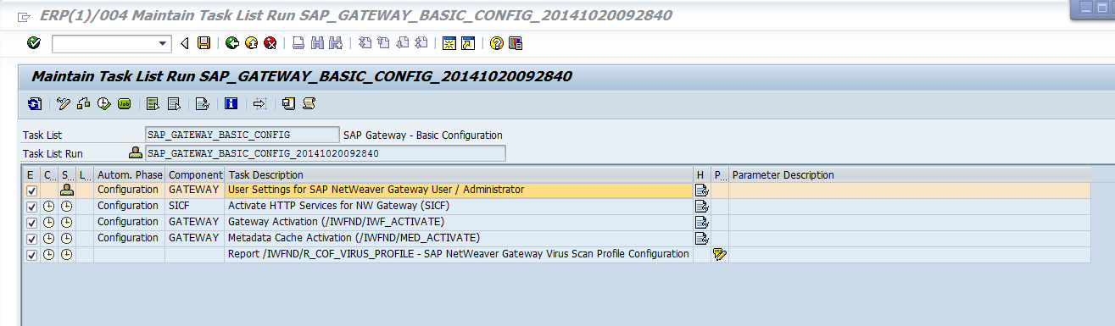

- As the icon in the Status column implies, the first task displayed in this list has to be carried out manually: User Settings: Definition der GW Roles: SAP NetWeaver Gateway User/Administrator.
- Once you have finished the manual tasks, choose the icon in the Status column.

- Confirm the popup message. A green light indicating Executed successfully is displayed in the Status column.
- Before starting the task list run, make sure you have the Execute checkbox for the respective task list selected:
- Activate HTTP Services for NW Gateway (SICF)
- Gateway Activation (/IWFND/IWF_ACTIVATE)
- Metdata Cache Activaition (/IWFND/MED_ACTIVATE)
- Report /IWFND/R_COF_VIRUS_PROFILE - SAP NetWeaver Gateway Virus Scan Profile Configuration
- Choose Start/Resume Task List Run in Dialog (or in Background). Once the task list run has been finished successfully, green lights appear in the Status column.
Result
You have successfully carried out the task list run SAP_GATEWAY_BASIC_CONFIG.
To check the task list run, call the respective transaction named in brackets above. For example, in transaction SICF, you can check the activation of the following HTTP services for NW Gateway:
- /SAP/OPU/ODATA/*
- /SAP/PUBLIC/ICMAN
- /SAP/PUBLIC/ICF_INFO/*
Note
In case you need detailed description of the single steps select the task documentation icon in the help column.
Within the last step the Virus Scan Profile is executed. This step corresponds to the following IMG setting where you can check for further details:
Transaction Code | SPRO
SAP Reference IMG Menu | SAP NetWeaver → Gateway → Odata Channel → Administration → General Settings→ Define Virus Scan Profiles

Task List SAP Fiori Launchpad Initial Setup
Use
You use task list SAP_FIORI_LAUNCHPAD_INIT_SETUP to activate launchpad OData and HTTP services on an SAP Gateway system (frontend).
Procedure
- Log on to your SAP ABAP system.
- Call the following transaction:
Transaction Code | STC01

- On the Task Manager for Technical Configuration screen, insert SAP_FIORI_LAUNCHPAD_INIT_SETUP in the Task List field.
- Choose Generate Task List Run (F8). The Maintain Task List Run screen is displayed.
- Before starting the task list run, make sure you have the Execute checkbox for the respective task list selected:
- Activate Gateway OData Services for Launchpad (/IWFND/MAINT_SERVICE)
- Activate HTTP Services for SAP Fiori Launchpad (SICF)
- Activate HTTP Services for UI5 (SICF)
- Add Launchpad / Launchpad Designer URLs to Favorites for current user
- Choose Start/Resume Task List Run in Dialog (or in Background). Once the task list run has been finished successfully, green lights appear in the Status column.
Result
You have successfully carried out the task list run SAP_FIORI_LAUNCHPAD_INIT_SETUP.
To check the task list run, call the respective transaction and check the successful activation:
- /IWFND/MAINT_SERVICE
- /UI2/INTEROP
- /UI2/PAGE_BUILDER_PERS
- /UI2/PAGE_BUILDER_CONF
- /UI2/PAGE_BUILDER_CUST
- /UI2/TRANSPORT
- SICF (Activate HTTP Services for SAP Fiori Launchpad)
- /sap/bc/ui2/nwbc
- /sap/bc/ui2/start_up
- /sap/bc/ui5_ui5/sap/ar_srvc_launch
- /sap/bc/ui5_ui5/sap/ar_srvc_news
- /sap/bc/ui5_ui5/sap/arsrvc_upb_admn
- /sap/bc/ui5_ui5/ui2/ushell
- /sap/public/bc/ui2
- /sap/public/bc/ui5_ui5
- SICF (Activate HTTP Services for UI5)
- /sap/bc/ui5_ui5/ui2
- /sap/public/bc/ui5_ui5

Task List Create Trusted Connection from SAP System to SAP Gateway
Use
You use task list SAP_SAP2GATEWAY_TRUSTED_CONFIG to create a trusted connection from an SAP system to SAP Gateway.
Caution
This task list needs to be executed in the respective backend system and NOT as all the other task lists in the SAP Gateway system.
Procedure
- Log on to your SAP ABAP system.
- Call the following transaction:
Transaction Code | STC01

- On the Task Manager for Technical Configuration screen, insert SAP_SAP2GATEWAY_TRUSTED_CONFIG in the Task List field.
- Choose Generate Task List Run (F8). The Maintain Task List Run screen is displayed.
- Before starting the task list run, make sure you have the Execute checkbox for the respective task list selected:
- Create/Select ABAP RFC Destination to SAP System (SM59) [Parameter maintenance]
Note
Before carrying out this task list run, you must fill parameters. In the Parameters column, choose and make the respective entries on the Edit Variants screen.

- Add SAP System as trusted system (SMT1)
- Set profile para RZ10 login/accept_sso2_ticket=1
- Set profile para RZ10 login/create_sso2_ticket =1
- Configure Logon Ticket for SSO (STRUSTSSO2)
- Choose Start/Resume Task List Run in Dialog (or in Background). Once the task list run has been finished successfully, green lights appear in the Status column.
Result
You have successfully carried out the task list run SAP_FIORI_LAUNCHPAD_INIT_SETUP.

Task List SAP Gateway - Add Backend System
Use
You use task list SAP_GATEWAY_ADD_SYSTEM to connect an SAP system (backend) to an SAP Gateway system (frontend).
Procedure
- Log on to your SAP ABAP system.
- Call the following transaction:
Transaction Code | STC01

- On the Task Manager for Technical Configuration screen, insert SAP_GATEWAY_ADD_SYSTEM in the Task List field.
- Choose Generate Task List Run (F8). The Maintain Task List Run screen is displayed.
- Before starting the task list run, make sure you have the Execute checkbox for the respective task list selected:
- Check authorization for current user in SAP System [Manual step ]
- Create / Select Customizing Request (SE09) [Parameter maintenance]
- Create / Select trusted ABAP RFC Destination to SAP System (SM59) [Parameter maintenance]
- Set Profile Parameter: login/accept_sso2_ticket=1 (RZ10)
- Set Profile Parameter: login/create_sso2_ticket=2 (RZ10)
- Configure Logon Ticket for Single Sign-On (STRUSTSSO2)
- Create System Alias for SAP System [Parameter maintenance]
- Choose Start/Resume Task List Run in Dialog (or in Background). Once the task list run has been finished successfully, green lights appear in the Status column.
Result
You have successfully carried out the task list run SAP_GATEWAY_ADD_SYSTEM.

Task List SAP Basis SSL Check
Use
You use task list SAP_BASIS_SSL_CHECK to perform a basic SSL check.
Procedure
- Log on to your SAP ABAP system.
- Call the following transaction:
Transaction Code | STC01

- On the Task Manager for Technical Configuration screen, insert SAP_BASIS_SSL_CHECK in the Task List field.
- Choose Generate Task List Run (F8). The Maintain Task List Run screen is displayed.
- Before starting the task list run, make sure you have the Execute checkbox for the respective task list selected:
- Check SAP Cryptographic Library [Parameter maintenance]
- Check ICM HTTPS Configuration [Parameter maintenance]
- Check SSL Profile Parameter [Parameter maintenance]
- Check SSL Server Standard PSE [Parameter maintenance]
- Choose Start/Resume Task List Run in Dialog (or in Background). Once the task list run has been finished successfully, green lights appear in the Status column.
Result
You have successfully carried out the task list run SAP_BASIS_SSL_CHECK.

Displaying Log Information for Task List Runs
Use
In this step, you view detailed log information about a task list run.
Prerequisites
You have executed a task list or task list variant.
Procedure
- Log on to your SAP ABAP system.
- Call the following transaction:
Transaction Code | STC02

- On the Task List Run Monitor screen, enter or search for the task list run you want to view in the Task List field.
- Choose Start Search (F8). The Task List Runs screen is displayed.
- Double-click the task list run you want to view.
- On the Display Task List Run screen, choose (Display Log).
Result
You have viewed information like:
- Task list run header information
- Task list information
- Task overview
- Task details
It is possible to download a ZIP file with the log information by choosing .

Creating Fiori Users
Use
An admin user and an end user are created in ABAP Front-end server, Suite on HANA server, and HANA server to facilitate further role- based configuration tasks and verification processes. Alternatively, if such users already exist, only the role assignment is needed.
Procedure
- Login into the ABAP front-end server.
- Access the activity using the following navigation options:
Transaction Code | SU01
- Create administrator user FIORI_ADM and end user FIORI_USER.
- Login into the Suite on HANA server.
- Access the activity using the following navigation options:
Transaction Code | SU01
- Create administrator user FIORI_ADM and end user FIORI_USER.
- Go to SAP HANA studio, go to the SAP HANA Systems view, and choose Security→ Users.
- Create the database users FIORI_ADM and FIORI_USER.
Note
User FIORI_ADM is to be used by administrators or consultants, who perform the configuration. User FIORI_USER is to be used by end user or testers, who perform verification.

Connecting SAP NetWeaver Gateway to SAP Business Suite

Gateway System: Assign role template for administrators
Use
To create roles to provide all users with access to create Trusted RFC in NetWeaver Gateway, proceed as follows.
Procedure
- In the SAP Gateway system, access the activity using one of the following navigation options:
Transaction Code | PFCG
IMG Menu | Tools → Administration → User Maintenance → Role Administration → Roles
- Enter the name of the role, for example, Z_RT_ADMIN.
- Choose Single Role to create the user role.
- Open the Authorizations tab, in the Save the role dialog box, choose Yes.
- Choose Change Authorization Data to specify a template for the role.
- In the Choose Template dialog box. Select the Template /IWFND/RT_ADMIN and choose Adopt reference.
- Choose Generate (Shift + F5) and press Enter.
- Choose Back and click on Generate (F6).
- Open the User tab, Insert the administrator user ID/name in the User Assignments area, for example, FIORI_ADM.
- Choose Save ( Ctrl+S).

Gateway System: Creating Trusted RFC in NetWeaver Gateway to SAP Business Suite
The trust relationship is defined between the SAP Business Suite system and the SAP NetWeaver Gateway system by configuring the SAP NetWeaver Gateway system to be the trusting system, the SAP Business Suite system (backend system) to be the trusted system. Below are the steps need to be finished in the gateway system.
Add the Caution/Example/… paragraphs to your Quick Parts in the Insert ribbon (Insert → Quick Parts → Save Selection to Quick Part Gallery). Then delete these paragraphs below.
Note
This is a RFC destination used to establish the trust which will be used during runtime.
Note
You can skip this step if you have carried out this step in an automated way. See chapter Technical Configuration Automation.
Procedure
- In gateway system, access the activity using one of the following navigation options:
Transaction Code | SM59
SAP Menu | Tools → Administration→ Administration → Network → RFC Destinations
Choose Create.
- In the RFC Destination field, enter the RFC destination name in the following format: <system id >CLNT<Client>.
- In the Connection Type field, enter 3.
- In the Description 1 field, enter an explanatory text, for example, RFC Destination to SAP Business Suit.
- Save the settings.
- On tab Technical Settings, enter the parameters according to the table below:
Field Name | Entry
Load Balancing Status | No
Target Host | <Server name of Business suit system>  For example, vhcalerpci.wdf.sap.corp
System Number | < Business Suit System number>  For example, 00
- On tab Logon & Security, enter the following parameters.
Field Name | Entry
Language | EN
Client | <Client of Business Suit system>  For example, 180
User | Check current user
- For Trust Relationship, activate Yes.
- Save the settings.

Defining Trust between SAP Business Suite and SAP NetWeaver Gateway
The trust relationship is defined between your SAP Business Suite system and the SAP NetWeaver Gateway system by configuring the SAP Business Suite system (backend system) to be the trusting system, and the SAP NetWeaver Gateway host to be the trusted system. Below are the steps that need to be finished in the business suite system.

Note
This is a RFC destination used to establish the trust which, will be used during runtime.
Note
You can skip this step if you have carried out this step in an automated way. See chapter Technical Configuration Automation.
Procedure
- In your Business Suite system, access the activity using one of the following navigation options:
Transaction Code | SM59
SAP Menu | Tools → Administration→ Administration → Network → RFC Destinations
Choose Create (F8).
- In the RFC Destination field, enter the RFC destination name in the following format: <system id >CLNT<Client>.
- In the Connection Type field, enter 3.
- In the Description 1 field, enter an explanatory text, for example, RFC Destination to SAP NetWeaver Gateway.
- Save the settings.
- On the Technical Settings tab, Enter the parameters according to the table below:
Field Name | Entry
Load Balancing Status | No
Target Host | <Server name of Gateway System >  For example, vhcalabaci.wdf.sap.corp
System Number | < Gateway System number>  For example, 00
- On tab Logon & Security, enter the following parameters.
Field Name | Entry
Language | EN
Client | <Client of Gateway system>  For example, 080
User | Check current user
- Save the settings.
- In transaction SMT1, choose Create.
- Proceed with the steps outlined in the wizard. In the RFC Destination field, enter the RFC destination which created to represent the gateway system. A RFC logon to the SAP NetWeaver Gateway system takes place and the necessary information is exchanged between the systems.
- Log on to the SAP NetWeaver Gateway host using the administrator user and password. The trusted entry for the SAP NetWeaver Gateway host displays.
- Save the settings.

Add the Caution/Example/… paragraphs to your Quick Parts in the Insert ribbon (Insert → Quick Parts → Save Selection to Quick Part Gallery). Then delete these paragraphs below.
Caution
End users must have authorization object S_RFCACL assigned to them before they can use a trusted connection. For more information, see RFC Trusted/Trusting Systems.

Gateway System: Creating System Alias
Note
You can skip this step if you have carried out this step in an automated way. See chapter Technical Configuration Automation.
Procedure
- In the ABAP Front-End Server, access the activity using one of the following navigation options:
Transaction Code | SPRO
SAP Reference IMG menu | SAP NetWeaver → Gateway→ OData Channel → Configuration→ Connection Settings→ SAP NetWeaver Gateway to SAP System→ Manage SAP System Aliases
- Choose New Entries.
- Enter the following parameters.
Field Name | Entry
SAP System Alias | <your RFC destination name>  For example, ERPCLNT180
Description | Description of your system
RFC Destination | <your RFC destination name>  For example, ERPCLNT180
Software Version | DEFAULT
- Choose Save.
Note
The system alias which represents the NetWeaver Gateway system itself, Local should have been maintained by default. If not, please maintain it with the following parameters.

Field Name | Entry
SAP System Alias | Local
Description | Local System Alias
Local GW | Check the Local GW box
RFC Destination | NONE
Software Version | DEFAULT

Gateway System: Activating SAP NetWeaver Gateway
Procedure
Note
You can skip this step if you have carried out this step in an automated way. See chapter Technical Configuration Automation.

- In the ABAP Front-End Server, access the activity using the following navigation options:
Transaction Code | SPRO
SAP Reference IMG Menu | SAP NetWeaver → Gateway → OData Channel → Configuration → Connection Settings → Activate or Deactivate SAP NetWeaver Gateway
- Choose Activate. A message is displayed to inform the current status.
Note
Alternatively, you can also execute transaction /IWFND/IWF_ACTIVATE.

Configuring SAP Web Dispatcher
Use
SAP Fiori client applications are HTML5 applications that access multiple back-end systems. However, JavaScript code is constrained by the same-origin policy. For this reason, all systems are exposed to the browser through the SAP Web Dispatcher, which brings them into a common origin (combination of protocol, hostname, and port). In addition to solving the same origin problem, this enables you to control which services are effectively exposed to the client, reducing the system attack surface. You must implement and configure SAP Web Dispatcher as an SSL client in the system landscape.
We use a standalone SAP Web Dispatcher to deal with the incoming requests from the Front-End Server, (several) Back-End XSEs, (several) Back-End Enterprise Searches; below we’ll just have one ERP instance on HANA as an example.

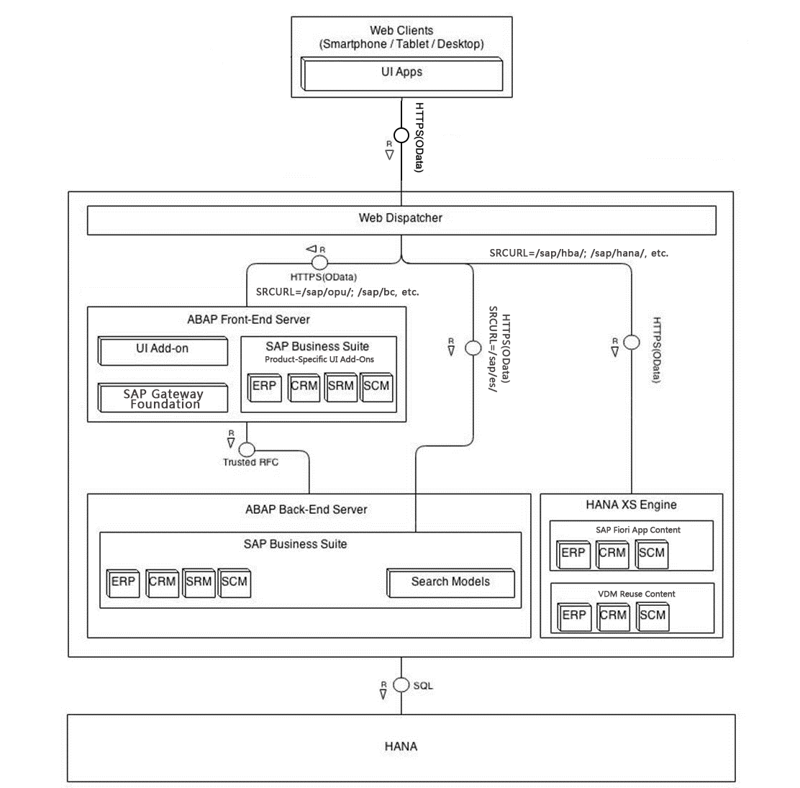
Note
Please notice that this chapter is optional if only Transactional apps are to be used. If you want to deploy Fact Sheets or Analytical Apps in your system landscape, you must perform the installation procedure.
For more detail information regarding the installation of the SAP Web Dispatcher, please refer to Configuration Guide - Getting started with implementing the SAP Fiori Apps Rapid-Deployment Solution.
For more information regarding SAP Web Dispatcher, please refer to http://help.sap.com → Technology → SAP NetWeaver Platform → Function Oriented View → Application Server → Application Server Infrastructure → Components of SAP NetWeaver Application Server → SAP Web Dispatcher.
Procedure
- Access the operating system of SAP Web Dispatcher; edit its Instance Profile WDP_W<Instance Number>_<hostname>.
Note
This is an example for Linux system. Since Web Dispatcher uses a different System Number from SAP NetWeaver, so if you install the Front-End NetWeaver Gateway and the SAP Web Dispatcher in the same server, the profile for SAP Web Dispatcher is not the one can be displayed in transaction RZ10.
- To enable HTTPS for Web Dispatcher, make sure that you have sapcrypto.dll file installed already. Add following profile parameters in the instance profile WDP_W<Instance Number>_<hostname>.
DIR_INSTANCE = <SECUDIR_Directory>
ssl/ssl_lib = <Location_of_SAP_Cryptographic_Library>
ssl/server_pse = <Location_of_SSL_server_PSE>
ssl/client_pse = < Location_of_SSL_client_PSE >
wdisp/ssl_encrypt = 1
wdisp/ssl_auth = 1
wdisp/add_client_protocol_header = 1
wdisp/ping_protocol = https
icm/HTTPS/verify_client = 1
Note
The parameter wdisp/ssl_encrypt determines whether the SAP Web Dispatcher encrypts the request again with SSL before forwarding it.
wdisp/ssl_encrypt = 0 (receives https encrypted data, web dispatcher decrypts the data and forwards unencrypted data to SAP Backend)
wdisp/ssl_encrypt = 1 (receives https encrypted data, web dispatcher decrypts the data, re-encrypt again and forwards encrypted data to SAP Backend)
wdisp/ssl_encrypt = 2 (the SSL is not terminated and request is sent encrypted to SAP Backend)

Example
The following example shows the profile parameter settings to enable HTTPS for Web Dispatcher.
wdisp/ssl_encrypt = 1
wdisp/ssl_auth = 1
wdisp/add_client_protocol_header = 1
wdisp/ping_protocol = https
icm/HTTPS/verify_client = 1
DIR_INSTANCE = ./
ssl/ssl_lib = /sapmnt/ABA/exe/uc/linuxx86_64/libsapcrypto.so
ssl/server_pse = /usr/sap/WDP/W03/sec/SAPSSLS.pse
ssl/client_pse = /usr/sap/WDP/W03/sec/SAPSSLC.pse
- Add following profile parameters for ICM ports:
icm/server_port_0 = PROT=HTTPS,PORT=<Web Dispatcher Port>,TIMEOUT=120
Example
icm/server_port_0 = PROT=HTTPS,PORT=1081,TIMEOUT=120
- Add following profile parameters for Web Dispatcher routes:
wdisp/system_0 = SID=<Front-End SID>, MSHOST=<Front-End Hostname>, MSPORT=
<Front-End Messaging Port>, SRCSRV=*:<Web Dispatcher Port>,
SRCURL=/sap/opu/;/sap/public/;/sap/bc/;/sap/saml2/;/ui2/nwbc/, CLIENT=<Front-End
client>
wdisp/system_1 = SID=<Back-End SID>, MSHOST=<Back-End Hostname>, MSPORT=<Back-End
Messaging Port>, SRCSRV=*:<Web Dispatcher Port>,SRCURL=/sap/es/, CLIENT=
<Back-End client>
wdisp/system_2 = SID=<HANA SID>, EXTSRV=<HANA XS URL>,SRCSRV=*:<Web Dispatcher
Port>, SRCURL=/sap/hba/;/sap/hana/;/sap/bi/;/sap/viz/;/sap/vi/;/sap/ui5/
Example
The following example shows the profile parameter settings for Web Dispatcher routes.
wdisp/system_0 = SID=ABA, MSHOST=vhcalabaci.wdf.sap.corp, MSPORT=8101, SRCSRV=*:1081, SRCURL=/sap/opu/;/sap/bc/; /sap/public/bc/;/sap/saml2/;/ui2/nwbc/,CLIENT=080
wdisp/system_1 = SID=ERP, MSHOST= vhcalerpci.wdf.sap.corp, MSPORT=8101, SRCSRV=*:1081, SRCURL=/sap/es/, CLIENT=180
wdisp/system_2 = SID=HDB, EXTSRV=https://vhcalhdbdb.wdf.sap.corp:4302, SRCSRV=*:1081, SRCURL=/sap/hba/;/sap/hana /
- Save the Instance Profile and restart the Web Dispatcher process.
Note
To ensure confidentiality and integrity of data, we recommend encrypting communication path for web browser to SAP Web Dispatcher. To enable SAP Web Dispatcher to use https, refer to chapter Enable Web Dispatcher to Use HTTPS in Building Block Configuration Guide - Basic Network and Security Configuration

Setting up the Fiori Launchpad and Launchpad Designer

Gateway System: Activating Launchpad OData Services
Use
In this activity, you activate the corresponding OData service for SAP Fiori Launchpad and Launchpad Designer.
Note
You can skip this step if you have carried out this step in an automated way. See chapter Technical Configuration Automation.

Procedure
- Login to the front-end server.
- Access the activity using the following navigation options:
Transaction Code | SPRO
SAP Reference IMG Menu | SAP NetWeaver → Gateway → OData Channel → Administration → General Settings → Activate and Maintain Services
- On the Activate and Maintain Services screen, choose Add Service.
- On the Add Service screen, choose Local as the System Alias. A list of services is then displayed.
- Choose the entry with technical service name /UI2/LAUNCHPAD (Service for accessing Launchpad links).
- In the Add Service dialog box, specify Package, choose ICF Node as Standard Mode, and then choose Continue (Enter). A message is displayed at the bottom of the screen informing you that Service ‘<Service Name>’ successfully created. Choose Back (F3).
- Perform steps 5 to 7 for following services respectively:
Service | Description
/UI2/PAGE_BUILDER_CONF | Page Builder - Configuration Level
/UI2/PAGE_BUILDER_CUST | Page Builder - Customizing Level
/UI2/PAGE_BUILDER_PERS | Page Builder - Personalization Level
/UI2/INTEROP | Gateway Service of Interoperability
/UI2/TRANSPORT | UI2: Transport Service
- In the Activate and maintain Services screen, call each service once by selecting it and clicking Call Browser in the screen area ICF Nodes. Always select the OData node, not the SDATA node.
Note
A service has been successfully called when an XML document is displayed without any error messages. Once a service is called, a hash key is generated in the background. The hash key is required for the generation of authorizations described in the chapter Configuring Authorization Roles.
Result
The mentioned OData services have successfully activated.

Gateway System: Configuring ICF Nodes
Use
In this activity, the corresponding ICF nodes for SAP Fiori Launchpad UI are activated.
Note
This step can be skipped if it has been carried out in an automated way. See chapter Technical Configuration Automation.
Procedure
- Login to the ABAP front-end server.
- Access the activity using the following navigation options:
Transaction Code | SICF
- Choose Execute. The Maintain Service window displays.
- Activate following relevant paths.
/sap/bc/ui2/start_up
/sap/bc/ui2/nwbc/
/sap/bc/ui5_ui5/ui2/ushell
/sap/bc/ui5_ui5/sap/arsrvc_upb_admn
/sap/bc/ui5_ui5/sap/ar_srvc_news
/sap/bc/ui5_ui5/sap/ar_srvc_launch
/sap/public/bc/ui5_ui5/
/sap/public/bc/ui2/
/sap/public/bc/icf/logoff
Result
The mentioned ICF nodes have successfully activated.

Gateway System: Configuring Login Screen for Launchpad and Launchpad Designer
Use
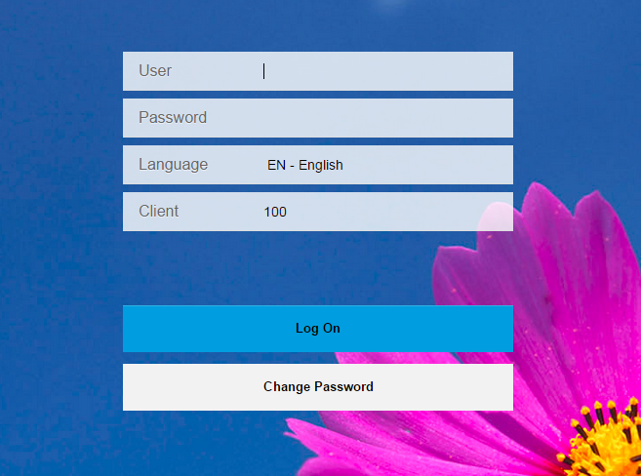
The logon page of the SAP Fiori Launchpad is configured in this activity.
Procedure
- Login to the ABAP front-end server.
- Access the activity using the following navigation options:
Transaction Code | SICF
- Choose Execute. The Maintain Service window displays.
- Double - click on the node /sap/bc/ui5_ui5/ui2/ushell.
- Choose the Error Pages Tab.
- Choose System Logon and then choose the Configuration button beside.
- On the System Logon Configuration dialog box, Choose Custom Implementation and input /UI2/CL_SRA_LOGIN into the ABAP Class text field.
- Choose Save.
- On the Create/Change a Service screen, choose Save.
- Repeat above steps for Launchpad Designer service /sap/bc/ui5_ui5/sap/arsrvc_upb_admn.
Result
The default logon page is configured. Then you will see this logon page if you visit the Launchpad through http(s)://<FronEndServer>:<Port>/sap/bc/ui5_ui5/ui2/ushell/shells/abap/FioriLaunchpad.html?sap-client=<Client>

Gateway System: Adapting the Logout Page in the SAP Fiori Launchpad (Optional)
Prerequisites
The Authorization Obj. S_ADMI_FCD is needed to edit Error Pages.
Use
Once the user is logging out from the SAP Fiori Launchpad via the Log Out button a Logoff page is displayed.
This section describes how to redirect the html call to a different page. This example describes the redirection to SAP Fiori Launchpad again. Any other URL might be set here which, fits to the customer needs.
Procedure
- Access the following transaction:
Transaction Code | SICF
- Choose Execute (F8).
- Expand the folder default_host → sap
- Find the services navigating to this path:
Path | External Service Name
public → bc →icf → logoff | Logoff
- Double-click the selected service.
- Choose Change (Ctrl+F1).
- Select tab Error Pages.
Note
If the customers are using SAML2.0 authentication method to login to the SAP Fiori Launchpad, There is an additional setting need to be modified. In the sub-tab Logon Errors, select the System Logon instead of Explicit Response Time.
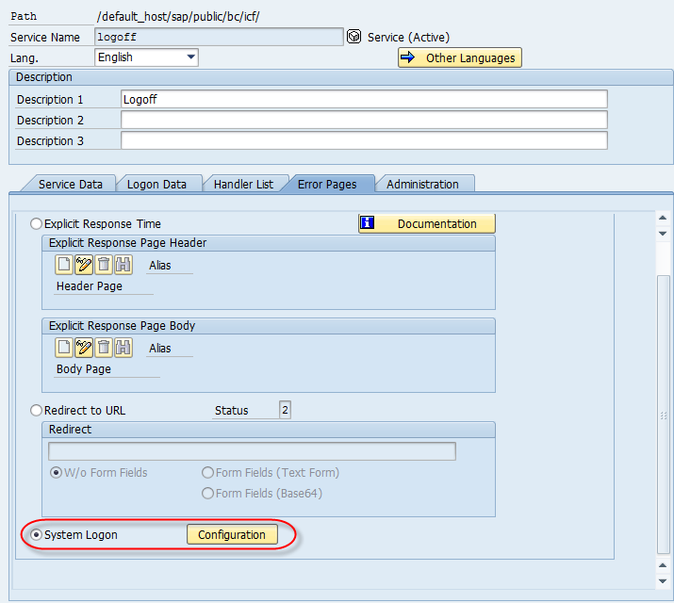
- Select sub-tab Logoff Page.
- Choose option Redirect to URL. Enter the URL to be called after the logout in the field Redirect.
Note
For a redirection to the SAP Fiori Launchpad, enter the following link: Error! Hyperlink reference not valid.
- Choose Save.
- Select Display → Change (CTRL+F1) button.
Transaction Code | SPRO
SAP Reference IMG Menu | SAP NetWeaver → Gateway → Odata Channel → Configuration → Connection Settings → SAP NetWeaver Gateway to SAP System → Manage RFC Destinations

Caution
If the customers are using X.509 authentication method to login to the SAP Fiori Launchpad, The logout function may not work properly. For more detail information regarding Fiori Logout page, please refer to SAP Note 1984739
Result
After logging off from the SAP Fiori Launchpad the html page maintained is being called.

Gateway System: Configuring Authorization Roles
Use
Users need authorization roles to run the SAP Fiori Launchpad (as an end user) and the SAP Fiori Launchpad designer (as an administrator). When users have these roles, they can access the catalogs and groups assigned to the roles by a role administrator.
Procedure
- Login to the ABAP front-end server.
- Access the activity using the following navigation options.
Transaction Code | PFCG
- In Role Maintenance (transaction PFCG), copy the roles SAP_UI2_ADMIN_700 to your customer namespace.
- Add additional authorization default entries in the copied roles for the TADIR Service. On the Menu tab, choose and select Authorization Default.
- In the Service pop-up that opens, select TADIR Service and specify the following values:
Field Name | Entry
Program ID | R3TR
Object Type | IWSG
TADIR Service | Use the value help to select the correct object name. Enter the names of the activated services (see Activating Launchpad OData Services).
  - The TADIR Service names in SAP NetWeaver Gateway are as follows
Role | TADIR Service
ZSAP_UI2_ADMIN_700 | ZINTEROP_0001  ZPAGE_BUILDER_PERS_0001  ZPAGE_BUILDER_CUST_0001  ZPAGE_BUILDER_CONF_0001  ZTRANSPORT_0001
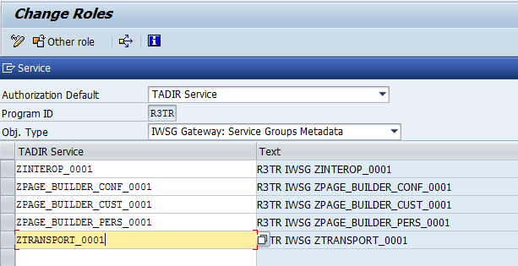
- Choose Copy.
- On the Authorizations tab, click Propose Profile Name next to the Profile Name field.
- Choose Change Authorization Data. On the screen that opens up, click the Generate button.
- Save the settings.
- Repeat the steps 3 to 8 for the role SAP_UI2_USER_700 as a template and assigning only a subset of services:
Role | TADIR Service
ZSAP_UI2_USER_700 | ZINTEROP_0001  ZPAGE_BUILDER_PERS_0001

Gateway System: Assign Generic Roles for administrators and end users
Use
Different activities require different roles for authorization. Some are application-specific, some are app-type-specific, and some are more generic, e.g. used for general UI services.
Procedure
- In the SAP Gateway system, access the activity using one of the following navigation options:
Transaction Code | PFCG
IMG Menu | Tools → Administration → User Maintenance → Role Administration → Roles
- On the Role Maintenance screen, enter the PFCG role for Business Catalog in the Role field: ZSAP_UI2_ADMIN_700.
- Choose Change.
- On the Change Roles screen, choose the User tab page.
- Insert the administrator user ID/name in the User Assignments area, for example, FIORI_ADM.
- Repeat steps 2-5 to assign another role ZSAP_UI2_USER_700 to the test user ID/name, for example, FIORI_USER.
- Choose Save (Ctrl+S).

Testing the Fiori Launchpad
Use
In this activity, you check whether the Fiori Launchpad can be displayed properly.
Procedure
- Login to the Fiori Launchpad as the <End User> (for example. FIORI_USER).
http(s)://<web dispatcher server>:<webdispatcherport>/sap/bc/ui5_ui5/ui2/ushell/shells/abap/FioriLaunchpad.html
Note
If the SAP Web Dispatcher is not configured, then the following link can be used to login to the Fiori Launchpad:
http(s)://<Frontend server>:<Frontendport>/sap/bc/ui5_ui5/ui2/ushell/shells/abap/FioriLaunchpad.html
- The search option  should be visible in the shell bar on the Fiori Launchpad.
Note
The Search option is the entry for Enterprise Search and to search the apps in the Fiori Launchpad Homepage
- The Fiori Launchpad homepage should display without any issue.

Generic Configuring for Fact Sheet

Backend System: Assign Roles for Embedded Search administration
Use
Fact Sheets are shown in the result list of embedded search. Therefore embedded search need to be enabled. The required authorization to administrate embedded search is to be granted.
Procedure
- In the backend ERP system, access the activity using one of the following navigation options:

Transaction Code | PFCG
IMG Menu | Tools → Administration → User Maintenance → Role Administration → Roles

- On the Role Maintenance screen, enter PFCG role SAP_ESH_LOCAL_ADMIN in the Role field.
- Choose Change.
- On the Change Roles screen, choose the User tab page.
- Insert the user ID/name in the user assignment area, e.g. FIORI_ADM
- Choose Save (Ctrl +S).

Backend System: Activating Embedded Search Business Functions
Use
Fact Sheets are shown in the result list of embedded search. Therefore embedded search need to be enabled. In order to enable embedded search, certain business functions need to be activated first in the system. This is cross-client setting.
Procedure
- Login to the backend ABAP server, for example: ERP system.
- Access the activity using the following navigation options:
Transaction Code | SFW5
SAP Reference IMG Menu | Activate Business Functions
- On the Security Information screen, choose Continue.
- Expand the node ENTERPRISE_BUSINESS_FUNCTIONS. A list of business functions is then displayed.
- Choose the entry with name BSESH_HANA_SEARCH and BSCBN_HANA_NAV. Check if they're in active status (marked in yellow and the bulb is on).
- If they are not active, select the check box Planned Status, Choose Activate Changes.

Backend System: Check Primary Database Connection to SAP HANA
Use
Fiori search could use a newly created secondary DB connection to access SAP HANA, but that is normally used for side-car scenario. With the backend system already on SAP HANA, the primary DB connection is preferred.

This is to check the name of primary DB connection.
Procedure
- Login to the backend ABAP server, for example: ERP system.
- Access the transaction using the following navigation option:
Transaction code | DBACOCKPIT

- In the next screen as below, choose System Configuration in the left frame, the DB connection will be shown on the right frame, choose Display.
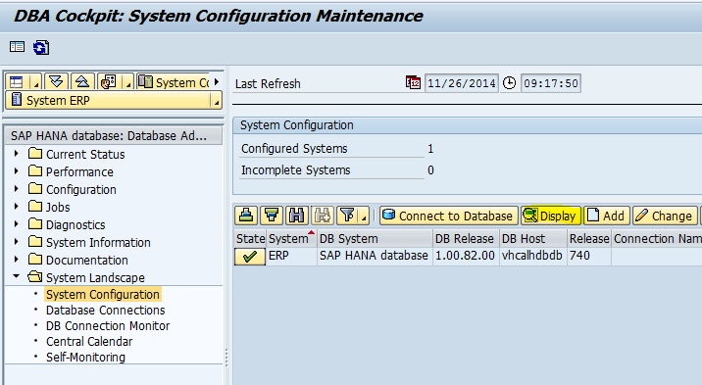

- The DB connection name can be found in the next screen as below:
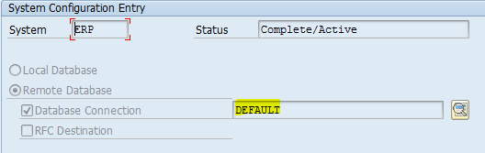
- Note down the DB connection name for later usage.

Backend System: Creating a Connection between Embedded Search and SAP HANA
Use
After the database connection is created, the embedded search needs to know where is the destination, which is the SAP HANA.
Procedure
- Login into Backend ABAP Server, for example: ERP system.
- Access the transaction using the following navigation option:
IMG menu | SAP NetWeaver → Search and Operational Analytics → Common Settings for Operational Analytics and Embedded Search → Configure Indexing → Set TREX/BWA Destination or SAP HANA DB Connection
ABAP Report | ESH_ADM_SET_TREX_DESTINATION

- On the screen below, choose Use SAP HANA, and then specify the DB Connection Name as the one you noted down in previous step.
- Execute the program, if successful a message will be shown in status bar.

Backend System: Activating Embedded Search UI Services
Use
There are several central UI services used by embedded search, and they need to be activated in advance.
Procedure
- Login into Backend ABAP Server, for example: ERP system.
- Access the transaction using the following navigation option:
Transaction code | SICF
- On the Maintain Services screen, choose Execute (F8).

Navigate to the following services and choose Activate Service in the context menu.

default_host  sap  bc  webdynpro  sap  ESH_ADMIN_UI_COMPONENT
default_host  sap  bc  webdynpro  sap  esh_eng_modelling
default_host  sap  bc  webdynpro  sap  esh_eng_wizard
default_host  sap  bc  webdynpro  sap  esh_search_results_ui
default_host  sap  bc  webdynpro  sap  wdhc_help_center
default_host  sap  es  cockpit
default_host  sap  es  saplink
default_host  sap  es  search
default_host  sap  es  ina

Backend System: Check UI Area Key for Fact Sheet
Use
Sometimes the key entries in a system table are not present and cause search model error. Check this before creating search connectors.
Procedure
- Login into Backend ABAP Server, for example: ERP system.
Note
This procedure needs to be performed in both client 000 and the client where the fact sheets are going to be used

- Access the transaction using the following navigation option:
Transaction code | SE16

- Specify the table name: ESH_OM_UI_AREA, and open the table content.
- Check if there are two entries with UI_AREA value set to FACTSHEET and LONGTEXT.
- If such entries don't exist, create them manually:
GUID | UI_AREA
5CF3FCDA894C1EE2A5A8C83A9376D459 | FACTSHEET
00300583074102EF90EF80FEFE8A1385 | LONGTEXT

Backend System: Prepare Model Data
Use
The updates of model data are firstly prepared in Client 000, then replicated to target client. To prepare the model data, certain program is to be executed in background.
Procedure

- Login into Backend ABAP Server, e.g. ERP system. Use Client 000.
- Access the transaction using the following navigation option:
Transaction code | SE38
- Specify the program name ESH_OM_PREPARE_MODEL_DATA
- From menu choose Program -> Execute -> Background
- In the Execute Report in Background screen, choose Execute immed.
- A system job ESH_OM_PREPARE_MODEL_DATA will be created and running for hours, wait and see the job log to make sure it finished in success.

Generic Configuration for Analytical App
Note
This section is only needed for Analytical Apps created by SAP Smart Business Modeler.

HANA DB: Assign Roles for accessing SAP Smart Business Modeler
Procedure
- Open the HANA Studio, on the Systems view, choose Security.
- Locate the admin user (for example: Fiori_adm) and open user profile, on the Granted Roles tab, choose.
- Input sap.hba.r.sb.core.roles::SAP_SMART_BUSINESS_MODELER, Choose OK.
- Repeat steps 2 and 3 to assign another role to both end user and admin user(Fiori_user or Fiori_adm): sap.hba.r.sb.core.roles::SAP_SMART_BUSINESS_RUNTIME.
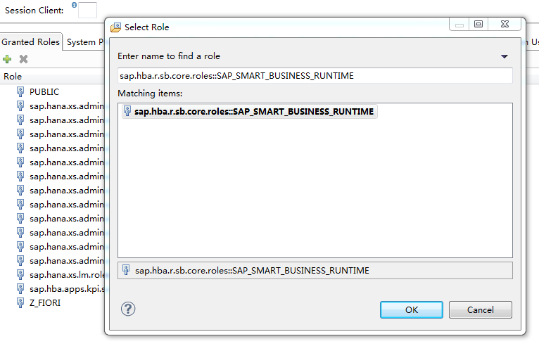
- Choose Save (Ctrl+S).

Gateway System: Assign role for accessing SAP Smart Business Modeler
Procedure
- In the SAP Gateway system, access the activity using one of the following navigation options:
Transaction Code | PFCG
IMG Menu | Tools → Administration → User Maintenance → Role Administration → Roles
- On the Role Maintenance screen, enter the PFCG role for Business Catalog you noted down before in the Role field: /UI2/SAP_KPIFRW5_TCR_S.
- Choose Change.
- On the Change Roles screen, choose the User tab page.
- Insert the admin user and end user (for example: Fiori_adm and Fiori_user) in the user assignment area.
- Repeat steps 2-5 to assign another role to admin user(for example: Fiori_adm):
/UI2/SAP_KPIMOD_TCR_S.
- Choose Save (Ctrl+S).

HANA DB: Generating Time Dimension
Procedure
- Log on to SAP HANA studio as a SYSTEM user.
- Open perspective, open the menu, Help → Quick Launch to open Quick Launch page.
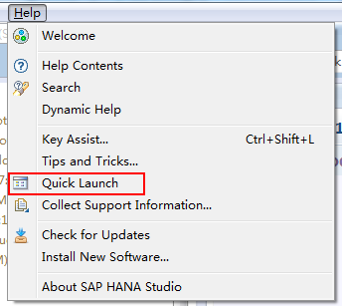
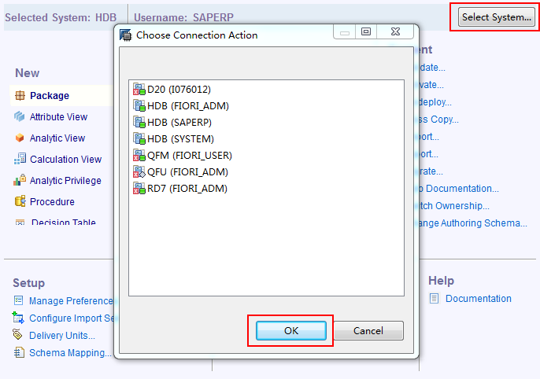
- Choose the HANA System.

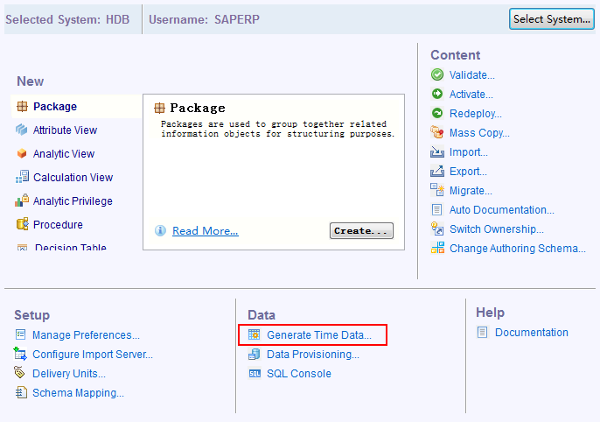
- Choose Generate Time Data.
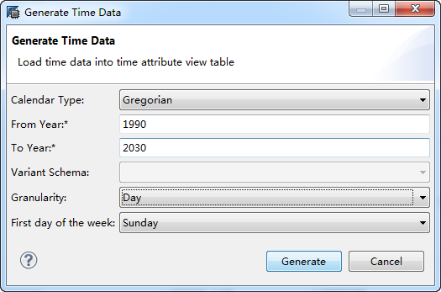
- In the Generate Time Data dialog, input following values and choose Generate:
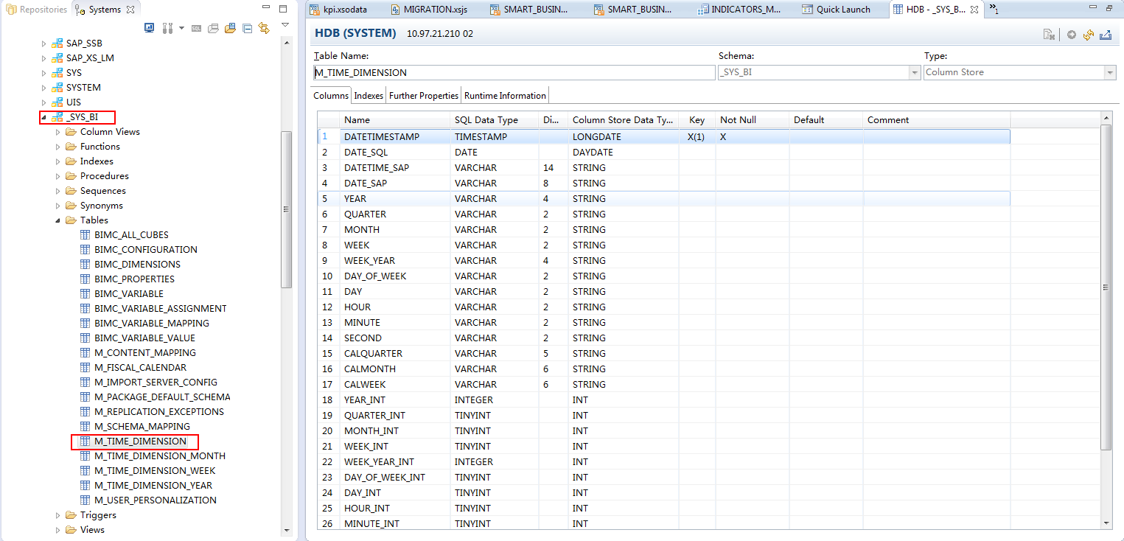
- Check table M_TIME_DIMENSON in schema _SYS_BI to confirm the time generation is successful (the table is not empty).

www.sap.com/contactsap
© 2015 SAP SE or an SAP affiliate company. All rights reserved.
No part of this publication may be reproduced or transmitted in any form or for any purpose without the express permission of SAP SE or an SAP affiliate company.
The information contained herein may be changed without prior notice. Some software products marketed by SAP SE and its distributors contain proprietary software components of other software vendors. National product specifications may vary.
These materials are provided by SAP SE or an SAP affiliate company for informational purposes only, without representation or warranty of any kind, and SAP or its affiliated companies shall not be liable for errors or omissions with respect to the materials. The only warranties for SAP or SAP affiliate company products and services are those that are set forth in the express warranty statements accompanying such products and services, if any. Nothing herein should be construed as constituting an additional warranty.
SAP and other SAP products and services mentioned herein as well as their respective logos are trademarks or registered trademarks of SAP SE (or an SAP affiliate company) in Germany and other countries. All other product and service names mentioned are the trademarks of their respective companies. Please see www.sap.com/corporate-en/legal/copyright/index.epx for additional trademark information and notices.
Material Number:

