Building Block Configuration Guide  SAP Fiori Apps rapid-deployment solution  Document Version: 1.0 – 2015-07-06 | Customer
Advanced Network and Security Configuration(EE2)

Typographic Conventions
Type Style | Description
Example | Words or characters quoted from the screen. These include field names, screen titles, pushbuttons labels, menu names, menu paths, and menu options.  Textual cross-references to other documents.
Example | Emphasized words or expressions.
EXAMPLE | Technical names of system objects. These include report names, program names, transaction codes, table names, and key concepts of a programming language when they are surrounded by body text, for example, SELECT and INCLUDE.
Example | Output on the screen. This includes file and directory names and their paths, messages, names of variables and parameters, source text, and names of installation, upgrade and database tools.
Example | Exact user entry. These are words or characters that you enter in the system exactly as they appear in the documentation.
<Example> | Variable user entry. Angle brackets indicate that you replace these words and characters with appropriate entries to make entries in the system.
EXAMPLE | Keys on the keyboard, for example, F2 or ENTER.

Document History
Version | Date | Change
1.0 | 2015-07-06 | Version 1
Table of Contents
1 Purpose 6
2 Preparation 7
2.1 Prerequisites 7
3 Internet-Facing Deployment Security 8
4 Intranet Single Sign on (SSO) Enablement 9
4.1 SSO with KERBEROS 9
4.1.1 Readiness check for KERBEROS 9
4.1.1.1 Network Requirements 10
4.1.1.2 Software Requirements (0ptional) 10
4.1.1.3 Organizational Requirements 10
4.1.2 SSO for SAP Front-end Software with Kerberos 11
4.1.2.1 Create Kerberos service user 11
4.1.2.2 Create Kerberos test user 12
4.1.2.3 Set service principal name for Kerberos service user 13
4.1.2.4 Create Kerberos keytab for SNC 14
4.1.2.5 Configure ABAP Parameters 16
4.1.2.6 Configure SNC for SAP ABAP server 16
4.1.2.7 Configure SNC user mapping in SAP user management 18
4.1.2.8 Configure SNC for SAP Front-end application 18
4.1.2.9 Test logon 19
4.1.3 SSO for SAP HANA XS with Kerberos 21
4.1.3.1 Setup for Hostname Resolution 21
4.1.3.2 Setup for SAP HANA Database Server krb5.conf 22
4.1.3.3 Create the SAP HANA Database Service User(s) 24
4.1.3.4 Verification of SAP HANA Database Service User(s) 25
4.1.3.5 Create the SAP HANA Database test User(s) 25
4.1.3.6 Register Service Principal Name in AD 26
4.1.3.7 Verification of SPN Register 26
4.1.3.8 Create keytab for the DB Server 27
4.1.3.9 Create keytab for the Web Dispatcher 28
4.1.3.10 Securing the keytab 28
4.1.3.11 Verification of keytab 29
4.1.3.12 Mapping SAP HANA database user 29
4.1.3.13 Verification of Kerberos for SAP HANA XS 30
4.2 SSO with SAML 2.0 32
4.2.1 Readiness check for SAML 2.0 32
4.2.1.1 Installation of SAP NetWeaver AS JAVA 32
4.2.1.2 Downloading and Installing the Federation Software 33
4.2.1.3 Enabling HTTPS for AS JAVA 33
4.2.1.4 Prerequisites for Service Provider 33
4.2.2 Configuring AS JAVA as the Identity Provider 33
4.2.3 Configuring NetWeaver Gateway as the Service Provider 35
4.2.4 Trusting the Service Provider 36
4.2.4.1 Preparation for the Identity Provider 36
4.2.4.2 Adding the Service Provider into Trust List 37
4.2.4.3 Enabling the Service Provider 38
4.2.5 Trusting the Identity Providers 39
4.2.5.1 Preparation for the Service Provider 39
4.2.5.2 Adding the Identity Provider into Trust List 40
4.2.5.3 Enabling the Identity Providers 42
4.2.6 SSO with SAML 2.0 Verification 43
4.3 SSO using SAP Authenticator on Mobile Devices 44
4.3.1 SAML Identity Provider and Service Provider Setup 44
4.3.2 One-Time Password Authentication Setup For SAML Identity Provider 44
4.3.3 Setup a Relay State on SAML Service Provider for SAP Fiori Launchpad 45
4.3.4 SAP Authenticator Setup On The Mobile Device 45
4.3.5 Managing User Accounts 48
4.4 SSO with X.509 49
4.4.1 Setup SSO with X.509 for ABAP Front-end Server 49
4.4.1.1 Adding the Root CA of the User Certificates to the ABAP Front-end Server Trust Store 49
4.4.1.2 Configuring ICM Parameter in ABAP Front-end Server 50
4.4.1.3 Rule-Based Certificate Mapping 50
4.4.2 Setup SSO with X.509 for ABAP Back-end Server 53
4.4.3 Setup SSO with X.509 for HANA XS 53
4.4.3.1 Configuring HANA Web Dispatcher to Allow X.509 Certificate Authentication 53
4.4.3.2 Create the Trust Store for HANA XS 54
4.4.3.3 Adding the Root CA of the User Certificates to SAP HANA Trust Store 55
4.4.3.4 Maintain XS Application Security 55
4.4.3.5 Mapping a User Which is Ready for X.509 Authentication 56
4.4.4 Configuring Web Dispatcher to Enable Certificate Forwarding 56
4.4.5 SSO with X.509 Verification 58
4.4.5.1 Importing User Certificate into Web Browser 58
4.4.5.2 Verifying original links from respective servers in system landscape 58
4.4.5.3 Verifying original links from the SAP Web Dispatcher 59
4.5 Configuring Logon Procedure on Gateway 59

Purpose
The purpose of this document is to describe the SAP Fiori related advanced Single Sign-On configuration.
When running the SAP Business Suite system, make sure that the business needs supported by the data and processes do not allow unauthorized access to the critical information. User errors, negligence, or attempted manipulation of the system must not result in loss of information or processing time. These security requirements apply equally to SAP Fiori applications.
This document provides the internal network advanced security related system components in settings, and based on SAML2.0&SSO2 and X.509 Single Sign-on authentication configuration.
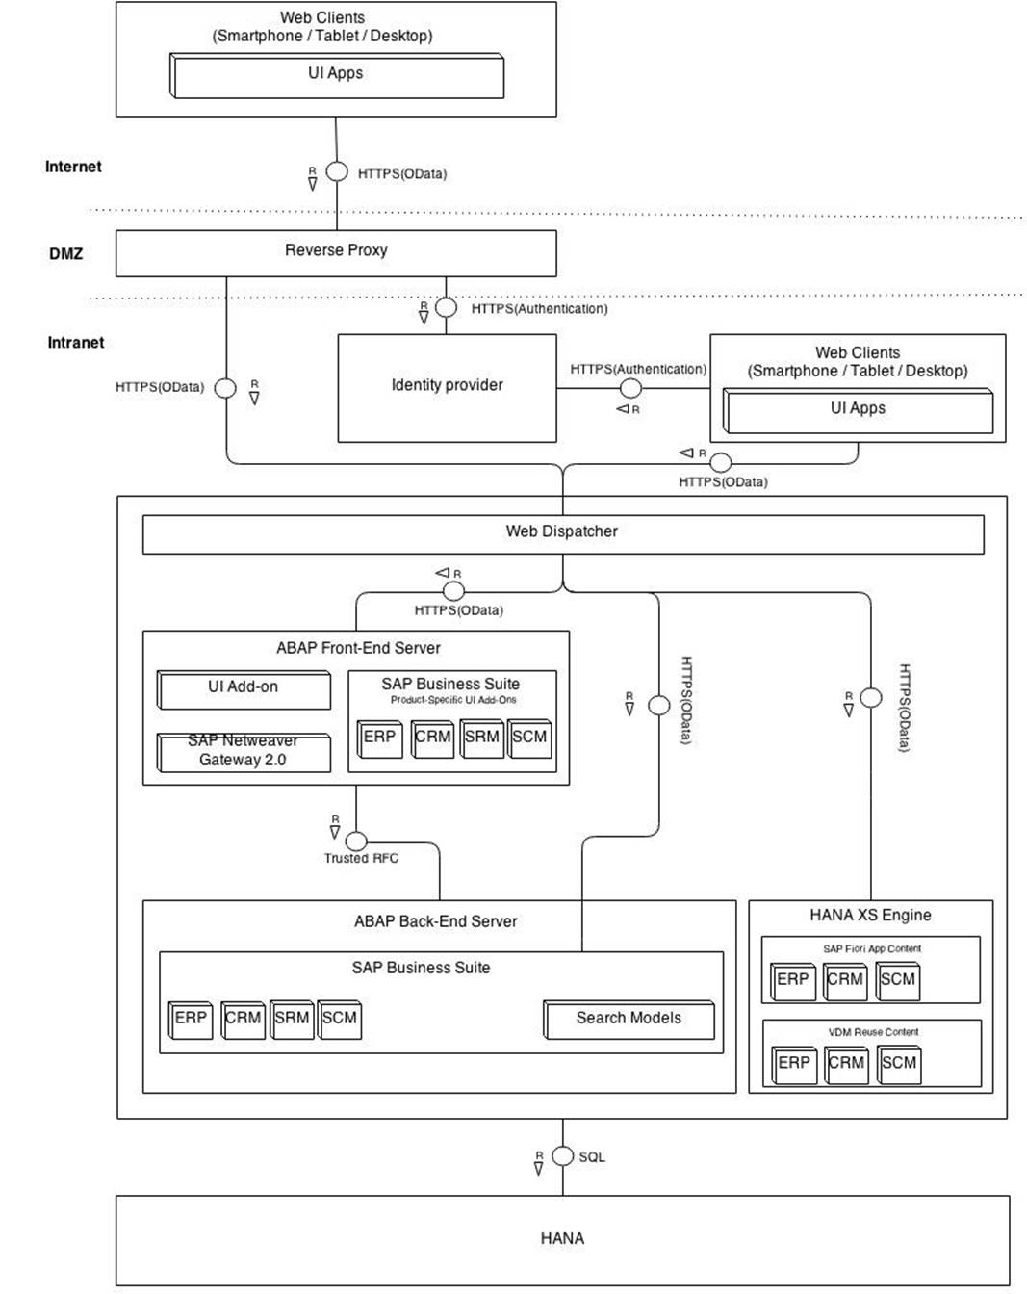
The picture below shows the overview of the security landscape of Fiori internet and intranet scenario. Only intranet deployment security is described in this document.

Preparation

Prerequisites
Before you start installing this scope item, you must install the prerequisite building blocks. For more information, see the Building Block Prerequisites Matrix for SAP Fiori Apps rapid-deployment solution. You will find this document in the content library included in the documentation package.

Internet-Facing Deployment Security
There are different ways to implement the reverse proxy. Following are the two recommended options:
- One Single SAP Web Dispatcher, if the customer finds Web Dispatcher offers sufficient security, they can deploy it into the DMZ (demilitarized zone), either with another SAP Web Dispatcher in intranet or without. However, the security features are not very strong, in particular the SAP Web Dispatcher do not have scanning of incoming POST bodies.
- Third Party Reverse Proxy in the DMZ and put a SAP Web Dispatcher in the intranet. Apache Reverse Proxy is an example of the Third Party Reverse Proxy.
In this document, only SAP Web Dispatcher deployed in the intranet is described.

Intranet Single Sign on (SSO) Enablement
Single Sign-On (SSO) can be used with SAP Fiori to eases user interaction with many components. With SSO, the user can access different applications without having to repeatedly enter his or her user information for authentication. SAP NetWeaver Application Server (AS) ABAP supports several Single Sign-On (SSO) mechanisms; the following sections describe the configuration steps of following SSO mechanisms.
- Kerberos
- SAML2.0
- X.509

SSO with KERBEROS
Enable Kerberos/SPNego authentication for the SAP server is especially recommended for SAP Fiori apps that are accessed from corporate network. Kerberos/SPNego authentication provides the following advantages:
- It simplifies the logon process by reusing credentials that have already been provided, for example, during logon to the Microsoft Windows workstation. A separate logon to the ABAP Front-end server is not required.
- It is also supported for logon to the SAP GUI. Using Kerberos for both SAP GUI and HTTP access simplifies the Single Sign-On setup within your system landscape.
- It is supported by a growing number of mobile device vendors.
During logon, Kerberos/SPNego authentication requires access to an issuing system (for example, Microsoft Active Directory). As this system is typically located within the corporate network, Kerberos/SPNego cannot be used for most internet-facing deployment scenarios. To enable Single Sign-On with Kerberos/SPNego authentication from outside corporate network, VPN connection might have to be set up
Setting up single sign-on for Fiori apps works similar to implement it for other SAP environments, such as SAP GUI for Windows or HTML. With SPNEGO, a trust relationship is established between the SAP Fiori app and the SAP NetWeaver Gateway, that publishes SAP Business Suite backend data via easy-to-consume OData ervices. Users log in once to their Windows domain, and a Kerberos token mechanism handles all subsequent authentication processes.

SPNego is available with product SAP Single Sign-On.

Readiness check for KERBEROS
Before start the Kerberos configuration, several conditions must be met. The following steps need to be processed for requirements check.

Network Requirements
The SSO of Kerberos provides secure authentication plus encryption depending on network communication between Domain and Server. Before starting the SSO of Kerberos configuration, check the following prerequisites carefully to avoid issues.
- The clocks of all hosts involved are synchronized.
- On the Active Directory domain controller, Kerberos is forced to use TCP instead of UDP (see http://support.microsoft.com/kb/244474/en-us for reference)
- Hostname reverse lookup (/etc/hosts on the DB server and/or DNS record type PTR in Active Directory) is set up for “physical” and “virtual” DB server hostname(s).
- On the DB server, hostname resolution must be consistent with reverse lookup.
- A “virtual” hostname must actually be a DNS alias, while the “physical” hostname must be a canonical name.

Software Requirements (HANA only)
It is assumed that the SAP HANA system has been installed on the Linux Server. In addition, the MIT implementation of the Kerberos client and server libraries must be installed (if this is not the case, contact the responsible administrator).
Example
[d058623@lu002600 ~]$ rpm -qa | grep krb5
krb5-1.6.3-133.48.48.1
krb5-client-1.6.3-133.48.48.1
krb5-32bit-1.6.3-133.48.48.1

The version numbers don’t have to match exactly, but should be above 1.6.3-132 to include important security patches

Organizational Requirements
Before setting up SSO, you will need to satisfy the following prerequisites:
- Root access to the DB server
- Domain user: will be used for verifying SSO to SAP HANA database
- Domain Administration: You need an administrator with the right to manage Users and Computers for the Domain Organizational Unit, where the SAP HANA database Service User shall be maintained.

SSO for SAP Front-end Software with Kerberos
Kerberos authentication on SAP NetWeaver Application Server (SAP NetWeaver AS) ABAP with a web client requires simple and protected GSS API Negotiation Mechanism (SPNego) for SAP NetWeaver Application Server ABAP.
Many company employees who use Microsoft Windows operating systems and SAP business applications for their daily work want to have Single Sign-On for their employees. The employees use PCs in a Microsoft Windows environment. They log on, for example to a Microsoft Windows operating system, which gets the respective Windows users, from the domain controller of Active Directory. Kerberos is the authentication method used. The Kerberos key distribution center, which is integrated in the Microsoft environment, grants a Kerberos ticket to the users who log on.
When a user tries to access the Application Server ABAP with a Web browser (using HTTPS), the AS ABAP requests a Kerberos service ticket from the browser. The browser forwards this request to Active Directory. The Kerberos key distribution center in the domain controller of Active Directory grants a Kerberos service ticket for the AS ABAP and the user can log on using his or her browser.
The following step-by-step guide shows how to implement SSO of Kerberos.

Create Kerberos service user
A domain user must be created for register as Kerberos services user. The following steps show how to create a Kerberos service user.
- Open ‘Active Directory Users and Computers’
- Chose ‘Action’->’New’->’User’
- Define user name, for example:'kerberos_abap'->'Next'
Example
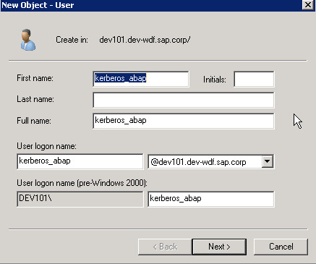
- Deselect ‘User must change password at next logon’
- Select ‘User cannot change password’ and ‘Password never expires’
- Enter password
Example
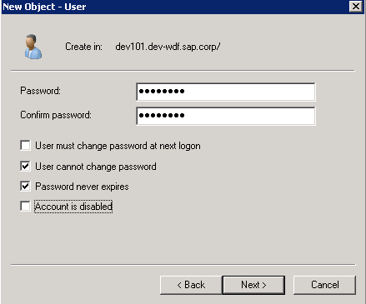

- Click Next
- Finish

Create Kerberos test user
The following steps show how to create a domain user. This user will used as a test user later.
- Open ‘Active Directory Users and Computers’
- Chose ‘Action’->’New’->’User’
- Define user name, for example : 'fiori_adm'
Example
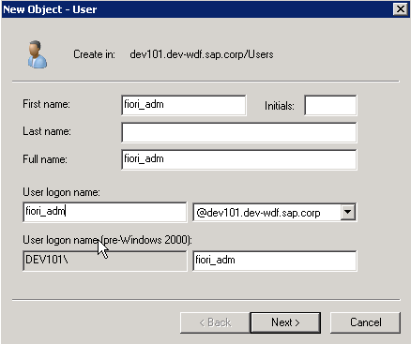

- Click Next
- Input password
- Click 'finish' button

Set service principal name for Kerberos service user
The Service Principal Names identify, for example, dialog instances or servers of the AS ABAP. To make Kerberos authentication with SPNego possible, a Service Principal Name must be registered for Kerberos services user.
To register Service Principal Names for a Kerberos Principal Name, perform the following steps:
- Open ‘ADSI Edit’
- Open the tree view of domain
- Open the ‘CN=users’ view
- Select the ‘CN=<user name created as services user>’, for example : 'kerberos_abap'
- Right- click and select ‘properties’
- Double-click Attribute ‘servicePrincipalName’
Example
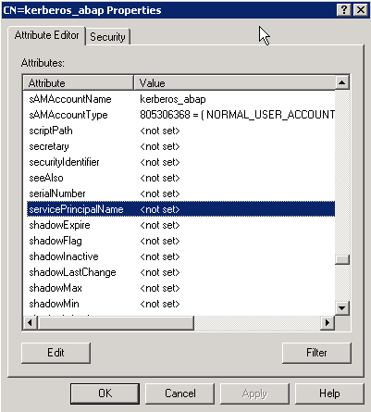
- Add the SPN (this is prefix ‘HTTP/’+’ full qualified Domain name’, for example : 'HTTP/mo-026968435.mo.sap.corp') and click 'Add' button
- Add the SPN (this is prefix ‘SAP/’+’<user name created as services user>’, for example: 'SAP/kerberos_abap') and click 'Add' button
Example

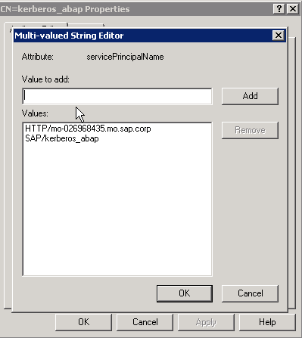

- Click 'OK' button
Caution
For each ABAP system in landscape, the Service Principal Names must be registered for Kerberos services user. For ABAP system with load balanced, each hostname needs to be registered as Service Principal Names for Kerberos services user.
Caution
Service Principal Names must be unique. For conflict of same hostname, full hostname can be replaced by short hostname.
For example: replace 'HTTP/mo-026968435'with 'HTTP/mo-026968435.mo.sap.corp'.

Create Kerberos keytab for SNC
The keytab for Kerberos-based SNC and SPNego establishes trust between the Key Distribution Center and SAP NetWeaver Application Server ABAP.
The following steps show how to create Kerberos keytab.
- Switch to <sid>adm
- Go to /usr/sap/<SID>/DVEBMGS<SYS NR>/SLL
- Base on different shell ,use the following command to set the SECUDIR:
set SECUDIR=/usr/sap/<SID>/DVEBMGS<SYS NR>/sec
setenv SECUDIR /usr/sap/<SID>/DVEBMGS<SYS NR>/sec
- Run following command to create keytab :
./sapgenpse keytab –p SAPSNCSKERB.pse –a <service user>@DOMAIN.COM
- Input password
Example
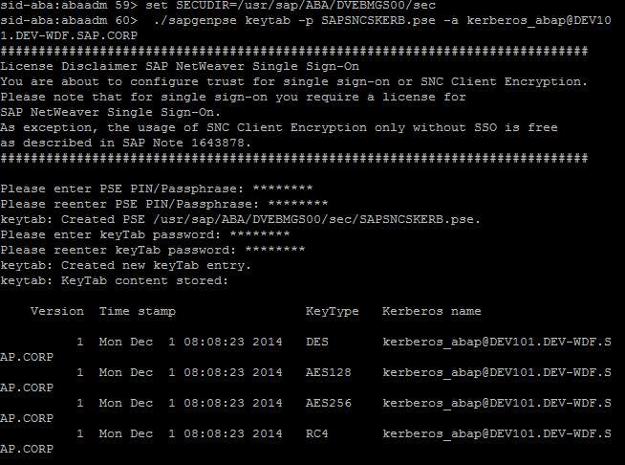
- Run following command to create credentials:
./sapgenpse seclogin –p SAPSNCSKERB.pse –O <sid>adm
- Input password
Example
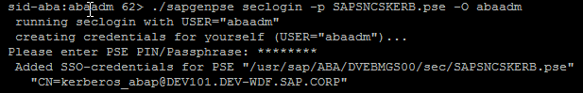
- run command './sapgenpse seclogin –l' for verification
Example
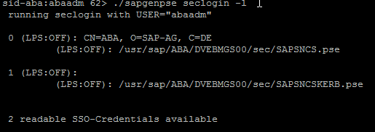
Caution
For each ABAP system in landscape, this step need be performed.

Configure ABAP Parameters
Some parameters need to be set to active SSO of Kerberos in ABAP system. It can be done once the ABAP system is restarted will be effort after ABAP system restarted. For every ABAP system in Fiori landscape, these parameters must be modified.
- Start SAP GUI or SAP GUI for HTML.
- Start Edit Profiles (transaction RZ10).
- Choose instance profile.
- Select Extended maintenance.
- To edit or add profile parameters, choose the Change button.
- Set the following profile parameters as required.
snc/enable = 1
snc/gssapi_lib = /usr/sap/<SID>/DVEBMGS<SYSTEM NR>/SLL/ libsapcrypto.so
snc/identity/as = p:CN=<service_User_Principal_Name>
snc/data_protection/max = 3
snc/data_protection/min = 2
snc/data_protection/use = 3
snc/r3int_rfc_secure = 0
snc/r3int_rfc_qop = 8
snc/accept_insecure_cpic = 1
snc/accept_insecure_gui = 1
snc/accept_insecure_rfc = 1
snc/permit_insecure_start = 1
snc/force_login_screen = 0
spnego/enable = 1
spnego/krbspnego_lib = /usr/sap/<SID>/DVEBMGS<SYSTEM NR>/SLL/ libsapcrypto.so
- Restart sap services

Configure SNC for SAP ABAP server
The user principal name needs to be registered in ABAP system. The service user should be assigned via t-code: SPNEGO.
- Logon to SAP ABAP system
- Run t-code: SPNEGO
- Choose 'edit->ok'
- Click ‘Add’ button
- Input services user principal name and password, for example: 'kerberos_abap@DEV101.DEV-WDF.SAP.CORP'
Example

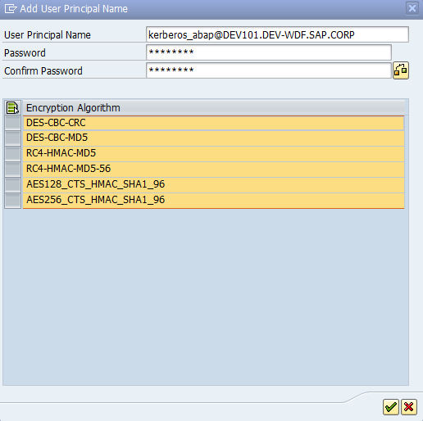
- Click 'Save' button
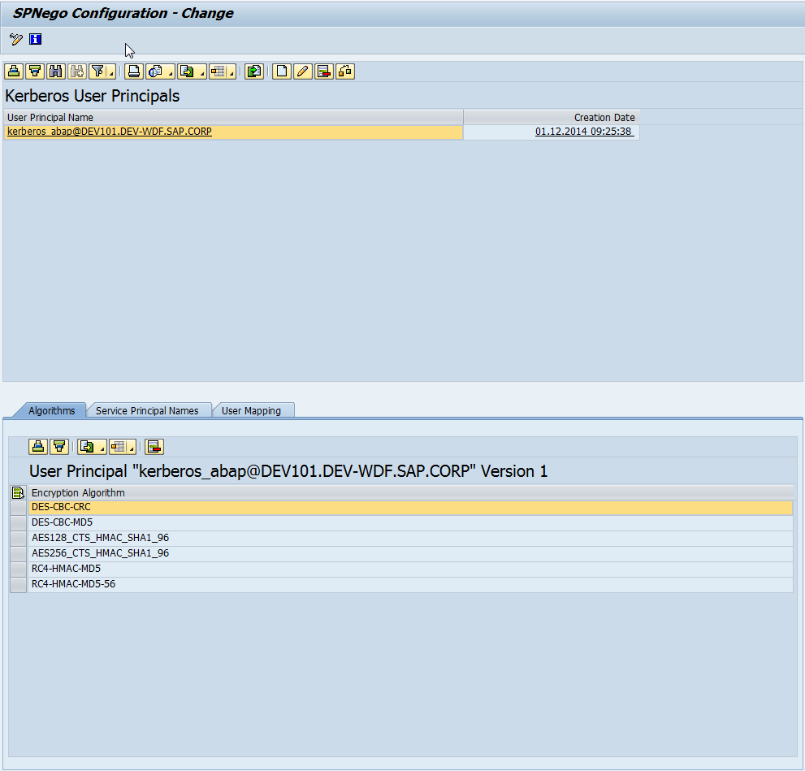
Example

Configure SNC user mapping in SAP user management
- Logon to SAP ABAP system
- Run t-code: SU01
- Input user name, for example : 'fiori_adm'and click 'edit' button.
- Select ‘SNC’ option
- Fill ‘SNC name’ with ‘p:CN=<tester_user__Name>@MYDOMAIN.COM’. For example: 'p:CN=fiori_adm@DEV101.DEV-WDF.SAP.CORP'
Example
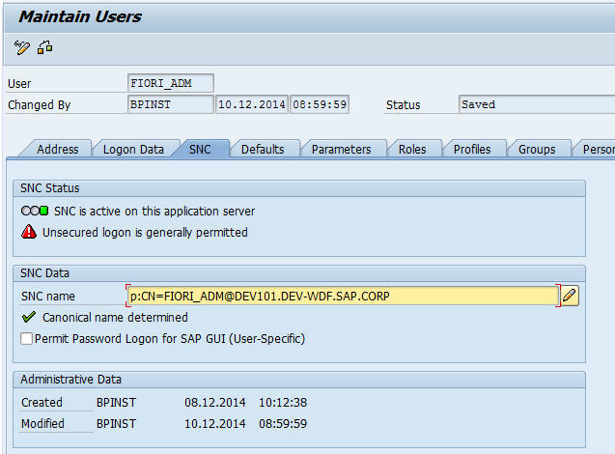

- Click ‘Save’ button

Configure SNC for SAP Front-end application
This step is processing on Domain client.
- Open SAP Front-end application
- Select connection
- Right- click connection name and select ‘Properties’
- Select ‘Network’ option
- Select ‘Activate Secure Network Communication’
- Fill ‘SNC Name’ filed with ‘p:CN=<service_user__Name>’.
For example: 'p:CN=kerberos_abap@DEV101.DEV-WDF.SAP.CORP'
Example

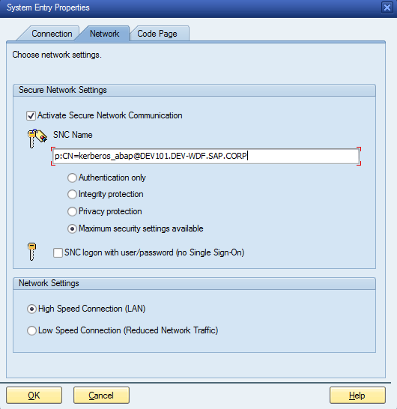

- Click ‘OK’ button

Test logon
This scenario provides the simple test of SSO of Kerberos.
- Test logon with SAP GUI
After setting the Kerberos, you can directly logon to SAP system without input user name and password in the domain client.
- Logon to domain client with Kerberos test user, for example: 'fiori_adm'
- Open SAP GUI
- Open connection
The result should look like

Example
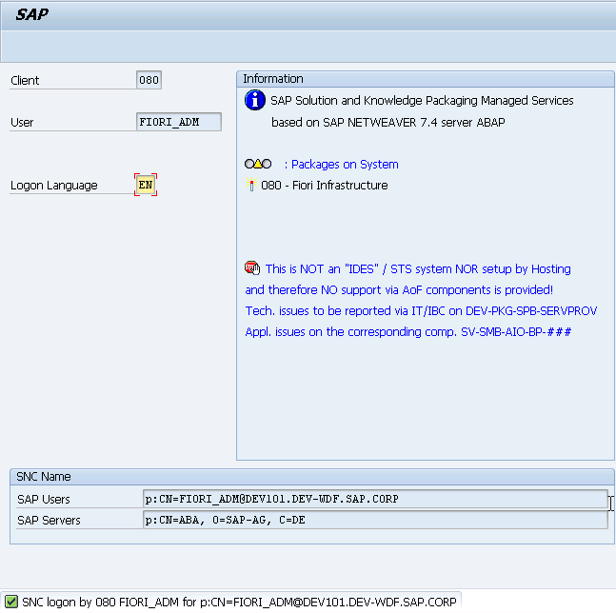

- Test logon with HTTP base software
The SAP WEB-GUI is recommended to be used for test in this step. After SSO of Kerberos configuration finished, the SAP WEB GUI should be opened without input username and password.
Note
For active SAP WEB-GUI, check with below link:
http://scn.sap.com/docs/DOC-29485
Note
For the MS Internet Explorer the following article explains how to setup the browser for Kerberos authentication:
HTTP-Based Cross-Platform Authentication by Using the Negotiate Protocol:
http://msdn.microsoft.com/en-us/library/ms995329.aspx
Authentication Uses NTLM instead of Kerberos:
http://technet.microsoft.com/en-us/library/cc779070.aspx
Unable to negotiate Kerberos authentication after upgrading to Internet Explorer 6: http://support.microsoft.com/kb/299838

- Logon to domain client with Kerberos test user, for example: 'fiori_adm'
- Open web browser
- Go forward to address: http(s)://<abap system>:port/sap/bc/gui/sap/its/webgui,
for example: 'https://mo-026968435.mo.sap.corp:1081/sap/bc/gui/sap/its/webgui'
- SAP WEB GUI should be opened without input username, password

- Test logon with HTTP base software through Web Dispatcher
Base the system landscape of SAP Fiori apps, all the requests for Fiori apps should be accessed via web dispatcher. This test is used for ensure SSO of Kerberos for ABAP system is available through web dispatcher.
- Logon to domain client with Kerberos test user, for example, fiori_adm
- Open web browser
- Go forward to address: http://<web dispatcher>:port/sap/es/search
- SAP WEB GUI should be opened without input username, password
Note
If the SAPGUI works fine while the SAP WEB GUI could not open properly without input username and password. If the Internet Explorer has been configured correctly, try to perform the following steps:
Go to the transaction code SPNEGO in the ABAP system. Choose Display/Change (Ctrl+F1), select the user principal name which has been created in previous chapter. Choose Change, there's no need to change anything but just enter password and Save. In this way, the version of the user principal name could be updated. After that, the Http SPNEGO may work.

SSO for SAP HANA XS with Kerberos

Setup for Hostname Resolution
The main point here is that the reverse lookup must be configured consistently with the hostname lookup, since this will be used by the SAP HANA database server Kerberos implementation for determining the SPN. The SPN in turn will be used for the lookup into the keytab.
The following step shows how to test the hostname resolution.
- Hostname resolve
Local hostname resolution is made via the file /etc/hosts.
Example
On the DB server:
#> cat /etc/hosts | grep myhdbserver
<IP address> myhdbserver.mydomain.com myhdbserver
Where <IP address> has to be replaced with the primary IP address of the DB server.
Caution
In Windows, hostnames are sometimes created in upper case. However, the MIT Kerberos implementation used by SAP HANA database strictly requires a lower case hostname in the keytab entry, so the respective SPN must be created with a lower case hostname part in Active Directory.

- Test FQDN name of HANA database
Example
For getting the FQDN of the DB server
#> hostname --fqdn
myhdbserver.mydomain.com

.
- Checking the reverse lookup
Example
#> python <<EOF
> import socket
> host = socket.gethostbyaddr('<IP address>')[0]
> print host
> EOF
myhdbserver.mydomain.com
Note
Where <IP address> has to be replaced with the primary IP address of the DB server.

Setup for SAP HANA Database Server krb5.conf
Several krb5.conf use cases can be differentiated. The MIT Kerberos libraries all use the same format, but depending on the use case, many parameters from other use cases are irrelevant (or may even be detrimental). The following use cases exist:
- KDC: In case you want to run an MIT Kerberos based KDC (not applicable)
- Client: When you want to connect from a Linux box as a client (forexample: hdbsql) to another server (for example: SAP HANA database on another or the same host)
- Server: The server could be the SAP HANA database and this is exactly the case at hand

In case Kerberos is not configured in DNS, the SAP HANA database server will additionally need the default_realm and the [realm] specification. Make sure that the Active Directory domain (MYDOMAIN.COM in the example) is consistent across default_realm , realms, domain_realm. Furthermore, the keytab for the DB server must contain an entry exactly matching this Active Directory domain, that is the SAP HANA Database Service User must be created within this domain.
- Standard Kerberos configuration (HANA DB server):
#> cat /etc/krb5.conf
[libdefaults]
default_realm = MYDOMAIN.COM
[realms]
MYDOMAIN.COM = {
kdc = mykdc1.mydomain.com
kdc = mykdc2.mydomain.com
}
[domain_realm]
.mydomain.com = MYDOMAIN.COM
mydomain.com = MYDOMAIN.COM

Caution
The [domain_realm] covers only the mapping for the DB server domain (it has nothing to do with the client domain(s)). This will be used in mutual authentication when the SAP HANA database client tries to authenticate the SAP HANA database server.
Caution
The domain part in the [domain_realm] mapping must consist of the domain name in its full length. In case the FQDN of the DB server is hdbserver.subdomain.domain.com, the [domain_realm] entry has to be:
.subdomain.domain.com = DOMAIN.COM
subdomain.domain.com = DOMAIN.COM
but not
.domain.com = DOMAIN.COM
domain.com = DOMAIN.COM
Note
In case the IT landscape contains multiple KDC servers, you have to provide a separate configuration line for each of them as mentioned in the example above.
Caution
Changes to the krb5.conf take effect only after restart of the DB server. A restart can be avoided by setting the SAP HANA database trace component Authentication to DEBUG.
Example
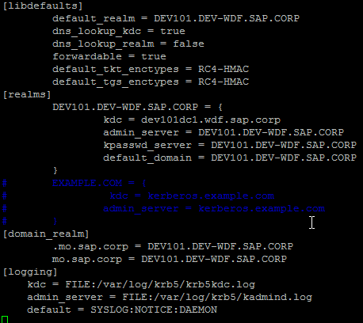

Caution
In case, ‘mo.sap.corp’ is the FQDN name of HANA database.
‘DEV101.DEV-WDF.SAP.CORP’ is the domain name of KDC.
‘dev101dc1.wdf.sap.corp’ is the domain controller name.

After kerb5.conf file is changed, the following steps need be verified.
1. Connectivity between the DB server and the Active Directory
2. DB server krb5.conf
Example
#> /usr/bin/kinit <domain user name>@MYDOMAIN.COM
Password for <domain user name>@MYDOMAIN.COM:

Using klist we can see this ticket:
#> /usr/bin/klist
Ticket cache: FILE:/tmp/krb5cc_1003
Default principal: <domain user name>@MYDOMAIN.COM
Valid starting Expires Service principal
02/18/13 15:25:58 02/19/13 01:26:02 krbtgt/ MYDOMAIN.COM@MYDOMAIN.COM
renew until 02/19/13 15:25:58

Create the SAP HANA Database Service User(s)
- Creating the user via CLI is recommended .Logon to Domain Controller, in an elevated Windows command shell, and run (choosing a strong password matching the local policy):
> dsadd user "cn=myhdbserviceuser,cn=users,dc=MYDOMAIN,dc=COM" -pwd <passwd> -disabled no -pwdneverexpires yes -acctexpires never
Recommendation
In case command run into problems, do not blindly rely on the correctness of the service user. There was a Very High customer message due to a service user with an encryption type not supported (it was DES, now considered insecure). Rather, donot hesitate to start over with a fresh service user.
Caution
The Active Directory domain (dc=MYDOMAIN,dc=COM in the example above) must be the same as specified in the DB server’s krb5.conf.
Example

Verification of SAP HANA Database Service User(s)
- On the HANA DB server, run
#> /usr/bin/kinit <myhdbserviceuser>@MYDOMAIN.COM
To get a TGT for the SAP HANA database service user. The password that was used when the service user account was created in AD has to be supplied.
- Afterwards, run klist to check the resulting ticket cache:
#> /usr/bin/klist
Ticket cache: FILE:/tmp/krb5cc_1003
Default principal: <myhdbserviceuse>r@MYDOMAIN.COM
Valid starting Expires Service principal
02/18/13 15:50:47 02/19/13 01:50:50 krbtgt/MYDOMAIN.COM@MYDOMAIN.COM
renew until 02/19/13 15:50:47
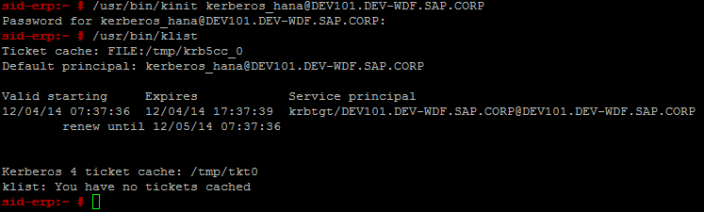
Example

Create the SAP HANA Database test User(s)
- Creating the user via CLI is recommended. Logon to Domain Controller, in an elevated Windows command shell, run:
> dsadd user "cn=myhdbtestuser,cn=users,dc=MYDOMAIN,dc=COM" -pwd <passwd> -disabled no -pwdneverexpires yes -acctexpires never
Recommendation
The test user create in chapter 4.1.2.2 can be reused f, if the user 'fiori_adm' was already been created, this step can be ignored.

Register Service Principal Name in AD
SPNEGO for SAP HANA XS should be setup. The SPN is simply a mapping of a service name to a service user. The SPN is needed to create the DB server’s keytab. For each physical host of the system exactly one SPN must be created.
An SPN for SAP HANA XS must strictly follow the following format:
HTTP/<DB server>@<domain>
Where <DB server> should be the fully qualified canonical domain name of the DB server host or any alias of the same and <domain> is the AD Domain Name.
Caution
In Windows, hostnames are sometimes created with upper case. However, the SAP HANA implementation strictly requires a lower case hostname in the keytab entry, so the respective SPN must be created with a lower case hostname part in Active Directory.

- Logon to domain controller, in an elevated Windows command shell run
> setspn -S HTTP/myhdbserver.mydomain.com MYDOMAIN\myhdbserviceuser
Example
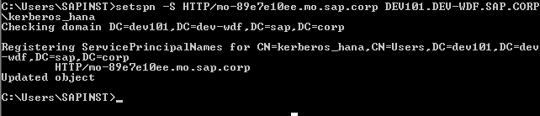

Verification of SPN Register
- Logon to Domain controller, in a Windows command shell, run
> setspn –L MYDOMAIN\myhdbserviceuser
to see the SPN mapped to the service user account.
- To query the existence of the SPN run
> setspn –Q HTTP/myhdbserver.mydomain.com
Example
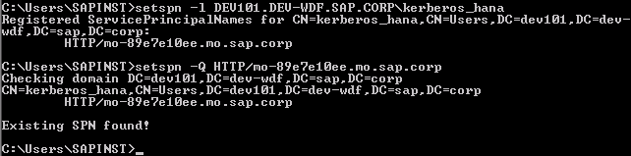

- On the DB server, run
#> /usr/bin/kinit myhdbserviceuser@MYDOMAIN.COM –S HTTP/myhdbserver.mydomain.com@MYDOMAIN.COM
to retrieve a service ticket for the DB server.
- The result should be similar to
#> /usr/bin/klist
Ticket cache: FILE:/tmp/krb5cc_1003
Default principal: myhdbserviceuser@MYDOMAIN.COM
Valid starting Expires Service principal
02/18/13 20:13:40 02/19/13 06:13:40 HTTP/myhdbserver.mydomain.com@MYDOMAIN.COM
renew until 02/19/13 20:13:40

Example
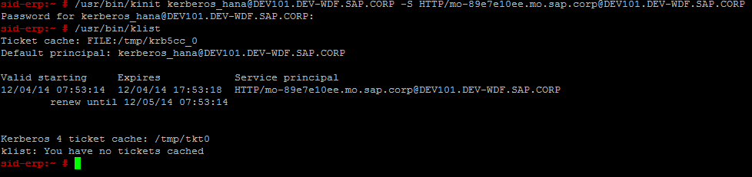

Create keytab for the DB Server
- Creating the keytab on the DB Server (ktutil)
- Remove the old keytab:
$ rm /etc/krb5.keytab
- Create the new keytab:
$ /usr/lib/mit/sbin/ktutil
ktutil: addent -password -p HTTP/myhdbserver.mydomain.com@MYDOMAIN.COM -k 2 -e rc4-hmac
Password for HTTP/myhdbserver.mydomain.com@MYDOMAIN.COM:
ktutil: wkt /etc/krb5.keytab
ktutil: q
Caution
Changes to the krb5.keytab take effect only after restart of the DB server.
Recommendation
For setting up SSO the first time, we strongly recommend to start with encryption type rc4-hmac. This is the most wide-spread algorithm for Kerberos. Optionally, after successful completion of the Kerberos configuration, you can switch to aes256-cts, which offers a stronger protection.
Example
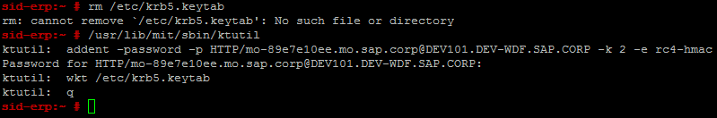

Create keytab for the Web Dispatcher
- Creating the keytab for Web Dispatcher on the DB server(ktutil)
$ /usr/lib/mit/sbin/ktutil
ktutil: addent -password -p HTTP/<WebDispatcher.mydomain.com>@MYDOMAIN.COM -k 2 -e rc4-hmac
Password for HTTP/<WebDispatcher.mydomain.com>@MYDOMAIN.COM
ktutil: wkt /etc/krb5.keytab
ktutil: q

Caution
Changes to the krb5.keytab take effect only after restart of the DB server.

Securing the keytab
- Adapt access permissions for the new keytab:
$ chown <SID>adm:sapsys /etc/krb5.keytab
- As a <SID>adm, run
#> chmod 400 /etc/krb5.keytab

Verification of keytab
- First, on the DB server, check the content of the new keytab:
$ /usr/bin/klist -k /etc/krb5.keytab -etK
Keytab name: FILE:/etc/krb5.keytab
KVNO Timestamp Principal
---- ----------------- --------------------------------------------------------2 09/11/14 12:08:50 HTTP/myhdbserver.mydomain.com (ArcFour with HMAC/md5) (0x58a478135a93ac3bf058a5ea0e8fdb71)
- Second, verify the consistency of the keytab with the SAP HANA database service data stored in the KDC. As a preparation step for kvno, run :
#> /usr/bin/kinit myhdbserviceuser@MYDOMAIN.COM
to get a TGT for the SAP HANA database service user. To check the correctness of the key version number and the key(s) contained in the keytab run
#> /usr/lib/mit/bin/kvno -k /etc/krb5.keytab HTTP/myhdbserver.mydomain.com@MYDOMAIN.COM
HTTP/myhdbserver.mydomain.com@MYDOMAIN.COM: kvno = 2, keytab entry valid
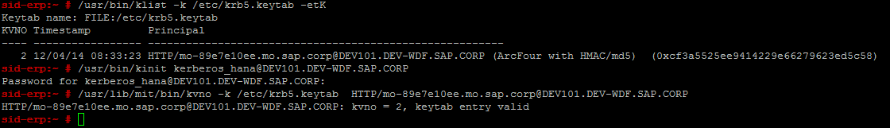
Example

Mapping SAP HANA database user
To complete the SSO configuration for SAP HANA DB, a DB user representing the Windows test user needs to be created in the SAP HANA database user administration
- Open SAP HANA studio
- Connect to HANA database
- Open tree view of HANA database
- Open 'Security' option
- Right- click 'Users'-> 'New User'
- Define 'User Name'
- Deselect 'Password' option
- Select 'Kerberos' option
- Fill 'External ID*' option
In 'External ID*' filed input: '<HANA test user name>@MYDOMAIN.COM'
For example: 'fiori_adm@DEV101.DEV-WDF.SAP.CORP'
Example
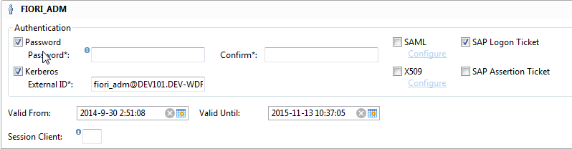

- Click 'Deploy' button

Verification of Kerberos for SAP HANA XS
For verify the Kerberos of SAP HANA XS, the Web browser configuration must be checked in first place. Each browser handles it differently, but SPNEGO authentication has to explicitly allow sites or domain.
Note
*. mydomain.com won’t work! You cannot use wild cards.
Note
For the MS Internet Explorer the following article explains how to setup the browser for Kerberos authentication:
HTTP-Based Cross-Platform Authentication by Using the Negotiate Protocol:
http://msdn.microsoft.com/en-us/library/ms995329.aspx
Authentication Uses NTLM instead of Kerberos:
http://technet.microsoft.com/en-us/library/cc779070.aspx
Unable to negotiate Kerberos authentication after upgrading to Internet Explorer 6: http://support.microsoft.com/kb/299838

After web browser has been checked, the SAP HANA XS Administrator Tool is recommended to test the SSO of Kerberos.
HANA XS Administrator Tool: Error! Hyperlink reference not valid.
If the Kerberos setting is correctly, the website should be opened without username and password input.
Caution
Before the verification is start, the authentication type 'SPNEGO' must be enabled for HANA XS Administrator Tool.

- Verification of access to HANA XS Administrator Tool
- Logon to domain client with Kerberos test user, for example: 'fiori_adm'
- Open web browser
- Go forward to address: http(s)://<hana server>:port/sap/hana/xs/admin/
For example: 'http://mo-89e7e10ee.mo.sap.corp:8002/sap/hana/xs/admin/'
- HANA XS Administrator Tool should be opened without input username, password or certification.

- Verification of access to HANA XS Administrator Tool through Web Dispatcher
Base the system landscape of SAP Fiori apps, all the requests for Fiori apps should be accessed via web dispatcher. This test is used for ensure SSO of Kerberos for HANA is available through web dispatcher.
- Logon to domain client with Kerberos test user, for example: 'fiori_adm'
- Open web browser
- Go forward to address: http(s)://<web dispatcher>:port/sap/hana/xs/admin/
- HANA XS Administrator Tool should be opened without input username, password or certification.
Caution
If the customer deploys not only Kerberos authentication method, but also Sap logon ticket or X.509 authentication method. Additional settings for specific browser need to be done.
For Internet Explorer Browser and Chrome, it is a must to finish the Client Side job mentioned in http://msdn.microsoft.com/en-us/library/ms995329.aspx→ Client Side - Internet Explorer
To configure a Firefox browser to use Windows Integrated authentication, complete the following steps:
- Start Firefox.
- Enter about:config in the Location Bar
- If a warning message appears, choose I'll be careful, I promise!
- Enter the filter string network.negotiate.
- Double click on the preferences to modify the value.
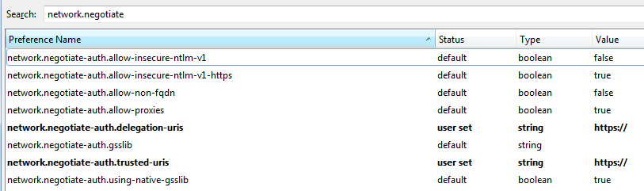
- Set the preferences as shown in screenshot below:

SSO with SAML 2.0
Security Assertion Markup Language 2.0 (SAML 2.0) is a version of the SAML standard for exchanging authentication and authorization data between security domains.
The SAML specification defines three roles: the principal (typically a user), the identity provider (IdP), and the service provider (SP). In the use case addressed by SAML, the principal requests a service from the service provider. The service provider requests and obtains an identity assertion from the identity provider. On the basis of this assertion, the service provider can make an access control decision – in other words it can decide whether to perform some service for the connected principal.
The purpose of this activity is to describe the implementation steps required to configure the host SAP NetWeaver Application Server(AS) JAVA (where the SAP Identity Management is installed) as the Identity Provider and the host SAP NetWeaver Gateway as the Service Provider, which are required for Single Sign-On with SAML 2.0.
Note
The SAML 2.0 authentication method only takes effect for Logon into the Fiori Launchpad. For the whole system landscape, you have to perform the chapter SSO with SSO2 in the EE1_NWG20_BB_ConfigGuide_EN_XX.doc configure guide first. The SAML 2.0 and SSO2 SSO authentication method will take effect in the whole system landscape.

Readiness check for SAML 2.0

Installation of SAP NetWeaver AS JAVA
For more details regarding the installation of SAP NetWeaver Application Server JAVA (AS JAVA), refer to Configuration Guide - Getting Started with implementing the SAP Fiori Apps Rapid-Deployment Solution.

Downloading and Installing the Federation Software
As of SAP NetWeaver Identity Management 7.1, the federation software component archive (SCA) includes the identity provider. In SAP NetWeaver Identity Management 7.2 and later, the federation SCA also includes the security token service software.
For more information regarding how to install the Federation Software, refer to Configuration Guide - Getting Started with implementing the SAP Fiori Apps Rapid-Deployment Solution
Note
After installing the Federation Software, you can find this component with name IDMFEDERATION in System Information→Components Info.

Enabling HTTPS for AS JAVA
HTTPS is required for identity provider in SAML authentication. Hence, you should enable HTTPS for identity provider after you have installed the AS JAVA. For AS JAVA HTTPS details, refer to SAP NetWeaver Application Server Java Security Guide in https://help.sap.com .

Prerequisites for Service Provider
- The SAP Cryptographic Library is available in the SAP NetWeaver Gateway system.
- The user must have a role that allows him or her to create aliases in the Internet Communication Framework (ICF). This role must include the authorization object S_ICF_ADM
- You have been assigned the role SAP_SAML2_CFG_ADM
- You have configured the AS ABAP to use HTTP security sessions.
For more information, see Activating HTTP Security Session Management on AS ABAP in EE1 Building Block.

Configuring AS JAVA as the Identity Provider
- Start SAP NetWeaver Administrator with the quick link https://<hostname>:<port>/nwa.
- Go to Configuration tab→Authentication and Single Sign-On
- Switch to SAML 2.0 tab.
- Choose Enable SAML 2.0 Support.
- Enter a name for the Provider Name.
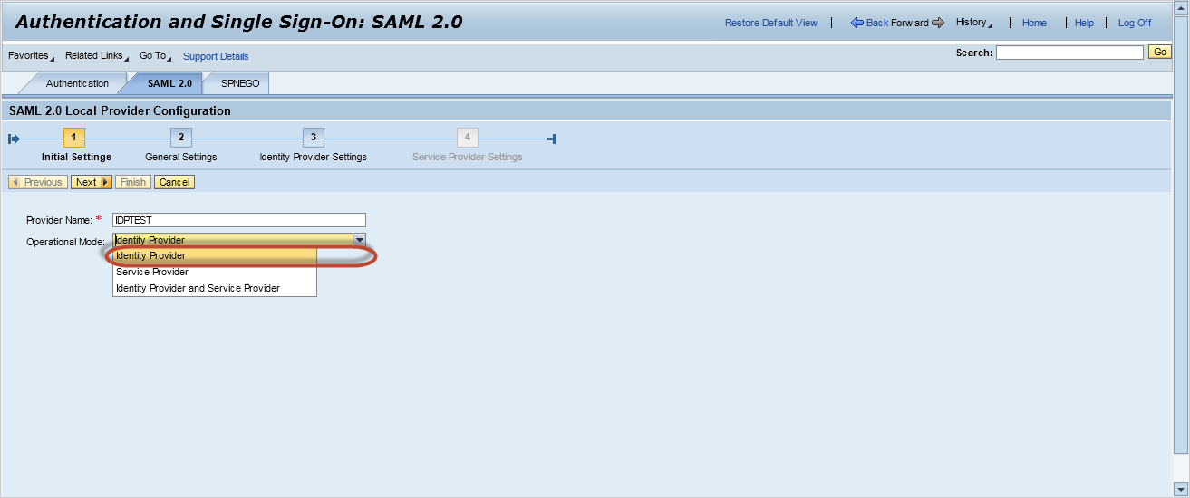
- Choose an operation mode for the provider.
- Enter Identity Provider.
- Choose Next.
- Open the dropdown box of key type in the field Keystore View.
- Choose SAML2 and Choose Browse in the row of Signing Key Pair.
- On the Select Keystore Entry screen, Choose Create.
- On the Key Storage screen, enter a name for the Entry Name.
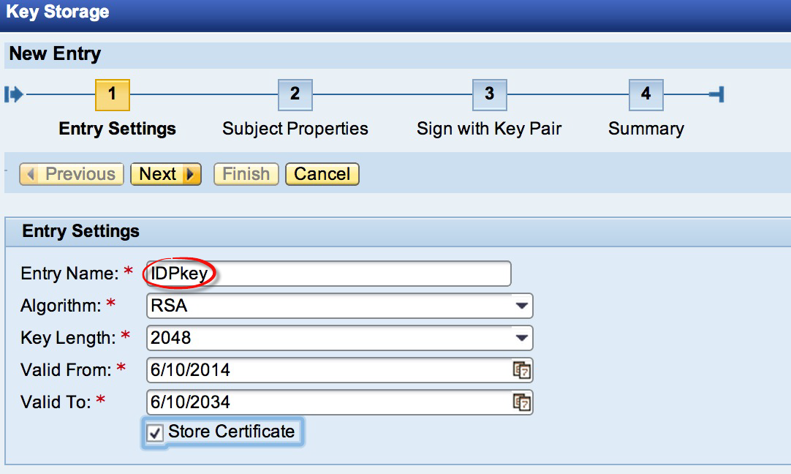
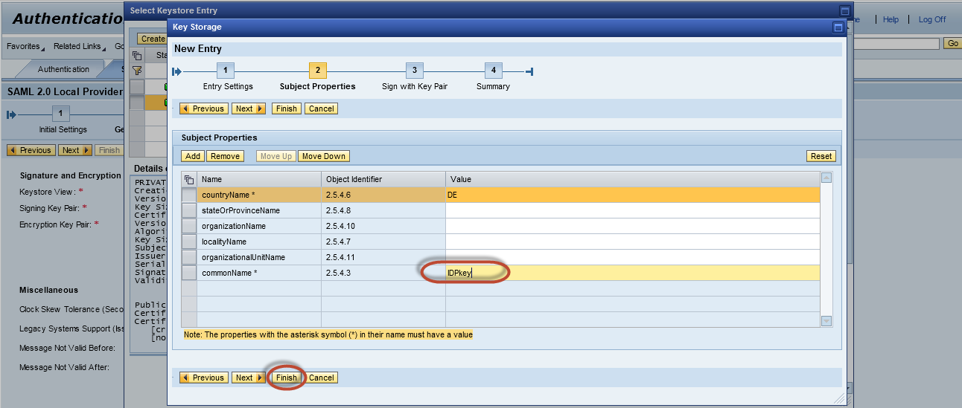
- Check Store Certificate.
- Choose Next.
- Enter a name for the commonName.
- Choose Finish.
- On the Select Keystore Entry Screen, Choose OK.
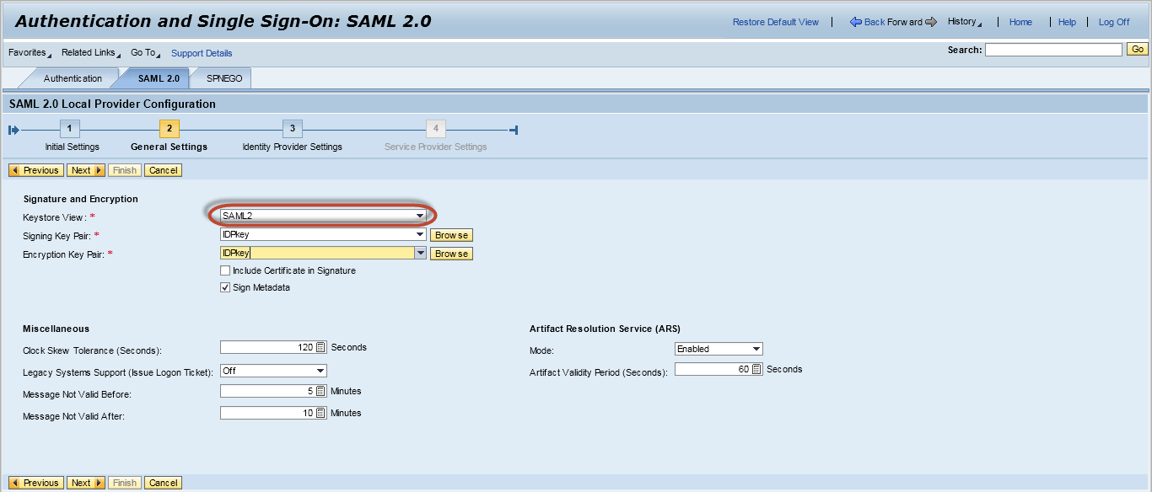
- On the SAML 2.0 tab, choose Next.
- Choose Finish.

Configuring NetWeaver Gateway as the Service Provider
- In the SAP NetWeaver Gateway system, start the SAML 2.0 configuration application (transaction SAML2).
- In the SAP GUI Security dialog box, choose Allow.
- Choose Enable SAML 2.0 Support→Create SAML 2.0 Local Provider.
- Enter a name for the provider.
Note
The service provider name should be different from your identity provider name.
- Choose Next.
- Choose Next.
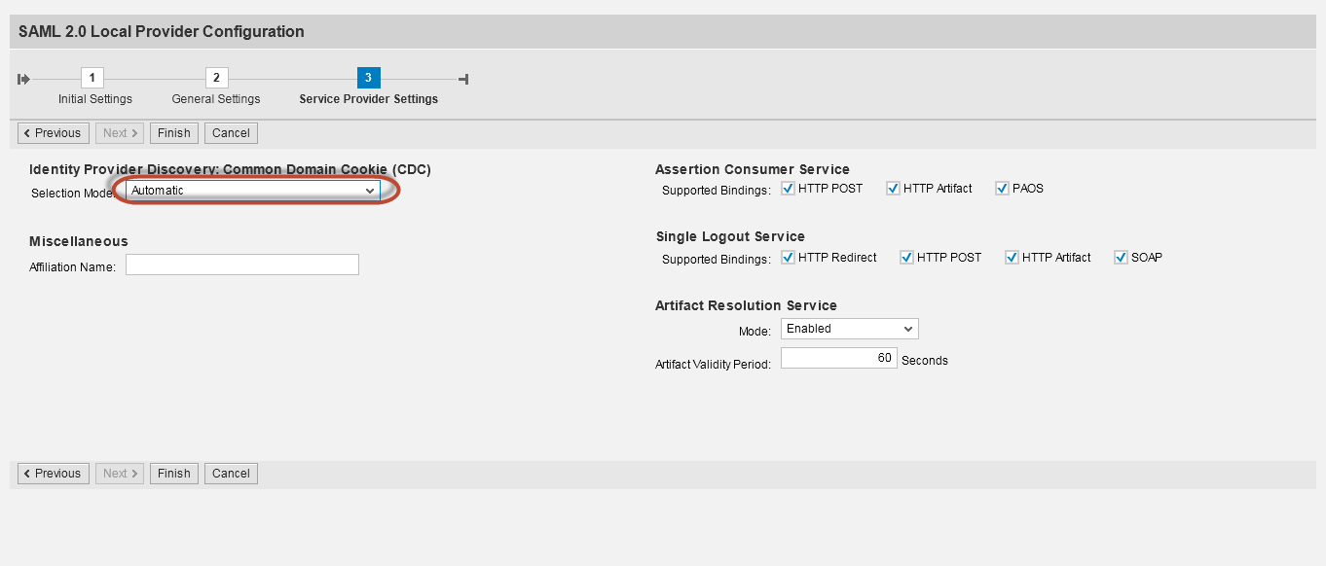
- On the SAML2.0 Local Provider Configuration screen, in the step of Service Provider Settings, change the field Selection Mode to Automatic.
- Choose Finish.
Note
This procedure only covers enabling SAML 2.0. Once enabled, you can configure the bindings supported by the service provider, trust an identity provider, configure identity federation, and protect resources with SAML. The configuration creates two Secure Store and Forward (SSF) applications and associates Personal Security Environment (PSE) files with them. The PSE files contain the signing and encryption key pairs of the service provider.
- Choose Edit.
- Go to tab Service Provider Settings, switch Legacy Systems Support (Issue Logon Ticket) to On.
Note
Having legacy systems support setting set up to On means that the service provider will issue SAP Logon ticket which could be consumed later by the ABAP system(For example, the Suite on HANA system in the SAP Fiori system landscape).
- Choose Save.

Trusting the Service Provider

Preparation for the Identity Provider
The following configurations are the prerequisites for the identity provider to trust the service provider.

Downloading metadata XML file from the Service Provider
- In the SAP NetWeaver Gateway system, start the SAML2.0 configuration application (transaction SAML2).
- In the SAP GUI Security dialog box, choose Allow.
- Change the hostname and port in the URL into the hostname and port of your web dispatcher. Logon with a valid user in your gateway.
Caution
This step is very important for SAML2.0 authentication since the Web dispatcher host and port will be used for service provider. Make sure that this step is completed without any issue. If the customer only deploys the transaction app in his SAP Fiori system landscape and the SAP Web Dispatcher is out of scope, then keep the URL as default.
- On the SAML2.0 Configuration of ABAP system screen, go to the Local Provider tab.
- On the Local Provider tab, choose Metadata.
- Choose Download Metadata.
- Save the XML file in your local folders.
- Choose Close.
Note
If the customer only deploys transactional apps in their SAP Fiori system landscape and not use the SAP Web Dispatcher. There's no need to change the hostname and the port. Metadata with SSL encryption is recommended. The prerequisite is the HTTPS has been enabling in the SAP NetWeaver Gateway system. To do so, proceed as follows:
- In the SAP NetWeaver Gateway system, use transaction SICF to open the service maintenance page.
- Choose Execute.
- Locate the service by path: default_host→sap→bc→webdynpro→sap→saml2
- Double click on service saml2 to open the configure page.
- Go to Logon Data tab.
- Choose Change.
- Under Security Requirement, change to SSL
- Choose Store (Ctrl + S).

Downloading certificate from the Service Provider
- In the SAP NetWeaver Gateway system, start the Trust Manager application(transaction STRUST)
- On the Trust Manager screen, you should see the green node by expanding SSF SAML2 Service Provider-S.
- On the Own Certificate tab, double click field Subject.
- Go to the menu Certificate→Export.
- In the Export Certificate dialog box, choose ‘Base64’file format and save the SAML2 certificate with a file type of cert in your local folders.
- In the SAP GUI Security dialog box, choose Allow.

Adding the Service Provider into Trust List
- Start SAP NetWeaver Administrator with the quick link https://<hostname>:<port>/nwa.
- Choose SAML2.0→Trusted Providers. If you are not in My Workspace, then you need to go to Authentication and Single Sign-On.
- On the Trusted Providers tab, choose Add→Uploading Metadata File.
- On the SAML 2.0 Configuration screen, choose Browse and provide the path to the metadata XML file of the service provider.
- Choose Next.
- Select File and choose Browse.
- Provide the path to the certificate of the service provider to ensure trust.
- On the SAML 2.0 Configuration, keep the following steps as default.
- Choose Finish and stay on this page.

Add the Caution/Example/… paragraphs to your Quick Parts in the Insert ribbon (Insert → Quick Parts → Save Selection to Quick Part Gallery). Then delete these paragraphs below.
Caution
The signature and encryption options must match with those of the service provider. If the service provider requires that SAML assertions are always digitally signed and the identity provider never signs them, then the SAML configuration cannot function.

Enabling the Service Provider
- Choose SAML2.0→Trusted Providers.
- Open the dropdown box of the trusted providers in the field Show.
- Choose Service Providers.
- Choose Edit.
- Go to the Identity Federation tab.
- Choose Add.
- In the Name ID Format dialog box, open the dropdown box of Name ID format in the field Format Name.
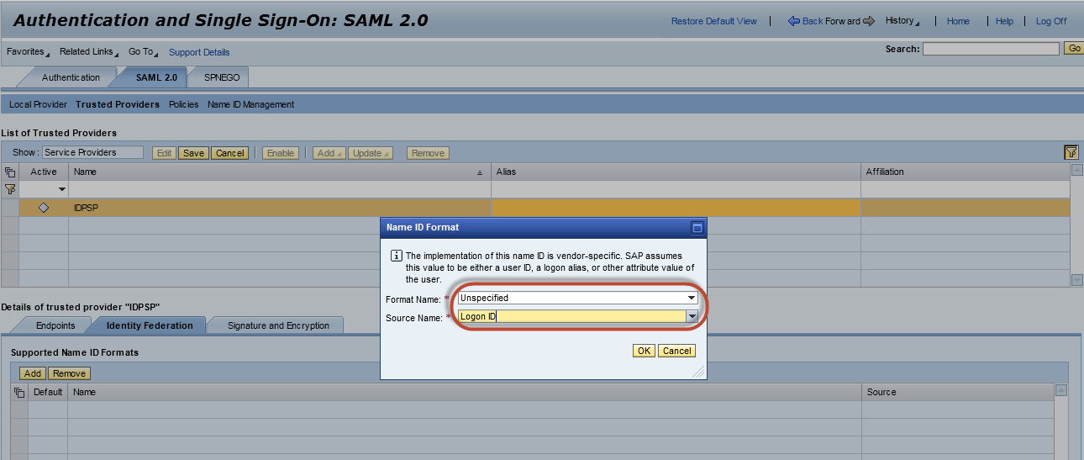
- Choose Unspecified.
- Enter Logon ID in the field Source Name.
- Choose OK.
- On the Trusted Providers tab, choose Save.
- Choose Enable.

Trusting the Identity Providers

Preparation for the Service Provider
The following configurations are the prerequisites for the service provider to trust the identity provider.

Downloading metadata XML file from the Identity Provider
- Start SAP NetWeaver Administrator with the quick link https://<hostname>:<port>/nwa.
Note
For internet scenario, the access hostname and port should be that you configured in the reverse proxy server, then the endpoints URL will be contained in the XML metadata file for SAML authentication.
- Go to the SAML 2.0 tab.
- Choose Local Provider page under the SAML 2.0.
- Choose Download Metadata.
- Open the link Download Metadata.
- Save the XML file in your local folders.
- Choose Close.

Downloading certificate from the Identity Provider
- Start SAP NetWeaver Administrator with the quick link https://<hostname>:<port>/nwa.
- Choose the Go To menu.
- Choose Configuration→Security→Certificates and Keys→Key Storage.
- On the Key Storage tab, select the view “SAML2”.
- Choose the entry you generate in the list the Details of view”SAML2”.
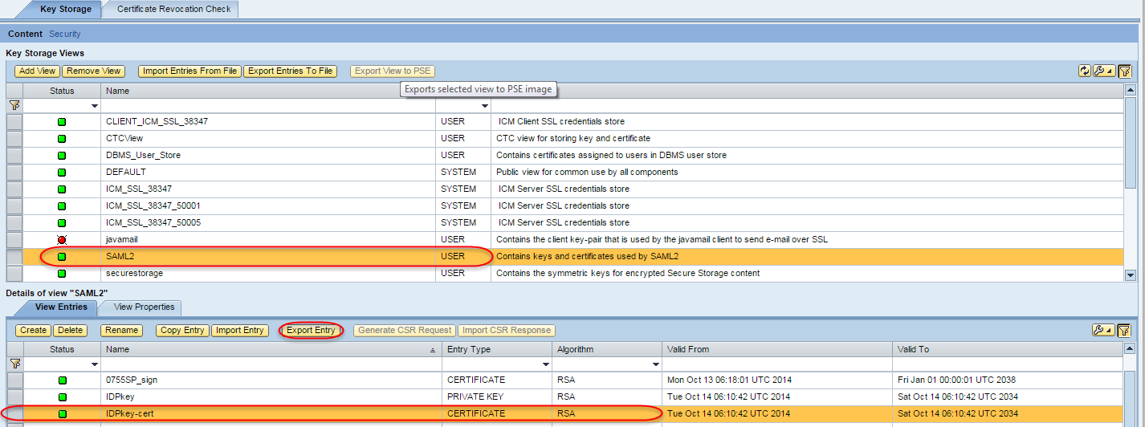
- Choose Export Entry.
- In the Export Entry To File dialog box, choose Base64 X.509 in the field Select export format.
- Choose the Download Link Download for the X.509 Certificate File.
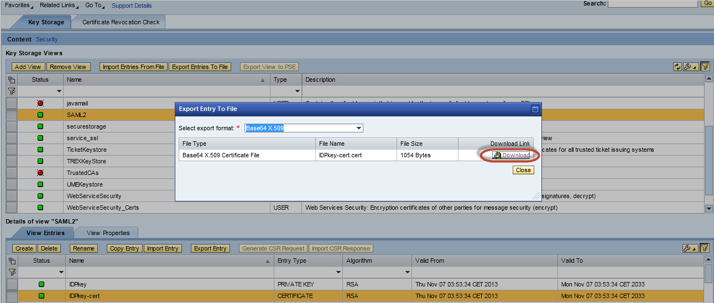
- Save the certificate file in your local folders.
Add the Caution/Example/… paragraphs to your Quick Parts in the Insert ribbon (Insert → Quick Parts → Save Selection to Quick Part Gallery). Then delete these paragraphs below.
Caution
Make sure that you download the right public-key certificate for the identity provider, not the private key.

Adding the Identity Provider into Trust List
- In the SAP NetWeaver Gateway system, start the SAML2.0 configuration application (transaction SAML2).
- Go to the Trusted Providers tab.
- Open the dropdown box of the trusted providers in the field Show.
- Choose Identity Providers.
- Choose Add→Upload Metadata File.
Note
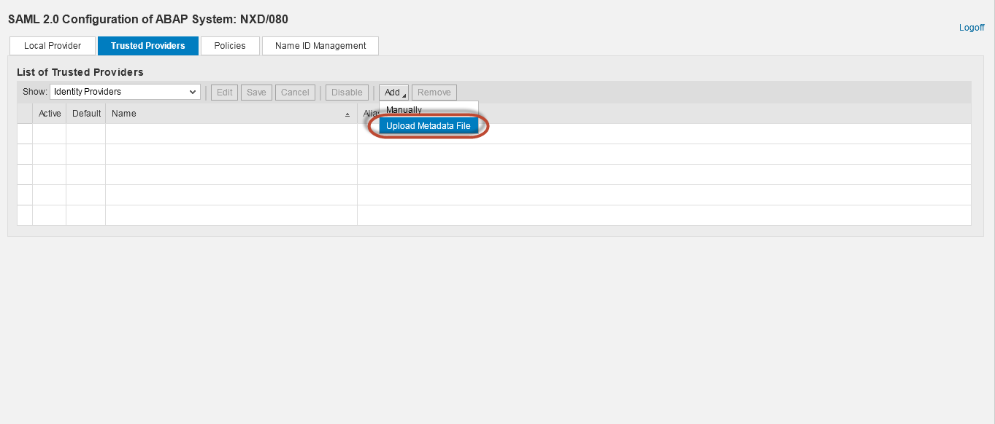
You could also add a trusted provider manually.
- Choose Browse and provide the path to the metadata XML file of the identity provider.
- Choose Next.
- Select Upload from File and choose Browse.
- Provide the path to the public-key certificate with which the service provider can verify the signature.
- On the SAML 2.0 Configuration screen, keep the following steps as default till step 9 – Authentication Requirements.
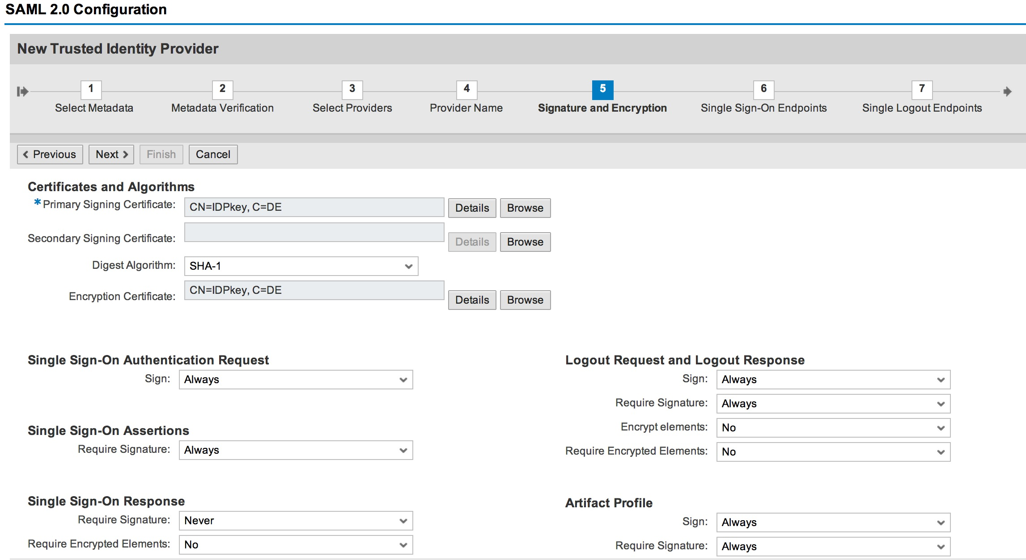
- On the Authentication Requirements screen, under Authentication Response, change the following parameter value.
Field Name | Field Value
Assertion Consumer Service | Applicatoin URL
Binding | HTTP POST

- Choose Finish and stay on this page.

Enabling the Identity Providers
- Go to the Trusted Providers tab.
- Open the dropdown box of the trusted providers in the field Show.
- Choose Identity Providers.
- Choose Edit.
- Go to the Identity Federation tab.
- Choose Add.
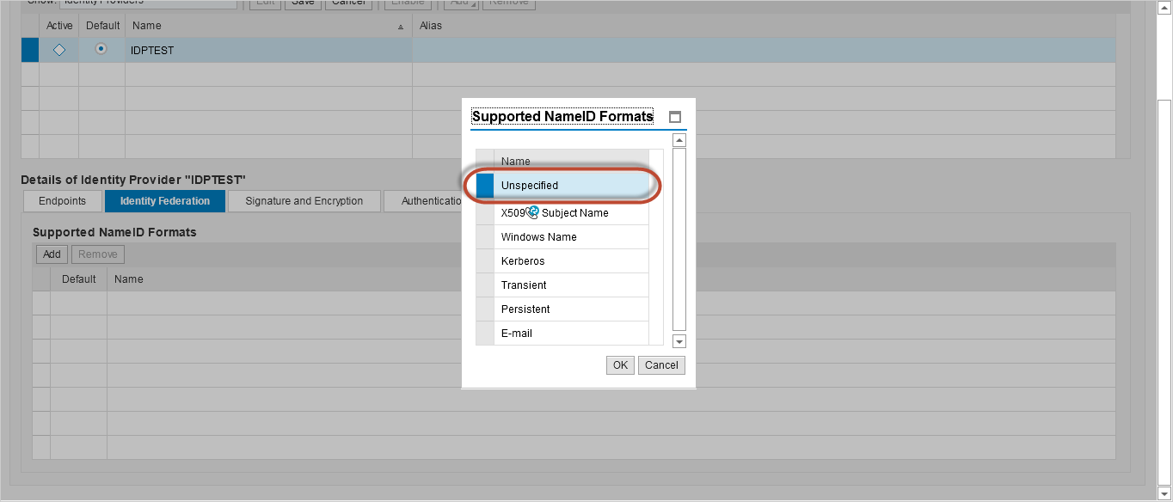
- In the Supported NameID Formats dialog box, select Unspecified name ID format and choose OK.
- On the Identity Federation tab, make sure the following values in the table are correct for Unspecified name ID format.
Field Name | Field Value
User ID Source | Assertion Subject NameID
User ID Mapping Mode | Logon ID
Allow Identity Provider to Create NameID | Yes
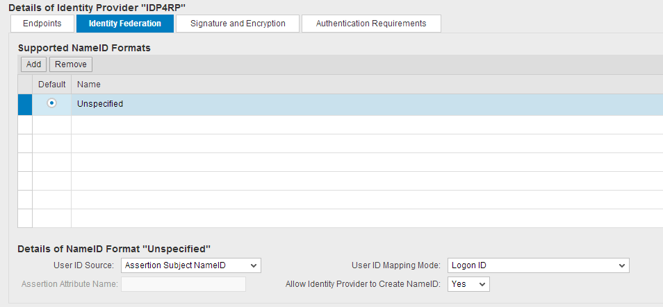

- Go to Authentication Requirements tab.
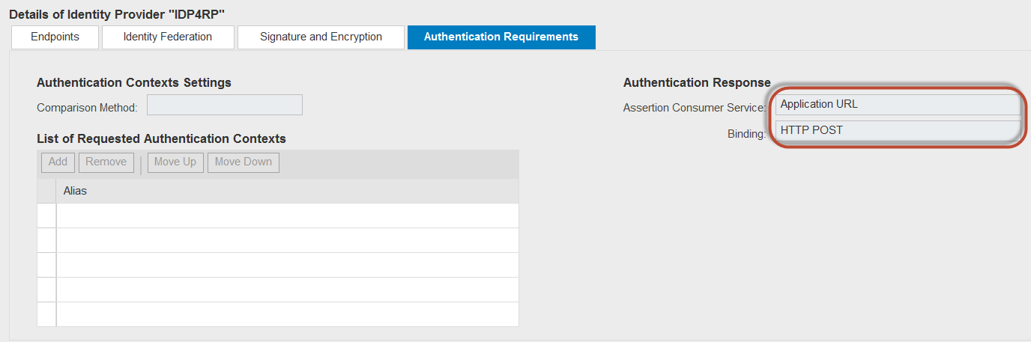
- Under Authentication Response property, make sure the value of Assertion Consumer Service has been set to Application URL and the value of Binding has been set to HTTP POST.
- Choose Save.
- Choose Enable.
Note
If the dump: DYN_CALL_METH_CLASS_NOT_FOUND occurs while enabling the Identity Provider, refer to the SAP Note 1988201.
- In the SAML 2.0 Configuration dialog box, choose OK.

SSO with SAML 2.0 Verification
Use this procedure to verify whether if the configuration of SSO with SAML 2.0 has been configured successfully.
Procedure
- Open the Chrome or Firefox browser from local PC.
- Input the URL below in the URL field:
https://<WebDispatcher>:<WebDispatcherPort>/sap/bc/ui5_ui5/ui2/ushell/shells/abap/FioriLaunchpad.html, which is mapped to the Front-end Server.
Note
If the SAP Web Dispatcher is out of scope in the system landscape, use the port and the hostname for SAP NetWeaver Gateway instead.
- Input the user name and password for the identity provider.
Note
The user name should be same as the user ID in the SAP NetWeaver Gateway system.
- The SAP Fiori Launchpad homepage will be displayed and no additional logon information is required for the Analytical apps or the Fact sheets.
Result
The configuration of SSO with SAML 2.0 has been configured successfully.

SSO using SAP Authenticator on Mobile Devices
Mobile Single Sign-On for Fiori is available with SAP Single Sign-On 2.0 SP04.
Mobile SSO solution is based on the Time-based One-Time Password (TOTP) Algorithm of the open standard RFC 6238. This algorithm computes a one-time passcode from a shared secret key and a current time.
The server side of the TOTP implementation is an add-on module for SAP NetWeaver Application Server (AS) Java and it is part of the SAP Single Sign-On 2.0 product. The TOTP Server is taking care about the mobile devices activation and deactivation on user level and the administration of the TOTPLoginModule per application.
SAP Authenticator is the mobile application for the TOTP Client and it is available for iOS and Android platforms.
The solution requires a SAML 2.0 Identity Provider, configured to accept authentication with Time-Based One-Time Passwords. The authentication to the Identity Provider, with the respective username and passcode, triggers IDP INITIATED SINGLE SIGN-ON mechanism.

SAML Identity Provider and Service Provider Setup
For detail information, refer to the previous chapter SSO with SAML 2.0.

One-Time Password Authentication Setup For SAML Identity Provider
Prerequisites
You have SSO Authentication Library (component of SAP Single Sign-On) installed on SAML Identity Provider.
Procedure
- In Identity Provider NetWeaver Administrator page, like Error! Hyperlink reference not valid., choose tab Configuration -> Security -> Authentication and Single Sign-On.
- In the Authentication and Single Sign-On page, choose tab Authentication -> Login Modules, and then choose the line TOTPLoginModule.
- Choose Edit in the Login Module Options tab, and then set Value of mode to opt|pwd, and then choose Save.
Note
(In the “otp|pwd” mode the TOTPLoginModule requires a single factor for authentication and it could be a passcode (TOTP) or password.)
- Choose tab SAML 2.0 -> Local Provider -> Authentication Contexts, choose Edit, and then choose Add.
- On the Create Authentication Context dialog box, input Alias as MobileTOTP, input Name as urn:oasis:names:tc:SAML:2.0:ac:classes:MobileTOTP, and then choose OK.
- Choose HTTPS select box for the newly added MobileTOTP Authentication Context, and then choose Save.
- Choose tab SAML 2.0 -> Local Provider -> Identity Provider Settings, choose Edit, and then choose Add in the Supported Authentication Contexts table.
- On the Authentication Context and Login Module Mapping dialog box, select Authentication Context Alias as MobileTOTP, select Login Module as TOTPLoginModule, and then choose OK.
- Choose the newly added MobileTOTP Authentication Context, and then choose Copy to -> Default HTTPS Authentication Contexts, it will appear in the right side table, choose Save.

Setup a Relay State on SAML Service Provider for SAP Fiori Launchpad
- Access t-code SAML2 of ABAP Front-End Server (the Service Provider), choose tab Local Provider -> Service Provider Settings, and then choose Edit.
- Choose Add in the Relay State Mapping. In the SAML 2.0 Configuration dialog box, input Relay State as fiori, input Path as /sap/bc/ui5_ui5/ui2/ushell/shells/abap/FioriLaunchpad.html, and then choose OK.
- Choose Save in the Local Provider tab.

SAP Authenticator Setup On The Mobile Device
- Login to the http(s)://<IDPHost>:<Port>/otp using your FIORI_ADM user, choose Install iOS Version or Install Android Version if you don't have SAP Authenticator on your mobile device. After it's installed, open it and set a App Password to protect from unauthorized access.
- In the http(s)://<IDPHost>:<Port>/otp, choose Activate Device, a QR code will be displayed. In the SAP Authenticator on mobile device, choose Scan QR Code to scan it, then the account name will be displayed, like FIORI_ADM; your device will start generating passcodes.

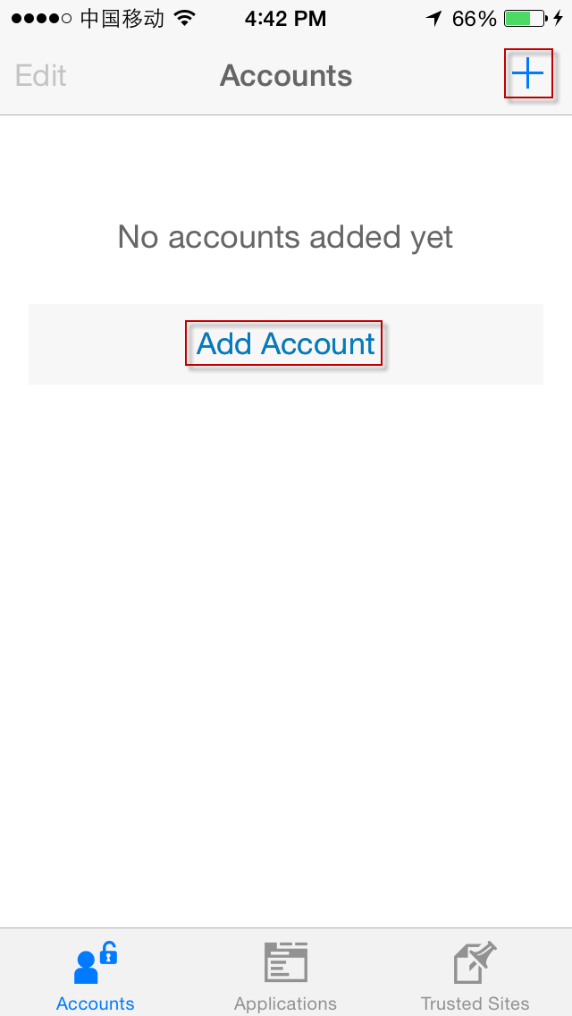
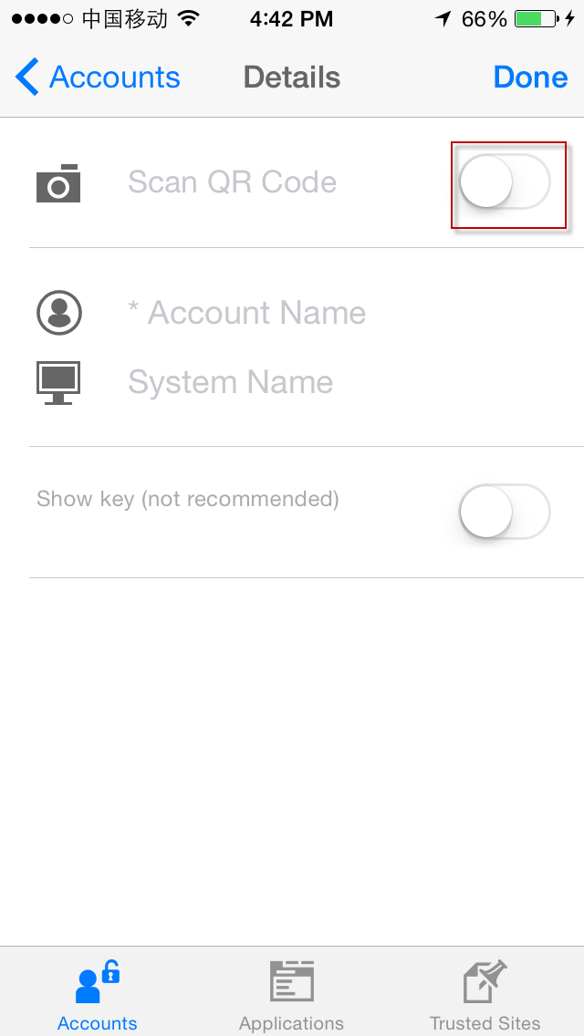

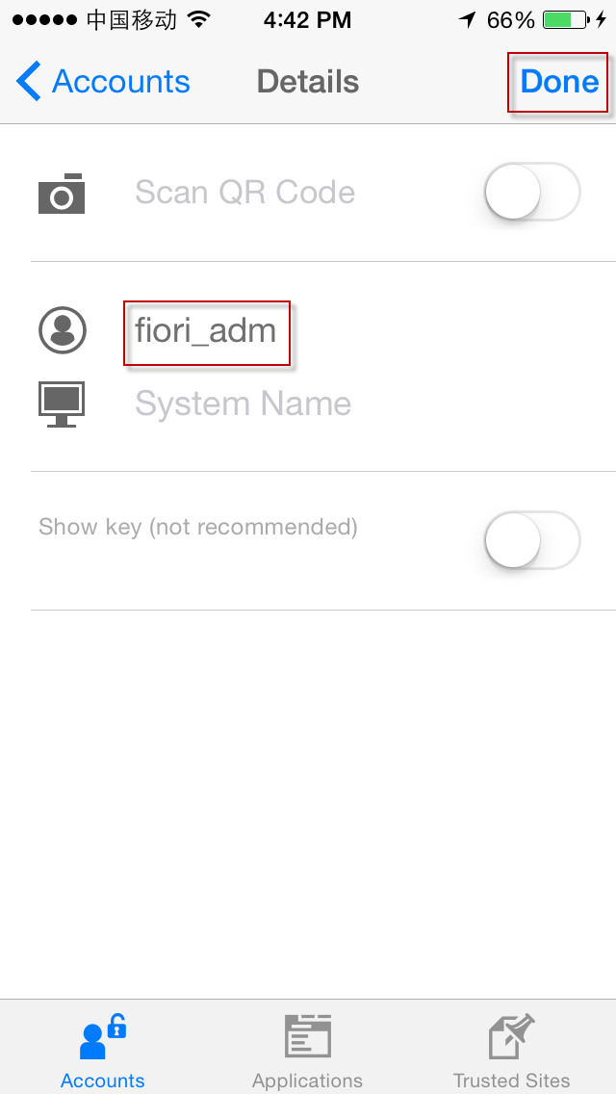
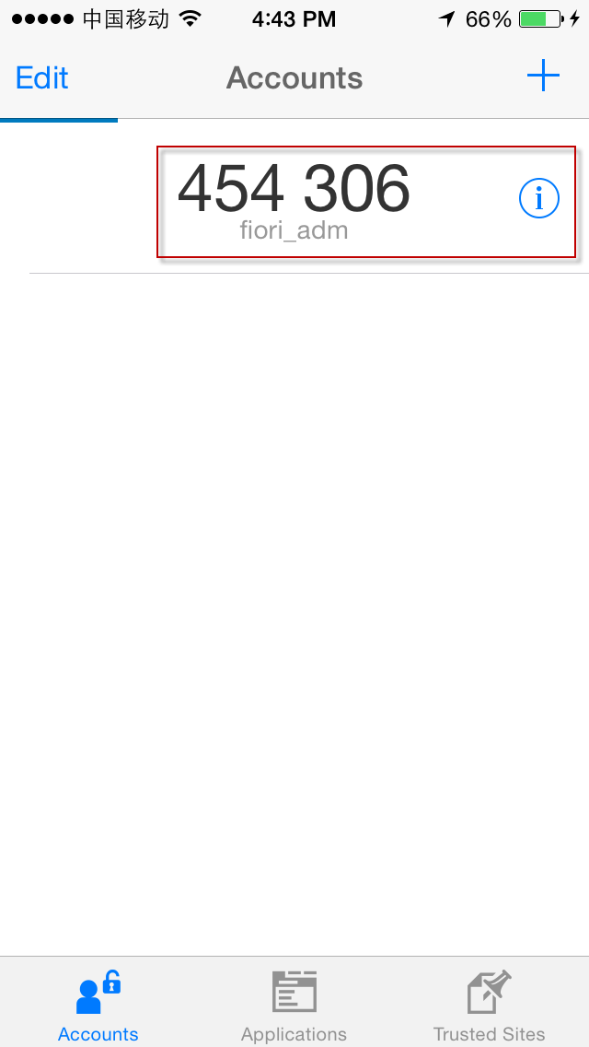

- In the http(s)://<IDPHost>:<Port>/otp, choose Finish, and then choose Yes to confirm that you scanned successfully the QR Code.
- In the Setting app on mobile device, select Mobile Single Sign-On for the Authenticator app, this will enable the section with Applications and Trusted Sites for the SAP Authenticator.
- In the SAP Authenticator on mobile device, add An application of URL https://<IDPHost>:<Port>/saml2/idp/sso?saml2sp=<SPName>&RelayState=fiori&j_username=[username]&j_passcode=[passcode]
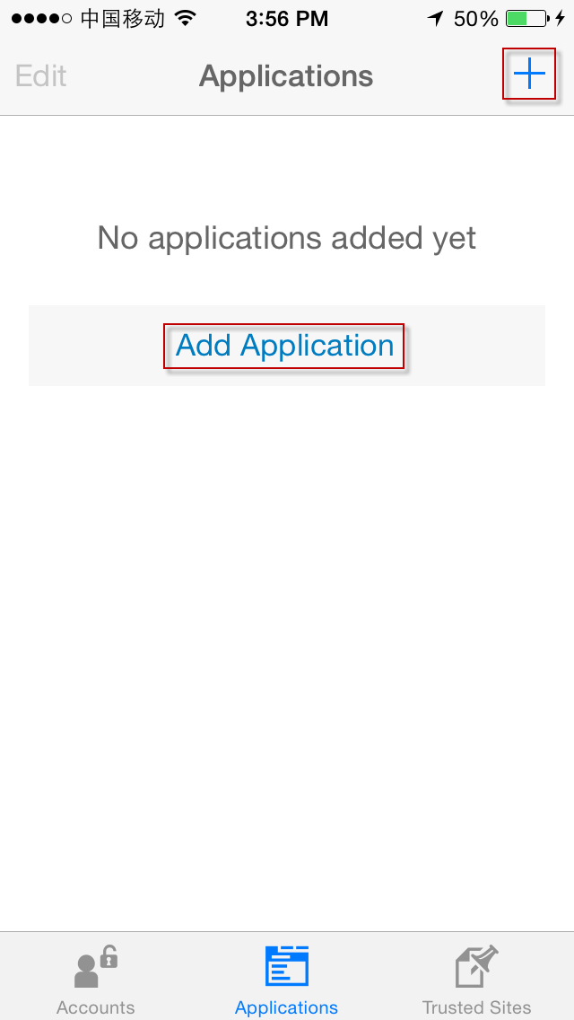
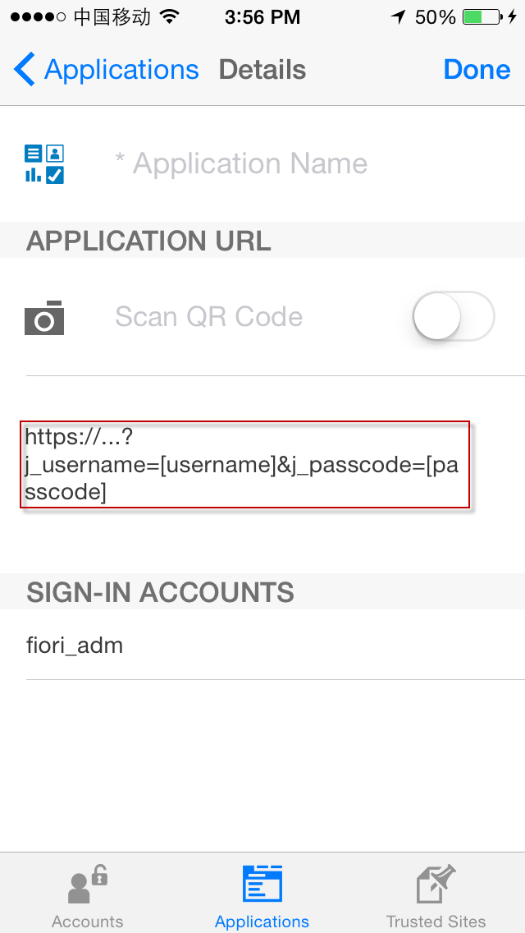

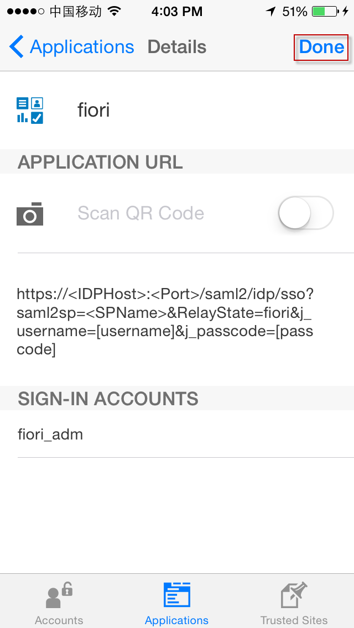
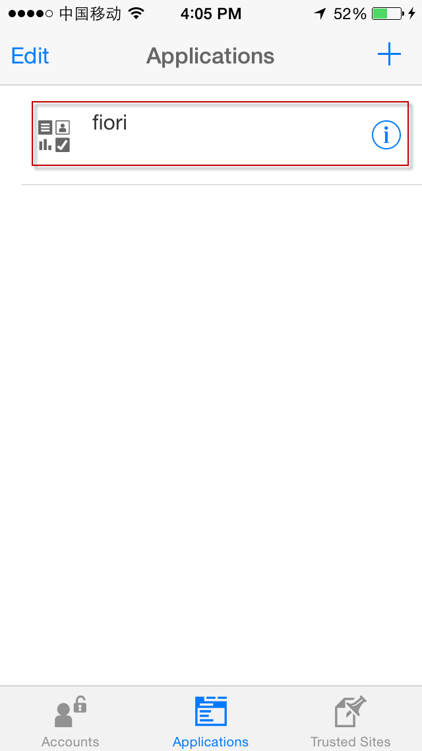

- Then you choose the newly created fiori Application, web browser on mobile device will open the Fiori Launchpad.

Managing User Accounts
This activity is used to manage user accounts to resolve issues such as locked accounts, lost or stolen mobile devices, and possible logon XSRF attacks.
Actions of this kind for users can be performed when they have installed SAP Authenticator on their mobile devices and have activated their devices in the Mobile Device Installation and Activation user interface (UI). SAP Authenticator is a mobile application that generates passcodes for systems that require one-time password authentication.
The following user management actions can be performed:
- Unlocking user accounts
Unlock a user account if the user needs the account before the automatic unlock time has passed.
- Deactivating user accounts
User account can be deactivated by choosing the Disable button. By disabling a user, all his or her registered devices have been deactivated. A user can also deactivate an account if he or she has more than one registered device.
- Setting a new validity for user accounts
A new validity period for users' account activation or their secret keys can be set (a user account is active as long as its secret key is valid). The default validity is specified under the Settings tab.
Note
For more information about the additional settings, see Additional Settings.
Procedure
- Log on to the One-Time Password Administration UI at http(s)://<IDPHost>:<Port>/otpadmin.
- Choose the User Management tab.
- Search for the users to manage.
- Select these users.
- Choose the button for your operation.
Once the operation is completed, a success message is displayed.
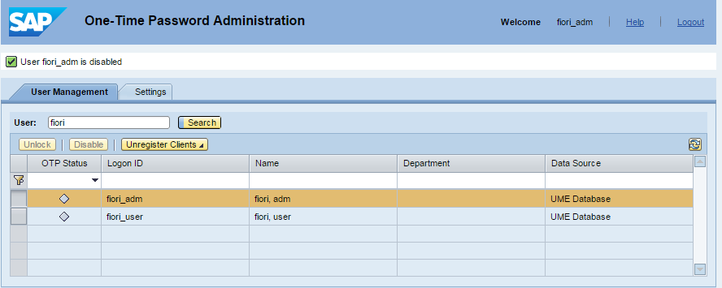

SSO with X.509
If you have implemented a PKI infrastructure for user authentication in your organization, you can use X.509 certificates by configuring the required systems (ABAP Front-end server or SAP HANA) to accept X.509 certificates.
The SAP Fiori apps and the SAP Fiori Launchpad can send requests directly to the SAP Front-end server (also a SAP NetWeaver Gateway System), SAP Backend Server and to SAP HANA. All of those requests are authenticated by each system respectively. Which systems should be configured for X.509 certificate authentication depends on the type of app in use.
- Transactional apps
You must setup the X.509 certificate authentication for ABAP Front-end server.
- Fact sheets
You must setup the X.509 certificate authentication for ABAP Front-end server and ABAP Backend server.
- Analytical apps and SAP Smart Business apps
You must setup the X.509 certificate authentication for ABAP Front-end server and SAP HANA XS engine.
Add the Caution/Example/… paragraphs to your Quick Parts in the Insert ribbon (Insert → Quick Parts → Save Selection to Quick Part Gallery). Then delete these paragraphs below.
Caution
In the following configuration, we assume that all the server’s certificates (used for outbound SSL or inbound SSL) are issued by the same CA. (For example, CA_FOR_SERVER.cer)
And user certificates are issued by another CA. (For example, CA_FOR_USER.cer)

Setup SSO with X.509 for ABAP Front-end Server
This activity is to enable ABAP Front-end server (also a SAP NetWeaver Gateway system) to use single sign-on (SSO) authentication with X.509 certificates to confirm the logon credentials of a user.

Adding the Root CA of the User Certificates to the ABAP Front-end Server Trust Store
- Login to ABAP Front-end server.
- Open the transaction STRUST.
- Expand folder SSL Server Standard and click on the node named <SAP host>_<SID>_<Instance No.>.
- In the bottom panel Certificate, choose the Import Certificate button, and then input the file path of the root CA of the user Certificate (for example, CA_FOR_USER.cer).
- Choose Input (Enter).
- Choose Add to Certificate List.
- Choose Save (Ctrl + S).

Configuring ICM Parameter in ABAP Front-end Server
Since SAP Web Dispatcher is used to dispatch Fiori requests to the Front-end server, the user’s certificate will be encoded and transferred to ABAP front end server as the HTTP header.
Following steps have to be performed to let ABAP Front-end server accept that header of the request from Web Dispatcher.
And also we have to maintain parameter icm/HTTPS/verify_client to 1 (allow) or 2 (require) to allow the user authentication using X.509 certificate.
For rule-based certificate mappings, the login/certificate_mapping_rulebased profile parameter has to be set to 1.
- Login into ABAP Front-end server.
- Access the transaction using the following navigation path:
Transaction Code | RZ10
- Choose the instance profile and under Edit Profile select Extended maintenance.
- Click on Change.
- Choose Create (F5).
- Add following parameters:
icm/HTTPS/trust_client_with_subject = <subject of the WebDispatcher outbound SSL certificate>
icm/HTTPS/trust_client_with_issuer = <issuer of the WebDispatcher outbound SSL certificate>
icm/HTTPS/verify_client=1
login/certificate_mapping_rulebased=1

Example
To simplify the configuration, wildcards can be used:
* stands for any number of characters, below is an example.
icm/HTTPS/trust_client_with_subject = *
icm/HTTPS/trust_client_with_issuer =CN=SERVER_CA, O=SAP, C=DE
icm/HTTPS/verify_client=1
login/certificate_mapping_rulebased=1
- Save and restart the SAP instance.

Rule-Based Certificate Mapping
Use
Rule-based certificate mapping (transaction CERTRULE) enables the mapping of users from parts of the subject or the subject alternative name of an X.509 certificate for a given issuer to the user ID or alias of a user master record. With a few rules, logon with X.509 certificates can be enabled for all users. The tool also enables a possibility to load an X.509 certificate and check if a rule applies to the certificate and if the certificate maps to a user. For individual users that do not map to the existed rules, exceptions can be performed.
Prerequisites
The profile parameter: login/certificate_mapping_rulebased has been set to 1
Rule-based certificate mapping requires the following authorization objects:
- CCMS: System Administration(S_RZL_ADM)
- User Master Maintenance: User Groups(S_USER_GRP)

Creating Rules for Certificate Mapping
Use
This procedure enables you to create a rule for mapping X.509 certificates from a given issuer to user records of SAP NetWeaver Application Server (AS) ABAP. Each certificate contains attributes in the subject, and sometimes, in the subject alternative name fields.
Prerequisites
The X.509 certificate has been saved as a file

Procedure
- Login into ABAP Front-end server.
- Access the transaction using the following navigation path:
Transaction Code | CERTRULE
- Choose Import Certificate.
- Specify the path of the X.509 certificate and choose Open.
- In the SAP GUI Security dialog box, choose Allow.
- Choose Display/ Change (F6) to switch to change mode.
- Choose Create rule.
- Choose whether you want the AS ABAP to read the logon name (user name or alias) from an attribute of the subject or the subject alternative name.
- Select User Name as the logon attribute.
- Once the Certificate Attr. has been selected, the Subject Filter will be updated accordingly.
- Press Enter
Example
Assume a certificate with the following attributes:
CN=C****, O=SAP-AG, C=DE
A rule can be created as shown:
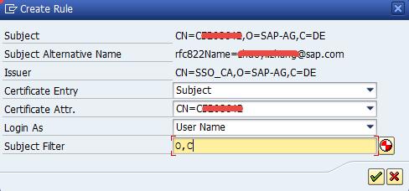
Remove the attributes from the subject filter to make the attribute a wildcard. If C=DE is removed from the subject filter, the AS ABAP still expects the attribute in the same position, but the attribute can include any value. The rule includes the attribute as C=*.
To regenerate the default list of attributes after changes are made to the subject filter or to the subject certificate attribute for mapping. Choose Generate
- Move the rule up or down in the list of rules as required.
Note
The AS ABAP checks the rules in order and applies the first rule that matches. If the AS ABAP finds a rule that applies, but does not find a user to match the certificate, the logon fails even if a later rule would apply and result in a successful logon.
- Save your entries.
- Choose Back (F3).

Checking Certificates for Rule Coverage
Prerequisites
The X.509 certificate has been saved as a file
Procedure
- In the ABAP Front-end server, start Rule based Certificate Mapping using the following navigation path:
Transaction Code | CERTRULE
- Choose Import Certificate.
- Specify the path of the X.509 certificate and choose Open.
- In the SAP GUI Security dialog box, choose Allow.
- Check the results in the Certificate Status Based on Persistence section.
Note
The display indicates whether the certificate can be mapped with a rule or an explicit mapping. If the system can map the certificate, the display indicates the user ID or alias the system reads from the certificate and whether such a user exists in the system.
- If the system can map the certificate, it should look like:
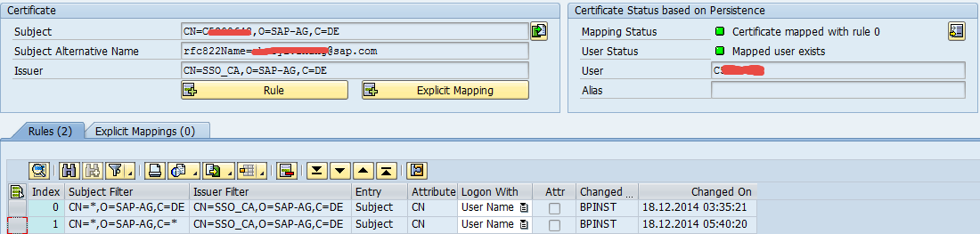

Setup SSO with X.509 for ABAP Back-end Server
Since the ABAP Backend Server is also based on SAP NetWeaver, it has the same configuration steps with ABAP front-end. For setup SSO with X.509 for ABAP Back-end Server, refer to chapter Setup SSO with X.509 for ABAP Front-end Server

Setup SSO with X.509 for HANA XS
This is to enable HANA XS engine to use single sign-on (SSO) authentication with X.509 certificates to confirm the logon credentials of a user. It’s applicable to analytical apps only.

Configuring HANA Web Dispatcher to Allow X.509 Certificate Authentication
Maintain web dispatcher parameter icm/HTTPS/verify_client to 1 (allow) or 2 (require) to allow the user authentication using X.509 certificate.
- Login into HANA system OS.
- Edit /usr/sap/<INSTANCE>/HDB<InstNo>/<host>/wdisp/sapwebdisp.pfl
- Maintain following parameters:
icm/HTTPS/trust_client_with_subject = <subject of the Webdispatcher outbound SSL certificate>
icm/HTTPS/trust_client_with_issuer = <issuer of the Webdispatcher outbound SSL certificate>
Example
icm/HTTPS/trust_client_with_subject = *
icm/HTTPS/trust_client_with_issuer =CN=SERVER_CA, O=SAP, C=DE
icm/HTTPS/forward_ccert_as_header=true
icm/HTTPS/verify_client = 1
- Save.

Create the Trust Store for HANA XS
- Access the Operating System of SAP HANA with user <SID for HANA>adm.
- Create an SSL key pair and a certificate request:
- Change to the following directory.
cd /usr/sap/<SAPSID>/SYS/global/security/lib
- Add the directory containing the security libraries to the library path.
export LD_LIBRARY_PATH=/usr/sap/<SAPSID>/SYS/global/security/lib
- ./sapgenpse get_pse -p sapsrv.pse -x <PIN> -r sapsrv.req "CN=<Fully Qualified Domain Name>, OU=<org_unit>, O=<company>, C=<country>"
Note
If the -x parameter is not used, sapgenpse interactively asks for a personal identification number (PIN). The PIN request provides extra security since nobody can read the password from the screen or find it in the command history.
The export command creates two files, one in the sec/ directory and one in the current directory. The file sapsrv.req is an ASCII file whose content must be sent to a CA (certification authority). According to the rules of the CA, the CA will sign the request and return a file with the signed certificate. SAP offers CA services at http://service.sap.com/Trust, where the test certificates can be signed instantly. There is also a navigation point called “SSL Test Server Certificates” https://websmp106.sap-ag.de/SSLTest
- Import the signed certificate.
Copy and paste the signed certificate into a file on the server hosting the SAP HANA and execute the commands indicated below:
- Paste the text of the signed certificate into SAPSSL.cer, which is located in the directory /usr/sap/<SAPSID>/HDB<instance_nr>/<hostname>/sec/.
- Copy sapgenpse to the directory /usr/sap/<SAPSID>/HDB<instance_nr>/<hostname>/sec/.
- Place the certificate SAPNetCA.cer that has been downloaded from SAP Service Marketplace into the following directory /usr/sap/<SAPSID>/HDB<instance_nr>/<hostname>/sec.
- Import the certificate using the following command.
./sapgenpse import_own_cert -c SAPSSL.cer -p sapsrv.pse -x <PIN> -r SAPNetCA.cer
Note
Make sure that the date and time settings on the server hosting the SAP HANA are correct and synchronized with the certificate authority (CA) that issued the certificate have been imported, otherwise the certificate might be interpreted as invalid.
- Restart the SAP HANA instance.
- Check with the following link:
https://<host_name>:<port>/sap/hana/xs/admin
Switch to the TRUST MANAGER tab and no error messages should appear.

Adding the Root CA of the User Certificates to SAP HANA Trust Store
- Access the Operating System of SAP HANA with user <SID for HANA>adm.
- Make sure that following pse files exist in the folder /usr/sap/<INSTANCE>/HDB<InstNo>/<host>/sec/
SAPSSL.pse, sapsrv.pse.
- Use sapgenpse utility to import the root CA of the user certificate into SAP HANA trust store and the Webdispatcher trust store.
./sapgenpse maintain_pk -p /usr/sap/<INSTANCE>/HDB<InstNo>/<host>/sec/SAPSSL.pse -a <rootCA cer file>
(for exmaple, CA_FOR_USER.cer).
./sapgenpse maintain_pk -p /usr/sap/<INSTANCE>/HDB<InstNo>/<host>/sec/sapsrv.pse -a <rootCA cer file>
(for exmaple, CA_FOR_USER.cer).
- After importing certificates to a pse file, restart the SAP HANA instance.
SAPSSL.pse => sapwebdisp_hdb
sapsrv.pse => hdbxsengine/hdbindexserver

Maintain XS Application Security
- Login into HANA XS administration tool with URL https://<hostname>:43<InstNo>/sap/hana/xs/admin.
- Choose application package sap→hba and configure X509 as an additional authentication method.
It should now looks like:
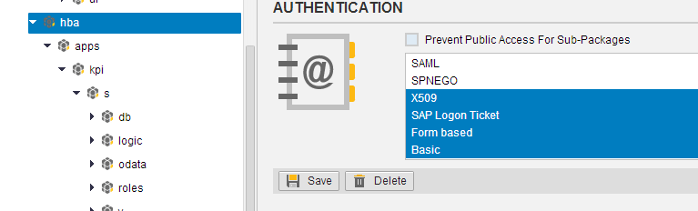
Note
All Smart Business HANA services are located in sap→hba folder. We are going to change its authentication method in order to make all HANA services to be accessed through Launchpad via SSO.
In production environment, the customer or the system administrator can adapt this authentication method to X509 only or SAP Logon Ticket only and so on to meet the customized SSO strategy.

Mapping a User Which is Ready for X.509 Authentication
- Access the HANA system using the SAP Hana Studio as an administrator.
- Locate and open the tree node Security→Users → <End User> (for example, FIORI_USER).
- Choose the check box X509.
- Choose Configuration under X509.
- On the Configure X509 User Certificates dialog box, choose Add Manually.
Maintain following entry:
Field Name | User Action and Values
Issued To | <The DN of the user certitifcate>  (for exmaple, CN=user id, O=SAP, C=DE)
Issued By | < The DN of the user certitifcate issuer>  (for exmaple, CN=USER_CA, O=SAP, C=DE)
- Choose OK.

Configuring Web Dispatcher to Enable Certificate Forwarding
In SAP Fiori Scenario, user logon to Front-end server, Backend Server and HANA XS through the SAP Web Dispatcher. Below is to enable SAP Web Dispatcher to forward the client certificate to the servers behind.
- Access the Operating System of SAP Web Dispatcher, copy the root certificate of User Certificates as /usr/sap/<SID>/W<Instance Nr.>/sec/client-ca.cer.
- In Command Prompt, run below command:
./sapgenpse maintain_pk -p /usr/sap/<SID>/W<Instance Nr.>/sec/SAPSSLS.pse -a client-ca.cer
- Edit the Instance Profile, add following profile parameters:
icm/HTTPS/verify_client=1
icm/HTTPS/forward_ccert_as_header = true
icm/HTTPS/trust_client_with_subject = <DN of the Reverse Proxy certificate>, since there should be many clients, so it’s better to use some pattern, like *.
icm/HTTPS/trust_client_with_issuer = <DN of the issuer of the Reverse Proxy certificate>,
Example
icm/HTTPS/verify_client=1
icm/HTTPS/forward_ccert_as_header = true
icm/HTTPS/trust_client_with_subject= *
icm/HTTPS/trust_client_with_issuer = EMAIL=maik.mueller@sap-ag.de, CN=SAPNetCA, OU=SAPNet, O=SAP-AG, C=DE.
- Save the Instance Profile and restart the Web Dispatcher process.
Example
In the operating system of SAP Web Dispatcher, switch to the <SID>adm user. Run below command:
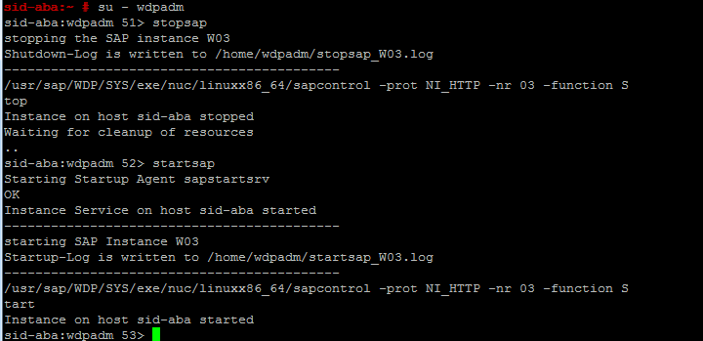
$Stopsap
$Startsap

SSO with X.509 Verification
The Web Browser is used to verify the X.509 authentication for respective servers in the SAP Fiori system landscape including Front-end Server (also the SAP NetWeaver Gateway system), Back-End Server (the Suite on HANA system) and HANA Backend. The SAP Web Dispatcher is also involved into the scope to verify the authentication to servers through the SAP Web Dispatcher.
Note
Chrome browser is used as an example. Make sure always use the latest version of the Web browser.
Prerequisites
The X.509 user certificate existed in the local file. The HANA user has enough privileges for the HANA XS OData service. Make sure that all the cookies of the referred server hosts have been removed before performing the following verification steps.

Importing User Certificate into Web Browser
- Open the google chrome browser.
- Choose Settings in chrome and click on Show advanced settings….
- Click on Manage certificates….
- Choose Personal tab on the opened Certificates dialog box.
- Choose Import… and select your user certificate from your local file.
- Enter your certificate file password in the next step after importing the certificate file.
- Choose Next button till finish all the steps.

Verifying original links from respective servers in system landscape
- Open the google chrome browser.
- Open the Front-end URL https://<Front-end Server>:<Port>/sap/bc/ping?sap-client=<Front-end client>
- In the Select a certificate dialog box, confirm the user certificate and choose OK.
- A message of Server reached successfully is displayed in the browser after the X.509 user certificate has been chosen.
- Repeat steps 2 to 4 for the Suite on HANA X.509 verification; use the back-end url instead.
https://<Back-end Server>:<Port>/sap/bc/ping?sap-client=<back-end client>
- Repeat steps 2 to 4 for the HANA X.509 verification; use the back-end HANA url instead.
https://<Back-end HANA Server>:<Port>/sap/hba/r/sb/core/odata/SMART_BUSINESS.xsodata
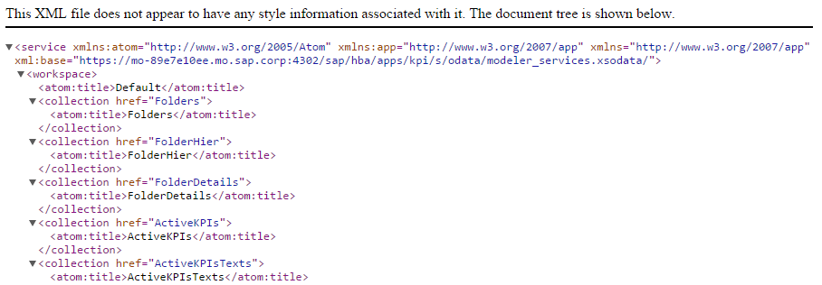
- A XML response is displayed in the browser after the X.509 user certificate has been chosen.

Verifying original links from the SAP Web Dispatcher
- Open the google chrome browser.
- Open the URL through the SAP Web Dispatcher https://<Web Dispatcher host>:<Web Dispatcher Port>/sap/bc/ping?sap-client=<Front-end client>
- In the Select a certificate dialog box, confirm the user certificate and choose OK.
- A message of Server reached successfully is displayed in the browser after the X.509 user certificate has been chosen.
- Repeat steps 2 to 3 for the Suite on HANA X.509 verification; use the url through SAP Web Dispatcher instead.
https://<Web Dispatcher host>:<Web Dispatcher Port>/sap/es/search?sap-client=<back-end client>
- The Enterprise Search web interface is displayed in the browser after the X.509 user certificate has been chosen.
- Repeat steps 2 to 3 for the back-end HANA X.509 verification; use the url through SAP Web Dispatcher instead.
https://<Web Dispatcher host>:<Web Dispatcher Port>/ sap/hba/r/sb/core/odata/SMART_BUSINESS.xsodata
- A XML response is displayed in the browser after the X.509 user certificate has been chosen.

Configuring Logon Procedure on Gateway
Since we introduced various approach for authenticating, it’s essential to enforce a sequence for them.
- Logon to ABAP Front-end Server.
- Use transaction SICF to open the service maintenance page.
- Choose Execute.
- Locate the service by path: default_host→sap→bc→ui5_ui5→ui2→ushell.
- Double click on service ushell to open the configure page.
- Go to Logon Data tab.
- Choose Change.
- In field Procedure, choose Alternative Logon Procedure from the list.
- Scroll down to the logon procedure list; change the sequence by defining the procedure number according to the sequence below.
No. | Logon Procedure
1 | Logon Through SSL Certificate
2 | SAP Logon/Assertion Ticket
3 | SAML Logon
4 | Logon Through HTTP Fields
5 | Basic Authentication Logon
6 | SAP Assertion Ticket
7 | SAP RFC Logon
8 | SPNEGO Authentication
9 | Logon Through Service Data
Note
The customer can modify this accordingly.
- Choose Save.

www.sap.com/contactsap
© 2015 SAP SE or an SAP affiliate company. All rights reserved.
No part of this publication may be reproduced or transmitted in any form or for any purpose without the express permission of SAP SE or an SAP affiliate company.
The information contained herein may be changed without prior notice. Some software products marketed by SAP SE and its distributors contain proprietary software components of other software vendors. National product specifications may vary.
These materials are provided by SAP SE or an SAP affiliate company for informational purposes only, without representation or warranty of any kind, and SAP or its affiliated companies shall not be liable for errors or omissions with respect to the materials. The only warranties for SAP or SAP affiliate company products and services are those that are set forth in the express warranty statements accompanying such products and services, if any. Nothing herein should be construed as constituting an additional warranty.
SAP and other SAP products and services mentioned herein as well as their respective logos are trademarks or registered trademarks of SAP SE (or an SAP affiliate company) in Germany and other countries. All other product and service names mentioned are the trademarks of their respective companies. Please see www.sap.com/corporate-en/legal/copyright/index.epx for additional trademark information and notices.
Material Number:

