Building Block Configuration Guide  Document Version: 1.0  2015-07-06  English | Customer
SAP Fiori Smart Business Enablement (MF6)

Typographic Conventions
Type Style | Description
Example | Words or characters quoted from the screen. These include field names, screen titles, pushbuttons labels, menu names, menu paths, and menu options.  Textual cross-references to other documents.
Example | Emphasized words or expressions.
EXAMPLE | Technical names of system objects. These include report names, program names, transaction codes, table names, and key concepts of a programming language when they are surrounded by body text, for example, SELECT and INCLUDE.
Example | Output on the screen. This includes file and directory names and their paths, messages, names of variables and parameters, source text, and names of installation, upgrade and database tools.
Example | Exact user entry. These are words or characters that you enter in the system exactly as they appear in the documentation.
<Example> | Variable user entry. Angle brackets indicate that you replace these words and characters with appropriate entries to make entries in the system.
EXAMPLE | Keys on the keyboard, for example, F2 or ENTER.
Document History
Revision | Date | Change
1.0 | 2015-07-06 | Version 1
Table of Contents
1 Purpose 5
2 Preparation 6
2.1 Prerequisites 6
3 Configuration 8
3.1 Changing a Navigation Target in Sales Order Fulfillment Issue Smart Business 8
3.1.1 Changing a Navigation Target in Front-End Server (Option 1) 8
3.1.2 Changing a Target Mapping in Launchpad Designer (Option 2) 9
3.1.3 Verifying Navigation Target change 9
3.2 SAP Lumira Server Integration enablement 9
3.2.1 Assigning roles and creating technical user 9
3.2.2 Run Lumira Server configurations 10
3.2.3 Using Lumira in Fiori Launchpad 12
3.3 SAP Jam Integration enablement 13
3.3.1 Create SAP Jam User and Group 13
3.3.2 Change Front-End Server User to map to SAP Jam User 13
3.3.3 Configuring HTTP Proxy on Front-End Server 14
3.3.4 Importing SAP Jam Server Certificate into Front-End Server 14
3.3.5 Configuring SAML2 Authentication for SAP Jam 14
3.3.6 Configuring OAuth Client for SAP Jam 14
3.3.7 Configuring ABAP Social Media Integration in Front-End Server 15
3.3.8 Configuring ABAP SMI for SAP Fiori Apps 16
3.3.8.1 Activating ABAP SMI OData Services 16
3.3.8.2 Creating the Social Media Catalog 16
3.3.8.3 Creating a Social Media Integration Role 16
3.3.9 Verify Jam Integration 16

Purpose
Smart Business Apps are usually start from a KPI, and then can drill-down and navigate to other apps, this is called Insight-to-Action working model. Below we introduce the required configurations for Smart Business integration.

Preparation

Prerequisites
A Smart Business Cockpit need involvement of several different Fiori Apps, you can check in http://www.sap.com/fiori-apps-library -> Search for a Smart Business App -> App Documentation link -> Navigation Targets section for linked apps.
Caution
Navigation targets may be not completed in this page, actuals can be found in the Smart Business Cockpit itself.
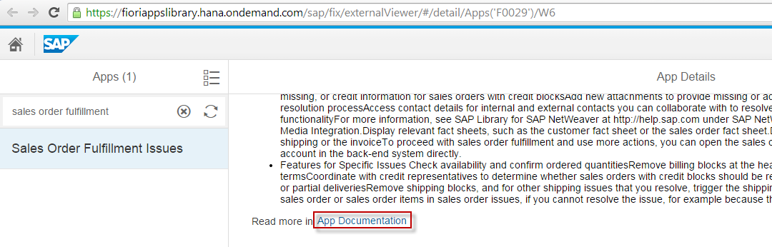

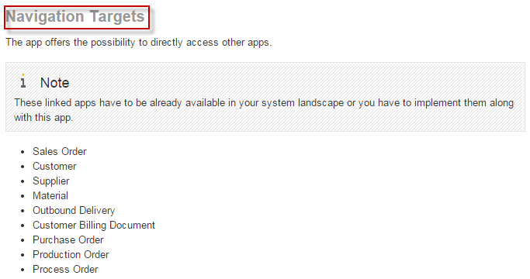

For example we use below: Sales Order Fulfillment Issues, it needs below Fiori Apps be enabled according to corresponding configuration guides.
Archetype | Fiori App | Configuration Guide | Comment
Analytical App | Sales Order Fulfillment Issues | MF2 | KPI App, it supports both Generic Drill-Down and Other Drill-Down, we will use Other Drill-Down Tile as the entry of Smart Business enablement.
Transactional App | Change Sales Order | MF1 | Since we will show how to replace Navigation Target, so use this additional one, no need by default.
Fact Sheet | Customer  Customer Billing Document  Material  Outbound Delivery  Purchase Order  Production Order  Process Order  Sales Order  Supplier | MF3
NWBC App | Change Sales Order  Change Billing Document  Change Outbound Delivery  Display Customer Credit Account  Display Purchase Order  Display Production Order  Display Process Order | EE3 | In LPD_CUST UISERP01 TRANSACTIONAL, NWBC Apps cannot be found in Fiori Reference Library

Configuration
During the steps, especially on ABAP server, you may need to provide a Customizing Request or Workbench Request; these screens will not be mentioned below since they're essential and quite standard.

Changing a Navigation Target in Sales Order Fulfillment Issue Smart Business
Use
In Sales Order Fulfillment Issue, there are several Navigation Targets to NWBC apps and we can also configure them to other apps. Below we will introduce changing existing "Change Sales Order" NWBC app to the "Change Sales Order" Fiori transactional app, below two options are alternative. Since Sales Order Fulfillment Issues is a specific "Hybrid" App, so some behaviors may be different from other Smart Business Apps.
Prerequisite
In Launchpad, use the Sales Order Fulfillment Issue app, choose any of the Issue in In Order status, and then choose Open In… -> Change Sales Order, check if a NWBC App of VA02 transaction is opened.

Changing a Navigation Target in Front-End Server (Option 1)
Procedure
- In Front-End Server, access the activity using the following navigation options:
Transaction code | LPD_CUST
SAP Reference IMG menu | SAP NetWeaver → UI Technologies → SAP Fiori → Define Navigation Targets → Define Navigation Targets
- In Overview of Launchpads screen, double-click the line UISERP01 TRANSACTIONAL.
- In Change Launchpad screen, double-click the line Change Sales Order.
- In right side panel, change Application Type from Transaction to URL, and input URL as /sap/bc/ui5_ui5/sap/sd_so_man, and then choose Show Advanced (Optional) Parameters.
- Input Application Alias as ChangeSalesOrder, input Additional Information as SAPUI5.Component=cus.sd.salesorder.manage, and then choose Save (Ctrl+S).
- Choose Exit (Shift+F3) twice, check that the change is saved; you can also choose Reset to SAP Version to undo the change.

Changing a Target Mapping in Launchpad Designer (Option 2)
Procedure
- In Launchpad Designer, choose the SAP_SD_BC_InternalSalesRep_A Catalog, and then choose Target Mappings in right side panel.
- Choose the SalesOrder change line, and then choose Configure.
- In the Configure: 'Target Mapping' screen, change Launchpad Role from UISERP01 to UIX01SD, choose Device Types also for Tablet and Phone, and then choose Save.
- Check if the change is saved.

Verifying Navigation Target change
In Launchpad, use the Sales Order Fulfillment Issue app, choose any of the Issue in In Order status, and then choose Open In… -> Change Sales Order. Check if a Fiori Transactional app is opened instead of the previous NWBC App.

SAP Lumira Server Integration enablement
SAP Lumira is a self-service solution that allows analysts and decision makers to access, transform, and visualize data; SAP Lumira contains Lumira Desktop, Lumira Cloud, and Lumira Server. Lumira Server is installed on top of HANA, and can be integrated in Fiori Launchpad. SAP Lumira server provides browser and mobile based experiences to analyze data and collaborate with colleagues on datasets, stories, and other Business Intelligence artifacts.

Assigning roles and creating technical user
Procedure
- In HANA Studio, create a new user called LUMIRATECH, assign the sap.bi.common::BI_TECH_USER role to it.
Caution
You should login to http(s)://<HANAServer>:<Port>/sap/hana/xs/formLogin/ to ensure that the user is created OK.
- Assign the sap.bi.admin::BI_CONFIGURATOR (configure Lumira Server features) and sap.bi.admin::BI_ADMIN (manage chart extensions) roles to administrative users like FIORI_ADM.
- Assign the sap.bi.common::BI_DATA_ANALYST or sap.bi.common::BI_DATA_CONSUMER to end users like FIORI_USER; a user assigned to BI_DATA_CONSUMER is granted permission to view stories, a user assigned to this role is granted the same permissions as the BI_DATA_CONSUMER plus the ability to publish a dataset from SAP Lumira.
- In ABAP Front-End Server, in t-code PFCG, assign the SAP_LUMIRA_TCR role to both administrative users and end users.

Run Lumira Server configurations
Use
In order to configure the Lumira integration you need to access another Fiori Launchpad which, is embedded in the SAP HANA system. Configuration Tile for SAP Lumira Server is available in this Fiori Launchpad.
Procedure
- Access http(s)://<HANAServer>:<Port>/sap/bi/launchpad/fiori/ using the administrative user like FIORI_ADM.
- In HANA Fiori Launchpad, choose Show/hide groups button in top-left corner, and then choose Tile Catalog in bottom-left corner.

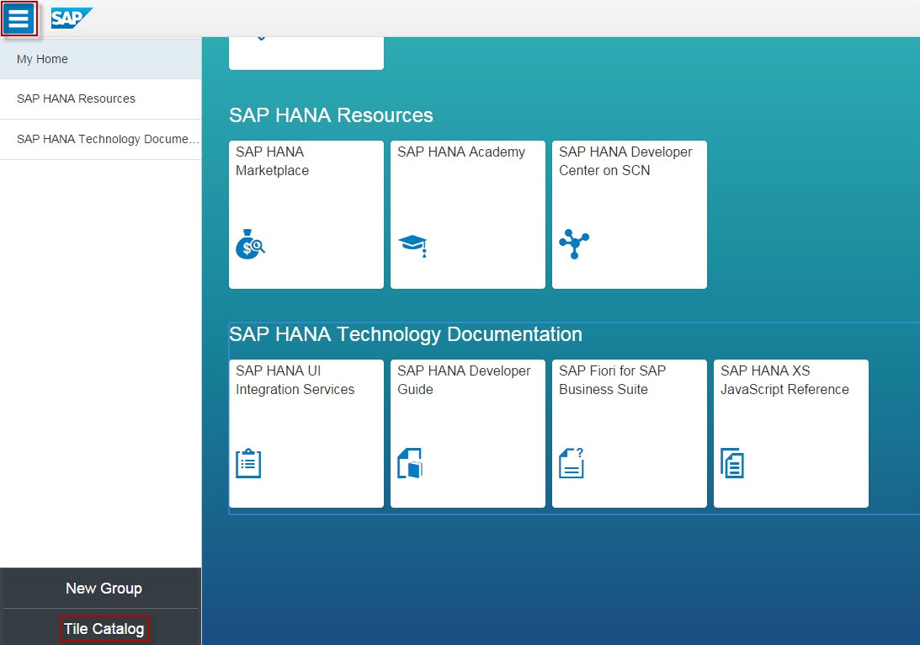
- In the Tile Catalog screen, choose the + under the Configuration SAP Lumira Server tile, and then choose My Home in the Add Tile To Groups dialog box, and then choose OK.

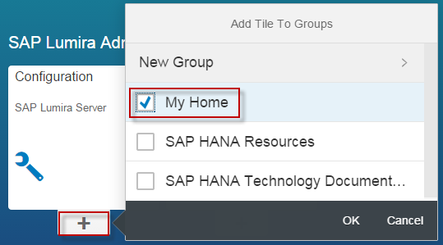
- Choose the back arrow to Launchpad screen, and then choose the Configuration SAP Lumira Server tile.
- In the SAP Lumira Configuration screen, choose Use the same user for all rights assignments, input Enter technical user as LUMIRATECH, and then choose Run Configuration. Check all the Features are with green check.
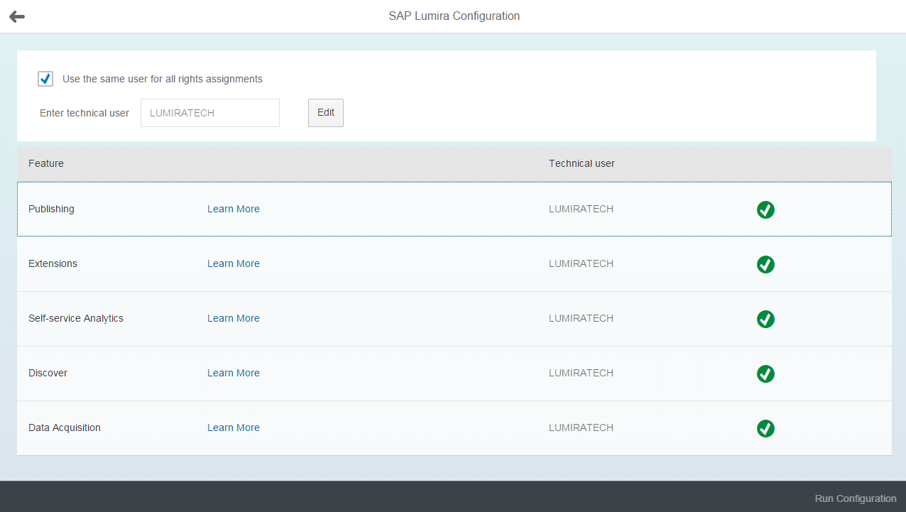

Using Lumira in Fiori Launchpad
Use
Queries visualized by SAP Lumira can be accessed via the SAP Fiori Launchpad. Several steps are required to achieve this:
- On SAP Lumira - based on an existing HANA Query - a story is being created.
- The story is assigned to a user group assigning a HANA role.
- Using the KPI Modeler tools a new tile is created to access this Lumira story.
Procedure
Create a Lumira Story:
- In Launchpad, choose the SAP Lumira tile.
Note
In case it is not visible on your Launchpad yet - open the Tile Catalog as described in the previous step - and add the SAP Lumira Server tile to your homepage.
- The Lumira Server page will be opened. Datasets and Stories can be created here. Views from HANA are listed as Datasets, many of them are also views for Analytical Apps.
- Select a view that fits to your needs. The screen Query view for <your selected query> is displayed.
- Maintain the Measures and Dimensions on the right-hand side of your screen by selecting the +button.
Note
Maintain the data for the SAP Client to be displayed once requested.
- Once data for the selected query is available a chart is populated. You can select the chart type in the upper right corner.
- Save the entries (upper right corner).
- Select the Compose view.
- Choose Blank in the New Story dialog.
- Enter a Board Title and drag from the left area your visualization just created and drop it in the Drop Object Area.
- Save the entries (upper right corner).

Assign the Lumira Story to roles:
- In the HANA Launchpad, choose the All Stories tile. All Stories will be listed.
Note
In case it not visible on your Launchpad yet - open the Tile Catalog as described in the previous step - and add the All Stories - SAP Lumira Server tile to your homepage.
- Enter the name of the story just created in the search field and select the magnifier glass symbol.
- Select the story from the list and choose Access.
- Choose Edit and Add.
- Select the Role in the upcoming dialog and choose OK.

- Configure KPI Tile in Launchpad:
- In the Fiori Launchpad, choose Configure KPI Tiles tile, choose an Evaluation, and then choose Add Tile.
- In the Add Tile screen, choose Drill-Down as Other Drill-Down.
- Choose Select Drill-Down as SAP Lumira.
- Choose the search button for Story ID.
- In the Story ID dialog box, choose a Story ID relevant to this Evaluation. In case you use the search enter the story name in the search field and choose the magnifier glass.
- In the Add Tile screen, input Semantic Object as LumiraAnalytics and openStory, and then choose Save and Activate.
- In Launchpad, choose Show/hide groups button in top-left corner, and then choose Tile Catalog in bottom-left corner.
- In the Tile Catalog screen, choose the + under the newly created tile, and then choose any Group in the Add Tile To Groups dialog box you want to assign to and choose OK.
- Choose the back arrow to Launchpad screen, and then choose the newly created tile. A Lumira Story will be opened.

Result
The Lumira Story can be accessed via the SAP Fiori Launchpad.

SAP Jam Integration enablement
Prerequisite
You must have purchased a license for SAP Jam.

Create SAP Jam User and Group
For SAP Jam integration, each Fiori user should have access to your SAP Jam site. Please have your SAP Jam administrator create user IDs and groups for Fiori users, who need to use the Jam integration functionality.

Change Front-End Server User to map to SAP Jam User
- In t-code SU01, input User as your Fiori user, like FIORI_ADM, and then choose Change (Shift+F6).
- In the Maintain Users screen, input E-mail Address as your SAP Jam user.
- Choose Save (Ctrl+S) to save the change.

Configuring HTTP Proxy on Front-End Server
Since Jam Integration requires the Intranet Front-End Server connecting to Internet SAP Jam, so we need to set a HTTPS proxy for the Front-End Server.
- In t-code SICF, choose Execute (F8).
- In the Maintain Service screen, choose menu Client -> Proxy Settings.
- In the Proxy Configuration for HTTP Client dialog box, choose the HTTPS Protocol tab, input proxy values and then choose Execute (F8).

Importing SAP Jam Server Certificate into Front-End Server
- Access SAP Jam in web browser, and download the server certificate root as sapjam.cer.
- In t-code STRUST in Front-End Server, choose Display <-> Change (Ctrl+F1).
- In Trust Manager: Change screen, choose the node under SSL client SSL Client (Anonymous), and then choose menu Certificate -> Import.
- In the Import Certificate dialog box, choose the sapjam.cer file, and then choose Continue (Enter), the SAP Jam server certificate details will appear.
- Choose Add to Certificate List, the certificate will be added to the above table, and then choose Save (Ctrl+S).

Configuring SAML2 Authentication for SAP Jam
- Access t-code SAML2 in Front-End Server, in the SAML 2.0 Configuration of ABAP System page, enable Local Provider, input Provider Name as <TrustedIDP>, and choose Operation Mode as Service Provider.
- In t-code STRUST, choose the node under SSF SAML2 Service Provider – S, and then double click on the Subject field, the certificate details will appear.
- Choose menu Certificate -> Export. In the Export Certificate dialog box, choose File format as Base64, save the certificate as SSFSPS.cer.
- In SAP Jam, choose menu Admin -> SAML Trusted IDPs, and then choose Register your identity provider.
- In the Register a new SAML Trusted Identity Provider page, input IDP ID as <TrustedIDP>, choose Allowed Assertion Scope as Users in my company, copy and paste the content of SSFSPS.cer as X509 Certificate (Base64), leave other fields as default values, and then choose Register.
- Check the newly created one appears in the SAML Trusted IDPs page.

Configuring OAuth Client for SAP Jam
- In t-code STRUST in Front-End Server, if there's no PSE under SSF Collaboration Integration, choose Create in the context menu, choose Algorithm as RSA with SHA-1, and then choose Continue (Enter).
- Choose the PSE under SSF Collaboration Integration, and then double click on the Subject field, the certificate details will appear.
- Choose menu Certificate -> Export. In the Export Certificate dialog box, choose File format as Base64, save the certificate as SSFCI.cer.
- In SAP Jam, choose menu Admin -> OAuth Clients, and then choose Add OAuth Client.
- In the Add your OAuth Client page, input Name as <OAuthClient>, input Integration URL to your company's URL like http://www.sap.com, copy and paste the content of SSFCI.cer as X509 Certificate (Base64), and then choose Save.
- Check the newly created one appears in the OAuth Clients page, choose View for it, and copy the Key value as <ConsumerKey> for latter usage.

Configuring ABAP Social Media Integration in Front-End Server
- In t-code CLB2_PLATF in Front-End Server, on the Change view "Server Communication": Overview screen, choose New Entries.
- In the New Entries: Details of Added Entries screen, input entry as below table:
Field | Value
Serv. Provider Type | Jam, select via F4 help
Server | Jam productive, select via F4 help
Service Provider | cubetree.com.
Server URL | <JamURL>, for example https://integration3.sapjam.com
Proxy Host  Proxy Port | Proxy information if your Front-End Server can't directly connect to SAP Jam
SSL Application ID | ANONYM
- Double click on Authentication Method in the left side Dialog Structure, and then choose New Entries, input entries as below table, and then choose Save (Ctrl+S).
Context | Authentication Method
APPLI | OAUTH_10_SHA1
APPUSR | OAUTH_10_SHA1_3
NONE | NONE
USER | SAML_20
- In t-code CLB2_APPLI_PLATF, on the Change view "Application-Server Assignment": Overview screen, choose New Entries.
- On the New Entries: Overview of Added Entries screen, input Application ID as DEFAULT, input Service Provider Type as Jam via F4 help, and input Server as Jam productive via F4 help.
- Double click on Server Settings in the left side Dialog Structure, and then choose New Entries, input Ext. Application ID as <OAuthClient>, input Consumer Key as <ConsumerKey>, and then choose Save (Ctrl+S).
- In t-code SICF, activate service /sap/bc/ui2/smi/rest_tunnel/
- In t-code CLB2_TUNNEL, choose New on the New Entries: Details of Added Entries screen, input entries as below table one by one, and then choose Save (Ctrl+S).
Tunnel Destination | Service Provider Type | Application ID | Service Root | Resource Path | Authentication Context
Jam | Jam | DEFAULT | api/v1/OData | $metadata | NONE
Jam | Jam | DEFAULT | api/v1/OData |  | USER
Jam | Jam | DEFAULT | api/v1/feed/post |  | USER
Jam | Jam | DEFAULT | /v1/single_use_tokens | $metadata | USER

Configuring ABAP SMI for SAP Fiori Apps

Activating ABAP SMI OData Services
- In t-code /IWFND/MAINT_SERVICE of Front-End Server, activate services SM_INTEGRATION_V2_SRV and SM_CATALOG_SRV for System Alias LOCAL.

Creating the Social Media Catalog
- In Launchpad Designer, choose the Catalogs tab, and then choose the +.
- In the Create Catalog dialog box, input below entry and then choose Save.
 | Title | ID | Remote ID | System alias | Base URL
Remote | Social Media Catalog | Jam | SMCatalog | LOCAL | /sap/opu/odata/sap/SM_CATALOG_SRV/

Creating a Social Media Integration Role
- In t-code PFCG of Front-End Server, create a role for Social Media Integration or change an existing role, and assign the users to it.
- In the Change Roles screen, choose the Menu tab, and then choose the dropdown list for Transaction, choose SAP Fiori Tile Catalog.
- In the Assign Tile Catalog screen, choose Catalog Provider as Remote Catalogs, choose Catalog ID as Jam from the dropdown list, and then choose Continue (Enter).
- In the Change Roles screen, choose Save (Ctrl+S).

Verify Jam Integration
- In Launchpad, use the Sales Order Fulfillment Issue app, choose any of the Issue.
- In the Issue Details page, choose Share.
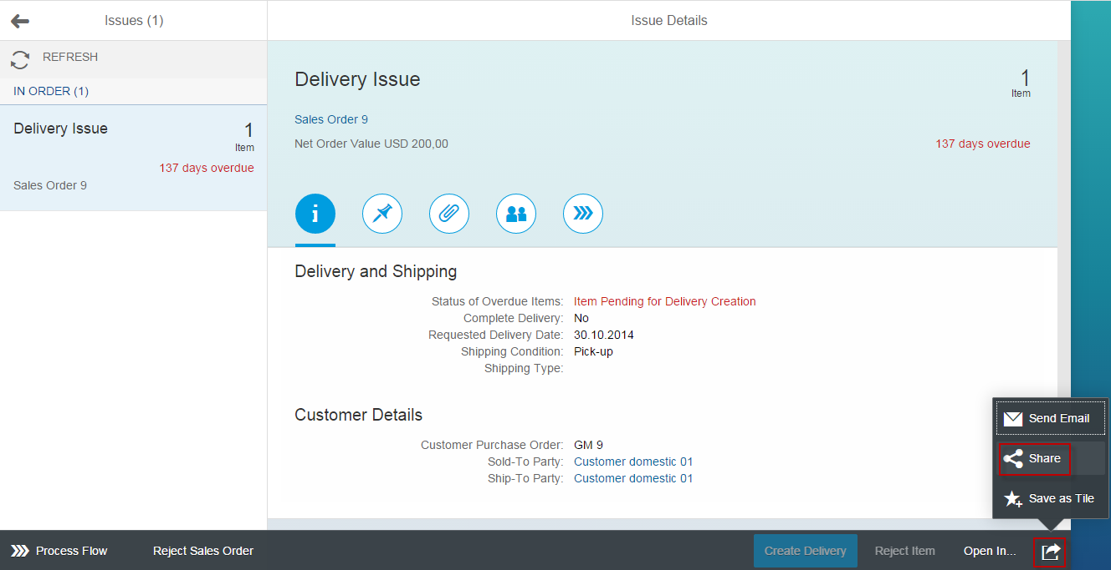

- In the Share on SAP Jam dialog box, choose your Jam Group, and then choose OK.
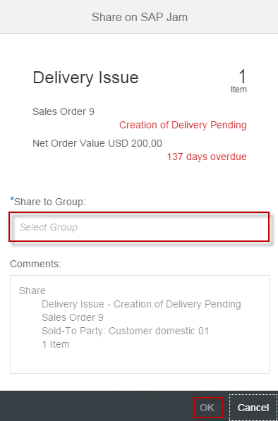

- In SAP Jam, choose Feed Updates, check your Share appears.
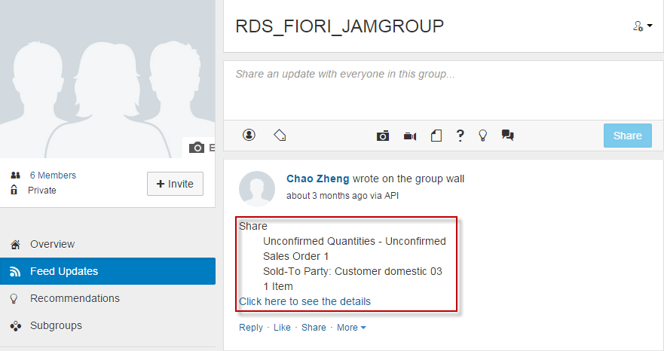
www.sap.com/contactsap
© 2015 SAP SE or an SAP affiliate company. All rights reserved.
No part of this publication may be reproduced or transmitted in any form or for any purpose without the express permission of SAP SE or an SAP affiliate company.
SAP and other SAP products and services mentioned herein as well as their respective logos are trademarks or registered trademarks of SAP SE (or an SAP affiliate company) in Germany and other countries. Please see http://global.sap.com/corporate-en/legal/copyright/index.epx#trademark for additional trademark information and notices.
Some software products marketed by SAP SE and its distributors contain proprietary software components of other software vendors.
National product specifications may vary.
These materials are provided by SAP SE or an SAP affiliate company for informational purposes only, without representation or warranty of any kind, and SAP SE or its affiliated companies shall not be liable for errors or omissions with respect to the materials. The only warranties for SAP SE or SAP affiliate company products and
services are those that are set forth in the express warranty statements accompanying such products and services, if any. Nothing herein should be construed as constituting an additional warranty.
In particular, SAP SE or its affiliated companies have no obligation to pursue any course of business outlined in this document or any related presentation, or to develop or release any functionality mentioned therein. This document, or any related presentation, and SAP SE’s or its affiliated companies’ strategy and possible future developments, products, and/or platform directions and functionality are all subject to change and may be changed by SAP SE or its affiliated companies at any time for any reason without notice. The information in this document is not a commitment, promise, or legal obligation to deliver any material, code, or functionality. All forward-looking statements are subject to various risks and uncertainties that could cause actual results to differ materially from expectations. Readers are cautioned not to place undue reliance on these forward-looking statements, which speak only as of their dates, and they should not be relied upon in making purchasing decisions.

