Building Block Configuration Guide  Document Version: 1.0 – 2015-03-06  English | Customer
Mobilizing SAP Fiori With SAP Fiori Client (MP7)

Typographic Conventions
Type Style | Description
Example | Words or characters quoted from the screen. These include field names, screen titles, pushbuttons labels, menu names, menu paths, and menu options.  Textual cross-references to other documents.
Example | Emphasized words or expressions.
EXAMPLE | Technical names of system objects. These include report names, program names, transaction codes, table names, and key concepts of a programming language when they are surrounded by body text, for example, SELECT and INCLUDE.
Example | Output on the screen. This includes file and directory names and their paths, messages, names of variables and parameters, source text, and names of installation, upgrade and database tools.
Example | Exact user entry. These are words or characters that you enter in the system exactly as they appear in the documentation.
<Example> | Variable user entry. Angle brackets indicate that you replace these words and characters with appropriate entries to make entries in the system.
EXAMPLE | Keys on the keyboard, for example, F2 or ENTER.

Document History
Version | Date | Change
1.0 | 2015-06-08 | First version.
Table of Contents
1 Purpose 5
2 Configuration 6
2.1 Running Launchpad in SAP Fiori Client 6
2.1.1 Installing SAP Fiori Client 6
2.1.2 Launching SAP Fiori Client 7
2.1.3 Configuring SAP Fiori Client 9
2.2 Custom Fiori Client From SAP Mobile Platform SDK 11
3 Appendix 14
3.1 Creating an Apache Cordova project 14
3.2 Kapsel Plugins Overview 15
3.2.1 Logon Overview 16
3.2.2 AppUpdate Overview 17
3.2.3 Push Overview 18
3.2.4 EncryptedStorage Overview 18
3.2.5 Logger Overview 19
3.2.6 Settings Overview 20
3.2.7 AuthProxy Overview 20
3.2.8 Online Application Overview 21
3.2.9 Toolbar Overview 22
3.2.10 Barcode Scanner Overview 22
3.2.11 Application Preferences Overview 23
3.2.12 Cache Manager Overview 24
3.2.13 SAP Fiori Client Overview 25
3.2.14 Offline OData Overview 25
3.2.15 End to End Trace Overview 26
3.3 Importing CA Root Certificates 27
3.3.1 Importing a CA Root Certificate into Windows 27
3.3.2 Importing a CA Root Certificate into iOS 27
4 Troubleshooting 29
4.1 Logon failed – Check your connection data 29
4.2 Importing a CA Root Certificate into Android 29
4.3 Eclipse for Android build custom Fiori client project 30

Purpose
SAP Mobile Platform is a platform for creating and deploying mobile applications. There’s a server-based process that exposes a large set of very interesting and useful services for an enterprise and multiple ways a developer can create mobile applications that consume those. Those services can be administrative services, services that provide some sort of functionality to the application and a way of exposing data to mobile devices as well.
Using the platform, you can build native applications using the platform’s native SDK, Hybrid Web applications using the Kapsel SDK and Apache Cordova. You essentially use whatever tools you want (except in the Agentry case) and the platform’s SDK to build the apps your enterprise needs.
SAP Fiori is a set of Web applications. The SAP Fiori Launchpad is a framework that can run one Fiori app or a bunch of Fiori apps. The Fiori apps are role-based.
SAP Fiori runs great in the desktop browser. Users running SAP Fiori in a mobile browser can experience performance issues – not because of SAP Fiori, but issues stemming from the limited processing, network and storage capabilities of a mobile device.
SAP’s solution to these performance problems of mobile browsers is to support running Fiori within a native application container like the SAP Fiori Client. The SAP Fiori Client has specific capabilities that mitigate some of the limitations of the mobile browser. Once Fiori runs within a native application, there are additional capabilities that are then available to the application. The SAP Fiori Client works today against the Fiori Front-end server and/or SAP Gateway directly, but when you route Fiori application traffic (Web asset and data requests) through the SMP server or HCPms, additional capabilities quickly become available to the application:
- Data available offline
- Push notifications
- Access to Device features (Camera, GPS, etc…)
- Improved performance through cache management and updates

Configuration
Prerequisites
SAP Mobile Platform should have been deployed in the landscape, reference MP2 Deployment of SAP Mobile Platform.
Or build HCPms environment reference MP9 Mobilizing SAP Fiori Apps.
Node.js and Apache Cordova and SMP SDK are installed, please refer MD4 Setup Development Environment and Verification Entities.

Running Launchpad in SAP Fiori Client

Installing SAP Fiori Client
Use
SAP Fiori is a collection of Web applications that are designed to be multichannel: both desktop and mobile browser. This means a single instance of the application supports end users regardless of the device they are using.
SAP Fiori is a collection of web-based applications, and as such may suffer from potential performance issues due to network latency and browser caching issues. To help address these problems, SAP created the SAP Fiori Client, a native application runtime for SAP Fiori on Android and IOS devices.
Features are as follows:
- SAP Fiori Web application asset cache management (eliminates performance issues that are caused by the mobile browser randomly purging its cache)
- Full screen operation for SAP Fiori
- More streamlined attachment handling on IOS
The application currently supports devices running Android 4.1.3 through 5.0, IOS 7.1, 7.11, 7.12, 8.1, 8.1.1, and 8.2.
Procedure
The SAP Fiori Client is a native application that must be installed on your device. A system administrator may perform the installation automatically, or you can download the application directly from your device manufacturer’s app store.
Note
Android – Search keyword “SAP Fiori Client” from Google play
IOS – Search keyword “SAP Fiori Client” from App Store.
Result
You have successfully install SAP Fiori Client.

Launching SAP Fiori Client
Use
SAP Fiori Client supports the standard Fiori SSO configuration. The application does not support basic authentication and will not operate in an environment where a self-signed certificate is used. So before running SAP Fiori Client, you can import the Launchpad CA certificate to the device trust list (refer Appendix – Import CA Root Certificates).
In this section, you can learn more about how to initialize the configuration.
Procedure
- Open the application in your device.
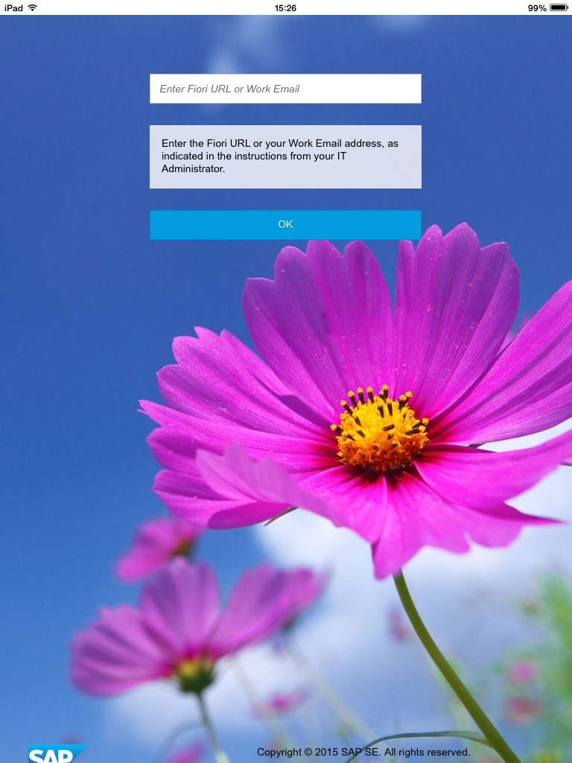
- The first time you launch the application, you are prompted to enter a URL for your organization’s SAP Fiori server, as shown in following figure. Enter the URL and click OK.

Note
Fill in the following URL error how to fix it? Please refer to the following chapters – Configuring SAP Fiori Client.

- After configuring the application for your Fiori environment, when you start the application, you see the Fiori logon screen shown in following figure. At this point, you can type your user name and password then tap Log On to access your SAP Fiori applications.
Add the Caution/Example/… paragraphs to your Quick Parts in the Insert ribbon (Insert → Quick Parts → Save Selection to Quick Part Gallery). Then delete these paragraphs below.
Note
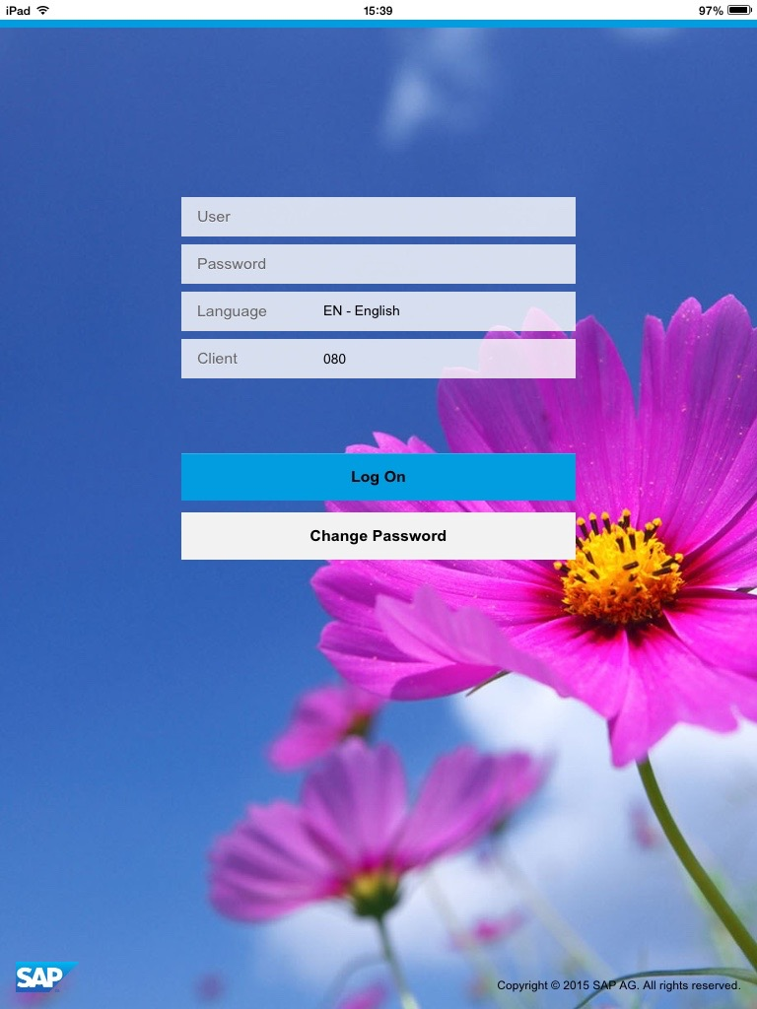
If your company’s implementation of SAP Fiori can be accessed only while your device is connected to a virtual private network (VPN) and you are not connected to the VPN. Connect to the VPN, and then tap the Reload button to reload the Logon page from the SAP Fiori server.
Result
You can already run Launchpad in SAP Fiori Client.

Configuring SAP Fiori Client
Use
This section will guide you how to configure the SAP Fiori Client.
Procedure
To configure the SAP Fiori Client, you must access the application’s settings screen. Use the instructions in the following sections to configure the application.
- Android
Newer Android devices do not expose a menu button, so on these devices, double-tap on a blank area of the SAP Fiori Client application screen to open the toolbar shown in following figure.
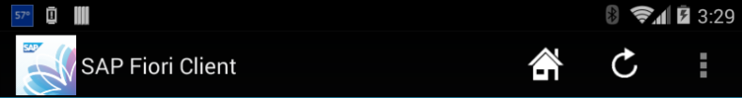

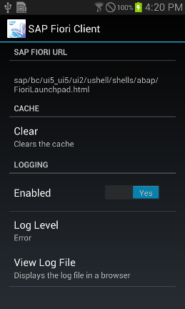
Tap the three dots aligned in a vertical bar at the right side of the toolbar; the application opens a pop-up menu. Tap the Settings menu; you see the settings screen shown in following figure.

Older Android devices expose a menu button a user can tap to display application options. On these devices, when you tap the menu button the device opens a pop-up menu above the button. Tap the Settings menu that appears, to see the settings screen shown in above figure.
- IOS
On IOS, the SAP Fiori Client Settings screen is not available from within the application. Instead, you must navigate to the IOS Settings application, then scroll through the list of applications and open the entry for the SAP Fiori Client. The Settings application opens a screen similar to the one shown in following figure.
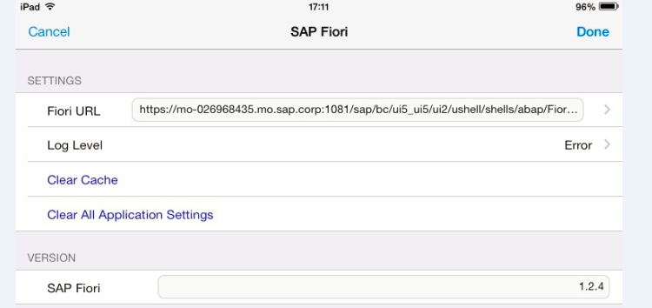

There’s no option for viewing the log file from the settings application. To view the log file after enabling it, hold two fingertips against the screen for a few seconds; the activity menu shown in following figure will appear at the bottom of the screen. Tap the ‘Log’ button to open the log file.
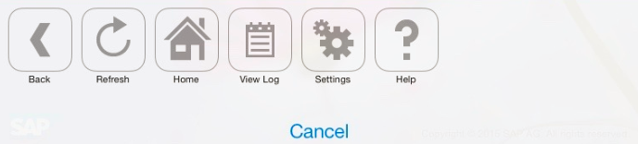

- The settings screen options:
The Fiori URL field points to the SAP Fiori Client application to your organization’s Fiori implementation.
One of the benefits SAP Fiori Client provides is an improved cache manager for Fiori Web assets. As part of the application troubleshooting process, you may be instructed to open the Settings screen and tap the Clear button to force the application to clean out its cache of Fiori application assets.
The SAP Fiori Client application can log detailed information about its operation, then display the information to the user. By default, logging is disabled; to enable it, set the Status switch to on. With logging enabled, you can set the application’s log level by tapping the current log level then selecting from one of the following options:
- Error – instructs the application to write only error messages to the log.
- Info – instructs the application to write errors and some additional information to the log.
- Debug – instructs the application to write detailed information (including errors) to the log. This option generates the most information about the application’s operation and may slow application performance more than the other options.
Once logging is enabled, and after the application has been used for a while, you can tap the View Log File item to display the current contents of the log.
Result
You know how to operate the setting interface and each setting of uses.

Custom Fiori Client From SAP Mobile Platform SDK
Use
SAP Fiori Client is an application of Cordova. Kapsel is Cordova plugins for SAP Mobile Platform by SAP developed. You can find more information about Cordova and Kapsel from Appendix.
Before the operation of this section, you will need to download and install the SAP Mobile SDK to local, reference MD4 Installing SAP Mobile SDK.
The section describes how to build a SAP Fiori Client Application, SAP Fiori Client can be installed into a mobile device to access Launchpad.
Companies often have custom application requirements, including enhanced capabilities and custom generated by applying Fiori Client, users do not need to manually enter the address of Launchpad etc.
Procedure
- Edit the file <SMP SDK>/apps/fiori_client/config.json, Provide values such as those shown below.
Note
If you are running the script on Windows remove "IOS" from the platforms or if you are running on a Mac and only wish to build one platform remove either "IOS" or "android".
Code | {  "packageName": "com.sap.fiori.client",  "targetFolder": "FioriClient",  "appName": "FioriClient",  "platforms": ["IOS", "android"]  }
- In a command window in the folder <SMP SDK>/apps/fiori_client run:
Command | npm install  node create_fiori_client.js
- Note that the create_fiori_client.js script has conveniently created a Cordova project containing Kapsel and Cordova plugins.
- Add SAP OData Kapsel plugin.
Command | cd FioriClient  cordova -d plugin add com.sap.mp.cordova.plugins.odata  cordova plugin add org.apache.cordova.network-information

- Edit the following file <SMP SDK>/apps/fiori_client/FioriClient/www/appConfig.js and provide values such as those shown below.
Sample | cordova.define('fiori_client/appConfig', function(require, exports, module) {  var appConfig = {  "appID": "com.sap.fiori",  "fioriURL": " https://<SMP_SERVER>:<port>/sap/bc/ui5_ui5/ui2/ushell/shells/abap/FioriLaunchpad.html",  "fioriURLIsSMP": true,  "passcodePolicy": {  "expirationDays":"0",  "hasDigits":"false",  "hasLowerCaseLetters":"false",  "hasSpecialLetters":"false",  "hasUpperCaseLetters":"false",  "defaultAllowed":"true",  "lockTimeout":"10",  "minLength":"6",  "minUniqueChars":"0",  "retryLimit":"0"  }  };  module.exports = appConfig; });  Note  If you use HCPms, add the following contents of this node is located behind passcodePolicy.  "auth": [{  "type": "saml2.web.post"  }]
Note
fioriURL can be a Launchpad url from SMP or HCPms, can also be a Launchpad url from Gateway.
If you need to use the SMP or HCPms, you need to specify the value of fioriURLIsSMP is true.

- (Optional)Copy the files to the platform directory by running:
Command | cordova -d prepare
- If you need to verify that you can refer MD9 document.
Result
Android and iOS project is located <SMP SDK>/modules/KapselSDK/KapselSDK/apps/fiori_client/FioriClient/platforms folder, you can run this project use IDE and build to device.

Appendix

Creating an Apache Cordova project
Use
In this section, you can create an Apache Cordova project.
Prerequisite
Node.js and Apache Cordova is installed.
Please refer MD4 Setup Development Environment and Verification Entities.
Procedure
- A new project can now be created using:
Command | cordova –d create <path>\<Project Name> <Name Space> <Project Name>  For example:  cordova –d create c:\Kapsel_projects\LogonDemo com.mycompany.logon LogonDemo
- To add platform run the following command:
Command | cd C:\Kapsel_projects\LogonDemo  cordova –d platform add android ios  Note  C:\Kapsel_projects is a sample path, you can replace own path.  Create the appropriate platform, you need to have installed the corresponding local platform development environment. Android development environment setups see here.  If you encounter an error can refer to Troubleshooting section.
- A plugin can be added with the following command. The below plugin enables console.log to display log message.
Command | cordova plugin add https://git-wip-us.apache.org/repos/asf/cordova-plugin-console.git  Note  For a list of additional plugins click one of the API's such as Camera at Plugin APIs.
- Changes would now be made to index.html file followed by calling the prepare command to copy the files in the project/www folder to the platform specific www folders.
Command | cordova –d prepare android ios
- At this point the project can be opened in a development environment such as Xcode or the Eclipse IDE that includes the Android Development Tools plugin. Alternatively, the Cordova command line can also be used to build and deploy the project.
Note
To open the project in Eclipse and then run it choose the following step Into Workspace.
Path | File → Import → Android → Existing Android Code
Then right-click on the project and choose:
Path | Run As → Android Application
To open the project in Xcode, double click on the file:
File | ~/Documents/Kapsel_Projects/LogonDemo/platforms/IOS/LogonDemo.xcodeproj
Result
You created a project.

Kapsel Plugins Overview
Kapsel is a set of plugins that enhance Apache Cordova with functionality such as a stream-lined logon to an SMP 3.0 server. The plugin list currently has the following.
- Logon
- App Update
- Push
- Encrypted Storage
- Logger
- Settings
- AuthProxy
- Online Application
- Toolbar
- Barcode Scanner
- Application Preferences
- Cache Manager
- SAP Fiori Client
- Offline OData
- End to End Trace
You can find more detailed information on each plugin to use in http://scn.sap.com/docs/DOC-49592.

Logon Overview
Use
The logon plugin manages the onboarding or registration process to the SMP 3.0 server or HCPms. When an application onboard to the SMP server or HCPms, it receives a registration ID (also known as an application connection ID). In all subsequent requests to the SMP server or HCPms, the registration id is sent via a header named X-SMP-APPCID or through a cookie that is set following a successful registration. This enables tracing functionality for each app instance.
Procedure
Add the logon plugin in command:
Command | cordova –d plugin add com.sap.mp.cordova.pugins.logon
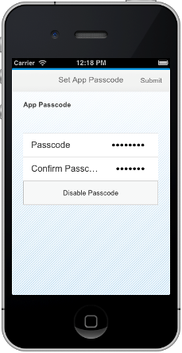
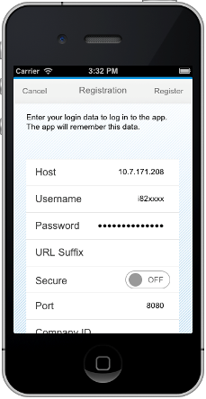
Use logon plugin screenshots:

Result
You can use the logon plugin.

AppUpdate Overview
Use
The AppUpdate plugin is used to enable the contents under the www folder (HTML, JavaScript, CSS, images, etc.) of a deployed Kapsel app and its config.xml to be updated. As an example, a new project named AppUpdateDemo will be created and used to demonstrate how to update a deployed app. A Kapsel app with the AppUpdate plugin installed will check with the SMP 3.0 server on startup to see if there is a newer version of the Kapsel app available. The revision number of the Kapsel app is automatically incremented with each deployment to the SMP 3.0 server. If the revision on the server is higher than the revision in the config.xml on the device or simulator, then a notification is shown asking the user if they wish to accept the update.
Procedure
Add the AppUpdate plugin in command:
Command | cordova –d plugin add com.sap.mp.cordova.plugins.appupdate

Result
You can use the AppUpdate plugin.

Push Overview
Use
Push messages provide a way to inform or remind a user that an action should be taken by delivering a short message that appears as a notification on the device. When clicked on, the app that is associated with the message is opened. The Kapsel push plugin provides an abstraction layer over the Google Cloud Messaging for Android (GCM) and Apple Push Notification Service (APNS). A notification can be sent to a device registered with an application via a REST call to
http://<SMPServer>:<port>/Notifications/<application_registration_id>
The REST call should either contain a header named X-SMP-DATA or X-SMP-GCM-DATA which includes values for the title and message content to be displayed or the values can be included in the URL.
Note
For SMP servers that are on a network that uses a proxy, the proxy settings in the server's props.ini file should be configured so that the SMP server can access the GCM and APNS servers.
That both GCM and APNS require open ports that may be blocked on some corporate networks or routers. GCM uses ports between 5228 and 5330. APNS uses the ports described here.
Procedure
Add the Push plugin in command:
Command | cordova –d plugin add com.sap.mp.cordova.plugins.push

Add the Caution/Example/… paragraphs to your Quick Parts in the Insert ribbon (Insert → Quick Parts → Save Selection to Quick Part Gallery). Then delete these paragraphs below.
Result
You can use the push plugin.

EncryptedStorage Overview
Use
The EncryptedStorage plugin provides an asynchronous API to store key value pairs securely. The API is based on the the Web storage interface but is asynchronous in nature.
Procedure
Add the EncryptedStorage plugin in command:
Command | cordova –d plugin add com.sap.mp.cordova.plugins.encryptedstorage

Result
You can use the EncryptedStorage plugin.

Logger Overview
Use
The Kapsel logger plugin enables messages to be logged at one of four levels (Debug, Info, Warn or Error) using:
Code | sap.Logger.debug(“Message to be logged at DEBUG level”);  sap.Logger.info(“Message to be logged at INFO level”);  sap.Logger.warn(“Message to be logged at WARN level”);  sap.Logger.error(“Message to be logged at ERROR level”);
It also provides a method:
Code | sap.Logger.upload();
That when called can upload the log to the SMP 3.0 server.
The default log level is ERROR. If the log level is set to WARN, then messages logged at WARN or ERROR would appear in the log.
The log level is set by calling:
Code | sap.Logger.setLogLevel(sap.Logger.DEBUG);
Note
This is a transient setting and is in effect as long as the application remains in memory.
Procedure
Add the Logger plugin in command:
Command | cordova –d plugin add com.sap.mp.cordova.plugins.logger
Note
That the Kapsel Logon plugin includes the console plugin via a dependency setting in its plugin.xml.
Result
You can use the Logger plugin.

Settings Overview
Use
The settings plugin is used to exchange settings between the SMP 3.0 server or HCPms and a Kapsel application. To demonstrate this, the settings plugin will be added to the Logger Sample and will enable the changing of the log level of the Kapsel app by making changes to the log settings from within the management cockpit. It also automatically uploads the log file to the SMP 3.0 server or HCPms each time that app starts or resumes if the option to Log Upload is checked on the Client Logging dialog of a registration.
Procedure
Add the Settings plugin in command:
Command | cordova –d plugin add com.sap.mp.cordova.plugins.settings

Result
You can use the Settings plugin.

AuthProxy Overview
Use
The webview used in a Cordova application does not prompt the user for credentials or for a client certificate as a regular browser does when this information is not provided. In addition, on IOS the webview does not provide any feedback when incorrect credentials are used.
The authproxy plugin can be used to handle the communication from an app and as of SP04 will present a dialog for the user to enter credentials or to choose a client certificate.
When an app needs to provide a certificate to the server to identify itself this is known as client authentication or mutual authentication. An example of this is if you are required to provide a client certificate as part of the onboarding process to register with an application or perhaps to access an OData provider (not needed to complete the example). This occurs mostly in Business to Business (B2B) applications. This is different from most business to consumer or B2C websites where it is only the server that authenticates itself to the client with a certificate that has been signed by a certificate authority (CA) such as an online banking site.

Procedure
Add the AuthProxy plugin in command:
Command | cordova –d plugin add com.sap.mp.cordova.plugins.authproxy

Result
You can use the AuthProxy plugin.

Online Application Overview
Use
This plugin adds the include for cordova.js to the HTML page being loaded. This makes it easier to enhance an existing hosted Web app by running it inside a Cordova container enabling access to native device functionality.
Imagine that you have an existing application that is being hosted by a Web server. Because it is an HTML5 app it can be accessed from multiple platforms and on multiple devices (for example Windows, Mac, Android and IOS devices). It is also easy to update the app as after a new fix or feature is added to the website it immediately becomes available to all users the next time they load the app. You now have a new feature request that when run on a mobile device, the battery level and network should be checked before executing a potentially long running operation so that the user can opt to not execute the operation.
Procedure
Add the Online Application plugin in command:
Command | cordova –d plugin add com.sap.mp.cordova.plugins.online

Result
You can use the Online Application plugin.

Toolbar Overview
Use
This plugin adds a hidable native toolbar to an app. The toolbar is displayed using a double tab gesture. The last button in the toolbar on Android displays items that do not fit or are less commonly used. On Android, the toolbar has been implemented as an action bar while on IOS it was implemented as a UIActivityViewController.
Procedure
Add the Toolbar plugin in command:
Command | cordova –d plugin add com.sap.mp.cordova.plugins.toolbar
Below is a screenshot of IOS toolbar:
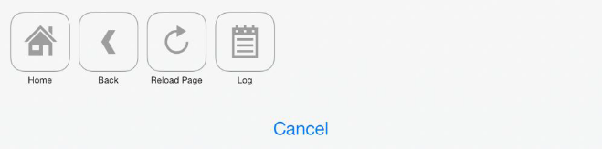

Result
You can use the Toolbar plugin.

Barcode Scanner Overview
Use
This plugin enables the ability to scan and decode a barcode. It uses the open source BarcodeScanner plugin and has upgraded it to use the 3.0.0 version of the ZXing barcode image processing library on the Android platform and on IOS corrects some warnings associated with deprecated code and fixes an issue where it is not possible to dismiss an alert dialog in a callback method.
Procedure
Add the device plugin to determine if the device is Android or IOS, and then either the Kapsel or open source barcode scanner:
Command | cordova –d plugin add com.sap.mp.cordova.plugins.barcodescanner  or  cordova -d plugin add https://git-wip-us.apache.org/repos/asf/cordova-plugin-device.git  or  cordova -d plugin add https://github.com/wildabeast/BarcodeScanner

Result
You can use the Barcode Scanner plugin.

Application Preferences Overview
Use
This plugin provides a settings page for an app. On IOS, this appears under Settings > App Name. On Android the settings screen can be shown by calling:
Code | sap.AppPreferences.showPreferencesScreen(successCallback, errorCallback);
The settings are specified on Android by calling:
Code | sap.AppPreferences.configurePreferencesScreen(preferencesJSON, successCallback, errorCallback);
Where preferencesJSON describes the settings to be shown.
On IOS the settings are specified in a plist file under Resources > Settings.bundle > Root.plist. The values can be accessed and modified programmatically by calling:
Code | sap.AppPreferences.getPreferenceValue(key, successCallback, errorCallback);  sap.AppPreferences.setPreferenceValue(key, value, successCallback, errorCallback);

Procedure
Add the Application Preferences plugin in command:
Command | cordova –d plugin add com.sap.mp.cordova.plugins.apppreferences
Application Preferences screenshots on the device are as follows:

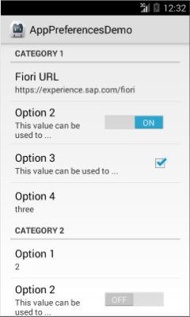
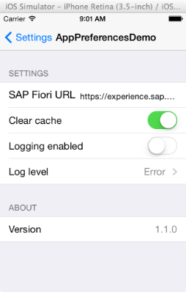

Result
You can use the Application Preferences plugin.

Cache Manager Overview
Use
This plugin provides a persistent cache of the HTML content that is used by an online app and can detect when an SAP Fiori app has been updated and purge the cache. It is currently intended to be used only with the SAP Fiori client.
The aim of caching is to reduce the load time of the application and data usage by reducing the number of files that must be transferred from the Web server to the browser or webview. If the contents of the Web app have been previously requested and they still exist in either memory or on the file system, they do not need to be transferred again the next time the application is opened. Headers in a request and response are used to indicate which files a browser should cache and for how long.
Note
The Kapsel Cache Manager plugin is currently intended to be used only with the SAP Fiori client.

SAP Fiori Client Overview
Use
SAP Fiori is a set of applications that cover some of the most frequently used SAP software functions. These apps were written using SAPUI5 and hence can be accessed in a browser on a variety of devices.
When a SAP Fiori app is run in the SAP Fiori Client, it provides a set of enhancements to the app including the ability to access native device functionality such as a barcode scanner, improved caching of the app resources using the Cache Manager plugin, security enhancements such as the ability to set a whitelist of URLs the application can communicate with, handling of authentication challenges within a webview via the AuthProxy plugin, improved attachment handling on IOS and additional benefits when integrated with the SMP 3.0 server.
Note
This plugin After generating app has integrated all of the above plugin.

Offline OData Overview
Use
The Kapsel Offline OData plugin enables an OData version 2.0 based application to be used when a device or emulator is offline by creating a store on the device.
The data that will be updated when a device is offline should ideally be data that multiple offline users are not simultaneously updating. As well, the quantity of data downloaded to a device should be kept to a minimum. Adding OData filters to the defining requests to limit the data on the device to the subset of data required is one technique to do this.
An offline store can only be used with one OData service. Once the offline store has been created, changes made to it can be sent to the SMP server or HCPms via a call to store.flush(). The offline store can update its copy of the data by calling store.refresh(). All datajs calls are redirected to the offline store after sap.OData.applyHttpClient() is called. The customHttpClient can be removed by calling sap.OData.removeHttpClient().
In SMP 3.0 SDK SP05, value requests which are used for binary data are not supported. OData function imports are also not supported as the service metadata document does not describe what changes occur as a result of calling them.
Note
OData version 2 is supported for the offline OData feature, with several exceptions.
- There is no support for these OData concepts:
- Function imports.
- Media resources.
- Deep inserts.
- ETags when using the if-match/if-none-match headers when performing LOCAL reads.
- Modifying properties or complex type properties by addressing them in the URL.
- Metadata annotations are not populated in the Metadata object.
- The Offline OData feature has the following limitations:
- The maximum length (MaxLength) of Edm.String key properties is 512 characters.
- The maximum length (MaxLength) of Edm.Binary key properties is 1536 bytes.
Procedure
Add the Offline OData plugin and the Cordova network information plugin in command:
Command | cordova –d plugin add com.sap.mp.cordova.plugins.odata  cordova –d plugin add org.apache.cordova.network-information
Result
You can use the Offline OData plugin.

End to End Trace Overview
Use
This plugin enables the tracing of HTTP calls made within a Kapsel application. This trace information is updated to the SMP server or HCPms which then forwards it on to a Solution Manager installation specified in the management cockpit under Settings → System → Solution Manager URL.
Procedure
Add the End to End Trace plugin in command:
Command | cordova –d plugin add com.sap.mp.cordova.plugins.e2etrace
Result
You can use the End to End Trace plugin.

Importing CA Root Certificates

Importing a CA Root Certificate into Windows
Use
If you check the properties of a certificate and you see in the tab Certification path the status : ” The issuer of this certificate could not be found. “ you might forgot to import the Root CA certificate into your computer’s certificate store. Download the Root CA certificate (usually a .cer or .crt file) to your computer and follow the described steps.
Procedure
- Open Start > Run and execute “mmc.exe”,
- Click on File > Add > Remove Snap-in…
- Select the snap-in “Certificates” and click on “Add > ”.
Important: Select “Computer account” and click Next
- After that the Certificates snap-in is attached and you can navigate in the tree to “Trusted Root Certification Authorities”.
- Right click on sub folder Certificates and choose All Tasks > Import and choose the downloaded Root CA certificate and go through the Certificate Import Wizard by always clicking “Next”.
- After that you should see your newly imported certificate under Trusted Root Certification Authorities > Certificates.

Importing a CA Root Certificate into iOS
Use
Apple provides the iPhone Configuration Utility free of charge. This utility can be used to create profiles with attached certificates. These profiles can be installed on an iDevice which is connected via cable.
Procedure
- Download the iPhone Configuration Utility, search in https://www.apple.com/support/ .
- Install the utility and start it
- Connect your iPhone or iPad to your computer
- In the utility click on “Configuration Profiles” listed under “Library”
- Click on the “New” button to create a new profile
- Specify a display name (e.g. NewProfileForCACert) and a unique identifier (e.g. com.test.ca)
- Scroll down and choose “Credentials” from the property list
- Click on “Configure” and select the CA Root certificate
(If you cannot find your certificate here, make sure that you imported it to your computer’s certificate store in advance as described in section “Importing a CA Root Certificate into Windows”)
- Select your device on the left side listed under “Devices”
- Choose the tab “Configuration Profiles” and click on the “Install” button beside your new created profile
(Make sure, that your device is unlocked, otherwise you will get an error message)
- Install the certificate on your device, by simply clicking “Install” at the profile installation dialog and confirming the message, that this certificate will be imported.
- Verify that the certificate got imported by open Settings / General / Profile on your device
(Here you can also remove the certificate if you do not need it any longer. )
Note
If you are using SAP Afaria in your mobile landscape you can create a new “Credentials Policy” and push the certificate file onto Afaria managed iOS devices.

Troubleshooting

Logon failed – Check your connection data
Procedure
- Check “appID” whether has been configured in SMP Server
- Check “fioriURL” whether correct
- If “fioriURL” is HTTPS, check whether the device is trusted root certificate for the URL. Import referent section “Importing CA Root Certificates”.

Importing a CA Root Certificate into Android
Use
Android provides the user the possibility to import certificates from the phone’s internal storage
Procedure
- Copy the certificate file (.cer or .crt) from your computer to the root of your device’s internal storage
- Open the Android Settings and go to Personal > Security > Credential storage > Install from storage
- Choose your certificate file and install it
(Displayed are only certificates which you did not install before and which are placed in the root directory of the device’s internal storage)
- Verify if the certificate got successfully imported by navigating in the Android Settings screen to Personal > Security > Credential storage > Trusted credentials

Note
If you did not set up a pattern, PIN or password to protect your device, you will be prompted to set one up. After the certificate import the certificate file in your root directory will be deleted.

Eclipse for Android build custom Fiori client project
Use
When create a custom Fiori client with android from run create_fiori_client.js, build the project with IDE might meet a lot of problems. Here are a standard build process.
Procedure
- Install Eclipse for Android and ADT.
- Open Eclipse and DO NOT choose “copy to workspace” checkbox, copy would lose some property and make the cordovalib project broken. Just import.
- Now you should see two projects, one is FioriClient, the other is FioriClient-Cordovalib, right click on FioriClient project, choose project property, then choose project reference, and make sure FioriClient-Cordovalib is not selected.
- Build FioriClient-Cordovalib project, make sure in the bin folder there’s a .jar file generated.
- Go back to FioriClient project and select the FioriClient-Cordovalib in the project reference.
- Now build the FioriClient project.

www.sap.com/contactsap
© 2015 SAP SE or an SAP affiliate company. All rights reserved.
No part of this publication may be reproduced or transmitted in any form or for any purpose without the express permission of SAP SE or an SAP affiliate company.
The information contained herein may be changed without prior notice. Some software products marketed by SAP SE and its distributors contain proprietary software components of other software vendors. National product specifications may vary.
These materials are provided by SAP SE or an SAP affiliate company for informational purposes only, without representation or warranty of any kind, and SAP or its affiliated companies shall not be liable for errors or omissions with respect to the materials. The only warranties for SAP or SAP affiliate company products and services are those that are set forth in the express warranty statements accompanying such products and services, if any. Nothing herein should be construed as constituting an additional warranty.
SAP and other SAP products and services mentioned herein as well as their respective logos are trademarks or registered trademarks of SAP SE (or an SAP affiliate company) in Germany and other countries. All other product and service names mentioned are the trademarks of their respective companies. Please see www.sap.com/corporate-en/legal/copyright/index.epx for additional trademark information and notices.
Material Number:

