Building Block Configuration Guide  SAP Fiori apps rapid-deployment solution  Document Version: 1.0 – 2015-07-06 | Customer
Deployment of SAP Fiori Analytical Apps (MF2)

Typographic Conventions
Type Style | Description
Example | Words or characters quoted from the screen. These include field names, screen titles, pushbuttons labels, menu names, menu paths, and menu options.  Textual cross-references to other documents.
Example | Emphasized words or expressions.
EXAMPLE | Technical names of system objects. These include report names, program names, transaction codes, table names, and key concepts of a programming language when they are surrounded by body text, for example, SELECT and INCLUDE.
Example | Output on the screen. This includes file and directory names and their paths, messages, names of variables and parameters, source text, and names of installation, upgrade and database tools.
Example | Exact user entry. These are words or characters that you enter in the system exactly as they appear in the documentation.
<Example> | Variable user entry. Angle brackets indicate that you replace these words and characters with appropriate entries to make entries in the system.
EXAMPLE | Keys on the keyboard, for example, F2 or ENTER.

Document History
Version | Date | Change
1.0 | 2015-07-06 | First version.
Table of Contents
1 Purpose 5
2 App-Specific Configuration 6
2.1 SAP Fiori Apps Reference Library 6
2.2 SAP Fiori Analytical App (Not created by SAP Smart Business Modeler) Configuration Walkthrough Example 6
2.2.1 SAP Fiori Apps Reference Library: Check App’s Technical Information 7
2.2.2 HANA DB: Assign the Role for the User 9
2.2.3 Gateway System: Creating and Assign Transport Request 10
2.2.4 Gateway System: Activate UI5 Services 10
2.2.5 Gateway System: Assign a User to the SAP Fiori Launchpad 11
2.2.6 SAP Fiori Launchpad: Add app into Home Page 11
2.3 SAP Fiori Analytical App (Created by SAP Smart Business Modeler) Configuration Walkthrough Example 12
2.3.1 SAP Fiori Apps Reference Library: Check App’s Technical Information 13
2.3.2 HANA DB: Assign the Role for the User 14
2.3.3 Backend System: Assign the Backend Role for the User (Optional) 15
2.3.4 Gateway System: Activate UI5 Services (Optional) 16
2.3.5 Gateway System: Activate Gateway Service in SAP Gateway (Optional) 16
2.3.6 SAP Smart Business Modeler: Create KPI 18
2.3.7 SAP Smart Business Modeler: Create Evaluation 19
2.3.8 SAP Smart Business Modeler: Add Tile 20
2.3.9 SAP Smart Business Modeler: Configure KPI Drill-Down 21
2.3.10 SAP Smart Business Modeler: Manage KPI Authorizations 23
2.3.11 SAP Fiori Launchpad: Add app into Home Page 23
3 Additional App-Specific Configuration 25
3.1 My Quotation Pipeline 25
4 Troubleshooting 27
4.1 Online Information Resources 27

Purpose
The purpose of this document is to describe the steps required to manually configure analytical apps end-to-end.
The document covers the following topics:
- App-specific configuration: SAP Fiori Analytical Apps Configuration Walkthrough Example
This section will use My Quotation Pipeline as example to show how to enable an Analytical app.
- App-specific configuration: SAP Fiori Analytical Apps Configuration Walkthrough Example
This section will use Valuated Stock Val. as example to show how to enable an Analytical app.
Note
The difference between My Quotation Pipeline and Valuated Stock Val. is Valuated Stock Val. is created by SAP Smart Business Modeler.
- Troubleshooting

App-Specific Configuration

SAP Fiori Apps Reference Library
The SAP Fiori apps reference library can explore, plan, and implement SAP Fiori, the new user experience for SAP software
- Discover all the SAP Fiori apps available today
- Find key information for each app, especially the technical data needed for installation and configuration
- View the data for previous app versions
- Show aggregated installation and configuration information for a selection of apps
- Navigate directly to related resources, such as app documentation and the Product Availability Matrix

Access it via:
Link | http://www.sap.com/fiori-apps-library

SAP Fiori Analytical App (Not created by SAP Smart Business Modeler) Configuration Walkthrough Example
Purpose
In this section, the configuration steps to activate an SAP Fiori Analytical application are described. Here, we use the SAP Fiori (ERP) app My Quotation Pipeline as an example. This app is a pre-delivered app, so all the steps need to be done is activate or enable several services on front-end server. All the other apps are configured likewise – using the respective technical metadata available via the SAP Fiori apps reference library.
Prerequisites
Make sure that the following prerequisites are fulfilled:
- You have set up the system landscape and checked all the software requirements.
- Check the RDS-specific SAP Note for further information. Find the link on the Step-by-Step Guide.
- Check that all app-specific mandatory SAP Notes have been implemented. Find the list of additional SAP Notes to be implemented in the Software and Delivery Requirements document available via the Step-by-Step Guide.
- The required users have been created in the SAP system, SAP Gateway system, and HANA DB. The users in the all three systems must be identical.

Note
For more information on SAP Fiori in general, see the SAP help portal: http://help.sap.com/fiori.
Procedure
See the high-level configuration sequence here:
- Check the SAP Fiori apps reference library for the app’s technical information
- HANA DB: Assign the Role for the User (HANA Studio)
- Gateway system: Activate UI5 Services (Transaction: SICF)
- Gateway system: Assign a User to the SAP Fiori Launchpad

SAP Fiori Apps Reference Library: Check App’s Technical Information
- Access the SAP Fiori apps reference library via the link provided in the Step-by-Step Guide.
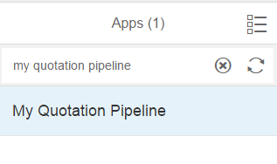
- In the top left search bar, enter My Quotation Pipeline and choose the magnifying glass icon.
- Choose My Quotation Pipeline from the list. The implementation information is displayed.

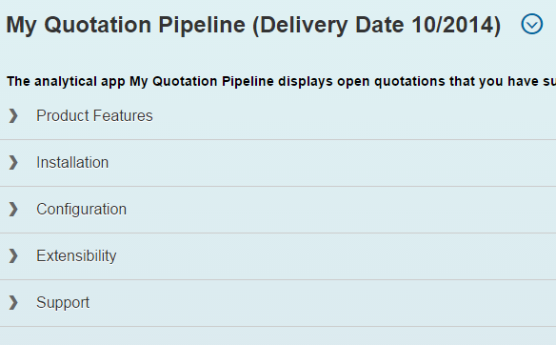
Note
The implementation information covers details on the following:
- Product Features: provides links to Help Portal pages on the My Quotation Pipeline app
- Installation: provides software requirements information like the front-end and back-end components as well as required SAP Notes
- Configuration: lists app-specific data required to configure the app
- Extensibility: provides information on extending the UI5 application the front-end server (for example, extension points in views)
- Support: provides the component for customer messages
- Choose Configuration and note down the following technical details needed for the configuration steps that follows (see also the screenshots below):
# | Section under Configuration | Technical Detail
1 | Role → sap.hba.apps.qtpl.s.roles::qtpl | sap.hba.apps.qtpl.s.roles
2 | Technical Configuration → SAPUI5 Application | SD_MYQUOT_PL
3 | Technical Configuration → PFCG role for Business Catalog | SAP_SD_BCR_FIELDSALESREP_A
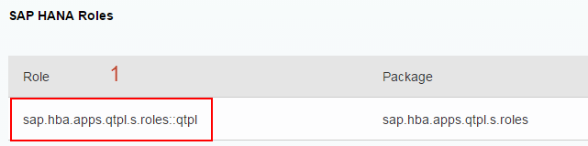
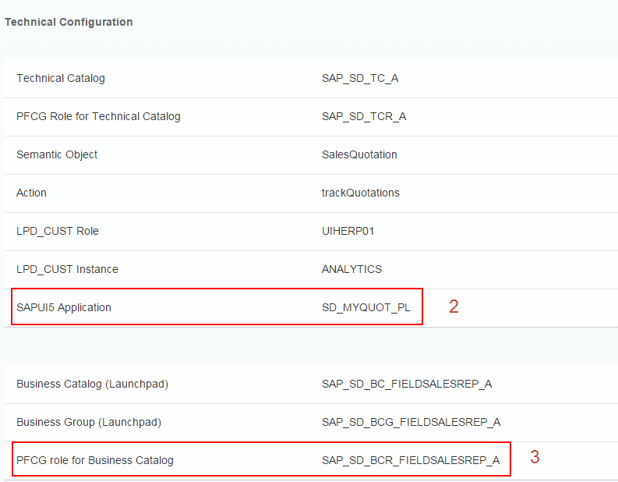

HANA DB: Assign the Role for the User
- Choose Start → All Programs → SAP HANA → SAP HANA Studio to open SAP HANA studio.
- Choose menu Window  Open Perspective  Other...
- Choose Perspective SAP HANA Modeler.
- In the Systems view, open context menu and choose Add System…
- Input the HANA hostname, instance number, and Description → choose Next >
- Input username and password and choose Finish
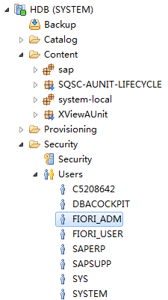
- Select the HANA Instance in the upper right corner and extract the tree Security
- Locate the User and double-click to open user profile, on the Granted Roles tab, choose.
- Input sap.hba.apps.qtpl.s.roles::qtpl, Choose OK.
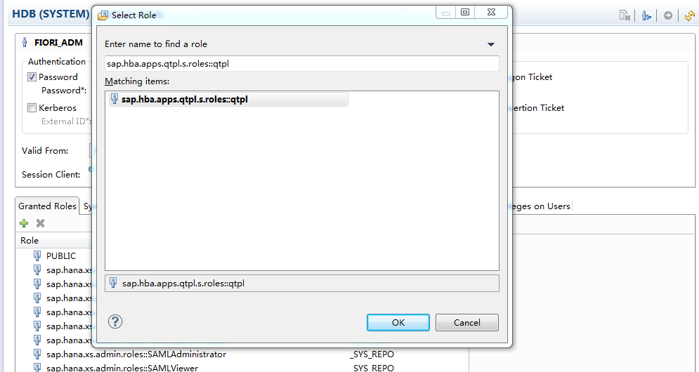
- Choose Save (Ctrl+S).

Gateway System: Creating and Assign Transport Request
Use
Since the operations will be recorded in Front-End Server, so a Transport Request needs to be assigned. A Workbench Request is needed for Configuration scope, and a Customizing Request is needed for Customizing scope.
Procedure
- Login to the ABAP Front-End Server.
- Access the activity using the following navigation options:
Transaction Code | SE01
- Choose Create.... The Create Request dialog box displays.
- Select Customizing Request and then Choose Copy (Enter).
- Maintain the description and the Target parameter in the request details.
- Choose Save.
- In Launchpad Designer, choose the Settings button in the top right corner.

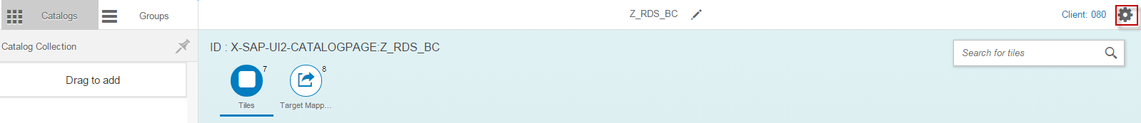
- In the Assign Transport Request dialog box, select the Workbench/Customizing Request (or choose None (Local Object) if you do not want to record changes), and then choose OK.

Gateway System: Activate UI5 Services

- In the SAP Gateway system, access the activity using the following navigation option:
Transaction Code | SICF
- Choose Execute (F8).
Activating the UI5 Service
- For activating the UI5 Service (that is: SD_MYQUOT_PL, see from above), choose the following navigation path on the Maintain service screen:
Navigation Path | default_host → sap → bc → ui5_ui5 → sap

- Select the service SD_MYQUOT_PL from the list.
- Right-click this service and choose Activate Service.

Gateway System: Assign a User to the SAP Fiori Launchpad
- In the SAP Gateway system, access the activity using one of the following navigation options:
Transaction Code | PFCG
IMG Menu | Tools → Administration → User Maintenance → Role Administration → Roles
- On the Role Maintenance screen, enter the PFCG role for Business Catalog in the Role field: SAP_SD_BCR_FIELDSALESREP_A.
- Choose Change.
- On the Change Roles screen, choose the User tab page.
- Insert the user ID/name in the user assignment area.
- Choose Save (Ctrl+S).

SAP Fiori Launchpad: Add app into Home Page
- Open Sap Fiori Launchpad as test user or administrator user (for example. FIORI_ADM or Fiori_user). (Example URL: http(s)://<webdispatcher-server host>:<webdispathcer-port> /sap/bc/ui5_ui5/ui2/ushell/shells/abap/FioriLaunchpad.html)
- On the home page, choose icon on the top-left corner of the screen, choose Tile Catalog on the bottom-left corner.
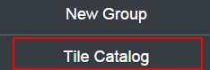
- On the Tile Catalog page, find the tile under Catalog SAP: SD - Analytical Apps.
- Choose plus icon and check My Home group and choose OK.
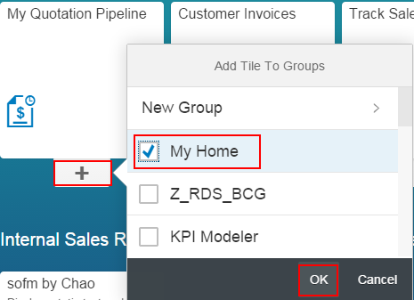
- Choose home icon to go back to Launchpad, the tile will be shown on the home page.
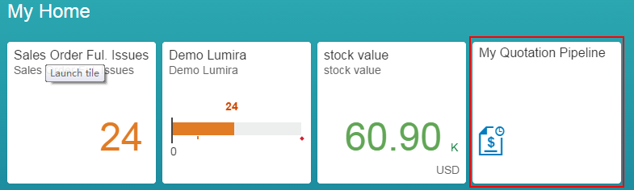
Caution
Currently the app is not fully activated, so there will be an error if trying to open the app. There is another app-specific step need to be done, please refer chapter 3.1.

SAP Fiori Analytical App (Created by SAP Smart Business Modeler) Configuration Walkthrough Example
Purpose
In this section, the configuration steps to activate an SAP Fiori Analytical application are described. Here, we use the SAP Fiori (ERP) app Valuated Stock Val. as an example. This app is not like My Quotation Pipeline, itis created by SAP Smart Business Modeler. All the other apps created by SAP Smart Business Modeler are configured likewise – using the respective technical metadata available via the SAP Fiori apps reference library.
Prerequisites
Make sure that the following prerequisites are fulfilled:
- You have set up the system landscape and checked all the software requirements.
- Check the RDS-specific SAP Note for further information. Find the link on the Step-by-Step Guide.
- Checked that all additionally required (app-specific) SAP Notes have been implemented. Find the list of additional SAP Notes to be implemented in the Software and Delivery Requirements document available via the Step-by-Step Guide.
- The required users have been generated in the SAP system, SAP Gateway system, and HANA DB. The users in the all three systems must be identical.
Procedure
See the high-level configuration sequence here:
- Check the SAP Fiori apps reference library for the app’s technical information
- HANA DB: Assign the Role for the User (HANA Studio)
- Backend system: Assign the Backend Role for the User (Transaction: PFCG)
- Gateway system: Activate OData and UI5 Services (Transaction: SICF)
- Gateway system: Activate Gateway Service in SAP Gateway (Transaction: /IWFND/MAINT_SERVICE)
- Gateway system: Use SAP Smart Business Modeler to customize a KPI and a tile on Launchpad
Note
In the following example app, there are no steps 3, 4 and 5, but some apps for example Sales Order Fulfilment Issues need steps 3, 4 and 5.

SAP Fiori Apps Reference Library: Check App’s Technical Information
- Access the SAP Fiori apps reference library via the link provided in the Step-by-Step Guide.
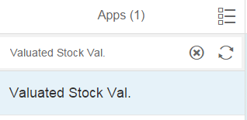
- In the top left search bar, enter Valuated Stock Val. and choose the magnifying glass icon.
- Choose Valuated Stock Val. from the list. The implementation information is displayed.

Note
The implementation information covers details on the following:
- Product Features: provides links to Help Portal pages on the Valuated Stock Val. app
- Installation: provides software requirements information like the front-end and back-end components as well as required SAP Notes
- Configuration: lists app-specific data required to configure the app
- Extensibility: provides information on extending the UI5 application the front-end server (for example, extension points in views)
- Support: provides the component for customer messages
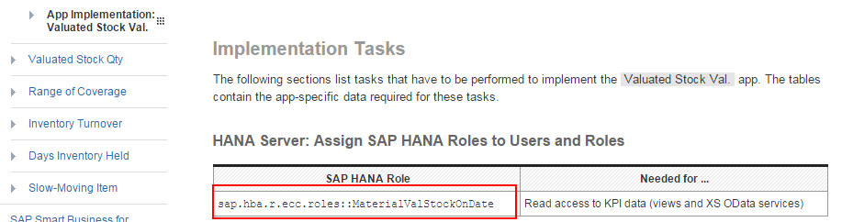
- Choose Configuration and open the link Configuration Documentation, and open also, the App Implementation: Valuated Stock Val. on help portal (see also the screenshots below):
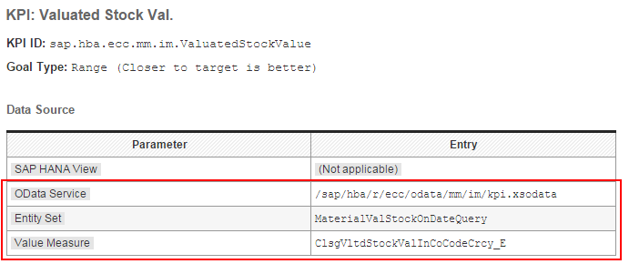

HANA DB: Assign the Role for the User
- Open the HANA Studio, on the Systems view, choose Security.
- Locate the User and open user profile, on the Granted Roles tab, choose.
- Input sap.hba.r.ecc.roles::MaterialValStockOnDate, Choose OK.
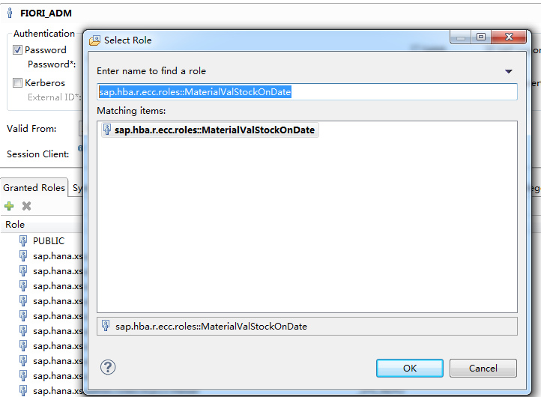
- Choose Save (Ctrl+S).

Backend System: Assign the Backend Role for the User (Optional)
Note
This is step is no need for Valuated Stock Val. Some apps for example Sales Order Fulfilment Issues need this step.

- In the SAP backend system, access the activity using one of the following navigation options:
IMG Menu | Tools → Administration → User Maintenance → Role Administration → Roles
Transaction Code | PFCG
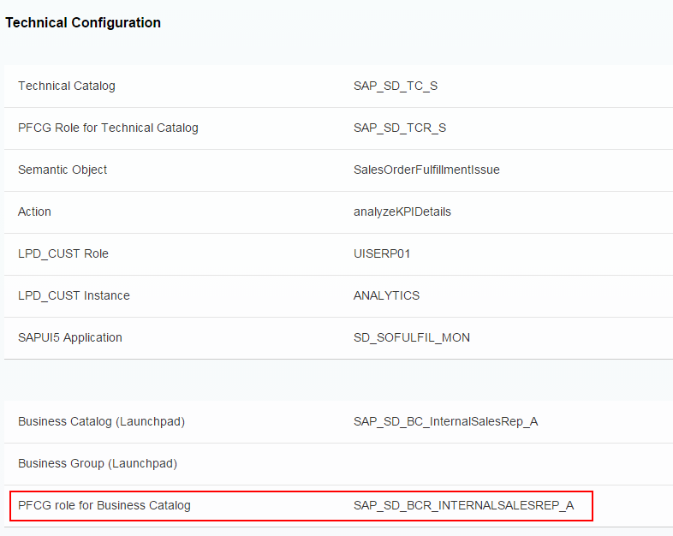
- On the Role Maintenance screen, enter the Back-End Authorization Role you noted down before in the Role field on SAP Fiori Reference Library or Help Portal.
Note
This is an example of Sales Order Fulfilment Issues.
- Choose Change.
- On the Change Roles screen, choose the User tab page, input the user ID as backend user.
- Choose Save (Ctrl+S).

Gateway System: Activate UI5 Services (Optional)
Note
This is step is no need for Valuated Stock Val. Some apps for example Sales Order Fulfilment Issues need this step.

- In the SAP Gateway system, access the activity using the following navigation option:
Transaction Code | SICF
- Choose Execute (F8).
- For activating the UI5 Service (the name of service can be found on SAP Fiori Reference Library or Help Portal), choose the following navigation path on the Maintain service screen:
Navigation Path | default_host → sap → bc → ui5_ui5 → sap
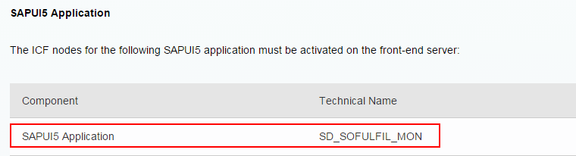
Note
This is an example of Sales Order Fulfilment Issues.

- Select the service from the list.
- Right-click this service and choose Activate Service.

Gateway System: Activate Gateway Service in SAP Gateway (Optional)
Note
This is step is no need for Valuated Stock Val. Some apps for example Sales Order Fulfilment Issues need this step.

- In the SAP Gateway system, access the activity using the following navigation options:
Transaction Code | /IWFND/MAINT_SERVICE
IMG Menu | SAP NetWeaver → Gateway→ OData Channel → Administration → General Settings →Activate and Maintain Services
- On the Service Catalog screen, choose Add Service.
- On the Add Service screen, enter the System Alias that has been created when in the course of the configuration in the SAP Gateway system. You can also use F4 help.
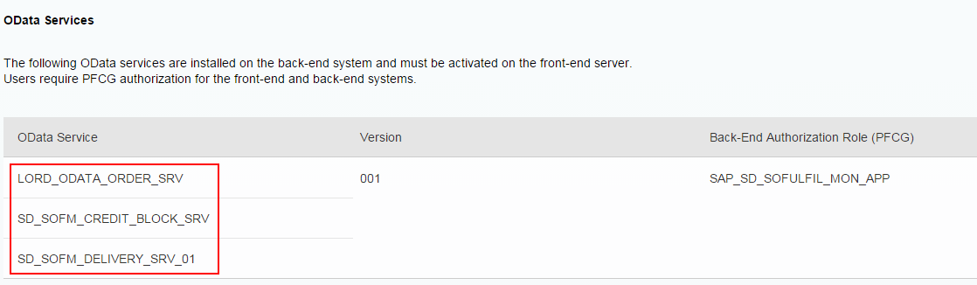
- Enter the OData service (the name of service can be found on SAP Fiori Reference Library and Help Portal).
Note
This is an example of Sales Order Fulfillment Issues.
- Alternatively, you can also get a list of services available from the system. After step 3, you choose Get Services. A list of services is displayed. From the services listed choose the OData service.
- Choose Enter.
- Select the service from the list.
- Choose Add selected services.
- In the Add Service pop-up, enter the name of the Package being used in the Package Assignment field.
- Select Standard Mode in the ICF Node section.
- Select the Set current client as default client in ICF Node checkbox.
- Choose Continue (Enter).
Assign your workbench and customizing requests and confirm the displayed messages.
- Confirm the information message that the metadata was loaded successfully.
- Choose Back.
- From the Service Catalog, select the record you have just created.
- Choose Gateway Client.
- Choose Execute (F8).
- The HTTP Response is displayed and an XML-File shows up in the lower right corner. This indicates that the Web Service is configured properly.

Note
For Web Service calls, you must maintain authorization object S_SERVICE. You then assign the Web Service operations to a role in transaction PFCG.
Find more information in this SAP Help Portal location.

Note
In case an error message shows up indicating that the http requests failed then check the following:
- Does the trusted RFC connection work properly?
- Check in the Trust Manager (transaction strust) if the SSL certificates are set up properly so the gateway system can communicate properly with the respective backend system.

SAP Smart Business Modeler: Create KPI
- Open Sap Fiori Launchpad as administrator user (for example. FIORI_ADM). (Example URL: http(s)://<webdispatcher-server host>:<webdispathcer-port> /sap/bc/ui5_ui5/ui2/ushell/shells/abap/FioriLaunchpad.html)
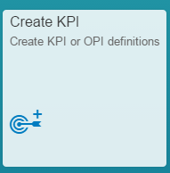
- Choose Create KPI app in the group SAP Smart Business Modeler (KPI Modeler has been renamed to SAP Smart Business Modeler, but on Launchpad the group name is still KPI Modeler).

In the Create KPI or OPI page, make the following entries:
Field Name | Entry Value
ID | Unique ID for the KPI (for example <sap.hba.ecc.mm.im.ValuatedStockValue>)
Tile | An intuitive title for the KPI, it will appear in the KPI header (for example <Valuated Stock Val.>)
Description | Description for this KPI
Type | KPI
Goal Type | Choose Range(Closer to target is better)
Tags | To make this KPI easier to search(for example <Valuated Stock Value>)
Owner Name | Description for this KPI
Owner ID and E-mail | Leave it empty or enter Owner ID and E-mail.
Property Name and Value | Leave it empty or enter some property and value. These property names and values are displayed on the Information tab of the KPI Workspace app.
SAP HANA View | Leave it empty.
OData Service | /sap/hba/r/ecc/odata/mm/im/kpi.xsodata
Entity Set | MaterialValStockOnDateQuery
Value Measure | ClsgVltdStockValInCoCodeCrcy_E
Additional Information | Leave it empty or enter the description of this data source.
Semantic Object/Action | Leave it empty.
- Choose Activate and Add Evaluation.

SAP Smart Business Modeler: Create Evaluation
- In the Add Evaluation page, make the following entries:
Field Name | Entry Value
Evaluation ID | An intuitive title for the KPI, it will appear in the KPI header (for example <Valuated Stock Val.>)
Evaluation Title | Enter a meaningful title for the variant that helps to identify the purpose of the variant outside the context of the KPI
Description | Description for this Evaluation
Tags | To make this KPI easier to search(for example <Valuated Stock Value>)
Owner Name | Description for this KPI
Owner ID and E-mail | Leave it empty or enter Owner ID and E-mail.
Property Name and Value | Leave it empty or enter some property and value. These property names and values are displayed on the Information tab of the KPI Workspace app.
SAP HANA View | Leave it empty.
OData Service | /sap/hba/r/ecc/odata/mm/im/kpi.xsodata
Entity Set | MaterialValStockOnDateQuery
Value Measure | ClsgVltdStockValInCoCodeCrcy_E
Additional Information | Leave it empty or enter the description of this data source.
Semantic Object/Action | Leave it empty.
P_StartDate | P_StartDate Equal to <A Date> (for example <20120101>)
P_EndDate | P_EndDate Equal to <A Date>(for example <20141231>)
Optional Dimension Filters | Enter the filter parameters to limit the output to a specific business purpose (for example, limit the selection to Country: US). Choose to Add Filters to add additional filter pairs.  Note  SAP client must be included as a filter criterion even if the client is not a parameter but an attribute of the SAP HANA view. However, this does not replace the proper authorization setup.
- Choose Activate and Add tile.
Note
When choose Activate and Add tile, there will be a warning that says "You have not entered a target. Do you want to continue? ". Click continue.

SAP Smart Business Modeler: Add Tile
- Locate and choose Evaluation just created.
- Choose Add Tile.
- In the Tile Configuration tab, make the following entries:
Field Name | Entry Value
Tile Format | Numeric Tile
Title(KPI) | Enter a meaningful title for the tile.
Subtitle (Evaluation) | Subtitle for this tile
Keywords | Keywords for this tile.
Drill-Down | Choose Generic Drill-Down.
- Choose Save and Activate.
- Choose home icon to go back to Launchpad.
Note
Some apps, for example Sales Order Fulfilment Issues, may support both Generic Drill-Down and Other Drill-down. So it is possible to add a second Tile which, navigation is “Other Drill-down”, enter semantic object and action and then add new tile to Launchpad.

SAP Smart Business Modeler: Configure KPI Drill-Down
- Choose Configure KPI Drill-Down app in the group SAP Smart Business Modeler (On Launchpad is KPI Modeler).
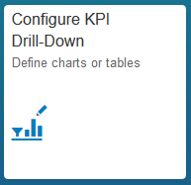
- Locate and choose Evaluation just created.
- Choose Configure.
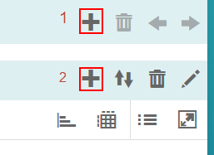
- Choose the first plus icon .
- In the KPI Evaluations tab, choose Number.
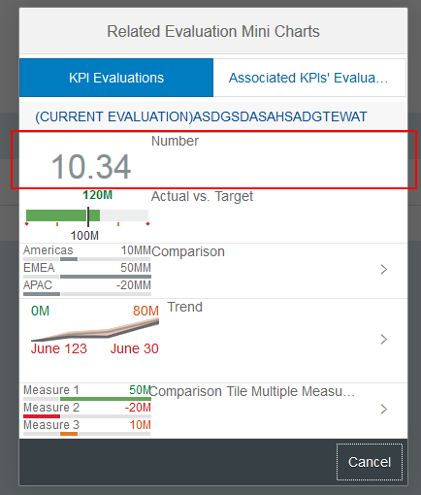
- Choose Save.
- Choose the second plus icon.
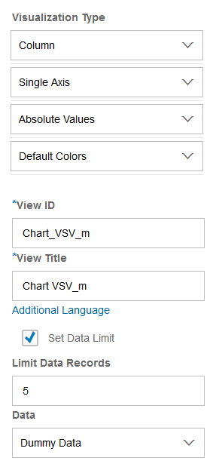
- In the Drill-Down Chart Configuration page, make the following entries:
- Choose the pencil icon on the left panel.
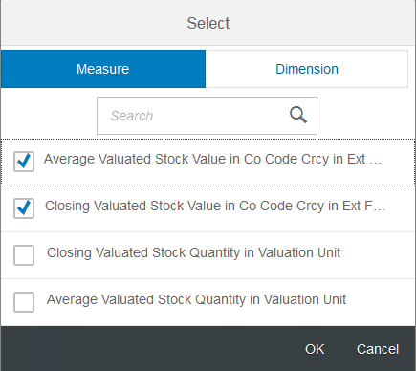
- On the Measure tab, choose following measures:
- On the Dimension tab, choose Plant and Material.
- Choose OK.
- Choose Save to go back to SAP Smart Business Generic Drill-Down page.
- Choose Save to go back to Drill-Down Configuration Details page.
- Choose home icon to go back to Launchpad.

SAP Smart Business Modeler: Manage KPI Authorizations
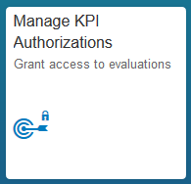
- Choose Manage KPI Authorizations app in the group SAP Smart Business Modeler (On Launchpad is KPI Modeler).
- Locate and choose Evaluation just created.
- Choose Authorize Users and Roles at the bottom right.
- Choose the users (for example: fiori_adm or fiori_user)
- Choose Save.

SAP Fiori Launchpad: Add app into Home Page
- Open Sap Fiori Launchpad as test user or administrator user (for example. FIORI_ADM or Fiori_user). (Example URL: http(s)://<webdispatcher-server host>:<webdispathcer-port> /sap/bc/ui5_ui5/ui2/ushell/shells/abap/FioriLaunchpad.html)
- On the home page, choose icon on the top-left corner of the screen, choose Tile Catalog on the bottom-left corner.
- On the Tile Catalog page, find the tile defined in the previous step under Catalog SAP: KPIs.
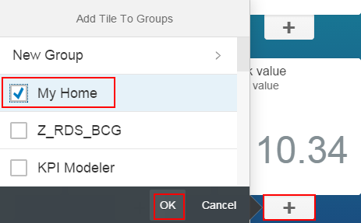
- Choose plus icon and check My Home group and choose OK.
- Choose home icon to go back to Launchpad, the tile will be shown on the home page.
- Choose tile to open the app.

Additional App-Specific Configuration
Note
The following chapter covers a selection of apps that need additional configuration.

My Quotation Pipeline
There is one more step need to be done to enable My Quotation Pipeline. The HANA view does not know the client number. So for My Quotation Pipeline, the client number must be configured in Launchpad designer.
Procedure
- Launch SAP Fiori Launchpad designer as administrator user (for example. FIORI_ADM). (Example URL: http(s)://<webdispatcher-server host>:<webdispathcer-port>/ sap/bc/ui5_ui5/sap/arsrvc_upb_admn/main.html)
- Choose top-right setting icon.
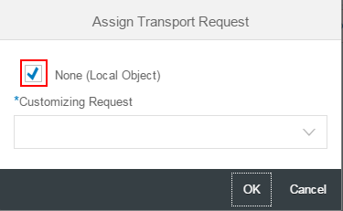
- Make sure the Transport Request setting is correct, you can either choose the Transport Request created in chapter 2.3.3, or choose None (Local Object).

- In the "Search for catalog" search box, enter SAP_SD_BC_FIELDSALESREP_A and choose the magnifying glass icon.
- Choose Target Mapping tab.
- Choose SalesQuotation Line.
- Choose Configure.
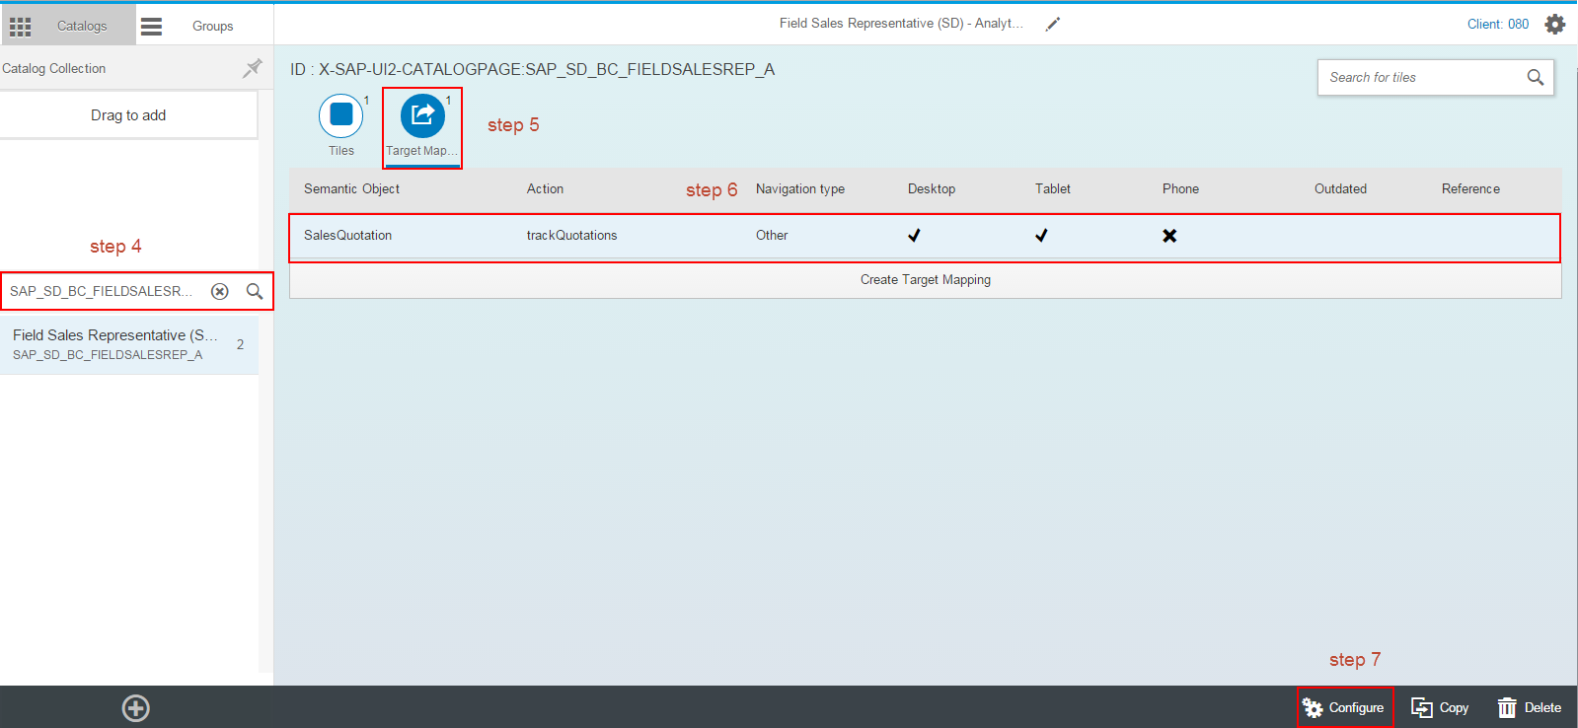
- In Configure: 'Target Mapping' page, add a new parameter SAPClient, the value is back-end client.
Note
The parameter can be found at Help Portal pages on the My Quotation Pipeline app.

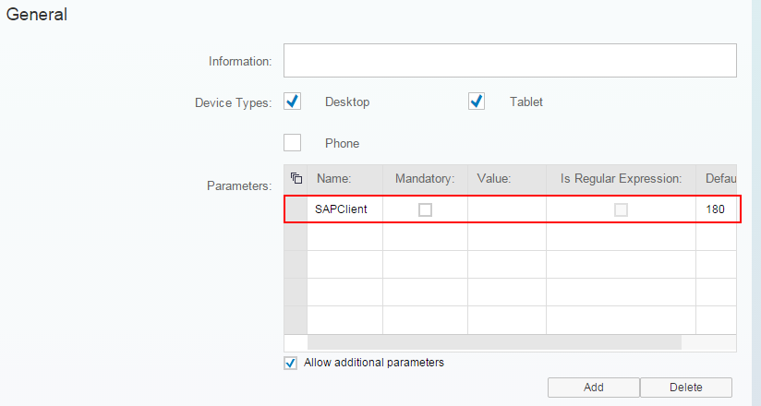
- Choose Save.

Troubleshooting

Online Information Resources
Add the Caution/Example/… paragraphs to your Quick Parts in the Insert ribbon (Insert → Quick Parts → Save Selection to Quick Part Gallery). Then delete these paragraphs below.
On SAP Community Network (SCN), there are several information sources on topics around troubleshooting and lessons learned about how to deal with SAP Fiori app implementation issues. See a selection of information resources here:

- SAP Fiori - Generic troubleshooting steps
- SAP Fiori LL03 - Apply all SAP Notes before implementation
- SAP Fiori LL04 - Make sure that the backend applications are running before implementation
- SAP Fiori LL05 - Common mistake for setting trusted RFC
- SAP Fiori LL06 - Define system alias for the TASKPROCESSING service
- SAP Fiori LL09 - Check the latest support package level
- SAP Fiori LL11 - Consultants should know about OData troubleshooting
- SAP Fiori LL12 -Consultants should know about SAPUI5 troubleshooting
- SAP Fiori LL15 - Approve/Reject comment handling
- SAP Fiori LL16 - http 403 Forbidden CSRF token error

www.sap.com/contactsap
© 2015 SAP SE or an SAP affiliate company. All rights reserved.
No part of this publication may be reproduced or transmitted in any form or for any purpose without the express permission of SAP SE or an SAP affiliate company.
The information contained herein may be changed without prior notice. Some software products marketed by SAP SE and its distributors contain proprietary software components of other software vendors. National product specifications may vary.
These materials are provided by SAP SE or an SAP affiliate company for informational purposes only, without representation or warranty of any kind, and SAP or its affiliated companies shall not be liable for errors or omissions with respect to the materials. The only warranties for SAP or SAP affiliate company products and services are those that are set forth in the express warranty statements accompanying such products and services, if any. Nothing herein should be construed as constituting an additional warranty.
SAP and other SAP products and services mentioned herein as well as their respective logos are trademarks or registered trademarks of SAP SE (or an SAP affiliate company) in Germany and other countries. All other product and service names mentioned are the trademarks of their respective companies. Please see www.sap.com/corporate-en/legal/copyright/index.epx for additional trademark information and notices.
Material Number:

